The University of Stirling

Consumption of Politics – it’s not always a rational choice:

The Electoral Decision Making of Young Voters

being a thesis submitted for the Degree of Doctor of Philosophy

in the University of Stirling

By

Dianne Dean
BA, Hons. University of Hull

September 2006

Acknowledgements

I would firstly like to thank my supervisor Eric Shaw for his continued patience and guidance throughout. His advice has been invaluable, as I have developed ideas and made sense of them and hopefully seen them come through to fruition. I would also like to thank Doreen, Sharon, and Stella for their ability to cheer me up when things got just a little stressful. Finally, last but not least, I would like to thank Martyn and the girls for their patience and willingness to give up weekends of ‘quality time’ as they say these days. I appreciate all this and will never be able to return the favour.

Abstract
The aim of this thesis was to explore the efficacy of the rational choice model in the electoral decision making of young people. The initial view was that this was too narrow a concept to apply to a real world situation. Therefore, consumer behaviour theory was reviewed in order to find out how marketers understand consumer decision making and explore if this could add anything to electoral decision making. Using an ideographic approach, this research revealed a number of different groups that did not conform to the rational choice model. Moreover, it was interesting to discover that many voter and non-voter groups exhibit what can be described as irrational behaviour. Using education as a key variable and the Elaboration Likelihood Model as an analytical framework, it was possible to identify the different ways in which the groups built up their political knowledge and what effect this had upon the extent of their engagement with the electoral process. Two models were developed that described the various groups and their electoral behaviour. The thesis concludes by suggesting that engagement is limited to a small number of groups and the level of engagement is determined by a complex mix of education, life stage and the notion of risk.

Contents Page

Abstract

Acknowledgements

Preface i

Introduction 1

Chapter 1 Rational choice, rationality, critics and alternatives 20

Chapter 2 Methodological issues 81

Chapter 3 Introducing the Extended Elaboration Likelihood Model 120

Chapter 4 Introducing the Life-world Model 138

Chapter 5 Informed Inquisitors 146

Chapter 6 Mercenaries 164

Chapter 7 Authoritarians 177

Chapter 8 Habitual Loyalists 200

Chapter 9 Don’t know, don’t care, don’t vote 208

Conclusion 245

References 263

Figures Page

Figure 1 Rationality 43

Figure 2 Consumer Decision Making Process 64

Figure 3 Influences on Consumer Decision Making 66

Figure 4 Determinants of the extent of problem solving 68

Figure 5 Elaboration Likelihood Model 113

Figure 6 Extended Elaboration Likelihood Model 124

Figure 7 Attitude Typology 134

Figure 8 Life-world Model 139

Figure 9 Respondent drawing - Informed Inquisitor - President Blair 153

Figure 10 Cognitive map - Informed Inquisitor 160

Figure 11 Respondent drawing - Informed Inquisitor - Place in world 161

Figure 12 Cognitive map - Mercenary 172

Figure 13 Respondent drawing - Mercenary - Place in world 174

Figure 14 Respondent drawing - Authoritarian - Place in world 187

Figure 15 Respondent drawing - Authoritarian - Place in world 188

Figure 16 Respondent drawing - Authoritarian - Place in world 189

Figure 17 Respondent drawing - Authoritarian - Place in world 190

Figure 18 Cognitive map - Authoritarian 196

Figure 19 Respondent drawing - Habitual Loyalist - Place in world 204

Figure 20 Cognitive map - Habitual Loyalist 206

Figure 21 Cognitive map - Guilty Know Nothing 217

Figure 22 Respondent drawing - Know Nothing - Place in world 224

Figure 23 Cognitive map - Know Nothing 230

Figure 24 Respondent drawing - Political Cynic - Shiny Blair 234
Figure 25 Respondent drawing - Political Cynic - Bottom 237

Figure 26 Respondent drawing - Political Cynic - Bigger 238

Figure 27 Cognitive map - Political Cynic 239

Figure 28 Cognitive map - Disengaged 242

Appendices

Appendix 1a In-depth Interview Discussion Guide

Appendix 1b In-depth Interview Transcripts

Appendix 2a Group Discussion Guide

Appendix 2b Group Discussion Transcripts

Appendix 3a Stage 3 Word Association Results

Appendix 3b Projective Drawings - Conservative

- Labour

Appendix 4 Group Profile from Stages 1 and 2

Preface

This thesis came about when I combined my research interest and undergraduate degree subject of politics with my work experience which was, and still is, in the field of marketing. At the time, there was little in the literature about political marketing, apart from some extensive US campaign literature monitoring gubernatorial and presidential campaigns, driven occasionally by negative perceptions of media manipulation. This really indicates the long gestation period of my interest in political marketing.

The first real investigation in the UK to the application of marketing to politics was in 1990 with Martin Harrop likening political marketing to services, in particular, banking. Since then there has been a rapidly burgeoning raft of literature from both sides of the Atlantic. In the first instance, much of this literature explored aspects of political communication, in the US which explored Presidential campaigns, use of media, political advertising, funding etc., whilst in the UK there appeared to be two foci, campaign studies in the guise of ‘designer politics’, and others who explored the applicability of marketing theory to politics.

I followed this second route. My first approach was in marketing terms to look at the customer satisfaction, this is the primary aim of marketers, was it the same for politicians? More importantly, could customer satisfaction be applied to politics in the same way as marketing? Many of the comparative issues were evaluated by Lock and Harris (1995) in their seminal paper ‘Politics is Different: Vive le Difference’. However, in the early and mid-1990s relationship market theories began to go beyond the dyadic, transactional ‘marketing as exchange’ paradigm. This seemed to be a useful application to politics, party affiliation was decreasing and voter volatility increasing - was customer satisfaction declining and could Relationship marketing be utilised to rebuild party loyalty and provide some stability to voting intentions. In true marketing traditions, the only way to find out how to identify customer satisfaction and build customer loyalty was to find out not only what voters thought about politics and political parties but how they thought.

In electoral behaviour theory there are three main models the sociological determinism model; the valence model and; rational choice (Denver 2007). From my marketing background I was familiar with rational choice as it was inexorably linked to the exchange process and the understanding of consumer behaviour. However, economic marketing theory did not provide an adequate explanation of how consumers made purchasing decisions and it was even more problematic to predict consumer behaviour. Consumer behaviour theorists and marketers needed to look at other disciplines in order to understand the complexity that was inherent in the decision making process and areas of psychology, sociology and anthropology were examined. Consumer decision making was multifaceted, more importantly, rationality didn’t seem to be the key variable. Indeed, more often, decision making demonstrated the lack of rationality. Was political decision making the same? Thus my approach to this thesis was to examine the extant political literature on electoral behaviour with specific reference to rational choice theory, and identify the extent to which it can explain electoral behaviour. Was rationality important? Could the other models of electoral behaviour provide a clearer understanding? Could consumer behaviour theory add anything further to our understanding of electoral behaviour? After some considerable deliberation, this problem and discussion evolved over time, an exploration of the concept of rationality was undertaken, whilst augmenting the notion of rational behaviour with consumer behaviour theory. The research sought to identify alternative models that could aid understanding of electoral behaviour and this became the ultimate focus of the work. This focus questioned both the notion of rationality and the methodological approach to the study of economic rationality.

There were also other issues that were also explored, for instance, voter literacy, levels of political knowledge, and engagement with political information.

The research was qualitative in nature and the findings are presented as verbatim quotes with the results of a variety of projective techniques. Quotes add to the richness of the data and illuminate many of the issues that relate to rationality or in some instances, the lack of it. I also have used a number of ‘reductionist’ methods in order to make the data more manageable such as cognitive mapping.

From the research undertaken I would like to propose that there can be no universal model of electoral behaviour; moreover, rational choice is inadequate as a predictor of electoral behaviour for the majority of voters. The research uncovers a number of groups, which cognitively process political information in different ways, whilst there are other groups who avoid cognitive processing altogether. However, the groups that represent the ‘politically literate’ are far outweighed by the other groups both in terms of types of cognition and also by significance. Making an informed decision, assumes some level of rationality and the lack of it has disturbing implications for the quality of democracy. The thesis suggests that if political strategists continue to communicate as they do, the gap between the voter literate and voter illiterate will grow, leading to further alienation and disengagement with the political process.

Voter ability to understand messages is not the only problem facing political strategists who use marketing methods. In marketing theory there are two schools of thought, firstly that marketing messages inform and educate so the consumer is able to make better purchasing decisions, this is rooted in trust and believability in the brand. This matches the first view of the rational voter cognitively processing information making a logical decision from the information collected. The second, however, believes that the consumer is manipulated as marketers use ‘psychiatric and psychological techniques’ (Packard, 1974) to condition the consumer. This scenario is more alarming as there is evidence that political strategists have used these methods to exploit voter irrationality, feeding upon insecurity, particularly with regard to issues such as immigration. One of the key findings of this research has been to identify groups who are most susceptible to this kind of message manipulation.

In marketing if a promise is not delivered or an advertisement is perceived to be unbelievable, then that alienates the consumer from that brand. Equally, politicians who do not deliver on their promises to the electorate face the same fate, if they are not to be trusted or seen as manipulators of facts, and, the thesis contends that this will lead to further alienation and an erosion of the quality of democracy.

Introduction
Understanding how voters behave when deciding whether or not to vote has been an enduring preoccupation of political scientists and practitioners alike. The perplexing issue is that there is no one universally agreed model of electoral behaviour although there are a number of contenders. Even more puzzling is the drive to find this model; can it really exist? If one recognises the complexities of the decision making processes and that there are both macro and micro influences at work, these factors make model building an exceedingly complex undertaking.

Firstly, consider the micro factors that influence decision making. How the individual personalities of each voter are developed and how this contributes to the voting decision are significant factors. The influences on the voter by peers and family members play an important role in electoral behaviour, particularly parental influence. There is also a conscious or unconscious political attitude towards voting that has been built up over time with previous stocks of knowledge. Whether these stocks of knowledge form a coherent cognitive map depends upon the individual, for not everybody stores and processes information in the same way.

Another factor is how interested or motivated people are in voting: are they keen to search out information or do they feel detached from the whole process? In particular, there has recently been much debate over the lack of young peoples’ motivation to vote. Finally, the salience of a political issue to the voter will have an effect on whether and how they actually add information to their existing knowledge base and ultimately how they act upon it. What are the salient issues according to young people? What does, or would, motivate them to get involved in politics?

Research Questions

Building upon these findings the key questions this research hopes to address are:
- Can the variables that impact upon the young voter’s decision making processes be mapped to provide a coherent model that provides a greater understanding of electoral behaviour?
- What thought processes does the young voter go through when making a voting decision?

Macro influences can also affect electoral behaviour. In today’s media fragmented environment there is an opportunity to collect vast amounts of data from many sources if one is minded to, from the newspapers, terrestrial television to satellite and digital television and the Internet. There are numerous slants on how the information is presented and attempts to put a spin on issues by the political parties. If the voter wishes to evaluate alternatives he has to delve through this clutter.

However, with this media proliferation, paradoxically, there is also a greater opportunity to avoid the media altogether. This study will explore if and how young people collect political information, how it aids their decision and the extent to which rationality forms the basis of these decisions.

Young people are bombarded with a variety of information and from many different sources and it has been claimed that young people are more media literate than their parents. Is this the case? They exist in a ‘soundbite’ culture, where media is entertainment, including the news. They are a target market and both recognise and resent it, ‘Generation X, purposefully hiding itself’ (Coupland 1997: 63). Exacerbating this is the proliferation of TV channels, both satellite and terrestrial. So rather than being better informed they are able to avoid the news media altogether, given the range of choice on television.

The result, it is claimed, is that young people’s level of interest in politics is at an all time low (Heath and Park 1997: 6). This is particularly evident in the opinion polls after the election, which indicated that many young people stayed away from the polling booths and abstained rather than casting their vote. However, this apparently does not apply to all young people during an election campaign. With the development of internet web sites that enable tactical voting and vote swapping, the use of this new type of media by young people suggests that some do still get involved in the political process but not through the traditional channels.
So there are two perspectives on this proliferation, firstly, there is a wider more accessible media and voters who are better educated fostering a greater rationality; secondly, there is the dumbing down thesis, where voters do not watch the news, engage in debate nor evaluate political discourse. This thesis contends that these are not rival propositions but complementary and dependent upon young voters' internal and external influences.

The thesis questions the extent to which rationality determines voting decision making, that is to say whether voters engage in rational and informed consideration of the issues. Rational decision making underpins the majority of decision making theories whether in economics, behavioural law, marketing or politics (Lowenstein 2001).

Behaviourist research into decision making has sought to provide a broader understanding of decision making, nevertheless it starts from the same premise of instrumental rationality in that decision making is deliberative. However, many studies indicated that decision making not deliberative but post deliberative (Lowenstein 2001).

This thesis addresses two areas of concern. Firstly, questioning the heuristic value of the rational choice voter as an efficacious predictive model; and secondly, examining the extent of de-politicisation amongst young people. The research will focus upon young people aged 18-30.
This will comprise of first time voters and also voters who are moving through the initial life stages of marriage, owning their own home and parenting. The research will examine the development of their political attitudes and evaluate how this affects their voting intentions. The research is exploratory in nature and will take a phenomenological approach in order to develop an understanding of how their political attitudes are formed. The phenomenological approach will allow for exploration of the diversity of variables in a similar manner to Robert Lane’s influential study published in 1972. The research will explore the complexities of electoral behaviour and the evolution and development of voting decision making.

It will commence by exploring the rational choice paradigm, which has been a major theoretical contribution since Downs’ seminal text in 1957, which has subsequently been built upon by Olson, (1971) and Riker and Ordeshook (1968) amongst many others. It will dispute the notion that rational choice theory is an accurate predictor of electoral behaviour. It will claim that the scope of rational choice is too narrow; disregarding the role of emotion, irrationality and the multifarious nature of electoral decision.

The thesis will explore the theoretical nature of rationality which, according to Habermas (1986), consists of multiple levels of which economic rationality is the narrowest of all the levels. It will compare and contrast Aristotle’s notion of irrationality and its ‘participation with reason’ (rev 1976) suggesting that irrationality is not simply ignorance but can sometimes be a legitimate aid to decision making.

Moreover, just as there is a distinction between rationality and irrationality, there is also a distinction between irrationality and non-rational decision making and all of these notions contribute towards decision making. For instance, rather than emotional decision making which is ‘viewed as an explicit and central detriment to good citizenship’. Marcus (2002) argues non-rational decision making in the form of emotional decision making can provide the motivation to make an electoral decision.

The degree of success that rational choice has enjoyed has been mainly due to the simplicity of the model. There are few variables to include, the models tend to be one-dimensional and exclude any extraneous variables that may in some way render the model unworkable. Moreover, the variables under investigation are always measurable which again arguably excludes many of the aspects of the voting decision making process. But if the popularity of the model stems from its simplicity, this very simplicity, I will argue, leads to a one-sided analysis.

I shall suggest that the methodological foundations of rational choice are too abstract for a model to be formulated and then applied to human behaviour. The research queries whether the substantive issues of rational choice, principally the cost benefits analysis, assumed to be undertaken by voters, and the concept of exchange, do in fact adequately illuminate the complexities in the voting decision making process.

There is an acceptance that there may be alternative ways of building an understanding of electoral behaviour by extending the notion of rationality (Butler and Stokes 1969; 1974; Heath et al. 1985; Clarke, et al. 2004); or appreciating the value of psycho-social analysis (Himmelweit et al. 1993; Petty and Cacioppo 1986; Tversky and Kahneman 1982).

Analysis of voting also appears to lag behind developments in marketing theory. In the advanced capitalist economy it is crucial for marketers to understand consumers’ behaviour in order to provide good or services that the consumer requires; they need to be aware of the motivations that trigger purchasing behaviour. However, increasingly in marketing, there seems to be a greater acceptance of the diversity of decision making than appears to be acceptable in political science literature (Lowenstein 2001). Marketing, along with rational choice theory, has evolved from neo classical economics. A prime example of this would be the concept of the exchange where both rational choice theory and marketing use the exchange process to explain how either votes or money are exchanged for promises or goods.

In contrast to rational choice theory, however, buying behaviour models have developed from the economic consumer to complex holistic models, (eg. the classic work of Howard and Sheth 1969). Studies have also taken place exploring irrationality of consumers (Holbrook 1986), how emotional attachment affects brand loyalty (Holbrook 1986) and also the experiential or symbolic meaning of brands (Hirschman and Holbrook 1992; Belk 1988) or advertising imagery. Marketing theory began with economic rationality as its foundation but needed to draw on other theories that more closely matched how consumers actually made their buying decisions.

For instance, psychology, where the theories of Freud and Maslow amongst others have been used to understand conscious and unconscious drives and how they affect behaviour. In consumer behaviour theory the key driving factors in decision making are the notions of risk or more importantly perceptions of risk. This thesis will contend that these factors are taken into consideration by political strategists but have not been made explicit in the political science literature.

In order to investigate the questions it is necessary to build an understanding of the mental world of the voter to appreciate how they make sense of the data that comes to them, how they interpret it, what understanding they have of political concepts and how they relate to politics. As Converse (1964) argues

The stuff of politics – particularly that played on a national or international stage – is, in the nature of things remote and abstract.

So how do young people make sense of the information and the political system they find themselves in? What belief systems do they have? How are they developed and what is the extent of their development? What concepts or notions are central to their beliefs and how consistent or stable are they? Are they able to make sense of ‘remote and abstract’ constructs, if so, how and what is their relevance? What is the nature of their cognitive map of the political sphere and how then does this inform their electoral behaviour?

This is important as it can build a greater understanding of how the reasoning process takes place. For instance, Sniderman, et al. (1991: 73) discuss the reasoning chains of voters. In their quantitative study they identify that voters who like blacks are more likely to blame their problems on the situation blacks find themselves whilst people who do not like blacks argue it is a weakness of will. There is no discussion as to how these beliefs developed, so this research takes a step back and looks at why beliefs such as these occur in the first place (Chong 1993). Thus this research will be undertaken on a qualitative basis, exploratory in nature.

When consumers or voters are provided with information, the way they process this information is determined, according to Petty and Cacioppo (1986), by their ability and motivation to process this information. The Elaboration Likelihood Model (ELM) will be evaluated and used to provide an analytical framework to the empirical research. The ELM was developed by Petty and Cacioppo in order to understand how and why attitudes develop, shift or remain constant, how information is processed or elaborated. They suggested there were two routes to attitude change each route requiring a different level of elaboration, leading to central or peripheral persuasion. Each route was dependent upon the ability and motivation of an individual to process information.

Ability to process information can be defined in three ways: are people able to understand information? Do they notice the message? And how does new information relate to their existing knowledge? This research augments the Elaboration Likelihood Model with Bernstein’s (1971) work where he explored sensitivity to structure or content, that is the capacity to understand a concept in relation to the wider issues; what Converse (1964) calls the ‘what and why’. Basil Bernstein (1971) considered the effects of class and education on a child’s ability to learn focusing on the complexity and coherence of the belief systems. These questions are of central relevance to understanding electoral behaviour but they are difficult to explore using quantitative methods.

For Petty and Cacioppo (1986) a person, who has both ability and motivation to process information, engages in central processing or information elaboration. This involves a careful, considered approach evaluating the information available and elaborating this in the context of their existing knowledge. If the person has no ability nor motivation to process information Petty and Cacioppo argue that processing will be limited, receivers will only pick up peripheral cues such as signs or symbols without any central processing nor elaboration. The core argument of this thesis maintains that if young people only process information ‘peripherally’ then this is incompatible with rational choice theory.

Peripheral processing suggests that people do not evaluate the alternatives as rational choice claims, their existing stock of knowledge is not modified with new information and no central processing takes place. At best, peripheral processing, using heuristic devices, merely leads to a temporary change in the voters’ attitude taking the information into the sensory memory where it is soon forgotten. This is also supported by the work of Bartels (1996) who found that voters were not able to act using information cues and ‘political shorthand’ as if they were fully informed. The voter is unable or unwilling to rationally evaluate alternatives and order their preferences, thus undermining the basic premise of rational choice. Moreover, this thesis contends that rationality does not always form the basis for decision making, and will attempt to identify a variety of forms of political processing and non-processing amongst young voters. It follows that there is no one universal model of electoral behaviour. Rationality is much more complex than rational choice theory presupposes (Butler and Stokes 1974; Clarke et al. 2004; Denver 2007) and this complexity leads not only to more difficulty in finding a coherent model but also uncovers greater propensity for unpredictability.

Finally, an adapted version of the Petty and Cacioppo Elaboration Likelihood Model is tentatively proposed which takes into consideration the fluidity and heterogeneity of decision making, placing ability, motivation and other such variables on a continuum as suggested by Petty et al. (1986; 1999). Moreover, this model is extended to include variables that also influence decision making such as emotion, a much neglected component of the electoral decision making process.

To augment this extended ELM, a ‘life-world model’ is built. The purpose of this model is to illustrate the sources of information that are available to the citizen. These are potentially extensive if the receiver chooses to use them; however, they are also able to ignore them. In accordance with Petty and Cacioppo and Bernstein’s work the citizen’s ability and motivation are determinants in how he uses the information available to him, how he makes sense of the world, events, issues, political information, and ultimately how these factors contribute to his electoral decision making.

The structure of the dissertation will be as follows. The first chapter will explore competing models of electoral behaviour and will focus upon the theoretical issues of rational choice. It examines the concepts of rationality and reason through a review of the philosophical literature and examines the distinction between instrumental rationality and the philosophical concept of rationality. It will question the value of rational choice as a framework for understanding electoral behaviour and secondly highlight the failure of rational choice literature to resolve the paradox of voting.

Alternative theories of electoral behaviour will be reviewed including the socio psychological model, valence model, and the party identification model, in order to identify how they attempt to reconcile the complexities of voting decision making.

Chapter 1 will examine the extant consumer behaviour literature and endeavour to understand why the marketing literature takes a more pluralist approach than political science in its attempt to understand decision making. It will begin with an historical review of how consumer behaviour has been analysed, from the economic model right through to the post modern perspective. The discussion will focus upon why there has been such a rapid development in this area and briefly explore the underlying dynamics. The methodological pluralism used in consumer research provides a wider understanding of the consumer, their life-world and how decisions are made and influenced. The argument for methodological pluralism will then be extended to this research and will be discussed in Chapter 2.

Chapter 2 will provide an examination of the positivist methodological approaches to studying electoral behaviour. More specifically, it will discuss the philosophical underpinning of the positivist approach whilst highlighting some of the problems relating to the usage of such methods suggesting at worst these methods can reinforce the uni-dimensional, tautological nature of rational choice.

The research will also review occasions where political practitioners have utilised alternative methodological approaches and examine why these approaches were taken, and how they relate to the traditional methods of research. If electoral behaviour is to be truly understood, the chapter claims, then a methodological pluralist approach needs to be considered more fully.

Chapter 2 discusses why the thesis adopts a qualitative methodological approach and introduces the analytical tools used to make sense of the data. The research was exploratory in nature and comprised of a three stage approach. Firstly, 15 individual in depth-interviews were undertaken following a phenomenological method, using an unstructured questionnaire or discussion guide. The sample was selected on a convenience basis. This stage of the research identified some of the important issues amongst young people and also provided in initial indication of the levels of interest in politics amongst the age group 18-30. This was followed by six group discussions consisting of 8 people in each. For the second stage the respondents were recruited through a quota sample. The key variable examined was education, in order to investigate if political issues were processed differently by respondents with different education levels. These group discussions lasted for two hours.

The methodology applied Bernstein’s (1971), notion of communicational linguistic codes, particularly with regard to form and content of understanding. The respondents in both stages were selected as (1) unemployed, no qualifications, (2) clerical worker, no degree and (3) management with degree. All respondents were aged 18-30. This would take into consideration the changes in life stages from single to married; to married with children, and identify drivers for involvement in the political process.

The discussions that followed explored what information people take from a political campaign, what sources they are exposed to, how they deal with those sources, what is their understanding of political concepts such as democracy, sovereignty etc, and what other influences guide their voting decision. The final stage recruited degree educated people working in a junior management position. The sample was selected by convenience sample and there were four mixed gender groups in total. These discussions lasted for one hour.

In Chapter 3 and 4 two models are tentatively proposed that provide a contribution to the extant literature. Firstly, the Elaboration Likelihood Model extension which builds Petty and Cacioppo’s (1986) ELM into a two dimensional framework. This extends the notions of ability and motivation which then is able to define eight distinct voter and non-voter groups. The second model is described as a ‘Life-world model’ in that it identifies the key variables within the respondents’ life-world and examines how they impact upon the voters described in the ELM extension model. Although further research is required to test the efficacy of these models they are useful to distinguish between different voter groups.

Chapters 5 to 9 report on the main findings. Firstly, this research will demonstrate that there are a number of variables that affect electoral decision making, and that levels of rationality and irrationality differ amongst groups. Key findings suggest crucially that voters do not behave and do not evaluate information in the same way and this is guided by a number of factors including their education, milieu, their belief systems and degree of involvement in the political process.

The research identified eight groups, defined as ‘habitual loyalists’; ‘informed inquisitors’; ‘disengaged’, ‘guilty know nothings’; ‘authoritarians’, ‘mercenaries’; ‘political cynics’, and ‘know nothings’. Some of these groups have also been identified in the political science literature previously. Amongst all groups there was limited involvement in the political process and little trust in parties and politicians, reflecting the discussion of Dunleavy (1990). In most cases there was little indication of ability to conceptualise abstract issues of a political nature and little awareness of abstract political concepts such as democracy and sovereignty supporting the findings of Converse (1964).

Many individuals do not follow a ‘costs versus benefits’ analysis, nor does the concept of exchange appear to have any substantial relevance. These two concepts are fundamental to rational choice theory so much so that if they have little relevance for many individuals the rational choice paradigm has little solid ground. Moreover, the research identified problems such as incorrect assumptions about issues, reliance on parental choices and meagre cognitive activity. This was compounded by evidence of irrationality, emotionally clouded views and discussions that demonstrated a lack of the means end analysis characteristic of rational choice theory.

One of the major findings of the research indicates that salience was a catalyst for learning and understanding issues. If an individual identified an issue that affected their own or their family’s lives, they would become more active, seek further information and build an opinion. Interestingly, findings suggest that the education level had an effect on what was salient and the level of sophistication was related to educational attainment. The research explains how issue saliency changes through life. Younger single people for instance, were less inclined to get worried about mortgage rates or house prices but once they had purchased a house this was an issue that they became concerned with. Even though the age group is relatively narrow, the findings suggest that marriage, children, change of job and buying a house (situations that usually occur during this life stage) all have an impact on determining what is an important issue for the respondent at that time. The different groups exhibited different levels of rationality and also different levels of involvement and motivation. In the consumer market the product sector determines, to a great extent, the level of involvement. However, in politics it appears that the opposite is true. For some voters politics is treated as a high involvement ‘product’ or decision where there is involvement in the process but for others politics is low involvement where there is little motivation or ability to elaborate and become involved in the political process.
The conclusions suggest that two major themes emerge from these findings, low involvement and authoritarianism. The former, I suggest takes two forms, estrangement with the political system and frustration with the political choices on offer. The findings also indicate that the possession of traits associated with an authoritarian personality is a major force shaping the thinking in electoral behaviour of the less well educated. However, this is not to suggest that authoritarians do not exist in groups with higher levels of education.

Alarmingly, this reflects upon Adorno et al’s (1950) research where they attempted to identify characteristics of a fascist personality. Although this research does not attempt to measure levels of authoritarianism there are a number of defining characteristics that are enduring.

The ‘Authoritarian’ group tends to be conformist and to particularly admire a strong leader, who provides guidance and security and can alleviate their fears by providing measures for protection or strong decisive action in fearful situations. Authoritarians believe in a natural hierarchy where their place and other groups’ places are clearly demarcated. This research uncovered respondents sharing these same features.

My conclusions suggest that both disengagement and authoritarianism cast doubt upon rational choice theory, in four ways. Disengagement emphasises the paradox of voting, still unresolved by rational choice theorists. Moreover, young people are not an homogenous group; this research identified eight distinct groups, four of which demonstrated varying degrees of disengagement or estrangement. Another significant group comprised of individuals exhibiting authoritarian personality characteristics. This group have a limited capacity for reasoning; their main concerns surround their own security. They are motivated to preserve the existing political and social system in which they feel protected by strong leaders and their position in the social order. Fear is a mobilising factor, Authoritarians are concerned about asylum seekers, crime and the findings from the research indicate that they are repeatedly exposed to peripheral cues with little cognitive elaboration. This echoes the findings of Marcus and MacKuen (1993), who argue that emotional and irrational thinking is demonstrated in much electoral decision making.

Finally, and most significantly, if the majority of people fall into these categories where there is little involvement or interest in the electoral process and limited cognitive activity about politics, then the universality of the rational choice theory is called into question.
Chapter 1

Rational choice, rationality, critics and alternatives

This chapter will review the development of the theories and concepts of rational choice and discuss the relevance of rationality and reasoning as components of electoral behaviour. The concept of rationality first articulated in the neo-classical economic framework will be explored and conclusions reached about the capacity of rational choice theory to explain electoral behaviour. Rational choice theory will be critically evaluated from the perspective of the philosophical literature in particular Rescher’s (1988) notion of rationality, Habermas who defines four levels of rationality; and Aristotle (1976) who explored the components of irrationality and the interplay of rationality and reason. Secondly, it will review current thinking upon rationality in electoral behaviour examining valence politics (Butler and Stokes, 1974, Clarke et al, 2005); heuristics (Tversky and Kahneman, 1982) and; the nature of political knowledge amongst different groups of citizens. Finally, decision models from the marketing discipline will be examined in order to compare and contrast the development of neoclassical economics in rational choice and marketing theory.

The discussion suggests that while rational choice may be appropriate in certain instances or amongst certain groups of people it is only one tool of many that can be utilised to understand individual and social choice.
However, as Clarke et al (2005:34) noted there has been a ‘growing interest in the power of the individual rationality framework to explain electoral choice and political change’. This is especially significant, as the traditional demarcation lines of class, culture, religion and education are no longer as effective as predictors of party identification. Party identification itself was seen as a heuristic device in rational choice theory but research has indicated that this is also declining (Sarlvic and Crewe1983; Dalton 2000). It has been claimed that the development of digital TV and the internet, means that more information sources are available to the voter, enabling the citizen to deliberate more rationally but is this the case?

Hence, there are two major challenges facing rational choice theory:

- empirical testability ( Joyce 2000; Schiemann 2000)

- the paradox of voting (Ferejohn and Fiorina 1974; Aldrich 1993; Whiteley 1995)

Rational choice was developed from neo-classical economic theory and was first articulated by Anthony Downs in his seminal text in 1957. For Downs, rational man works only towards his own selfish ends. He explored rationality from an economic perspective and though he recognised that other factors influenced the decision making process he excluded these from the model as they reduced its predictable value. He claimed that if the theorist knew what ends the individual sought to achieve he would be able to predict the most reasonable way to reach those goals assuming that the individual was rational. The economic concept of rationality suggests that rationality is demonstrated through the route taken and the tools used to get to the end, ie. the processes of action (Downs 1957:6), as the end is assumed to be given. For Downs (1957:5) the rational voter:

Moves towards his goals in a way which, to the best of his knowledge, uses the least possible input of scarce resources per unit of valued output

Hence, the voter evaluates and identifies his own preferences, orders those preferences and votes accordingly for the party or candidate that would most closely match his value system. Thus, the voter behaves rationally in that the patterns followed in searching out and evaluating alternatives are the ‘most reasonable way for the decision maker to reach his goals’ (Downs 1957:4). It is all about investment benefits rather than consumption benefits (Blais 2000:5). However, whilst Downs’ model proposes this narrow framework, he simultaneously acknowledges that reality paints a different picture where ‘men are not always selfish, even in politics’ (Downs 1957:27).

After justifying the theoretical nature of the rational choice model, Downs then reduces it to its narrowest classification of economic exchange. He assumes that the individual approaches a situation ‘with one eye on the gains to be had and the other on costs’ (Downs 1957:7). But rational choice theory does not take into consideration how those preferences were formed and what other factors can influence the voting decision. Downs recognises behaviour may be different in practice from what the theory postulates and equally that the model does not allow personality or social milieu to be included. Notwithstanding, according to Downs the efficacy of the model lies precisely in its ability to reliably predict within a constricted framework. He supports the theoretical simplicity of the model by citing Friedman (1953) who argues that ‘theoretical models should be tested primarily by the accuracy of their predictions rather than the reality of their assumptions’. The only concession to reality is that he believes ‘this political man to be uncertain about the future’ (Downs 1957:7).

The rational choice model defined by Downs exhibits five major characteristics. Firstly, rational man can make decisions when faced with a series of alternatives. Secondly, he ranks the alternatives according to his own preferences. Thirdly, he ranks those preferences transitively. Fourthly; if he has a large number of preferences he selects his highest-ranking preferences; and finally, he would always make the same decision given the same alternatives on another occasion.

For Downs, rationality is measured by how a voter ‘strives for what they desire, or at least act as if they were pursuing some end’ (Brams 1985). There is no room for emotion, or other variables that could impact upon the instrumental processing of the information. Downs cites a number of examples where rational behaviour could be clouded by secondary emotional factors but claims that he is only looking from a political rather than a psychological perspective (Downs 1957:7). Curiously though, rationality also appears to be discussed independently of ends, as if the voter merely seeks to selfishly satisfy his own needs. Is there no morality in voting? It would appear that this is the case with economic rationality. The voter simply weighs up the benefits and costs associated with their own individual gains. The model presented by Downs, clearly explains one notion of the process of voting, however, it does not provide an adequate explanation of why people actually vote. Furthermore, when one considers this self interest notion of ‘pocket book voting’, there is little empirical evidence to support this (Udehn 1996:79). The evidence suggests that ‘pocket book’ voting occurs amongst less knowledgeable voters (Kinder and Kiewiet 1979; Carpini and Keeter 1993; 1996; Lau and Redlawsk 1997). However, Gomez and Wilson (2001), who explored levels of sophistication in economic voting, not only found an heterogeneity amongst voters but also argued that the accepted view of pocket book voting was undermined. They proposed that higher sophisticates were more likely to vote according to pocket book rather than sociotropic considerations.

Kinder and Kewiet (1981) reviewed the notion of sociotropic voting where voters were more likely to vote according to ideological or social issues rather than merely self interest.

Moreover, how do voters determine what issues motivate them when deciding what is in their self interest? As Udehn (1996:79) noted that:

it is clear that other considerations are at work also and may even be more decisive

Within rational choice theory altruism is factored out since according to instrumental rationality theory, it is not rational to look at others interests unless they are of direct or indirect benefit to the individual making the decision. These issues are not satisfactorily accounted for within rational choice theory, which does not provide a consistent explanation of why people vote, and how they come to their final decision. Rational choice, Downs acknowledged, reduced the voter to an ‘artificial man’ in a theoretical model (Downs 1957:8). The model is predictable, accurate but impossible to prove empirically as man lives and works in a much more complex environment than Downs’ equation is able to hypothesize. Downs acknowledges this but argues that the test of a theory is its heuristic value, again this is questioned in this research.

Another problem Downs faces when reducing voting to a cost benefits analysis is the problem of explaining why people vote at all.

When one considers the paradox of voting, first identified by Condorcet in the eighteenth century, it is difficult to justify how one vote can actually make a difference to the electoral outcome. As Heath, Jowell, and Curtice (1985:9) succinctly remarked
the individual vote can make so little difference to the outcome of an election that the rational, instrumental elector would never waste his or her time and effort in going to the ballot box

Dunleavy (1991:80) concurred with this viewpoint recognising that if a rational voter
works out her party differential, multiplied by the likelihood that her own vote will be decisive in determining which party forms that government’ and as ‘this probability is almost always minute’ the rational voter would abstain

This paradox of voting first has been a major problem for rational choice theorists and a number have attempted to ameliorate this. Kenneth Arrow (1963) addressed this problem by making two ‘rationality’ assumptions. Firstly, he defined the notion of connectivity; where there is a direct link between the individuals voting decision and their values. If a voter has a particular cognitive map that supports a set of belief systems, it would be logical to suggest he would vote for the party that would be most likely to uphold those. Within this notion there would be no tactical voting as this would mean that the voters would contradict their own values, which Arrow argues is irrational. Arrow’s second condition that attempts to ameliorate the paradox of voting is transitivity. After these two conditions have been fulfilled, Arrow then proposes that five conditions would then have to be met in order to ensure democratic social choice (Brams 1985:59). These included:
- Universal admissibility of individual preference scales
- Positive association of individual and social values
- Independence from irrelevant alternatives
- Citizens sovereignty
- Non dictatorship

So rational choice sets such rigid conditions for the process of individual choice to aggregated to the public choice within a democracy that the conclusion is quite clear when one considers that this is noted as ‘Arrow’s Impossibility Theorem’. Thus as Brams (1985:60) argues ‘it condemns to an ineradicable arbitrariness all methods of summing individual preferences that satisfy the notions of fairness and justice embodied in the five conditions’. So, even if rational choice theory goes out of its way to prove that in a rational choice world there is no rational need to vote because, notwithstanding the costs of voting, the individual’s vote does not make a difference, so why would they vote?

Riker and Ordeshook (1968) recognise this flaw in the rational choice argument and attempt to develop the Downs discussion on civic duty further. It is what Riker and Ordeshook denote as the ‘D’ term that makes the paper so different from other works on rational choice electoral behaviour. The satisfaction represented by the “D” term can be derived from a number of sources. The voter can affirm allegiance to a particular political system, party or candidate, thus gaining satisfaction from the activity of voting. For that reason it seems reasonable to suggest a modification of rational choice theory combined with some notion of civic allegiance but only if the political system can be seen to be of benefit to the voter. However, this raises a further question according to Barry (1970:16) ‘why do some people have this kind of motivation more strongly than others’. Indeed, Blais and Young (1998) explored the concept of duty defined in the context of Riker and Ordeshook (1968) and concurred that most people did vote out of a sense of duty. For Blais and Young (1998):

voting for most people is an unreflective and habitual act, based primarily on a sense of duty. We surmise that the great majority of citizens neither contemplate nor calculate the costs and benefits when they think about going to the polls

However, their sample was conducted amongst students at two universities. It could be argued that the sample consists of more middle class people who have a greater degree of civic duty. It is ironic, that in order to prove civic duty is an important component of voter turnout they then provide evidence to counter the rational choice costs benefits analysis by suggesting voters do not evaluate the issues when voting.

Further, there appears to be a generational decline in the notion of civic duty and how this affects voter turnout (Clarke et al. 2005). Aldrich (1993), an advocate of rational choice theory, also sees the ‘D’ term as problematic, arguing that possibly some sense of civic duty may not ameliorate the paradox of voting. He argues that there are other smaller variables to consider, ‘small changes in costs and benefits alter the turnout decision for many voters’ and that for the majority of voters costs are usually low in a standard election. However, in a closely fought election this alters the stakes and this then introduces the notion of the ‘strategic politician’ (Aldrich, 1993) who focuses more on marginal seats where there is a greater propensity for the voter to turnout. Jackman (1993) suggests that Aldrich’s (1993) work exploring the impact of the ‘strategic politician’ who motivates voters to turnout, in their own self interest, ‘restores political considerations to the analysis in turnout’. This would support the analysis of Negrine (1996:145) who argues that:

politicians…seek to influence by shaping the perceptions of events or by defining the nature of ‘reality’.

Thus, the paradox remains, is it explained by merely a sense of civic duty, astute politicians, or, are there other factors that are not accounted for in this puzzle? Nevertheless, even in a marginal seat where voting could possibly bring about benefits, information searching is costly, in terms of the time it takes to look for information, make sense of it and evaluate alternatives. However some people take little notice of political information. Low involvement in the decision making process is an important aspect in the study of electoral behaviour.

Downs attempts to justify how a lack of involvement in the political process can be perceived as rational. He argues that the voter believes he has decided he has collected enough information to make a voting or non voting decision. There are a number of ways that information can be gained with little effort. For instance, ideology is a form of political issue shorthand (Udehn 1996:18). An ideological platform can indicate where the party stands on a bag full of political issues and voter allegiance to a particular party or partisan self image can reduce the amount of information searching. Downs advanced the argument that political parties are a means of political shorthand, in that they stand for a whole range of issues on a section of the ideological continuum. This spatial model proposes a left/right one dimensional space where political parties position themselves.
Voters choose the party closest to them on policies that reflect positions on a left-right ideological continuum (Whiteley, et al (2005)

However, if this were to be the case then there would be a clear identification of partisanship amongst the electorate. But party identification has declined both in the US and UK (Dalton and Wattenberg 2000; Denver 2007), so if party identification is a means of making a rational decision, what are the effects of its decline? In the UK, party identification strongly reflected the class base (Butler and Stokes 1974; Heath et al. 1985; Rose and McAllister 1990).

In their classic study of electoral behaviour, Butler and Stokes (1969, 1974) suggested that factors such as class and party identification which were built up over time were much more influential than the short term effects of campaign activity and party leadership. Increasingly though, it was argued that as party identification declined, issue based politics increased as voters were making their electoral judgements upon specific issues. This was proposed as one of the reasons for a decline in party identification. Voters focused upon issues rather than long term party preferences (Denver 2007:97). However, Butler and Stokes (1974) (cited in Denver 2007:96), claimed that for an issue based model to be borne out, the voter must be aware of the issue; hold an attitude towards it; understand the policy stance of the political parties towards the issue and; the voter must voter for the party who most closely matches his view on this issue. Nevertheless, they can be wrong (Lakoff 2004, MacKuen and Parker-Stephen 2006), they can have a misunderstanding of the issue and also misunderstand which party holds the position closest to their own position (Kuklinski et al 2000). Thus Butler and Stokes (1994) proposed a ‘valence model’ which explored issues that related to the citizens as a whole, such as crime, health, etc., issues that are universally favoured rather than just pure self interest. Later studies, particularly in the 1980s examined the decline of party identification as a determinant of decision making. Although Green et al. (2002: 168) suggest that party identification is far stronger in the United States politics than the UK. This has been gradually eroded since the 1960s (Butler and Stokes, 1969) and the 1979 General Election highlighted this.

The Conservative vote grew from 36% in 1974 to 44% in 1979 and this remained relatively constant with the Conservatives retaining a vote of over 40% right up to 1992. Labour’s traditional voter, the members of the working class has declined. However, although Franklin and Mughan (1978) identified a decrease in class voting they also concluded that it was difficult to prove the dealignment thesis conclusively, as other variables are contributory factors. Särlvik and Crewe (1983) reflected these findings in a later study and claimed that:

The relationships between individuals’ social status and their choice of party have by no means vanished. But as determinants of voting they carry less weight than before.

Whilst in Ivor Crewe and Thompson’s (1999) study of electoral behaviour, he argued that the most significant factor to affect electoral sociology was the collapse of the working class Labour vote. However, more recently, the Conservative vote has remained at 32% for both the 2001 (Morgan 2001; www.parliament.uk) and 2005 General Election (Butler and Kavanagh 2005), which would suggest party identification is more complicated as argued by Sinnott (1998), Ray (2003), and Sanders (2003). Whilst Sarlvik and Crewe (1983) claimed that class voting had declined, rather voters evaluated issues to make their electoral choices, Heath et al., (1985) argued that party identification was still a strong determinant in electoral behaviour.

Nevertheless, there remains a significant decline in voting that has caused concern either through a lack of motivation or commitment to a political party (Curtice 2005) or there is a breakdown of trust in political parties or the political system (Bromley et al. 2004; Electoral Commission 2006; White 2006:4). The Electoral Commission (2005:8) identified a number of reasons for non voting. Firstly, there was a ‘difficulty in deciding who to vote for due to weakening party alignments or the campaigns were too similar’. This was echoed in the later report the campaign and media coverage Electoral Commission 2005:29; secondly, the campaign was negative and boring (Electoral Commission 2005:8) and finally; the ‘result was a forgone conclusions and nothing would change’ (Electoral Commission 2005:8). In order to understand the remaining voters, the valence model re-emerged as a tool of analysis with Clarke et al’s (2004) exposition of electoral behaviour. They argued that voters looked at the parties or the party leaders who were most likely to successfully manage the issues deemed as important. They claimed that voters did not think about politics on a regular basis and made ‘rough and ready’ judgements (Clarke et al. 2004:326) based upon heuristic devices such as party leaders. Moreover, ‘valenced partisanship’, as a store of ‘party and party leader performances’ (Clarke et al. 2004:211) served another heuristic for electoral choice. Moreover, ‘partisanship in Britain is fundamentally connected to notions of performance’ (Clarke et al. 2004: 316).

There is a rational ordering of information that is built up in the manner associated with normative rationality but as Loewenstein (2001) claims even behavioural research contains an inherent assumption of deliberative decision making. Could it be, that for some voters, the internalisation of attitudes and attachments occurs prior to (or without) considered thought?

Lau’s (1989) model proposes that voters have stocks of knowledge in their memory and he advances the argument that voters search out specific information that fits most closely with that of their schema. Thus, they only search out information that matches with their existing thinking, but for Lau, there is no discussion of rationality. Furthermore, he does not really cover the voters/non-voters who do not go through the information searching process and fails to account for how they come to make voting decisions. Clearly, complexity in electoral decision making is difficult to map (Electoral Commission 2005:21), which leads the discussion on to the seven ‘cognitive domains’ advanced by Newman and Sheth (1985). Their research was based upon a primary US election. They specified clearly the domains within the model, which comprised of issues and policies; social imagery; candidate image; emotional feelings; current events; personal events. The model relied on the voter’s memory and also recognised the many variables that can impact upon the decision making process.

It was proposed that voters augment their belief systems developed through childhood with a number of different influences, including party identification, milieu, and mass media. Whiteley et al (2005) took this a stage further arguing that within the valence model there is a sub-model called the issue-priority model which takes into consideration the salience of an issue. Political parties can ‘benefit differentially from the salience of particular issues’ (Whiteley et al. 2005). Thus on economic and non economic valence issues the party deemed most likely to deliver on these will be supported. This leads to a multi-dimensional framework adding further layers of complexity to electoral behaviour theory.

All these studies of electoral behaviour reject the narrowly defined rational choice perspective, choosing to extend the boundaries of influence that affect electoral decision making. Nevertheless, these studies still assume some sort of deliberation even though there is minimal cognition, voters relying on heuristic devices and some sort of affective attachment acquired through childhood. As Kuklinski and Hurley (1994) reflect [rationality scholars] ‘view cue-taking as a rational and an effective means by which citizen can make the right choices’. So how can a heuristic device enable a voter to process electoral information? Heuristic is defined in the New Oxford English Dictionary as ‘enabling a person to discover or learn something for themselves’ they go further to suggest that in computing it is ‘proceeding to a solution by trial and error or by rules that are only loosely defined’.

This would support the notion of stocks of knowledge built up over time and that party identification is a knowledge structure that is held in the memory. Moreover, research has indicated that heuristics are socially shared (Todorov et al., 2002) although not endorsed. In terms of knowledge usage, there are three principles; availability, accessibility, and applicability (Todorov et al., 2002). Availability of the knowledge structure and how it can be accessed is important. If political information is available and accessible so it can be retrieved from the memory without too much effort leads to the applicability of that heuristic device.

Some heuristics are highly accessible, such as attitudes and opinions, and are easily retrieved from memory (Huckfeldt, et al. 1998). Huckfeldt, et al (2005) examined partisanship, ideology, and highly salient issues in their research and uncovered some confusion amongst respondents regarding the combination and use of these heuristics and this questions the applicability of such heuristic devices. Applicability refers to the degree of fit between the accessibility of the knowledge structure and the level of appropriateness to the judgement task (Higgins 1996). Moreover, a heuristic device is more likely to be utilised if there is consistency and it matches the existing frames of reference. If there is no consistency between the heuristics used to make a decision, there will be cognitive dissonance Festinger (1957). Consequently, the use of heuristic devices is complex, when examining multiple heuristics there is the issue of weighting, preference ordering and also new information becoming available.

This becomes still more difficult to determine as policy statements from either of the major parties are less clearly defined. They have discarded much of their ideological baggage and become, in Kircheimer’s terms, ‘catch-all parties’. This has made it more difficult for the voter to use the political shorthand described by Downs. So how informed are voters? What access do voters have to information sources and how effectively do they process it? In Lane’s (1972) later study, he questions the decline of ideology in the wake of the knowledge society, where information searching is costly, there is more information available to the voter, and this increases during election time. There are really two sources for information gathering, the social and the political. The everyday life in which the citizen lives affects the level of political literacy and social stratification often determines the quality of discourse in personal social life. Access to the political sphere, the extent of elaboration, or how much voters take notice from political communications is also determined by social stratification and of course, educational attainment.

Some citizens are able to access and understand information from a variety of sources whilst others either have no access or understanding (MacKuen and Parker-Stephen 2006; Bartel 1996). So potentially for some - the politically literate - there is a great opportunity to collect information from both social and political spheres but it is irrational for voters to examine all the information that comes their way on a daily basis as Miller et al. (1986) noted.

How the voter searches and orders the available information has been the focus of a number of studies and there are a number of factors such as political sophistication, political literacy, perceptions, and the influence of social factors upon involvement. An excellent account of how voters respond to political communication was undertaken by Zaller (1992). Whilst De Sart (1995) and Granberg (1982) looked at how perceptions of issues affected voting intentions. A number of studies explored the impact of political sophistication upon candidate evaluation (Luskin 1987; Carpini and Keeter 1993; 1996; Gomez and Wilson 2001). From the many messages that reach the voter, he chooses which information to process, Zaichkowsky (1991) describes him as a cognitive miser, a low involvement consumer getting the best value out of minimum information necessary to make a decision.

Zaller (1992) argues that voters with high and low levels of awareness of political issues are unlikely to be swayed from their decision to vote or abstain, it is the members of the electorate who have moderate levels of political awareness that will be more likely to be influenced by campaign messages. So if they are influenced, are they behaving rationally?

How does the voter deal with the information coming through the television channels, which have proliferated over the past ten years? With the development of satellite and digital television, there is greater potential for the voter to catch the news and evaluate campaign issues but there is also the opportunity to switch channels and avoid any news. Moreover, there are conflicting views of the role of TV in the 1997 election such as claims of limited analysis, or too much coverage. Combined with negative campaigning these factors were largely perceived to contribute to a decline in political debate and political participation.

For instance, Goddard et al. (1998); and Deacon, et al. (1998) all highlighted complaints of the election coverage ranging from limited levels of analysis, but conversely Norris et al. (1999) argued that there was too much coverage and this was switching people off. Opinions are mixed and although the print media and terrestrial television claimed the election was a ‘turn off’, Sky reported a ‘significant upsurge in regular viewing’ (Boulton 1998).

This could indicate that some people are processing information more elaborately, as Sky’s digital audience is composed of ‘youngish, AB adults and opinion formers’ (Boulton 1998). This appears to be the ‘knowledge society as described by Lane (1972). This would support the view of Gomez and Wilson (2001) who claim that there is a far greater heterogeneity in electoral behaviour than the extant literature suggests.

Nevertheless, this still does not explain why other citizens are avoiding media coverage of politics. There is evidence to suggest that as message sources increase, attempting to reach the voter from every possible angle; some voters are switching off from the traditional methods of communication. This may be due to the attitudes towards negative campaigning, outlined by Ansolabehere and Iyengar (1995) and Scammell and Harrop (1997). However, other researchers have claimed that negative campaigning strengthens previously held attitudes. Franklin (1994:11) paints a picture of the armchair electorate similar to the armchair football supporter, taking information on board as entertainment. This is reflected in the post modern literature as voters graze information, partaking of the tastier morsels that are easier to digest and it appears that the media and political candidates recognise this. Jacobs and Shapiro (2000) argue that due to the need for the media to maintain audience interest in a subject that is increasingly unimportant to them, they need to ‘avoid complexity’ and use ‘easy to sell stereotypes and audience-grabbing plots’. Moreover, they suggest that these tactics ‘draw audiences addicted to titillating entertainment’ (Jacobs and Shapiro, 2000: 57).

Kate Adie reflecting upon her time in Bosnia, claimed that the news reports were not selected for significance but for interest (Adie 2002:9) and news is only part of the world of media ‘information of dodgy provenance, slick advertising and public relations half truths’ (Adie 2002:9). Her view has considerable support, Aneurin Bevin (cited in Perry 1993) lamented the state of affairs where ‘advertising is taking the poetry out of politics’ and Brown and Coates (1996:5) agree beginning their critique of New Labour’s communications strategy with ‘public relations is all today’. So for some, rather than empowering voters, Aronowitz (1987) argues that this lack of debate erodes the democratic decision making process, encouraging an impoverished form of discourse. He claims that communicative rationality is diminished and argued that:

Mass politics signifies the end of public discourse, where there is face to face communication and decisions are arrived at through consciously applying rules of evidence and argument

He complains about the demise in public discourse and the development of ‘sound bite’ politics which keeps the message simple, concentrating on image with no real in depth policy debate. The reluctance of political parties to debate issues in depth only serves to exacerbate the remoteness of the electorate to the process of government (Habermas 1992:218). For Habermas (1992:220) this leads to a potential for political parties and candidates to manipulate the message and prevent the formation of coherent public opinion which has been documented by Page and Shapiro (1992) in US politics.

However, there is little evidence to suggest that in the information age, people are using more information (Lurie 2002) and Bartels (1996) would suggest that information shortcuts such as heuristic cues do not enable citizens to act as if they were fully informed, rather they can be misinformed.

Kuklinski et al., (2000) distinguish between the ‘ideal’ informed citizen who searches out information, orders preferences and votes accordingly with the ‘real’ uninformed citizen. Moreover, they argue that there is a further distinction between the uninformed citizens ‘who do not hold factual beliefs at all’ and the misinformed who ‘firmly hold beliefs that happen to be wrong’. Tversky and Kahneman (1982) went even further to claim that although heuristics may be useful they ‘sometimes lead to severe and systematic errors’ (Tversky and Kahnemen, 1982: p3). So, if the ability to make informed decisions is undermined by the steady decline in the efficacy of heuristic devices such as party identification; and information searching has been reduced to image, signs and symbols, does this undermine the democratic decision making process? Habermas (1992:219) argues that this is the case and would be more in keeping with an authoritarian regime, where voters have no opportunity for listening to debate and political discourse. He claims that voters can be manipulated through political advertising focusing upon anxieties and insecurities, which would suggest high levels of irrationality and this is a serious concern about the use of political marketing.

But what precisely is ‘rationality’? The concept of rationality, as used in philosophical/sociological analysis differs from the meaning assigned to it in rational choice theory. For Wedgewood (1999) ‘rationality is just a matter of some sort of internal justification or coherence’. This perspective follows the Weberian concept of rationality, which is goal seeking and closely aligned to problem solving, a teleological rationality (cited in Habermas 1986:12). Rational choice is a narrow economic interpretation of teleological rationality, albeit means rather than goal driven.

However, there are a number of areas where philosophy concurs with economic theory. Firstly, rational choice is a logical progression. If a person makes a decision, they would evaluate alternatives and progress through a series of steps towards the final decision. Secondly, that rational thought is consistent (Taylor 1986). If a person were faced with the same alternatives at a later period, they would follow the same pattern and reach the same decision. However, this is the point where concepts of rationality diverge from instrumental rationality.

Figure 1 illustrates how Habermas (1986) articulates four types of rationality, outlining a hierarchy which highlights the different characteristics that distinguish the various levels. Instrumental rationality has been added as the least developed mode. As he progresses his discussion, he considers the various levels of rationality and evaluates how each component contributes towards communicative rationality. The important factor is that there are different levels of rationality, which are interchangeable and dependent upon context. This serves to highlight the complexity of electoral decision making.

Firstly, each situation is different; the way the individual interprets the situation can determine the level of rationality and the capability of the individual also determines the extent of reasoning. Further, the complexity and intelligibility of the message also has an impact upon how the message is understood and processed.
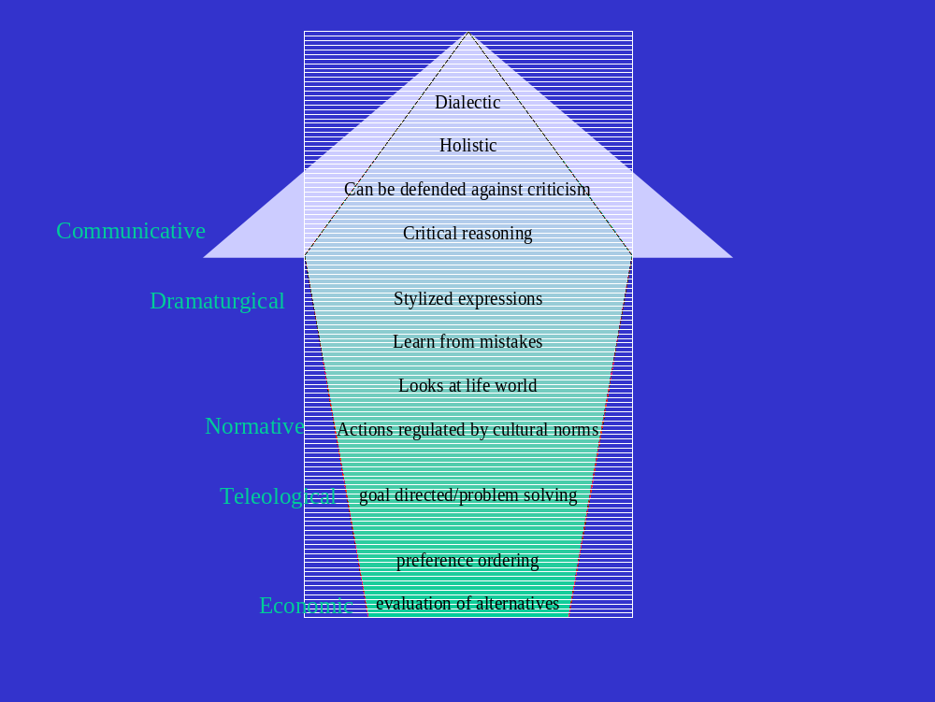
Figure 1
This is determined by the life-world the citizen inhabits. The life-world has been defined according to Husserl as the social world in which the citizen lives, it is where they learn through the frameworks of education, family and social life.

It is the ‘the general structure which allows objectivity and ‘thinghood’ to emerge in the different ways in which they do emerge in different cultures’ (Moran 2000:182). For instance, it is the surroundings and influences that build an individual’s belief systems and cognitive map, through which they make sense of the world. However, the interesting point that Husserl makes is that people can live within more than one life-world (Moran 2000) and these are interchangeable and can overlap. This is a similar notion to that of Habermas’s public sphere; this is the social world in which the individual exists. The following section will define the levels of rationality according to Habermas and integrate these with other notions of rationality.

Rational choice is, firstly, the most rudimentary version of rationality, where the defining characteristics are the voters’ ability to evaluate alternative policies and order their preferences according to their own perception of self-interest. Secondly, Habermas (1986) introduces the concept of ‘teleological rationality’. This builds upon the economic characteristics of rationality but changes the emphasis from means driven to goal directed. Teleological rationality was first conceptualised in Greek philosophy: for Aristotle, rationality is action with a purpose, whilst irrationality is aimless (Barker 1959:126). Habermas (1986) suggests that the individual is able to cognitively evaluate the ‘existing state of affairs’ and relate them to their own existence, thus building attitudes that will direct action towards ‘bringing the desired state of affairs in to existence’ (Habermas 1986:87).

Thus, if this is applied to an election, the voter is able to recognise their present situation and hold a positive or negative attitude towards this. They can then evaluate which party is most able to either maintain the status quo or improve their condition. Within this notion of teleological rationality, there is no explicit consideration of external or transient variables. The focus is on the self and how that self will attain their own preferred goals, given a series of alternatives. Teleological rationality proposes a logical drive towards their goal with some degree of cognitive elaboration.

According to Habermas, the next level of rationality is normative rationality and takes a broader perspective claiming that rational action is not only goal directed but also directed by the interrelationships and cultural norms within the individual’s life-world. At this level of rationality there is a:

normative context that lays down which interactions belong to the totality of legitimate interpersonal relationships (Habermas 1986:20)

Understanding the relationship between these variables and their linkages can build a more coherent understanding of why goals are set and the pattern of behaviour that follows in order to achieve those goals. For Habermas, normative rationality has a cognitive component combined with a motivational aspect driven by situational factors.

He argues that it is related to ‘a learning model of value internalisation’ and this fits neatly with the conception of rationality, as defined by Wedgwood (1999). For the voter, this means that if an election were to take place, the voter would have learned from their family, their milieu, and their peers about the political system and the electoral process. They would have built up positive or negative attitudes toward the political parties shaped by their normative influences, which would then determine their voting decision. Further, Bernstein’s (1971) work on learning supports this as the individual’s life-world determines how they learn, interact and process information. This is a higher, more extensive form of rationality and provides a mechanism towards understanding how preferences are developed and prioritised in order to make an electoral decision. However, Downs would argue that rational choice merely attempts to predict voter choice, given their preference ordering. He is not interested in how or why those preferences are ordered.

Dramaturgical rationality articulates the work of Goffman (1959) suggests that the individual’s action is not only determined by his own perception of himself within his social groups but also by those who he communicates with. For instance, if he was communicating with people in a higher socio economic group his behaviour would be altered. Thus, his actions are not always determined by his own values but what he thinks others would expect of him. This is even more difficult to place in a predictive model, as this declared behaviour is very difficult to separate from observed behaviour.

The failure of the polls to predict the outcome of the 1992 UK General Election was explained in part by this behaviour (Butler and Kavanagh 1992; King 1992) and this will be discussed in detail in the next chapter. Interestingly, dramaturgical rationality can be applied to political actors who tailor their behaviour to their target audience, a recent criticism of Tony Blair (Fairclough 2000:99).

Finally, Habermas postulates his notion of a holistic, complex rationality that is systemic. Communicative action combines all other modes of rationality, whilst augmenting these with the notion of communication. The communication aspect is ‘pragmatic’ in that it is used to create understanding between other actors within the life-world, or in Habermas’ terms, the ‘public sphere’. Although Habermas agrees that this is a complex construct (Habermas 1992:1), he attempts to define it as a ‘part of civil society’ (Habermas 1992:3) where ‘public life went on in the market place (agora) ’ (Habermas 1992:3) but not exclusively. It was a place where discussion and consultation occurred, and ‘only in the light of the public sphere did that which existed become revealed, did everything become visible to all’ (Habermas 1992:4). This is a public area where open discussion and debate enable transparency of thought and actions, an essential condition for democracy. Through communication they are able to interpret, react and reflect on other actors communications.

Hence, communicative action is not action with communication, it is communication between actors, which then leads to their actions, and it is a teleological process. Thus, Habermas argues these utterances will be contested, debated and elaborated, which hone the attitudes and behaviour of all individuals within the public sphere. Alternative viewpoints are considered and critically evaluated which strengthens or weakens attitudes dependent upon the coherence of the arguments presented. This is a dialectic and reflective mode of rationality, comprising of two key aspects. Firstly, the notion of political knowledge, for instance ‘civic knowledge’ (Anderson et al. 2002) such as knowledge about government, political issues, candidates, etc; secondly, the dimension of critical reasoning where voters’ opinion can be formulated through communication with their normative group and the media they are exposed to. This would concur with the thinking of Frazer (1993) who takes Habermas’ notion of the public space still further, arguing that different groups of people exist in multiple public spaces that hold particular normative values and follow specific normative practices. Moreover, these public spaces do not operate in isolation, as Husserl argued, they are also interchangeable and citizens may be able to access more than one public space at any one time (Frazer 1993). But these public spheres have different codes of communication and these codes may restrict access.

Throughout all the notions of rationality outlined by Habermas, rationality is goal driven and involves some degree of reasoning to a lesser or greater extent and the drives for reasoning come from a variety of internal or external sources. For Rescher (1988:2) rationality can be defined as a mode of understanding and making decisions based upon an ‘intelligent pursuit of appropriate objectives’. Habermas concurs with this, claiming ‘well grounded assertions and efficient actions are certainly a sign of rationality’. In the philosophical literature, rationality is also used interchangeably with reason (Wedgewood 1999). Reasoned argument, or reasoned action, is arrived at through logical progression and evaluation of appropriate alternatives. Again, Horkheimer (2004:3) suggests that reasonable action is possible through ‘the faculty of classification, inference, and deduction’. Whilst Habermas identifies 4 degrees of rationality, Rescher (1988) explores what he identifies as the constituents of rationality, which could be viewed as cognitive, pragmatic and evaluative. Cognitive rationality defines the information processing aspect of rationality. Pragmatic rationality recognises the nature of the situation that the individual finds themselves in and identifies solutions that can solve the problem. Evaluative rationality describes the process of evaluation of alternatives and preference ordering. These elements cannot be isolated from one another; they form an enduring whole, where all three are evident to a varying degree dependent upon circumstance. This holistic interpretation sits well with Habermas and his notion of communicative rationality, whilst economic rationality merely isolates the evaluative component of this definition of rationality.

Clearly though, there is a strong economic basis for rationality where the evaluation of alternatives is often driven economically. However, in the philosophical literature, rationality is portrayed as complex and multifaceted. The sociological and philosophical literature recognise the economic component that is prevalent in rational choice theory, but not to the exclusion of other notions that contribute to rational thought or reasoning.

So what constitutes irrationality? Habermas (1986:18) identifies a number of criteria that demonstrate irrationality. He argues that rather than defending opinions with critical reasoning, an irrational person would respond inappropriately with stereotypical opinions and little cognitive elaboration. For instance, if a pensioner did not support an increase in pensions this would be irrational and against the normative actions of other members of this group. Another irrational act would be to ignore the validity of the other argument, even though it has been formulated logically. If a person does not think through the arguments and just makes dogmatic assertions through either a lack of consideration or interest, this is also considered irrational but many may base their voting decisions in this way. In the words of Kuklinski, et al. (2000),

if they firmly hold beliefs that happen to be wrong, they are misinformed – not just in the dark, but wrong-headed

Finally, deceiving oneself is clearly irrational. For Aristotle, however, there are two components of irrationality. Firstly, a vegetative irrationality, which is stimulated by instincts, these are basic unconscious drives where there is no reasoning, closely aligned to the work of Freud and classical conditioning. Aristotle also suggests that, on occasions some reasoning does take place but this reasoning is limited to a sense of obedience to authority. It is a conscious progression, influenced by a course of rewards and punishment leading to persuasion and behaviour which can be manipulated in this way. However, this can also have the opposite effect
If observation shows them that heeding the words of trusted experts continually leads to undesired consequences, they will, in due time abandon even the weakest version of the heuristic (Kuklinski and Hurley, 1994)

This desiderative component of irrationality is more closely linked to Skinner’s notion of operant conditioning. This thesis will contend that both Aristotle’s and Habermas’ explanations of irrationality are also evident for some respondents’ electoral behaviour. Moreover, using the levels of rationality outlined by Habermas and Rescher, I will explore the other studies of electoral behaviour and examine the extent to which rationality and irrationality are used as determinants in electoral behaviour. Is rationality implicit in their assumptions about electoral behaviour? Do any studies explore irrationality amongst voters? Can any of these models provide a more accurate predictor of electoral behaviour?

The majority of studies on electoral behaviour, particularly the pioneering post-war surveys (Campbell et al.1954; 1960; Lazarsfeld, et al. 1948) suggest that there is an inherent assumption that the voter is rational or, as Berelson et al. (1954) noted they are expected to be informed about political issues; know what the relevant facts are; understand the alternatives and; have the ability to anticipate or appreciate the consequences of their actions. This was not borne out in his conclusions. In Campbell et al’s classic study in 1960, this model of understanding electoral behaviour was described as the socio-psychological model. Campbell et al. (1960) found that party identification was built up over time through family and peers’ normative interrelationships. They concluded that voter choice developed through childhood, guided by parental influence.

Social groupings and education also had a direct impact upon electoral behaviour but for some respondents there was little cognitive evaluation when the voting decision was made. However, they also found evidence of a ‘lack of involvement and ignorance among the voters’. Moreover, they were surprised:

at their readiness to vote for a particular party even though they might disagree with their policies (cited in Himmelweit et al. 1993:4)

This would indicate a level of irrationality, as defined by Habermas, or wrong-headedness (Kuklinski, et al. 2000). These findings clearly cast doubt upon the universality of rational choice theory. If voters have goals, they should vote for the party that can achieve those goals. Clearly, this is not evident in the findings outlined by Campbell et al. (1960).

More recently, there have been studies that evaluate the affective components in decision making, rather than focus purely upon rationality. Abelson et al., (1982) examined the role of emotion in political perception whilst Arkes, (1993) questioned whether emotion could be a substitute for rationality. Conover and Feldman (1984) recognised that there was an emotional reaction to political events such as the economic situation and this had a bearing on the voters’ decision. Moreover, they argued that a voting decision may be based on how information is interpreted, how it affects their own life-world, and how voters feel about the economic situation rather, than just merely economic self-interest. Furthermore, Clarke et al (2004) noted the importance of a positive affective attitude towards party leaders. Jamieson (1992) argued that negative emotion was more effective than positive emotion in changing voters’ positions. The role emotion plays, whether positive or negative, in the voting decision is important as again it undermines the potency of the rational choice model.

Emotion is one factor that can affect electoral decision making, other psychological factors may also have an influence. Other studies have focused more on personality types in order to investigate the extent to which this would affect political perception and attitude development Eysenck (1999). For instance, when Adorno et al. (1950) explored the notion of a fascist personality, their objective was to identify individuals who would be susceptible to anti-democratic propaganda. This research will focus upon irrationality and non-rationality in decision making and will argue that the concept of the Authoritarian Personality is one such instance, amongst others, of irrational behaviour. Adorno et al. (1950) were the first to attempt to identify key components of the Authoritarian Personality. It was an extensive study that covered both qualitative and quantitative research methods. Their work identified a number of collective characteristics that are held by people who have a propensity to ‘show extreme susceptibility to fascist propaganda’ (Adorno et al.:1). These people, they argued, were most likely to belong to the petit bourgeoisie, although Lipset (1959; 1960) suggested that these characteristics were much more widespread than Adorno et al. first identified.

Authoritarian characteristics included conformity to the system, particularly to a strong leader, to provide guidance and security. Equally, they believed in a natural hierarchy where their place, and other groups’ places, is clearly demarcated. A position in this hierarchy increases their security and, depending upon where their perceived place is, gives them a sense of superiority over groups further down their hierarchical system, thus increasing the status of their own group. Stone et. al. (1993) define the authoritarian personality as a:
threat-oriented, defensive individual who copes with threats by conventionality and obedience and who shows hostility toward weaker members of out groups.

Rather than merely focus upon the single construct of personality, other have investigated the links authoritarianism and ideology and (McClosky 1958); class (Middendorp and Meloen 1990; Rigby et al. 1996); and education (Gabennesch 1972). The authoritarian personality can be described as irrational according to Habermas (1986), as they are dogmatic in their assertions and opinions. They ignore the validity of other views again reflecting the wrong-headedness outlined by Kuklinski, et al., (2000). Interestingly, if political communication does focus upon ‘anxieties and insecurities’ (Habermas 1992:219) this would involve such personalities, concurring with Aristotle’s notions of irrationality. Similarly, if fears and uncertainty leading to insecurity are raised during a campaign there is little elaboration, rather there is a knee jerk reaction towards the situation. Moreover, the campaign could seek to target other levels of irrationality highlighting either the benefits or rewards of voting for the party. Alternatively (or simultaneously), they could highlight the negative aspects or the punishment the voter would receive from voting for the alternative party.

However, this reflects Aristotle’s notion of desiderative irrationality where this group appreciate a strong degree of guidance and are clearly influenced by rewards or are fearful of anything that will threaten their life-world.

Young people’s voting behaviour

Can young people be categorised according to rationality in their electoral behaviour? The prevailing view is that young people ‘don’t know, don’t care and don’t vote’ (Heath and Park 1997:6). That is to say they have lower levels of knowledge and commitment to the political process and are less likely to cast their vote. Further, they are less likely to vote than their older counterparts (Clarke et al 2004:319; Electoral Commission 2005:7). This is supported by the findings of Hiscock (2001) who found that 44% of 18-24 year olds did not vote in the 1997 UK general election falling to 20% who stated they were ‘absolutely certain’ to use their vote in 2001 (Electoral Commission, 2001:11). Although this continued decline is alarming it is not the full picture. In the 2001 election 40% of young people stated they were participating in some way so the picture is more complex than it first appears (Diplock 2001). It is difficult to argue that young people per se are not involved in the electoral process, again reflecting the heterogeneity identified by Gomez and Wilson (2001).

Fahmy (1996) identified different levels of participation noting that 5% of 15-21 year olds taking part in some sort of political activity, other than voting and 4% of the sample taking an ‘active part in a political campaign’. Phelps (2005) went further to suggest that ‘young peoples’ political behaviour is qualitatively different to other age groups’. He noted that they were engaging in alternative methods of political activism, for instance through demonstrations or using the internet as a communicational tool.

What is needed is a deeper understanding of young people and why some participate in the political process and the mobilising factors involved. To what extent does rationality play a part? What is the difference between young voters and young people who do not participate? Explanations have been provided to elucidate low political participation and these range from the lack of relevance to young people, to the complexity of politics. (White et al. 1999: Electoral Commission 2001; Electoral Commission 2002). Molloy (2002) identified apathetic young citizens who felt ignorant of politics and felt ignored by political parties and institutions. But most importantly the research identified that young people were ‘out of the habit of voting’ (Electoral Commission 2005:8).

Brynner and Ashford (1994) argue that the person’s experience at school and employment prospects can determine levels of alienation; again this links to Bernstein’s thinking about education and learning in social groups. Bhavnani (1994) argues that young people find politics boring and complex and believe there is little point in voting, whilst others claim that there is little trust in the political system, politicians and the media (Dermody and Hanmer-Lloyd 2003, 2005; Russell 2003). White’s (2000) research supported the established view that many young people merely follow their parents’ electoral behaviour. Denver and Hands (1990) and Crewe and Thompson (1992) contend young people do not really enter the electoral process until there is something that mobilises them, such as paying tax, owning a home or having children etc. Mulgan and Wilkinson (1997) support this by suggesting that issues such as environmentalism and animal rights mobilise political action.

Interestingly, research undertaken by Wring, et al. (1999); suggested that for some young voters alienation and cynicism did not provide an accurate picture of young people’s voting intentions. They identified a marked level of involvement amongst some respondents who did take part in political activity at a number of levels, again reinforcing the notion of electoral heterogeneity amongst young people. They noted that different groups demonstrated varying characteristics and levels of interest and participation. These findings are supported by the qualitative analysis of White et al. (2000). They organised the groups of young people according to their level of interest and connection with the political system. Further, they identified some groups of young people who did vote but also recognised that there was a significant group of people that were not interested and alienated from the political process. Later research on first time voters in the 2001 UK General Election supported this (Henn and Weinstein 2002; Henn et al. 2002; Henn et al. 2005). The Power Report (2006) challenged the ‘myth of apathy’ suggesting that it was not a system failure but a representation failure. Young people felt they didn’t have a voice and were not listened to by political parties, furthermore the leadership was remote and the decision making process was hierarchical rather than representative. Nevertheless, the key point is that the decline of young people actually voting is disproportionally steeper than other members of the electorate (Pirie and Worcester, 2000). Hence, if we consider the electoral behaviour of young people, it is much more puzzling than rational choice would suggest. Indeed, the complexity inherent in a young voter’s thinking is further complicated when attempting to build a composite picture of young people’s electoral behaviour. Henn et al. (2005) suggest that it is complex, and young peoples’ election behaviour is diverse, they support the political system but are alienated by politicians and political parties but attitudes are determined by social class, education and gender.

Qualitative research, used extensively in marketing research, has been increasingly used in political science research (Electoral Commission 2005; Henn et al. 2005; Bhavnani 1994; White et al. 1999). This takes into consideration the complexity which is evident in the political and commercial environment, which is hardly surprising as both marketing and politics exist within the social domain.

Brown (1995:107) suggests ‘marketing …. reflects developments in the social, economic and cultural spheres’. But there has been a gradual evolution of thinking in marketing, taking it as Brown et al. (1998) and Hunt (1994) discussed from a ‘science’ to an ‘art’. This debate explored the reliance upon the positivist paradigm and the inability to adequately explain consumer choices and behaviour. Marketing was alleged to be succumbing to a ‘crisis of confidence’; ‘marketing crisis’; and as some suggested its ‘demise’; or the ‘end of marketing’ (Brady and Davis 1993; Thomas 1994; Hunt 1994; Brown 1999). Araujo (1999) argues that the:

crisis in marketing theory stems from over-reliance on the managerial paradigm which holds the neoclassical economic conceptualisation of exchange as its primary ontological foundation.

However, both political science and marketing (in the form of consumer behaviour theory) have drawn from the same research pool of economics, psychology and sociology but marketing has been rather less loyal to the notion of homo economicus than rational choice. However, key differences between the two disciplines emerge when comparing the basic concept of the exchange process; the development of research methods and the notion of the rational voter/consumer.

If these concepts developed from the same seed, why did marketing adapt the hypothetical constructs of exchange and the rational consumer, and what was the catalyst for change?

It appears that rational choice with its focus upon a narrow quantifiable rationality continues to be aligned with modernist notions of Cartesian mechanism, reducibility and analysis (Capra 1999:19). However, some scholars in the marketing discipline are beginning to embrace some of the theoretical concepts of postmodernism (Brown 1995; Thomas 1994; Brownlie 1997; Firat and Shultz 1997). According to Maffesoli (1997, cited in Desmond 2003) people who live in an advanced consumer society are not rational, isolated, self disciplined people. Rather they are bound together with:

powerful emotional bonds and are connected through a variety of diffuse and fleeting encounters, from those which bind together people who live in neighbourhoods…. to those swarms of consumers who populate city-centre high streets and shopping malls (Desmond 2003:19)

Consumer behaviour theory reflects a shift in this thinking towards the experiential, affective, ‘symbolic’ consumer. Traditionally, as in political science, consumer behaviour theory focused upon two key paradigms, the consumer as a rational information processor or the consumer whose decisions are shaped by socio psychological factors (Markin 1979). Later studies point to the inability of these models to build an understanding of consumer behaviour, so sought to explore other factors of influence, principally emotion (Loewenstein 2001; Markin 1979; Shiv and Fedorikhin 1999).

Williamson (2002) examines the power of emotion as a ‘behavioural driver’ and suggests that in a complex environment, everyday decisions are undertaken with no cognitive processing or ‘involvement of our conscious minds’. If we recognise that in these complex environments even simple decisions ‘rapidly overwhelm human cognitive capacities’ (Loewenstein 2001), so other factors must be at work.. Bakamitsos and Siomokos (2004) identify that mood has a significant impact upon decision making which is interesting when we consider how many governments try to embody feel good factors occurring from events such as Royal Weddings, Jubilees and major sporting occasions. Nelson (2002) highlights the idea that in marketing there is an acknowledgement of an increasingly complex environment. The enthusiasm for choice and the capacity for decision making are determined by their ability to evaluate the diversity of choices. Even so, Klein and Yadav (1989) suggest that even respondents with strong cognitive capabilities demonstrate that:
relatively few decisions are made using analytical processes such as generating a variety of options and contrasting their strengths and weaknesses

We have already discussed how affective components are studied when considering electoral behaviour, so could marketing theory add anything more to the study of voting?

There have been a number of studies that add to our understanding of the application of marketing concepts to politics (Niffenegger 1989; O’Shaughnessy, 1990; Maarek 1995; Scammell 1995; Negrine 1996) but also recognition that a direct application of marketing theories and applications to politics can be problematical (Lock and Harris,1996; Collins and Butler 2003). Harrop (1990) likened politics to services marketing, Lees-Marshment (2001) explored the application of marketing concepts to political parties whilst Wring focused upon the Labour Party and its organisational development (Wring 1996a; 1997a) and political communications (Wring 1996b; 1997b, 1999). But crucially, consumer behaviour theory has not been adequately explored apart from the work by Burton and Netemeyer (1992) and in particular, the impact of risk upon the extent of the decision making process. Only recently O’Cass and Pecotich (2005) incorporated the notion of risk when exploring the use of opinion leaders in electoral decision making. The thesis will broaden this discussion further, arguing that risk is a vital part of electoral decision making, focusing upon the key tenet of both marketing and rational choice theory, namely the exchange process. The argument follows that risk can both complicate the exchange process and extend the decision making process. Whilst in politics there has been little elaboration of the process of exchange, in marketing the exchange process has been broadened in two ways. Firstly, the decision making process has been extended to 5 main stages. At each stage behaviour varies and marketers use different marketing strategies and tactics to encourage advancement through the decision making process.

The second is the development of relationship marketing, which recognises that there is a network of exchange relationships that have varying influences on the decision making process. These two aspects illustrate the complexity of the decision making process and draw attention to how irrational behaviour can be manipulated to trigger a need, want or desire. This concurs with Aristotle’s thoughts upon irrationality (rev 1976).
The Consumer Decision Making Process extends the boundaries of the exchange process and defines the stages the consumer, or voter, would go through as they search for the right product, or service, to satisfy their need. The model suggests logical, deliberative progression through the cognition stages as early marketing theory assumed the same economic rationality. Figure 2 outlines the key stages from the decision making perspective (Kotler 1991:182). However, Foxall et al., (1998) argue from a behavioural standpoint that the model is a simplified abstract version of reality but it is useful for identifying factors that shape both the consumer and electoral decision making.

Subsequent thinking in marketing outlines a greater understanding of the complexity of the decision making process and this thinking highlights that, at each stage, there are a number of factors that can influence or prevent purchase. For instance, the time spent on each stage is determined by the product type; level of involvement; situational factors or the degree of risk involved in the decision.
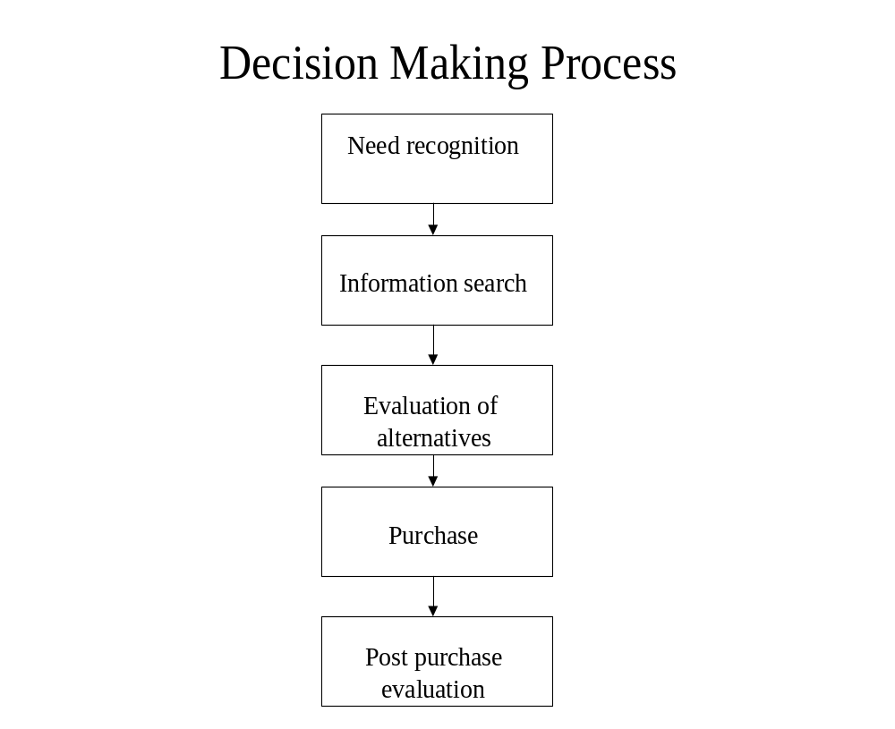
Figure 2
In addition to this, rather than follow the deliberative, information processing model, there is evidence to suggest little cognitive thinking (Loewenstein 2001; Bargh 2002). With this in mind, the consumer can, at times, and at each stage, in the model demonstrate levels of irrationality, apathy, enthusiasm and rationality (Reid and Brown 1996).

There are many factors that can impact upon the decision making process, both internal and external and Figure 3 highlights this. Within the extant marketing literature there is a debate over the assumed rationality of the consumer, sometimes they behave rationally at other times aspects of irrationally can be identified (Holbrook 1986; Brown and Reid 1996). Figure 4 identifies the determinants of problem solving and each of these determinants fit together differently depending on the context of the decision. This indicates that there are many outcomes and different consumer groups will also make decisions differently. There are also numerous studies identifying a myriad of consumer typologies (for instance, Stone 1954; Westbrook and Black 1985). However, in politics there is a continued search for a universal model of electoral behaviour.
This thesis will argue that the search for a ‘one size fits all’ model will not provide a genuine understanding of electoral decision making. Figures 3 and 4 serve to outline the complexity in consumer decision making and this thesis will argue that this is the case in electoral decision making. Further, it will use the current thinking in consumer behaviour to illustrate the complexity of the decision making process (Figure 2).
This combines the deliberative decision making with social cognition models but adds experiential and affective components to the model and the notion of risk. By augmenting these three models there is an opportunity to identify different groups of people who display different levels of these factors in different contexts and different situations. If we commence with an exploration of the decision making process and the problems inherent within it, consumption begins with the identification of a need.

Influences on Decision making
Consumer
The buying
process
Personal influences

information processing
beliefs and attitudes
personality
lifestyle
motivations
Social influences

culture
social class
geodemographics
reference groups
Figure 3
There is an assumption throughout much of the literature that there is some sort of goal pursuit inherent in the activity (Markin 1979; Bagozzi and Dholakia 1999). It is recognised that problem identification is usually consumer driven but could be stimulated by marketing communication activity, which arouses a latent need. According to Blackwell et al. (2001), need recognition occurs if there is a difference between actual situation and the desired situation. If it is a matter of product replacement there are two options, either to to replace or to trade up and improve, for instance with a television. Bagozzi and Dholakia (1999), distinguish between 3 goal directed needs. Firstly, habitual goal directed consumer behaviour, where there is a measure of deliberative processing or learning - or a combination of both. Secondly, impulsive behaviour which involves an awakening of a latent need but no prior deliberation and finally, goal pursuit activities, which concurs with Engel et al. (2001).
According to Maslow, there is a hierarchy of needs that determines the consumption type. At the lowest level, food, shelter and security are the basic drives that initiate consumption of products. Once these have been satisfied, Maslow argues consumption moves on to a higher level, leading ultimately to self actualisation. For UK politics though, the process begins with the calling of a general election, the date is determined by the incumbent political party. The Government announces a forthcoming election through a variety of media channels, but at this stage the voter has no control. There are no voter needs that have precipitated the election, unless collective civic action has forced the incumbent government into this initiative. It is purely a strategic decision by the Government. (Lock and Harris 1996).
However, for some voters this is a call to action and may propel them towards the next stage of decision making. This research questions how voters determine the type of ‘need recognition’ - how do they respond to the call to action? Are some focused upon voting in order to achieve their goal of electing their party of choice, or are they merely voting from habit? Do some fail to recognise the ‘need’ to vote?
Determinants of the
extent of problem solving
Self image
Perceived risk
Social factors
Hedonism
Level of
awareness
Differentiation
and number of
alternatives
Time pressures
Extent of
problem solving
Figure 4
Involvement in Decision Making
The information searching stage and the degree to which this occurs, depends upon the product type, the consumer (Alba and Hutchinson 2000; Ariely 2000; Campbell and Kirmani 2000), the consumers’ existing knowledge of the product (Kivetz and Simonson 2000) and the environment (Pratkanis and Greenwald 1993). In marketing theory, the decision could generate high or low involvement but even in a highly priced product, for some consumers, there is little involvement again, depending upon the degree of risk. Involvement is an important component when looking at the reasoning processes of the consumer or the voter. However, it is a component that is lacking in the rational choice exchange model though both political scientists and social psychologists (including consumer behaviour theorists) identify involvement as a crucial element in any decision making process.
Involvement is defined by Antil, cited in Engel et al. (1995:161) as ‘the level of perceived personal importance and/or interest evoked by a stimulus (or stimuli) within a specific situation’. Thus, involvement is determined by the consumer’s motivation after they have evaluated how relevant the product or service is to them. A consumer can be highly involved in the decision-making process or exhibit low involvement characteristics.
Simplistically, the level of searching is much greater for a high involvement product such as a washing machine than it is for toothpaste, generally described as a low involvement product. The determinants of involvement are complex and varied, depending upon the product type and the consumers’ situation (Laurent and Kapferer 1985; Williams, 2002). For Foxall et al. (1998), involvement is not a single construct to be taken in isolation; rather an integrated framework to be used that builds an understanding of the determinants of decision making. This provides a more accurate predictor of consumer behaviour, so it would be useful to adapt some of the models to electoral decision making. However, to a great extent all these notions of involvement involve a certain level of deliberation and this deliberation is determined by the level of risk. The concept of risk is an important component in this study as this thesis argues that security, or the perceived threat to a voter’s security, can determine the level of cognitive activity, elaboration and ultimately determine electoral behaviour.
Moreover, in marketing there are a number of risk factors (Antonides and van Raaij 1998:257) that are identified as influential in the decision making process which could be applied to political decision making
- Financial risk
- Functional risk
- Physical risk
- Social risk
- Psychological risk
Aspects of risk that determine the level of involvement in the product or service, this could be viewed as either actual risk or perceived risk. For instance, Volvo claim their cars have a number of safety features that reduce the risk of driving. But it is how risk is conceptualised that is important, and levels of risk increase during times of uncertainty.
Financial risk is possibly a type of risk that most voters would acknowledge. Many voters tend to have an idea about taxation and what it means to them, with the most basic understanding of the budget recognising an increase in tax on cigarettes and alcohol. The Conservative Party focused on the ‘tax and spend’ policies of the Labour Party during the 1992 General Election Campaign (Crewe and Thompson 1992). During the build up to the 2005 General Election Campaign, the Labour Government used terms such as ‘negative equity’ to remind voters of the Thatcher years and how voting Conservative could affect financial security. But Lakoff (2002) argues irrational behaviour can be identified. Low taxation does not benefit the poorer sections of society but they still voted for George W Bush, an advocate of low taxation, in the two most recent Presidential elections.
Functional risk, in electoral terms, could mean that there is a fear an elected party could fail to make the country’s health service, education system or economy run efficiently. In response, all political parties present themselves as competent managers and existing governments attempt to demonstrate that their policies have been effective.
Fear of terrorism or personal security, is a physical risk that has been highlighted in recent times. There is a perceived fear of terrorism that has been highlighted in a number of surveys (see for instance: Taylor 2004). Blair’s strap line ‘tough on crime, tough on the causes of crime’ sought to take the mantle of a strong focus on law and order from the Conservatives. Again this was important as there was a perceived physical risk amongst some members of the electorate. These fears affect the extent of involvement in the decision making process, as if there is a perception of insecurity that will then affect cognition amongst some voters.
Interestingly, the majority of electoral behaviour theory, which explores rationality, would recognise the low involvement voter - a voter who does not consider other extra information but votes according to Downs’ notion of ‘political shorthand’. Within the rational choice literature, the key argument is that the voter is rational and considers his preferences logically and orders them transitively.
This would indicate that there is some degree of involvement, although this is not explicit in the literature. Some voters may be involved in the political process and for some reason want to search out for information that supports or adds to their existing stock of knowledge. During the campaign, they will select media and review the campaign progress to evaluate how their vote can be cast. Once the consumer feels they have collected sufficient information, which they believe will aid their decision making, they can then evaluate the alternatives.
This follows the rational choice approach of preference ordering, identifying the advantages and disadvantages of each alternative. In the consumer behaviour literature, the research and debate is more extensive and reflects some of the political behaviour literature such as Campbell et al. (1960), Butler and Stokes (1974), Heath et al., (1985) amongst others. In consumer theory, elaboration of the results of the information search with existing knowledge, is determined by the type of product or existing data relating to the product. This elaboration is also dependent upon the ability and motivation of the consumer (Petty and Cacioppo 1986). It is these two stages that consumer behaviour theorists have focused upon most closely, judging whether the consumer behaves rationally or not.
The consumer stage of product purchase can be equated with casting their vote. Product purchase is relatively straightforward but behaviour is different for certain product sectors, so the marketing communications strategy needs to be adapted. For instance, with a high involvement product there is usually a high level of elaboration and an extensive information search.
Marketing communication activities such as advertising, enable information to reach the consumer in the communication codes they are familiar with and sales personnel with specific expertise who can also provide further information. These searches are performed to collect enough information in order to reduce the element of risk associated with the purchase of a high involvement product.
Conversely, for a low involvement product, such as an habitual purchase, there is little risk, so little cognitive elaboration. In this situation marketing communication tools such as sales promotion and point of sale activities are utilised to shake the consumer out of their routine and to remind and reinforce brand values at the point of purchase. During the election, there is little the political party can do at the election booth. Any marketing activities are limited during the day of election (Harris and Lock 1996), causing a problem for political parties attempting to reach those people who are habitual voters.
The final stage is post purchase evaluation; this is where the product must perform as promised. If there is any mismatch between performance of the product and the expected benefits from the product purchase, then cognitive dissonance arises and the risk associated with the purchase of the product is increased and possibly the product is not purchased again. After the election, the voter has the next session of Government to evaluate the outcome of their decision. So rather than purchase, use and evaluation as immediate steps, voting can be a much longer drawn out process, particularly with the development of the ‘long campaign’ as witnessed during the UK 2001 election. Moreover, the ‘post purchase evaluation’ looks at the effectiveness of government and the success of their policy implementation. For some voters it continues right up to the next election, where they use it to determine their voting decision next time.

Whilst the customer decision making model looks at the micro aspects of the process, since the 1990s (and responding to the ‘crisis in marketing’), there has been a paradigmatic shift in marketing towards ‘relationship marketing’ (Sheth and Parvatiyar 2000). Although this philosophy continues to focus upon the exchange process between the consumer and the seller, it also recognises the importance of the nano and macro associations. Nano relationships (Gummersson 2002), are what Christopher et al. (1994) defined as the internal market in the 6 markets model. In relationship marketing, it is the employee who holds a pivotal relationship with the customer (Varey and Lewis 2000). The organisation is structured in such a way that all employees, whatever their role or position within the organisation, work towards customer satisfaction. Customer satisfaction is not only the domain of the sales and marketing departments but also research and development, human resources, purchasing and also of course production and quality control. This interpretation of internal marketing extends the boundaries of the exchange process and provides a clearer understanding of the interrelationships between the members of the internal market.

In politics, however, the internal markets are as complex as in the commercial domain, with added difficulties related to the levels of autonomy and hierarchy which exist in politics (Dean and Croft 2001). The dilemma for the leadership of a democratic political party is the extent to which the party can be led by the membership, particularly when the grass roots members play such an important part in the local election campaign. The balance between local autonomy and the leadership control is problematic. Indeed, many political organisations do not have a conventionally structured line management system. The strategic task facing any political movement is to ensure that the voter receives a coherent message, reiterating the aims and objectives of the organisation as a whole. Voters are reassured about a unified political party communicating a coherent single message and it appears that they punish parties they perceive to be disunited (Butler and Kavanagh 1997; Whiteley 1997). The complex structure of the political parties’ organisation and how they manage their internal markets is not accounted for in the rational choice exchange framework, but is clearly a determinant of electoral behaviour.

However, relations between the seller, manufacturer and suppliers are also recognised as vital elements in the marketing environment (Easton and Håkensson 1996). Relationship marketing recognises that there is a network of players in the market. This defines links between suppliers and manufacturers and how costs can be reduced if this is a profitable relationship. Reflecting the rational choice concept of mutual benefit through exchange, this relationship only continues to be viable if both parties continue to profit from this relationship.

This notion of relationship marketing has been applied to politics where the multiple markets model was introduced (Dean and Croft 2001). This again highlighted the complexity of the exchange process in politics, identifying key players and relationships that were important in order to inform, influence and motivate the voter. This model highlighted the complexities and potential difficulties in developing and maintaining relationships within the political environment and emphasised the notion of controllability, or power relations, as pivotal when managing interrelationships. As voters are less trusting of politicians and political messages (Marquand 2004), it is important to recognise the players in the voters’ relationships. Who are the opinion leaders? Who influences their electoral decisions? These are vital factors and need to be recognised in the exchange process but the complexity of the decision making process before exchange and who the participants are in the exchange process demonstrate a complexity that is not made explicit by the rational choice literature.

So, if marketing can provide a greater understanding of the exchange process, and in the process, provide a framework for understanding levels of rationality or irrationality, can the evolutionary stages of consumer theory development add to our understanding of political behaviour? In this section, I will outline the development of marketing with reference to consumer behaviour.
Both economists and social psychologists sought to find a generalisable approach to the study of decision-making. Gabriele Tarde (1890; 1902), cited in Antonides and van Raaij (1998), studied the process of consumption amongst the upper classes in France, and Victorian Britain. He emphasised how there was competition to get the latest fashion item and also how this was a key determining factor amongst the followers in the class. Allport (1966) explored the extent to which the concept of attitude could predict decision making (Katz 1960; Fishbein and Ajzen 1975). What were the influences affecting attitude development and, more importantly, could an attitude really elicit predictable behavioural responses? Solutions to this vexed question proved elusive, and interest in attitudes as a tool to predict behaviour began to wane. Later research focused upon single issues including factors such as risk taking/reduction (Bauer 1960; Johnson and Tversky 1983), and personality, (Foxall et al., 1998). However, it was soon recognised that singly there could be some contribution to understanding but it was difficult to isolate each variable, as they all had some impact upon the consumer decision making process to some degree or other. A number of consumer behaviour theorists attempted to develop an overarching theory of consumer behaviour, to include all variables (Nicosia 1966; Engel, et al. 1995; Howard and Sheth 1969). Later developments saw the burgeoning of the study of information processing, (Jacoby 1977; Bettman 1979) and Fishbein and Ajzen (1975) focusing on attitude development, change, and measurement.

Consumers were identified as ‘problem solvers’ searching out information and consciously seeking solutions to their consumer needs. Conversely, researchers also identified the ‘cognitive miser’ (Hoyer 1984; Taylor 1986; Zaichkowsky 1991), who didn’t take time to search for information either because he was unwilling or unable to do so, relying instead on his existing knowledge base. These studies share some consistency with the notion of rational choice and the notion of the rational consumer, who makes conscious decisions based on evaluating alternatives and consideration of issues such as price, quality, etc. However, they still did not provide an adequate explanation of consumer decision making, as it was becoming increasingly evident to marketers that rationality was not applicable for many products, including for example, cosmetics for women and cars for men.

These studies to a great extent mirror the behaviourist arm of the political science literature. However, it is ironic that when Downs published his seminal work on the rational voter in the 1950s, marketing theorists were beginning to define the characteristics of an irrational voter (Zaichowsky 1991). Ernest Dichter (1964), building on the work done by Bernays, drew on Freudian and Pavlovian theories and introduced the notion of the ‘irrational consumer’ (Zaichkowsky 1991). Using motivational research methods, he argued that he could uncover consumers’ unconscious needs and wants, ultimately their subliminal desires, which could then be used to influence decision making.

This is where the concept of risk is so important. If a researcher could determine what insecurities affected the consumer, this could be capitalised upon and utilised to influence consumer behaviour. This is linked to the notion of emotion and during the 1990s research has been focused upon symbolism, experiences, semiotics through postmodernism, (Hirschman and Holbrook 1992; Holbrook, 1994; Brown, 1995) and the hedonistic consumer. Moreover, there is now a growing acceptance that the consumer can behave in different ways depending upon their situation, their emotional state and the time pressure they face. These behavioural patterns are difficult to predict but once recognised provide a greater understanding of consumers, rather than the more unsatisfactory notion of economic rationality which fails to acknowledge any decisions based on irrationality.

This notion of differential response can be applied to electoral behaviour but it requires exploration of what motivational factors affect voters - are they unconscious or conscious, rational or irrational? How do these drives trigger information searching, how do different voters evaluate or process political information and why are they motivated to do so? How is the message received and are voters able to understand these messages? How does this affect the electoral decision making process?

This chapter commenced with a discussion and critique of rational choice theory, it reviewed the notion of rational choice theory and provided a discussion of the alternative approaches. These consisted of extending the rational choice concept, using sociological and psychological theories to build an understanding of electoral behaviour. It looked at how some voters try to make sense of electoral information by only looking at superficial information such as sound bites, party image and leadership, or other heuristic devices. These are used extensively in marketing, particularly in the advertising industry, so marketing theories were explored to identify if they can illuminate voter choice more effectively than rational choice theory. However, although there is evidence to suggest that may be the case, marketing models cannot and do not provide a universal model to replace the rational choice process of exchange. Rather, marketing has recognised that rationality is not the ultimate basis for decision making: there is an acceptance that rationality may be appropriate for certain consumer or voter types but there are a number of voters who do not conform to that model. Marketing theory has recognised the plurality of consumers and also identified irrational characteristics in some transactions and research methods have been developed in order to uncover these characteristics. Increasingly, there is a view that voters are as diverse as consumers in other market places (for instance, Kuklinski and Hurley, 1994; Gomez and Wilson, 2001; Kuklinski, et al., 2000). In the light of this discussion, the next chapter will evaluate the methodological approach to electoral behaviour research.
Chapter 2

Methodological Issues

The research methods used to understand rational choice behaviour are almost universally quantitative. This chapter will review the philosophical underpinning of this approach and then provide a critique. It will suggest that quantitative research methods reinforce the uni-dimensional tautological nature of rational choice and argue that if electoral behaviour is to be truly understood, then an interpretivist methodological approach needs to be incorporated into the research design. The central argument of the thesis claims that in order to build an understanding of the voting decision, there has to be a systemic understanding of the voter thought processes. These findings will attempt to build a model that provides a greater understanding of electoral behaviour, whilst emphasising the limitation of the rational choice framework’s predictive capabilities. Rather than design a survey that examined levels of rationality, this research explored the extent to which levels of irrationality also influenced the voting decision. This model identifies a number of different voter types who have different belief systems and shows how these have been developed through their own life-worlds. Life-world as conceived by Husserl is ‘the world of pre-theoretical experience which is also that which allows us to interact with nature and to develop our own cultural forms’ (Moran 2000).

He argues that everybody exists within a life-world, where they develop their thinking through their experiences and social contact within that life-world. Moreover, there is no one life-world and they can overlap, there is a personal or ‘home’ life-world and this can overlap with other life-worlds that people come into contact with through travel, education, employment etc. These different life-worlds can be remote or in close proximity to the individual, such as other cultures or countries; or the work environment. This is particularly relevant to research in electoral decision making, as some individuals will be able to make sense of political issues related only to their own home life-world. Others may live in other more remote life-worlds such as a political life-world or other cultures, and these are different for each individual. Some inhabit many life-worlds, whilst others occupy few. Clearly, this emphasises the diversity in electoral decision making amongst voters.

Political science, as applied to electoral behaviour, has striven to be recognised as a ‘hard’ science. Historically, positivism has been the dominant paradigm when researching electoral behaviour. The Michigan School regularly utilised quantitative methods eg. Lazarfeld et al. (1948), and Berelson et al. (1954). Electoral research falls soundly into the positivist model. Studies examining voters choices and behaviour involved careful studies, hypotheses were constructed and tested, with carefully composed sample frames, thus ensuring a true representation of the total electoral population, was drawn.

As the economic paradigm of instrumental rationality became more significant, it was plausible to use the a priori premises of positivism to examine the cost/benefit analysis ostensibly undertaken by voters. As costs and benefits could be operationalised simply and measurement tools were readily available, quantitative methods from the positivist tradition suited the study of rational choice and also other models of electoral behaviour.

The ontological perspective of the positivist paradigm argues that reality is independent and external. The world is made up of ‘hard, tangible, immutable structures’ (Burrell and Morgan 1988:7). These structures exist even if they are not observed; they exist even if they are not labelled; and they exist independently from any individual. Thus, quantitative research is interested in defining those structures, identifying relationships between structures and how these can be expressed in measurable terms. Objectivity is also a pivotal concept in the epistemology of positivism. For a programme of study to be objective it must be justifiable, not only in a Kantian sense but it must also be verifiable and testable (Popper 1995:44). The research method must also maintain the distance between researcher and subject. The bias that is acknowledged as inherent in any study could be eliminated due to careful research design. Sampling error could be measured accurately if random sampling methods were employed. Epistemologically, traditional theories of electoral behaviour supported the scientific, deductive approach on the grounds that it yielded, more accurate, measurable and ‘hard’ data.

Hypotheses could be generated and tested. Hard data could be manipulated, concepts could be operationalised, measured and later statistically verified. The scientific, objective nature of this type of research was perceived to build the reputation of political studies.

However, positivism has been criticised from a number of angles. The interpretivist paradigm argues that reality is, in fact, internal and socially constructed. Structures are made sense of by the existing set of value systems that are in operation within the culture, class, or social grouping of the individual. The individual will more often reflect the value system that exists within his social group and interpret the world through the framework of this value system. For instance, the extent of an individual’s knowledge of the processes involved in the electoral process is determined by the individual’s knowledge built up by their own experience within their own social group. Burrell and Morgan (1988:255) elucidate the key criticisms of positivism based on this viewpoint when they claim:

Science is based on ‘taken for granted’ assumptions, and thus, like any other social practice, must be understood within a specific context. Traced to their source all activities which pose as science can be traced to fundamental assumptions relating to everyday life and can in no way be regarded as generating knowledge with an ‘objective’ value-free status.

Moreover, knowledge is based on understanding and is subjective.

Gill and Inductive methods such as ethnography, Gill and Johnson (1997:8) argue:
accuse those working deductively of imposing an external logic upon phenomena that have their own internal logics

From an operational standpoint, the questions asked in a quantitative study can determine or even direct, how the respondent will reply to a particular question. For instance, positivists acknowledge the existence of unlabelled structures and concepts within the world (Burrell and Morgan 1988:4). Concepts that are unfamiliar to some, still exist in another unfamiliar environment. If respondents have no knowledge of political structures, it is difficult for researchers to build an understanding in a quantitative survey. These ontological and epistemological issues are not fully reconciled within the positivist tradition.

Richard Rose (1967:152) recognised that predetermined conceptualisations of the politician or the analyst, may not reflect the understanding of the voter. This raises the possibility that errors could occur at the data collection stag,e if the respondent misunderstands the questions. In a situation such as this, the respondent can attempt to reply with an answer they believe the researcher would like to hear; or answer in the affirmative (acquiescence bias), eroding the reliability of the data. Likewise, researchers may comprehend issues in an abstract fashion, whereas the respondent may only be able to relate the issue to their own concrete working or living situation.

Equally, the respondent may not be aware of particular issues or have limited knowledge. If a particular issue has little saliency with the respondent, he may give an arbitrary response. Commonly, respondents are expected to respond, on a five point scale: to strongly agree to strongly disagree, with neither disagree nor disagree as the central point. This gives no opportunity to articulate a lack of awareness, or interest in the subject. Furthermore, if the respondent volunteers no attitude towards a subject the interviewer may be instructed in the questionnaire to prompt one. The prompted answer may be contorted, and not related to any genuine attitude. These problems are exacerbated when the respondent does not understand the descriptors given to concepts or structures in the questionnaire. Cicourel (1964) argued that quantitative surveys, using a structured questionnaire, assume a competent use and understanding of language. However, studies conducted in consumer research indicated that there was confusion over many words used in a questionnaire. For instance, in the Belson (1986:115) study, words such as ‘paradox’ was only understood by about one fifth of the population, whilst the words ‘proximity’ and ‘discrepancy’ were only correctly defined by half the population. Amongst the general electorate there is not a great deal of awareness of political phrases and concepts. For example, terms such as public ownership, infrastructure, market forces, or knowledge of how a particular political institution operates such as the European Commission, is not widely understood.

Supporters of interpretative methods have also criticised the limitation of quantitative attitudinal studies using questionnaires as a data collection tool. Ernest Dichter (cited in Block, 1994), argued that respondents would not always tell the truth in a survey, although there is little empirical evidence to support this. There are a number of problems highlighted with scaling procedures used as measurement tools in quantitative surveys. Firstly, evidence to support the notion that distance between the extremity points in the scale is larger than the differences between the points nearer the centre (Oppenheim 1994). Secondly, context is not fully considered in quantitative surveys. Finally, there are a number of errors that could be explained as method error, as Bagozzi (1994:342) outlines, such as halo effects, social desirability, and key informant biases such as peer or expert opinion influencing the respondent.

Quantitative research is useful to measure a voter’s likelihood of voting for a particular party, and can provide historical trended data to aid the policy making decision (Worcester 1993). The advantages of quantitative research methods are that they are generalisable and measurable. In any research study where a sample has been constructed through probability methods, there is a statistically verifiable and measurable sampling error. This is important when relating the findings of the sample to the total population, thus, quantitative research methods measure the ‘who; what; how; and when’. The reliability of this research when exploring measurable variables is not under question. Nevertheless, when questionnaires are administered during a quantitative survey attitude measurement is taken in isolation. With this in mind, surveys conducted before an election cannot replicate the contextual boundaries that frame an election decision at the point of voting. As Worcester (1993) noted, surveys are ‘thermometers not barometers’. Moreover, if voters developed their thinking from an irrational basis, or voted irrationally, a quantitative survey would not uncover this. The questioning methods in a quantitative survey assume some sort of rationality or cognitive processing in their decision making. Morrison (1992:1) takes this further and provides a critique of the arbitrary nature of decision making arguing that:

statistics are the ossified voice of people devoid of emotion and feeling......and the statistics of political opinion polls do not capture the active process of how individuals come to make up their minds and the idiosyncrasies that often go into the decision to act one way rather than another

A more interpretive approach, it has been argued, would uncover how voters think about voting and what influences affect them.

It is important to establish how attitudes are formed and how information is processed in the context of the respondents’ own experiences and existing knowledge. Jean Pierre Changeux (1985:145) states:

we are awake and attentive, we appreciate and pursue the formation of concepts. We can store and recall mental objects, link them together, and recognise their resonance. We are conscious of all of this in our unending dialogue with the outside world, but also within our own inner world, our ‘me’

Thus, for Changeaux the subject’s reality is developed from a mix of understanding phenomena within the life-world of the subject and how phenomena relates to the inner self. There is a regular interaction between the individual’s existing attitudes and any new stimuli that may be introduced to the individual. This interaction may modify existing attitudes or the existing attitudes may colour the view of the stimuli presented to the individual.

Giddens (1993) supports this and suggests that the ‘stock of knowledge’ that is acquired in the manner according to Changeaux, is collected and stored according to the individual’s needs at that particular time. Hence, these stocks of knowledge are adequate until further notice, or until the subject requires new knowledge in order to understand or react to a new situation. The interplay that exists between knowledge and new information is fundamental to Petty and Cacioppo’s Elaboration Likelihood Model, which can advance the understanding of how notions of politics or ‘stocks of political knowledge’ are formulated by the voter and how these impact upon attitude change and ultimately electoral behaviour. There is a need to build a more holistic understanding of how the political will is developed in relation to the various political cultures; established institutions; and how this relates to the respondents everyday life. It is important to understand how different young voters build their attitudes and how attitudes are formed in order to understand electoral behaviour. The development of the political personality is the culmination of this and Lane (1972:5) defines this as:

the enduring, organised, dynamic response sets habitually aroused by political stimuli

In this study, we will try to build an understanding of the different characteristics that make up a cognitive map through which respondents base their decisions. Moreover, this study will argue that there is no one model that explains electoral behaviour and will describe a number of different voter types, all of which have different belief systems and cognitive maps. The methods used in psychology and sociology to understand peoples’ attitudes are the basis for motivational, qualitative and phenomenological research. Thompson et al (1989) highlight the strengths of this interpretative method when:

reflected meanings and symbols emerge from the ground of unreflected experience

This method takes the form of an ‘interview as conversation’. The discussion is casual and there is no pressure on the respondent to justify his beliefs. It should not be the intention of the interviewer to do so. For Kvale (1996):

it is beyond the scope of the interviewer to argue the strength of their own conception of the topic to be investigated or to try to change the subjects convictions

This research methodology has developed from Husserl’s philosophy of phenomenology. It was developed in ethnographic investigation and supports the notion that this process of research delves into the behavioural patterns of the respondents in the context of their life-world, a ‘world of everyday experience as opposed to the realm of transcendental consciousness’ (Burrell and Morgan 1988:243). Moreover, there are no “why” questions in the interview as this ‘can engender feelings of prejudgement and defensive responses’ (Thompson et al. 1989). Thus, respondents are not asked to rationalise or post rationalise their own behaviour. This would subsequently limit the potential for any social desirability bias that often occurs when discussing political and electoral behaviour. Moreover, asking “why?” not only leads the respondent to rationalise their own thoughts and actions but also impels them to interpret their behaviour.

For this examination of young people’s voting intentions it is important to establish what latent or repressed views, or memories of experiences, shape the respondents’ attitudes which in turn shape their views on politics, political parties or candidates (Ansolabehere and Iyengar 1995:10). This is so they can identify levels and types of risk that can then be used in policy formulation. On a positive note, political parties could understand how the type of risk affects the respondents’ lives and develop policy to ameliorate either the risk or perception of risk. From a more negative perspective, one could find types of risk or latent risk and formulate political communications to raise this further, using negative campaigning. Qualitative research methods uncover underlying motivations as to why people behave as they do rather than quantitative methods which merely elicit respondents behavioural intentions.

White, et al., (1999) support this argument by claiming that:

the advantage of intensive interviews is the ability to unpack the processes by which people come to their final decision

But how sound is qualitative research? Is it generalisable? Is it sufficiently rigorous? Qualitative researchers do not claim that the method can be generalisable. Rather, it provides a more holistic picture of the phenomenon, building hypotheses that can then be tested with other quantitative methods. For qualitative research the research questions will be different, thus the methodological approach, findings and conclusions will be of a different nature to that of a quantitative study. Cresswell (1998:9) claims the positivist arguments critiquing the lack of rigour in qualitative research are spurious arguing that it:

represents a legitimate mode of social and human science exploration without apology or comparisons to quantitative research. Good models of qualitative enquiry demonstrate the rigor, difficulty and time-consuming nature of this approach

He claims that qualitative research must be undertaken with the same rigor as any quantitative study but the collection and analysis is clearly different. For Cresswell, qualitative research is conducted when one needs to explore an issue, or when a detailed focus on a particular research question is called for. It is a holistic expansive, complex research methodology. Moreover, it is not necessary to be generalisable, as it builds a rich picture of a respondent that can be compared and contrasted with other respondents to identify similarities and differences between them. Hypotheses can be generated that could later be tested in a quantitative study. It seems more appropriate to use this method of research to understand the underlying motivations in present day political consumers, rather than a traditional quantitative study. Indeed, as motivational or qualitative research methods are used by political strategists in order to understand how voters process information.

This has been particularly well documented by Radice (1992; 1993; 1994) and Gould (1998) who argued that motivational research methods helped in the metamorphosis of old Labour into New Labour. In the light of this, it would be useful to replicate this type of research in order to build an understanding of what exactly political strategists uncover and identify, if young voters do or do not process information rationally. This method was utilised by Robert Lane (1972) in the early 1970s. He recognised the motivational approach as crucial in understanding the cognitive processes of the voter and used this to justify extended interviews in his research, which would:
provide an opportunity for contextual analysis. An opinion, belief, or attitude is best understood in the context of other opinions, belief and attitudes, for they illuminate its meaning, mark its boundaries, modify and qualify its force......by grouping opinions the observer often can discover latent ideological themes; he can see the structure of thought: premise, inference, application. (Lane 1972:9)

Thus, in order to understand how an individual makes their voting decision, it is crucial to understand how other environmental factors inform and influence that decision. In areas of social and marketing research, qualitative methods have gained respect since the 1960’s. Qualitative research methods are almost universally used at the concept stage for new product development.

By tapping the consumer’s underlying motivations, using various projective techniques and brainstorming, and working closely with the respondents in group discussions, research and development departments traditionally associated with the scientific and positivist paradigms, have been working with marketing to develop new products together. Qualitative research is necessary in order to reveal these unconscious drives and attitudes that influence electoral behaviour.

Philip Gould (1998) detailed how qualitative research was used to uncover attitudes towards the Labour Party back in 1983. Using both in depth and group discussions, the Labour Party and the Fabian Society made extensive use of qualitative research. These group discussions were not limited to attitudes expressed towards Labour Party policy but wider issues such as how their policies were perceived to affect the respondents (Gould 1998: 52; Butterfield and Glen 1992; Radice 1992; 1993; 1994). The findings revealed in the research, paved the way for the ‘repositioning’ of the Labour Party and its metamorphosis into New Labour. This could possibly not have been achieved by the use of quantitative research techniques alone. Presidential election campaigns in the USA have long used qualitative research, with the intention of uncovering feelings that may influence voting decisions (Popkin 1994).

However, quantitative studies tend to look at the macro level of analysis whilst intensive interviews ‘focus specifically on individual behaviour’ (White et al. 1999:1). Supporters also argue that research addressing the micro issues of electoral behaviour can complement quantitative analysis. It can ‘assess the validity of competing theories and explanations’ that are arrived at through statistical analysis’. (White et al. 1999:2). Interpretive research methods also enable the researcher to build an understanding of the factors that influence attitude development and also to what extent these attitudes impact upon the decision making process (Silverman: 1997). Garfinkel (1967) suggests that interpretive methods can help the researcher build an understanding of how the respondent makes sense of their world.

Quantitative research methods are ill-equipped to understand the ‘stocks of knowledge’ that are built up over time, through the network of direct and indirect relationships that the voter forms with their peers, family and media. It is these relationships that form the underpinning framework that is the basis for their belief systems, which ultimately determine their electoral behaviour. These relationships make the analysis of electoral behaviour so much more complex and richer than the one dimensional rational choice leads us to believe.

There are so many layers that need exposing and this complexity cannot be understood through quantitative research methods. These methods by definition do not explore, they measure existing, known relationships and variables. As van Maanen (1988) argued when explaining the principles of qualitative research and differentiating qualitative from quantitative research; there were a number of interpretive methods which attempt to describe, decode, translate and understand meaning, rather than measure the frequency of phenomena. Although there are still a number of researchers who continue to adhere to one particular approach, there is an increasing view that one does not need to remain entrenched in one particular paradigm in all instances. The influence of methodological pluralism is growing and is now perceived as a legitimate methodological approach. This is an approach that looks at methodological issues from the perspective of the research problem. Each problem can be explored according to how the research question is framed, and at different stages in the research process, the research question changes. Thus, in electoral behaviour a multi method approach can be used to build a greater understanding of the voter, their life-world, their cognitive processes and their behaviour. Qualitative research can add to the existing knowledge of electoral behaviour. It can also unearth notions of politics, politicians and political parties. It can examine how voters come to make their voting decision. It can determine how long they take to decide whether to vote and how to vote. It can explore what other influences they are exposed to and study the extent to which these influences impact upon the voting decision. Clearly, some influences will have a stronger weight than others. These influences can be mapped out and understood in detail, so a multidimensional profile of the voter or non-voter can emerge.

This approach to understanding political behaviour is gaining momentum in a number of disciplines, other than just politics. Marketing, whilst also developed from neo-classical economics, is adopting a qualitative research methodology in many studies when attempting to understand consumer behaviour. Sociology and psychology have both had a long tradition of phenomenology combined with statistical analyses. Methodological pluralism can mitigate against the limitations of qualitative research. Although it is useful for building an in depth account of behaviour and its origins, it is not able to be generalisable. If generalisability is required, then the findings generated from a qualitative research study can be tested in a larger scale quantitative survey.

Against this background, this next section will discuss the data collection methods for this study of young peoples’ electoral behaviour.

Data Collection Methods

The research will explore not only specific questions relating to young peoples understanding of politics and the political process but also the respondents’ life-world, in order to build an understanding of how these factors affect their electoral behaviour. Thus, this research programme followed interpretive research methods to explore people’s attitudes to voting and more holistically, the political system. This methodological approach was used in order to demonstrate what other themes and views may be uncovered that could illuminate the decision making process of the voter. Moreover, the method is flexible, fluid and renegotiated for each interview (Easterby Smith et al. 1991). This supported the view of Janesick (2000:395), as she advanced the notion that:

qualitative design is adapted, changed and redesigned as the study proceeds, due to the social realities of doing research.

Garfinkel (1967:78) emphasises this dialectic is an advantage of this research method and this approach to building understanding reflects Habermas’ view of communicative rationality. Interpretive methods will be evaluated in the context of the three major issues of research methodology, namely reliability, validity, and generalisability. There will be a brief discussion of how I attempted to ameliorate these research problems, firstly in terms of research design, secondly data collection and finally data analysis.

This research attempted to follow these techniques, not only to understand people’s electoral behaviour but to identify how they came to make their decisions and what factors were taken into consideration. The initial inspiration for this was to pose the question, could rational choice provide a universal model for electoral behaviour? Rather than design a quantitative survey, which identified levels of rationality, and reinforce this notion, the research took a step back and questioned the universality of rational choice. This exploratory research was intended to understand the meaning of voting and the political process to respondents. It could be argued that it is inappropriate to conduct exploratory research when there is so much literature on the subject of electoral behaviour. However, the rationale for this is that most research conducted appears to have an implicit assumption that the voter is rational. It is this assumption that the thesis questions. That although characteristics such as self interest and economic self interest were prevalent in the decision making process of some respondents, other less rational traits were also uncovered. However, it is important to remember that the whole point of qualitative research is to build a picture of the respondents’ life-world and how this impacts upon their decision making process. Jansick (2000) believes the richer more holistic picture humanises qualitative research which far outweighs the benefits of generalisability
People are taken out of the formula and, worse are often lumped together in some undefinable aggregate as if they were not individual persons’

Thus research strategy was, of course, determined by the researchers own predetermined views of research. This is unavoidable, as all researchers have a particular epistemological worldview. However, within interpretive research methodology, it is recognised and the process of reflexivity is utilised (Gill and Johnson, 1997). The notion of being reflexive is important to the interpretive researcher in that they must be aware of their own bias and how this affects their interpretation of the respondents’ behaviour in the field and must reconcile that with their findings. Steedman (1991:4) supports this construction of meaning and argues that:
nothing means anything on its own. Meaning comes not from seeing or even observation alone, for there is no ‘alone’ of this sort. Neither is meaning lying around in nature waiting to be scooped up by the senses; rather it is constructed. ‘Constructed’ in this context, means produced in acts of interpretations.

However, it is still argued that the benefits of using this research methodology in this instance will outweigh the disadvantages. As discussed earlier sociologist Robert Lane (1972) used an interpretive approach when he attempted to build a cognitive map of political understanding. It would therefore be appropriate to follow the approach of Lane’s study, in order to determine any similarities or differences between his conclusions and this investigation.

Interviews can be differentiated by their structure. Gilbert (1993) identified 3 types, namely structured; semi-structured; and unstructured. In this study, there were three stages to the research (these are detailed in appendices); firstly, 15 individual in-depth interviews amongst 18-30 year olds (appendix 1); the second stage comprised of 6 group discussions (appendix 2), the third stage further group discussions amongst degree educated respondents (appendix 3). The first stage was exploratory where there was little understanding of the respondents’ electoral behaviour and attitudes towards the political system. The interviews were unstructured, and took the format of ‘interview as conversation’, which enabled the themes to surface. The opportunity for further discussion into areas of interest that emerged is a benefit of using this type of interview.

The initial stage of the primary data gathering process replicated Lane’s methodological approach and adopted a phenomenological style. 20 respondents were selected on a convenience basis, half were in full time employment and the other half were in full time university education. Although students were interviewed in Hull, many of the students were from other parts of the country and these details are outlined in appendix 1. Unfortunately only 15 respondents attended the discussions, as there was no financial incentive on this occasion. Thus, the breakdown of respondents were - 3 employed male; 4 employed female; 4 male students; and 4 female students. Respondents were interviewed individually in-depth for approximately one hour.

The interviews described and illustrated the experience of the respondent in their every day lives, such as working, relaxing and socialising with family or friends. They intended to establish how this life experience developed or influenced attitude formation, with regard to politics and voting. This was investigated further whilst looking at what respondents take from the news, talking with peers, or reading the newspapers, probing issues that may provoke a reaction or any emotive or passive response. The discussion then moved to specific political issues and then on to political communications such as party political broadcasts and political advertisements (see discussion guide in appendix 1a). The interviews commenced in February 1997 before any election campaigning had begun (there had been no date for a general election set, although an election was imminent) finishing the day after the election in May 1997. The purpose of the initial exploratory research was to develop a framework for the analysis of voters attitudes towards elections and voting, attempting to look at the parameters of the voting decision making process. In addition, what thought processes did respondents go through when making a voting decision? These key questions were investigated in more depth. For instance, did respondents take notice of any new information or ignore all messages and rely on existing ‘stocks of knowledge’? Were there any issues that they saw as important? Did they say one thing and contradict this by their electoral behaviour? If this happened, why did they do this? Why did some voters not bother to vote at all? How did they feel about this action?

Since in an individual interview respondents would not be intimidated or influenced by any other people, there was an opportunity to explore individual influences in much more depth and to encourage them to talk about a subject they rarely discussed. For many of the respondents, discussing politics was problematic as they did not think about politics and how it affects their daily lives. Thus, although the discussions were expected to take around 1 hour, some were curtailed as the discussions about politics were limited due to lack of interest, understanding and the perception that it was irrelevant in their lives. Many of the concepts and issues discussed were only given cursory attention by the respondent, despite probing and prompting. This was an indication of many young peoples’ lack of interest in politics. However, individual interviews are a useful starting point in a staged research programme, as they are quite easy to recruit and administer. They are also helpful as they can uncover issues that may be explored later in the research programme which can then frame the discussion in the subsequent group sessions. Transcripts for the individual interviews are in appendix 1b.

Themes that were identified in the unstructured interviews were explored in more depth by 6 semi structured group discussions amongst young people aged 18-30. Two major research issues guided the purpose of stage two of the research. Firstly, looking at cognition processes, thinking about politics and modes of reasoning in the decision making processes and secondly, examining how these variables relate to each other and contribute to the process of electoral behaviour.

Once key issues had been identified in Stage One, these were explored in more depth in the group discussions following the rationale explained by Janesick (2000). These initial interviews framed the discussion guide for the subsequent group discussions (appendix 2a). 6 group discussions were conducted consisting of 8 people who were able to take part in a general election, local election or European Election. All respondents recruited were taken from the 18-30 year age group, using a quota sampling method. The funding for this stage of the research programme was kindly provided by the Research Committee at the University of Lincoln and Humberside. This enabled a professional marketing research recruiting company to source the respondents, provide a financial incentive for attendance (£20) and provide for respondents’ travel expenses to and from the recruiter’s home. The respondents were recruited both in Hull city centre and also in Beverley. Interviews took place at the recruiter’s home near Beverley in order to provide a relaxing, non-threatening environment. They were provided with refreshments of snacks, and both alcoholic and non-alcoholic drinks, again to provide a relaxed, casual atmosphere which would encourage conversation. Respondents were drawn from the region of North Humberside and there was a mix of rural and urban respondents, some residing in the city of Hull, others residing in the market towns of Beverley and Driffield.
The six groups were split 3 male and 3 female. 1 of each of these groups were unemployed people; 1 of each were clerical workers with no higher qualifications; and the final 2 groups were holders of a higher qualification, such as a degree, in a management position. The reason that the age band was broadened to 30 years was to ensure adequate representation in the management groups. The rationale behind this breakdown was to examine the role of the education variable and how it impacted upon the respondents’ ability to process available information in order to make a voting decision. This approach also considered how respondents conceptualised abstract issues such as the economy, taxation, democracy, welfare, etc. These discussions took place during the period of June/July 1998, approximately one year after the UK General Election had taken place.

Questions the second stage sought to address built upon the findings of the first stage. These covered ‘Are the variables identified in Stage 1 articulated and supported in the focus group discussions?’ ‘Do any other issues emerge in discussion with other people?’ Can the variables that impact upon the voters’ decision making processes be mapped to provide a coherent model that provides a greater understanding of electoral behaviour? What thought processes does the voter go through when making a voting decision? Finally, what are the influences that affect electoral decision making?

Group discussions were useful in exploring some of the findings in the initial stage, they were also useful for observation of the interaction between group members. I would like to add at this stage, that these were group discussions rather than focus groups. This is an important distinction, as focus groups tend to concentrate upon a particular issue, whilst a group interview or discussion, tends to explore a variety of issues in depth (Fontana and Frey, 2000). A variety of data collection methods were used in conjuction with the interview. Firstly, projective techniques, such as drawings; choice ordering; and also brand personification for the party leaders. Projective techniques are useful in order to uncover latent or suppressed thoughts. They are used extensively in both psychoanalysis and also marketing and political research. Projective techniques are useful in that they are an indirect way of examining beliefs, attitudes or opinions that may be difficult to articulate (Webb 1992:125-126). Projective techniques can also uncover respondents’ perceptions of their place in their world (Kline, 1983:35; Gordon and Langmaid 1988:95). Hence, it was appropriate to ask respondents to draw how they see Britain’s place in the world. This uncovers issues related to how prevalent is the notion of empire, how Britain relates to Europe, how insular or tolerant it is. Moreover, projective techniques can also provide an understanding of the importance of politics and political issues. The respondents were asked to write down the three best and the three worst things about Britain. This again has been used to good effect to identify issues related to patriotism, sovereignty, services and the government without intimidating the respondents. It is also useful to provide an understanding of what issues are important to the respondents. These projective techniques have also been used by Labour (Gould 1998; Radice (1992; 1993; 1994) the Clinton campaign team in the US Presidential elections in 1992 and 1996 (Freedland, 1997). Brand personification as a projective technique can also be a useful tool. For instance, in the Freedland’s (1997) example, respondents were asked to describe the colour that most represented President Clinton, the answer from one respondent was ‘plaid’. This crucial finding highlighted the ‘floating nature of the President’s convictions’ (Freedland, 1997), and led to an amendment in Clinton’s style of leadership and presentation of issues. Attributing colour to political candidates and parties is useful but one dimensional, so asking respondents what fabric most represented politicians is multi-dimensional. The researcher can glean if the politicians is perceived as hard or soft; rough or smooth; slippery or dry; warm or cold; thick or thin; hard-wearing or flimsy; and combined with colour, this can give a clearer indication of the respondents’ perception of politicians.

The interviews began with a brief explanation of why they had been asked to take part in the discussion. There were looks of trepidation when they found out it was about politics, most suggesting they had no knowledge and articulated their concern about being there. After reassurance that it wasn’t a test of their ability to understand or analyse politics they relaxed a little. Consequently, the initial discussion of the respondents’ life-world, their education, family, and work was designed to give the respondents a chance to relax and talk about something they felt comfortable with. It also provided an insight into the respondents’ backgrounds and associations. Again, discussion was quite stilted in parts, as many respondents didn’t really feel confident about the subject and how it related to their own everyday life.
The first projective technique of brand personification was introduced as a light hearted way of engaging respondents in discussion. This technique lets the respondent think about a politician in different ways. The main question was ‘if ……… was a fabric, what type of fabric would he be?’ Politics and political concepts was difficult for many of the respondents to deal with, so this was quite fun for them and generated laughter occasionally. As the discussion progressed other projective techniques such as the ranking technique were used. Finally, the last of the projective methods was the most challenging in that the respondents were asked to draw what they saw as Britain’s place in the world. Following on from the previous projective technique this gave an indication of how they perceived Britain, relations with other countries, again sovereignty, notions of empire etc. This was the technique that many respondents did not complete, particularly those in the lower education groups. The results of these projective techniques can be found in the transcripts in Appendix 2c.

These discussions were subsequently followed up by 6 further group discussions, comprising of degree educated junior executives. The groups were selected purely on a convenience basis. Respondents were from different parts of the country and brought together for a management course. Three group discussions took place in November 1999 and the remaining three in March 2000. The group discussions followed the same format as the second stage interviews. A number of themes were followed up particularly in relation to education levels and conceptualisation of political issues. Again the discussion commenced with a review of respondents’ lifestyles and political interest. A number of projective techniques were used on an individual basis for instance - sentence completion and drawing, whilst word association utilised group dynamics. The transcripts for these discussions are not available as permission was not granted to use them and the participants preferred them not to be reproduced, the majority of participants were happy for comments to be used as long as the whole transcript was not published. Moreover, some results from the projective techniques have been included (with permission) in the appendices. The discussion lasted for one hour and the projective techniques used were word association and drawings. The word association explored the distinction between old and new Labour and also how the traditional Conservative Party was perceived compared with the Party under the leadership of William Hague (see Appendix 3b). The drawings looked at both the Labour and Conservative Party and a selection of these drawings are included in Appendix 3c.

Using a variety of research methods is helpful in qualitative research. Denzin (1989) argues that this process of data triangulation adds to the validity of the research findings. Furthermore, the advantages of this method of interpretative research compared with individual depth interviews are that ideas may trigger responses with other members of the group and lead to further discussion. Moreover, as Popkin (1994) argues:
small group discussions can do something that surveys and private interviews cannot: they can reveal inchoate attitudes that people are usually reluctant to express unless they are validated or reinforced by others
However, this research does recognise the limitation of a strong member leading the groups’ ideas, or quieter members not contributing. Careful moderation attempted to ameliorate these potential problems during the discussions.

There are a number of frameworks that are appropriate for analysis of qualitative data. This research tends to follow the guidelines of Schutz (1967) and phenomenological analysis. Rather than merely explore the rational choice exchange process of electoral decision making, this research attempted to explore the diversity of the voter’s life-world and how it influences their electoral decision. The materials for interpretation were transcripts of the individual interviews and group discussions. There were also video recordings of the Stage 2 group discussions, which enabled observation of reactions to discussion and the body language of the respondents. Finally, the results of the projective techniques including respondent’s drawing of ‘Britain’s place in the world’, the political parties; and also word association, which explored perceptions of political parties were completed.

Analytical Framework

The study incorporated two analytical frameworks in order to build a stronger understanding of the findings. The first is derived from Bernstein’s research into the link between social background and learning ability, the second from Petty and Cacioppo’s Elaboration Likelihood Model. For Bernstein, ability to learn is determined by the manner in which boundaries of thinking are determined. He explored how a sensitivity to content or structure could determine how people understood phenomena and things in their everyday life. Sensitivity to structure is defined as:

a function of learned ability to respond to an object perceived and defined in terms of a matrix of relationships ( Bernstein, 1971:24)

So sensitivity to structure is a more complex type of learning, recognising linkages and associations. Bernstein claims that young middle class children learn to look at the holistic picture of a situation and understand links between situations. It is a developed ability to understand issues and concepts in relation to other variables or situations, rather than taking the issue or concept in isolation.

Young people learn to understand the implications and effects of an issue. It is a systemic type of learning, where the interrelatedness of objects is recognised and acknowledged and then is used to enable a greater understanding. However, according to Bernstein, working class children are not taught to develop this capacity and suggest they are more sensitive to content. Sensitivity to content is less complex and is defined as:

a function of learned ability to respond to the boundaries of an object rather than to the matrix of relationships and interrelationships in which it stands with other objects.(Bernstein, 1971:24)

This type of learning looks at a situation or issue in isolation, there is no consideration of impact upon other variables. It is one dimensional and a type of learned ability that limits cognition to the boundaries of the issue only. There is no understanding of the effect or impact of one issue or situation on another. Bernstein argues that the educational level of people determines their ability to conceptualise issues on a either a macro or micro level. Less educated people will only be able to conceptualise issues on a micro level, whilst more educated people will be able to understand the complexities of issues. The key point this thesis will argue is that firstly, modes of reception of political messages will be different and secondly, that variation in educational sophistication will affect conceptualisation of politics. As Bernstein argues that the cognitive process differ between classes, he also articulates the notion that the process of language is different.

Language is differentiated from speech in that speech is a specific act of communication, however, language is a codified system of communication that functions within a particular system of social relations (Bernstein, 1971:123) what he describes as a ‘public language’. The language used by respondents will also be evaluated to determine if there is any significant difference in the understanding of politics. This is also important when we consider their access to information, what they read and the impact of a specific language code upon the capacity to process information sources. However, although information may be available through media and campaigns and voters may have the ability to understand the messages communicated, there may be limited motivation to engage in this information collection. So in this research, the accessibility of information will be explored as well as ability to understand the messages communicated. Since another variable is the degree of motivation to search out and make sense of information, the effect of motivation will also be evaluated. The variables of ability and motivation are vital in determining how, or if, a voter rationally processes the information. Firstly, if respondents do not have the ability to elaborate on political information, rationality is replaced by other, possibly irrational, decision making mechanisms. Secondly, if respondents are not motivated, they will not search out for the information and have an inadequate stock of knowledge to make a rational decision.

The key arguments of this thesis that follows from Bernstein’s analysis is that firstly, there is no single theory that can encompass voter understanding and response to the electoral process. Secondly, voters will differ in the extent to which they exhibit rational responses, since their ability to engage in rational judgement varies according to educational level. As Petty and Cacioppo (1986) grasped, the ability to process information is a vital component of the decision making process. The Elaboration Likelihood Model (ELM) (Figure 5), was developed in order to understand how attitudes develop or change.

When consumers or voters are provided with information, the manner by which they process this is determined, according to Petty and Cacioppo (1986), by two key variables, their ability and motivation to process this information. Moreover, the level of ability and motivation determines how the information is processed. They identified two routes to persuasion; the central route and the peripheral route. These two routes each required a different level of elaboration, that is, ability and motivation of an individual to process information.

Petty and Cacioppo considered elaboration to be a mechanism for augmenting the existing knowledge with new information or message cues. Elaboration referred to the cognitive process of attitude formation, or attitude change, or ‘the extent to which a person thinks about issue relevant information’ (Petty and Cacioppo, 1986:7).

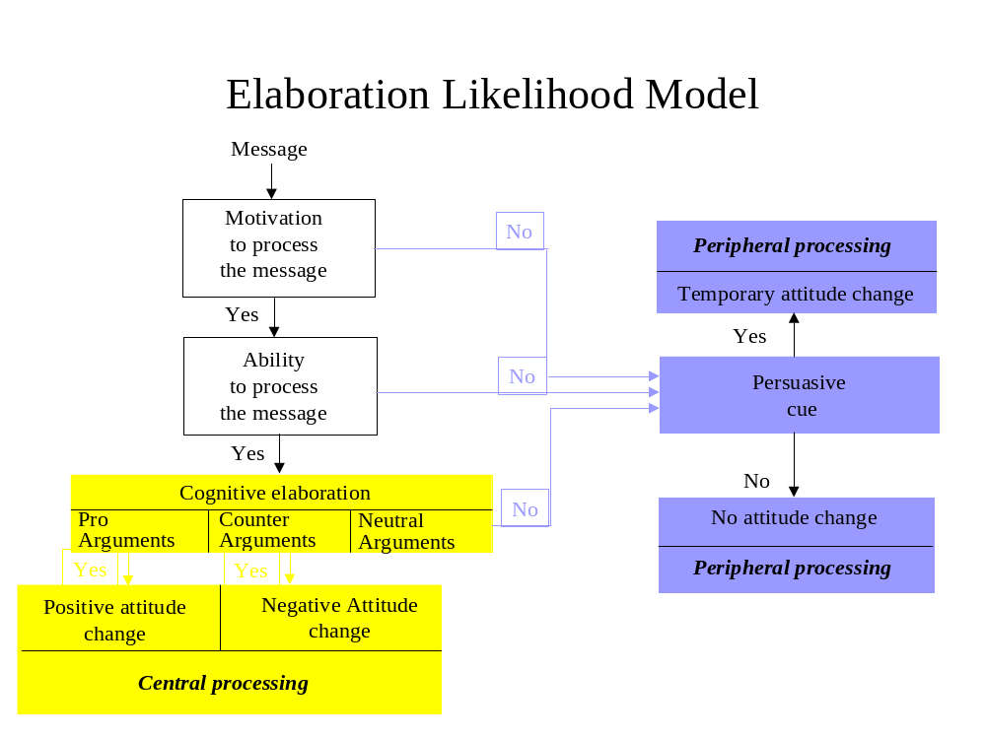
Figure 5
If the message was relevant, or salient, then this was a cue to further elaboration. If this occurs then the person may decide to seek out additional information to elaborate further, which would indicate their level of motivation. Thus, the ELM can help explain whether or not someone will engage in the electoral process. The degree of elaboration could also be dependent on how it closely it matches with the existing attitude. If there is some cognitive consistency between the existing attitude and the message, there will be a greater propensity to elaborate and strengthen the existing attitude. Further, the believability of the message can also encourage elaboration, as this shares a consistency with previous communications. For instance, the perception of Tony Blair as being untruthful has been a major factor in the 2005 UK General Election. Media reports of the Hutton Enquiry, before the election was seen to be a problem to the Labour campaign and a potential opportunity to the Conservative campaign.

Ability to process information can be defined in three ways; do voters notice the message; what do they notice? To what extent do they understand the information? In political communications, the issues and subsequent messages are often complex with alternative messages from different political parties. The message needs to be communicated in a variety of ways, in order to reach the different audiences in the electorate. In relationship marketing terms, this becomes even more problematic for the political marketer; how they control the message from the internal market; ensure it is transmitted through the diverse media with little distortion; and how partners in the external market support or reiterate the message. Each political party faces the dilemma of attempting to communicate with a diversity of audiences and the electorate are bombarded with these messages, through a variety of media. How these messages are understood relates to the third point, how do the messages correlate with voters existing belief systems?

The level of motivation is a function of firstly, the relevance or salience of the information; secondly, the level of responsibility the individual feels to evaluate the information which is particularly relevant when discussing issues such as civic responsibility; and thirdly, the personal characteristics and background of the voter. If a voter has both ability and motivation to process information, this is classed as central processing and leads to elaboration. This would involve a careful considered approach, evaluating the information available and elaborating this with his existing knowledge.

Information is processed peripherally, if there is a neutral argument, or if ability and motivation are not high enough to encourage elaboration. However, whether there is a temporary shift in attitudes depends upon the presence of persuasive cues. If persuasive cues are present, they can engender a temporary shift in attitude; if they are not present, or unnoticed, then the attitude will remain the same as before. The key point about the peripheral route is that it is a non-rational form of information retention.

Critics have identified a number of problems with this construct. Firstly it has been suggested that ability and motivation are not dichotomous variables, they work more on a continuum, Gabbot and Clulow (1999). Secondly, the implication of the ELM is that if a message is repeated often enough, some level of awareness will be created. However, whether this generates elaboration depends on message frequency, intensity or novelty. Hence, this model will be evaluated in the light of the empirical research and adapted to take these issues into consideration. The Elaboration Likelihood Model has been adapted as an heuristic device in order to recognise this diversity and enable categorisation, which allowed for a greater understanding of the different voter groups. With the assistance of projective techniques, it was possible to build an insight into the cognitive maps, or schema, through which the voter makes sense of their own life-world. A taxonomic framework, based on the concept of attitude, was also used. The basic components, affective, cognitive and connative were applied to how people feel think and behave about politics, political issues and concepts. This provided a mechanism to examine how elements were linked and their relevance to the respondent (Silverman, 2000). In the light of Bernstein’s research, this thesis sought to explore the significance of relationships between respondents, their life-world and the extent to which it influences decision making. It is also crucial to build an understanding of how issues become salient within this environment and where the conceptual boundaries of issues are but also understanding the extent to which boundaries are placed on issues and how this impacts upon cognitive capacity.

Data Analysis

To enhance the validity of the data, a reflexive methodology was used. This entailed a process of reiteration, in the first instance, conducting the literature review before embarking upon the first stage of empirical research, analysing findings, then looking through the literature again, conducting the second stage of research, conducting further analysis. Any findings at the second stage that emerged from the discussions were then explored in the context of the extant literature. The final part of the research programme was determined by the findings of the earlier stages and the literature reviews. This was an iterative process which involved revisiting data and building theory. This research was exploratory and thus attempted to identify characteristics of electoral behaviour that can be applied to specific groups. Analytical tools that were used in this process were principally model building and cognitive mapping. The Elaboration Likelihood Model was evaluated in the light of the discussion with respondents and it was viewed that it could be extended to demonstrate the complexity of the model. Secondly, cognitive maps were employed to illustrate how different groups of respondents think about politics and political issues. Cognitive mapping has been used extensively in systems thinking and, in particular, with soft systems methodology. Key authors, for instance, Eden, et al., (1983), Checkland and Scholes (1999); and Jackson (2000) all discuss the notion of ‘messy, ill-structured problems’ (Checkland and Scholes 1999:299) and the need to provide clarity and simplification.

This is clearly in evidence when trying to make sense of electoral behaviour. In soft systems thinking which is generally applied to organisational problems, a cognitive map is built by:
Listening to what an individual says and capturing this in a model consisting of a network of that person’s ideas linked by arrows. (Jackson, 2000: 275)

When applying this technique to understanding the electoral decision making process, the discussion highlights key thoughts and arrows are linked to where the ideas stem from and the implications on decision making of those ideas. It is a useful mechanism which can simultaneously highlight complexity but can also simplify relationships, due to the pictorial nature of the tool.

This chapter has attempted to describe the process of research and justify the use of the interpretive approach, when responding to the research question. It has been argued which this approach would yield other findings which have not specifically been identified earlier. Rather, it is hoped that this research enabled the respondents to be open and relaxed and therefore more amenable to discussion within an area which proved to be quite difficult for many of them. This would aid a greater in depth examination of the issues that relate to the voter and their voting decision in their own life-world. The problems related to interpretation are acknowledged, but I argue that this type of research yields a much richer picture of the respondents’ electoral behaviour. A taxonomy was developed that utilised the concept of attitude. This served to identify how the groups were different in their thinking about politics and aided categorisation of the groups. Each of the groups shared a type of thinking, from which, a Cognitive Map was developed highlighting the key issues relating to that group. The cognitive maps emphasised the interrelationships between concepts and how they related to the respondents in their respective groups. This underlined the differences in the level of understanding and the priorities of each group. The following chapters will discuss the findings.
Chapter 3
Introducing the Extended ELM

This chapter focuses upon the diversity of voter groups in the political environment. The extant literature tends to focus on voter and non-voter citizens (Opinion Research 2005; Electoral Commission 2002; 2002; 2005; 2006; White 2006; Phelps 2005; Curtice 2005; Henn et al. 2005). However, this research has highlighted that the dichotomous distinction is inadequate and within these two groups there are further sub-groups. Petty and Cacioppo’s Elaboration Likelihood Model, considered the significance of ability and motivation when processing information. They argued that these were key determinants when looking at the strength of attitudes and how attitudes develop or change. From this analytical framework and the research undertaken, a typology of voter types emerged. This is the first model, and extends the Elaboration Likelihood Model into a two dimensional framework, which differentiates the views and perceptions of the respondents according to their ability and motivation. More importantly, the aim was to illustrate the differences between the groups in terms of their political knowledge and their understanding and elaboration of political information, when making their electoral decision.

The groups were distinguished by these factors, each having a greater or lesser degree of elaboration, due to their ability or motivation to process political information. This adaptation goes some way to illustrating the complexity of the Elaboration Likelihood Model and highlights the notion that central and peripheral processing should be viewed as a continuum rather than a dichotomous alternative, something Petty and Cacioppo emphasised in a later work.

This model significantly advances the understanding of electoral decision making as it can indicate levels of:
- rationality (in terms of ability to reason)
- irrationality (in terms of conscious and unconscious drives)
- knowledge
- information processing.
It identified 8 different groups who have varying degrees of motivation and ability to process information, the key variables used by the ELM, and these variables are intrinsically linked to the education levels and life-world of the respondent. The motivation dimension was operationalised through the following four variables;
- level of interest and identification with the political system and political party;
- belief and ideological commitment;
- issue salience, or relevance to the individual and their family;
- campaign messages.
These variables emerged as the key drivers of motivation towards electoral behaviour.
The ability dimension concentrated upon five aspects:
- education levels of the respondents;
- use of and understanding of language codes; this is applying Bernstein’s (1971, p26) notion of a public language, language reflecting the ‘interaction and response to the environment’;
- cognition, the respondent’s ability to use thought and reason to generate understanding; in relation to their awareness of the political process;
- the cognitive map, through which the respondent’s organise their thoughts about politics, and political issues in their own life-world
To a great extent, education determines the level of cognition, and also the ability to understand political messages, but this is not always the case. It is important to take into consideration the consistency of cognition, as this can indicate levels of rationality. The thesis hypothesised that the respondents’ ability to elucidate their opinions, was determined by their education level and the degree to which political discussion took place within the home and other life-worlds. However, for most, discussions of a political nature were limited to home. Thus, respondents were evaluated according to their ability to conceptualise abstract political issues and also their motivation to get involved in the political process and evaluate political information. Other aspects of investigation considered included the strength of their attitude towards the political system and political parties, and also whether the respondents voted in the last election or indeed, if they had ever voted. The degree-educated group were, as expected the most articulate. Sentences were much longer using a wider vocabulary, discussion was more extensive, with more elaboration demonstrated, issues were thought through and conceptual ability demonstrated. The less educated groups demonstrated an inferior level of understanding and there was a more limited discussion. Many responses to probing were just short sentences that seemed to be built up from sentiment, rather than a rationally derived response.

The ELM adaptation (Figure 6) was designed to distinguish between the voter groups in terms of their ability and motivation to process information about political concepts and issues. Respondents were placed in groups according to the level of ability and motivation and their levels of understanding of the political process. Eight groups emerged from the in depth interviews and group discussions. The groups occupied positions in 4 quadrants. In the first quadrant of high motivation and high cognitive ability, the research identified the ‘Informed Inquisitors’ who demonstrated the greatest level of reasoning and motivation. Within the same quadrant were the ‘Guilty Know Nothings’. The ‘Guilty Know Nothings’ showed evidence of high reasoning ability and a sophisticated understanding of the interrelationships between concepts in their life-world. However, there was little understanding of political issues and the political process. In the second quadrant of high motivation but low cognitive ability were the, ‘Habitual Loyalists’ and ‘Authoritarians’. The ‘Habitual Loyalists’ demonstrated strong party loyalty and repeated the stereotypical arguments for and against the main parties. The level of interaction with people in their life-world and the newspapers they read, reflected their own viewpoints and reinforced their opinion. They were very loyal and found it difficult to criticise their preferred political party. However, they demonstrated a similar enthusiasm to criticise other political parties.
Extended
Elaboration Likelihood Model
Informed Inquisitors
High
Cognitive
Ability
Low
Cognitive
Ability
High
Motivation
Low
Motivation
Habitual Loyalists
Political Cynics
Know Nothings
Authoritarians
Mercenaries
Guilty Know
Nothings
Disengaged
Figure 6

The continued presence of the ‘Authoritarian’ was most interesting and was strongly in evidence in both the clerical and unemployed groups and surprisingly, cut across gender. For the ‘Authoritarians’ there is little cognitive ability to process political information, but they can be mobilised when exposed to the threats they perceive to exist within their life-world. They are motivated by fear and distrust which was manifested in their strong emotional comments during discussion.

There is a high level of irrationality but in accordance with Aristotle’s notion of desiderative irrationality, they looked to strong leadership for guidance and protection. In the third quadrant of low motivation but high ability, I placed the ‘Disengaged’ and the ‘Political Cynics’. For the ‘Political Cynics’ there was evidence of high reasoning ability, both in their own life-world and the political environment, but motivation in politics was low due to levels of distrust in political leaders and the political system. For the ‘Disengaged’ group, there was some ability to understand political concepts. Despite this, they had not really engaged in any political activity because it was perceived to be irrelevant to them. Finally, in the fourth quadrant of low motivation and low cognitive ability were the ‘Mercenaries’ and the ‘Know Nothings’. The ‘Mercenaries’ had little cognitive ability but displayed signs of economic rationality, particularly when considering their own perceived self interest. However, the ‘Know Nothings’ showed no understanding of politics and no interest in the electoral process. In the unemployed groups where education has been minimal, responses were superficial, generalised knee jerk responses such as it’s rubbish, stupid etc., with no justification. They are completely intimidated by the language of politics, by politicians, and by the electoral process. In effect, they are excluded from the political life-world. This confirms the heuristic value of Bernstein’s codes which links educational level to ways of making sense of politics.
Moreover, the higher education levels also indicated a greater level of rationality, in terms of a respondent’s knowledge about politics, how they comprehend politics and their capacity for reasoning. This links with Habermas’s notion of normative rationality as many respondents clearly relied on information primarily from their home life-world. It is interesting to note, however, that the higher educated groups also occupied more than one life-world and used communication codes that reflected the different life-worlds they inhabited. On reflection, there appears to be a standardised response to politics and political decision making which is developed from a general view of the politics life-world. The majority of respondents felt excluded from this life-world and had little motivation to join, even if they were able to do so. These issues resonated, though unevenly, through all the group discussions and the most common complaint about politics was that it was ‘boring’ and politicians were ‘out for themselves’ and ‘untrustworthy’. However, this negative opinion that many respondents held of government and politicians was totally different when talking about them personally. In such cases, it was much more positive. The reason, it can be hypothesised, is that different cognitive maps are being activated here. On the one hand, there is clearly a distinct almost stereotypical view of politicians, amongst the unemployed. Whilst amongst the degree educated group the cognitive map was clearly more extensive. Within the unemployed groups, however, the negative attitudes expressed towards politicians and government did not reflect attitudes to named politicians such as John Prescott, clearly a different schema was activated.

In the group discussions, particularly in the lower educated groups, there was little evidence of respondents’ ability to conceptualise abstract political issues. For some, there was only a notional understanding of an idea such as sovereignty, which many respondents found difficult to define. Respondents from all the groups displayed a rather superficial understanding of political information, suggesting that their political decision making was based upon limited cognition. In view of this, the thesis will propose that education has a crucial effect upon the level of sophistication of the cognitive map which builds citizens’ belief systems. Yet it is more complex. Firstly, it is clear that education is merely a component in the ability to process information but in many cases it does not facilitate motivation to process information. Secondly, the cognitive map used for every day life may not be adequate for electoral decision making and finally, some cognitive maps can be fruitfully applied to other situations, as Kohler identified in his experiments on insightful learning, where solutions to one problem in a particular circumstance can solve a problem in another situation (cited in Assael, 1998). For instance, degree educated students have an extensive cognitive map regarding their career progression or taking a holiday. They know the information sources available and have a stock of knowledge that is built up over the time spent at university, or since they began taking holidays away from their parents. However, in politics a different cognitive map needs to be developed. There is a specific language and system that needs to be learned, and access has to be gained to the media that communicates political messages.

Political Knowledge
This section will explore political knowledge from the perspective of political personalities, concepts and the political process. Awareness levels of politicians were quite limited across all groups. except the male degree respondents.
Although all respondents knew Tony Blair, only a small proportion of the respondents were aware of William Hague, even after others mentioned his name and attempted to describe him. Paddy Ashdown was identified spontaneously by some respondents during the discussions. In addition, John Prescott, John Major and Margaret Thatcher were the only other politicians known to the groups. All respondents knew Margaret Thatcher. However, their attitudes towards her and her government differed considerably between the groups. She evoked extremely strong feelings both for and against when discussing her personality, style of leadership and government policies. Attitudes towards valence issues such as her political performance and her economic management contrasted sharply amongst the groups. However, for the Authoritarians, her perceived strength far outweighed any other identified weaknesses.

As would be expected, a preference to political leaders was strongly linked to their party preference. Although Tony Blair was respected, he was not trusted by the brand loyal Conservative voters. Local council politicians were not recalled at all by any respondents in the group discussions. Interestingly, all could discuss politicians in general but few could discuss the role of the politician and their relationship with the electorate on a conceptual basis. This was again evident across all educational attainment levels. However, after some probing certain respondents in the degree groups discussed parliamentary and voting procedures. Clearly, saliency is a crucial aspect of motivation in this elaboration process. For instance, those who had bought a house remembered exactly how many times the interest rate had increased after the Labour Party election victory and when the increases were implemented. Whilst many respondents recognised the ultimate responsibility of the position of Member of Parliament and respected cabinet positions, there was little trust evident when discussing the role of politicians in general. Indeed, they were perceived as self interested, career oriented, and ‘in it for themselves’. This ‘self interest perception was elucidated in all discussions and cut across education classifications; the only difference was the level of articulation. There was a general disinclination to believe. Parties were perceived as the same and since the change in government there was a sentiment that nothing really had changed. Neither local nor national political issues were followed on a regular basis and they were not seen as an important part of any of the respondents’ lives. There was no active searching for current affairs programmes and only one respondent in the lower educated group said they had watched Panorama. Programmes such as Newsnight were perceived as boring. If they watched Parliamentary Question Time, they had stumbled across it by accident, whilst surfing the television channels. It was ridiculed, as there was a perception of too much shouting and childish behaviour. They did read the newspapers, normally the local paper but others included the Daily Mail, Mirror and the Sun. However, political commentaries were rarely read even during an election campaign. If Party Political Broadcasts were discovered by accident the usual response was to switch over or leave the room to make a cup of tea, etc. This behaviour cut across all educational backgrounds.

Engagement
There were different engagement levels for each group. For the ‘Informed Inquisitors’ they acted as an information junkie cognitively processing information on a regular basis and were usually opinion leaders in their home life-world. The ‘Political Cynics’ had little faith in the legitimacy of the political system nor trust in politicians but they were capable of understanding political concepts and messages. However, they were alienated from the electoral system because they were cynical about the efficacy of the political process and politicians. The ‘Disengaged’ were a group who did not feel particularly alienated like the ‘Political Cynics’, rather they hadn’t really thought about politics because they didn’t believe it affected them.

This group tended to be younger and female, and although they had the ability to process political information they had not found a motivational factor to engage in the political system. The ‘Guilty Know Nothings’ also had the ability to process information, they tended to be degree educated but felt intimidated by the language and concepts in politics. They felt guilty because they knew they were capable of understanding politics but hadn’t got the motivation to process political information or make a considered electoral decision. Finally, the ‘Know Nothings’, were the closest to the ‘don’t know, don’t care, don’t vote’ Generation X. They had little knowledge; they were alienated from the system and totally disenfranchised from politics. This group was as unlikely to vote as the ‘Political Cynics’.

Extent of Evaluation
The extent to which evaluation takes place, is also an important component of decision making. In marketing, this is explained in terms of high and low involvement, with high risk products generally extending the evaluation and decision making process. Although the type of product most often determines the extent of evaluation, for some consumers, personal and situational variables have a greater impact on product choice. This reflects political decision making, where the extent of evaluation is different amongst the various voter/non-voter groups. The time taken and effort to process information was quite limited amongst most respondents, particularly with regard to their understanding of political issues. Although this is not measurable there were considerable variances amongst the different groups. The ‘Informed Inquisitors’ demonstrated the greatest level of evaluation and this was exemplified by their responses to democracy. Many respondents, including the graduate respondents, found it difficult to define democracy. It was something that was expected, or more accurately, taken for granted. Even after prompting, there was no discussion of how democracy works, only the mechanics of the democratic process in terms of the voting procedure. A vague notion of proportional representation was expressed, but there was no real understanding of how that was different from the existing ‘first past the post’ system. There was a superior understanding amongst some members of the degree educated groups. The discussion of proportional representation was more extensive in the female degree group with two respondents mentioning the French electoral system which was seen to be more democratic. Whilst acknowledging this point, it was also argued that this is where Jean Marie Le Pen got his power and strong parties were weakened by having to work with other parties, ‘watering down’ policies. However, this discussion was not as extensive in the male degree group and proportional representation was not discussed at all in any of the other group discussions. The clerical and unemployed groups had no understanding of proportional representation. It was clear that education level had an influence on how people recalled and internalised political messages, and levels of articulation of concepts increased in proportion to education. There was also a difference between male and female group discussions. The notion of civic responsibility appeared to be much higher amongst the female degree educated group. One respondent claimed she hadn’t voted, as she felt she didn’t know enough about the issues and was concerned that her one ‘ill thought through’ vote could change the whole outcome of the election. Male degree holders were, on the whole, much more cynical of the election process.

Attitudes
Key characteristics of the groups’ attitudes are broken down into the three component parts of attitude, namely affective, cognitive and connative. These are outlined in Figure 26.
This follows the classic marketing example of identifying the 3 attitudinal components of Coca Cola: ‘I like Coca Cola, I think it’s good, I buy Coca Cola’. So, for the ‘Informed Inquisitors’, ‘I enjoy politics, I think it’s important, I always vote’. Figure 7 outlines the component parts of the different political attitudes held by the different groups and illustrates how their feelings about politics affect their cognitive activity and ultimately their behaviour. Each group had a distinct attitude, even the four groups of non-voters had differences in their attitudes towards politics and politicians and the reasons for abstention are diverse. Moreover, for some of these groups such as the ‘Know Nothings’ abstention was a more enduring component of their decision making. Whilst for others, particularly the ‘Disengaged’, abstention seems to be a temporary phase, possibly due to age and a lack of saliency of political issues on the agenda. The attitudinal taxonomy is helpful, in that it indicates the affective nature of the respondents and emphasises how different the voter groups are. It is this component that seems to determine how voters ultimately think about politics and then decide to cast their vote.

Voter Type | Affective | Cognitive | Connative
Informed Inquisitors | Enjoy politics  - Feel informed  - Feel empowered  - Feel involved | Think it’s  - interesting  - challenging  - important | Always vote  Vote same  Rarely change  Tactical voting
Mercenaries | Do not like politics  - feel insecure  - feel worried | Think it’s  - necessary  - economic | Usually vote  Vote same  Vote change
Authoritarians | Don’t like politics  - feel insecure  - feel threatened | Think it’s  - complicated  - for the elites | Usually vote  Vote same  Vote change
Habitual  loyalists | Like their party  - feel secure  - feel part of a team | Think it’s  - important  - complicated | Usually vote  Vote same
Political Cynics | Distrust politics  - feel cynical  - alienated | Think its  - unethical  - sleazy | Don’t vote  Will not vote  Alternative voting
Guilty  Know Nothings | Scared of politics  - feel guilty  - feel ignorant  - concerned | Think it’s  - too important  - too difficult | Don’t vote  Should vote  Will vote - eventually
Disengaged | Not interested  - feel apart  - feel indifferent | Think it’s  - irrelevant  - boring | Don’t vote  May vote later
Know Nothings | Excluded from politics  - feel fearful  - feel intimidated | Think it’s  - remote  - inaccessible | Don’t vote  Will not vote
Figure 7
Further, they also hold attitudes towards valence issues and this contributes towards their electoral decision. Nevertheless, it is clear that some respondents had little understanding of valence issues such as the economy, or political performance.

The findings of this research support the notion that ideas about politics are generated initially by parental influence and their milieu. However, salience emerges as a catalyst for involvement in politics. For instance, respondents with children who had little interest in politics generally, were aware of a local maternity hospital closure. Their children had been born there and this was part of their community and their life-world. Saliency motivates political learning, which leads to political knowledge. However, the extent of political knowledge is determined by levels of understanding, and the extent of evaluation. Thus, the next section will discuss and categorise the groups according to their political knowledge. Furthermore it will consider and if (or how) they order this information when making their electoral decision.

Levels of Understanding
As argued earlier, the ELM suggests that respondents with a higher education level, should be able to elaborate political messages more efficiently. The research confirms this but indicates little motivation to do so. The only group that was motivated to process political information were the ‘Informed Inquisitors’, who could elaborate on political concepts such as taxation whilst considering a wider perspective such as the effect on the economy. In general, other groups could only make sense of such concepts when they related them to their own life-world. The striking aspect is when political issues were seen as relevant to these respondents; they were motivated through either concern for their families or themselves, insecurity or fear. This was then augmented with their existing belief systems. However, although for some respondents there was the motivation to get involved, if levels of understanding were limited, making sense of complex issues was still problematic. This thesis uncovered not only that there are different levels of understanding amongst the respondents, but that individual respondents also have varying levels of understanding in different situations, depending upon ability, the issue, and the context or the level of motivation.

The adapted Elaboration Likelihood Model differentiated respondents by ability and motivation and was a useful tool as it facilitated the examination of different types of decision making, through cognitive and peripheral processing. The ELM uses ability and motivation as variables to distinguish between different types of decision making and this model was adapted to provide an analytical framework to consider the fluidity and diversity of decision making amongst different groups. However, this is only a partial explanation as the ELM does not make explicit the multiple message sources, source repetition and the interpretation of messages from opinion leaders, peer groups and the media. The second model attempted to ameliorate this, providing a picture of how messages were received, through which medium and to what extent they were elaborated upon.

Chapter 4
The Life-world Model

This chapter introduces the second model developed in the thesis. This model examined the variables that affected decision making, the extensiveness of the life-world in which each voter group lives and how they receive and use political information to make their electoral decisions. It explored the diversity of internal and external variables that influence individual electoral decision-making. Moreover, it served to demonstrate how information sources were selected and the extent to which they were used to inform each group’s electoral decision making. In short this model serves to highlight the paucity of rational choice whilst emphasising the multiplicity of the sources, respondents and the message. This model helps to illustrate the complexity inherent within electoral behaviour in today’s fragmented environment. In order to build a picture of the variables that are involved in the generation of political thinking and how they impact upon electoral decision making, a tentative model has been proposed (see Figure 8). The Life-world model augments the ELM by outlining the extent of information sources available and the degree to which they improve the respondents’ knowledge and develop their attitudes. These are placed on a home and remote life-world continuum. It incorporates Bernstein’s (1971) work on home and remote life-worlds, suggesting that in the home life-world the citizen is familiar with the mode of communication and customs, whilst in the more remote life-worlds, customs and codes are less familiar. However, Bernstein (1971) notes that education can determine the ability to understand communication codes used in remote life-worlds.
Life-world Model
Previous
knowledge
Parental
Influence
Peers
Media
Local
Issues
National
Issues
International
Issues
Government
Performance
Opposition
Parties
Leadership
Campaigns
Existing
Attitude
Voting decision
Trust
Disengagement
Abstain
Vote Change
Vote Same
Home life-world Remote life-world

Figure 8

However, this thesis will argue that for politics and electoral decision making, education is not enough, motivation is also necessary. Despite the fact that there are a number of variables which can impact upon electoral decision making, it is clear that only a small minority actually do use these. Again, the extensiveness of the decision making is determined by ability and motivation. Lack of ability limits understanding of the more remote life-worlds but lack of motivation is a significant obstacle to engagement. This model can illustrate that different groups have varying levels of understanding and engagement in the electoral decision making. Occasionally, respondents used information derived from a different life-world and applied this to answer a question in another life-world – what Kohler defined as ‘insightful learning’. For instance, when considering the single currency; information gleaned about duty free products and currency was acquired from their holiday life-world and this contributed to their knowledge in the politics life-world. Graduates who studied abroad (Europe), added the knowledge gained from this life-world to their own. Consequently, it is important to remember that information collected from one life-world, can contribute towards the development of a cognitive map to be used in decision making in another life-world. Nevertheless, the cognitive map developed will be as extensive or as limited as the respondents’ cognitive ability allows with motivation determining the factors that need to be learned and then included in the map.

An extensive cognitive map relates to Bernstein’s notion of ‘sensitivity to structure’ (1971:24), and this is why salience is so significant as a catalyst for learning and understanding political issues. For many respondents, there were issues that resonated personally and this motivated them to either find more information or to take part in a political activity, such as petition signing or attending a public meeting. For instance, during the period of empirical research, a local maternity hospital was to be closed and planning permission was given for a McDonalds to be built in a residential area. Some respondents had attended public meetings and signed petitions, relating to these issues. It is important to note however, that salient issues also changed according to change in life style or life stage. Nevertheless, amongst the majority of the groups, there was little involvement in the political process and little searching for information unless there was a catalyst for learning and action. For those respondents who voted the formative stage of decision making was shaped by parental influence. Furthermore, if they became interested in particular issues, then they would search out additional information from other sources, including for example, the media or their peers. Further, understanding would be gained when considering governmental management of those issues. If that was not deemed satisfactory, they would look at other alternatives such as opposition parties or abstention.

This information was then elaborated with their formative knowledge to either strengthen or weaken their existing attitude, which then informed their voting intention. Clearly, evaluation levels depend on ability and motivation to enter the world of politics and electoral decision making. The need to understand the practice of politics and the communication codes of the political life-world is important, as these are quite distinct from most respondents communication codes used in their home life-world. However, the majority of respondents did not engage in the political process in this way. The Life-world Model can illuminate information gathering, cognition and decision making of the different groups. There is a marked difference between the way the groups actually act upon these influences and whether or not they really take any notice of or understand any of the information sources. Thus this model argues different groups can take or ignore influences as they choose and that this will also be dynamic between elections. These findings would support the post modern marketing literature of a fragmented electorate taking information as and when they feel like it, dependent upon saliency, their current situation and media messages. They are, more importantly, also able to switch off and avoid influences altogether and from this research there is evidence that some groups do exactly that.

For information seekers such as the ‘Informed Inquisitors’, they demonstrated a sound knowledge of local, national and international issues. They also understood the ideological positions of the political parties, and evaluated governmental performance and leadership. They also evaluated the media slant on those issues and discussed this with family or the peers. Politics was interesting and relevant to them and they amended their attitude over time. Although they were quite loyal they still questioned their preferred party on the efficacy of their policies to deal with political or economic issues. The ‘Political Cynics’ behaved in exactly the same way as the ‘Informed Inquisitors’ but they had a distaste for politics and politicians that alienated them from the electoral process. They also had an awareness of local, national and international issues and criticised Government performance. They were sceptical of the media, believing that they also had an agenda. It was unlikely that this group would ever vote unless to vote tactically to get one over on the system. For the ‘Guilty Know Nothings’ there was little consideration of any of the factors identified in the Life-world Model, apart from the notion that maybe they should get involved as they did have an understanding that it affected their lives. The ‘Disengaged’ had as little involvement as the ‘Guilty Know Nothings’ but did not share the guilt. They couldn’t see the relevance of politics and how it affected their lives.

The ‘Guilty Know Nothings’ and the Disengaged’ were capable of understanding concepts and political issues. In sharp contrast, the ‘Know Nothings’ weren’t capable, their limited cognition and lack of interest in politics left them outside the system with little chance of engagement. Their life-world had no room for politics. ‘Habitual Loyalists’ had similar levels of cognition and interest in politics but through parental influence they participated in the electoral process. This was a very limited type of engagement which only entailed a walk to the polling booth, and satisfaction if their ‘team’ had won. Any consideration of the issues was stereotypical and there was no critical evaluation of their own party. This was reserved for the opposition. Stereotypical beliefs were also the norm for the ‘Authoritarian’, there was little consideration of national or international issues unless it affected their security. Terms of engagement were related to personal and economic security and fear. However, the ‘Mercenaries’ focused upon financial security. Again, they had little cognitive ability and limited motivation as they were only interested in getting what was best for them without expending too much effort. For all the groups in the low cognitive ability quadrant, the use of the media was merely relying upon soundbites rather than extensive discussion.

Incumbent governments do little to encourage the search and evaluation mechanism in voters; they need to maintain the status quo. Conversely, it is the opposition’s particular need to generate interest in the election. Therefore, they attempt to spice up the campaign and get issues onto the agenda. These models recognise the situation and thereby identify the groups that are most susceptible to change, which issues would be of relevance to them, and how they would be mobilised. This is also dependent upon the degree of trust the voter has for the political party or system and the level of trust determines whether the voter’s choice remains the same, changes or abstains. If the voter is content with the political party he will continue to vote for the same party. Trust has built up either from habit, in the case of the ‘Habitual Loyalists’; or evaluation of the alternatives, in the case of the ‘Informed Inquisitors’ and ‘Mercenaries’. Again, these two groups are also likely to change their vote to another political party, if the previously voted for party has not fulfilled expectations. Similarly, the ‘Authoritarians’, who look to political parties that can provide them with a secure environment, where they are protected from threats to their own economic and personal security, will consider change, if they believe their needs are not sufficiently met.

This chapter introduced the ‘Life-world’ Model suggesting that it could provide a comprehensive view of how different voters make electoral decisions. This model suggests that there is a great deal of dynamism in electoral decision making. This thesis suggests that there is no one model that can explain the vagaries of voting and non-voting; situational factors combined with access to information and ability to understand the information sources add to the complexity. This complexity is not acknowledged in the current literature.

This model attempts to map alternative political consumption patterns which are determined by ability and motivation. The final chapter provides a conclusion to this thesis whilst identifying possible limitation and areas for further research.

Chapter 5

Informed Inquisitors

This chapter seeks to build an understanding of how this group thinks about politics, what are the defining factors and how do these influence their electoral behaviour. It will explore these aspects from their own life-world and will begin by briefly outlining their lifestyles and the information sources that are utilised to evaluate policy issues. Respondents who fit into this group tend to come from the degree educated groups, but not exclusively. This is the group that searches out for the most information and is the only group that demonstrates high levels of ability and motivation. They tend to be degree educated, have management roles either in the public or private sector. Some have children but this does not have a bearing upon their political activity, rather it determines the policy issues that have saliency. This group conforms to the ‘ideal citizen’ who evaluates policy and votes after consideration of the issues in line with Lau (1989), Aldrich (1993). The group has a solid understanding of the political system, concepts and the political parties’ positions and have built their political information base from their parents’ political beliefs, with the majority sharing their parents’ party loyalties (Campbell et al. 1960). They are genuinely interested in politics, recognising the relevance it has to their own lives with an understanding of the implications of policy decisions on the wider environment. In contrast to the increasingly widespread view that young people are disengaged and disenchanted with politics and the political process, Wring et al. (1999) argued that there were groups of young people who did take their civic responsibility seriously and engaged in the electoral process. This group of respondents supported this view, as they took time to search out for information and tended to read the papers regularly, particularly the broadsheets and also watched current affairs programmes on a regular basis. This was borne out by the findings from the Power Report (2006) and also Henn et al. (2005) who suggested that young voters did engage in political discussion and activities (Fahmy 1996).

The newspapers they choose tend to reflect their political persuasion, for instance, Conservative ‘Informed Inquisitors’ tended to read the Daily Telegraph and the Daily Mail occasionally, whilst Labour ‘Informed Inquisitors’ mostly read the Guardian. ‘Informed Inquisitors’ are also the only group that stated that they enjoy discussing politics with their family and peers. They take the issue of voting very seriously and it is not without considerable elaboration that they ultimately cast their vote. Their modes of reasoning are logical and consistent, demonstrating a rational ordering process supporting Bernstein’s (1971) observation of middle class elaboration of sensitivity to structure. With regard to their understanding of political parties and awareness of politicians, this group, of course, demonstrated the deepest understanding, though some did revert to stereotypical viewpoints of the opposing party and political personalities. This was highlighted in some of the projected techniques such as word association. In stage 3 the degree-educated groups were asked about words to describe their perceptions of the two major political parties and they were invited to distinguish between both old and new Labour and old and new Conservative, these are in Appendix 3b. It was interesting to see that they were much more critical of opposing parties than their preferred party, demonstrating an inbuilt party loyalty which is difficult to change. This would indicate that there are partisan preferences and evidence of party loyalty However, there are certain issues that can turn allegiances, suggesting a periodic evaluation of party performance in relation to those issues (Lupia et al. 2000),. This was evident amongst the traditional Conservative voters in these discussions who were concerned about the perceived shift towards the right of the political spectrum under William Hague.

There was a high level of understanding when considering the values and positions of the political parties and they were the only group who differentiated between left and right politics. For instance, Conservative respondents did not claim to be right wing in any form and argued that the ‘right of centre’ was their preference. Moreover, they were conscious that the new Labour government were now holding that position. For some Conservative voters, the perceived Conservative shift to the right was enough to change their allegiance to New Labour. Other loyal Conservative voters could not make the change, due to a lack of trust in the opposing party. Perceptions of Labour such as nationalisation, high taxes, strikes and unions were too entrenched and they didn’t trust Tony Blair. They believed him to be slick, and shallow with little substance. New Labour voters shared with the Conservative voters negative perceptions of old Labour. Again these were stereotypes of Arthur Scargill and the miners, cloth caps and the ‘North’! The majority of these respondents were not really old enough to remember Arthur Scargill and the miners strike, nor the ‘three day week’. Development of interest in politics and voting tends to stem from parental influence and parental political activities. One respondent commented;

My father was interested in politics, and he became an activist in the Conservative Party. He became a local councillor in Scarborough and I also helped in the elections when I was at home. (male, degree, R2a)

There was a sound understanding of the relative positions of the political parties. Some Conservative ‘Informed Inquisitors’ saw the Conservatives under William Hague developing a racist and extremist profile and this concerned them. This was apparent in the Stage 3 research with many of the ‘Informed Inquisitors’ as the interviews with the junior managers in the later stages of the research on both sides of the political spectrum. It appears that loyalist ‘Informed Inquisitors’ do question their party’s position but is rare that they vote for another party. However; they do elaborate and are aware of changes in their party’s position. The male degree group recognised Blair as being very ‘media friendly’. They were the only group to actually discuss the presentation of Blair. Indeed, one respondent actually remarked that:

He reminds me of American religion, evangelical almost (male, degree, R5)

‘Informed Inquisitors’ do demonstrate an understanding of electoral decision making and an awareness of the issues and are able to discuss them in the wider context. One respondent, typical of this group, was a loyal Conservative voter but still considered her voting alternatives carefully, as she was dissatisfied with the Conservative leadership. She demonstrated a sound understanding of the political candidates, their policy positions and also their reputations; she could also assess the impact of the candidates’ positions in the context of the wider environment.

The level of elaboration was extensive and evident amongst all members of this group and the next section of the discussion highlights the dilemma that faced Conservative loyalists and also the extent of elaboration caused by their dissatisfaction. This ‘Informed Inquisitor’ was very reluctant to vote for Hague as she believed he was taking the party too far to the right, she also believed he was not an effective leader and was very concerned about the factions in the Conservative party, particularly with regard to Europe. She was also concerned about the infighting and intrigue that was spilling over into the media, as she believed that this was not sending out a clear Conservative party image to the voters. This, she thought, was the responsibility of William Hague. Moreover, this respondent lived in the London area and was faced with the possibility of voting for Ken Livingstone in the election stating she was

totally opposed to the idea of electing Jeffrey Archer to the status of Mayor of London (female, degree Stage 3 discussions)

She had a real dilemma here; Jeffrey Archer was to blame for many of the Conservative party’s problems particularly with the allegations of sleaze. Ideologically, she could not vote for Ken Livingstone. She vaguely entertained the notion of abstention but she was a Conservative party member in the Kensington and Chelsea constituency, and a genuine party loyalist. In the end Jeffrey Archer withdrew his candidature and Steven Norris stood as the Conservative candidate.

In her view, he was much more suitable but would probably not beat Ken Livingstone. However, she could exercise her right to vote. This clearly shows that she has clear ideas relating to the role of party leader, she understands how the media can highlight party divisions and how that affects party perception. Moreover, she was also acutely aware of the issues relating to Europe and how they can impact upon the economy. This level of elaboration is not unusual, as other Conservative ‘Informed Inquisitors’ living in the Northern Constituency of Haltemprice and Howden, were also concerned about the Hague leadership. Their dilemma stemmed from balancing the desire to remove the Hague leadership by voting Liberal Democrat, with the need to vote for the Conservative candidate, David Davies, who they perceived to be a future leader of the Conservative Party. These examples serve to highlight the ‘Informed Inquisitors’ level of elaboration during the election process, particularly when there is a degree of cognitive dissonance, brought about by unsatisfactory policies or candidates. The extensiveness of discussion and debate amongst their peers and the communication codes used illustrate their comprehensive understanding of political concepts and how they apply to their electoral decision making. Levels of motivation are high and the problems faced by the respondents did little to deter them from voting. Rather their motivation levels gave them added impetus to evaluate alternatives and extend their elaboration of issues, in the manner of the high involvement consumer decision making process.

They felt strongly compelled to vote to such an extent that they considered voting for their least preferred candidate, voting tactically, to send a message of dissatisfaction to the party. For a significant number of Labour ‘Informed Inquisitors’, there was a concern that New Labour had moved too far to the right and were ‘losing their roots’. Some believed that this was temporary and done in order to get elected,
now they’re in they’ll change back to Labour policies of redistribution of wealth and the rebuilding of the health service (female, degree, R3)

There was a strong sense of optimism after Labour gained power but this soon dissipated, as many loyal Labour voters felt disillusioned. These respondents were also seriously considering voting for alternative parties, with the Liberal Democrats as most likely candidates, in the absence of any other suitable socialist party. Many did not like Tony Blair, sharing the concerns of the Conservative voters but voted for him in 1997. This view had changed by 2000 as one respondent claimed to have

A visceral hatred of Tony Blair (male, degree, R7)

Strong views were also highlighted in the some of the drawings. For example, in the drawing below this Conservative Informed Inquisitor clearly highlights his distrust of New Labour (male, degree, Stage 3 discussions). He believed that Labour was not delivering on the policies promised and if one looks at the crown on Tony Blair’s head, this indicates that there is a significant concern that Blair is either too Presidential or taking the role of the Sovereign (Figure 9).

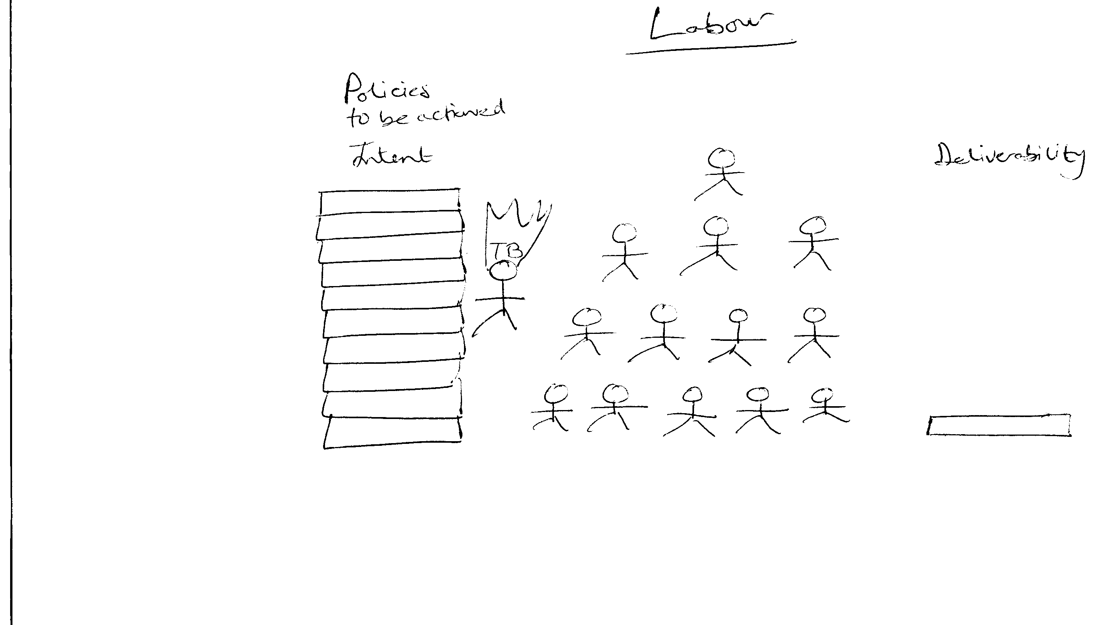
Figure 9
This group engaged in information searching and augmented this with their existing political knowledge, as Petty and Cacioppo suggested. ‘Informed Inquisitors’ believed passionately in their politics, and enjoyed political discussion. They were generally opposed to any change in party position. Many of the Labour and Conservative ‘Informed Inquisitors’ were ideologically committed to their party, although they did monitor any changes in political position.
There was evidence of a high level of motivation again reflecting Wring et al. (1999), and Henn et al. (2005), and after further questioning and deliberating some voters revealed that they had made a strategic decision to change their vote, as the Conservatives were no longer reflecting their interests with new Labour moving into that position. However, if new Labour do not deliver on their promises, it would be interesting to see how this group of switchers within the ‘Informed Inquisitors’ behave.

Paradoxically, this group could rationalise that there was no point in voting, as it didn’t make a difference to the overall outcome. However, they still tended to vote in both local and national elections, as there was a belief that if they voted they could
put pressure on their party leadership and make them conform (male, degree, R2)

This gave them a sense of empowerment in that they believed their vote could influence debate within their party, which would then determine party policy. This behaviour was evident for one respondent in the stage 3 discussions. He punished the Conservative Party by voting against them, as he held them responsible for his parent’s predicament. This respondent appeared emotionally scarred by the effect of negative equity in his parent’s home, he recounted how people were encouraged to buy their own council houses and his parents had bought their London council flat.

This was the only time his parents had invested in anything and they believed that this would give them a significant profit, as the housing market was booming. Houses were always a solid investment for the middle classes and therefore it was seen as a great opportunity to get involved in this. His parents were traditional Labour voters who changed their vote to Conservative in 1979 when Margaret Thatcher came into power. There was a palpable feeling of disillusionment from the son who grew up in a working class environment, where Margaret Thatcher offered them the opportunity to buy their own council house. His parents could take advantage of the middle class belief that

money would grow if you put it into bricks and mortar (male degree, Stage 3 interviews)

This clearly was not the case in the 1980s and many people lost money and in some cases their homes. This was noted and remembered by this respondent, whose parents had considerable negative equity in their home. He argued that

this should be what Labour should be saying in future elections NEGATIVE EQUITY as this is the story of many people in the South (male, degree, Stage 3 interviews)

This anecdotal example illustrates the situation for many people in the South East (Forest et al., 1998) and shows how situational influence shape electoral behaviour. Moreover, it highlights how non-rational emotional thinking can influence the decision making process.

This was a very emotive issue for this respondent and shows clearly how this distressing experience increased motivation which impacted upon his voting behaviour. Interestingly, in the 2005 UK General Election, this issue was used as part of the Labour Poster campaign. This suggests that although this was only one respondent, his experiences reflected many others who were in the same position in the 1990’s.

This will possibly have been uncovered using the same qualitative research methods undertaken by Labour Party strategists. However, there are other aspects of attitude formation that are not merely normative. For instance, there was considerable interest in current affairs amongst the group. They did vote and read the newspapers regularly mainly the Times, Guardian, Daily Mail and the Daily Telegraph. They felt they needed to watch the news at least once a day in order to keep up to date and watched current affairs programme if it was of interest. Some became interested in politics at university,

I wasn't really terribly interested in politics first but funnily enough it became a major interest ….while I was studying about Hitler's Germany and it starts to click about how important politics are …. so after that I really started taking interest I had to read the Guardian regularly, in London I used to love reading the papers from front to back particularly the Independent I found that very interesting (female, degree, R4)

‘Informed Inquisitors’ tended to base their decisions on interest and issues rather than habit; self interest; or merely what their parents did. Their ability to conceptualise political issues was no stronger than the ‘Political Cynics’.

However, they were motivated to find information either from a belief in civic duty, or enjoy the stimulation that the evaluation and debate provided. This was evident in the Electoral Commissions Report (2005) where verbatim comments highlighted a notion of civic duty.

I think if I didn’t take up the opportunity to vote, it would be an insult to everyone who fought for the right to vote. 18-25 year old voter (Electoral Commission 2005:28)

It’s something a lot of people in the world don’t get to do. It’s such as was if you don’t do it. 26-45 year old voter (Electoral Commission 2005:28)

On the other hand, the ‘Political Cynics’ thought they understood the issues and then discounted the political parties at voting time. All ‘Informed Inquisitors’ voted at local, national and European elections. The group enjoyed the election and evaluated the alternatives, identified their own preferences and voted accordingly. However, it is interesting to note that although they did evaluate alternative partys’ policies, there was a strong residual loyalty built up from the parental vote that coloured their values and perceptions of importance issues. They elaborated and thought about the messages politicians were conveying and evaluated them, interacting with their existing cognitive structure.

I listen to politicians I can relate to, for instance, Conservative politicians who seem to have upper class backgrounds, what have you, I can’t necessarily relate to directly. I can’t really believe that they can understand what’s happened to the country so I don’t pay any attention to what they say. (male, degree, R6)

‘Informed inquisitors’ were the only group to evaluate all parties and then take a broader view of the election process.

They also considered tactical voting (Huang, 2001). They appreciated that the process of voting is important even if their vote would not count and they looked at alternatives that can then make their vote more effective.

yes I voted Labour actually purely because I didn't want the Conservatives to get back in and I didn't think liberal would make the votes to get in properly. I don’t know now whether it was the right thing to do or not I suppose I didn't want to lose my vote (female, degree, R3)

The high level of elaboration in this group was demonstrated not only by the consideration of tactical voting but also by how they evaluated issues and questioned what politicians were saying. The following brief discussion is taken from the male degree transcripts, where a Labour informed inquisitor was responding to a Conservative ‘Mercenary’.
cos its like £6 isn’t it and if you do need your tonsils out its straight in like that and you’re paying this every month on (male degree, R4)

You’re paying more than that (male degree, R6)

But you’re getting a better service aren’t you (male degree, R4)

They can’t cope with the demand, there’s an aging population which is going to get more and more so there’s going to be more and more people getting ill but they just can’t cope with it and especially at the moment they just haven’t got the taskforce to cope with the demand (male, degree, R6)

There was a clear distinction between the thinking between these two respondents, and Bernstein’s concept of sensitivity to structure and sensitivity to content can be used to explain the difference. For the ‘Informed Inquisitor’, he understood the wider issues of managing the health service.

One of the major issues facing the government is dealing with the changing health requirements of the aging population; he recognised that this will be expensive with an increased demand and insufficient resources. This sensitivity to structure is apparent as he articulated his concerns about the UK economy, taxation and changing demographics. However, for this Labour ‘Informed Inquisitor’, his existing view of the National Health Service did not reconcile with the option of private health care. Whilst for the ‘Mercenary’, his simplistic solution was private care with no discussion of how much it would cost the individual (as long as they could afford it). Moreover, for the ‘Informed Inquisitor’, the language patterns used were similar to the mode of communications used by the media and political parties so they are able to understand and process this information. For the ‘Mercenary’, the modes of communication were different and so it was more difficult for them to build an understanding of the issues. This reflects Bernstein’s (1971) notion of sensitivity to content, there is no ability to conceptualise health care in the wider context, it is purely related to the individual and how it would affect them. This issue will be discussed in the later chapter looking at ‘Mercenaries’.

The cognitive map (Figure 10) indicates the major aspects of the ‘Informed Inquisitors’ thinking and illustrates the issues of concern and demonstrates the relationship between these issues.

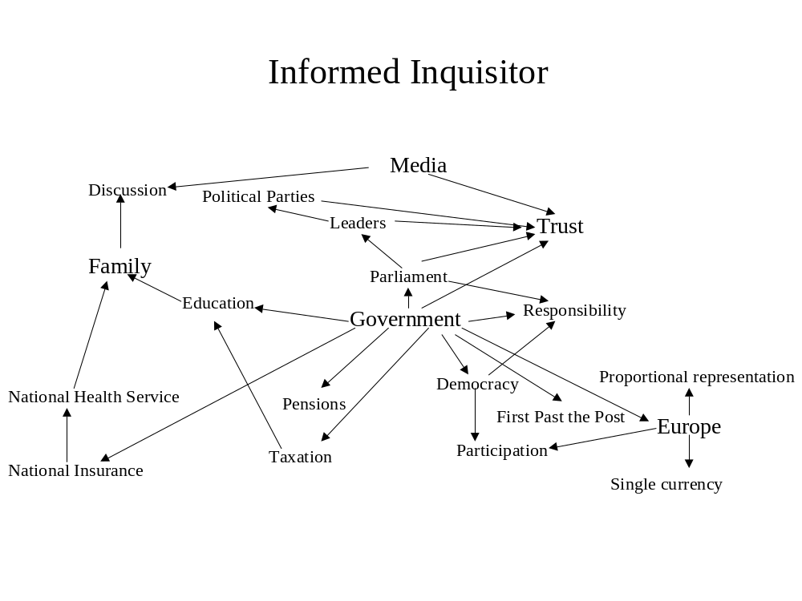
Figure 10

For the ‘Informed Inquisitors’ their cognitive map illustrates the widest range of concepts and also the strongest linkages between the concepts and the macro and micro environment. This group does not look at concepts or issues in isolation, they recognise that it is important to build a sound understanding and their mode of reasoning takes into consideration ‘knock on’ effects. They were very much family influenced, and they recognised the responsibility of government. There was a strong degree of trust within the group of the political system and their preferred political parties. There was little cynicism due to the notion of responsibility of government and politics. If there was criticism of the parties, leaders or policies, they had a coherent understanding of the issues and built a logical argument through rational processing of information, in the manner of the Petty and Cacioppo model. They were motivated and had ability to process this information. As Petty and Cacioppo suggested if they have processed information that would either reinforce or change their existing attitude. For one ‘Informed Inquisitor’ when asked to draw Britain’s place in the world he was quite literal demonstrating the key power groups and Britain’s geographical position within these power groups (Figure 11).

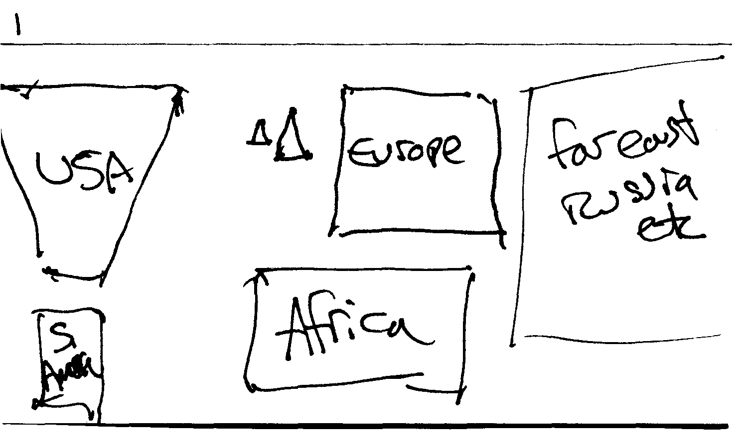.
Figure11

The elaboration process for the ‘Informed Inquisitor’ takes into consideration many sources of information. There was a high level of elaboration through reading and watching current affairs programmes and these were supplemented with discussions with peers. This would most closely follow the notion of communicative rationality, rather than the economic rational choice perspective. Communicative rationality recognises the diversity of the information sources and the interactivity of actors within the public sphere.

The discussions helped to demonstrate the development of political interest and attitude formation in formative years through parents or peers. There was also an ongoing elaboration through access to the media of government performance and how it affected them personally. There was an understanding of how the government was performing both with the economy and the national and international environment. ‘Informed Inquisitors’ understood the positions of the political parties and also recognised the major players in the environment. They were able to critically evaluate both the parties’ positions and other debates that occur in the media. They also debated these issues with parents and friends. This influence although primary is also, I would suggest, continuous for many of the ‘Informed Inquisitors’. They recognised the impact of a leader upon a political party and made judgements about the efficacy of the leadership.

With regard to election time ‘Informed Inquisitors’ were able to evaluate issues both on a local and national basis. The distinctive feature of this group was the level to which they elaborated information with their existing information. There was a high level of rationality but it was much more complex than economic rationality and more closely reflected the notion of communicative rationality. Their decision making was periodically evaluated in the light of political or media communication. The group demonstrated the inadequacy of the rational choice model to adequately explain their cognitive reasoning. The variables influencing decision making were unable to fit into the narrow rational choice cost/benefits equation. These included parental influence, peer group influence, media influence and also political communication and these factors contribute to the decision making process. The key tenet of rational choice theory and the costs/benefits analysis presumed to be undertaken by voters lies purely in self interest.

For the ‘Informed Inquisitor’ this is only the partial story because although they did think about themselves and how they would benefit from their desired election result, they also acknowledged that some wider macro economic issues need to be addressed. For instance if we consider the ongoing debate about Europe, there was a discussion of how the single currency could affect them, there was also discussion and a clear understanding of the possible economic and societal implications.

In short, the mode of thinking about politics exhibited by this group was not consistent with the Rational Choice model but reflected Habermas’ notion of communicative rationality in the public sphere.

Chapter 6
Mercenaries

This chapter examines the characteristics of the ‘Mercenary’. They are one of two groups in the quadrant of low motivation and low cognitive ability and are most closely aligned to the rational choice perspective. Their primary motivation was self interest and money; or voting for the party who they believed would deliver on these aspects. This group was interested in valence issues (Butler and Stokes 1974; Clarke et al 2004) although for some members in the group there was a limited understanding of these reflecting the work of Campbell et al (1960) who found that for some voters there was a lack of involvement and ignorance. This group was unashamedly disloyal to any political party and claimed to switch if they believed they could get a better deal. ‘Mercenaries’ demonstrated the greatest propensity for pocket book voting. As in the Electoral Commission research some voters only looked at policies that affected them ‘I voted for the Lib Dems because they’ve got better policies for students, haven’t they’ (Electoral Commission 2005:16). They were to be found more in the male clerical group, although were also present in the female degree group, and to a lesser extent in the female clerical, male unemployed and female unemployed groups. For ‘Mercenaries’ information sources used to augment their existing knowledge focused mainly upon media, often only the tabloids, primarily the Sun, the Daily Mail and TV news. Even the degree educated respondents read the Daily Mail, none read the broadsheets. Government performance was evaluated in terms of whether they were personally better or worse off a key component of the valence model. They actively avoided party election broadcasts and made their voting decisions based on previous knowledge, parental influence, family and peers. Issues that arose during the campaign were only registered if they believed them to affect them directly.

This was particularly evident if there were personal financial implications. However, although they did not like politics, they still believed it was necessary to vote primarily for their own economic security. This group were the most vague and prone to sweeping generalisations. Stereotypical notions of politicians and political parties were much in evidence with many respondents sharing same views like:
Labour’s useless, sounded good before now it’s all gone pear shaped, just looking out for themselves (male, unemployed, R3)

Though there was little evidence of cognitive elaboration, they were sufficiently interested to switch on to Sky News in order to get a review of the days events, if they had missed the news on a terrestrial channel. Sky News was used regularly to get a sound bite of the key issues of the day and this behaviour increased during election time, in order to identify if any policy promises would suit them more. There was no interest in contextualising the information received, and any more elaborate information sources using more complex modes of communication, were outside the understanding of this group. There was a reasonably high level of awareness of government performance but this was only related to their own situation. In particular, mercenaries who owned their own homes evaluated the government on interest rates as this was related to their mortgage. Those who were thinking about going into higher education were concerned about tuition fees.

‘Mercenaries’ political attitudes are developed from their own perceived self-interest. They only take an interest in politics when an issue appears to threaten or benefit them within their personal situation. For instance

No not until they come up and it affects me (female, unemployed, R3)

They take little interest in the political process outside of election time, other than reading the newspapers and watching the news on an occasional basis.

Only watch politics when it’s the budget didn’t put beer up this time (male, unemployed, R3)

One Mercenary claimed he voted so he could then complain if they didn’t deliver on their promises (male, Clerical, R2). They said that they got involved when they started to pay for their house, either through a mortgage or rental

You get more interested when you get your own home. (female, clerical, R1)

Now labour’s in its 5 interest rate increases in the past year (female, clerical, R1)

They were also concerned about the amount of tax they paid, although this is seen primarily as income tax, ‘it’s about how much tax I pay’ (male, clerical, R7).

They did not watch the news generally and would not make a point of watching it, if it is on and something relates to them then they will watch but they do not generally watch the news to get an overview of the political situation or catch up with what is going on in the world.

It depends on what I’m watching at the time (male, degree, R4)

They had no particular political allegiance and would change parties if they believed they would get a better deal. Moreover, they also claimed that issues would only interest them when they became relevant to their life stage

The first election I voted Conservative cause I was living at home. I know that sounds really selfish but that’s how my dad voted, if I voted like him he would be better off so I would benefit (female, degree, R2)

and with particular reference to education, one respondent stated he wasn’t interested because
my kids aren’t old enough (male, unemployed, R3)

When the election campaign begins, they started to evaluate the parties’ stance on various issues. This was often quite simplistic; their modes of reasoning purely focused upon personal financial considerations.

Anything that benefits me (male, unemployed, R3)
Surely the wages that are paid to politicians could go to some of the poorer countries I mean you don’t need some git in a suit dictating to people in England what we’ve got to do. Is it necessary? We’ve got the Queen. (female, unemployed, R3)

Moreover, they want their money’s worth from her too.
Well she should get off her backside and do more (female, unemployed R3)

Taxation is their first priority. They were interested in who will provide the lowest rate of income tax, although their ability to conceptualise issues such as taxation was quite limited. There was a poor understanding on what tax was deducted for and which services it supported. Discussion on types of taxation was restricted to mainly to income tax and there was little awareness of other types of taxation apart from VAT, after prompting. The level at which taxation was levied was not known. Furthermore, they had no knowledge of how the overall taxation burden would affect them and no real understanding of what income tax was used for. Taxation was seen as something that attacked their personal earnings, which was theirs to be protected. For the unemployed ‘Mercenaries’, it was resented that if they worked they would then be taxed.

Tax takes it out of my wages, I might as well sit at home on the dole (female, unemployed, R3)

Lakoff (2004:18-19) discusses the irrationality of this decision making as lower taxes tend to benefit the rich, whilst higher taxes would increase benefits for this group, but there was no perception of this. They were convinced that taxation was a bad thing for them and could not see beyond this. When Europe was mentioned, the main concern was the abolition of duty free shopping. This was perceived to be a perk of the holiday
They are knocking duty free on the head that’s fine if they are going to even out the prices but if you can’t get it cheaper abroad it’s not fair (female clerical, R1).

Interestingly, others were pro-Europe as they had employment links with European companies. A number of the degree graduates were linguists, either working in the travel industry or banking; they recognised this unselfconsciously as self interest
because we all work for European customers (female, degree, R2)

yeah (laughs), its self-interest again isn't it (female, degree,R1)

For this group of linguists their pro or anti-European stance was dependent upon which company they worked for. One group discussed the problems associated with the strong pound and how a single currency would be so much more convenient

we're losing a lot of money so far because of the pound being so strong, and its having quite a direct effect and to be honest I mean we've got sales offices in different countries it would make it so much easier if everything was in the same currency to our customers to our subsidiaries to everybody and in the business I don't really see why it would be a problem (female degree, R1)

Others believed that their jobs would be threatened if there was a move towards a single currency. Again reflecting the level of self interest

Lots of businesses will close down if we go into to the European currency it’s going to affect industry and possibly my job (female, degree)

Interest in politics for the rest of this group starts when they begin to pay their way and move out of the family home. There was a strong perception of taxation coming out of their own money and so they wanted to know if it was being used in the way they believed appropriate

maybe because now I'm paying taxes I want to know what they're doing with our money (female,degree, R2)

‘You notice when bills are coming in (female, clerical, R1)

If you’ve got your own house then you’re more interested (female, unemployed, R4)

Nevertheless, they are still only interested in the home life-world issues, such as monthly incomings and outgoings. Even those who have a degree education recognise the self interest in their motivation and only look towards their own life-world

having a house now I pay attention to what's happening to the interest rates and things which before obviously I wouldn't have taken much notice of but now it's going to affect me directly (female, degree, R2)

The following comments highlight the cognitive process behind decision making. This decision is purely based on her own life-world and what perceived advantage the vote would give her.

Reduce house prices, mortgages, I work for as much money as I can get then I’m happy, well there are other things as well but that’s it. I don’t have kids so I don’t have a care about childcare. I don’t know any old people so I don’t care (female, clerical, R1)

The pattern of information seeking followed that of a bargain hunter, getting the best deal. They argued they would only take more interest in politics, if there was some sort of incentive. For the unemployed members of this group, there was a sound understanding of the New Deal and in both the male and female groups an extensive knowledge of the benefits system. They knew what amount of money they needed to earn, before it was worth their while to go out to work.

Need £200 minimum after tax, otherwise it’s not worth me going to work. I have to pay so much out with two kids by the time you’ve got the dole and other benefits I’m better off at home (male, unemployed, R3)

Clearly this group was most closely aligned to the rational choice view of a voter. They order their limited knowledge of their preferences and vote according to their own specific interests, looking towards individual rather than collective interests. It is a very narrow form of decision making with few variables, which would have extended the elaboration process and there was little ability nor motivation to do that. They relied on heuristics, such as news headlines, with little elaboration. Mercenaries didn’t like politics, or politicians in general. When criticising politicians it was simplistic using stereotypical perspectives, and lacked a coherent argument.

This cognitive map in Figure 12, attempts to demonstrate the key issues that mobilise the ‘Mercenary’. Clearly the focus is the self and all major issues discussed tend toward how it will affect them, as mentioned earlier.

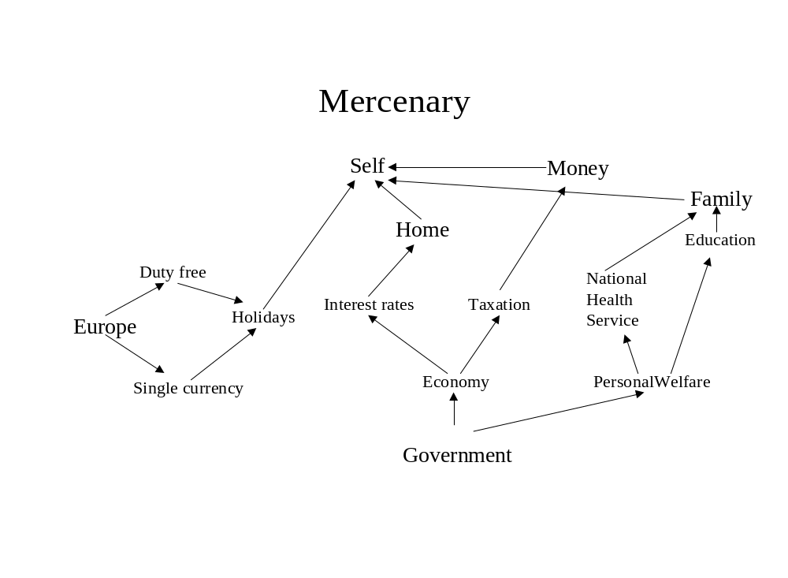
Figure 12
Money was a key component and all issues were discussed in terms of the relationship of finance to self. Government was purely responsible for making the economy secure, so that interest rates could be kept low to benefit their mortgages. ‘Mercenaries’ accepted that the Government controlled personal welfare, in that it raised taxes or provided unemployment benefit if needed.

Europe and the single currency were only considered in the light of their holidays and how it would affect their duty free purchases. With regard to the concepts that were outlined in this cognitive map, there were fewer identified than for the ‘Informed Inquisitor’ group and the relationships between concepts were linked primarily to self interest with little consideration of the wider context. ‘Mercenaries’ were keenly aware of getting their fair share and those who had children, developed an interest in the National Health Service and education. When they did consider the wider issues there was still a self interest motivation. For example, in the drawing below (Figure 13), this female, clerical mercenary (R1) sees the rest of the world looking away. She annotates on the drawing ‘all looking away but looking for help/aid. She believes that Britain should help herself before, helping anyone else
We need to look after ourselves and once we’re strong enough then we can start to help somebody else. It’s like you’ve got ‘flu but go next door and do that person’s housework – you know you need to build the person up first before they can help. England is firing on two cylinders.(female, clerical, R1)

When an election was called, the ‘Mercenaries’ did search for information. They used a number of sources of information but they did not really look in any great detail, for instance with regard to the media and the campaign there would be a superficial involvement looking merely at tabloids and catching the news. The salient issues were related purely to self interest. ‘Mercenaries’ conform very closely to the rational choice perspective of self interest with information sources accessed solely in relation to their self and how they will benefit. There was no real evidence of civic duty here, their duty is only towards themselves.

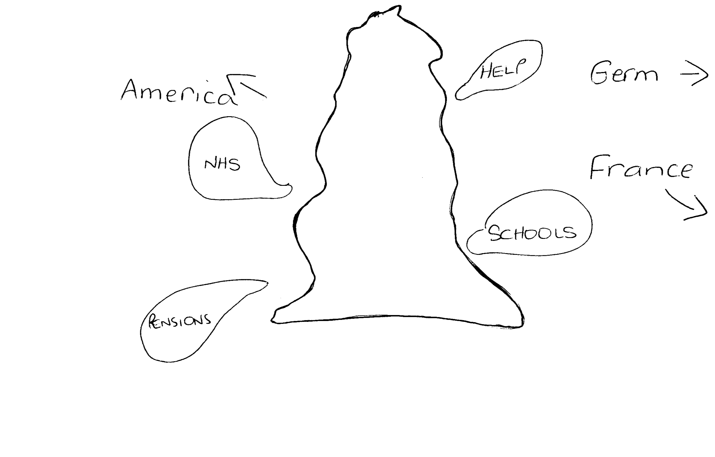

Figure 13
They had stereotypical views and these colour their judgement and also determine the type of information they select. In Bernstein’s terms they focus purely on their own life-world and ‘sensitivity to content’. Although there appears to be extensive information searching, it is at a superficial level with little cognitive elaboration, heuristics such as party leadership and ‘ability to manage the economy’ were often used to evaluate performance or potential performance (Clarke et al. 2005:118). The discussion ‘Mercenaries’ have with their peers and family is limited, using stereotypical language and restricted communication codes. Moreover, this group will only actively consider post-election government performance if they are not satisfied. There was an expectation that promises should be kept

yeah, they promised it – education, national health service, minimum wage, they were going to make it better (male unemployed, R3)

These findings correspond closely to those whose allegiance New Labour were seeking in 1997 and after. Philip Gould (1998) highlighted these as key issues in the repositioning of New Labour. There was a concern in the 1992 election about how taxation was framed (Gould, 1998:120); Labour’s review of taxation showed that people were

hostile to the principle of paying taxes which they felt did not benefit them directly (Gould, 1998: 121)

‘Mercenaries’ information processing was simplistic and constricted by a lack of political understanding. After the election defeat in 1992, the modernisers sought to learn from the Clinton victory, so Gould went to the US. He learned that the perception of the Democratic Party before Clinton was

short on patriotism, weak on defence, soft on criminal and minorities, indifferent to work, values and the family, and inexplicably, infatuated by taxes,(Gould, 1998: 173)

These were values that corresponded to the ‘Mercenaries’ values but they were also very close to the values of the ‘Authoritarians’. It was interesting to see the change in the values of New Labour. Following their defeat there was a concerted effort to show that they were the party of low taxation. Moreover, they were also distancing themselves from the trappings of old Labour, so we saw the demise of the Union bloc vote and Clause 4. Political messages were very simple and clear and there was a concerted effort to show unity, strong leadership and clear easy to understand values. The ‘Mercenaries’ in this section were clearly supportive of the Labour Party, but they had previously supported the Thatcher government, who also used similar simple messages. They were targeting this group with values (or valence issues) they could identify with, using the language codes understood by them delivered by a leader that was increasingly presidential (Power Report 2006: 155).

There are clear parallels between the findings of this research and the findings discussed in Gould’s book. The findings from this chapter to some extent, support the notion of rational choice in terms of means driven economic rationality and this was a group that focused upon valence issues but it is only really one group out of eight in this study. The following chapters will demonstrate how other voter groups significantly do not base their electoral decisions on any form of economic rationality.

Chapter 7
Authoritarians

This chapter focuses upon the ‘Authoritarian’. Although the uncovering of these tendencies is not new, it is disturbing to note that this phenomenon re-emerges periodically and a significant group of respondents exhibit some of the characteristics today. This is particularly pertinent when one considers the rise of racial tension is apparent throughout many Northern cities and towns, the ongoing debate about Europe and how asylum seekers are dealt with.

Adorno et al. (1950) were the first to attempt to identify and measure key components of the Authoritarian personality. Their major concern was to establish if there were any shared characteristics of a ‘potential fascist’. Their work identified a number of collective characteristics, which are held by people who have a propensity to ‘show extreme susceptibility to fascist propaganda’ (Adorno, et al.:1). They uncovered a number of key aspects of the personality, which included a conformity to the system and, particularly to a strong leader, providing guidance and security. They believed in a natural hierarchy, where their place and other group’s places are clearly demarcated. A position in this hierarchy increases their security and, depending upon where their perceived place is, gives them a sense of superiority over groups further down their hierarchical system.
Thus increasing the status of their own group. Adorno et al (1950) explored the notion of a fascist personality, primarily to identify individuals who would be susceptible to anti-democratic propaganda. Authoritarian views were most pronounced in the lower strata. This is consistent with Levinson (1955) who suggested a

relatively low but consistent negative correlation between intelligence and ethnocentrism (Levinson, 1955:280)

Furthermore, he identified the characteristics of ethnocentrism, which characterised the ‘Authoritarian’

ethnocentrism is related to stereotypy, rigidity, and concreteness in thinking, to narrowness of the ego bounds, and to difficulty in grasping psychosocial explanations of social phenomena (Levinson, 1955:280)

Evidence cited to substantiate authoritarian descriptions always took the form of hearsay, rather than personal experience, knowledge or observation. It was Lipset (1959; 1963) who argued that the authoritarian personality was less likely to be drawn from the petit-bourgeoisie and that levels of education and forms of civic culture, were a more accurate predictor of authoritarianism. O’Neill (1982) suggested that the notion of the ‘personality is problematic. He argued that
while it may be true and even empirically verified, that there are individuals who have an ‘authoritarian personality’ and that all of them express a measurable authoritarianism, this does not imply that all those who express authoritarianism necessarily possess an ‘authoritarian personality’. (O’Neill 1982:22)

For O’Neill, the situational context of the individual determined levels of ‘authoritarianism’ and termed this ‘normative acquiescence’ (O’Neill 1982:23). However, this distinction precipitated considerable discussion in the literature, (for a review see Middendorp and Meloen 1990). Further investigations also questioned the validity of the ‘F’ scale used by Adorno et al and subsequent researchers (see for instance Christie and Jahoda 1954; Heaven 1984; Ray 1988; Rigby et al. 1996; Roiser and Willig 2002). This research does not attempt to enter into this debate; rather this chapter will focus on whether this personality type existed among our voter respondents. It will explore their concerns, values and ultimately evaluate how this phenomenon can be explained, in the context of overall electoral behaviour. It is important to note that consideration of the authoritarian personality was not a major objective of the study. These characteristics emerged spontaneously during the group discussions. The group indicated that the work undertaken by Adorno et al. in the 1950s is still relevant. Their definition of the authoritarian personality cited in Stone and Laurence (1993) is a ‘threat-oriented, defensive individual who copes with threats by conventionality and obedience and who shows hostility toward weaker members of out groups’. The characteristics exhibited by this group of respondents were consistent with the attitudes held by Adorno’s Authoritarian type however, these characteristics were not just exclusive to the ‘Authoritarian’ group but were much more evident there. ‘Authoritarian personalities’ are predominantly male (although some women exhibited these characteristics) and are frequently less educated.
By definition, they admire a strong leader, usually with predominantly radical right wing views. Their major concerns are jobs and unemployment. They held extreme anti European views and probing unearthed some racist, sexist and homophobic views.

Of particular heuristic value is Authoritarian’s ‘potentiality’, that is people are not overtly ‘Authoritarian’ but can be found to be so, after probing. Moreover, there are certain issues that cause them to become more authoritarian: anything that disturbed the order of things, or appeared to threaten their perceived position in the established hierarchy or more importantly, their security. This was particularly evident in the debate over joining the single European currency. Discussions were not overtly racist and racist views were not spontaneously evident. They focused upon the simplistic notion that the French were French and this is why they behaved in a particular way, demonstrating an inbuilt, possibly irrational dislike of the French. However, many had holidayed in France and had no unpleasant experiences with the French people generally. Nevertheless, many of the respondents read the Sun, and their anti European agenda was often agreed with and interpreted to support their anti-French views. Issues that were salient to them including for example, the French banning English or British produce, the blockades and also, more importantly to them the abolition of duty free shopping which was perceived as part of the holiday perks.

Duty free shopping was seen as being taken away by the Brussels Bureaucrats but the French were held as the instigators, even though it was a Europe wide decision. The ‘Authoritarians’ felt threatened by France; they believed it was eroding England’s (or Britain’s) authority, or position, in the European hierarchy. This position was perceived to be very important to the ‘Authoritarians’ as this reflected their superiority over other nations and their allegiance to the British Empire. They lamented the demise of the British Empire as they dislike change and its affects their security, but they clung to symbols of conventionality such as the Royal Family. The main categories that set this group apart from the others were law and order, leadership, Europe, and family values. These were the valence issues (Butler and Stokes 1974; Clarke et al. 2005)that were salient to this group but as Denver (2007:97) highlighted in order to arrive at a rationally driven conclusion, the voter must be aware of the issue, have an attitude towards it; recognise the difference between the parties positions and vote for the party most closely in line with his position. However, for this group it was not always the case, there were occasions of irrationality and these will be discussed in the next section of the chapter.

Law and Order

The major issues arising from the discussions on law and order, was the Authoritarians’ support for capital punishment. Murderers and rapists ‘should be strung up’ (female clerical, male clerical, female unemployed). They believed in ‘short, sharp, shock treatment:

I mean we’re not heavy enough on sentencing – you murder the lady down the road and you get a slapped wrist and don’t do it again. Bang ‘em up for life, and life means life. They don’t seem to say it, you go in for 10 years and you’re out but if you’re like me and you don’t pay your poll tax…. (female clerical, R3)

Politicians don’t give us any real answers, I think they should bring back hanging but they don’t, save tax payers money, they should be strung up (female, unemployed, R4)

They regarded themselves as law abiding citizens, though there was a perceived difference amongst this group between ‘playing the system’ and crime. In terms of avoiding work and benefits, they had very intransigent views. People should not claim benefits and ‘moonlight’. Many of this group believed there should be less tax and fewer benefits, as this would force people to work.

if you stopped paying benefits well it would force people out to work (female:unemployed, R4)

History books shows that this happens, if people didn’t work they didn’t get any money (female: unemployed, R5)

There is a concern that some individuals are abusing the system and although they are unemployed they resent the fact that some are moonlighting and taking a wage as well as their unemployment benefit

I know one where she’s been doing it for seven years (female unemployed, R3)

But I think if she’s been robbing for seven years. I’d say where’s the number? I’d report them. (female, unemployed, R8)

They also had little sympathy for rehabilitation and preparing prisoners for life outside prison.
It’s ridiculous, they’re not there for recreation, it’s a punishment’ (female, unemployed, R5)

Again, once the offender left prison, there was a perception that they were given an easy ride by the authorities, they were given a house and money to furnish it.
When they come out of prison, they get a house just like that and they’re given money to set it up they’re mollycoddled. Need to get out into the real world (female, unemployed, R4)

There was no evidence of knowing anyone personally, but this was an enduring perception, and there was clear resentment towards this supposed system of support.
‘They go right to the top of the housing list and get a house above everybody, single parents the lot’ (female, clerical, R8)

This was of greatest concern to the female unemployed group possibly due to the fact that council housing and getting a decent house from the local authority was very high on their list of priorities. Considerable time was spent during the discussion on housing and the problems they faced. This alleged preferential treatment for former inmates, was seen to threaten their place in the housing list, whilst also reducing their levels of security. There was also a fear about the defence of the country. They were concerned that the Labour Party would not support the army as the Conservatives would.

Labour are against the army. I know people in the army and they’re told to vote conservative as Labour are against the army, they’re cutting back and my friends could lose their jobs (male, unemployed, R5)

A strong defence of the country was seen as crucial but not only for their own personal and family security, but because it made England, or Britain, look strong. The ‘Authoritarians’ lamented the decline of the British Empire, and looked for ways in which Britain could at least demonstrate some superiority.

Leadership

Strength was seen as a vital prerequisite for a leader.
All these political parties are weak, they need more guts. (female, clerical, R8)

It was recognised as a fundamental aspect of the Prime Minister’s role in order to protect England’s position. They admired Margaret Thatcher for her perceived strength and, indeed, she was respected enormously amongst this group. She was remembered for leading the troops in the Falklands and ‘we want our money back’ (male clerical). She was perceived as ‘hard’ (male, clerical) with a ‘killer instinct’ (female degree) by most respondents and revered by this group. This is where the distinctions between the groups started to emerge. There were a significant number of people who believed that Margaret Thatcher was a good strong leader and this was clearly a view of the ‘Authoritarian’ group.

Yeah, she’s hard (male clerical, R3)

There was a regret that she hadn’t stayed even longer,

Thatcher stood up and voiced herself, she should have stayed longer (female, clerical, R8)

Tony Blair was perceived to share these qualities and was equally respected for them.
With Tony Blair – what you see is what you get – he will do his damnedest to help you, he’s a family man (female, unemployed, R4)

he could gain respect for Britain in the world again (male, unemployed, R5)

They voted for Labour primarily due to Tony Blair’s ‘effective leadership’ (male clerical, R5). He was also seen as a person who would stand no nonsense.

He has got rid of the loony left and those that were giving Labour a bad name it took a lot to do that (Male, clerical, R4)

His notion of ‘tough on crime – tough on the causes of crime’ were noted and approved of. Many of the respondents within this group had switched their allegiance to Labour from the Conservatives, and this was primarily due to Tony Blair. They regretted the displacement of Margaret Thatcher from the Conservative leadership by John Major. He was identified as weak and seen as a poor leader, although a ‘nice man’ (male clerical)

People telling him what to do rather than the other way round (female, clerical, R8)

Weak, not strong or forceful (female, clerical, R3)
However, he was perceived as being honest, a quality much admired, though seen as unusual in a politician.

Europe

This group demonstrated the greatest degree of scepticism and fear over Europe. The concern arose from two main areas, firstly the war and secondly the loss of sovereignty. The projection techniques used to show respondent perceptions of Britain’s place in the world, demonstrated a feeling of a former great country that was taken advantage of by other weaker countries.

They always come to us when they need help (female clerical, R8)

Other discussions on this area were related to the war and how Britain made a stand against Hitler. After 50 years, the group still based many of their views on the events of World War 2, particularly the male, clerical group. European issues were very salient to the group. They were definitely against anything to do with the Europeans, particularly the Germans and the French.

Politicians should stand up more, they are a bit wimpish – I hate the French and every time something comes up about the French, its all right then if you want it and poor little England gets shoved right down. We seem to get walked all over in this country (female, clerical, R3)

There was a belief in this group that Britain was still a great country, who gave the world many things and the rest of the world just didn’t appreciate it and gave little respect. This was most strikingly illustrated by a drawing (Figure 14), where respondents were asked to show Britain’s place in the world (female, unemployed)

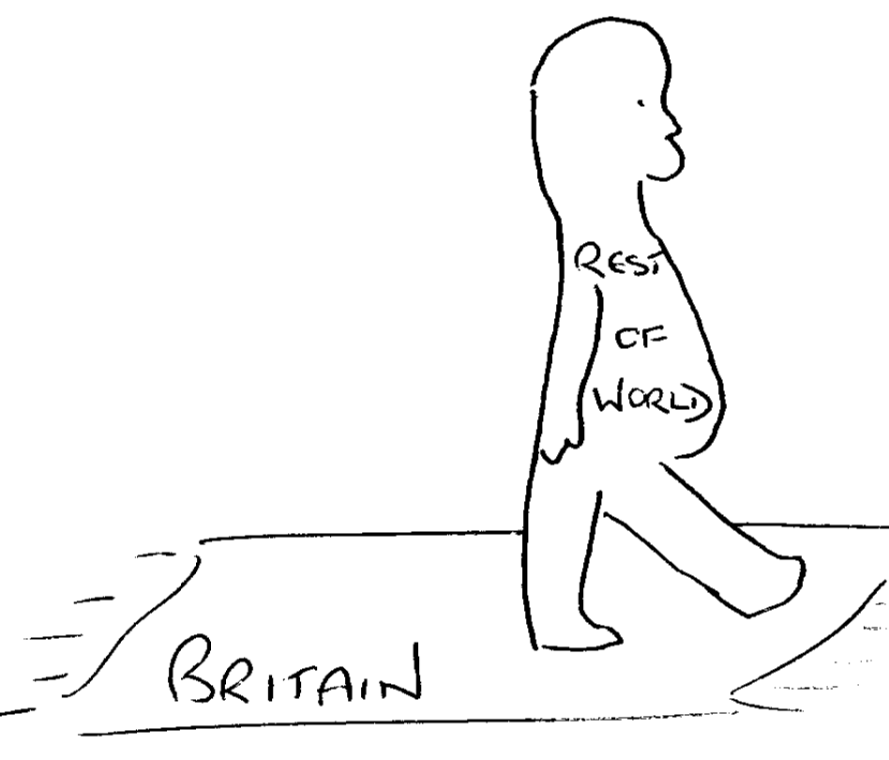

Figure 14

It was interesting that Britain was also seen as central to other countries. (Figure 15). Many of the drawings either showed Britain in the centre of the world with all the other countries surrounding, or Britain was drawn much larger in relation to other countries. There was a perception that countries only really regarded Britain with any respect when they needed assistance, and developing nations were perceived as a draw on Britain’s limited resources. They were particularly proud of their heritage and, they also believed that the Empire was still important and relevant, if only to them. Whilst there was the feeling that the Empire still had influence in many countries, there was also a belief that we were better and more important. This is an important characteristic of ‘Authoritarians’, who need a strongly demarcated hierarchy where they are familiar with their place. They also felt reassured by what they believed to be the continued influence of the British Empire in many countries. These drawings were created after the prompt ‘draw what you believe Britain’s place in the world’.


Figure 15
In Figure 15, the world has been edited to a large extent, according to the understanding of the respondent. In this simplistic elucidation, Asia has been omitted, Africa is an island and Australia has been moved.

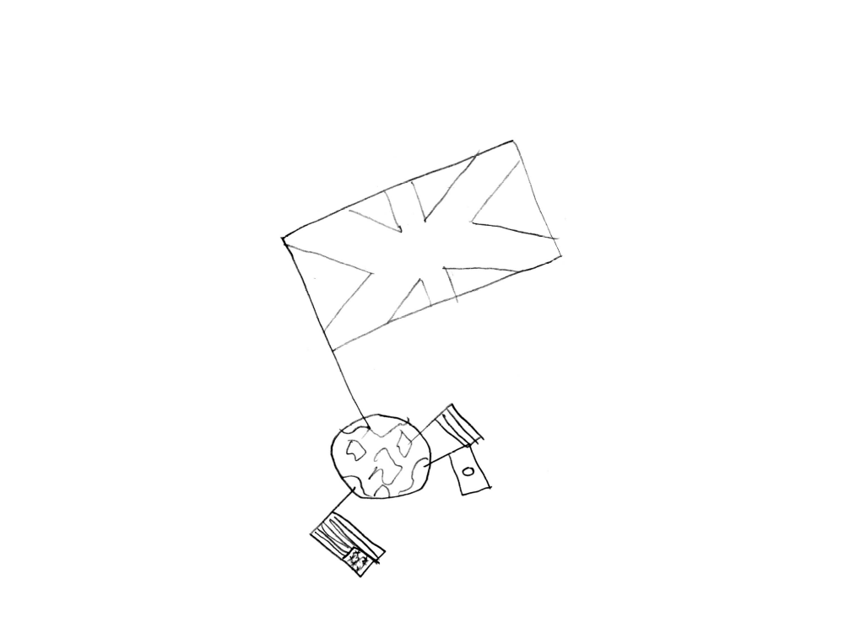

Figure 16
One of the most interesting aspects of this respondents thinking, is that Britain has strong influences in the former colonies, but Britain is not present in Europe at all. There was a pride in the Union Flag as this was a symbol of Britain’s greatness and, if the next drawing (Figure 16) is to be taken literally, at the top of the world. The flag is also significantly bigger than the other flags but also larger than the Earth itself. The US flag is present along with the Japanese and a flag with no clear identity. The American’s are looked upon quite fondly by the ‘Authoritarian’s’ thinking as they admire them for their strength and also remember them as allies during World War II. They like the idea of Britain being ‘friends’ with the US as this made them feel more secure than the perceived disparate European Union, with France and Germany using it for their own self interest.

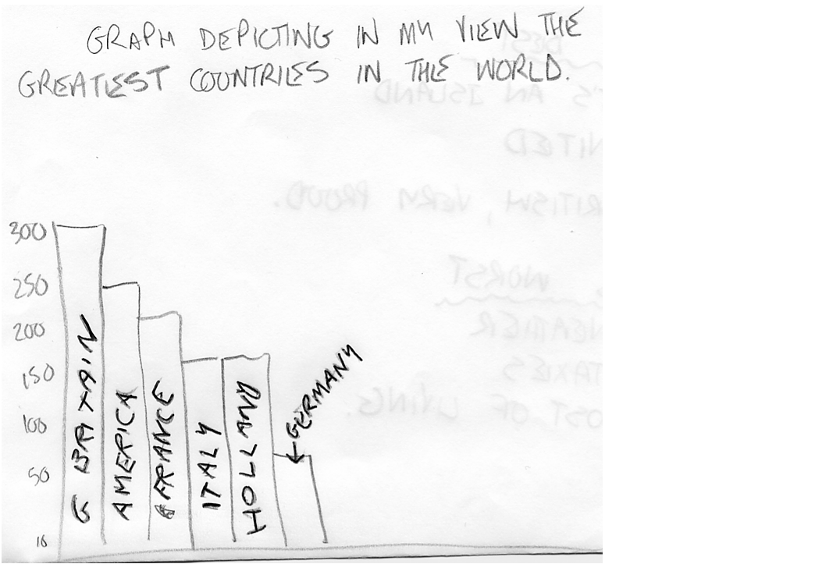
Figure 17
The other flag that is curious is the Japanese flag. The group see Japan as economically strong, which again they admire. However, this is more than likely due to their car and electronics industries, rather than an understanding of Japan’s current economic performance. The male authoritarians believed Britain to be influential and important in the world. Attempts were made to quantify this (Figure 17) but the drawing was based on no real understanding. However, one respondent, regarded being an island as the most important factor, secondly unity (no understanding of devolution) and finally, being British. Other respondents used a graph to symbolise their views on Britain’s place in the world but used some sort of rudimentary economic criterion. They were also proud of the monarchy. They liked the notion of the pound but the single currency was a real problem for them, as this was directly linked to their British sovereignty.

England is the monarchy, the British pound (says proudly) that is us and we should stay that way we shouldn’t intermingle and have the same currency (female, unemployed, R4)

There was a real concern amongst this group, that greater European unity would ultimately weaken Britain.

England becomes part of Europe and England gets dumped on. (female, clerical, R3)

A strong leader was seen as necessary to protect England from the threat of European takeover. This concern was voiced consistently across all groups, where the authoritarian’s took part. There was a belief that the European Union was some sort of strategic move by the French and the Germans to take over England which would be subsumed into a European super-state. England or English was the description most used along with the term Britain or British. Interestingly, was no real distinction between the two. The single currency was a great worry to this entire group, although they didn’t understand how it would affect them or the implications for the country as a whole. However, they strongly believed it was a threat to their perception of sovereignty, even though they didn’t really understand what it was and how it would be threatened. Self interest was apparent in the discussion as it was reduced to duty free products ‘cheap beer and cigs’ (male, unemployed). They shared the ‘Mercenaries’ concern over the loss of duty free products. There was some glimmering of understanding of what the single currency was

Every one uses the same currency. French Germans, even the Scots – they’ll kick up a fuss them lot. The Germans and the French, once they’ve got their claws in we will not be able to do anything – they’ll be in charge, we’ll have more wars (female, clerical, R3)

There was a strong sense of xenophobia amongst this group. We won the war, so this was another attempt by the Germans to take Britain over. There was also much confusion over how the Euro would work and how it would affect them personally. The Euro was perceived to threaten a loss of sovereignty

We’re living by German rules (female, clerical, R8)

Do as you’re told England (female, clerical, R3)

I don’t agree (with single currency) ‘cos we’ll just end up ruling our country as others want us to run it (female, clerical, R8)

Sovereignty was related to the Queen and the Queen’s head, which was simplistically related to the currency, as the Queen’s head was on all UK currency. This was classed as sovereignty due to a coin being called a sovereign (female, clerical, R8).
All the Queen’s heads on all our coins so if we have the Euro there will be no sovereignty (female, clerical, R3)

Immigration was an issue that was raised spontaneously (though respondents did not live in an area with a large ethnic minority group). Racist comments were not uncommon, often prefaced by ‘I’m not racist or anything’ (female, clerical, R3, male, unemployed, R5).

Nurses doctors, where will they come from, nobody will work the long hours for the shit pay so we’ll get people that we just don’t understand I just can’t stand Pakistani doctors (female, unemployed, R4)

Significantly, such comments were made spontaneously in the context of the National Health Service. Fears were expressed about a constant influx of ethnic minorities
a lot of them over here, all got corner shops, no coloured people have got bad jobs’ (male, unemployed, R2)

This again, reflected their concerns over their status. They see themselves as superior to immigrants, but the immigrant job status indicates the opposite. The cognitive processes were very limited with the preferred solution to the issue as ‘don’t let them in’ (male, unemployed). However, there was a gradual dawning that this potential solution was not as simple as it seemed.

I’m not racist or anything, but if you sent them all back, home, I’m not saying that, if you were born here it’s ok, but their ancestors shouldn’t have been allowed to settle here, where are you going to put them? (male unemployed, R5)

‘Serbian’ refugees had been given temporary assistance and were expected to return when the crisis was over. There was resentment that they ‘got dole’

Them refugees, Serbians got dole and we gave them houses (male unemployed, R1)

This respondent led this discussion and made a number of comments that were supported by many of the members of this group. Respondents in other groups also shared the same stereotypical opinions:

staying in hotels, and people living on the street don’t qualify (female, clerical R3)

The discussion was then illuminated by a metaphor by one of the group.

We need to look after ourselves and once we’re strong enough then we can start to help somebody else. It’s like you’ve got ‘flu but go next door and do that person’s housework – you know you need to build the person up first before they can help. England is firing on two cylinders (female, clerical, R8)

There was little awareness or sympathy for the plight of refugees; it just wasn’t their problem. Their main concern was that people were just trying to get into the country, to ‘get onto the social’ (male clerical). A simple solution to the asylum problem was to ‘send them all back’ (male, unemployed). This approach would solve both the immigration and the jobs issue, in one. Racism was seen as a product simply of immigration,

‘That’s why there’s racism, ‘cos they let them in’ (male, unemployed, R5)

In this group of unemployed respondents there was no counter argument, just nods of agreement.

Family values

There was a traditional view of family values, that women should stay at home and a dislike of the women’s liberation movement. The balance was seen to have swayed in favour of women.

yeah, we’re stuck at home with the kids (male, unemployed, R5)

Some women members of this group believed that it was their place to look after their children. There was a good deal of resentment against women who stayed at home and claimed benefit whilst they worked. The issue of working and entitlements differed amongst working and unemployed authoritarians. For the unemployed authoritarians it was generally accepted that they are only on the ‘dole’ because there were no jobs for them and even if a job became available the wages would be too low for them to take it. They did not believe this was their fault and the government should do something about it, they had nothing to do with the people who played the system. Working authoritarians in contrast believed that people should be made to work and it was costing them money to pay for other people’s social security. There was little sympathy for the unemployed. Thus, the out groups for the employed were principally immigrants and spongers whilst for unemployed, it was immigrants. The female unemployed authoritarians believed that they would work if there was adequate childcare, and the government should provide this. People who moonlighted, or held a job when claming state benefits were condemned although most stated they ‘wouldn’t grass someone up’ but there was a good deal of resentment towards people who didn’t want to work and took benefits.
I resent paying say my £50 and I just get some of it while someone down the road gets some too. When they’ve been doing nothing, taking drugs. They’ll get exactly the same as me and I’ve slogged my guts out (female, clerical, R3)

Authoritarian views frequently surfaced spontaneously, without any prompting and in a haphazard manner, unrelated to the current conversation. Significantly, the topics covered in this chapter were frequently discussed in an animated fashion, as they found articulation of unfamiliar concepts difficult so raised voices and vigorous movements compensated for this.
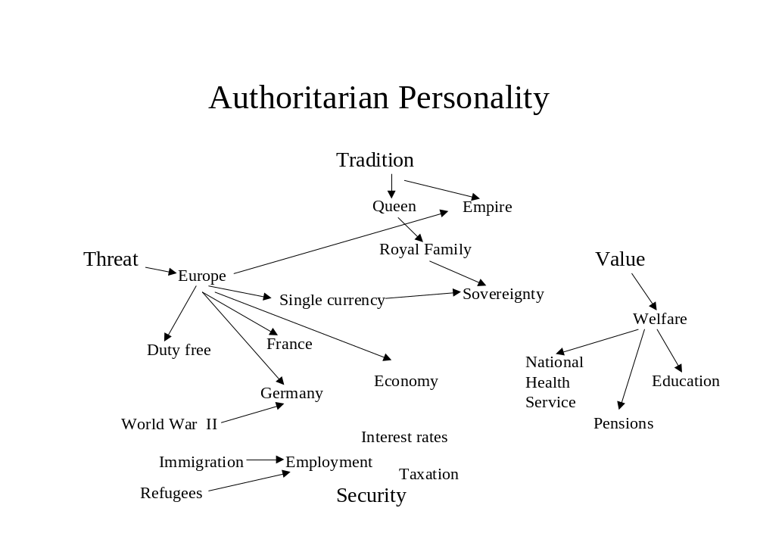

Figure 18
Bernstein noted that those who have difficulty with a more elaborate code of communication, use other non verbal modes of communication. In summary, ‘Authoritarians’ are conservative, who share a respect for traditional values and the security of stability. There is a certain isolationist attitude which is reflected in the anti-Europe stance. Many voted for Tony Blair due to his strong leadership, reflecting the Greenberg comments in Gould’s (1998) review of Labour’s repositioning.

The cognitive map of the ‘Authoritarians’ can be summed up diagrammatically in Figure 18. When looking at levels of cognition, there is no elaboration to the wider issues in terms of Bernstein’s notion of sensitivity to structure. All discussions are related to their own personal life-world. For example, one female ‘Authoritarian’ who worked for the police, explained the concept of democracy purely in terms of how it impacted upon her and her own working environment
Everywhere when everybody has got an equal say. Equal rights across the board no matter where you live or what you’ve got you still have a say – is that right?. We’ve just brought this in at work where if I say my boss has to fill in a form he has to no matter what his rank, I have the right to tell him. Even up to the Chief Constable – well I don’t know about him- but everybody else has to do this (female, clerical, R3)

Her understanding of democracy was from deriving general from the particular and tangible rather than vice versa. Conceptually, democracy is a difficult notion for many, although for the more articulate it is something to do with freedom of speech and equality. There was a marked lack of ability to conceptualise. In the ‘Authoritarian’ group, the central components of their belief system were tradition, security, value, and threat. These devices were used to frame all discussions. This group didn’t spend a great deal of time thinking about politics, they had developed very strong views but with no substance behind them. Moreover, there was no active searching out for information, even during the election.

This group had a sizeable percentage of the total respondents, across gender but the majority came from the lower educated groups. ‘Authoritarians’ demonstrated stereotypical thinking, little cognitive elaboration and dogmatic responses in discussions. However, although these factors reflect the ‘Authoritarian personality’ outlined by Adorno, et al. the most concerning aspect was the notion of security. They were very insecure and felt threatened by a number of factors, particularly immigration and Europe. Although this model suggests that ‘Authoritarians’ use a variety of information sources, they do not really use them in depth, so it is a headline searching sort of information collection. Their conclusions are based on fear and insecurity, rather than a rational ordering and processing of information. In terms of Petty and Cacioppo’s ELM, there is little ability to conceptualise abstract issues, and the only motivational factor is fear. ‘Authoritarians’ are also very easy to manipulate, due to their levels of insecurity and campaigns that highlight any perceived threat will be noticed. There was a strong feeling amongst the group, that the political leaders should protect and maintain their security. They expected them to be strong and lead and are quite content with decisions that are difficult. They are happy to take their ‘medicine’, in the words of Margaret Thatcher. This is very closely in line with Aristotle and his notion of desiderative irrationality, where there is an abrogation of decision making to political leaders. They are seen as superior and better placed to make these decisions, so they will vote for a strong leader who will discharge his duties with a hard, determined approach.

This affective decision making does not conform to the notion of rational choice and it needs to be highlighted that this group is the most susceptible to extreme political communication and inflammatory issues. The next chapter will discuss another voter group, consisting of respondents who think little about politics and whilst ‘Authoritarians’ are loyal to a strong leader who they believe will protect them, ‘Habitual Loyalists’ comprise of respondents who do not think about politics at all but are unthinkingly, unswervingly, loyal to a particular political party.

Chapter 8
Habitual Loyalists

This chapter explores voters who think little about the political process, who possess little understanding of political issues and concepts, but they continue to vote. They have a sense of civic duty mainly through parents but as the Electoral Commission (2005B:29) uncovered there is a general ignorance of ‘politics, parties and what they stand for’. The ‘Habitual Loyalists’ were a curious group, who were uninvolved with the political process, and yet, either through habit, pressure from family, or civic duty they actually voted (Carpini and Keeter 1996). The key aspect which united this group was their apparently unswerving loyalty to their particular favoured party. They had always voted for this party and mostly, their parents had too. However, information searching was limited; there was no interest in politics and very little interest in any election campaigns. In spite of this, there was a persistent, enduring belief that their party was the only legitimate one to vote for. Their faith in their chosen party could not be shaken by criticism and their attitudes were grounded more through an osmotic absorption of knowledge rather than a rational decision search and evaluation of alternatives. They demonstrated little understanding of concepts, no matter what their educational level was and the extensiveness and sophistication of their thinking, reflected that of the ‘Authoritarians’ and the ‘Know Nothings. They thought very little about politics, displayed stereotypical views and a distrust of politicians in general and politicians not belonging more specifically, to their preferred party.

I listen to what they say on the news but how much you believe or trust in them is another thing (female, clerical, R4)

‘Habitual Loyalists’ share the same stereotypical distrust of the ‘Know Nothings’, but still have views. This is a comment from a ‘Habitual Loyalist’ Conservative voter
When labour was in before they did so many bad things and it followed from there. I remember candles and the 3 day week, and my parents told me other things about how awful it was when Labour was in and when the Conservatives got in it was better. (female, clerical, R4)

She didn’t really know what ‘bad things’ happened beyond a vague reference to the 3 day week and the miners strike. In addition, there was no knowledge about how or why they happened and more importantly, other factors that occurred at the same time, such as the oil crisis. Newspaper reading was mainly tabloid and there was no interest in reading a broadsheet. Generally, the Conservative Habitual Loyalists read the Daily Mail or the Mail on Sunday. Labour Habitual Loyalists read the Mirror but this was not universal and most said they read the Sun. Many, particularly the females, said they didn’t have time to read the papers and only caught the news if it was on. There was no active seeking of media information, unless there was something salacious

I read the Sun for the gossip (female, clerical, R4)
They also noted that they took more notice of the news on both the TV and in the press when Princess Diana died (female, clerical, R4; female, unemployed, R8). However, news of a more gruesome nature was acceptable in terms of fires, accidents etc., rather than ‘starving children’. Most of the time, news was something that they avoided. They were very conscious of the different communication codes used by politicians when compared to the restricted code used in the ‘Habitual Loyalists’ every day life. Generally, this group used the stereotypical language and soundbites gradually pummelled into them through sheer repetition. There were perceptions from Conservative ‘Habitual Loyalists’, that Neil Kinnock was a ‘windbag’. They allegedly remembered the ‘winter of discontent’ and the fuel shortage which was referred to as Labour’s problem. Interestingly, most of the stereotypical thinking which used such examples was from Conservative voters. This research could not uncover why this was the case. Possibly, that the individuals concerned had grown up in the Thatcher era. Awareness of politicians was quite limited and the following two comments illustrate the haphazard extent of information gathering. In response to the questions about the leader of the Conservative Party

I was told it last night but I’ve forgotten (female, clerical, R4)

It’s William Hague, I know ‘cos it was on Wheel of Fortune (female, clerical, R5)

Parental influence was the primary influence for many ‘Habitual Loyalists’ reflecting the accepted view (see for instance, Butler and Stokes 1974; Park 2004) but it is the lack of thinking about politics that is so pertinent to this group of respondents. For example, one respondent stated that when she got married she then voted the same as her husband; however, she had previously voted the same as her parents

I voted the same as my parents when I was at home, now I vote the same as my husband – it keeps the peace (female, clerical, R6)

This was the first time she had come into contact with someone who had a different political attitude so her reaction, rather than to search out and make her own decision, was to follow the same behaviour as her husband. One respondent described the voting process for her. She said that she didn’t really think about it but went with her family to the polling station, and once there

You go down to that place on your card and put a cross on where your grandma tells you to (female, clerical, R4)

However, whilst this ‘Habitual Loyalist’ demonstrated strong Labour party values, and was very critical Margaret Thatcher these views were stereotypical and displayed no evidence of developing her own attitude independently. The comments were based entirely upon her family and their values. There was no evidence of centrally processing the available information and while they believed they should take part in the political system, their participation would only be limited. Involvement was habitual, reflecting traditional family practice.


Figure 19

There was little understanding of which MP was leader of which party, and little understanding of the processes and information required to make an electoral decision. When asked about Britain’s place in the world, the group found this exercise difficult, although one member of the female group did appear to copy another group member, (Figure 19) who was an Authoritarian.

Half the unemployed male group voted and they all voted Labour. Again, they demonstrated stereotypical views of the Conservatives who were

For the rich (male unemployed, R6)

This group would be more likely to be influenced by peripheral and heuristic cues and it would take a major issue directly affecting their life-world for this group to contemplate changing their voting habit. This group was consistent in terms of the cues that they did remember and these were in line with their existing views of political parties. This group again felt quite intimidated by politics and the political process due to the elaborate codes used to communicate and the difficulty of cognitive process. However, rather than abstain or avoid this altogether they voted with no knowledge of issues or candidates. The cognitive map of the ‘Habitual Loyalist’ (Figure 20) is not very extensive as there is little that they think about political issues. There is little elaboration and no cognitive processing of issues and few issues were related to each other. However, there was a belief that even if their preferred party was not elected, the opposing party would not govern correctly and things would get worse under their leadership. For those whose party was elected there was pleasure that their ‘team’ had won.
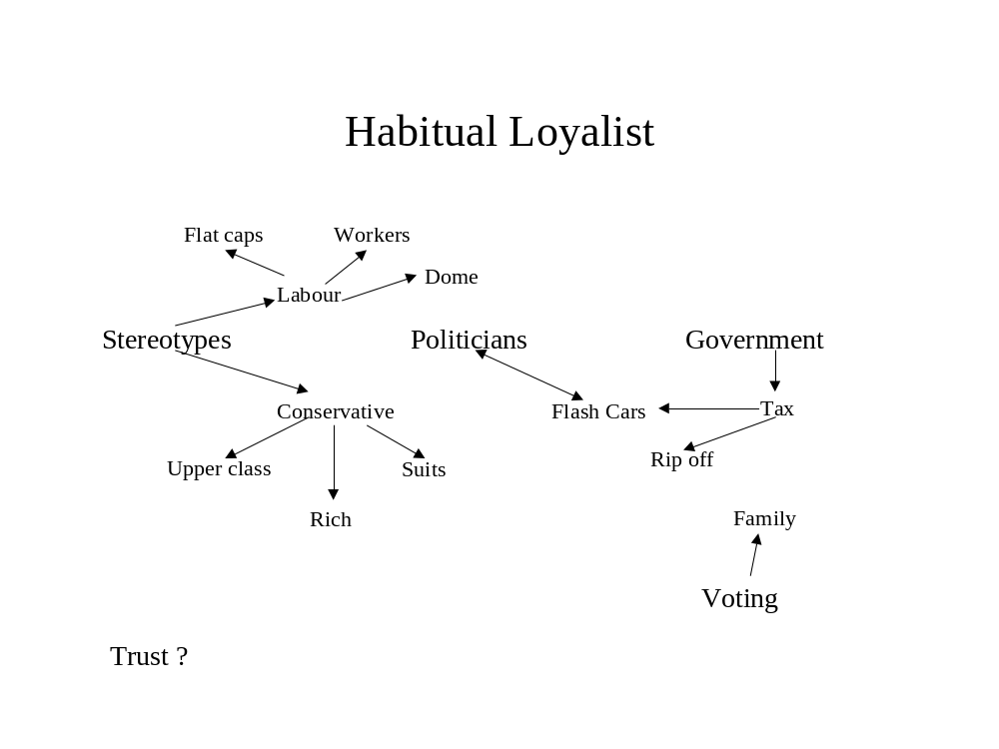Figure 20
Figure 17 indicated the lack of interest shown in the information searching of the ‘Habitual Loyalist’. The primary influences are evident and this is the basis for their future voting intentions. At the post election evaluation stage they think nothing about what was promised to them and there is no consideration if it was delivered. They are totally uninterested in the political process but are involved in the voting process. Their decision making is strongly related to the desiderative notion of irrationality identified by Aristotle, they are directed to vote and there is little consideration of issues. They delegate the responsibility for voting to family members who consider the alternatives for them.

Although there is little evidence from this research to suggest that the decision makers cognitively process political information more extensively. Any emotion they feel tends to be hostile to their least preferred party for instance, Conservative ‘Habitual Loyalists’ are hostile to Labour and vice versa. Some ‘Habitual Loyalists’ are quite enthusiastic about their chosen party but cognition was limited and tended to be restricted to stereotypical views.

This chapter concludes the voting groups identified in this research, the next chapter evaluates the non voting groups and establishes 4 different groups that are avoiding the political process. The thesis will argue that the non-voters are as complex as the voters in that the reasons to avoid participation are diverse and can be differentiated by ability and motivation.

Chapter 9
Don’t know, Don’t care, Don’t vote

This chapter looks at young people who are disengaged from the political process but rather than identify one group of non-voters, this research identified four distinct groups. These groups articulated a range of reasons as to why they avoided the electoral process. This is supported by the Electoral Commission (2005:30) who claimed that non-voting ‘was not a simple case of apathy’. Electoral studies in the US when investigating young people and politics, were concerned that if people do not understand the civic process and take their civic responsibility seriously, there would be serious implications for democracy (Stein, 1983). In the UK, it has also been argued that young people are not interested in politics as they are less politicised and as Butler and Stokes (1974) note
For most people who are just moving into adulthood, politics looms very small among the many claims on their time and interests.

Voting is traditionally a low priority pastime amongst young people (Park 1995, 1999) and a number of explanations have been provided for this phenomenon including a decline in the notion of voting as a civic duty (Phelps 2005).

Butler and Stokes (1974) suggested that age was a determinant in electoral behaviour and that young people become more interested in politics and political issues as they become older. The Institute for Conflict Research (2004) supported this view as they found that ‘many 16-17 year olds stated ‘they were not really interested in elections and voting, as they did not see these issues as being relevant to them at this stage in their lives’. However, Kimberlee (1998) argued that due to social changes, for instance staying on in education and continuing to live with parents, young people do not have the responsibilities that encourage an interest in politics. Whilst relevant to the debate, these explanations do not fully explain why some young voters do vote and others avoid the political process altogether. If, as this research has identified, young voters are different, then are non-voters different too? Crewe et al. (1992:26) claimed that there were 2 types of non-voter which could be identified. Firstly, an ‘alienated abstainer’ who they believed to be a ‘miniscule minority’ within the total population, however, this research would indicate that the group is more prevalent than Crewe et al. suggest. I call this group the ‘Political Cynics’ because although their modes of reasoning indicate that they have a sound understanding of the political process and the concepts involved, they have very little trust in the political system or politicians. Crewe et al. (1996:26) also identified an ‘apathetic abstainer’, however, findings from this research suggests this classification is inappropriate as the definition of ‘abstain’, according to the new Oxford English Dictionary, is to either ‘restrain oneself from doing something’ or to ‘formally decline to vote either for or against’.

This would indicate a level of cognitive processing, which the abstainer follows with a conscious decision not to vote. The apathetic abstainer according to Crewe et al., (1996) is more closely aligned to the group identified by Hyman and Sheatsley (1947) namely the ‘Know Nothings’. These people are:

unwilling to receive or incapable of encoding information (Bennett, 1988)

They are alienated from the political process for a number of reasons. However, this research argues that ‘Know Nothings’ are alienated but they do not abstain, rather they avoid the political process altogether so no conscious decision is made. Wring, et al., (1999) also identified two groups amongst young people. The first group fits the profile of the ‘Know Nothings’ alienated from the political process, whilst the other is classed as an activist. Although activism is defined broadly from petition signing to membership of a political organisation, the activist group could be described as the ‘Informed Inquisitor’ outlined earlier. However, for the purpose of this discussion, I will focus upon the non-voter groups who I believe to be more complex than the current literature suggests. The belief systems and cognitive processing amongst non-voters are diverse and this research sought to explore the reasons for abstention. For some it is an active decision, whilst for others it is an avoidance of the whole political process. Interestingly, this research also identifies another more unexpected group who feel guilty about not voting.

They know they should vote but feel overwhelmed and intimidated by the complexity of the concepts, institutions and the political process. This, I will argue, is a temporary stage but important nonetheless. So the four groups of non-voters are ‘Guilty Know Nothings’ who are estranged from the political process, ‘Political Cynics’ who are alienated from the political process, ‘Disengaged’ who perceive politics to be irrelevant to their lives, and ‘Know Nothings’, who feel excluded from the political process and political system.

Guilty Know Nothings
This was an interesting group, who were educated and articulate. Their awareness of the political system and avoidance of any political information was similar to the ‘Know Nothings’. However, there were two characteristics that set this group apart from the ‘Know Nothings’. One is their ability to conceptualise abstract political issues and secondly was their assumption that politics was so vitally important that they were overawed by it. For this group, motivational levels were quite low. There was little interest, and a lack of understanding of political communication codes. Their elaborate communication code used in everyday life indicated a capability for political cognition, but there was a lack of familiarity with political concepts. This led to a degree of estrangement, prompting limited participation in the political process. This group thought politics was important and a responsible activity.

They believed it should be taken seriously and as they became older, they felt guilty that they should know more about politics and the alternatives available. The respondents in this group who had children, demonstrated the greatest feelings of guilt. They recognised that they should do something to make the world, or the country, better for their children. In this instance, the galvanising issue was the environment and this generated considerable discussion. The environment was an issue that arose spontaneously in the female groups although, interestingly, it was never mentioned in the male groups. Curiously, ability to conceptualise political issues was quite limited, primarily due to lack of awareness rather than ability, and this was recognised by the respondents themselves. Their own children were their motivational factor and this influenced the issues that affected them. They were primarily concerned about health and education and became aware of these as political issues when experiencing the National Health Service first hand, for instance, when their children were born; and the education system, when their children started school. Clearly, saliency is a key motivational factor for engagement with this group of women. This group of respondents was predominantly ‘female with a degree’ or ‘female clerical’. They had never voted, and they found politics boring, but recognised they should really get to know more about politics and the issues
I’m just not interested in it, although I would like to know more about it (female, degree, R8)

Not really interested, although I know I should be (female, clerical, R2)

Politics for this group was difficult to understand, and remote from their everyday life.
It’s just so complicated, I can’t follow it, I know I should like with the hospital but I just didn’t get involved as I didn’t know enough about it (female, clerical, R2)

There was a perception within the group that they had a capability to understand politics. They were able to understand issues related to other more remote life-worlds and could understand and use the communication codes developed in those life-worlds. However, they still did not know enough about the complexities of the issues. In Bernstein’s terms of sensitivity to structure, they had recognised that it was important to understand the foundations of the policies and also that they could not be considered in isolation. It is that which made them so reluctant to get involved in the political process
It just all seems so complicated. Where do you start? It’s all above the head (female, degree, R8)

Whilst they have the ability to recognise the complexity of politics and how it relates to the electoral process, they haven’t got the motivation at this stage. They know it will take time to learn about the issues and evaluate them, both in terms of how it would affect their own life-world and the remote life-worlds. I would suggest that the ‘Guilty Know Nothings’ group are at a transititional stage, and are therefore able move to the ‘Informed Inquisitor’ group because of the similar levels of cognitive ability.

However, at the present moment in time, there is little to motivate them into elaborating or engaging with political information. There was also a sense of frustration about how politics is presented, particularly when discussing the Houses of Parliament.
When they televise the house of commons, you can see them falling asleep and carrying on – no wonder there are so many wars – all stood there arguing with each other but if they just talked to each other I’m sure they could sort it out sensibly. (female, clerical, R2)

There was a naivety about how politics should be articulated and debated. Although they felt ignorant of the political process, and frustration at the level of debate, they thought politics was important but the complexity of the issues made it too difficult to follow.
I mean, it does affect you and sometimes it is a bit indirect, in a way, but I think you should be interested in it, although it's a bit boring but I think you should listen to things, or it’s irrelevant. I should take far more notice than I do but a lot of what’s said its just tittle-tattle, it just doesn't mean anything. (female, degree, R8)

The importance they attached to the understanding of politics meant that they were reluctant to get involved in the process until they were sufficiently informed to make an educated decision. This added to their feelings of guilt. They felt quite intimidated during the early stages of the discussion merely by another respondent discussing her own particular interests and reading of political issues in general.

I would love to be able to talk like that - I was sat there thinking what? (female, degree, R8)

They believed that they really should pay attention to the issues, as voting was a responsible activity, relating both to civic duty and also to the implications of their voting action.
I didn't think about it myself so I didn't think it was fair to vote if I wasn't 100% sure of what I was voting for (female, degree, R8)

Voting without understanding the issues was irresponsible and the implications of a casual vote would be too much to bear; so abstention was more appropriate at the time, until they could build up enough knowledge of the issues to vote responsibly. ‘Guilty Know Nothings’ demonstrated the capacity for cognition and a potential to develop the required motivation that would progress them into the ‘Informed Inquisitor’ category.

There was much resentment about the way that politicians obfuscated the issues. Many in this group, believed that they should simply speak the truth

You get frustrated with it. I watch the BBC's breakfast news programme in the morning. You get frustrated, whenever a direct questions is asked you never get a direct answer back (female, degree, R2)

There was little political discussion in the household. Interestingly, this group did indicate a range of triggers that would make them participate eventually. One respondent reflected the findings of Butler and Stokes (1974) that age was an important criterion, as her knowledge of politics had increased as she became older.

It’s getting easier for me. I used to watch when it was on the news I didn’t know who was who and so I wasn’t interested. I watch the news more now and I’m getting more interested because I understand it more. As I'm getting older it's getting more interesting for me (female, degree, R3)

This research also identified life stage changes, such has marriage and having children and how this affected political involvement. This group of women were also non-confrontational. Politics was rarely discussed in the family home and although most of tem knew what their parents voting intentions were, they didn’t really oppose or challenge them.

I have never been particularly involved. My dad is quite strongly Conservative and my mum was but she has gone towards the Liberal party and my grandparents are very strongly Conservative as well (female, degree, R8)

When respondents married and the spouse had a different political allegiance, the priority was to maintain harmony in the family

My other half is a member of the Labour Party. He is really strongly involved. I felt it would be irresponsible to vote, because I don't pay enough attention. I was probably influenced by my parents politics and thought maybe for the wrong reasons, so I didn’t (female degree, R8)

The level of ability to process information and elaborate new information with their existing knowledge was evident in the transcripts where discussions were quite articulate. Discussions were demonstrably longer and vocabulary was much more varied than other groups such as habitual loyalists, authoritarians or other uninvolved groups. They were able to articulate abstract issues, but political abstract issues were too remote for them to evaluate.

If we consider the cognitive map outlined in Figure 21, it illustrates the lack of understanding of politics and political issues. Indeed, there were no political concepts articulated. For instance, responsibility is a crucial component for the Guilty Know Nothings. They acknowledge that politics is a difficult job for the politicians; however, there is a palpable sense of frustration that is two fold. Firstly, frustration that the language codes used in politics are inaccessible to them, and secondly, the level of debate and discussion is perceived as childish, which is inappropriate to the seriousness of the areas under discussion

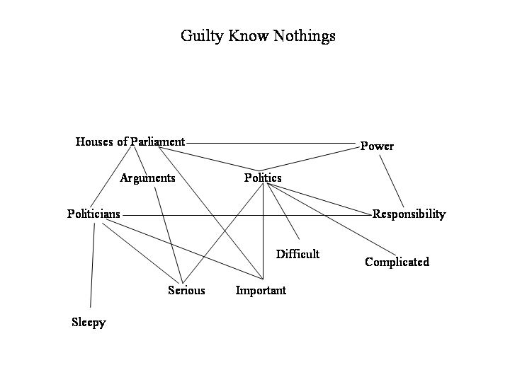
Figure 21

Guilty Know Nothings do see the relevance of politics, in principle, and how it relates to themselves and the wider environment. However, there is no ability to discuss substantive issues, as they have no subject or policy knowledge. This is in sharp contrast to the Know Nothings, who will be discussed in the next section.

Know Nothings
The group split into two and this tended to follow gender. They felt excluded from the political process for numerous reasons. The male ‘Know Nothing’ was much more aggressive in their alienation whilst the female ‘Know Nothing’ was alienated through intimidation of both politics and the political process. ‘Know Nothings’ have no voting intentions, they are much more sceptical about politics in general. They believe politicians are trying to sell them something. In the female unemployed group, there was complete silence when asked what politics meant to them. There were many anxious glances amongst each other and the body language was very defensive, with arms and legs crossed and the respondent making themselves small where they were sitting. They do not vote and felt left out, or excluded, from the political system. As one respondent commented:

Don’t know really, don’t think about it (female, unemployed, R2)

These views of ‘boring’, ‘remoteness’ and ‘confusion’ were borne out in the raft of electoral studies post 2001 and 2005 General Elections (see for instance Institute for Conflict Research 2004; Electoral Commission 2002, Electoral Commission 2005). Both in the male and female unemployed groups, the negative attitudes towards politicians and government stretched across to personalities. Although the strength of feeling was more prevalent in the male groups;
Greedy flash cats …………. .they make lots of money by just talking to people (male, unemployed, R4)
It’s all about lining their own pockets – driving about in their big flashy cars. (Institute for conflict Research)

The group were generally unemployed or other members of society that had been excluded, either economically or socially. This group of non-voters have been identified in previous research for instance, Bennett 1988; Henn et al. 2002; Crewe et al. 1992 amongst others but the young do seem to be increasingly more disenchanted with the political system. They do not read the newspapers apart from the Sun, they avoid the news on TV, never watch Party Political Broadcasts and avoid politics as much as possible.

After the initial warm-up questions about lifestyle and family background, questions began to become more focused towards politics and how it affects them. The questions were framed in a very unthreatening manner but there was still a tense silence and much shuffling. Two of the group looked at each other in almost panic and drew their legs up beneath them and folding their arms and avoided eye contact with the rest of the group and moderator.

This was most in evidence within the female unemployed group, who had the greatest proportion of Know Nothings. These respondents were probably the most extreme example of a ‘Don’t Know’. They contributed little to the discussion, regularly looking out of the window, or at each other and giggling self-consciously. If a question was directed towards them, even with gentle probing, there was a non-committal ‘don’t know’ and eye contact was broken off to look out of the window. Lack of interest was evident across gender and the lower education groups (See Public Opinion Research Winter 04/05:12). They did not perceive politics as having any relevance to their own lives they were quite alienated from the issues and also the political process which resulted in a high level of apathy
I just get on with my life, wouldn’t vote (male, unemployed, R4)

I didn’t bother, I don’t bother, didn’t really care either way at that situation. It has never affected me before so I didn’t think it would now (male, clerical, R1)

Amongst this group there was a stronger lack of trust in politicians and the political system with some cynicism of politicians in general.

All smiles, they all smile (male, unemployed, R4)

They had no understanding of the political codes of communication and were unable to differentiate between the various parties and candidates. There were no issues they believed to be important to them, and a perception that the issues that political parties discussed, were of no direct relevance to them.

didn’t vote cos they’re all basically the same (male, unemployed, R4)

If parliament comes on the telly I just switch it over, I’ve just got no interest at all (male, clerical, R6)

Their perception of politics was that there was no real debate, just arguing. When they caught the Prime Minister’s Question Time, they never listened to the discussion, all they could discern was the noise and the arguments. They had a simplistic approach to the solution:
Why don’t they all club together and maybe they might come up with a bright idea, they don’t talk they just argue – we had that idea months ago and you pinched it off us (male, unemployed, R4)

If they just talked to each other – compromise – this is what women would do (female, clerical, R5)

When they inadvertently catch TV coverage of the House of Commons, there was little respect for the politicians, they did not understand the process of debate and there was little understanding of the issues under discussion.

Calling each other all the names under the sun and not getting anywhere (female, unemployed, R1)

Others suggested that more women in Parliament (Institute for Conflict Research 2004) may be the solution to the interminable problem of argument, due to their conciliatory nature

Need more women, definitely (female, clerical, R5)

There was a naivety in the discussion, which emphasised their exasperation with the system and no understanding of the complexities of decision making. They appeared to be oblivious to the relative positions of political parties and the limits to which they could ‘compromise’. Furthermore, they also believed that the debates were of no relevance to them and that politicians had no understanding of how their life actually was. This was when the females in the group were most animated
Politicians are not brought up on a council estate, they don’t understand (Female, unemployed, R1)

Yeah, it’s like that politician who said he could manage on benefit. He said I’ve bought a tin of beans for 8p and a bread loaf for 40p, yeah that’s just one day, try living like that for a week (female, unemployed, R6)

Yeah, they’ve got nannies, (Female, unemployed, R7)

They had little genuine respect for politicians, they were remote and ‘Know Nothings’ believed politicians to be ‘posh’. They also found it hard to understand them. The remoteness the ‘Know Nothings’ felt is related to the different frames of reference and the elaborate communication code used by politicians. They believed that the language employed by politicians was beyond them and would like them to talk in much simpler terms, using the restricted code they themselves use in every day life.

Can’t they talk proper English? (female, unemployed, R6)

Make things simpler (female, unemployed, R2)

However, there was also a view that politicians made conversation more difficult because of the lack of substance. Moreover, they suspected an attempt to mislead in which the use of an elaborate language code to illuminate particular issues was merely to conceal their true motives.

This group also believed that politicians were unable to appeal to young people, as they were so much older. In view of this, they felt that politicians did not address the issues that were relevant to young voters. Their language style, manner and even dress code were out of touch with young people.

They’re all so old no wonder they don’t appeal to kids, they’re all so boring (female, unemployed, R7)

In terms of parental influence, few even discussed voting with their parents. Respondents never asked how their parents voted, or if they voted at all. They didn’t know what the different parties stood for and didn’t really care, claiming
I aren’t that bothered (female, unemployed, R7)
don’t discuss politics with parents (male unemployed, R7)

These comments were reiterated by many of the groups. Ironically, at this point one member of the female unemployed group, who had previously made no comments at all, spoke quite animatedly and confidently about how the Vice Presidents are elected in the US schools. She was familiar with voting ‘From Saved by the Bell’ a US teenage situation comedy.

Many respondents had built a superficial understanding of political issues through soaps such as Eastenders. Similarly, Australia was more prominently presented in some of the projected drawings through the Australian soaps including for example, Neighbours and Home and Away (Figure 22). The size of the UK is large compared to the size of the Earth but in comparison to the USA and Australia it seen as smaller. In comparison to the ‘Authoritarian’ group who placed England or the UK at the top of the map, this respondent saw the US as having the dominant position. For this respondent, the world and Britain’s place in it is very simple, with four countries in total assuming Ireland is unnamed. The rough shape of Britain is reasonably accurate, which contrasts with Australia and the US.
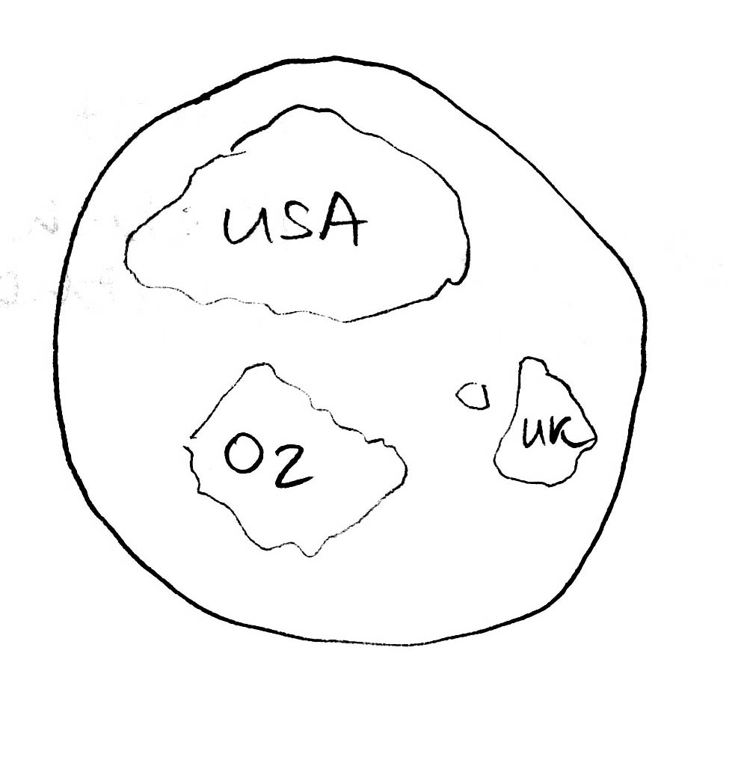

Figure 22

When asked what democracy meant to them, there was silence in both unemployed groups. The following extract is from the male unemployed group, in response to a prompt asking if the UK was democratic:

No not really lost our freedom of speech (male, unemployed, R2)

Sexism changed to male now(male, unemployed, R1 – Mercenary)

Yeah, we’re stuck at home with the kids (male, unemployed R5 – Authoritarian)

Burnt their bras and they can say what they want (male, unemployed, R4 – Authoritarian)

The discussion demonstrated the restricted communication code, as well as emphasising their feelings of inadequacy when discussing the notion of feminism. One respondent believing that men were now discriminated in the way women were before feminism. This was tenuously entwined with democracy and freedom. Although they blamed feminism for keeping them ‘at home with the kids’, they would not go to work due to the low wages and the possibility of taxation where they ‘get ripped off’ (male, unemployed, R4). This indicated there was a superficial understanding that democracy was related to freedom but this was a very limited explanation. They discussed the methods they employed in order to avoid paying tax altogether, sometimes they worked and also claimed social security. They perceived this action as getting one over on the system, as taxation was taken off them for no reason (see female unemployed group in particular, Appendix 2c).

There was no understanding of what happens to the taxes after collection and they made no associations with the public service. When prompted they believed tax revenue went on politicians high salaries and ‘politicians big fast cars’ (male unemployed, R4). The ‘Know Nothings’ held simplistic stereotypical views, which framed their thinking of political concepts, and this was exacerbated by the limited understanding they had of the process of politics and the institutions. For instance, when the concept of the welfare state was introduced again there was silence, until they were prompted gently but the extent of the discussion was limited, and with one unemployed respondent claiming

‘Well I wouldn’t be able to explain it’ (female, unemployed, R1)

There was a general lack of confidence in the discussions with many respondents reluctant or unable to respond. The most extensive response was that the welfare state was for ‘looking after people’ but this female clerical respondent was unable to identify how the welfare state worked, or how it was funded. Again, language was limited using a very restricted communication code. In the unemployed group, discussions gradually moved on to taxation but the comments were very superficial with no understanding of the role of taxation and how it contributes towards the welfare state, apart from funding the benefit system.

Again this supports Bernstein’s notion of ‘sensitivity to content’, as the respondents could only make sense of concepts relating to their own life-world. An extract follows that illustrates this:

What do they do with tax then? (female, unemployed, R6)

Pays people like me to sit at home (female, unemployed, R7)

Where does tax go? (female, unemployed, R2)

To taxpayers, I don’t know - Pays police wages (female, unemployed, R1)

There was no ability to broaden the thinking to wider issues related to taxation. When discussing local taxation, there was little awareness with some respondents demonstrating no understanding of what council tax was. This was particularly prevalent in the male, unemployed group, with some claiming total ignorance. Some respondents in the female, unemployed group demonstrating an understanding of how resources were allocated but the majority of the group had an immature notion of how local taxation could contribute to the community:

What is poll tax – council tax? (female, unemployed, R2)

Local rubbish, street lighting, don’t think anything is working down this street (female, unemployed, R3- Mercenary)

Council Tax should go towards making Christmas nice – turning lights on, they used to spend a lot on that (female, unemployed, R6)

Police, fire service, bloody politicians, I don’t know - council people? (female, unemployed, R7)

As the discussion on local taxation continued, the police were introduced to the debate. The police were perceived by some members of the group to be funded by council and there was little respect for them. Again, stereotypical comments such as needing ‘bobbies on the beat’, rather than driving around in police cars, were particularly in evidence in this group. Nevertheless, discussions could only relate to their own life-world, and the lack of ability to understand local taxation in relation to the local community, or the economy was apparent. The only motivational factors when discussing the police was an element of anger and contempt for them and there was no elaboration of how the police contributed towards their community

When do you see a policeman in Beverley? (female, unemployed, R7)

On a nice summers day, when they’re sat on their arses (female, unemployed, R6)

Understanding of the National Health Service was equally weak, with some totally irrelevant and unrelated comments. There were discussions of waiting lists, but these were only considered when their own family had any experience of waiting (what they believed to be) an undue period of time to see a specialist, or have an operation. Female respondents in this group saw their GPs regularly, either for themselves, but particularly for their children. However, dental care was not seen as important to them. GPs were regarded as experts and they were highly respected, in sharp contrast to respondents’ opinions of the police.

Nevertheless, this understanding of the health service and how it affects their own life-world was narrow, with some totally unaware of what the National Health Service provides for:
Vets bills are ridiculous its absurd (female, unemployed, R1)

This group had no respect for politicians; they were seen as boring, old, and irrelevant. Issues such as democracy, government, voting, and Europe were non existent and elicited comments such as, ‘rubbish’, ‘crap’. Even upon prompting, there was no elaboration upon this. There was a distinct inability to conceptualise political issues, and no motivation to do so either. This group was most closely associated with the Generation X characteristics of ‘disinterested, alienated, and cynical’. However, their cynicism was not articulated in the same way as the previous group mainly because they had little ability to criticise coherently and consistently. The schema through which they made sense of the world was limited to their own life-world and other concepts proved to be alien and remote to them. The reactions to discussion were very limited short sentence responses, rather than elaborated discussion. Body language was carefully observed with this group, as this indicated their feelings of alienation and boredom with the whole political process. Their perception of politics was that it was inherently corrupt and did nothing to assist them. There was also a general lack of trust in politicians. They again spoke in stereotypical language and used many sweeping generalisations that demonstrated their lack of understanding of the political system.

When a concept such as democracy was introduced, some of the female respondents reacted by glances and giggling at each other. Upon gentle probing, the respondents avoided eye contact with the moderator and curled up on the chair with arms folded.

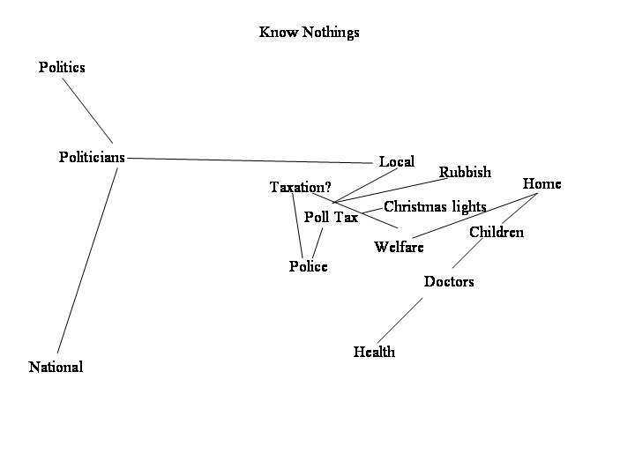
Figure 23

As the Cognitive Map in Figure 20 indicates there is a real remoteness of politicians and politics to the ‘Know Nothings’, particularly the national politicians. The ‘Know Nothings’ demonstrated the least ability and the lowest level of motivation amongst all the groups. Politics was distant to them, apart from at a local level. For instance, health was discussed primarily by mothers who took their children to the doctors. They held a personal view of health, however, there was no understanding of the abstract concept of the health service. Welfare was closely related to unemployment benefit and taxation was articulated most clearly when discussing poll tax or council tax. The majority didn’t really have an understanding of how this is budgeted and allocated to various sectors. This group presented mostly, in the female, unemployed group. However, there were also some respondents sharing the same characteristics in the male and female clerical groups. With reference to the Elaboration Likelihood Model, it is apparent that there is little ability to elaborate political information with information sources avoided, rather than sought out. The motivation variable which constitutes their identification and personal relevance to the political system, shows that there is no interest in this at all. This leads to a total disengagement from the system and political parties in general.

Political Cynics
The political cynics displayed a similar characteristic of disengagement, but their disengagement came from an alienation with the political system and the actors within it. There was little respect for politicians and the political system was claimed to be quite undemocratic. The most damning comments came from the male degree educated group:
Liars, on the whole, if it’s something that interests me personally. They all seem full of promises and then you don’t see a lot following that. The Labour Government for example… (male, degree, R5)

This was also reflected some of the comments in the research on voter registration (Public Opinion Research Winter 04/05). Interestingly, although this group feel relatively alienated from the political system their ability to process information is very similar to the ‘Informed Inquisitor’. Motivation is very low and they do not believe the newspapers, which are perceived to be politically biased and untruthful, as well as ‘spun’ by the political parties. One respondent from the Electoral Commission (2005:32) stated that they ‘felt slightly manipulated, because the parties tell you what you want to hear rather than what they really believe’ (36-49 year old voter). The information to be gained from the media was tainted, although a significant number of respondents in this group had voted in the 1997 election. There was a perception that they had been duped. This quote accurately reflected the feelings of the group:

They [the Government] run the country for the people. In general, they are often worried about who they’ll offend instead of doing what they feel is right for the country. They’ll see how little they can offend with what they do. (male, degree, R5)

This group believed that there had been little change between one Government and the next. There was no optimism about the Labour Government, even though some had voted Labour

They are all the same to me to be honest, they all seem to just canvas through the media so it’s just whatever’s in the papers. Nothing seems to change from one to the other(male, degree, R1)

They saw the role of the politician to represent the public.
They seem to do it for their self interest, there seems to be quite a lot of corruption and they should be serving the public interest (male, degree, R3)

Many viewed politicians as either corrupt or self interested, and they were very cynical. They knew what the politicians’ roles were and were strongly critical that these roles had not been carried out in the appropriate manner

Yeah, I think the local ones are probably more untrustworthy than the national ones, ‘cos there is a lot more media attention. When you think how many people actually do get caught nationally it makes headlines ‘cos it’s a real scandal but at the local level in the councils there’s probably loads of fiddles going on, probably a lot greater (male, degree, R5)

The perception of lying, corruption and spin were most prevalent in this group reflecting findings from the Electoral Commission research ‘It was all a public relations exercise’ 36-49 year old (Electoral Commission 2005:32) and ‘I felt slightly manipulated, because the parties tell you what you want to hear rather than what they really believe. Towards the end I just lost interest’ (Electoral Commission 2005b:32) and they saw no distinction between the parties, arguing they were all the same. This led to a further withdrawal from the process and what they defined as apathy. There was an understanding of the relative positions of the political parties and how Labour had moved along the left/right ideological continuum. There was also a strong level of cynicism of Tony Blair amongst Labour ‘Political Cynics’, who believed he was not what he presented himself to be.

Just apathy really not really interested in who won. I mean have long-term feelings through the history and it because of my job I don't feel there's a lot of difference between who is in power they play games. Certainly with teachers, whoever's in power I'm not interested. Generally speaking Britain has just got more and more Conservative I do believe very strongly that the new Labour leader Tony Blair is a bit of a wolf in sheep's clothing (female, degree, R6)

This group’s articulation of the issues were interesting, in that they used the same extensive communication code as the ‘Informed Inquisitor’ group. It was clear they understood the process of a representative democracy and were able to elaborate using political codes of communication. However, they chose to look at political issues and situations from a less open perspective.
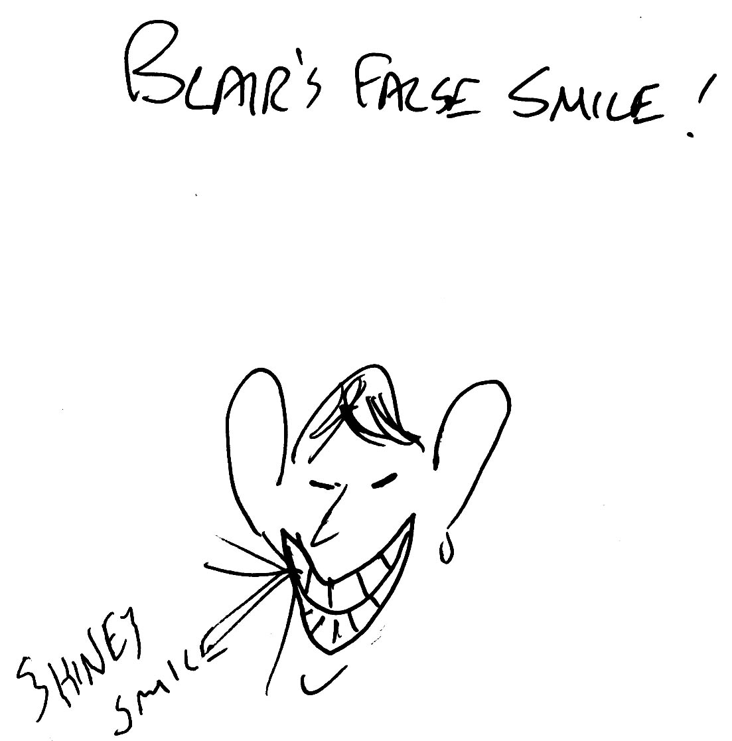

Figure 24
There was a strong cynicism of Tony Blair amongst this group. He was seen to be shallow, and superficial with a ‘shiny’ smile (Figure 24). This group was predominantly male, degree educated. They occasionally watched the news, but claimed not to take a great deal of notice and they rarely watched current affairs programmes. Newspaper coverage is generally; on a national tabloid basis, the Sun, Mirror and Star. They also bought a local paper but these were purchased or read for the entertainment or the sport. Some broadsheets were read, mainly the Times. Motivational levels to elaborate information were very low; there was little cognitive activity, with opinions formed and unlikely to change. The group had a demonstrably high ability to conceptualise political issues.

They recognised the difficulty of government, balancing the promises and also accommodating different interest groups but seemed to have a very pessimistic view of the outcome. The group also demonstrated a concern that politicians’ behaviour in general, was unethical. Although there were no examples brought forward to illustrate their points, except the ‘cash for questions’ involving the Hamiltons, there was an overall view that the politicians were serving themselves, rather than the public.

Yeah, there’s cash for questions, lying and general sleaze throughout the Conservative government, labour haven’t been in very long so they probably will behave themselves for now it seems to happen when they get in for a long time and get complacent.(Male, degree, R5)

There was limited claimed interest in the voting process and little interest in elections or politics in general. In essence, this group demonstrated the lowest level of trust in the political system.

I think they are all the same to be honest – they all seem to care about the media, what’s in the papers – nothing seems to change from one to another (male degree, R1)

Occasionally, they watched current affairs programmes in order to cynically wait to see if any promises were broken. This would reaffirm their view that politics is unethical. There was also little claimed interest in any political communication. Party Political Broadcasts were hardly recalled and when they did it was to reiterate their negative views of all the parties.
I just remember watching one, can’t remember which but I can remember watching one and it was either a Conservative slagging off Labour it was like it wasn’t that subtle or anything it was like they said this is gonna happen and it never and this is gonna happen and it never, and I couldn’t believe that they got away with doing it. No it was Labour they said this was going to happen and it didn’t and I just thought this has got nothing to do with anything else other than they never did it so vote for us. And they didn’t tell us what they were going to do, they just picked on what Conservatives hadn’t done, I just couldn’t believe that this had been allowed to do, it showed them slagging off the Conservatives rather than saying vote for us because of this; because of this; because of this (female, degree, R6)

Amongst these respondents their cynicism about PEBs was related to the notion that they were like advertising. They recognised the hooks and symbols used in classical conditioning and likened these PEBs to propaganda. Propaganda had negative connotations within this group and was strongly associated with manipulation.
It’s just pure propaganda in that three whatever minutes (female, degree, R4)
Out of all the media channels used by political marketers, posters had the greatest impact but little notice was taken of message content. However, this lack of awareness could be due to the fact that they wanted to emphasis their cynicism by not showing that they could possibly be influenced by political messages. There was a strong awareness of parties’ political positions on the various issues and they were able to critically evaluate some of those issues. This was particularly evident when discussing the National Health Service, education, and Europe.
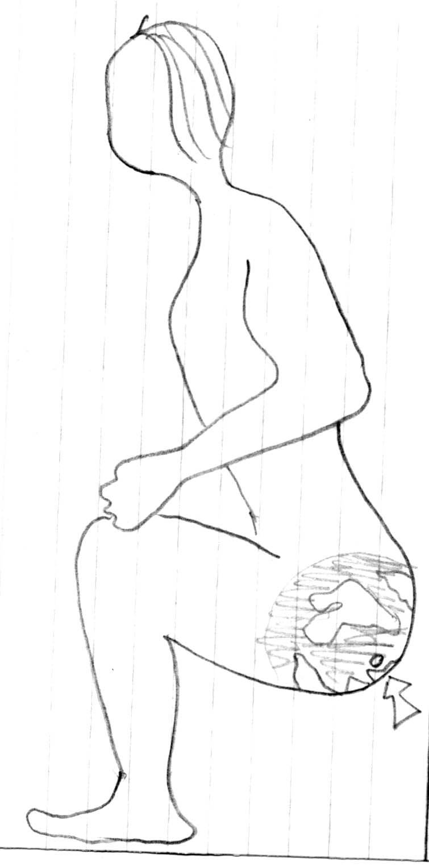
Figure 25
This group found negative campaigning more distasteful than any of the other groups and it further reinforced their view that politics was a dirty business. The posters that used attack-advertising methods were particularly despised (male, degree). They were also very cynical in their drawings, see Figure 25.
It appeared that there was little opportunity to influence their voting decision again reflecting the findings from the Power Inquiry (2006), and their attitudes were quite resolute. Their cynicism of the media and any political communication was built on a belief that they were able to decode and deconstruct the messages so they couldn’t be fooled by what they perceived to be a type of propaganda.

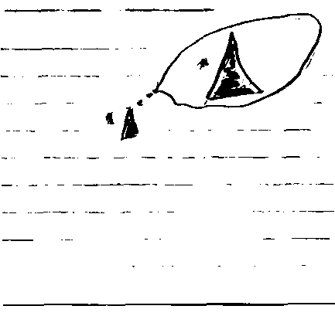
Figure 26
There was also a frustration and cynicism about Britain’s place in the world (Figure 26). This drawing also emphasised the cynicism amongst the group, and this related to Britain’s perception of Empire. It was seen as a strength to be able to criticise Britain in this way. The ‘Political Cynic’ cognitive map (Figure 27) highlights the lack of trust. In the map, democracy is located far from politics with sleaze and corruption in between. Politicians are perceived in terms of careerist, using rhetoric to persuade.

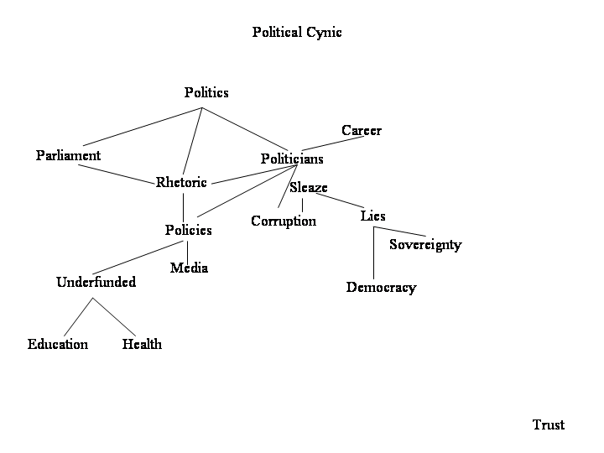
Figure 27
It appears that in politics, there is little positive for the ‘Political Cynics’ to highlight they have the most negative view of politics in all the respondents. On reflection this group will probably never vote as they believe themselves capable of understanding a political candidate’s ‘real agenda’ and rhetoric. They recognise that their vote will not really make any difference to the collective outcome, ultimately at the expense of democracy.
Disengaged
Along with the Guilty Know Nothings this group is significantly smaller than the other groups. However, the distinctiveness of their behaviour and attitudes warrants further attention. This group had similar levels of cognitive ability to the ‘Political Cynics’ although they had different levels of motivation, in that they believed politics at that moment in time to be irrelevant to them. They felt that they would get involved and vote - eventually - if there was something to engage them. The group tended to be younger and still lived at home with their parents. If they worked they paid their parents board and although taxation could possibly be an issue, many were on low wages so taxation was not a serious issue for them. They had few worries about bills and mortgages, as they hadn’t entered into the housing market and their interests in education and health were minimal. Although they had recently left full-time education, there was little interest in their schooling and they didn’t really make the link between education policy and their own experience of the education system. When discussion arose about the poor quality of schooling they were not interested and switched off from the discussion until prompted. Despite this they were people with recent first hand experience willing to contribute to the discussion. For example:
When I was at school about 12 or 13 years ago it went around these are the things that really stick in my mind that a science teacher was really really good and he left and he left teaching and we had a maths teacher and he was really really good as well and he left he left teaching as well. And they were like two of our really good teachers and the teachers we got in their place both of them were appalling (Female, degree R5)

They were not aware of their parent’s vote as there was no discussion in the home regarding political issues. Some didn’t even know if their parents voted at all.
I just didn’t feel part of it (Female, degree, R5)
Just don’t get involved, it’s just not relevant to me (female, clerical, R7)

In terms of their life-world, there appeared to be no areas where politics seemed to enter. They didn’t watch the news, they didn’t read the papers apart from the Sun, and held no political discussion amongst peers. If they caught any politics on the TV, the first action would be to turn over. For this group, politicians were also seen as remote and people who were not identifiable. Unlike the ‘Know Nothings’ they weren’t overawed by politicians and the language they used. They were just not viewed as their sort of people; outdated, too old and out of touch:
They don’t take any notice. They haven’t a clue about us, what do they know (female, clerical, R7)

There was no anger towards politicians. They were a passive group, who felt political issues were over their head and subsequently, irrelevant to their life.
Parliament – they stand up and sit down, I’ve never understood why they did that (female, clerical, R7)

In terms of the Elaboration Likelihood model, this group would probably be more susceptible to peripheral cues rather than engaging in any cognitive processing of political information, but engagement would still be limited. Figure 28 highlights the level of disengagement, their lives not related to anything to do with politics or the political system. It was seen as irrelevant.

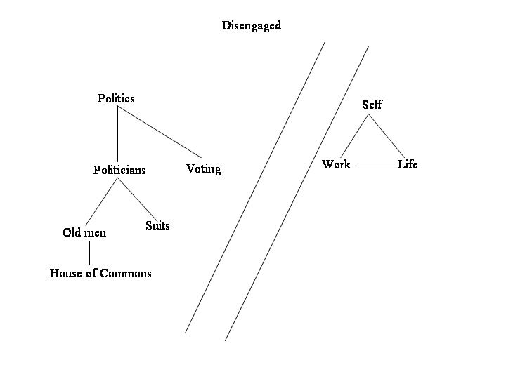
Figure 28
Even political actions, such as taking part in the ‘Make Poverty History’ campaign, was superficial as they wore the band more as a fashion rather than political statement. They certainly would not contextualise and relate any issues for discussion, to the wider environment. When discussing the electoral process, there was a familiarity with the procedures and processes, but a lack of awareness when considering the politicians and the issues involved. It was difficult to build a cognitive map that explained their thinking as they really didn’t think about politics but they didn’t deliberately avoid or ignore politics and political issues. Rather, they didn’t relate politics to their everyday life, and they could not see how politics would affect them. They absolved themselves from electoral decision making, as a meaningless activity which would achieve little.

In summary, the non-voter groups were much more diverse than the literature suggests, although some groups were very small in size and, as suggested earlier they were distinctive and merit further enquiry. Thus, the reasons for alienation or abstention were complicated, and were dependent upon background, education and also for some, previous experience. These variables were also interrelated and varied over time, dependent upon life stage and also saliency. Education determined the cognitive capacity of the uninvolved groups and this in turn determined the categories of non-voters. For instance, the ‘Guilty Know Nothings’ and the ‘Political Cynics’ were most likely to come from degree educated groups, whilst the outsiders were identified most strongly in the clerical and unemployed groups. When exploring the attitudinal components of their beliefs, from an affective perspective, both the ‘Know Nothings’ and the ‘Political Cynics’ distrusted politics but they differed in their cognitive structures, in terms of how they think about politics. For ‘Know Nothings’ and the ‘Disengaged’ politics was meaningless and irrelevant, whilst ‘Political Cynics’ believed politicians were all the same and the political system was corrupt, sleazy, and unethical. Their behavioural activity was also different in that all non-voter groups said they would not vote but historically some ‘Political Cynics’ had voted and from their discussions could look to do so in the future. If this were the case they would vote tactically and also evaluate the consequences in detail. On the other hand, ‘Guilty Know Nothings’ had a similar cognitive capacity to the ‘Political Cynics’ and were capable of understanding complex elaboration codes, yet they were unfamiliar with the language and communication codes of politics. This led to their diffidence towards politics, although they believed it was important and serious, they also thought it was too difficult to identify with. They did not vote but felt guilty that they should vote given its importance. This was more noticeable amongst ‘Guilty Know Nothings’ with children. This chapter highlighted the key distinctions between different non-voter groups, and argues that complexity in non electoral decision is as apparent as the voter groups. The next chapter will form the conclusion and discuss how these findings relate to electoral participation and the implications for engagement and democracy.

Conclusion

This study on electoral behaviour was initiated due to an interest in political marketing and a curiosity about the applicability of consumer behaviour theory to electoral behaviour. The research question initially sought to evaluate the rational choice model of electoral behaviour. However, this research also reviewed other theories of rationality, electoral behaviour and contemporary theory and practice in consumer research, to learn if they could provide a greater insight into electoral behaviour.
Research question
The key research questions focused upon building an understanding of the variables that impact upon a young voter when making their electoral decision and included:
- Was it possible to build a coherent model that could explain their behaviour?
- Can the variables that impact upon a young voter’s decision making processes be mapped, to provide a coherent model that provides a broader understanding of electoral behaviour?
- What thought processes does a young voter go through, when making a voting decision?
- If young people have access to political information, how does it aid their decision and what is the extent to which rationality forms the basis of these decisions?

In order to gain a deeper understanding of the influences that affect voting decisions, it was decided to use an ideographic methodological approach. The initial theoretical and methodological critique of rational choice theory guided the interpretive empirical research design. Thus, the approach was open and inductive and sought to identify themes that possibly would not have occurred, if a tighter research question had been posed. The thesis argues that qualitative research can be used to uncover the fears and insecurities of respondents, precisely those features that political parties seem to focus upon during election campaigns these days. Qualitative research methods can also build an understanding of how citizens make their decisions, using projective techniques amongst others, they can identify types of decision making and which variables are included in the process.

The objective of this thesis was to explore the factors that influence electoral decision making and to attempt to build a tentative model that can add to our current understanding of electoral behaviour. A model that can be later tested empirically. As the research progressed, two models were developed, the first to distinguish voter and non-voter groups, and the second to illustrate the diversity of information searching and how electoral decisions are made. The first model defined the groups by their ability and motivation to process political information in line with Petty and Cacioppo’s Elaboration Likelihood Model. The second model utilised theory derived from Bernstein’s work on education. The model examined the extensiveness of the communication channels used within the respondents’ life-worlds and how they deal with political information.

Significance of the research

The significance of the research is two-fold. Firstly, whilst this thesis explores the reasons behind voting, it also sheds new light upon the diversity of non-voting, identifying a plethora of reasons why respondents did not vote. For example, some groups demonstrated a sophisticated level of reasoning which then led to an avoidance of the political process and others behaved irrationally through either alienation or fear that led to disengagement with the political process.

Secondly, through the ‘Life-world’ model the thesis provides a deeper understanding of the complexity of electoral decision making. As Henn et al. (2005) emphasised, there is a variance in political engagement across sub-groups and these are related to social class, education and gender, the ‘Life-world’ model sheds light on how access to political information and levels of understanding determine the electoral behaviour of the different sub-groups.

Limitations
This research uncovered some interesting behavioural patterns amongst young voters. It highlighted that there is a far greater distinction between non-voters and voters, than has previously been documented.

However, this is qualitative research and although there was a 3 stage approach to the study using methodological triangulation, it is in no way generalisable as quantitative research methods would be. It would be useful to conduct further research, to test the penetration of the groups amongst a broader sample of young people. It would also be interesting to compare with other age groups, to establish if there is a consistency amongst age groups or life stage transition to other groups. Personal interpretation is also a potential pitfall of qualitative research. There is a bias inherent in all research methods. This was ameliorated by careful consideration of the transcripts and categorisation whilst recognising the inherent bias through taking a reflexive approach to the analysis.
.
Implications
This research supports much of the findings from a number of recent electoral studies (particularly Henn et al. 2005; Election Commission, 2005a; 2005b; 2005c; 2006, White 2006), and does indicate potential problems in democracies with low or declining voter turnouts (Electoral Commission, 2005d; Curtice 2005; Power Inquiry 2006; Institute for Conflict Research 2006). This thesis concurs with these studies suggesting that some groups are highly politically literate and able to engage in political discourse. Through the use of a variety of media in home and remote life-worlds these individuals participate in the political process, albeit some groups through alternative media (Phelps 2005). However, it is vital that young people do engage more fully with the political process if we are to maintain a healthy representative democracy. In the first instance we need to understand the diversity of non-voting and then deal with these groups in a manner that they can relate to.

Hence, the second conclusion argues that non voting behaviour is far more complex than previously acknowledged in the literature. Some non-voters are political literate, able to understand political concepts, issues and evaluate candidates but are cynical about the process either due to a lack of trust or cynicism in the presentational methods. However, other non-voter groups are not politically literate, are unable to grasp political concepts, fail to articulate political issues and are alienated by the political process. But it is still more complex, as some voter groups have limited political literacy and yet still feel they have enough information and motivation to make an electoral decision. For these voters valence issues are an important heuristic in voting although as Kuklinski (2000) established they could be misinformed about these issues. Some non-voters are just out of the habit of voting (Curtice 2005).

However, the most alarming conclusion concerns the ‘Authoritarian’ group with low political literacy, who seem to be the most susceptible to emotive political communication through peripheral cues.

Finally, although there is evidence to support the notion of instrumental rationality, it is an inadequate predictor of electoral decision making for the majority of respondents, as there are different levels of rationality and different levels of political literacy. Both of these factors impact upon the ability and motivation of a citizen to get involved in the political process.

Instrumental rationality, as distinguished from communicative rationality, is narrow and focuses upon economic self-interested decision making. Whilst communicative rationality suggests a high level of political literacy, knowledge and understanding of concepts but also an ability to debate issues in their life-world. The ‘Informed Inquisitors’ were the only group who had the ability to evaluate alternatives, consider the options and understand the implications of their decisions in the wider environment. They also demonstrated high levels of political literacy and had the motivation that enabled them to engage in discussion and debate. Having noted this, it must also be recognised that this was a relatively small group. The two groups that were the most significant were the ‘Authoritarians’ and the non-voters. The ‘Authoritarians’ had little political literacy and their motivation was insecurity. The non-voters were another significant group, but could be distinguished by different levels of political literacy and also their motivation levels. Non-voter groups such as the ‘Political Cynics’ were able to process information like the ‘Informed Inquisitors’, but their motivation levels were low, alienated by the modern methods of political communication. Conversely, the ‘Know Nothings’ had both low levels of political literacy and low motivation levels. They were, in effect, disconnected from the political process.

The key findings from this research uncover a complexity in the decision making of young people, which has not been examined in previous studies.

By the very nature of the study using an open, inductive method, different themes emerged that had not been previously documented. This research uncovered eight different groups whose access to information, information processing and decision making, was clearly distinct from each other and although they could be distinguished as voters and non-voters the situation was of a more complex nature. These groups hold different belief systems, there are different levels of cognitive processing and access to other life-worlds is determined by ability and motivation. Moreover, the political institutions are also complex systems whose influence fluctuates according to the situation at any given time. The political messages are diverse and complex with the citizen bombarded with messages from a wide variety of sources.

Concerns raised by the extant literature suggesting that young people are alienated by the political process were, to a great extent, borne out. Amongst the various voter groups there are very different drivers that ensure engagement and participation, including for instance; civic and social responsibility; fear and insecurity; or loyalty towards a particular party or candidate. Within the non-voter groups, this was equally complex. For some the driver was alienation, for others, it was disengagement, lack of interest, or irrelevance. Moreover, the underpinnings for these drivers are diverse but most important were educational ability and perception of risk. Some respondents, particularly the ‘Authoritarians’ and the ‘Mercenaries’ it was the level of perceived risk gave them the motivation to engage in the electoral process.

For ‘Authoritarians’ it was a physical or social risk; and for ‘Mercenaries’ it was a financial risk. The majority of respondents within these groups had lower levels of education and limited levels of cognition. Educational ability determines the boundaries of the life-world, and the ability to understand the language codes used in other life-worlds. It also determines the extent to which the respondent can understand issues according to Bernstein’s thinking of ‘sensitivity to structure’ and ‘sensitivity to content’. Again, this reflects the notion of remote and immediate life-worlds. Some remote life-world issues are only accessible due to awareness gained from education, or contact with the life-world through some other means. The language codes used in different life-worlds are more or less sophisticated and are determined by the life-world members. The level of ability also determines how elaborate the communication networks and discourse mechanisms become.

Consumer behaviour theory needs to understand how the consumers build their belief systems, what communications networks are used and how they influence decision making. It is therefore logical to assume, that marketing may offer political science an insight into electoral behaviour. It should be noted however, that there are problems when adapting one framework to another discipline. Electoral behaviour is not consumer behaviour. However, having employed consumer behaviour research methods a number of important factors have been uncovered.

There are two groups who do demonstrate rational thinking, but they are very distinct, ‘Informed Inquisitors’ have the cognitive capacity and also the motivation to elaborate political communication. Yet there is an understanding of the wider political issues rather than relating policy to self-interest. This suggests this group really do not conform to the rational choice perspective rather it relates to Habermas’s notion of communicative rationality. With regard to the ‘Mercenaries’ their motivation is self-interest, elaborating political communication purely in terms of their own benefits in line with instrumental rationality. ‘Habitual Loyalists’ could also fit within the rational choice model. Clearly, their actions reflect Down’s discussion of limited political information searching when individuals seek to cast their vote and they also support the notion of ‘civic duty’ identified by Riker and Ordeshook (1968). However, for this group, there is no interest in the economic effects of policy on other factors in the political environment. All decisions are based purely upon ‘political shorthand’. ‘Mercenaries’ and ‘Habitual Loyalists’ were the two groups that came closest to Downs’ thinking.

For some respondents, particularly the ‘Authoritarians’, communication networks were not very extensive, relating if at all, to family and peers but due deference to political leaders expertise and figures of authority, was clearly evident. Discourse was very limited in terms of the extensiveness of discussion and sophistication of dialogue.

In addition to this, their opinions tended to be based on dogmatic assertions and stereotypes of those who are perceived to be a threat to their status and living standards. This is not how rational choice theory suggests decision making takes place, more crucially, Habermas refers to this type of decision making as irrational. This irrational decision making is what is uncovered when interpretive methods of research are used and this would not become apparent in a quantitative study; which is arguably why political practitioners are increasingly using this method of research. This corresponds to the increase in emotion and fear being used in political messages. Manifestos include issues such as immigration, measures to deal with asylum seekers, and law and order. This strategy seeks to capitalise on this groups’ fears and insecurities which leads to a motivation to find out more information. In reality, the level of sophistication is limited and peripheral processing only really occurs amongst this group as they rely on soundbites and tabloid reporting.
Fear can encourage involvement in electoral decision making and is, to a great extent, determined by the ability to understand the political messages. But fear can also have an alienating effect where people switch off. This was particularly evident amongst the non-voter groups, who did not demonstrate an understanding of political concepts. The ‘Disengaged’, the ‘Know Nothings’ and the ‘Guilty Know Nothings’ believed that politics was of little relevance to them.

The ‘Disengaged’ did not feel that politics had any effect in their life-world and political issues had no salience for them. This group tended to be younger than the others and these findings support the notion that involvement in politics is for many, determined by their life stage. The ‘Know Nothings’ had no understanding of concepts, little ability to make sense of issues, even when relating it to themselves and they were truly excluded from the electoral process. Ability to understand political messages and the language codes used determines understanding. The ‘Guilty Know Nothings’, who demonstrated an understanding of many issues related to their own life-world and others, had a reluctance to get involved in political issues. Although they had the ability to understand political concepts, they were intimidated by it as they felt they were not familiar with the language so avoided involvement. There was a strong feeling of guilt and a need for involvement because they were aware of the fact that they should be able to understand the issues. However, this I believe is a transitional stage and saliency is crucial to involvement. If a political issue comes onto the agenda that they perceive as important it could result in the individual moving towards the ‘Informed Inquisitors’ group. Whilst acknowledging this, if they lose trust in the political parties or candidates, there is a chance they could move towards the ‘Political Cynics’. Saliency is key to reaching out for information.

One of the most alarming issues raised from this thesis is the notion of fear and this is where the concept of risk is so important. There are many groups who are fearful, and motivational research has identified which risk factors are relevant to particular groups. Issues such as asylum and immigration are issues that have been highlighted in this research, as has more recently, the perceived threat of terrorism. Political marketers must be aware of the monster they are creating. Engendering a notion of fear amongst the more insecure groups of citizens, can generate feelings of hatred and that may not be so easy to control. For the ‘Authoritarians’ who were insecure about many different issues, fear and the perception of fear were the mobilising factors for voting. If they were responding to emotive material that exploits their perceived threats then, this is an issue for representative democracy. Moreover, the ‘Mercenaries’ can be manipulated in the same way. ‘Habitual Loyalists’ ignored any opposing party political messages even if they were fearful, as they are so entrenched in their own views that anything negative espoused by the opposing party is perceived as doubtful material. However, if there were any negative or fearful political messages this reinforced their own existing stereotypical views and the choice of their preferred candidate.

The most serious concern about using negative and fearful political messages during a campaign is that the people that do possess high cognitive capacity are discouraged and alienated by the lack of political discourse.

The ‘Political Cynics’ see politicians as manipulating facts to achieve their own ends and the war in Iraq has done nothing to dispel their negative view of politics. However, the other two groups with high cognitive ability, the ‘Informed Inquisitors’ and the ‘Guilty Know Nothings’, could also become alienated from the political process. It seems that it is the politicians and political strategists, not political marketing, who are to blame here. Marketing theory and more specifically, consumer behaviour theory, suggests that marketers should identify what risks the consumer faces and then provide a product to ameliorate this. It has been argued that marketing manipulates consumers identifying risk and then exploiting this. However, marketing has been used in two ways. Firstly, and more responsibly, it can raise awareness, inform, and persuade using central processing. Conversely, it can condition and manipulate, using the ‘dark arts’ of motivational research (Packard 1979). In political marketing, it is crucial to understand how risk is perceived by the citizen and it is clearly irresponsible of political marketers to increase the perception of risk, particular with regard to asylum seekers or the ‘war on terror’. Once the level and type of risk is identified by political practitioners, the political messages should be highlighted to demonstrate how the political party will ameliorate these risks in line with their party position or ideology.

Trust has been built up over time for the ‘Habitual Loyalists’, who believe in their party and the efficacy of the political system. This is the group who is the most loyal and will very rarely change their vote. However, if they believe they are not being dealt with truthfully, or the promises made to them have been broken, there is a sense of betrayal. The implications of these findings are serious, but what is to be done? We cannot simply rely on one small group as the only section of the electorate cognitively engaging in the political process. More disturbingly, we need to ensure that other members of society are not manipulated through fear and negative campaigning. There needs to be a method of engendering a political participation dialogue, encouraging voters who may not be educated to learn about political discourse and enter into the debate. If the political system seems remote we need to develop methods of fostering a notion of civic debate starting early in a citizens’ life stage (Crick, 2000).

The raft of literature published since 2001 indicates the level of concern here, the Power Inquiry (2006) highlighted the issues related to engagement and participation and outlined proposals to re-engage citizens in a meaningful way. The Power Inquiry identified problems with a lack of representation and how political parties engaged with the electorate. In a British democracy these problems have been exacerbated by the static nature of the political system. These problems could be overcome and the Power Inquiry produced a series of recommendations that could ameliorate the lack of representation and participation. These focus upon systemic change and a stronger understanding of citizen needs. The systemic changes focus upon increasing the representative nature of the political system, through a process of decentralisation and more meaningful election process. Secondly, if marketing is able to inform and educate, perhaps it can be utilised to encourage and engage citizens in political discourse. This would be a responsible role for its application.

Further research

Whilst this thesis has uncovered a number of interesting findings which have not been discussed in the literature, there are more questions to answer. Firstly, from a methodological perspective, it would be useful to use a quantitative study to identify how measurable the groups are over a larger sample and also, amongst different age groups. This is particularly important with the emergence of a significant ‘Authoritarian’ group, demonstrating clear non-rational/irrational behaviour and the diversity of non-voter groups.

Since the completion of this thesis, the ELM adaptation has been taken a stage further (Dean, forthcoming), this research will be published in the Journal of Political Marketing. Investigations explored how components such as risk and emotion, could be incorporated into the model. The dimensions for this model were:
- rationality/irrationality
- secure/insecure
- enthusiasm/apathy
- volatility/calmness
This model reiterates the complexity of the reasoning process amongst voters and the difficulties encountered when attempting to predict electoral behaviour.

It emphasizes that different groups have different levels of knowledge; cognitive ability; involvement; and motivation; and that these factors determine the level of involvement in the electoral process. For instance, there are groups of voters or non-voters who have a strong capacity for reason and feel passionate about political issues. Yet, there are others who also have a strong capacity for reason, but are apathetic towards the political process. There will also be groups at the opposite end of the rationality spectrum, who have strong feelings for particular issues but do not have the ability or level of knowledge to make a reasoned decision; whilst there are others in a similar position on the rationality continuum who are apathetic about politics.

This would explain why some people are highly involved in the political process whilst others know little and avoid politics altogether. However, this is not to suggest that the model provides a coherent response to the problem of understanding political behaviour, but it can provide illumination into how different groups take on political messages and integrate them within their existing cognitive maps. Although situational elements influence the level of saliency of political issues, changes in the cognitive maps takes time. Interestingly, existing cognitive maps, which are used for one purpose, can be used for another and this again adds to the complexity.

Other research has centred upon the Elaboration Likelihood Model itself and focused more upon the peripheral route. Clearly, as this research suggests many voters and non-voters do not elaborate political messages, rather they rely on soundbites and other heuristic devices such as party leaders and valence issues. Hence, this research argued that the peripheral route should consider the frequency of the message, its repetition, impact, and source credibility (Dean and Croft unpublished paper; Dean and Croft forthcoming). These factors illustrate that it is also possible to elaborate on messages received through the peripheral route. This in turn, indicates that the notion of temporary attitude change is not as temporary as previously argued.

The Life-world model has been presented at conference (Dean 2007) and discussions were raised about the predictive qualities of the model. A research programme is currently being developed in order to evaluate this possibility.

Another area for further research would be to explore how non-voters can be encouraged to engage in the political process. With this in mind what motivational factors could encourage participation? As education was seen to be a key determinant in how young people thought about politics, it would be useful to explore how education can increase political literacy and motivate young people to vote. It would also be useful to evaluate the effectiveness of civic education in schools and the potential contribution of TV programmes, as this seems to be the only way the ‘Know Nothings’ appeared to have gained any understanding of the political process.

Future studies should identify and analyse other antecedent variables affecting civic engagement, particularly as this is crucial with today’s declining voter turnout. If we are to engage young people in electoral participation we need to engender a notion of civic duty amongst all groups. This thesis has identified barriers to entry through either ability or motivation, thus each group needs to be dealt with differently. The extended ELM had demonstrated the diversity of voter and non-voter groups highlighting the barriers to understanding and engaging in electoral participation. The life-world model looks at access to different life-worlds and future research could look at how we inform and educate different groups about the political life-world. There are stark options if we do not begin to embrace new ways of engaging the citizens within the electoral process, in a way that is meaningful to them as the Power Inquiry (2006) has identified. This is crucial and if these problems are not addressed adequately, then there are ominous implications for democracy.

References

Abelson, R. P., Kinder, D. R., Peters, M. D., Fiske, S. T., (1982), ‘Affective and Semantic Components in Political Person Persuasion’, Journal of Personality and Social Psychology, Vol 42, pp619-630
Adie, K., (2002), ‘The Kindness of Strangers’, the Autobiography’, London: Headline
Adorno, T. W., Frenkel-Brunswick, E., Levinson, D., Sanford, R. N. (1950), ‘The Authoritarian Personality’, New York: Harper
Alba, J. W., Hutchinson, W., (2000), ‘Knowledge Calibration: What Consumer’s Know and What They Think They Know’, Journal of Consumer Research, Vol 27, pp123-56
Aldrich, (1993), ‘Rational Choice and Turnout’, American Journal of Political Science, Vol 37, (1), pp246-278
Allport, G. W., (1966), ‘Attitudes’, in Murchison, C. M., (ed.), ‘Handbook of Social Psychology’, New York: Russell and Russell
Anderson, R., Heath, A., Sinnott, R., (2002), ‘Political Knowledge and Electoral Choice’, in Bennie, L., Rallings, C., Tonge, J., Webb, P., (2002), ‘British Parties and Elections Review, Volume 12 The 2001 General Election’, London: Cass
Ansolabehere, S., Iyengar, S., (1995), ‘Going Negative: How Political Advertisements Shrink and Polarise the Electorate’, New York: Free Press
Antonides, G., van Raaij, W., F., (1998), ‘ Consumer Behaviour, A European Perspective’, Chicester, Wiley
Araujo, L. M., (1999), ‘Exchange, institutions and time’, in Brownlie, D., Saren, M., Wensley R., Whittington, R., ‘Rethinking Marketing’, London: Sage, pp84-105
Ariely, D., (2000), ‘Controlling information flow: Effects on consumers’ decision making and preference’, Journal of Consumer Research, Vol 27, (2), pp233-48
Aristotle, (rev 1976), ‘Ethics’, Translated by J. A. K. Thompson, London: Penguin
Arkes, H., (1993), ‘Can Emotion Supply the Place of Reason?’, Comments on the Chapters on Passion and Tolerance’, in Marcus, G. E., Hardin R. L., (eds.), ‘Reconsidering the Democratic Public’, University Park, PA: Penn State Press
Aronowitz, S., (1987), ‘Postmodernism and Politics’, Social Text, Vol 18, pp19-25
Arrow, K., (1963), ‘Social Choice and Individual Values’, 2nd ed., New Haven: Conn: Yale University Press
Assael, H., (1998), ‘Consumer Behaviour and Marketing Action’, (6th ed.), Cincinnati, Ohio: South-Western College
Bagozzi, R. P., (1994), ‘Structural equation models in marketing research’, in Bagozzi, R., (ed.), ‘Principles of Marketing Research’, Oxford: Blackwell
Bagozzi, R. P., Dholakia U. M., (1999), ‘Goal-setting and goal-striving in consumer behaviour’, in Journal of Marketing, Vol 63, pp19-32
Bakamitsos, G. A., Siomkos, G. J., (2004), ‘Context effects in marketing practice: The case of mood’, ‘Journal of Consumer Behaviour’, Vol 3, (4), pp304-314
Bargh, J. A., (2002), ‘Losing Consciousness: Automatic Influences on Consumer Judgement, Behaviour, and Motivation’, Journal of Consumer Research, Vol 29, (2), pp280-285
Barker, E., (1959), ‘The Political Thought of Plato and Aristotle’, New York: Dover Publications
Barry, B. M., (1970),’ Sociologists, Economists and Democracy’, London: Collier Macmillan
Bartels, L., (1996), ‘Uninformed Votes: Information Effects in Presidential Elections’, American Journal of Political Science, Vol 40, (1), pp194-230
Bauer, R. A., (1960), ‘Consumer Behaviour as Risk Taking’ in Hancock, R. S., ‘Dynamic Marketing for a Changing World’, Chicago: American Marketing Association, pp389-398
Belk, R. (1988), ‘Possessions and the Extended Self’, Journal of Consumer Research, Vol 15, (2), pp.139-168
Belson, W. A., (1967), ‘The Impact of Television’, cited in Worcester, R. M., Downham, J., (1986), ‘The Consumer Market Research Handbook’, London: McGraw-Hill
Berelson, B. R., Lazarfeld, P. F., McPhee, W. N., (1954), ‘Voting’, Chicago: Chicago University Press
Bennett, S. E., (1988), ‘Know Nothings’ revisited: The Meaning of Political Ignorance Today’, Social Science Quarterly, Vol 69, pp476-490
Bernstein, B., (1971), ‘Class, codes and Control: Volume 1, theoretical studies towards a sociology of language’, London: Routledge and Kegan Paul
Bettman, J. R., (1979), ‘Memory factors, in consumer choice: A review’, Journal of Marketing, Vol 43, pp37-53
Bhavnani, K., (1994), ‘Talking Politics: A Psychological Framing of Views from Youth in Britain’, Cambridge: Cambridge University Press
Blackwell, R. D., Miniard, P. W., Engel, J. F., (2001), ‘Consumer Behaviour’, (9th ed.), Mason, Ohio: Thompson
Blais, A., (2000), ‘To vote or not to vote: The merits and limits of rational choice theory’, Pittsburgh: University of Pittsburgh Press
Blais, A., Young, R., (1998), ‘Why do people vote? An experiment in rationality’, Public Choice, Vol 99, (1-2) , pp39-44
Block, R., (1994), ‘Advertising in suspense – The future of planning’, in Campaign, 25th March, (5), pp24-25
Boulton, A., (1998), ‘Television and the 1997 Election Campaign: A View from Sky News’, in Crewe, I., Gosschalk, B., Bartle, J., (eds.), (1998), ‘Why Labour Won the General Election of 1997’, London: Cass
Brady, J., Davis, J., (1993), ‘Marketing’s mid-life crisis’, McKinsey Quarterly, Vol 2, pp17-28
Brams, S., (1985), ‘Rational Politics, Decisions, Games and Strategy’, San Diego: Academic Press
Brown, M. B., Coates, K., (1996), ‘The Blair Revelation, Deliverance for whom?’, Nottingham: Spokesman
Brown, S., (1995), ‘Postmodern Marketing’, London: Routledge
Brown, S., (1999), ‘Postmodern Marketing 2’, London: Routledge
Brown S., Doherty, A. M., Clarke B., (1998), ‘Stoning the romance: on marketing’s mind-forg’d manacles’, in Brown, S., Doherty, A. M., Clarke B., (eds.), (1998), ‘Romancing the market’, London: Routledge, pp1-21
Brownlie, D., (1997), ‘Beyond ethnography: towards writerly accounts of organizing in marketing’, European Journal of Marketing, Vol 31, (3/4), pp263-82
Brynner, J., Ashford, S., (1994), ‘Politics and Participation: some Antecedents of Young People’s Attitudes to the Political System and Political Activity’, European Journal of Social Psychology, Vol 24, (2), pp223-226
Bull, H., (1991), ‘The Anarchical Society: The Study of Order in World Politics’, London: Macmillan
Burrell, G., Morgan, G., (1988), ‘Sociological Paradigms and Organisational Analysis’, Aldershot: Gower
Burton, S., Netemeyer, R., (1992), ‘The Effect of enduring, situational, and response involvement on preference stability in the context of voting behaviour’, Psychology and Marketing, Vol 9, (2), pp143-56
Butler, D., Kavanagh, D., (1992), ‘The British General Election of 1992’, London: Macmillan
Butler, D., Kavanagh, D., (1997), ‘The British General Election of 1997’, London: Macmillan
Butler, D., Stokes, D. E., (1969), ‘Political Change in Britain: The Evolution of Electoral Change’, London: Macmillan
Butler, D., Stokes, D. E., (1974), ‘Political Change in Britain: The Evolution of Electoral Change’, London: Macmillan
Butterfield and Glen (1992), ‘Post election qualitative research’, Report prepared for the Labour Party
Campbell, A., Gurin, G., Miller, W. E., (1954), ‘The Voter Decides’, Evanston: Ill: Row Peterson
Campbell, A., Converse, P. E., Miller, W. E., Stokes, D. E., (1960), ‘The American Voter’, New York: Wiley
Campbell, M., Kirmani, A., (2000), ‘Consumers’ Use of Persuasion Knowledge: The Effects of Accessibility and Cognitive Capacity on Perceptions of an Influence Agent’, Journal of Consumer Research, Vol 27, (1), pp69-83
Capra, F., (1999), ‘The Web of Life’, London: Flamingo
Carpini, D., S, Keeter, (1993), ‘Measuring Political Knowledge: Putting First Things First’, American Journal of Political Science, Vol 37, pp1179-1206
Carpini, D., S. Keeter, (1996), ‘What Americans Know about Politics and Why It Matters’, New Haven: Yale University Press
Chang-Hoan, C., Cheon, H., (2004), ‘Why do People Avoid Advertising on the Internet?’, Journal of Advertising, Vol 33:, (4), pp.89-97
Changeaux, J. P., (1985), ‘Neuronal Man’, translated by Garey, L., Oxford: Oxford University Press
Checkland, P., Scholes, J., (1999), ‘Soft Systems Methodology in Action’, Chicester: Wiley
Chernev, A., (2004), ‘Goal Orientation and Consumer Preference for the Status Quo’, Journal of Consumer Research, Vol 31, (3), pp.557-565
Chong, D., (1993), ‘How people think, reason and feel about rights and liberties’, American Journal of Political Science, Vol 37, (3), pp867-899
Christie, R., Jahoda, M., (1954), ‘Studies in the Scope and Method of the ‘Authoritarian Personality’, Glencoe, Ill: Free Press
Christopher, R., E., Payne, A., Ballantyne, D., (1994), ‘Relationship Marketing’, London: Butterworth-Heinemann
Cicourel, A. V., (1964), ‘Method and measurement in sociology’, New York: Free Press
Clarke, H. D., Sanders, D., Stewart, M. C., Whiteley, P., (2004), ‘Political Choice in Britain’, Oxford: Oxford University Press
Collins, N., Butler, P., (2003), ‘When Marketing Models clash with Democracy’, Journal of Public Affairs, Vol 3, (1), pp52-62
Conover, P. J., Feldman, S., (1984), ‘Group Identification, Values, and the Nature of Political Beliefs’, American Politics Quarterly, Vol 12, pp151-75
Converse, P., (1964), ‘The Nature of Belief systems in Mass Publics’, in Apter, D., (ed.), ‘Ideology and Discontent’, New York: Free Press, pp206-61
Coupland, D., (1996), ‘Generation X., Tales for an Accelerated Culture’, London: Abacus
Cresswell, J. W., (1988), ‘Qualitative Enquiry and Research Design, Choosing Amongst Five Traditions’, London: Sage
Crewe, I., Thompson, K., (1999) ‘Partisan loyalties: dealignment or realignment?’, in Evans, G., Norris, P., (eds.), ‘Critical Elections: British Parties and Voters in Long Term Perspective’ (London: Sage Publications), pp. 64-86.
Crewe, I., Fox, T., Alt, J., (1992), ‘Non voting in British General Elections, 1966-October 1974’, in Denver, D., Hands, G., (eds.), ‘Issues and Controversies in British Electoral Behaviour’, Hemel Hempstead: Harvester Wheatsheaf, pp18-30
Crick, B., (2000), ‘Essays on Citizenship’, London: Continuum
Crockett, D., Wallendorf, M., (2004), ‘The Role of Normative Political Ideology in Consumer Behavior’, Journal of Consumer Research, Vol 31, (3), pp.511-527
Curtice, J., (2005), ‘Turnout: electors stay at home again’, in Norris, P., Wlezien, C., (eds) ‘Britain Votes 2005’, Oxford: Oxford University Press
Dalton, R. J., (2000), ‘The Decline of Party Identifications’, in Dalton, R. J., Wattenberg, M. P., ‘Parties without Partisans: Political Change in Advanced Industrial Democracies’, Oxford: Oxford University Press
Dalton, R. J., Wattenberg, M. P., ‘Parties without Partisans: Political Change in Advanced Industrial Democracies’, Oxford: Oxford University Press
De Sart, J. A., (1995), ‘Information Processing and Party Neutrality: A Re-examination of the Party Decline Thesis’, Journal of Politics, Vol 57, (3), pp776-795
Deacon, D., Golding, P., Billig, M., (1999), ‘Between Fear and Loathing: National Press Coverage of the 1997 British General Eleciton in Denver, D., et al., (1997), British General Elections and Parties Review. Vol. 8: The 1997 General Election’, (1998), London: Cass, pp 135-149
Dean, D. M., (2004), ‘A Faustian Pact: Political Marketing and the Authoritarian Personality’, Journal of Public Affairs, Vol 4, (3), pp244-267
Dean, D. M., (2007), ‘The Life-world Model: Exploring the vagaries of political consumption’ presented to the Political Marketing Conference, University of Bournemouth, February 2007
Dean, D. M., Croft, R., (2001), ‘Friends and Relations: long-term approaches to political campaigning’, European Journal of Marketing, Vol 35, (11/12), pp1197-1216
Dean, D. M., Croft, R., (forthcoming), ‘Reason and choice’, Journal of Political Marketing

Dean, D. M., Croft, R., (unpublished paper,) ‘From rabble-rousers to spin-doctors: mass communication in politics and the electoral process’
Denver, D., (2007). ‘Elections and Voters in Britain’ 2nd ed. London: Palgrave Macmillan
Denver, D., Hands, G., (1990), ‘Issues, Principles or Ideology? How Young People Decide’, Electoral Studies, Vol 9 (1), pp19-36
Denzin, N. K., (1989), ‘Interpretive interactionism’, London: Sage
Desmond, J., (2003), ‘Consuming Behaviour’, Basingstoke: Palgrave
Dermody, J., Hanmer-Lloyd, S., (2003), ‘Negative Campaigning: Another Nail in the Democratic Coffin’, Department of Media and Communications, Goldsmiths, London ‘Can’t vote, will not vote. Are the media to blame for political disengagement’
Dermody, J., Hanmer-Lloyd, S., (2005), ‘Promoting Distrust: A Chronicle of the 2005 British General Elections Campaigns’, Journal of Marketing Management, Vol 21, (9), pp1021-47
Devlin, L. P., (1986), ‘An analysis of presidential television commercials 1952-1984’, in L. L. Kaid, D. Nimmo, K. R. Sanders, (eds.), ‘New perspectives on political advertising’ pp 21-54, Southern Illinois University Press
Devlin, L. P., (1993), ‘Contrasts in presidential campaign commercials of 1992’, American Behavioral Scientist, Vol 37, pp81-99
Dichter, E., (1964), ‘The Handbook of Consumer Motivations: the psychology of consumption’, New York: McGraw Hill
Downs, A., (1957), ‘An Economic Theory of Democracy’, New York: Harper Row
Dunleavy, P., (1990), ‘Mass Political Behaviour: Is there more to learn?’, Political Studies, 38: pp453-69
Dunleavy, P., (1991), ‘Democracy, Bureaucracy and Public Choice, New York:
Harvester.
Easterby-Smith, M., Thorpe, R., Lowe, A., (1991), ‘Management Research: An Introduction’, London: Sage
Easton, G., Håkensson, H., (1996), ‘Marketing as Networks: Editorial Introduction’, International Journal of Research into Marketing, Vol 13, pp 407-13
Eden, C. Jones, S., Sims, D., (1983), ‘Messing About in Problems’, Oxford: Pergammon Press
Electoral Commission, (2001), ‘Election 2001: The Official Results’, London: Politico
Engel, J. F., Kollat, D. T., Blackwell, R. D., (1995), ‘Consumer Behaviour’, Hisdale, IL: Dryden
Evans, D., (2001), ‘Emotion: The Science of Sentiment’, Oxford: Oxford University Press
Eysenck, H. J., (1999), ‘The Psychology of Politics’, New Jersey: Transaction Publishers
Fairclough, N., (2000), ‘New Labour, New Language?’, London: Routledge
Ferber, R. (1981), Comments, Advances in Consumer Research, 8:1, pp.545-546
Ferejohn, J., Fiorina, M., (1974), ‘The Paradox of not voting: A decision theoretic analysis’, American Political Science Review, Vol 68, pp525-36
Festinger, L., (1957), ‘A Theory of Cognitive Dissonance’, London: Tavistock
Firat, A. F., Shultz, C. Z., (1997), ‘From Segmentation to fragmentation: markets and marketing strategy in the postmodern era’, European Journal of Marketing, Vol 31, (3/4), pp182-206
Fishbein, M., Ajzen, I., (1975), ‘Belief, attitude, intention, and behaviour: An introduction to theory and research’, Reading MA: Addison-Wesley
Fontana, A., Frey, J. H., (2000), ‘The Interview: From Structured Questions to Negotiated Text’, in Denzin, N. K., Lincoln, Y. S., (2000), ‘Handbook of Qualitative Research’, London: Sage
Forest, R., Kennett, P., Leather, P., (1998), ‘Attitudes to Homer Ownership in the 1990s’, Report commissioned by the Office of the Deputy Prime Minister
Foxall, G. R., Goldsmith, R. E., Brown, S., (1998), ‘Consumer Psychology for Marketing’, (2nd ed.), London: Thompson
Franklin, B., (1994), ‘Packaging Politics: Political Communications in Britain’s Media Democracy’, London: Arnold
Franklin, M. N., Mughan, A., (1978), ‘The Decline of Class voting in Britain: Problems of Analysis and Interpretation’, American Journal of Political Science, Vol 72, pp 523-534
Frazer, N., (1993), ‘Rethinking the Public Sphere: A contribution to the Critique of Actually Existing Democracy’, in Robbins, B., (ed.) ‘The Phantom Public Sphere’, Cultural Politics 5, Minneapolis: University of Minnesota
Freedland, J., (1997), ‘Politcy and Politics: Focus groups feed on politics: Pizza-munching public have ear of US President’, Guardian, July 14, p9
Friedman, M., (1953), ‘Essays in Positive Economics’, Chicago: Chicago University Press
Fromm, (1994), ‘Escape from Freedom’, New York: Holt
Furnham, A., Gunter, B., (1989) ‘The Anatomy of Adolescence: Young People’s Social Attitudes in Britain’, London: Routledge
Gabbennesch, H., (1972), ‘Authoritarianism as a World View’, American Journal of Sociology, Vol 77, (5), pp857-875
Gabbot, M., Clulow, V., (1999), ‘The Elaboration Likelihood Model of Persuasive Communication’, in ‘Marketing Communications: Principles and Practice’, Kitchen, P., (ed.), London: Thompson
Garfinkel, H., (1967), ‘Ethnomethodology studies of work’, London: Routledge Kegan Paul
Giddens, A., (1993), ‘New Rules of Sociological Method’, (2nd ed.), Cambridge: Polity Press
Gilbert, N., (1993) ‘Researching Social Life’, London: Sage
Gill, J., Johnson, P., (1997), ‘Research Methods for Managers’, (2nd ed.), London: Paul Chapman Publishing
Goddard, P., Scammell, M., Semetko, H. A., (1998), ‘Too Much of a Good Thing: Television in the 1997 Election Campaign’, in Crewe, I., Gosschalk, B., Bartle, J., (eds.), (1998), ‘Why Labour Won the General Election of 1997, London: Cass
Goffman, E., (1959), ‘The Presentation of Self in Everyday Life’, Harmondsworth: Penguin
Gomez, B. T., Wilson, J. T., (2001), ‘Political Sophistication and Economic Voting in the American Electorate: A Theory of Heterogeneous Attribution’, American Journal of Political Science, Vol 45, (4), pp899-914
Gordon, W., Langmaid, R., (1988), ‘Qualitative Market Research’, Aldershot: Gower
Gould, P., (1998), ‘The Unfinished Revolution’, London: Little Brown
Gould, S., (1991), ‘Jungian Analysis and Psychological Types: an Interpretive Approach to Consumer Choice Behavior’, Advances in Consumer Research, Vol 18, pp743-54
Granberg, D., (1982) ‘Political Perception’, in Nimmo, D., ‘Handbook of Political Communication’, London: Sage
Green, D. L., Palmquist, B., Schickler, E., (2002), ‘Partisan Hearts and Minds: Political Parties and Scoial Identities of Voters, London: Yale University Press
Gummesson, E., (2002), ‘Total Relationship Marketing’, (2nd ed.), London: Butterworth-Heinemann
Gurau, C., Tinson, J., (2003), ‘Early Evangelist or Reluctant Rudolph? Attitudes Towards the Christmas Commercial Campaign’, Journal of Consumer Behaviour, 3:1, pp.48-62
Habermas, J., (1986), ‘The Theory of Communicative Action: Vol 1’, Cambridge: Blackwell
Habermas, J., (1992), ‘The Structural Transformation of the Public Sphere’, Oxford: Blackwell
Harrop, M., (1990), ‘Political Marketing’, Parliamentary Affairs, Vol 43, (3), pp277-91
Heath, A., Jowell, R., Curtice, J., (1985), ‘How Britain votes’, Oxford: Pergamon
Heath, A., Park, A., (1997), ‘Thatcher’s Children?’, in Jowell, R., et al., (eds.), British Social Attitudes: The 14th Report, The End of Conservative Values?, Aldershot: Gower, pp1-22
Heaven, P. C. L., (1984), ‘Predicting authoritarian behaviour: Analysis of three measures’, Personality and Individual Differences, Vol 5, pp251-253
Higgins, E. T., (1996), ‘Knowledge activation: Accessibility, applicability and salience’, in Higgins E. T., Kruglanski, A. W. (eds.) Social Pyschology: Handbook of Basic Principles, New York: Guilford
Himmelweit, H. T., Humphries, P., Jaeger, M., (1993), ‘How voters decide’, Buckingham: Open University Press
Hirschman, E. C., Holbrook, M. B., (1982), ‘Hedonic consumption: Emerging concepts, methods and propositions’, Journal of Marketing, Vol 46, pp92-101
Hirschman, E. C., Holbrook, M. B., (1992), ‘Postmodern Consumer Research’, London: Sage
Hiscock, D., (2001), ‘The Apathy Generation’, Guardian, May 9
Holbrook, M. B., (1986), ‘I’m hip: an autobiographical account of some consumption experiences’, in Lutz, R., (ed.), ‘Advances in Consumer Research’, Vol 13, Provo UT: Association for Consumer Research, pp614-618
Holbrook, M. B., (1994), ‘Postmodernism and social theory’, Journal of Macromarketing, Vol 13, (Fall), pp69-75
Holt, D., (2002), ‘Why Do Brands Cause Trouble? A Dialectical Theory of Consumer Culture and Branding’, Journal of Consumer Research, Vol 29, (1), pp.70-90
Horkheimer, M., (2004), ‘Eclipse of Reason’, London: Continuum
Howard, J. A., Sheth, J. N., (1969), ‘The Theory of Buyer Behaviour’, New York: Wiley
Hoyer, W. D., (1984), ‘An examination of consumer decision making for a common repeat purchase product’, Journal of Consumer Research, Vol 11, December, pp822-828
Huang, D. W. F., (2001), ‘Independents, Switchers and Voting for Third Parties in Britain 1979-1992’, in Fisher, J., Cowley, P., Denver, D., Russell, A,. (2001), ‘British Parties and Elections, (Vol 9), London: Cass
Huckfeldt, R., Levine, J., Morgan, W., Sprague, J., (1998), ‘Election campaigns, social communication, and the accessibility of perceived discussant preference’, Political Psychology, Vol 20, pp263-294
Huckfeldt, R., Mondak, J. J., Craw, M., Morehouse Mendez, J., (2005) ‘Making sense of candidates: Partisanship, ideology, and issues as guides to judgement’, Cognitive Brain Research, Vol 23, (1), pp11-23
Hunt, S., (1994), ‘On rethinking marketing: our discipline, our practice, our methods’, European Journal of Marketing, Vol 28, (3), pp13-25
Hyman, H., Sheatsley, P., (1947), ‘Some Reasons why Information Campaigns Fail’, Public Opinion Quarterly, Vol 11, pp 412-23
Jackman, R. W., (1993), ‘Rationality and Political Participation’, American Journal of Political Science, Vol 37 (1), p279-290
Jackson, M. C., (2000), ‘Systems Appraches to Management’, London: Kluwer Academic/Plenum Publishers
Jacobs, L. R., Shapiro, R. Y., (2000), ‘Politicians Don’t Pander: Political Manipulation and the Loss of Democratic Responsiveness’, Chicago: Chicago Press
Jacoby, J., (1977), ‘Perspectives on a Consumer Information Processing Research Programme’, Communication Research, Vol 2, pp213-215
Jamieson, K. H., (1992), ‘Dirty politics: Deception, distraction, and democracy’, New York: Oxford University Press
Janesick, V. J., (2000), ‘The Choreography of Qualitative Research Design: Minuets, Improvisations, and Crystallization’, in Denzin, N. K., Lincoln, Y. S., (2000), ‘Handbook of Qualitative Research’, London: Sage
Johnson, E. J., Tversky, A., (1983), ‘Affect, generalization, and the perception of risk’, Journal of Personality and Social Psychology, Vol 45, pp20-31
Joyce, J. A., (2000), ‘Why we Still Need the Logic of Decision’, Philosophy of Science, Proceedings, s1 – s13
Katz., D., (1960), ‘The Functional Approach to the Study of Attitude’, Public Opinion Quarterly, Vol 24, pp163-204
Keane, J., (1984), ‘Our Aging Populace: Advertising Implications’, Journal of Advertising Research, Vol 24, (6), pp.10-12
Kimberlee, R., (1998), ‘Young People and the General Election of 1997’, Renewal, Vol 6, (2), pp87-90
Kinder, D. R., Kiewiet, D. R., (1979), ‘Economic Discontent and Political Behaviour: the Role of Personal Grievances and Collective Economic Judgements in Congressional Voting’, American Journal of Political Science, Vol 23, (3), pp 495-527
Kinder, D. A., Kiewiet, D. R., (1981), ‘Sociotropic Politics: The American Case’, British Journal of Political Science, Vol 11, pp 129-61
King, A., (ed.), (1992), ‘Britain at the Polls’, London: Chatham House
Kivetz, R., Simonson, I., (2000), ‘The Effects of Incomplete Information on Consumer Choice, Journal of Marketing Research, Vol 37, (4), pp427-48
Klein, N. Yadav, M., (1989), ‘Context Effects on Effort and Accuracy in Choice: an Enquiry into Adaptive Decision Making’, Journal of Consumer Research, Vol 15, (4), pp.411-421
Kotler, P., (1991), ‘Marketing Management: Analysis, Planning, Implementation and Control’ (7th ed.), London: Prentice Hall
Koziak, B., (1999), ‘Homeric Thumos: The Early History of Gender, Emotion, and Politics’, Journal of Politics, Vol 6, (4), pp1068-1091
Kuklinski, J. H., Hurley, N. L., (1994), ‘On Hearing and Interpreting Political Messages: A Cautionary Tale of Citizen Cue-Taking’, Journal of Politics, Vol 56, (3), pp729-751
Kuklinski, J. H., Quirk, P. J., Jerit, J., Schweider, D., Rich, R. F., (2000), ‘Misinformation and the Currency of Democratic Citizenship’, Journal of Politics, Vol 62, (3), pp790-816
Kvale, s., (1996), ‘Interviews: An introduction to qualitative research interviewing’, London: Sage
Lakoff, G., (2002), ‘Moral Politics: How Liberals and Conservatives Think’, London: Chicago University Press
Lakoff, G., (2004), ‘Don’t Think of an Elephant: Know your values and frame the debate’, White River Junction: Chelsea Green Publishing
Lane, R., (1972), ‘Political Man’, New York: Free Press
Lau, R., (1989), ‘Construct Accessibility and Electoral Choice’, Political Behaviour, Vol 11, pp 5-32
Lau, R. R., D. P. Redlawsk, (1997), ‘Voting Correctly’, American Political Science Review, Vol 91, (3), pp585-598
Laurent, G., Kapferer, K. N., (1985), Measuring Consumer Involvement Profiles’, Journal of Marketing Research, Vol 22, (1), pp41-53
Lazarsfeld, P. F., Berelson, B. R., Gaudet, H., (1948), ‘The People’s Choice’, New York: Columbia University Press
Lees-Marshment, J., (2001), ‘Political marketing and British political parties: The party’s just begun’, Manchester: Manchester University Press
Lipset, S., (1960), ‘Political Man: The Social Bases of Politics’, London: Heinemann
Levinson, D. J., (1955) ‘An Approach to the Theory and Measurement of Ethnocentric Ideology’, Journal of Psychology, Vol 17, pp 19-39
Lock, A., Harris, P., (1996), ‘Political marketing – vive la difference!’, European Journal of Marketing, Vol 30, (1), pp21-33
Lowenstein, G., (2001), ‘The Creative Destruction of Decision Research’, Journal of Consumer Research, Vol 28, (3), pp.499-503
Lupia, A., M. D. McCubbins, S. L. Popkin, (2000), ‘Elements of Reason, Cognition, Choice and the Bounds of Rationality’, Cambridge: Cambridge University Press
Lurie, N., (2002), ‘Decision Making in Information-Rich Environments: The Role of Information Structure’, Advances in Consumer Research, Vol 29, pp 91-92
Luskin, R. C., (1987), ‘Measuring Political Sophistication’, American Journal of Political Science, Vol 12, pp 331-61
McClosky, H., (1958), ‘Conservativism and Personality’, American Political Science Review, Vol 52, pp27-45
Maarek, P. J., (1995), ‘Political Marketing and Communication’, London: J Libby
MacKuen, M. B., Parker-Stephen, E., (2006), ‘The Left Shift in American Politics: Affect, Information and Polarisation’, Annual Meeting of the Midwest PSA, April 20-23
Marcus, G. E., (2002), ‘The Sentimental Citizen, Emotion in Democratic Politics’, Penn: Penn State Press
Marcus, G. E. Mackuen, M. B., (1993), ‘Anxiety, Enthusiasm, and the vote: The emotional underpinnings of learning and involvement during presidential campaigns’, American Political Science Review, Vol 87, (3), pp672-685
Marcus, G. E., W. R. Neuman, Mackuen, M., (2000), ‘Affective Intelligence and Political Judgement’, Chicago: Chicago University Press
Markin, R. J., (1979), ‘The Role of Rationalization in Consumer Decision Proesses: A Revisionist Approach to Consumer Behaviour’, Academy of Marketing Science, Vol 7, pp316-334
Marquand, D., (2004), ‘Decline of the Public’, Cambridge: Polity
Middendorp, C. P., Meloen, J. D., (1990), ‘The Authoritarianism of the Working Class Revisited’, European Journal of Political Research, Vol 18, pp257-67
Miller, R. L., Brickman, P., Bolen, D., (1986) ‘Attribution versus persuasion as a means for modifying behavior’, Journal of Personality and Social Psychology, Vol 31, pp430-441, cited in Petty, R. E., Cacioppo, J. T., ‘Communication and Persuasion: Central and Peripheral Routes to Attitude Change’, Springer-Verlag, p7
Molloy, D., (2002), ‘Understanding Young Participation in Local Government’, London: DTLR
Moran, D., (2000), ‘Introduction to Phenomenology’, London: Routledge
Morrison, D. E., (1992), ‘Conversations with voters: The 1992 General Election’, A Report to the BBC and ITC on the General Election
Mulgan, G., Wilkinson, H., (1997), ‘Freedom’s children and the Rise of Generational Politics’, in Mulgan, G, (ed.), ‘Life after Politics: New Thinking for the Twenty-First Century’, London: Fontana
Nanayakkara, N., (2004), ‘Targeting Consumers’, Brand Strategy, Vol 186, pp.46-7
Negrine, R., (1994), ‘Politics and the Mass Media in Britain’, (2nd ed), London: Routledge
Negrine, (1996), ‘The Communication of Politics’, London: Sage
Nelson, W., (2002), ‘All Power to the Consumer? Complexity and Choice in Consumers’ Lives’, Journal of Consumer Behavior, Vol 2, (2), pp.185-195
Newman, B., Sheth, J. N., (1985), ‘A model of primary voting behaviour’, Journal of Consumer Marketing, Vol 6, (1), pp178-87
Nicosia, F. M., (1966), ‘Consumer Decision Making Processes: Marketing and Advertising Implications’, Engelwood Cliffs, NJ: Prentice-Hall
Niffenegger, P., (1989), ‘Strategies for Success from the political marketers’, Journal of Consumer Marketing, Vol 6, (1), pp45-51
Norris, P., Curtice, J., Sanders, D., Scammell, M., Semetko, H. A., (1999), ‘On Message: Communicating the Campaign, London: Sage
O’Cass, A., Pecotich, A., (2005), ‘The dynamics of voter behaviour and influence processes in electoral markets: a consumer behaviour perspective’, Journal of Business Research, Vol 58, pp406-414
O’Neill, N., (1982), ‘Fascism and the working class’, Southall: Shakti Publications
O’Shaughnessy, J. O., (1990), ‘The Phenomenon of Political Marketing’, London: Macmillan
Olsen, M., (1971), ‘The Logic of Collective Action, Public Goods and the Theory of Groups’, Cambridge, Massachusetts: Harvard University Press
Oppenheim, A. N., (1994), ‘Questionnaire Design, Interviewing and Attitude Measurement’, London: Pinter
Packard, V., (1991), ‘The Hidden Persuaders’, 2nd ed., London: Penguin
Page, B. I., Shapiro, R.Y., (1992), ‘The Rational Public’ Chicago: Chicago University Press
Park, A. (1995), ‘Teenagers and their Politics’, in Jowell, R., Curtice, J., Park, A., ‘British Social Attitudes, 12th Report’ Aldershot: Dartmouth
Park, A., (1999), ‘Young People and Political Apathy’, in Jowell, R., Curtice, J., Park, A., Thompson, K., Jarvis, L., (eds.), ‘British Social Attitudes: the 16th Report’, Aldershot: Ashgate
Park, A., (2004), ‘Has modern politics disenchanted the young? British Social Attitudes – the 21st report
Perry, J., (1993), ‘Admen take of the British elections; US gets the blame’, Wall Street Journal, 1 May
Petty, R. E., J. T. Cacioppo, (1986), ‘Communication and Persuasion: Central and Peripheral Routes to Attitude Change’, New York: Springer-Verlag
Petty, R. E., Wheeler, C., Bizer, G. Y., (1999), ‘Is There One Persuasion Process or More? Lumping Versus Splitting in Attitude Change Theories’ Psychological Enquiry, Vol 10, pp156-163
Phelps, E., (2005), ‘Young Voters at the 2005 General Election’, Political Quarterly, Vol 76, (4), pp482-487
Pirie, M., Worcester, R., (2000), ‘The Big Turn-Off: Attitudes of Young People to Government, Citizenship and Community’, London: Adam Smith Institute
Popkin, S. L., (1994) ‘The Reasoning Voter: Communication and Persuasion in Presidential Election Campaigns’, London: University of Chicago Press
Popper, K., R., (1995), ‘The Logic of Scientific Discovery’, London: Routledge
Pratkanis, A. R., Greenwald, A. G., (1993), ‘Consumer Involvement, Message Attention and the Persistence of Persuasive Impact in a Message-Dense Environment’, Psychology and Marketing, Vol 10, (4), pp 321-332
Radice, G., (1992), ‘Southern Comfort’, Fabian Society Pamphlet
Radice, G., (1993), ‘More Southern Comfort’, Fabian Society Pamphlet
Radice, G., (1994), ‘Any Southern Comfort’, Fabian Society Pamphlet
Ratner, R., Kahn, B., (2002), ‘The Impact of Private versus Public Consumption on Variety-Seeking Behavior’, Journal of Consumer Research, Vol 29, (2) pp.246-258
Ray, L., (2003), ‘When Parties Matter: The Conditional Influence of Party Positions on Voter Opinions about European Integration’, Journal of Politics, Vol 54, (4), pp978-994
Ray, J. J., (1988) ‘The Workers are not Authoritarian: Rejoinder to Middendorp and Meloen’, European Journal of Political Research, Vol 20, pp 209-212
Reid, R., Brown, S., (1996), ‘Square Pegs, Round Holes and Shopper Typologies: An Introspective Examination’, Working paper presented at the Marketing Educators Conference, Strathclyde
Rescher, N., (1988), ‘Rationality: a philosophical inquiry into the nature and the rationale of reason’, Oxford: Clarendon Press
Rigby, K., Metzer, J. C., Ray, J. J., (1996), ‘Working class Authoritarianism in England and Australia’, Journal of Social Psychology, Vol 126, pp261-2
Riker, W., Ordeshook, P., (1968), ‘A Theoretical Calculus of Voting’, American Political Science Review, Vol 62, pp25-42
Roiser, M., Willig, C., (2002), ‘The Strange Death of the Authoritarian Personality: 50 years of psychological and political debate’, History of the Human Sciences, Vol 15, pp71-97
Rose, R., (1967), ‘Influencing Voters’, London: Faber and Faber
Rose and McAllister, (1990), ‘The Loyalties of Voters’, London: Sage
Sanders, D., (2003), ‘Party Identification, Economic Perceptions and Voting in British General Elections 1974-1997’, Electoral Studies, Vol 22, (2), pp239-263
Sarlvik, B., Crewe, I., (1983), ‘The Decade of Dealignment: The Conservative Victory of 1979 and Electoral Trends in the 1970s’, Cambridge: Cambridge University Press
Scammell, M., (1995), ‘Designer Politics’, London: Macmillan
Scammel, M., Harrop, M., (1997), ‘The press: Labour’s finest hour’ in Butler, D., Kavanagh, D., The British General Election of 1997’, London: Macmillan
Schiemann, J. W., (2000) ‘Meeting Halfway Between Rochester and Frankfurt: Generative Salience, Focal Points and Strategic Interaction’, American Journal of Political Science, Vol 44, (1), pp1-16
Schutz, A., (1967), ‘The phenomenology of social world’, Evanston, IL: Northwest University Press
Shiv, B., Fedorikhin, A., (1999), ‘Heart and Mind in Conflict: The Interplay of Affect and Cognition in Consumer Decision Making’, Journal of Consumer Research, Vol 26, (3), pp278-292
Sheth, J. N., Parvatiyar, A., (eds.), (2000), ‘Handbook of Relationship Marketing’, London: Sage
Silverman, D., (1997), ‘Qualitative Research: theory method and practice’, London: Sage
Silverman, D., (2000), ‘Analysing Talk and Text’, in Denzin, N. K., Lincoln, Y. S., (2000), ‘Handbook of Qualitative Research’, London: Sage
Simon, H., (1982), ‘Models of Bounded Rationality’, Cambridge MA: MIT
Sinnott, R., (1998), ‘Party Attachment in Europe: Methodological Critique and Substantive Implications’, British Journal of Political Science, Vol 28, (4), pp627-650
Sniderman, P. M., Brody, R. A., Tetlock, P. E., (1991) ‘Reason and Choice: Explorations in Political Psychology’, Cambridge: Cambridge University Press
Sojka, J., (1986), ‘Understanding Donor Behaviour: a Classification Paradigm’, Advances in Consumer Research, Vol 13, (1), pp.240:245
Speck, P,. Elliott, M., (1997), ‘Predictors of Advertising Avoidance in Print and Broadcast Media’, Journal of Advertising, Vol 26, (3), pp.61-76
Steedman, P. H., (1991), ‘On the relations between seeking, interpreting and knowing’, in Steier, F., (ed.), ‘Research and Reflexivity’, London: Sage
Stone, G., (1954), ‘City Shoppers and Urban Identification: Observations on the Social Psychology of City Life’, American Journal of Sociology, Vol 60, p36-45
Stone, W., Ledere, G., Christie, R., (eds.), (1993), ‘Strengths and Weaknesses: The Authoritarian Personality Revisited’, New York: Springer Verlag
Taylor, S. E., (1986),’ The interface of Cognitive and Social Psychology’, in Harvey, J. H., ‘Cognition, social behaviour and the environment’, Hillsdale, NJ: Erlbaum cited in Petty, R. E., Cacioppo, J. T., ‘Communication and Persuasion: Central and Peripheral Routes to Attitude Change’, New York: Springer Verlag
Thomas, (1994), ‘Marketing – in Chaos or Transition?’, European Journal of Marketing, Vol 28, (3), pp55-62
Thompson, C. J., Locander, W. B., Pollio, H. R., (1989), ‘Putting consumer experience back into consumer research: The philosophy and method of existential-phenomenology’, Journal of Consumer Research, Vol 16, pp133-46
Thompson, C., Troester, M., (2002), ‘Consumer Value Systems in the Age of Postmodern Fragmentation: the Case of the Natural Health Microculture’, Journal of Consumer Research, Vol 28, (4), pp.550-571
Titmus, R., (1970), ‘The Gift of Blood’, in Titmus, R. and B. Abel-Smith (eds.), ‘The Philosophy of Welfare’, London: Allen and Unwin
Todorov, A., Chaiken, S., Henderson, M. D., (2002), ‘The Heuristic-Systematic Model of Social Information Processing’, in Dillard, J. P., Pfau, M., (2002), ‘The Persuasion Handbook: Developments in Theory and Practice’, London: Sage
Tversky, A., D, Kahneman, (1982), ‘Judgement under uncertainty: Heuristics and biases’, in D. Kahneman, P. Slovic, and A. Tversky, ‘Judgement under uncertainty: Heuristics and biases’, New York: Cambridge University Press
Udehn, L., (1996), ‘The Limits of Public Choice: A sociological critique of the economic theory of politics’, London: Routledge
Van Maanen, J., (1988), ‘Tales of the field: On writing ethnography’, Chicago: University of Chicago Press
Varey, R., Lewis, B., (2000), ‘Internal Marketing’, London: Routledge
Webb., J. R., (1992), ‘Understanding and designing marketing research’, London: Academic Press
Wedgewood, R., (1999), ‘The A Priori Rules of Rationality’, Philosophy and Phenomenological Research, Vol LIX, (1), pp113-131
Westbrook, R. A., Black, W. C., (1985), ‘A Motivation-Based Shopper Typology’, Journal of Retailing, Vol 24, pp258-270
White, C., Devine, F., Ritchie, J., (1999), ‘Voter Valatility: A Qualitative Study of Voting Behaviour at the 1997 General Election’, Social and Community Planning Research, January
White, C., Bruce, S., Richie, J., (2000), ‘Young People’s politics: Political interest and engagement amongst 14- to 24-year-olds, Joseph Rowntree Foundation, NCSR
Whiteley P., 1995, ‘Rational Choice and Political Participation – Evaluating the Debate’, Political Research Quarterly, Vol 44, pp211-234
Whiteley, P., (1997), ‘The Conservative Campaign’, in Norris, P., Gavin, N. T., ‘Britain Votes 1997’, Oxford: Oxford University Press
Whiteley, P., Stewart, M. C., Sanders, D., and Clarke, H. D., (2005), ‘The Issue Agenda and Voting in 2005’, Parliamentary Affairs, Vol 58, (4), pp802-817
Williams, T. G., (2002), ‘Social class influences on purchase evaluation criteria’, Journal of Consumer Marketing’, Vol 19, (2/3), pp249-276
Worcester, R., (1993), ‘Political Polling: 95% expertise, 5% luck’, Journal of the Royal Statistical Society, Vol 159, pp5-20
Worcester, R., Downham, (1986), ‘The Consumer Market Research Handbook’, (3rd ed.), London: McGraw-Hill
Wring, D., (1996a), ‘Political Marketing and Party Development in Britain: A Secret history’, European Journal of Marketing, Vol 30, (10/11), pp92-103
Wring, D., (1996b), ‘From Mass Propaganda to Political Marketing: The Transformation of Labour Party Election Campaigning’, in Rallings, C., Broughton, D., Denver, D., Farrell, D., (eds.), (1995), British Parties and Elections Yearbook, Hampshire: Frank Cass, pp105-124
Wring, D., (1997a), ‘Reconciling Marketing with Political Science: Theories of Political Marketing’, Journal of Marketing Management, Vol 13, (7), pp651-663
Wring, D, (1997b), ‘The Media and the Election’, in Geddes, A., Tonge, J., (eds.), Labour’s Landslide: The British General Election 1997’, Manchester: Manchester University Press
Wring, D., (1999), ‘The Marketing Colonisation of Political Campaigning’, in Newman, B., (ed.), (1999), ‘A Handbook of Political Marketing’, London: Sage, pp41-53
Wring, D., Henn, M., Weinstein, M., (1999), ‘Young People and Contemporary Politics: Committed Scepticism or Engaged Cynicism' , in Fisher, J., Cowley, P., Denver, D., Russell, A., ‘British Elections and Parties Review’, London: Cass
Williamson, M., (2002), ‘Emotions, Reason and Behaviour: A Search for the Truth’, Journal of Consumer Behaviour, Vol 2, (2), pp.196-202
Zaichkowsky, J. L., (1991), ‘Consumer Behaviour: Yesterday, Today, and Tomorrow’, Business Horizons, (May/June), Vol 34, (3), pp51-58
Zaller, J., (1992), ‘The Nature and Origins of Mass Opinions’, Cambridge: Cambridge University Press

Websites
http://www.community-relations.org.uk/consultation_uploads/Youth_Participation_in_Democratic_Process.pdf
‘Youth participation in the democratic process’, (2006), Institute for Conflict Research
www.electoralcommission.org.uk
‘Voter engagement and young people’ (2002)
‘An audit of political engagement 2’ (2005a)
‘Election 2005: turnout – How many, who and why? (2005b)
‘Election 2005: engaging the public in Great Britain: An analysis of campaigns and media coverage (2005c)
‘Social exclusion and political engagement’, (2005d)
‘An audit of political engagement 3’ (2006)
http://www.electoralcommission.org.uk/files/dms/MORIreport-WinterpublicopinionFINAL28FEB06_20411-15016__E__N__S__W__.pdf
Public Opinion Research (Winter 04/05) Voter Registration
http://www.jrrt.org.uk/PowertothePeople_001.pdf
‘Power to the People. The Report of Power, An Independent Inquiry into Britain’s Democracy’ (2006), Joseph Rowntree Foundation
www.radstats.org.uk/no070/article3.htm
Fahmy, E., ‘Young people’s political participation – results from a 1996 MORI Omnibus survey’
www.harrisinteractive.com/harris_poll/index.asp?PID=437
Taylor, H., (2004), Similar Levels of Fear of Terrorism in USA and Great Britain’
www.parliament.uk/commonslib/research/rp2001/rp01-054.pdf
Morgan, B., (2001), ‘General Election Results, 7 June 2001’, House of Commons Library
http://www.parliament.uk/commons/lib/research/notes/snpc-03948.pdf
White, I., (2006), ‘Power to the people: the report of Power, an Independent Enquiry into Britain’s Democracy’
http://www.jrrt.org.uk/PowertothePeople_001.pdf

For convenience and brevity, I have used ‘he’ rather than ‘he/she’ or any other gender generic terms that may be more politically correct but more cumbersome
For instance, a halo effect is when a respondent, when asked about a particular politician, colours their response with their general views of the political party or politics in general. See Oppenheim, A. N., “Questionnaire Design, Interviewing and Attitude Measurement”, new edition, Pinter: London, (1992) for a more extensive discussion
Social desirability bias occurs when a respondent responds to a particular question in order to impress such as claiming to earn more that he actually does. Again Oppenheim provides a clear account, p 138-40
The Elaboration Likelihood Model breaks cognitive responses down into three components: pro-argument which are positive messages, counter argument which are negative messages and neutral argument. If the new information is persuasive and the person elaborates this and the results of this elaboration support their existing views this leads to reinforcement of the existing attitude. If there are a number of counter arguments that are accepted and elaborated with the existing knowledge, this could lead to an attitude shift towards the counter argument. If the message is neutral, then there is no central processing rather the processing is peripheral. If information is processed peripherally, this means that the information is not elaborated upon and at best there will be a temporary attitude shift or the attitude will remain the same as before.
Some had actually taken part in different levels of political activity such as attending public meetings and signing petitions. This was not part of their usual behaviour.

