UNIVERSITY OF STIRLING
Stirling, Scotland

The relationship between early life trauma, anxiety, and the experience of chronic pain in adulthood, and the role of inflammatory biomarker C-reactive protein

Thesis

submitted for the requirements
of a Doctor of Philosophy in Health Sciences

by

Danielle E. Dalechek

Supervision team:
Anna C. Whittaker
Line Caes
Gwenne McIntosh

28 June 2024

DEDICATION

Dedicated to every child who didn’t choose to become an adult survivor, and for every safe adult who spoke up or stepped in. May we all become who we needed when we were younger. And if we didn’t need anyone, may we be that safe adult for someone else.

ABSTRACT
When investigating factors that may relate to chronic pain experiences in adulthood, adverse childhood experiences (ACEs) and anxiety should be considered as important contributors. However, evidence of these associations is scattered, typically based on small cross-sectional samples, and unclear. Consequently, this thesis had two aims. First, to summarise the existing literature on the relationship between ACEs, anxiety, and chronic pain experiences in adults. Second, to examine these associations, as well as the potential impact of inflammatory biomarker C-reactive Protein (CRP), within large, representative cohorts. It was hypothesised there would be a significant positive association between childhood adversity/trauma, anxiety, and chronic pain experiences. Chapter Two is a systematic literature review (SLR) and meta-analysis; while Chapters Three and Four used structural equational modelling (SEM), general linear modelling (GLM), and Poisson regressions on existing data from two separate UK- and US-based cohorts. The narrative summary in Chapter Two revealed a significant association between ACEs, anxiety, and chronic pain experiences in adults. The meta-analyses showed moderate associations between anxiety and chronic pain, between ACEs and anxiety, and indicated that participants who experienced ACEs are around twice as likely to present with chronic pain during adulthood. Chapter Three focused on the analyses of the UK Biobank database, which found that ACEs interacted with CRP to predict chronic pain experiences. The results in Chapter Four, analysing the Midlife in the United States (MIDUS) data, helped support and validate the results of the UK Biobank analysis. It revealed CRP was significantly correlated with anxiety, emotional abuse, physical neglect, socio-demographic variables, and chronic pain presence, but childhood adversity, anxiety, and CRP did not independently predict chronic pain. However, there were several interactions between these variables that did predict chronic pain experiences, such as ACEs with CRP and with gender. The MIDUS data also allowed investigations into the influence of childhood adversity on long-term medication use for chronic pain, which were found to be complex, with significant interactions between childhood abuse types, and between CRP and socio-demographic variables. Chapter Five presents an overall Discussion of the findings of this thesis, such that these three studies supported the hypothesis that ACEs and anxiety influence chronic pain experience in adults, with the cohort data from Chapters Three and Four advancing the literature by suggesting potential mechanisms of the impact of ACEs on chronic pain via inflammation, as well as the substantial role socio-demographic variables play. The findings contribute to both academic/clinical guidance and perspectives for future research, policy changes, and improving healthcare screening practices. The implications are also discussed, such that ACEs should be considered in public health policies and decision-making, particularly in intervention/preventative programmes. Implementing screening measures and/or identification of those with co-occurring anxiety, inflammation, and chronic pain would be important for future public health strategies and could be incorporated into treatment algorithm processes.

Table of Contents
Dedication Ii
Abstract Iii
Table Of Contents Iv
List Of Abbreviations V
Acknowledgements Vi
Publications Completed During This Thesis Period Vii
Credit Authorship Statement Ix
Chapter 1: Introduction 1
Chapter 2: Anxiety, History Of Childhood Adversity, And Experiencing Chronic Pain In Adulthood: A Systematic Literature Review And Meta-Analysis 20
Chapter 3: Uk-Based Study—An Analysis On History Of Childhood Adversity, Anxiety, And Chronic Pain In Adulthood And The Influence Of Inflammatory Biomarker C-Reactive Protein 66
Chapter 4: Us-Based Registered Report—An Analysis On The Impact Of Childhood Adversity, Anxiety, And C-Reactive Protein On Adult Chronic Pain In The Midlife In The United States (Midus) Study 93
Chapter 5: Discussion 143
Supplemental Materials 164
Chapter 2 Supplemental 165
Chapter 3 Supplemental 178
Chapter 4 Supplemental 194
Supplemental Publications 221

LIST OF ABBREVIATIONS

ACE, adverse childhood experience
CA, childhood adversity
CRP, C-reactive protein
CTQ, childhood trauma questionnaire
DV, domestic violence
ESR, erythrocyte sedimentation rate
GAD, generalized anxiety disorder
GLM, general linear modelling
ICD9, International Classification of Diseases, Ninth Revision
ICPSR, Inter-university Consortium for Political and Social Research
MIDUS, Midlife Development in the United States
NA, not available
PTSD, post-traumatic stress disorder
PV, plasma viscosity
SEM, structural equational modelling
STAI, State-Trait Anxiety Inventory
UK, United Kingdom
US, United States

ACKNOWLEDGEMENTS

When you grow up
In a burning house
You think the whole world is on fire.
If I do nothing else in my life
As a researcher; a scientist,
May I be able to teach
Even just one person
How to smell the smoke.

Thank you to my three supervisors for the past three years of dedicated patience and guidance to teach me the tools to try.

Thank you to my life partner, David, for the space and time to achieve this goal. Before we met, I never expected to be here at all. Perhaps we may even venture the stars next.

Thank you to my friends for your unwavering belief in me, seeing me as competent and capable even on my worst days.

Finally, thank you to all of my other mothers, for supporting me no matter how far apart we are in the world. You were all the safe adults who helped me hold on, even if I didn’t always realize at the time.

PUBLICATIONS COMPLETED DURING THIS THESIS PERIOD

PEER-REVIEWED PAPERS
- Dalechek DE, Caes L, McIntosh G, Whittaker AC. Anxiety, history of childhood adversity, and experiencing chronic pain in adulthood: A systematic literature review and meta-analysis. Eur J Pain. 2024 Jan 8. doi: 10.1002/ejp.2232.
- Dalechek DE, Caes L, McIntosh G, Whittaker AC. An analysis on history of childhood adversity, anxiety, and chronic pain in adulthood and the influence of inflammatory biomarker C-reactive protein. Sci Rep. 2023 Oct 21;13(1):18000. doi: 10.1038/s41598-023-44874-1.
- Dalechek, D. Anxiety and Pain: Mental Health is also Physical. SPARK; Stirling International Journal of Postgraduate Research. 2022: Issue 8. https://spark.stir.ac.uk/issues/issue-8/issue-8-anxiety-dalechek.
PUBLISHED PROTOCOLS AND ABSTRACTS
- Dalechek, D., Whittaker, A., McIntosh, G., & Caes, L. Registered Report Protocol. 2024 Mar 11. https://doi.org/10.17605/OSF.IO/3BKYC.
- Dalechek D., Whittaker A.C., Caes L., McIntosh G. Childhood Adversity Related to Anxiety and Chronic Pain in Adulthood, and to C-reactive Protein Levels. Psychosomatic Medicine, 2023:85(3), https://psychosomatic.org/wp-content/uploads/2023/03/APS-2023-Abstract-Book.pdf
- Danielle Dalechek, Anna Whittaker, Line Caes, Gwenne McIntosh. Anxiety, history of childhood adversity, and experiencing chronic pain in adulthood: a systematic literature review. PROSPERO 2021 CRD42021257706 Available from: https://www.crd.york.ac.uk/prospero/display_record.php?ID=CRD42021257706
CONFERENCE TALKS
- Dalechek, D. et al. Anxiety, History of Childhood Adversity, and Experiencing Chronic Pain in Adulthood (2022). NRS Pain/NHS/Scottish Pain Research Community (SPaRC) 12th Annual Scientific Meeting. Oral abstract presented on Friday 28 October 2022, at the Royal College of Physicians, Edinburgh. https://www.nhsresearchscotland.org.uk/research-areas/pain/nrs-pain-developments.
CONFERENCE POSTERS
Dalechek D., Whittaker A.C., Caes L., McIntosh G. (2023). Childhood Adversity Related to Anxiety and Chronic Pain in Adulthood, and to C-reactive Protein Levels. Poster presented at the American Psychosomatic Society 80th Annual Scientific Meeting, San Juan, Puerto Rico.

CREDIT AUTHORSHIP STATEMENT

Chapter 2: Dalechek DE, Caes L, McIntosh G, Whittaker AC. Anxiety, history of childhood adversity, and experiencing chronic pain in adulthood: A systematic literature review and meta-analysis. Eur J Pain. 2024 Jan 8. doi: 10.1002/ejp.2232.
Danielle Dalechek: Conceptualization, Methodology, Software, Data curation, Writing- Original draft preparation, Visualization. Line Caes, Gwenne McIntosh, Anna C. Whittaker: Supervision, Conceptualization, Writing-Reviewing, and Editing.

Chapter 3: Dalechek DE, Caes L, McIntosh G, Whittaker AC. An analysis on history of childhood adversity, anxiety, and chronic pain in adulthood and the influence of inflammatory biomarker C-reactive protein. Sci Rep. 2023 Oct 21;13(1):18000. doi: 10.1038/s41598-023-44874-1.
Danielle Dalechek: Conceptualization, Methodology, Software, Data curation, Writing- Original draft preparation, Visualization. Line Caes, Gwenne McIntosh, Anna C. Whittaker: Supervision, Conceptualization, Writing-Reviewing, and Editing.

Chapter 4: Dalechek, D., Whittaker, A., McIntosh, G., & Caes, L. An Analysis on the Impact of Childhood Adversity, Anxiety, and C-reactive Protein on Adult Chronic Pain in the Midlife in the United States (MIDUS) study. Psychosomatic Medicine, Accepted status but pre-publication stage – Introduction and Methods previously accepted as Registered Report.
Danielle Dalechek: Conceptualization, Methodology, Software, Data curation, Writing- Original draft preparation, Visualization. Line Caes, Gwenne McIntosh, Anna C. Whittaker: Supervision, Conceptualization, Writing-Reviewing, and Editing.

CHAPTER 1: INTRODUCTION
Chronic Pain
Chronic pain, defined by the International Association for the Study of Pain as “pain which has persisted beyond normal tissue healing time” (Merskey et al., 1994, p. 209–214) which, in the absence of other explanatory factors, is typically a duration of at least three months (Mills et al., 2019), and often arises from a combination of events or series of factors. In 2016, chronic pain occurred in roughly 1.9 billion adults globally according to the Global Burden of Disease Study (Vos et al., 2017). Chronic pain affects 13–50% of adults in the UK (Fayaz et al., 2016; Breivik et al., 2006), and 11 to 25% of adults in the US (Nahin et al., 2012; Dydyk et al., 2020).
Additionally, the financial impact of chronic pain poses a substantial burden on individuals experiencing it, as well as on caregivers, the healthcare system, and the wider society. Chronic pain significantly impacts the psychological stress levels of working adults, and the cost of pain‐related productivity loss can range from $299 to $335 billion based on results from a large‐scale survey using 2008 data in the US (Sakamoto et al., 2019). In the UK, the Health and Safety Executive report in 2015 estimated economic costs to the British economy due to pain-related stress at work were considerable, with £14.3 billion lost in 2013-2014 (Bhui et al. 2016). This makes the annual cost of pain greater than lifestyle diseases (such as heart disease, some cancers, and diabetes), which are currently considered to drive large economic losses (Bhui et al. 2016). Healthcare providers trying to treat chronic pain are impacted, finding the continued challenges (persisting pain, lack of resources, etc.) disheartening and frustrating over time, as well as feeling as if they cannot support their patients appropriately (Rice et al., 2018). Overall, in the US, pain has been implicated as the main reason why individuals seek medical care (Sauver et al. 2013). Based on a recent systematic review and meta-analysis of studies covering America, Europe, and the Western Pacific, the average Global annual and indirect healthcare cost estimate for chronic pain due to low back pain ranged from €2.3–€2.6 billion for direct costs; and €0.24–$8.15 billion for indirect costs, respectively, with a hospitalisation rate due to chronic pain of 3.2% (Fatoye et al. 2023), highlighting a substantial and persisting healthcare burden.
Although empirical evidence does support a biopsychosocial model when considering pain, in healthcare and clinical practice settings, psychosocial factors are often assigned secondary status and viewed largely as reactions to pain and not an important possible cause or contributor (Meints & Edwards, 2018). However, for adults experiencing chronic pain, co-morbid physical and mental health-related chronic diseases (e.g., chronic musculoskeletal pain and anxiety/depression) are more prevalent compared to those without chronic pain (Barnett et al., 2012; Dominick et al., 2012; Lumley et al., 2024), with roughly 88% of adults with chronic pain having other co-occurring chronic diagnoses (Barnett et al., 2012; Brevik et al., 2006; Donaldson et al., 2009; Lumley et al., 2024). For instance, individuals experiencing anxiety related to non-chronic or acute pain, appear to have a greater chance of developing chronic pain, and have a worse prognosis for chronic pain outcomes and recovery (Boersma et al., 2006). Additionally, a population study found that patients had a higher chance of seeking help for chronic pain if they had also consulted their general care provider about nerves, anxiety, tension, or depression (52.2%) compared to those who had not discussed them previously (38.0%) (Macfarlane et al., 2015). The long‐term impacts of the hyperarousal commonly experienced in high stress situations and with anxiety are not fully understood when considering pain, although studies on depression and PTSD have examined how these specific mental health conditions are associated with increased chronic pain experiences (Morasco et al., 2013).
Adverse Childhood Experiences (ACEs)
A further complexity that arises when considering pain and comorbid factors is the presence of early life adversity. ACEs are traumatic events that occur in childhood (prior to age 18), such as experiencing violence, abuse, neglect, witnessing violence, having a family member attempt suicide or die, and aspects of the home or community environment that can undermine their sense of safety and stability (CDC, 2022). ACEs inhibit optimal health and development by altering gene expression, brain function, immune system function, and even organ function. ACEs also compromise the development of healthy coping strategies, which can affect health behaviours, physical and mental health, life opportunities, and morbidity (Merrick et al., 2019).
Early-life adversity lays a critical foundation for health outcomes later in life, with evidence highlighting higher rates of chronic pain in adolescents who have reported one or more ACEs (Groenewald et al., 2020). By adulthood, ACEs can result in significant economic costs in the form of lost employment productivity and health care spending (Monnat & Chandler, 2015). ACEs are also associated with reduced adaptability and increased social isolation, reduced self-esteem, and increased rates of dissociation, anger, and hostility (NCSL, 2021; Tzouvara et al., 2023).
There remains a lack of understanding of the complex pathways linking ACEs to poor adult health outcomes, and exactly how those pathways may vary across different adverse adult outcomes such as chronic pain (Monnat & Chandler 2015). When seeking to understand the factors that impact chronic pain experiences in adulthood, both ACEs and mental health experience (and their interrelation) need to be considered.
Anxiety
Poor mental health is a comorbidity associated with ACE history and chronic pain, and although depressive disorders have been studied extensively in association with these, anxiety has not, perhaps partly due to conceptual complexities. The term anxiety has covered a variety of meanings and interpretations over time. Definitions range from the anticipation of a future threat to the emotional response to a real or perceived imminent threat (Crocq, 2015). The DSM‐5 adds additional nuance by focusing on the cognitive features of anxiety as apprehensive expectation (Crocq, 2015). Although anxiety can be considered to be biologically adaptive, in that it promotes survival by inciting people to avoid danger, a discrepancy exists between mild, adaptive anxiety in everyday life and distressing pathological anxiety requiring treatment or intervention (Robinson et al., 2013). This difference between adaptive and pathological anxiety is typically determined by clinical judgement and/or professional assessment. Pathological anxiety conditions include generalised anxiety, phobic anxiety, obsessive-compulsive disorder, and post-traumatic stress disorder (PTSD) (World Health Organization, 2019). PTSD, as well as other anxiety disorders, have been associated with childhood traumatic events (Kennedy & Niedzwiedz, 2021), but the biological mechanisms underpinning an individual’s risk for these disorders remain unclear.
During anxious and tense experiences, the brain is in a heightened state of stress, and this can have a negative impact over time if prolonged or frequent (Bremner, 2006). Existing research has focused on behaviour, emotional development, and mental, and physical health after stress (Schneiderman et al., 2005; Smith & Pollak, 2020), but research addressing a direct link between anxiety and the experience of chronic pain is limited. While depression has had a plethora of literature to date, including the last decade in particular examining associations with higher inflammation (Dooley et al., 2018; Remes et al., 2021; Li & Xiang, 2023), anxiety was rarely examined as a separate entity despite the unique and distinct differences between these conditions. Additionally, patients who experience chronic pain may struggle with functioning in daily life and with keeping up with social activity, which is more commonly attributed to mental health issues like anxiety versus the daily experience of being in pain, making anxiety of higher interest to examine independently from depression.
An additional difficulty when considering the societal and public health implications of ACEs, anxiety, and pain is that chronic pain experiences are multifaceted in terms of psychosocial impacts, which should be considered carefully (Sakamoto et al., 2019). The experience of living with chronic pain requires considerable emotional resilience and tends to deplete a person’s emotional reserve, which impacts both the person experiencing pain and those around them, such as a spouse and/or caregiver (Turk et al., 2008). Patients typically report feeling their lives are stuck or stagnant as a direct result of chronic pain, which corresponds with data showing that it is pain interference (the extent to which pain interferes with daily life) rather than pain intensity, that predicts an individual’s level of functioning (Gentili et al., 2019).
Looking more specifically at pain-related behaviour, a recent study examining the source of guarding behaviour showed that anxiety, not pain, directly predicted guarding activity. Guarding is defined as behaviour intended to prevent or alleviate pain, and includes stiffness, hesitation, and bracing. Pain only predicted guarding indirectly, mediated by anxiety, which serves as an important confirmation of parts of the fear and avoidance model (OlugbadeI et al., 2019; Vlaeyen & Linton, 2012), in which anxiety and fear that is pain-related is a significant predictor of avoidant behaviour (van der Hulst et al., 2010). The results of this study indicate that physical, pain‐related guarding should potentially be addressed in people with anxiety before any initial attempts at pain reduction. In other words, a closer look at addressing the neurophysiological aspects of anxiety (such as muscle guarding and tensing behaviour) may be key before directly addressing pain.
Neuroscience research has examined how pain is typically described as an uncomfortable sensory or emotional experience associated with actual or even potential tissue damage (Treede, 2018). The “feeling” of pain may indeed be more of a subjective perceptive experience involving cognitive processing rather than being a mainly sensory phenomenon (Khera & Rangasamy 2021). Although the working memory encoding process for pain has been implicated in several studies, the underlying neural mechanisms of experiencing pain remain unclear (Tseng et al., 2017), warranting further neurological exploration. Tseng et al. (2017) used functional MRI (fMRI) in heat-based pain stimulation delayed-discrimination tasks which assess brain regions involved in this working memory encoding processes for painful versus nonpainful stimuli. The results indicated that the brain region activated in the encoding of pain information was the medial thalamus, as well as functional connectivity amongst the thalamus and medial prefrontal cortex. The fMRI results showed both direct and indirect relationships with a participants’ self-reported trait anxiety and level of state anxiety (i.e., more anxious participants had lower error rates and faster reaction times). This indicated that the encoding process of pain did not appear to be impacted by perceived task difficulty, nor did participants’ attention to pain influence their task performance. The findings also suggested that the underlying mechanisms responsible for the encoding of noxious or harmful stimuli are different from those encoding innocuous or harmless stimuli, and that potentially these mechanisms are rather shaped by an individual’s anxiety levels (Tseng et al., 2017). The need for more clarity around these underlying mechanisms supported our interest in examining the neurophysiological aspects of anxiety and how it may impact pain experience.
Inflammation
One possible underlying biological mechanism of ACE history, anxiety, and chronic pain experience is inflammation. In a study that examined the potential brain regions involved with experiencing pain, depression, and anxiety, it was concluded that anxiety specifically could induce chronic pain by activating astrocytes in the anterior cingulate cortex (ACC) region. The mechanism proposed was that anxiety potentially increases the central sensitivity of pain by regulating inflammatory factors (such as IL‐1, IL‐6, IL‐10, TNF‐α, and noradrenaline) that contribute to experiencing a feeling of pain (Gu et al., 2019). Inflammatory markers have previously been implicated in studies looking at depression, PTSD, and pain experience, which has shown that central nervous system inflammatory activation is possibly involved in the regulation of the serotonin transporter gene (Du et al., 2019). Although Du et al.’s (2019) study is on mice, the results give insight into the underlying mechanisms of how a gene expression factor may be involved with the activation of proinflammatory cytokines.
In a human study examining similar underlying neural mechanisms in American adults, empirical evidence suggested that early life adversity alters normative development of the amygdala (Kalia et al., 2020). Results indicated that maltreatment, as a type of ACE, significantly predicted a higher sensitivity to environmental threats which leads to increased levels of anxiety. For individuals with experience of maltreatment, neuroimaging research has demonstrated how hypervigilance to threatening stimuli may be a side effect of heightened amygdala activity (Kalia et al., 2020).
Several other studies have already shown the involvement of neuroanatomical reorganisation, neurotrophin and monoamine depletion, neuroinflammation, and endocannabinoid system changes in the general experience of pain after trauma (Brown et al., 2018). It is unclear what this link means clinically, but the variety of neurobiological implications are important to consider in the development of chronic pain conditions, particularly for healthcare providers. Further, it is less complex to measure high concentrations of peripheral inflammatory markers such as cytokines and C-reactive protein (CRP) compared to other biomarkers like cortisol or cytokines, which have been described in PTSD, anxiety, panic disorder, and even a variety of phobias (Oliveira et al. 2023). A recent population study showed that monitoring cytokine levels and immune function may be beneficial in preventing the development of a current depressive episode. However, results also showed no statistically significant difference in serum cytokine levels between participants with a current depressive episode, both with and without childhood trauma (Oliveira et al. 2023). In a study of over 1000 Dutch adults that examined depressive and anxiety disorders as covariates that may confound the association between chronic musculoskeletal-related pain and functioning of the HPA-axis via cortisol measurement, none of the cortisol measures assessed significantly associated chronic pain with depressive/anxiety disorders (Generaal et al. 2014). Additionally, a slightly more recent systematic review did not find inflammatory biomarker associations with low back pain for most of the studies assessed, however, significantly higher median CRP levels were found in those with higher pain intensities versus low pain intensities (Morris t al. 2020). Unfortunately, as these were low levels of evidence and a small number of studies, further examinations of CRP specifically due to such inconsistent results examining broader inflammatory markers seems warranted. Such inconsistency in the results to date also makes it difficult to understand the clear relationship between inflammation and depression, as well differentiating from other mental health-related symptoms, highlighting a need to further explore the underlying role of inflammation in the maintenance of such disorders (Michopoulos et al., 2017).
Elevated levels of biomarkers, such as pro-inflammatory cytokines, have been observed in the blood of individuals who have experienced trauma (Muniz Carvalho et al. 2021) and CRP is commonly used as an indicator of systemic inflammation (Sproston et al., 2018), particularly as it requires less complex measuring than other biomarkers. Gaining insight into the underlying mechanisms of the inflammatory-trauma association is not only of importance for theoretical understanding but could help lead to important treatment implications for those with chronic pain and anxiety, such as identifying predisposition or vulnerability factors. For instance, if childhood trauma history is causally related to elevated CRP, inflammatory markers may be useful in identifying people at risk of chronic pain, and anti-inflammatory treatments may become a therapeutic option (in lieu of standard of care opioids). In other words, if childhood trauma appears to cause increased inflammation as indexed via CRP, evidence for a pathway where early life adversity increases the risk of chronic pain and/or anxiety would also support future inflammatory biomarker screening and treatment of inflammation as an option in persons with childhood trauma history. Alternatively, if there is no causal relationship between childhood trauma and inflammatory CRP, it would still be useful to be aware of this and form the basis for future studies looking into different factors (e.g., co-occurring mental health disorders such as anxiety).
From a practical standpoint, CRP is generally considered easier to assess than other inflammatory markers, such as the erythrocyte sedimentation rate (ESR) and plasma viscosity (PV). CRP is more sensitive and also has better specificity than ESR, meaning it is less likely to produce false positive results. CRP is not affected by as many other factors as PV or ESR. ESR, for example, is also affected by age, gender, smoking and anaemia. Cortisol sampling can be complicated and temperamental to the time of day. Finally, in regard to affordability, in particular for US populations or other countries with for-profit based healthcare, CRP tests are also more realistic, costing around $12–$16 and only requiring a small amount of blood to assess (Lubell et al., 2024; HHP, 2017).

Rationale
To date, most studies exploring the associations between anxiety and pain, and ACEs and pain, are cross-sectional and limited in sample size. Although observational correlational studies can show that two variables are related, they cannot directly determine causation or direction of causality. A correlational study may describe or predict an outcome, but not explain it. Longitudinal observational studies can help inform on a causal hypothesis if they are organised and performed properly (Lervåg, 2019). In this context, longitudinal studies can shed light on the possibility that experiencing an early life history of adversity may lead to anxiety symptoms or diagnosis and subsequently chronic pain in adulthood; as such, anxiety might be mediating the ACE-pain association. On the other hand, although ACEs and anxiety are likely to be related, it is possible that both independently predict later chronic pain to some extent, or that they interact in their contribution to the variance in chronic pain, such that anxiety only partially mediates or moderates the association between ACEs and pain. With the addition of biomarker data from a longitudinal database, there is a potential for longitudinal analysis to better substantiate these possible associations.
The conceptual model visualized in Figure 1 is based on the scattered evidence available to date and underpins the research objectives and hypotheses of this thesis. As visualized in Figure 1, exposure to chronic ACEs is anticipated to drive adrenocorticotropic hormone and cortisol release, and increased activity of the sympathetic nervous system. This activity is then anticipated increases expression of pro-inflammatory cytokines (e.g., IL-1, IL-6, TNF, IFN-γ) and CRP. A pro-inflammatory allostatic state is then anticipated to contribute to psychopathological symptoms via the systems in brain regions underlying emotion regulation and can contribute to chronic pain.
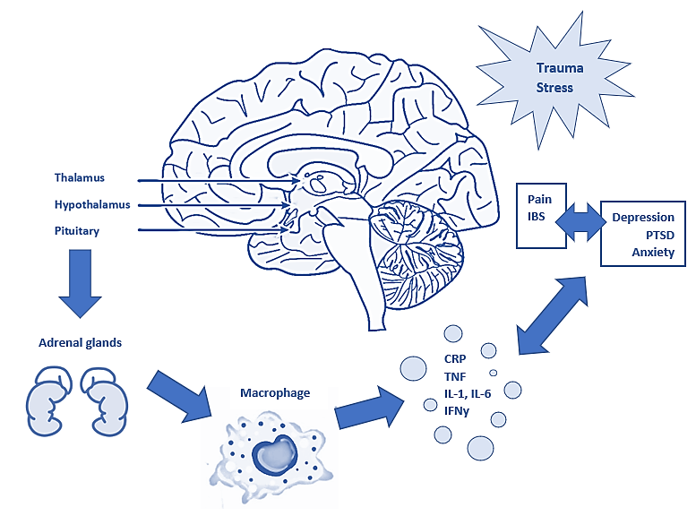
Figure 1. Conceptual model* of relations among early life stress and trauma/ACEs, the HPA axis, psychopathologies, and pain conditions
ACE, adverse childhood experience; CRP, C-reactive protein; IBS, irritable bowel syndrome; IFN, Interferon; IL, interleukin; PTSD, post-traumatic stress disorder; TNF, tumour necrosis factor.

Objectives
Primary Objectives
The objective of this overall PhD thesis was to investigate the relationship between childhood adversity and anxiety on chronic pain experiences in adulthood.
Secondary Objectives
The secondary objective was to look at whether these factors were also associated with the inflammatory biomarker CRP, as the link between childhood adversity, anxiety, and chronic pain may be influenced by CRP.
The null hypothesis was that no association between anxiety diagnosis, childhood adversity/trauma, CRP, and chronic pain exists. The alternate hypothesis was that there would be a significant positive association between childhood adversity/trauma, anxiety, CRP, and chronic pain experiences. Specifically, it was hypothesised that there would be positive associations between 1) childhood adversity and anxiety, 2) childhood adversity and CRP levels, 3) childhood adversity and pain, and 4) that the link between childhood adversity and pain will be influenced by anxiety and/or CRP.
The objectives of the PhD were achieved by completing three studies: a systematic review of the literature and meta-analysis (Chapter Two) and an analysis of longitudinal secondary data for Chapters Three and Four, using UK and US-based databases respectively. The cohort data provides a unique opportunity to explore the associations in large, representative samples rather than looking at one association separately in smaller samples.

Note on overlapping trauma terminology
The systematic literature review and meta-analysis used a variety of sources, thus including both ACEs and other trauma terms (e.g., early life adversity, childhood adversity, childhood trauma) which are overlapping. The UK Biobank study also utilized ACEs terminology. However, for the US-based MIDUS study, in order to avoid potential confusion and to consider the broadness and diversity of the ACEs concept, we instead referred to the experiences assessed in MIDUS by the childhood trauma questionnaire (CTQ) as “childhood adversity” (CA). It is worth noting, however, that the CTQ is a longer assessment (28 item; 3 of which to account for the commonly underreported aspect of “maltreatment”) and more detailed than the ACE (10 questions), and it assesses the frequency of occurrences. Due to this greater detail, research ethics committees may less commonly approve its use, especially for studies with sensitive populations, making its availability in these larger datasets even more valuable. For our study, we felt this reasoning was sufficient to justify the discrepancies in using consistent trauma terminology throughout.

Chapter 1 References
Barnett K., Mercer S.W., Norbury M., Watt G., Wyke S., Guthrie B. Epidemiology of multimorbidity and implications for health care, research, and medical education: a cross-sectional study. Lancet. 2012;380:37–43.
Bhui K, Dinos S, Galant-Miecznikowska M, de Jongh B, Stansfeld S. Perceptions of work stress causes and effective interventions in employees working in public, private and non-governmental organisations: a qualitative study. BJPsych Bull. 2016;40(6):318-325. Doi:10.1192/pb.bp.115.050823.
Boersma K., Linton S. Expectancy, fear and pain in the prediction of chronic pain and disability: a prospective analysis. Eur J Pain. 2006;10:551–557.
Breivik H., Collett B., Ventafridda V., Cohen R., Gallacher D. Survey of chronic pain in Europe: prevalence, impact on daily life, and treatment. Eur J Pain. 2006;10:287–333.
Bremner JD. Traumatic stress: effects on the brain. Dialogues Clin Neurosci. 2006;8(4):445-461. Doi:10.31887/DCNS.2006.8.4/jbremner
Brown, R. C., Plener, P. L., Braehler, E., Fegert, J. M., & Huber‐Lang, M. (2018). Associations of adverse childhood experiences and bullying on physical pain in the general population of Germany. Journal of pain research, 11, 3099–3108. Doi:10.2147/JPR.S169135
Capobianco, A., Cottone, L., Monno, A., Manfredi, A. A. and Rovere‐Querini, P. (2017), The peritoneum: healing, immunity, and diseases. Journal of Pathology, 243: 137‐147. Doi:10.1002/path.4942
Centres for Disease Control and Prevention (CDC). Adverse Childhood Experiences (ACEs). (2022). https://www.cdc.gov/violenceprevention/aces/index.html. Accessed 21 April 2022.
Chan AW, Bilger E, Griffin S, Elkis V, Weeks S, Hussey-Anderson L, Pasquina PF, Tsao JW, Baker CI. (2019). Visual responsiveness in sensorimotor cortex is increased following amputation and reduced after mirror therapy. Neuroimage Clin. 23:101882. Doi: 10.1016/j.nicl.2019.101882.
Crocq M. A. (2015). A history of anxiety: from Hippocrates to DSM. Dialogues in clinical neuroscience, 17(3), 319–325.
Dalechek D., Whittaker A., Caes L., McIntosh G. Anxiety, history of childhood adversity, and experiencing chronic pain in adulthood: a systematic literature review. PROSPERO (2021) CRD42021257706; Available from: https://www.crd.york.ac.uk/prospero/display_record.php?ID=CRD42021257706
Diagnostic and Statistical Manual of Mental Disorders (2013). 5th ed. Arlington, VA: American Psychiatric Association.
Dominick C., Blyth F., Nicholas M. Unpacking the burden: understanding the relationships between chronic pain and co-morbidity in the general population. Pain. 2012; 153:292–304.
Donaldson L. 2009. 150 years of the Annual Report of the Chief Medical Officer: On the state of public health 2008. Department of Health, Richmond House, 79 Whitehall, London SW1A 2NJ, UK.
Dooley LN, Kuhlman KR, Robles TF, Eisenberger NI, Craske MG, Bower JE. The role of inflammation in core features of depression: Insights from paradigms using exogenously-induced inflammation. Neurosci Biobehav Rev. 2018 Nov;94:219-237.
Dueñas M, Ojeda B, Salazar A, Mico JA, Failde I. A review of chronic pain impact on patients, their social environment and the health care system. J Pain Res. 2016; 9:457-467. Published 2016 Jun 28. Doi:10.2147/JPR.S105892
Du, H. X., Chen, X. G., Zhang, L., Liu, Y., Zhan, C. S., Chen, J., … Liang, C. Z. (2019). Microglial activation and neurobiological alterations in experimental autoimmune prostatitis‐induced depressive‐like behaviour in mice. Neuropsychiatric disease and treatment, 15, 2231–2245. Doi:10.2147/NDT.S211288.
Dydyk AM, Sizemore DC, Haddad LM, Lindsay L, Porter BR. NP Safe Prescribing of Controlled Substances While Avoiding Drug Diversion. StatPearls Publishing; 2020.
Fatoye F, Gebrye T, Ryan CG, Useh U, Mbada C. Global and regional estimates of clinical and economic burden of low back pain in high-income countries: a systematic review and meta-analysis. Front Public Health. 2023 Jun 9; 11:1098100. doi: 10.3389/fpubh.2023.1098100.
Fayaz A., Croft P., Langford R., Donaldson J., Jones G. Prevalence of chronic pain in the UK: a systematic review and meta-analysis of population studies. BMJ Open. 2016;6.
Generaal E, Vogelzangs N, Macfarlane GJ, Geenen R, Smit JH, Penninx BW, Dekker J. Reduced hypothalamic-pituitary-adrenal axis activity in chronic multi-site musculoskeletal pain: partly masked by depressive and anxiety disorders. BMC Musculoskelet Disord. 2014 Jul 9;15:227.
Gentili, C., Rickardsson, J., Zetterqvist, V., Simons, L. E., Lekander, M., & Wicksell, R. K. (2019). Psychological Flexibility as a Resilience Factor in Individuals with Chronic Pain. Frontiers in psychology, 10, 2016. Doi:10.3389/fpsyg.2019.02016.
Gilbert, L. K., Breiding, M. J., Merrick, M. T., Thompson, W. W., Ford, D. C., Dhingra, S. S., et al. (2015). Childhood adversity and adult chronic disease: an update from ten states and the District of Columbia, 2010. Am. J. Prev. Med. 48, 345–349. Doi: 10.1016/j.amepre.2014.09.006
Groenewald, C. B., Murray, C. B., & Palermo, T. M. (2020). Adverse childhood experiences and chronic pain among children and adolescents in the United States. Pain reports, 5(5), e839. https://doi.org/10.1097/PR9.0000000000000839
Gu, Damin, Zhou, Minmin, Han, Chao, Lei, Daoyun, Xie, Songhui, Yuan, Yanbo, & Ma, Tieliang. (2019). Preoperative anxiety induces chronic postoperative pain by activating astrocytes in the anterior cingulate cortex region. Revista da Associação Médica Brasileira, 65(9), 1174‐1180. Epub October 10, 2019. https://dx.doi.org/10.1590/1806‐9282.65.9.1174.
Harvard Health Publishing (HHP). C-Reactive Protein test to screen for heart disease: Why do we need another test? 21 March 2017. https://www.health.harvard.edu/heart-health/c-reactive-protein-test-to-screen-for-heart-disease. Accessed 24 October 2024.
Harvie, D., Broeker, M., Smith, R., Meulders, A., Madden, J., & Moseley, G.L. (2014). Bogus visual feedback alters movement‐evoked pain onset in people with neck pain. Psychological science. 26(4):385‐92. https://doi.org/10.1177%2F0956797614563339.
Kalia V, Knauft K, Hayatbini N. Cognitive flexibility and perceived threat from COVID-19 mediate the relationship between childhood maltreatment and state anxiety. PloS One. 2020;15(12):e0243881. Published 2020 Dec 11. Doi:10.1371/journal.pone.0243881.
Kennedy E, Niedzwiedz CL. The association of anxiety and stress-related disorders with C-reactive protein (CRP) within UK Biobank. Brain Behav Immun Health. 2021 Dec 27; 19:100410. Doi: 10.1016/j.bbih.2021.100410.
Khera T, Rangasamy V. Cognition and Pain: A Review. Front Psychol. 2021; 12:673962. Published 2021 May 21. Doi:10.3389/fpsyg.2021.673962.
Lervåg A. Editorial: Correlation and causation: to study causality in psychopathology. J Child Psychol Psychiatry. 2019 Jun;60(6):603-605. Doi: 10.1111/jcpp.13074. PMID: 31087558.
Li C, Xiang S. Adverse Childhood Experiences, Inflammation, and Depressive Symptoms in Late Life: A Population-Based Study. J Gerontol B Psychol Sci Soc Sci. 2023 Feb 19;78(2):220-229. doi: 10.1093/geronb/gbac179.
Lubell, Y. et al. C-reactive protein testing in primary care for acute respiratory infections: a cost-effective strategy to mitigate antimicrobial resistance across different income settings. Lancet Global Health. 2024. https://doi.org/10.1016/S2214-109X(24)00382-6.
Lumley S, Yu D, Wilkie R, Jordan KP, Peat G. Chronic pain-mental health comorbidity and excess prevalence of health risk behaviours: a cross-sectional study. Prim Health Care Res Dev. 2024 Apr 8;25:e15. doi: 10.1017/S1463423624000070.
Macfarlane G., Beasley M., Smith B., Jones G., Macfarlane T. Can large surveys conducted on highly selected populations provide valid information on the epidemiology of common health conditions? An analysis of UK Biobank data on musculoskeletal pain. Br J Pain. 2015; 9:203–212.
Meints SM, Edwards RR. (2018). Evaluating psychosocial contributions to chronic pain outcomes. Prog Neuropsychopharmacol Biol Psychiatry. 87(Pt B):168-182. Doi: 10.1016/j.pnpbp.2018.01.017.
Merrick MT, Ford DC, Ports KA, et al. (2019). Vital Signs: Estimated Proportion of Adult Health Problems Attributable to Adverse Childhood Experiences and Implications for Prevention — 25 States, 2015–2017. MMWR Morb Mortal Wkly Rep. 68:999-1005. DOI: http://dx.doi.org/10.15585/mmwr.mm6844e1.
Merskey H., Bogduk N., editors. IASP task force on taxonomy, Part III: Pain Terms, A Current List with Definitions and Notes on Usage. IASP Press; Seattle, WA: 1994. Pp. 209–214.
Michopoulos V, Powers A, Gillespie CF, Ressler KJ, Jovanovic T. (2017). Inflammation in Fear- and Anxiety-Based Disorders: PTSD, GAD, and Beyond. Neuropsychopharmacology. 42(1):254-270. Doi: 10.1038/npp.2016.146.
Mills SEE, Nicolson KP, Smith BH. Chronic pain: a review of its epidemiology and associated factors in population-based studies. Br J Anaesth. 2019 Aug;123(2):e273-e283. Doi: 10.1016/j.bja.2019.03.023.
Monnat, S. M., & Chandler, R. F. (2015). Long Term Physical Health Consequences of Adverse Childhood Experiences. The Sociological quarterly, 56(4), 723–752. https://doi.org/10.1111/tsq.12107
Morasco, B. J., Lovejoy, T. I., Lu, M., Turk, D. C., Lewis, L., & Dobscha, S. K. (2013). The relationship between PTSD and chronic pain: mediating role of coping strategies and depression. Pain, 154(4), 609–616. https://doi.org/10.1016/j.pain.2013.01.001
Morris, P., Ali, K., Merritt, M. et al. A systematic review of the role of inflammatory biomarkers in acute, subacute and chronic non-specific low back pain. BMC Musculoskelet Disord 21, 142 (2020).
Muniz Carvalho, C., Wendt, F.R., Maihofer, A.X. et al. Dissecting the genetic association of C-reactive protein with PTSD, traumatic events, and social support. Neuropsychopharmacol. 46, 1071–1077 (2021). https://doi.org/10.1038/s41386-020-0655-6.
Nahin RL. Estimates of pain prevalence and severity in adults: United states, 2012. J Pain. 2015; 16:769-780.
National Conference of State Legislators (NCSL). (2021). Adverse Childhood Experiences. https://www.ncsl.org/research/health/adverse-childhood-experiences-aces.aspx.
Nelson S, Beveridge JK, Mychasiuk R, Noel M. (2021). Adverse Childhood Experiences (ACEs) and Internalizing Mental Health, Pain, and Quality of Life in Youth With Chronic Pain: A Longitudinal Examination. J Pain. Mar 31: S1526-5900(21)00184-X. doi: 10.1016/j.jpain.2021.03.143.
Oliveira LC, Wirowski N, Souza PB, Lobato AS, Jansen K, de Azevedo Cardoso T, Mondin TC, Oses JP, Kapczinski F, Souza LDM, Azevedo da Silva R, Pedrotti Moreira F. Childhood trauma, inflammatory biomarkers and the presence of a current depressive episode: Is there a relationship in subjects from a population study? J Psychiatr Res. 2023 Feb; 158:255-260. Doi: 10.1016/j.jpsychires.2022.12.047.
Olugbade, T., Bianchi‐Berthouze, N., & Williams, A. (2019). The relationship between guarding, pain, and emotion. Pain reports, 4(4), e770. Doi:10.1097/PR9.0000000000000770.
Phillips JK, Ford MA, Bonnie RJ, editors. (2017). Pain Management and the Opioid Epidemic: Balancing Societal and Individual Benefits and Risks of Prescription Opioid Use. Washington (DC): National Academies Press (US); 4, Trends in Opioid Use, Harms, and Treatment. Available from: https://www.ncbi.nlm.nih.gov/books/NBK458661.
Remes O, Mendes JF, Templeton P. Biological, Psychological, and Social Determinants of Depression: A Review of Recent Literature. Brain Sci. 2021 Dec 10;11(12):1633. doi: 10.3390/brainsci11121633.
Rice K, Ryu JE, Whitehead C, Katz J, Webster F. Medical Trainees' Experiences of Treating People With Chronic Pain: A Lost Opportunity for Medical Education. Acad Med. 2018 May;93(5):775-780.
Robinson OJ, Vytal K, Cornwell BR, Grillon C. The impact of anxiety upon cognition: perspectives from human threat of shock studies. Front Hum Neurosci. 2013; 7:203. Published 2013 May 17. doi:10.3389/fnhum.2013.00203
Sakamoto, Y., Oka, T., Amari, T., and Simo, S. (2019). Factors Affecting Psychological Stress in Healthcare Workers with and without Chronic Pain: A Cross‐Sectional Study Using Multiple Regression Analysis. Medicina, 55(10), 652; https://doi.org/10.3390/medicina55100652.
Sauver JL St, Warner DO, Yawn BP, et al. Why patients visit their doctors: assessing the most prevalent conditions in a defined American population. Mayo Clin Proc, 88 (2013), pp. 56-67.
Schneiderman N, Ironson G, Siegel SD. Stress and health: psychological, behavioral, and biological determinants. Annu Rev Clin Psychol. 2005;1:607-28.
Smith, K.E., Pollak, S.D. Early life stress and development: potential mechanisms for adverse outcomes. J Neurodevelop Disord. 2020; 12:34.
Sproston NR, Ashworth JJ. Role of C-Reactive Protein at Sites of Inflammation and Infection. Front Immunol. 2018; 9:754. Published 2018 Apr 13. doi:10.3389/fimmu.2018.00754.
Treede RD. The International Association for the Study of Pain definition of pain: as valid in 2018 as in 1979, but in need of regularly updated footnotes. Pain Rep. 2018;3(2):e643. Published 2018 Mar 5. doi:10.1097/PR9.0000000000000643
Tseng MT, Kong Y, Eippert F, Tracey I. Determining the Neural Substrate for Encoding a Memory of Human Pain and the Influence of Anxiety. J Neurosci. 2017;37(49):11806-11817. doi:10.1523/JNEUROSCI.0750-17.2017
Turk DC, Swanson KS, Tunks ER. Psychological approaches in the treatment of chronic pain patients--when pills, scalpels, and needles are not enough. Can J Psychiatry. 2008 Apr;53(4):213-23. doi: 10.1177/070674370805300402.
Tzouvara V, Kupdere P, Wilson K, Matthews L, Simpson A, Foye U. Adverse childhood experiences, mental health, and social functioning: A scoping review of the literature. Child Abuse Negl. 2023 May; 139:106092. doi: 10.1016/j.chiabu.2023.106092.
Van der Hulst M, Vollenbroek-Hutten MM, Rietman JS, Schaake L, Groothuis-Oudshoorn KG, Hermens HJ. Back muscle activation patterns in chronic low back pain during walking: a “guarding” hypothesis. Clin J Pain 2010; 26:30–7.
Vincent A, Whipple MO, McAllister SJ, Aleman KM, St Sauver JL. A cross-sectional assessment of the prevalence of multiple chronic conditions and medication use in a sample of community-dwelling adults with fibromyalgia in Olmsted County, Minnesota. BMJ Open. 2015;5(3):e006681.
Vos T., Allen C., Arora M. Global, regional, and national incidence, prevalence, and years lived with disability for 328 diseases and injuries for 195 countries, 1990–2016: a systematic analysis for the Global Burden of Disease Study 2016. Lancet. 2017; 390:1211–1259.
World Health Organization. International Statistical Classification of Diseases and Related Health Problems. tenth ed. 2019. F40-48 Neurotic, stress-related and somatoform disorders. https://icd.who.int/browse10/2019/en#/F40-F48.

Chapter 2: Anxiety, History of Childhood Adversity, and Experiencing Chronic Pain in Adulthood: A Systematic Literature Review and Meta-analysis
In a first step to achieve the main aim of this thesis – evaluating the role of adverse childhood experiences (ACEs) and anxiety on chronic pain in adulthood – a systematic review and meta-analysis to summarise the existing literature on the relationship between ACEs and anxiety on chronic pain experience in adults was deemed necessary due to the scattered evidence available on this topic. This systematic review was independently carried out by the author of this thesis with supervision from PhD supervisors (AW, LC, and GM) and second screening of titles and abstract by an undergraduate student (HD). Results from this study informed the design and focus of the studies in Chapters 3 and 4. This chapter has been published in The European Journal of Pain:
Dalechek DE, Caes L, McIntosh G, Whittaker AC. Anxiety, history of childhood adversity, and experiencing chronic pain in adulthood: A systematic literature review and meta-analysis. Eur J Pain. 2024 Jan 8. doi: 10.1002/ejp.2232.

Abstract
Background: When considering factors that may impact chronic pain experiences in adulthood, adverse childhood experiences (ACEs) and anxiety should be considered. The literature on the associations between these 3 variables remains unclear.
Objective: To summarize the existing literature on the relationship between ACEs and anxiety on chronic pain experience in adults and examine the association between ACEs and anxiety.
Methods: A systematic literature review (SLR) and meta-analysis was used to examine adults (≥18) with a reported history of ACEs, self-reported and/or diagnosed anxiety, and chronic pain. The SLR included quality appraisal according to the Joanna Briggs Institute tool.
Results: The narrative summary indicated a significant association between ACEs, anxiety, and chronic pain experiences in adults. Of 52 selected studies, 79% reported a moderate-strong association. For ACE prevalence, the majority (50%, SD 16.01) reported experiencing sexual abuse, followed by physical abuse 46% (SD 20.7). Other ACEs included emotional abuse (33% (SD 17.17)), emotional neglect (25% (SD 21.02)), and physical neglect (23% (SD 22.44)). Meta-analyses showed moderate associations between anxiety and chronic pain (r=0.30; 95%CI = (0.14, 0.45), p<0.01) and between ACEs and anxiety (r=0.26; 95%CI = (0.15, 0.36), p<0.01), and that participants who experienced ACEs are around twice as likely to present chronic pain during adulthood (OR=1.99; 95% CI=1.53, 2.60), p<0.01).
Conclusion: The results of the SLR and meta-analysis indicated that ACEs and anxiety influence chronic pain experience in adults. Given the relationship between ACEs and anxiety, there would be value in exploring this as a potential mediator in future studies.
Significance: There was an unmet need to summarize the existing literature on the relationship between adverse childhood experiences (ACEs) and anxiety on chronic pain experience in adults, and the association between ACEs and anxiety. The results of this systematic review and meta-analysis indicated that both ACEs and anxiety influence chronic pain in adults, and help to inform on the diverse literature on these potential relationships to date.
PROSPERO 2021 CRD4202125770. Available from: https://www.crd.york.ac.uk/prospero/display_record.php?ID=CRD42021257706

Introduction
Historically, anxiety has had a wide variety of meanings and interpretations. Definitions have ranged from the anticipation of a future threat to the emotional response to a real or perceived imminent one (Crocq, 2015). The DSM‐5 (DSM, 2013) adds nuance to this by focusing on the cognitive features of anxiety as “apprehensive expectation” (Crocq, 2015). Although anxiety has been considered biologically adaptive by promoting danger avoidance, an obvious discrepancy exists between mild, adaptive anxiety in everyday life and the distressing pathological anxiety requiring immediate intervention (Robinson et al., 2013). This difference is determined by professional or clinical assessment, with traumatic or tense experiences often being triggers for developing maladaptive anxiety.
During these types of anxiety-inducing experiences, the brain is in a heightened state of stress, which has long-lasting negative impacts (Bremner, 2006). Although existing research has focused on behaviour, emotional development, mental, and physical health after anxiety, research addressing a direct link between anxiety and experiencing chronic pain is limited. The long‐term impacts of hyperarousal experienced in high anxiety states specifically and trauma history are not fully understood when considering pain. Studies have tended to focus on depression and post-traumatic stress disorder (PTSD) with pain (Morasco et al., 2013). One example that induces heightened, prolonged stress is adverse childhood experiences (ACEs). ACEs are childhood traumatic events, including experiencing violence, abuse, neglect, witnessing violence, having a family member attempt suicide or die, and aspects of home or community environments that undermine safety and stability (CDC, 2022). ACEs inhibit optimal development by altering gene expression, brain function, and even organ function (Merrick et al., 2019). ACEs also influence developing unhealthy coping strategies, which negatively affect behaviours, mental health, life opportunities, morbidity, and physical health such as chronic pain (Merrick et al., 2019).
In terms of economic burden, chronic pain has been a major factor affecting stress and anxiety in workers, and costs of pain‐related lost productivity ranged from $299–$335 billion based on results from a large‐scale survey using 2008 data in the US (Sakamoto et al., 2019). In the UK, the Health and Safety Executive report in 2015 estimated considerable costs to the British economy due to stress at work, with £14.3 billion lost in 2013–2014 (Bhui et al. 2016). This makes the annual cost of chronic pain greater than non-communicable diseases (e.g., heart disease, some cancers, diabetes), which are inaccurately considered to drive larger economic losses.
In a recent study examining underlying neural mechanisms associated with ACE history in American adults, empirical evidence suggested that early life adversity alters the normative development of the amygdala. Results indicated that maltreatment, as a type of ACE, tends to predict a higher sensitivity to environmental threats and this leads to increased levels of anxiety. For maltreated individuals, neuroimaging research has demonstrated how hypervigilance to threatening stimuli may be a side effect of heightened amygdala activity (Kalia et al., 2020). In chronic pain populations, it has been shown that anxiety disorders are second only to depression as a psychological comorbidity. Clinical or pathological anxiety involves increased feelings of dread that interfere with standard functioning and may be mediating hypervigilance, potentially contributing to or exacerbating pain experiences (Woo 2010). Additionally, a recent systematic review documented high levels of ACEs in adults with chronic pain, and showed that ACEs impacted the form, presence, severity, and extent of chronic pain in adults (Nicolson et al. 2023). Several studies have also shown the involvement of neuroanatomical reorganization, neurotrophin and monoamine depletion, neuroinflammation, and endocannabinoid system changes to the general experience of pain after trauma (Brown et al., 2018). It is unclear what this link means clinically, but the variety of implications involved are important to consider for the development of chronic pain conditions. In addition, high concentrations of inflammatory markers have been described in PTSD, anxiety, panic disorder, and even a variety of phobias; however, results on a relationship between inflammation and anxiety-related symptoms are inconsistent (Michopoulos et al., 2017). Despite links between ACEs and chronic pain, the role of anxiety in this pathway, independent of a link with depression, remains unclear and under-investigated. To enhance the understanding of this pathway, a critical first step is gaining a comprehensive overview of the current evidence on the associations between ACEs, anxiety, and chronic pain. To this end, the primary objective of this systematic review was to investigate the relationship between ACEs and anxiety on chronic pain experience in adults. This incorporated examining 1) the relationship between ACEs and chronic pain; 2) the relationship between anxiety and chronic pain 3) the association between ACEs and anxiety; and 4) if possible, the associations between all three variables. While many individual studies have explored the relationship between ACEs and pain or ACEs and anxiety, no overarching review has summarised all of the evidence available. By summarizing the diverse evidence on these associations, this review sought to bridge the current gap by better understanding each of the relationships between these factors.
Methods
Search strategy
For the systematic literature review, the search strategies focused on childhood adversity, trauma outcomes, comorbidities, chronic pain, ACEs, neurophysiology of anxiety, and neuroanatomical changes due to trauma. Chronic pain was defined by each individual article, with the standard assumption being pain lasting more than 3 months (see overview in Table 1, or each article-specific chronic pan measure in Table 2). The search was conducted in August 2021 and the publication range included the last 20 years to capture a meaningful span of the existing literature. Electronic databases searched included PubMed, Medline, PsychInfo, and PsychARTICLES. The focus was on primary studies, in English, which investigated patients with a history of anxiety as well as papers exploring the outcomes of childhood trauma, stress, and chronic pain. The subject index terms primarily utilized in the search strategies included: adult; adult survivors of childhood adverse events; anxiety; anxiety disorders; child; child health; chronic pain; humans; mental disorders; mental health; pain; risk factors. To allow for the variety of interpretation, cultural, and language differences of these terms globally, an extended variation of trauma, violence, abuse, and mental health terms were included to ensure as many studies as possible of relevance could be captured for review (Appendix A).
Selection strategy
The screening process was conducted via Rayyan software (Mourad et al. 2016) between September 2021 and May 2022. After the initial title and abstract screening in January 2022, a 20% quality check of selection and conflict resolution were performed by a second reviewer (with the option to bring in a third reviewer for mediation as needed). The full texts of the included abstracts were subsequently screened by the first author for inclusion, with 20% quality check by a second reviewer (an undergraduate psychology dissertation student). Full texts behind a paywall were obtained and provided by the University of Stirling Library and Student Services. It was decided not to contact corresponding authors to access further full-texts due to the large number (n = 91) of initial studies already included in the review. All three co-authors were available to address screening decision conflicts, but the limited number that came up were resolved between reviewers. Progress through screening and selection was illustrated in a PRISMA diagram (see Figure 1). Data extraction was conducted by the first author and reviewed by all three co-authors.
Eligibility criteria
Specific criteria were identified using the Population, Exposure, Controls, Outcomes, Setting, and Study designs (PECOS) criteria. Population was adults (age 18 years or over) with chronic pain and/or anxiety; self-reported and/or diagnosed. Exposure was adverse childhood experiences/early life adversities/early life or childhood trauma. Controls were not present in all studies but where present incorporated those without adverse childhood experiences who had chronic pain and anxiety. Outcome measures were presence of chronic pain and anxiety. Study designs included observational correlation studies, cross-sectional, interventional, and longitudinal. Exclusion criteria were less than 18 years of age with no anxiety and/or no chronic pain and no childhood adversity.
Critical Appraisal
Several study appraisal and quality tools were reviewed for this study, and the main three of relevance were the Joanna Briggs Institute (JBI) tool (JBI 2020), the National Institutes of Health tool (NHLBI NIH 2021) and the Critical Appraisal Skills Programme tool (CASP 2022). The JBI— an independent, international, not-for-profit researching and development organization that develops many critical appraisal checklists involving the feasibility, appropriateness, meaningfulness and effectiveness of healthcare interventions was selected for use in this review (Aromataris et al. 2020). The variety of tools to choose from is diverse, but the applicable range of study types captured by the JBI Critical appraisal checklist was the widest and helped in making this selection. The full JBI checklist can be reviewed in Appendix B, along with a table comparison of each quality appraisal tool originally assessed for feasibility.
Data extraction
Extraction was completed by the first author. Primary outcomes included chronic pain (both generally reported and/or defined conditions), childhood trauma history, and self-reported or diagnosed anxiety. Differences in sex were considered, if applicable depending on data, to highlight how rates of reported ACEs, anxiety rates, and pain outcomes might differ. For the extraction table, the following were examined: author information, year of survey or study, instrument to measure ACEs, participant age (mean), age at the ACEs (year), type and prevalence of ACE (%), association between ACEs and chronic pain (weak, moderate, strong), association between anxiety and chronic pain (weak, moderate, strong). Chronic pain was not limited to a specific condition and could be reported generally or as a commonly recognized chronic pain condition as noted in Table 1.
Where available, information on pain intensity was also extracted as assessed by either self-report, or records of the number of pain sites or chronic pain conditions. For ACEs, terms such as childhood maltreatment, childhood trauma, stressful experiences in childhood, early-life adversity, childhood adversities, and childhood psychosocial stressors were all considered as adverse childhood events. This review used the term ACEs, which links either directly to main types of childhood trauma (physical, sexual, emotional abuse, and neglect) or in combination to indirect types of ACEs (such as parental death, or exposure to domestic violence). In this review, direct ACE definitions were aligned with the terminology of the World Health Organization International Society for Prevention of Child Abuse and Neglect (WHO 2006). The range of outcomes relevant for each factor is summarized in Table 1. To align with the diversity in the literature and by country, pain and ACE measures were kept as broad as possible.
Table 1. Systematic review factors of interest
Factor | Range of outcomes as expressed across identified literature
ACEs  Anxiety | Childhood maltreatment; childhood trauma; stressful experiences in childhood; early-life adversity; physical abuse; sexual abuse; emotional abuse; verbal abuse; emotional or physical neglect; parental death or suicide; exposure to domestic violence; witnessing violence; parental incarceration; exposure to/witnessing addiction or drug abuse; parental divorce; lack of access to basic needs (going to doctor, food, etc.)  Self-reported; diagnosed
Chronic pain | Pain lasting more than 3 months; self-reported number of pain sites; chronic pain conditions (e.g., fibromyalgia, migraine, chronic urologic and/or pelvic pain, back pain, arthritis)
ACEs, adverse childhood experiences.
Data analysis: narrative synthesis
A narrative synthesis of findings and stratified results based on the type of persistent pain disorders and direct and indirect ACE exposures was conducted. Results from the studies were summarized and tabulated according to the variables listed above and discussed in narrative form.
For article appraisal and data extraction post the JBI quality check, a qualitative description of the association and the strength of the reported association (strong, moderate, weak) were assigned. These were based on the article’s characterization of results per the abstract, results, and discussion section, as “strong” or “weak”. Strong or weak were further justified by the statistical significance (p < 0.05) of the provided results or the effect size; depending on data availability in each study; on the score of the respective study questionnaire scale which was used to measure ACEs, anxiety, and chronic pain, etc. Weak associations and those without enough data to make a conclusion were still included and reported to avoid bias in the results reported. Rather than relying on visual means of determining publication bias (e.g. funnel plot) which can overlook other sources of bias typically present in meta-analysis, such as heterogeneity, we have instead transparently reported the heterogeneity for all analyses conducted.
Data analysis: meta-analysis
Anxiety and a history of childhood adversity may influence chronic pain experiences. Meta-analyses were conducted using R statistical software (R Core Team 2021) to investigate the size of any associations between types of ACE, anxiety and/or chronic pain. After considering multiple approaches to the available data and reported associations, it made sense to define by three types of different relationships for conducting the meta-analyses: Anxiety and chronic pain; ACEs and chronic pain; and ACEs and anxiety. This was because these were the patterns of associations most commonly available in the selected studies.

This involved pooling correlations (using the correlation coefficient and sample size for each study), or by using a binary classification of participants using one variable, and comparing means reported for the other variables. This approach was substituted with an Odds Ratio (OR) analysis when the scales used across studies were too different to be comparable; however, it may not be possible in all cases to classify the study participants. The extraction tables of the meta-analyses conducted are included in Appendix C. As even two studies are considered sufficient to perform a meta-analysis, provided that the two studies can be meaningfully pooled and provided their results are sufficiently 'similar' (Ryan 2016), there was no minimum study number set for conducting analyses.
An important limitation for the analyses was the wide variety of ACEs and chronic pain manifestations, resulting in variation seen in the methods, populations, and theoretical perspectives of the studies. Consequently, even if efforts were made to make the analysis as inclusive as possible, not every study could be included in the analysis for each association. Additionally, it should be noted that some studies are included several times; this is the consequence of those studies not reporting overall measurements or categories of either ACEs or chronic pain. Whenever possible, the separate measures were manually summarized to produce effects more in line with the rest of the studies; unfortunately, this was not always feasible. Hence, in studies where several categories of these variables were reported separately, each subcategory was included as a separate effect size in the meta-analysis.
Data Protection
Databases from the CDC are protected by Public Law 107‐174 (No FEAR Act). All data relevant to this review was stored on a password protected laptop that is locked up when not in use and was only accessible to the lead author. No personal identifiers were present in the data used.
Results
Systematic searches
A total of 3,415 articles were identified from the searches, and 519 were deleted due to being duplicates. A total of 91 articles were initially identified for extraction after reaching consensus with the secondary reviewer. Eight discrepancies between reviewers were identified at this stage, but consensus was agreed in discussion. After careful review of the available data in each and their feasibility for the analyses, a final total of 52 studies were selected for inclusion in this study based on the quality appraised via the JBI checklist (full table in Appendix B). There were no discrepancies that required an outside mediator, so the consensus ultimately came to 100%. The PRISMA Diagram of the systematic review article selection is displayed in Figure 1.
Figure 1. Study identification
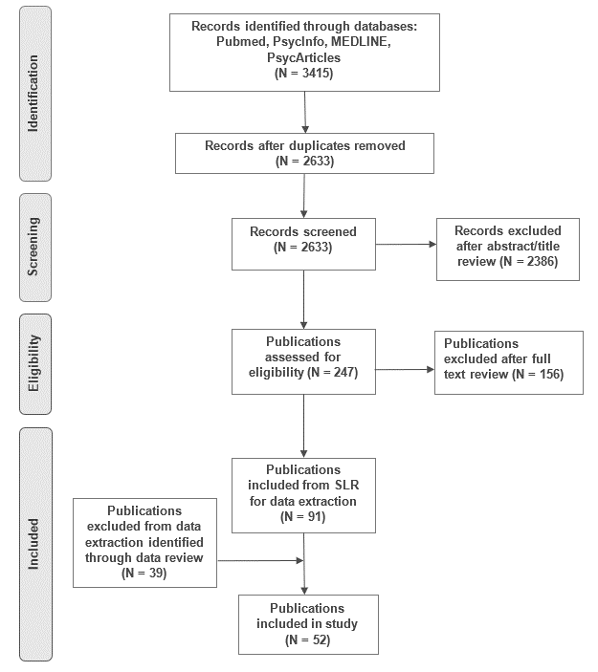
Narrative synthesis
Gender and ethnicity were not captured systematically across all studies; however, the majority of studies did report age or mean age. Based on the selected studies which reported age (n = 48), the mean participant age was 44.1 years old (SD = 8.52) and ranged from 19 years to 60 years, with most participants in their forties. For the measurement tools, the childhood trauma questionnaire (CTQ) was the most commonly used (18/52 or 35% of studies). For the selected outcomes to capture pain in adults, general or undefined chronic pain was most commonly measured in 59.6% of studies, followed by migraine or headache in 21.2%, back pain in 17.3%, arthritis in 17.3%, fibromyalgia in 15.4%, and pelvic pain in 15.4% of studies. The characteristics of all included studies are compiled in Table 2.
Table 2. Characteristics of selected studies for narrative synthesis (n = 52)

Study ID* | Year | Instrument(s) to measure ACEs, pain, and/or anxiety | Mean age | Type and prevalence of ACE (%)** | Pain measure or condition | Association between ACEs and chronic pain (weak, moderate, strong) |  | Association between anxiety and chronic pain  (weak, moderate, strong)
Alhalal et al. 2018 | 2015 | Arabic version CTQ, CPG | 41 | Emotional abuse: 9.18, physical abuse: 7.48, sexual abuse: 6.85 | Chronic pain severity |  | Strong | Weak
Bayram et al. 2014 |  | CTQ, HAD, NPS) | 39.1 | Emotional abuse: 40.4, sexual abuse: 5.3, physical abuse: 26.2 | Fibromyalgia, rheumatoid arthritis |  | Strong | Strong
Brennenstuhl & Fuller-Thomson 2015 | 2012 | CSA | 46.95 | Parental domestic violence: 15.7, physical abuse:52.3, sexual abuse (touching only): 8.4, sexual abuse (forced sexual activity): 11.7 | Migraine |  | Strong | n.m
Brown et al. 2018 | Sep 2016-Nov 2016 | CTQ, POLO, GADS | 48.3 | Physical neglect:22.4, emotional neglect: 13.1, Bullying at school: 10.8, multiple maltreatment: 31.2 | Levels of pain |  | Strong | Moderate
Coles et al. 2015 | 1996 | SF-36 | 30.6 | CSA | Bodily pain |  | Strong | n.m
Corsini-Munt et al. 2017 | 2014-2015 | CTQ, STAI-T | 27.8 | n.m | Vestibulodynia |  | Strong | Strong
Craner & Lake 2021 | Jan 2018-May 2019 | ACE, PROMIS-Pain, PROMIS-Anxiety, PCS, PSEQ | 49.03 | 1 ACE: 19.7, 2ACE: 12.6, 3 ACE: 11.9 | Chronic pain, fibromyalgia, back pain, headache/migraine |  | Strong | Weak
De Roa et al. 2018 | N/a | Visual Analog scale, CTQ, Holmes and Rahe Scale, HADS | N/a | Emotional neglect: 56.8, physical neglect: 9.1, emotional abuse: 20.5, physical abuse: 25, sexual abuse 8.8 | Fibromyalgia, migraine |  | Strong | Strong
Dennis et al. 2019 | Aug 2016- March 2018 | The ACE questionnaire, PROMIS, WPI | 43.3 | Mental illness: 54, Divorce: 50, emotional abuse: 47.9, emotional neglect: 44.8, household substance abuse: 40.2, sexual abuse: 34.7, physical abuse: 30.1, physical neglect: 16.6%, household member in prison: 8.0% | Chronic pain |  | Strong | Strong
Fowler et al. 2020 | 2002 | ACEs scale, DSM-IV | 54.5 | Parental death: 15, sexual abuse: 1.5 | Chronic neck or back pain, arthritis or rheumatism, frequent or severe  headaches, or any other chronic pain over the last 12 months |  | Strong | Strong
Fuller-Thomson et al. 2010 | 2005 | CCHS | 46 | Parental unemployment: 12.5, divorce: 10.1, parental addiction: 11.5 | Migraine |  | Strong | n.m
Fuller-Thomson et al. 2015 | 2012 | GAD, CSA | 60 | n.m | Chronic pain, inflammatory bowel diseases (IBDs) |  | Strong | Strong
Generaal et al. 2016 | N/a | CPG questionnaire | 44.7 | Early and recent life stress (100) | Chronic multi-site musculoskeletal pain |  | Strong | weak
Green et al. 2001 | March-August 1997 | Drossman Physical-Sexual Abuse Questionnaire, Hopkins | 46.4 | Physical abuse: 41, sexual abuse: 59, physical and sexual abuse: 41 | Pain (e.g., pelvic, back,  and head pain) |  | Strong | Strong
Hart-Johnson & Green, 2012 | n.m | DAQ. MPQ, PDI, PCPT, SF-36 | 34 | Physical or sexual abuse: 67 | Four pain subscales: sensory, affective, evaluative, and miscellaneous |  | Weak | n.m.
Hellou et al. 2017 | Feb 2013-Sept 2015 | CTQ, Patient Health Questionnaire-4 | 46.6 | Emotional abuse: 12, physical abuse: 9.3, sexual abuse: 9.3, emotional neglect: 16, physical neglect: 8 | Fibromyalgia, rheumatoid arthritis |  | Strong | Strong
Hughes et al. 2016 | April-July 2013 | SWEMWBS | 43.5 | n.m |  |  | Weak | n.m
Jones et al. 2009 | Mar-56 | Biomedical survey | 45 | Ever in institutional care: 23.3, Death of parent: 36.3, Family difficulties: 17.2 | Chronic widespread pain |  | weak | n.m
Kamiya et al. 2016 | Late 2009 and mid-2011 | HADS-A, SCQ | 60.4 | Parental experienced drug and drink: 22, Physical abuse parent: 17.5, physical abuse other than parent: 40 | Chronic pain |  | Strong | Moderate
Kascakova et al. 2020 | 2016 | CTQ | 46.61 | Emotional abuse:23.1, physical: 7.7, sexual: 9.9, emotional neglect: 33, physical neglect: 54.9 | Chronic pain-related condition (migraine, back pain, arthritis, pelvic  pain, or pain of unclear origin) |  | Strong | Strong
Kelly et al. 2011 | Aug 2006-June 2008 | VAMSTA | 40.3 | Childhood abuse: 60.4 | Chronic pain |  | Strong | n.m
Krantz et al. 2019 | April-Sept 2018 | ACE, HADS-A, CCI, BRFSS | 40 | Physical abuse: 43, sexual abuse: 55, emotional: 62, domestic violence: 35 | Chronic pelvic pain, fibromyalgia, other pain condition, IC, IBS |  | Strong | Strong
Lai et al. 2016 | Oct 2012-July 2014 | CTES, RTES, HADS-A, PROMIS | 53.4 | Death of close member: 51 divorces: 33.3, sexual experience: 29.4, violence: 23.5, injuries:27.4, others: 35.5 | Chronic bladder pain and/or non-urologic pain |  | Strong | Strong
Lee et al. 2009 | n.m | WMH–CIDI | 46.2 | Any childhood family advertise: 43.2 | Frequent and/or severe headaches |  | Strong | Moderate
Leisner et al. 2014 | n.m | CTQ, MPI-D, SES, HADS | 57.5 | Abuse: 40.8, physical, emotional and sexual FME: 2.91, physical FME: 21.4, emotional FME: 27.2, sexual FME: 19.4 | Chronic low back pain, sensory pain perception |  | Strong | n.m
Määttä et al. 2019 | Jan 2015-Dec 2016 | The Trauma and Distress Scale, BAI, BDI | 54 | Emotional neglect: 75, physical neglect: 63, emotional abuse: 35, physical abuse: 25, sexual abuse 10 | Chronic neuropathic pain |  | Strong | Moderate
Macedo et al. 2019 | n.m | CTQ, BPI | 24.82 | Emotional abuse: 54.5, physical abuse: 40.9, sexual abuse: 36.6, physical neglect: 45.5 | Chronic pain |  | Strong | n.m
McCall-Hosenfeld et al. 2014 | 2005-2007 | Health Home Questionnaire, PHQ | 47 | Sexual trauma: 49, IPV Victimization: 57, any interpersonal trauma: 73 | Chronic pain |  | Weak | n.m.
Mehta et al. 2017 | n.m | ASI, PI-SF, DASS-21, PCS, SPAHQ | 45.4 | Sexual abuse: (childhood: 29.5, adulthood: 39.8), physical abuse (childhood: 66.4, adulthood: 56.1) | Chronic pain, pain-related disability |  | Strong | n.m
Naliboff et al. 2015 | n.m | GUPI, HADS, BPI | 46.8 | n.m | Urologic chronic pelvic pain syndromes |  | n.m | n.m
Nicol et al. 2016 | Nov 2010-Feb 2014 | BPI, HADS. PROMIS | 45.47 | History of childhood abuse: 15.25 | chronic pain: spine pain (including cervical,  thoracic, and lumbar spine); headache and facial  pain; joint pain (eg, shoulders, elbows, hip, knees); extremity pain (eg, arms, legs, feet, hands); neuropathic pain; abdominal and genitourinary pain;  widespread musculoskeletal pain; cancer pain;  miscellaneous pain |  | Strong | Strong
Nicolson et al. 2010 | May 2002-March 2004 | CTQ-sf | 53.5 | Physical abuse: 8.3, sexual abuse:8.9, emotional neglect: 10.7, emotional abuse: 11.4, physical neglect: 7.1 | chronic pain  conditions (combined fibromyalgia and osteoarthritis or osteoarthritis only) |  | n.m | n.m
Noteboom et al. 2021 | n.m | CTQ-SF, NEMESIS-2 | 42.6 | Emotional neglect: 19.8, sexual trauma: 7.6, physical trauma: 7.8 | Adult chronic physical disorders (migraine, musculoskeletal, etc.) |  | No association | Strong
Nygaard et al. 2019 | March 2015- Nov 2016 | NRS, HSCL | 38 | Physical, phycological and sexual abuse: 39 | Chronic pain (back, headache, etc.), chronic pelvic pain |  | n.m | n.m
Ottenhoff et al. 2019 | Nov 7-Nov 20, 2017 | ACE scale, SHAI-5, PCS-4 | 51 | Amongst cases: 24 | Chronic pain intensity |  | No association | Strong
Piontek et al. 2021 | June 2012-July 2017 | ACE Scale, MPQ, GAD | 47.92 | Emotional abuse:19.65, Physical abuse: 13.10, sexual abuse:8.73, emotional neglect: 18.34, physical neglect: 4.7, divorce: 20.09, mother treated violently: 6.99, substance abuse in household: 12.66, mental illness: 19.65, incarcerated household: 1.31 | Chronic pelvic pain syndrome |  | Strong | Strong
Poli-Neto et al. 2018 | Feb 2012-Feb 2013 | CTQ, HADS, VAS | 38 | Childhood maltreatment: 77.9, emotional neglect: 58.4, multiple maltreatment: 18.2, physical neglect: 58.4, emotional abuse: 48 physical abuses: 45.4, sexual abuse: 29.9 | Chronic pelvic pain |  | Moderate | Moderate
Sachs-Ericsson et al. 2017 | 1990 | NCS | 43.03 | Early parental loss: 21.8, verbal abuse: 9.3, physical abuse: 2.9 | Chronic pain conditions (arthritis/rheumatism, chronic back or neck problems, severe headaches, other) |  | Strong | Strong
Schrepf et al. 2018 | n.m | CTES, HADS | 43 | Death of family member: 50, Divorce: 30, Traumatic sexual experience: 20, victim of violence: 15, injured: 20, other trauma: 34 | Urologic  chronic pelvic pain syndrome |  | Strong | Weak
Scott et al. 2011 | 2001–2004 | WMH–CIDI | n.m | Physical conditions (hazard ratios from 1.44–2.19) | Arthritis, chronic spinal pain, chronic headache |  | Strong | Strong
Sprang et al. 2020 | 2006-2014 | KWHR | 36.5 | Physical abuse: 8.7, sexual abuse:3.2, physical and sexual abuse: 4.7, Intimate partner violence: 51 | Chronic pain |  | Strong | n.m
Tietjen 2009c | Feb 2006-June 2008 | CTQ, HIT-6, BAI | 41 | Emotional neglect: 38, physical neglect: 22, emotional abuse: 38, physical abuse: 21, sexual abuse: 25 | Migraine or chronic headache |  | Strong | Strong
Tietjen et al. 2009 | Feb 2006-June 2008 | CTQ, PHQ, BAI | 41 | Emotional neglect: 38, physical neglect: 22, emotional abuse: 38, physical abuse: 21, sexual abuse: 25 | Migraine, chronic pain conditions (IBS, fibromyalgia, interstitial cystitis, arthritis, endometriosis, uterine fibroids |  | Strong | Strong
Tietjen et al. 2009b | Feb 2006-June 2008 | CTQ, PHQ, BAI | 41.05 | Emotional neglect: 38, physical neglect: 22, emotional abuse: 38, physical abuse: 21, sexual abuse: 25 | Migraine |  | Strong | Strong
Tietjen et al. 2015 | 2005-2009 | CTQ, Patient Health Questionnaire,2 | 54.4 | Emotional neglect:24.5, emotional abuse: 22.5, sexual abuse: 17.7 | Migraine, episodic tension-type headache |  | Strong | Strong
Tietjen et al. 2017 | May-Dec 1995 | Self-reported clinical diagnoses of depression and anxiety | 29.5 | Physical abuse: 22.4, emotional: 57.8, sexual abuse: 8.4 | Migraine |  | Strong | weak
Von Korff et al. 2009 | n.m | Conflict Tactics Scale | 45.5 | Death of parent: 12.8, parental divorce: 9.8, physical abuse: 9.6, family violence: 9.4 | Chronic pain condition: arthritis |  | Strong | n.m
Williams et al. 2019 | n.m | ACE, GAD‐7, SF‐12 | n.m | n.m | Pain level |  | Weak | Moderate
Yeung et al. 2016 | n.m | CTQ, MHI | 51.83 | n.m | Fibromyalgia, daily pain level |  | Strong | No association
You et al. 2019 | Sep 2012-April 2015 | ETISR questionnaire | 18.8 | General: 78, physical: 73, emotional: 44, sexual: 20 | Chronic pain, chronic back pain,  chronic headache, dysmenorrhea |  | Strong | Weak
Yücel et al. 2002 | n.m | DES, SDQ, Childhood abuse and neglect questionnaire | n.m | History of abuse: 9.58, history of neglect: 11.47 | Chronic pain: headache, low back |  | Weak | n.m
Zlotnick et al. 2017 | n.m | ACE-IQ, STAI | 43.21 | Physical abuse: 53.3, Alcohol abuse: 60, Jailed person: 41.4, depressed person: 46.7, witnessed violence: 46.7, divorced: 13.3, emotional neglect: 10, physical neglect: 6.7 | Pain level |  | Strong | Strong

NB. ACE questionnaire (Adverse Childhood Experiences Questionnaire), ETISR (Early Traumatic Inventory Self-Report), BAI (Beck Anxiety Inventory), BDI (Beck Depression Inventory, CPG (Chronic Pain Grade), WMH–CIDI (World Mental Health Composite International Diagnostic Interview), NCS: (National Comorbidity Survey), CTES (The Childhood Traumatic Events Scale), HADS (Hospital Anxiety and Depression Scale), DAQ (Drossman Abuse Questionnaire), MPQ (McGill Pain Questionnaire), PCPT (Posttraumatic Chronic Pain Test), MHI (Mental Health Inventory – Anxiety subscale), PHQ (Patient Health Questionnaire), GUPI (Genitourinary Pain Index), SWEMEBS (Short Warwick-Edinburgh Mental Well-being Scale), GAD (Generalized Anxiety Disorder Scale), VAS (visual analog scale), MPI-D (Multidimensional pain questionnaire) , SES (pain perception scale), POLO (Polytrauma Outcome), STAI (Spielberger’s State Trait Anxiety Inventor), NPS (numeric pain scale), KWHR (The Kentucky Women’s Health Registry), BPI (Brief Pain Inventory), SPAHQ (Sexual-Physical Abuse History Questionnaire), PCS (Pain Catastrophizing Scale), CTQ-sf (Childhood Trauma Questionnaire-short form), NRS (Numerical Rating Scale), HSCL (Hopkins Symptom Checklist), PHQ (Patient Health Questionnaire), BAI (Beck Anxiety Inventory), DES (Dissociative Experiences Scale), SDQ (Somatoform Dissociation Questionnaire), HIT-6 (Headache Impact Test), VAMSTA (Veterans Affairs Military Stress Treatment Assessment), STAI-T (State Trait Anxiety Inventory), SHAI-5 (Short Health Anxiety Inventory), PCS (Pain Catastrophizing Scale short form), CTES (The Childhood Traumatic Events Scale), RTES (Recent Traumatic Events Scale). N m = not mentioned.
*Bolded studies indicate they looked at all 3 outcomes of interest according to the methodology (but not all reported results in full).
**Trauma includes early life adversity (ELA), adverse childhood events (ACEs), childhood trauma, early life stress, etc. as applicable to any trauma or abuse prior to adulthood.

An analysis of the characteristics of reported abuse and prevalence are displayed in Figure 2. Of the 52 studies, the majority (50%, SD 16.01) reported participants had experienced sexual abuse, violence, or trauma in childhood; prevalence was 20.8% among these participants. Physical abuse was reported in 46.2% (SD 20.68) of selected studies, with an average prevalence of 27% reported by participants. For emotional abuse, 33.4% (SD 17.17) of studies, with an average prevalence of 32.6%, were reported by participants. Emotional neglect was reported in 25% (SD 21.02) of selected studies, with an average prevalence of 32.2%. Physical neglect was measured in 23.1% (SD 22.44) of selected studies, with an average prevalence of 26.5% reported by participants.
Figure 2. Early life adversity experiences reported by participants (%)
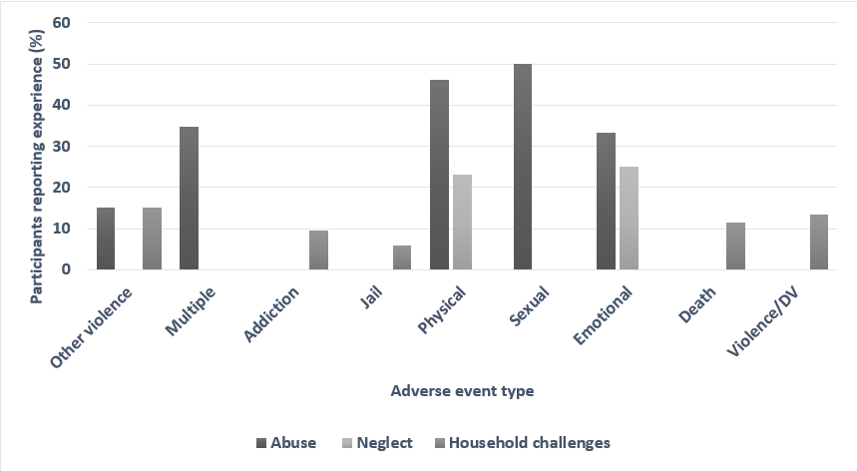
DV, domestic violence.
Witnessing violence against others at home (including parental domestic violence) experienced in childhood was reported in 13.5% of selected studies, with an average prevalence of 38.6% reported by these participants. Death of a parent or family member experienced in childhood was measured in 11.5% (SD 17.09) of selected studies, with an average prevalence of 31.2% reported by participants. Addiction or substance abuse by parent/family was measured in 9.6% of selected studies, with an average prevalence of 29.3% reported by participants.
A qualitative description of any associations between ACEs, anxiety, and chronic pain, and the strength of the reported association (strong, moderate, weak), was assigned based on the considerations described in the Methods. Of the selected studies, 41 (78.9%) had a moderate to strong association between ACEs and chronic pain. Eight studies had weak or no association (15.4%), and three did not have enough information to conclude or the study focus did not mention an association (5.8%).
Among the studies that associated anxiety and chronic pain without childhood adversity, nine had either a weak association or no association (17.3%), six had a moderate association (11.5%), and 22 had a strong association between anxiety and chronic pain (42.3%). The remainder did not have enough information to draw conclusions, or the study focus did not mention an association (28.9%).
Meta-analysis
The meta-analysis assessed the different relationships between ACEs, anxiety, and their influence and/or relationship with chronic pain, across several studies. As mentioned above, some studies were included more than once, but whenever it was possible, the separated measures were manually summarized to produce effects more in line with the rest of the studies and reduce the lack of independence between effect sizes in the meta-analysis. In studies where several categories of these variables were reported separately, each subcategory was included as a separate effect size in the meta-analysis.
Association between ACEs and pain
The first meta-analysis (Figure 3) explored the odds ratios (ORs) influencing chronic pain (or a pain condition) from presence/absence of ACEs. A total of 25 subsamples from 11 studies were included (Brennenstuhl & Fuller-Thomson 2015, Coles et al. 2015, Craner & Lake 2021, Fowler et al. 2020, Generaal et al. 2016, Kascakova et al. 2020, Krantz et al. 2019, McCall-Hosenfield et al. 2014, Sprang et al. 2020, Tietjen et al. 2009, Tietjen et al. 2016), resulting in an overall effect of OR = 1.99 (95%CI= [1.53, 2.60], p < 0.01). This indicated that participants who experienced ACEs were almost twice as likely to present chronic pain during adulthood. It should be noted that this analysis presented the largest between-study heterogeneity (I² = 93%, p < 0.01), reflecting the wide variety of pain conditions included across studies.
Figure 3. Likelihood of chronic pain presence in patients with ACEs compared to patients without ACEs
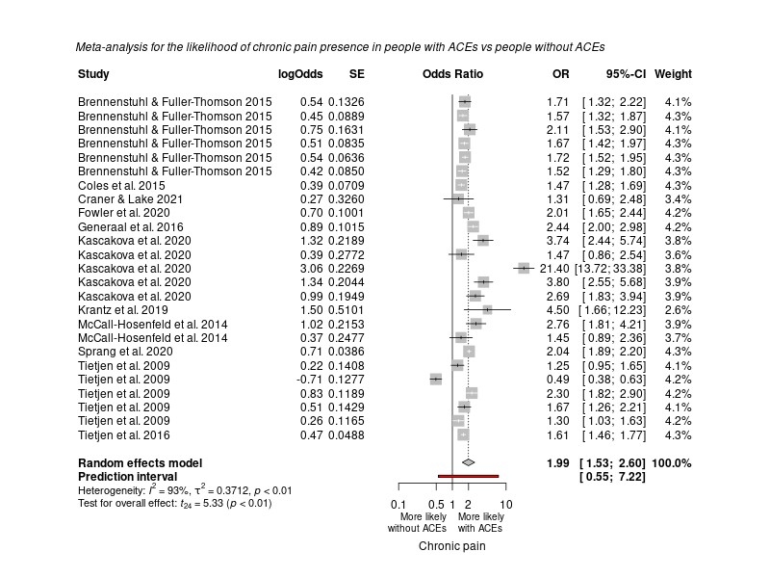
ACE, adverse childhood event; CI, confidence interval; OR, odds ratio; SE, standard error.
Additionally, it was possible to conduct a correlation between the index of ACEs as reported by different scales, and the intensity of chronic pain observed in patients. Pain intensity was measured either by self-report, or by records of the number of pain sites or chronic pain conditions.
A total of 15 different correlations were extracted from 13 studies (Alhalal et al. 2018, Brown et al. 2018, Corsini-Munt et al. 2017, Dennis et al. 2019, Kelly et al. 2011, Lai et al. 2016, Mehta et al. 2017, Ottenhoff et al. 2019, Piontek et al. 2021, Poli-Neto et al. 2018, Schrepf et al. 2018, Tietjen et al. 2009, Yeung et al. 2016), producing an overall correlation of r = 0.17 (95%CI = [0.11, 0.23], p < 0.001). This indicated there was a small but significant positive association between the index of ACEs and the intensity of chronic pain conditions in adulthood (Figure 4), such that the experience of more ACEs related to greater pain intensity. The meta-analysis had a large between-study heterogeneity (I² = 77%, p < 0.01).
Figure 4. Association between ACEs and pain
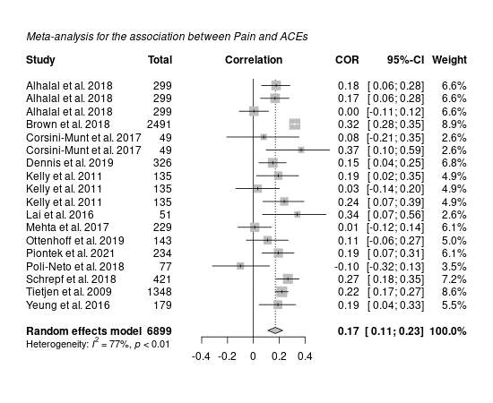
ACE, adverse childhood event; CI, confidence interval; COR, correlation.
Association between anxiety and pain
In assessing the association between anxiety and chronic pain, an OR meta-analysis was not possible using the available studies. However, a correlation meta-analysis was still achieved. As with the previous relationship, chronic pain intensity was measured using either self-reports of pain intensity, or the number of chronic pain conditions/pain sites reported. Anxiety, however, was measured using several standardized scales, including the HADS, GADS, and STAI.
As displayed in Figure 5, six different correlations were extracted from five studies (Corsini-Munt et al. 2017, Mehta et al. 2017, Dennis et al. 2019, Yeung et al. 2016, Piontek et al. 2021), producing an overall correlation of r = 0.30 (95%CI = [0.14, 0.45], p < 0.01). This indicated a significant moderate positive association between anxiety and chronic pain indices, such that higher anxiety symptomatology was associated with higher pain intensity. The analysis also had a moderate between-study heterogeneity (I² = 66%, p = 0.01).
Figure 5. Association between anxiety and pain
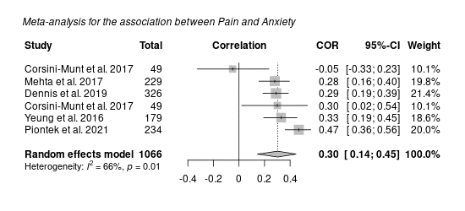
CI, confidence interval; COR, correlation.
Association between ACEs and anxiety
A correlation meta-analysis exploring the relationship between ACEs and anxiety was conducted. As stated previously, ACEs were measured using indices from scales such as the CTQ and the ACE scale, while anxiety was most often measured using common clinical instruments. As shown in Figure 6, 8 correlations across 8 studies were extracted (Corsini-Munt et al. 2017, Dennis et al. 2019, Lai et al. 2016, Mehta et al. 2017, Piontek et al. 2021, Poli-Neto et al. 2018, Schrepf et al. 2018, Yeung et al. 2016), producing an overall correlation of r = 0.26 (95%CI = [0.15, 0.36], p < 0.01), indicating a significant positive moderate association between ACEs and anxiety, such that greater frequency of ACEs related to greater anxiety symptoms. This analysis had a moderate between-study heterogeneity (I² = 59%, p = 0.02).
Figure 6. Association between ACEs and anxiety
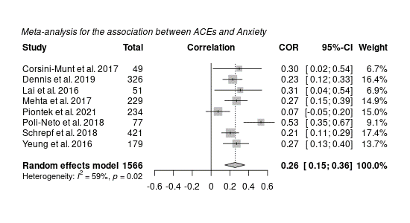
ACE, adverse childhood event; CI, confidence interval; COR, correlation.
Discussion
The results of this systematic review indicated that there was indeed substantial evidence available suggesting an association between childhood adversities and anxiety, and/or chronic pain experiences in adults, as well as associations between anxiety and pain. The meta-analyses further substantiated these relationships. There was an increased risk of chronic pain among those with ACEs and a small association between ACEs and chronic pain intensity. There were also moderate-sized significant associations between anxiety and chronic pain, as well as between ACEs and anxiety.
When examining the various types of adversity, results of the present narrative synthesis contrasted somewhat with past research in that sexual abuse was frequently reported on. For example, the CDC collection of ACEs data as a part of the Behavioural Risk Factor Surveillance Survey BRFSS indicated that sexual abuse was the least commonly reported ACE (Giano et al. 2020). This could be explained by variations in the ACE type studied, variations in the study sample characteristics, or simply variations in the ACE definitions. In one report, for example, the prevalence of reported child sexual abuse ranged from 7–36% for women and 3–29% for men, but then the WHO concluded 12% of children were sexually abused in 2015 (Broekhof et al. 2022) Additionally, the nature of ACE reporting indicates a shift to include more measures on not only physical and emotional abuse, but also neglect categories. This may provide valuable insight into any underlying changes associated with neglect and how that may overlap with the neurophysiological basis of anxiety as well, particularly in the context of adults with chronic pain that seems resistant to standard models of treatment. Further, some research in this area has focused on the specific type or number of ACEs. However, recent research by Broekhof et al. (2022) revealed a high amount of overlap between three ACE sub-types and individual ACEs, indicating that perhaps ACEs should be assessed as a combined group rather than individually.
ACEs and pain
The results of the meta-analysis revealed that participants who experienced an ACE were almost twice as likely to present chronic pain during adulthood. Although ACEs and the intensity of chronic pain were significantly associated too, this was a smaller effect. This is in line with findings which demonstrate that early-life adversity lays a critical foundation for health outcomes later in life, and there are already higher rates of chronic pain in adolescents who have reported one or more ACEs (Groenewald et al., 2020). By adulthood, ACEs can result in significant economic costs in the form of lost employment productivity and health care spending (NCSL, 2021). They are also associated with reduced adaptability and increased social isolation, reduced self-esteem, and increased rates of dissociation and anger hostility (NCSL, 2021). This highlights a substantial unmet need in treating adults with chronic pain who have a history of ACEs.
The role of anxiety
The results of the meta-analysis demonstrated a moderate-sized significant association between ACEs and anxiety, as well as a moderate-sized significant association between anxiety and chronic pain. When reviewing the narrative synthesis, most studies still indicated there was still an association between anxiety and chronic pain when excluding ACEs from the relationship assessment, but it was not significant. Similarly, a multivariate analysis showed that all ACE measures were significantly associated with higher odds of anxiety in youth, with the most significant increase if there were more than four ACEs reported (Elmore & Crouch 2021). Past research has clearly indicated long-term effects of ACEs on a variety of developmental problems, negative adult health outcomes (both psychological and physical), risky health-related behaviours, increased healthcare use, and higher financial burden (Bussières et al. 2020). In Europe and North America, for example, the total annual costs attributable to ACEs for the six main causes of health burden (cancer, diabetes, cardiovascular disease, respiratory disease, anxiety, and depression) was assessed to be between USD $417 and $487 billion; over 75% of this cost range was attributed to experiencing two or more ACEs (Bussières et al. 2020). Taken together, the findings highlight the importance of the ACEs-anxiety relationship in the context of personal, societal, and economic burden.
The present results add to the growing evidence of the importance of the ACEs-anxiety relationship in the context of chronic pain. The processing of pain is subject to different emotional and cognitive states across individuals (Tseng et al. 2017), many of which could be influenced by experiences of early life adversity, trauma, or violence. Patients who are in chronic pain may struggle with daily life and social activity, which are often seen as due to anxiety (Dueñas et al., 2016). The two have a complex relationship, and the results of this review highlight the need to target this relationship more directly, hopefully leading to better patient treatment options, higher quality of life despite the chronic pain, and lower costs annually. Additionally, this review held value by attempting to summarize the associations between all three variables, particularly indicating that anxiety could be a mediator in the association between ACEs and chronic pain, something that needs to be explored in future research. Studies featuring ACE prevalence are informative, but policy and work settings do not reflect how this could be incorporated and applied to address these issues, such as by offering discrete screening options for employees on risk factors and providing appropriate accommodations if found.
Strengths, weaknesses of existing studies, and implications for future research
Strengths of the studies incorporated in this review include that some studies now also include neglect in the measurement of childhood adversity alongside abuse, which means this research will now be able to more comprehensively demonstrate the impact of ACEs beyond more commonly acknowledged forms of abuse. Further, studies included a broad range of measuring chronic pain occurrence and intensity, which is likely to mean any associations with ACEs or anxiety are not underestimated. The meta-analyses did show an increased risk of chronic pain among those with ACEs and a small association between ACEs and chronic pain intensity, as well as moderate-sized significant associations between anxiety and chronic pain, and between ACEs and anxiety. Some key weaknesses were the known limitations of self-report measures, which are subject to recall bias, the potential for improper self-diagnosis, and gaps in a participant’s memory due to the young age of abuse and/or memories missing due to trauma. However, these studies are still valuable and worth including in this review to provide a more robust sample for analysis. Including only studies of those with diagnoses would likely underestimate any associations between these variables, given that many individuals may not seek medical help for anxiety and/or chronic pain (Clark et al. 2017). In future research of this type, it is recommended that both diagnosis of, and self-report measures of ACEs and anxiety, be included to maximise potential understanding of the associations between these factors and chronic pain. However, well-validated standardised commonly used measures should be implemented where possible to enable comparison of associations across studies. Further, studies incorporating ACE assessment should measure neglect as well as abuse, and also seek to standardise the assessment of a broader range of pain outcomes. Finally, the age range in the included articles was somewhat limited, and it would be of value for studies to examine whether the impact of ACEs on anxiety and chronic pain is maintained well into older adulthood, i.e., in those aged 65+ years.
Practical Implications and future directions
Chronic pain treatments and opioid abuse have been a topic for decades, but until the underlying mechanisms of pain are better understood, outcomes are unlikely to change, and treatments will continue to fall short (Phillips et al. 2017). By examining the potential influence anxiety has in chronic pain mechanisms via altered neurobiology potentially due to ACE history, and thus the corresponding impact on typical nerve behaviour, new treatment options could be developed. Historically, it is commonly known how impactful mirror‐therapy was for veterans and other individuals with painful phantom‐limb syndrome (Chan et al. 2019). Although this study had a very specific target population, it would be beneficial to examine the feasibility of perception‐based treatment options in place of opioid prescriptions for individuals with anxiety and pain, particularly when considering the biological predispositions (i.e., vulnerabilities) that may be present due to a history of childhood adversity.
The prevalence rates identified in this systematic review could be useful in better understanding the underlying mechanisms of how the brain may respond to trauma or violence, particularly for those struggling with anxiety and chronic pain that are resistant to standard treatment models or interventions. When considering that the origin of a patient’s symptomology may be rooted in developmental dysfunction attributable to early life adversity, it may help inform on and encourage new treatment options that are not exclusively designed according to standard functioning models of human development. Although this meta-analysis highlights a potential mediating effect of anxiety in the ACEs-chronic pain relationship, this was not possible to explore in the present analyses and warrants further investigation.
In addition, evidence-based precision health care has gained more traction in recent years. Although there are multiple evidence-supported psychotherapy (such as dialectical or cognitive behavioural therapy) and clinical intervention options, to date, no single approach, therapist, or treatment successfully helps every patient (Zilcha-Mano et al. 2022). Despite the prevalence of ACEs, many providers remain uncomfortable treating and recognizing trauma, particularly in the paediatric setting when the opportunity for intervention and prevention are still possible. In a hospital-wide survey assessing provider’s comfort with trauma-informed care, less than 40% of staff members felt sufficiently equipped to screen for ACEs and only 34% felt they could make an informed, appropriate referral to follow-up trauma services. Additionally, 80.5% felt the resources available for identified survivors of trauma, ACEs, or violence were inadequate (Slater 2021). While not everyone who has had an ACE is going to develop anxiety and later chronic pain, these types of screening factors could be a useful tool for assessing a patient’s future risk and potentially improving the current attempts at establishing pathways for individualized, tailored care.
Strengths and Limitations of this Review
As qualitative systematic literature reviews may be subject to interpretation bias, meta-analyses were also conducted, which follow a more objective and rigorous statistical procedure (Siddaway et al., 2019). Additionally, the present results—systematically summarising over two decades of research—meaningfully add to the growing evidence on the importance of the ACEs-anxiety relationship in the context of chronic pain in adults. However, there are some limitations to consider. Measures of anxiety in the included studies could be either by diagnosis or self-report, which covers a wide range of severity and includes non-diagnosed participants. However, the self-reports were in most cases based on standardised psychometric tools, increasing validity and giving a measure of severity. An important limitation was the wide variety of ACEs and chronic pain manifestations, resulting in variation in the methods, populations, and theoretical perspectives of the studies. Consequently, not every study could be included in the analysis for each association. Further, including non-independent samples effect sizes can also potentially introduce bias through increasing the impact of one or two studies with multiple effect sizes contributing to the overall effect size. However, when more than two or three measures are used in multiple studies to be included in a meta-analysis, conducting sensitivity analyses for every pair of outcomes is not considered feasible (Scammacca et al., 2014). Another reason for non-independent effect sizes is that the effect sizes of the independent samples are nested within a primary study (Cheung 2019). Although averaging the effect sizes or selecting one effect size within a study may remove valuable within-study variations stemming from potential moderators, the effect sizes within a study may represent different types of measures and conditions. When performing the meta-analysis, there was heterogeneity in the constructed variables measured across studies; therefore, it was not considered prudent to further attempt to synthesize the relationships between effects across psychological measurements that were too heterogeneous across studies in the first place (Cheung 2019). Other limitations included combining the reported findings from multiple countries, as there are different methods or reporting, different types of abuse categories, and potentially different levels of comprehension across translated questionnaires, particularly for abuse and violence and trauma terminology.
Conclusions
Based on the results of this systematic review, there was a significant association between childhood adversities, anxiety, and chronic pain experiences in adults. The meta-analyses showed moderate associations between anxiety and chronic pain as well as between ACEs and anxiety and found that participants who experienced ACEs are almost twice as likely to present chronic pain during adulthood. Providers, educators, and those who work in mental health with adults who suffer from anxiety and chronic pain may benefit by also screening for a history of adversity, so they can more comprehensively support their patients/staff/students, potentially through a broader range of available treatments, and help them improve their resilience and achieve more positive outcomes in adult life.
Chapter 2 references
Aromataris E, Munn Z (Editors). JBI Manual for Evidence Synthesis. JBI, 2020. Available from https://synt hesismanual.jbi.global. https://doi.org/10.46658/JBIMES-20-01.
Bhui K, Dinos S, Galant-Miecznikowska M, de Jongh B, Stansfeld S. Perceptions of work stress causes and effective interventions in employees working in public, private and non-governmental organisations: a qualitative study. BJPsych Bull. 2016;40(6):318-325. doi:10.1192/pb.bp.115.050823.
Bremner JD. Traumatic stress: effects on the brain. Dialogues Clin Neurosci. 2006;8(4):445-461. doi:10.31887/DCNS.2006.8.4/jbremner.
Brown, R. C., Plener, P. L., Braehler, E., Fegert, J. M., & Huber‐Lang, M. (2018). Associations of adverse childhood experiences and bullying on physical pain in the general population of Germany. Journal of pain research, 11, 3099–3108. Doi:10.2147/JPR.S169135.
Bussières, A., Hartvigsen, J., Ferreira, M.L. et al. Adverse childhood experience and adult persistent pain and disability: protocol for a systematic review and meta-analysis. Syst Rev 9, 215 (2020). https://doi.org/10.1186/s13643-020-01474-8.
Centers for Disease Control and Prevention (CDC). Adverse Childhood Experiences (ACEs). (2022). https://www.cdc.gov/violenceprevention/aces/index.html. Accessed 21 April 2022.
Chan AW, Bilger E, Griffin S, Elkis V, Weeks S, Hussey-Anderson L, Pasquina PF, Tsao JW, Baker CI. (2019). Visual responsiveness in sensorimotor cortex is increased following amputation and reduced after mirror therapy. Neuroimage Clin. 23:101882. doi: 10.1016/j.nicl.2019.101882.
Cheung, M.WL. A Guide to Conducting a Meta-Analysis with Non-Independent Effect Sizes. Neuropsychol Rev 29, 387–396 (2019). https://doi.org/10.1007/s11065-019-09415-6.
Clark, L. A., Cuthbert, B., Lewis-Fernández, R., Narrow, W. E., & Reed, G. M. (2017). Three Approaches to Understanding and Classifying Mental Disorder: ICD-11, DSM-5, and the National Institute of Mental Health’s Research Domain Criteria (RDoC). Psychological Science in the Public Interest, 18(2), 72–145. https://doi.org/10.1177/1529100617727266.
Critical Appraisal Skills Programme (2022). CASP Systematic Review Checklist. [online] Available at: https://casp-uk.net/casp-tools-checklists. Accessed: 30 July 2022.
Crocq M. A. (2015). A history of anxiety: from Hippocrates to DSM. Dialogues in clinical neuroscience, 17(3), 319–325.
Diagnostic and Statistical Manual (DSM) of Mental Disorders (2013). 5th ed. Arlington, VA: American Psychiatric Association.
Dueñas M, Ojeda B, Salazar A, Mico JA, Failde I. A review of chronic pain impact on patients, their social environment and the health care system. J Pain Res. 2016;9:457-467. Published 2016 Jun 28. doi:10.2147/JPR.S105892.
Elmore AL, Crouch E. The Association of Adverse Childhood Experiences With Anxiety and Depression for Children and Youth, 8 to 17 Years of Age. Acad Pediatr. 2020 Jul;20(5):600-608. Doi: 10.1016/j.acap.2020.02.012.
Giano, Z., Wheeler, D.L. & Hubach, R.D. The frequencies and disparities of adverse childhood experiences in the U.S. BMC Public Health 20, 1327 (2020). https://doi.org/10.1186/s12889-020-09411-z.
Groenewald, C. B., Murray, C. B., & Palermo, T. M. (2020). Adverse childhood experiences and chronic pain among children and adolescents in the United States. Pain reports, 5(5), e839. https://doi.org/10.1097/PR9.0000000000000839.
Kalia V, Knauft K, Hayatbini N. Cognitive flexibility and perceived threat from COVID-19 mediate the relationship between childhood maltreatment and state anxiety. PLoS One. 2020;15(12):e0243881. Published 2020 Dec 11. doi:10.1371/journal.pone.0243881.
Merrick MT, Ford DC, Ports KA, et al. (2019). Vital Signs: Estimated Proportion of Adult Health Problems Attributable to Adverse Childhood Experiences and Implications for Prevention — 25 States, 2015–2017. MMWR Morb Mortal Wkly Rep. 68:999-1005. DOI: http://dx.doi.org/10.15585/mmwr.mm6844e1.
Michopoulos V, Powers A, Gillespie CF, Ressler KJ, Jovanovic T. (2017). Inflammation in Fear- and Anxiety-Based Disorders: PTSD, GAD, and Beyond. Neuropsychopharmacology. 42(1):254-270. doi: 10.1038/npp.2016.146.
Morasco, B. J., Lovejoy, T. I., Lu, M., Turk, D. C., Lewis, L., & Dobscha, S. K. (2013). The relationship between PTSD and chronic pain: mediating role of coping strategies and depression. Pain, 154(4), 609–616. https://doi.org/10.1016/j.pain.2013.01.001.
Mourad Ouzzani, Hossam Hammady, Zbys Fedorowicz, and Ahmed Elmagarmid. Rayyan — a web and mobile app for systematic reviews. Systematic Reviews (2016) 5:210, DOI: 10.1186/s13643-016-0384-4.
National Conference of State Legislators (NCSL). (2021). Adverse Childhood Experiences. https://www.ncsl.org/research/health/adverse-childhood-experiences-aces.aspx
National Heart, Lung, and Blood Institute (NHLBI) National Institutes of Health (NIH): Quality Assessment of Systematic Reviews and Meta-Analyses (2021). Available at: https://www.nhlbi.nih.gov/health-topics/study-quality-assessment-tools. Accessed 30 July 2022.
Nicolson KP, Mills SEE, Senaratne DNS, Colvin LA, Smith BH. What is the association between childhood adversity and subsequent chronic pain in adulthood? A systematic review. BJA Open. 2023 Jun 7;6:100139. doi: 10.1016/j.bjao.2023.100139.
Phillips JK, Ford MA, Bonnie RJ, editors. (2017). Pain Management and the Opioid Epidemic: Balancing Societal and Individual Benefits and Risks of Prescription Opioid Use. Washington (DC): National Academies Press (US); 4, Trends in Opioid Use, Harms, and Treatment. Available from: https://www.ncbi.nlm.nih.gov/books/NBK458661.
R Core Team (2021). R: A language and environment for statistical computing. R Foundation for Statistical Computing, Vienna, Austria. URL https://www.R-project.org.
Robinson OJ, Vytal K, Cornwell BR, Grillon C. The impact of anxiety upon cognition: perspectives from human threat of shock studies. Front Hum Neurosci. 2013;7:203. Published 2013 May 17. Doi:10.3389/fnhum.2013.00203.
Ryan R; Cochrane Consumers and Communication Review Group. ‘Cochrane Consumers and Communication Group: meta-analysis. http://cccrg.cochrane.org. December 2016. Accessed 15 August 2023.
Sakamoto, Y., Oka, T., Amari, T., and Simo, S. (2019). Factors Affecting Psychological Stress in Healthcare Workers with and without Chronic Pain: A Cross‐Sectional Study Using Multiple Regression Analysis. Medicina, 55(10), 652; https://doi.org/10.3390/medicina55100652.
Scammacca N, Roberts G, Stuebing KK.(2014). Meta-Analysis With Complex Research Designs: Dealing With Dependence From Multiple Measures and Multiple Group Comparisons. Rev Educ Res. Sep 1;84(3):328-364. doi: 10.3102/0034654313500826.
Siddaway, A. P., Wood, A. M., & Hedges, L. V. (2019). How to do a systematic review: A best practice guide for conducting and reporting narrative reviews, meta-analyses, and meta-syntheses. Annual Review of Psychology, 70, 747– 770.
Slater, L. (2021). How to Identify and Address Childhood Trauma in Primary Care Settings: AACAP 2021. https://pro.psycom.net/news-research/conference-coverage/aacap-how-to-identify-and-address-childhood-trauma-in-primary-care-settings. Accessed July 30, 2023.
The Joanna Briggs Institute (JBI) tool: Checklist for Systematic Reviews and Research Syntheses (2020). Available at: https://jbi.global/critical-appraisal-tools. Accessed: 30 July 2022.
Tseng MT, Kong Y, Eippert F, Tracey I. Determining the Neural Substrate for Encoding a Memory of Human Pain and the Influence of Anxiety. J Neurosci. 2017;37(49):11806-11817. Doi:10.1523/JNEUROSCI.0750-17.2017.
Woo AK. Depression and Anxiety in Pain. Rev Pain. 2010 Mar;4(1):8-12. doi: 10.1177/204946371000400103.
World Health Organization: Preventing child maltreatment: a guide to taking action and generating evidence/World Health Organization and International Society for Prevention of Child Abuse and Neglect. 2006 World Health Organization. https://resourcecentre.savethechildren.net/document/preventing-child-maltreatment-guide-taking-action-and-generating-evidence. Accessed 18 June 2022.
Zilcha-Mano, S., Constantino, M. J., & Eubanks, C. F. (2022). Evidence-based tailoring of treatment to patients, providers, and processes: Introduction to the special issue. Journal of Consulting and Clinical Psychology, 90(1), 1–4. https://doi.org/10.1037/ccp0000694.

Chapter 3: UK-based study—An analysis on history of childhood adversity, anxiety, and chronic pain in adulthood and the influence of inflammatory biomarker C-reactive protein
Based on the identified needs for future research within the systematic review and meta-analysis on the relationship between ACEs and anxiety on chronic pain experience in adults, the potential role of inflammatory biomarker C reactive protein (CRP) was analysed in a sample of 2007 adults who participated in the UK Biobank study. This analysis also included examination of the associations between ACEs, anxiety, and chronic pain in the same sample. These analyses led from the systematic review and meta-analysis by identifying a lack of clarity on the underlying mechanisms potentially at play in this association, such as systematic inflammation. This statistical analysis was independently carried out by the author of this thesis with supervision from PhD supervisors (AW, LC, and GM), and all supervisors guided in directions for re-analysis and write-up/review of the publication. This chapter has been published in Nature Scientific Reports:
Dalechek, D.E., Caes, L., McIntosh, G. et al. An analysis on history of childhood adversity, anxiety, and chronic pain in adulthood and the influence of inflammatory biomarker C-reactive protein. Sci Rep 13, 18000 (2023). https://doi.org/10.1038/s41598-023-44874-1.

Abstract
Despite a link between adverse childhood experiences (ACEs) and anxiety, the role of anxiety in the pathway to chronic pain is unclear. Potentially, inflammatory biomarkers such as C-reactive protein (CRP) are involved. Objectives were to (1) examine relationships between reported ACEs, anxiety, and chronic pain, and (2) assess associations between ACEs, anxiety, and CRP levels and between CRP and chronic pain. Data from 24,172 adults who participated in the UK Biobank were used to conduct Poisson regressions to assess relationships between ACEs, anxiety, and chronic pain. For participants with CRP data who met the inclusion criteria (n = 2007), similar models were run between ACEs, anxiety, and CRP, and CRP and chronic pain. For objective 1, three statistically significant interactions were found to predict pain: frequency of physical abuse x reported muscular symptoms during anxiety (p = 0.01); frequency in which they felt hated x having discussed anxiety with a professional (p = 0.03), and reported frequency of sexual abuse x difficulties relaxing during anxiety attacks (p = 0.03). For objective 2, frequency of sexual abuse and informing a professional about anxiety significantly interacted to predict elevated CRP. For correlations, the largest was between CRP and the number of times pain was reported over the years (p = 0.01). Finally, ACEs (physical abuse, sexual abuse, and whether taken to a doctor) significantly interacted with CRP to predict pain. This study suggests mechanisms of the impact of ACEs on chronic pain may include inflammation and anxiety, which warrants further study.

Introduction
During traumatic and tense experiences, the brain is in a heightened state of stress, which can have negative impacts over time (Bremner 2006). Existing research has focused on behavioural responses, emotional development, and mental and physical health after stress, but research addressing a direct link between anxiety as a response to trauma and the experience of chronic pain in adults is limited. The long‐term impacts of the hyperarousal experienced in situations of high anxiety and stress are not fully understood when considering pain, although studies on depression and posttraumatic stress disorder (PTSD) have examined how these conditions are associated with pain experiences². For example, one study (Morasco et al. 2013) found that specific pain coping strategies and depressive symptoms had a partially mediating effect on the relationship between PTSD and both pain interference and severity. Prior studies of depression have also indicated a higher prevalence of inflammation, particularly in adults who experienced early life a diversity (Miller 2020).
Additionally, a large body of research has examined whether early life adversity or childhood adverse experiences (ACEs) contribute to the development of chronic pain in adulthood. The concept that childhood maltreatment predisposes individuals to develop pain conditions has been especially prevalent for disorders that involve unexplained pain paired with psychological complaints such as anxiety. One mechanism identified as a potential mediator of the relationship between ACEs and later vulnerability to chronic pain in adulthood is dysregulation of the hypothalamic pituitary adrenocortical (HPA) axis (Nicolson et al. 2010). The HPA axis is a complex system of neuroendocrine pathways involving the hypothalamus, anterior pituitary gland, and adrenal gland that function to maintain physiological balance via metabolism, immune responses, and the autonomic nervous system (Sheng et al. 2020). Experiencing ongoing ACEs may influence both the degree and the direction of HPA axis abnormalities (Gunnar & Vazquez 2006) These abnormalities can then affect other biological processes such as inflammation (Chrousos 1995; Muniz Carvalho et al. 2021).
Specific inflammatory processes, as reflected by blood-based markers such as C-reactive protein (CRP)—a protein that responds to inflammatory stimuli by triggering cellular reactions—could also be involved in the biological component effects of ACEs. Elevated levels of proinflammatory cytokines like interleukins—a downstream product of CRP signalling, and acute-phase proteins including CRP—have been observed in the plasma of individuals who have experienced ACEs (Wei et al. 2020). Meta-analyses of cross-sectional studies have also confirmed the association of higher inflammation with traumatic experiences (Wei et al. 2020).
Further, longitudinal studies have provided evidence supporting a bidirectional association: elevated inflammation may contribute to trauma symptoms, which in turn contribute to more elevated inflammation. Trauma symptoms are also known to be associated with several chronic diseases that have a confirmed inflammatory component, ranging from cardiovascular to chronic pain (Wei et al. 2020). Neuropeptides, which can exhibit a variety of inflammatory effects, modulate neural activity and other tissues, including the gut and heart (Milaneschi et al. 2021)., and it is possible that ACE exposure could impact normal neuropeptide synthesis. This can lead to disruptions in HPA axis development, which may then lead to abnormal physiological functioning in adulthood and increase the risk for disease and chronic problems in adulthood (Sheng et al. 2021).
Beyond their link with trauma symptomology, proinflammatory cytokines at higher levels may also influence neurotransmission. This can result in an altered production of neurotransmitters, which may be associated with specific psychiatric symptoms, and these cytokines could also impact neurocircuitry, causing changes in an individual’s levels and functionality of motivation, alarm-based responses, and anxiety (Wei et al. 2020). However, studies of inflammation and anxiety symptoms remain scarce (Zhuo et al. 2016). Indeed, most prior studies on anxiety were typically limited to the context of psychology and exclude a biological component (Monnat & Chandler 2015). In the last decade, neuroimaging studies have improved insights of brain pathways potentially mediating an anxiety–chronic pain interaction, with multiple brain areas implicated including the amygdala, anterior cingulate cortex, and insular cortex (Monnat & Chandler 2015).
There remains a lack of understanding of the complex pathways linking ACEs to poor adult health outcomes and exactly how those pathways may vary across different adverse adult outcomes, such as chronic pain versus heart disease (Ramirez et al. 2022). In particular, despite a clear link between anxiety and ACEs, as well as between anxiety and chronic pain, the role of anxiety in the pathway between ACEs and chronic pain is not yet understood. Limited evidence suggests that ACEs can influence biophysiological functioning in adults with chronic pain. However, whether the link between ACEs and biophysiological functioning is unique to individuals with chronic pain or can be accounted for or exacerbated by current psychopathologies or inflammatory biomarkers remains unclear. Understanding the potential mechanisms underlying the ACE-inflammation association could potentially lead to important implications for systemic-level dysfunction after early life adversity and resulting health outcomes in adulthood. The purpose of the current analysis was to examine the relationships between reported ACE(s), anxiety, and levels of CRP in adults with chronic pain.
Primary objectives
The first objective of this study was to investigate the relationship between ACEs, anxiety diagnosis, and chronic pain experience. A second objective was to explore whether ACEs, anxiety, and chronic pain experiences in adults are also associated with the inflammatory biomarker CRP and examine its role in the ACE-anxiety-pain pathway. It was hypothesized that there would be a significant association between ACEs, anxiety, and chronic pain experiences, and that CRP may also relate to some or all of these variables.
Methods
Data source
The dataset used—the UK Biobank (UKB)—holds an unprecedented amount of data on half a million participants aged 40–69 years (with a roughly even number of men and women) recruited between 2006 and 2010 throughout the UK. This retrospective analysis involved deidentified case data from 25,249 adults who participated in the UKB and met the inclusion criteria for this study. General inclusion for the current analyses required adults with at least one chronic pain measure (from Table 1), reported history of ACEs, and reported anxiety. Participants were excluded if they reported no anxiety, no chronic pain, and no ACEs.
Each objective had a different sample size due to exclusion criteria and availability of records. The way each exclusion criterion was interpreted was different for each. If the participant was excluded due to no anxiety, it meant they did not meet one of the three included anxiety measures (had informed a professional about their anxiety, reported muscular symptoms related to anxiety episodes, or reported trouble relaxing in relation to anxiety episodes). For exclusion due to no chronic pain, the person never reported pain of any type during their visits. For exclusion due to no ACEs, the participant did not report on at least one instance of an ACE as assessed by the biobank (see Table 1).
Ethical approval for this study was provided by the University of Stirling General University Ethics Panel, Stirling, UK (reference: EC 2023 13946 9461); all research was performed in accordance with relevant guidelines/ regulations.
Variables
The UKB datasets include genetics, self-reported medical outcomes, mental health, and more. For this study, the UKB factors of interest examined for this analysis are displayed in Table 1. These UKB factors represent the variables of interest for this study, which were ACE history, self-reported anxiety, and a chronic pain condition for the primary outcomes. The secondary variable included the presence of the inflammatory biomarker CRP.
Table 1. Factors of Interest from the UKB. UKB, UK Biobank.
Biobank ID | Description | Category* | Response type
1018 | Mental health (via online follow-up questionnaire)
20487 | Felt hated by family member as a child | ACE/Traumatic events | Scale (never–very often)
20488 | Physically abused by family as a child | ACE/Traumatic events | Scale (never–very often)
20489 | Felt loved as a child | ACE/Traumatic events | Scale (never–very often)
20490 | Sexually abused* as a child | ACE/Traumatic events | Scale (never–very often)
20491 | Someone to take to doctor when needed as a child | ACE/Traumatic events | Scale (never–very often)
20428 | Professional informed about anxiety | Anxiety | Yes/no
20417 | Tense, sore, or aching muscles during worst period of anxiety | Anxiety | Yes/no
20515 | Recent trouble relaxing | Anxiety | Scale (not at all–nearly every day)
1003 | Self-reported medical conditions (via touchscreen)
3571 | Back pain for 3 + months | Chronic pain | Yes/no
4067 | Facial pains for 3 + months | Chronic pain | Yes/no
2956 | General pain for 3 + months | Chronic pain | Yes/no
3799 | Headaches for 3 + months | Chronic pain | Yes/no
3414 | Hip pain for 3 + months | Chronic pain | Yes/no
3773 | Knee pain for 3 + months | Chronic pain | Yes/no
3404 | Neck/shoulder pain for 3 + months | Chronic pain | Yes/no
3741 | Stomach/abdominal pain for 3 + months | Chronic pain | Yes/no
717 | Biomarkers
30710 | C-reactive protein | Blood biochemistry | Instances 0–1 (mg/L)
*The category of childhood “traumatic events” as defined by the UKB was our marker of ACEs or early life adversity. Sexual abuse was written as molestation in the questionnaire, but we have updated abuse throughout this manuscript for consistency.
The independent variables were anxiety and history of childhood adversity, and the dependent variables were eight different pain measures (as listed in Table 1).
ACEs: Childhood adversity was operationalized by means of the five separate variables shown in Table 1 and scored as negative or positive (the third [item 20489] and fifth [item 20491] were reverse scored so that a higher score reflected more childhood adversity). Negative included reports of “felt hated”, “physically abused”, and/or “sexually abused” in childhood. Positive included “felt loved” and/or “taken to a doctor if needed”. NA reports were omitted.
Anxiety: Anxiety was operationalized as the three separate anxiety items (Table 1) scored as Yes/No for two of the items (i.e., items 20428, 20417) and by the reported frequency of the third (item 20515). In addition to yes and no responses, recoding was conducted to accommodate the N/A cases as “no”. This was because the first two items had ‘prefer not to answer’ and ‘do not know’ response options so we were confident handling missing or no response as reflecting some level of the respondent not agreeing with any of the options or simply that they were unwilling to identify themselves as having anxiety. This was felt to be the most conservative way to deal with missing data where we were unable to infer why a participant might choose not to answer a question. As per the UK Biobank’s study protocol (p18 and p69; available at https:// www. ukbio bank. ac. uk/ media/ gnkey h2q/ study- ratio nale. pdf), it is also worth noting participants had the option to skip questions whether due to sensitivity or otherwise, and for privacy reasons this was deemed acceptable. Additionally, other recent studies have handled this similarly, such as Ramirez et al. (2022) in that they handled skipped UK Biobank questions by omitting them, and changing prefer not to answer to N/A since the true reason cannot be inferred retrospectively for participants (R Core Team 2022). For variables such as smoking, participants who skipped the questions were fully excluded.
Chronic pain: For pain, coding required at least one measure of chronic pain reported (Yes/No), and if available, the number of times pain was reported over the data collection period of the UKB (at the time of this analysis) was captured. As shown in Table 1, for all pain measures included in this analysis, duration was required to be at least 3 months to differentiate the pain as chronic versus acute. This set of reporting was defined as “Reports of pain”, which is a numeric variable counting and summing all the chronic pain reported (in any category from Table 1) across the average 7 years of follow-up currently available in UKB (representing a baseline Assessment Centre visit between 2006–2010, and follow-up visits 2012–2013, 2014 +, and/or 2019 +). This score represented all types of pain reported at each visit (from Table 1) across all years which were counted and aggregated into a single variable (most frequently ranging from 0–7). Pain data were collected at the Assessment Centre using a touchscreen self-report system for each visit.
C-reactive protein: CRP (item 30710) was measured by immunoturbidimetric-high sensitivity analysis on a Beckman Coulter AU5800 and captured over two assessments: the initial assessment between 2006 and 2010 (468,441 participants) and the first repeat assessment between 2012 and 2013 (17,835 participants). The UKB used CRP as a defined variable, meaning more than one instance may be present, and each instance represented a fixed identifiable set of results across all participants. For CRP, the defined-instances (visits) ran from 0 (baseline visit) to 1 (first follow-up visit) and were labelled using instancing 2 (the sum of 0–1 captured in mg/L). This data is considered ‘accruing’ and may have a comparable level at a later timepoint; to date we have instance 2 (the summary of visit 0 and 1). The UKB does note the presence of a dilution problem that was observed to increase with aliquot number for certain serum samples; however, as CRP has a high biological coefficient of variation, it was unaffected and did not require an estimation correction or adjustment. With the secondary analyses, the addition of CRP was captured by recorded visits and the CRP average (mg/L). N/A cases were omitted, and the mean and variance were calculated.
Analyses
Coding for all analyses was conducted using R software (R Core Team 2022). As the dependent variable for the primary analysis (i.e., chronic pain) was count data, a Poisson regression model was determined to be the most suitable. This model enters all variables (i.e., the five ACE scores and the three anxiety indices) as well as their potential interactions. To answer the research questions, a generalized linear model using Poisson as the family (Poisson regression) was used. For questions with which the person could answer (yes, no, prefer not to answer), all the "yes" answers were coded as such, and any other answer was interpreted as a "no" (this includes non-answers). For the secondary CRP analysis, correlations between all variables of interest and CRP were assessed; Spearman correlations with Holm correction were used. Additionally for the CRP sample, a simplified version of the final model was created and compared against a corresponding adjusted version with socio-demographic/health behaviour variables added in to identify how such factors may be affecting the results via a generalized linear mixed-effects model (GLM; with a Poisson distribution family).
Further details on the analysis decisions and background can be viewed in Appendix A. Additionally, Appendix B details the preliminary SEM conducted, which helped prioritize the analyses choices for the objectives. Stepwise regression was used to select the best fitting model (i.e., the combination of variables and interactions that better explain the dependent variable Reports of Pain). This puts all variables in and then iteratively remodels fit by backward elimination of non-significant variables (displayed in Table S2 of Appendix B). For missingness, the R na.omit() function was used to handle missing data as it removes any row that has a missing value in it. For large samples such as the UKB, this is standard practice.
Results
Sample characteristics
The UKB demographics details can be reviewed in Table 2. Of the 9,238,453 men and women initially invited to join the UK Biobank, 503,317 (5.45%) provided informed consent and were recruited between 2006 and 2010. Overall, the participation rate was higher in women (participation rates were 6.4% and 5.1% in women and men, respectively) (Fry et al. 2017).
Each objective had a different sample size due to exclusion criteria and availability of records. Of the eligible cases, a total of 1077 records were omitted due to having missing responses in at least one of the variables of interest, and an additional 8 cases were omitted due to participants withdrawing from the UKB at the time of analysis.
Table 2. Self-reported ethnicity of UK biobank participants (recruited in 2006–2010) with census data for the age group 40–69 years in England, Wales, and Scotland in 2001 and 2011ª.
Ethnicity^{b} | UK Biobank  (n = 499,877)  No. of Persons | % | 2001 UK Census (n = 20,198,307)  No. of Persons | % | 2011 UK Census  (n = 23,146,612)  No. of Persons | %
White^{c} | 472,837 | 94.6 | 19,085,322 | 94.5 | 21,133,317 | 91.3
Black or black British^{d} | 8066 | 1.6 | 302,073 | 1.5 | 565,777 | 2.4
Mixed^{e} | 2958 | 0.6 | 82,389 | 0.4 | 191,085 | 0.8
Indian | 5951 | 1.2 | 325,651 | 1.6 | 442,338 | 1.9
Pakistani | 1837 | 0.4 | 147,695 | 0.7 | 239,166 | 1.0
Bangladeshi | 236 | 0.0 | 46,220 | 0.2 | 75,919 | 0.3
Chinese | 1574 | 0.3 | 70,572 | 0.3 | 109,412 | 0.5
Other Asian | 1858 | 0.4 | 73,917 | 0.4 | 240,324 | 1.0
Other ethnic group | 4560 | 0.9 | 64,468 | 0.3 | 149,274 | 0.6
ª Census datasets sourced from the Register Office and Office for National Statistics; National Records of Scotland; Northern Ireland Statistics and Research Agency (ONS 2016).
^{b} Excludes 2,778 UK Biobank participants aged 40–69 years who were missing data on ethnicity or responded “prefer not to answer” or “do not know.”
^{c} Included white British, white Irish, and other white backgrounds.
^{d} Included Caribbean, African, and other black background.
^{e} Included white and black Caribbean, white and black African, white and Asian, and other mixed ethnic backgrounds.

Thus, the final total number of cases available for the initial analysis was 24,164. In this sample, 61% reported female and 39% male. For the second objective, only n = 2007 individuals had records of CRP testing along with the initial inclusion criteria, so the sample size is considerably lower in comparison to the analysis for the first objective. In this second sample, 55% reported female and 45% male. For the simplified final CRP model to assess socioeconomics, five records were missing, making the total 2002 cases.
Poisson regression results
Objective 1
The theoretical assumptions of the Poisson regression model were met, and the practical assumption of variance and mean being equals were also met (variance: 2.15, mean: 2.04). Stepwise regression was then used to select the best fitting model (i.e., the combination of variables and interactions that better explain the dependent variable [Reports of Pain]). The anxiety variable with the most influence on reported pain was the presence of muscular symptoms related to anxiety, followed by having informed a professional about their anxiety, and then the amount of trouble relaxing reported. With regard to ACE variables, the variable with the most influence was the frequency of physical abuse, followed by the frequency with which the person felt loved as a child. The remaining childhood trauma variables did not show a significant effect on reported pain. The full results are reported in Appendix Table S2.
Objective 2
All associations examined for the secondary analysis are displayed in the heat map correlation matrix (Fig. 1). In brief, the strongest correlation was between CRP and the number of times pain was reported over the years (p = 0.01), followed by CRP and the reported frequency of sexual abuse in childhood (p = 0.05).
Additionally, Poisson regression models were conducted with the smaller sample for which CRP levels were available to assess the potential pathways of any relationships between the three concepts of interest and chronic pain as the outcome variable. These results are shown in Table 3. Of note, there was an important interaction between informing a professional about anxiety and CRP in predicting pain. Childhood abuse also interacts significantly with CRP to predict pain.
To further break down, contextualize, and examine the results of the Poisson regression more clearly, variable regression plots were conducted. These studies investigated each individual relationship, isolating it and plotting what it looked like when all the other variables were held constant. All significant effects and interactions pertaining to CRP were included, and the results are categorized as interactions and 3-way interactions. Individual effects of anxiety and ACEs were also assessed via partial regression plots (Appendix Figure S4).
Figure 1. Heatmap of associations* between variables of interest and CRP. CRP, C-reactive protein.
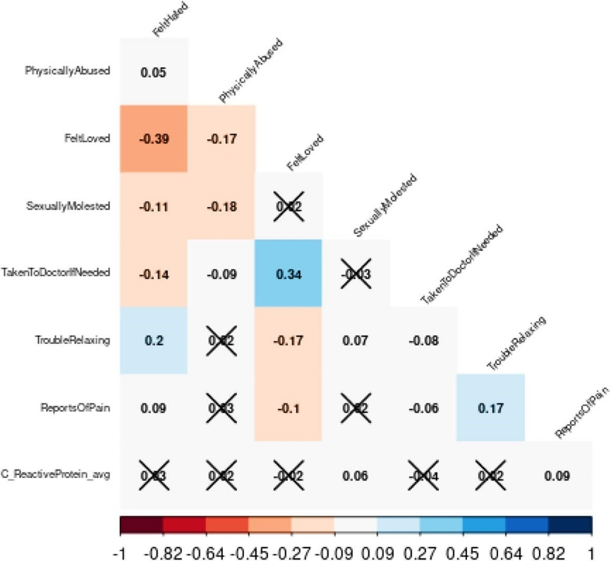
*X marks associations that were not statistically significant. In the shaded rows, each cell is shaded blue or red depending on the sign of the correlation, and with the intensity of colour scaled 0–100% in proportion to the magnitude of the correlation (standard coding from red, [1, 0, 0], through white [1, 1, 1], to blue [0, 0, 1]. This bipolar scale of colour leaves correlations near 0 empty (white) and makes positive and negative values of equal magnitude approximately equally intensely shaded.
Table 3. Poisson model: secondary objective (with CRP as the predictor of chronic pain).
Variable | Estimate | Std. error | z-value | P-value
(Constant) | 0.807 | 0.093 | 8.659 | < 2e−16
Felt Hated as a child (Likert) | 0.071 | 0.033 | 2.158 | 0.031
Physically Abused as a child (Likert) | 0.100 | 0.023 | 4.351 | < 0.001
Sexually Abused as a child (Likert) | 0.118 | 0.045 | 2.621 | 0.009
Felt Loved as a child (Likert) | − 0.011 | 0.017 | − 0.630 | 0.529
Taken to Doctor if Needed as a child (Likert) | − 0.040 | 0.017 | − 2.320 | 0.020
Has informed a professional about anxiety episodes
No (ref)
Yes | 0.030 | 0.058 | 0.520 | 0.603
Trouble relaxing during anxiety episodes (Likert) | 0.134 | 0.034 | 3.991 | < 0.001
Muscle symptoms during anxiety episodes
No (ref)
Yes | 0.239 | 0.059 | 4.025 | < 0.001
CRP average levels | 0.011 | 0.020 | 0.547 | 0.584
Interactions
Trouble relaxing X sexually abused | − 0.014 | 0.019 | − 0.733 | 0.464
Physically abused X sexually abused | − 0.080 | 0.019 | − 4.326 | < 0.001
Muscle symptoms X physically abused | − 0.089 | 0.042 | − 2.127 | 0.033
Has informed a professional about anxiety X felt hated as a child | 0.000 | 0.034 | 0.010 | 0.992
Trouble Relaxing X felt hated as a child | − 0.013 | 0.017 | − 0.773 | 0.439
Has informed a professional about anxiety X CRP | 0.036 | 0.014 | 2.679 | 0.007
Trouble relaxing X CRP | − 0.009 | 0.008 | − 1.133 | 0.257
Muscle symptoms X CRP | 0.005 | 0.012 | 0.391 | 0.696
Felt hated X CRP | − 0.003 | 0.009 | − 0.393 | 0.694
Physically abused X CRP | − 0.017 | 0.005 | − 3.324 | 0.001
Sexually abused X CRP | − 0.023 | 0.011 | − 2.113 | 0.035
Felt loved X CRP | − 0.003 | 0.004 | − 0.608 | 0.543
Taken to doctor if needed X CRP | 0.009 | 0.004 | 2.404 | 0.016
Trouble relaxing x sexually abused X CRP | 0.002 | 0.004 | 0.577 | 0.564
Physically abused x sexually abused X CRP | 0.019 | 0.005 | 3.970 | < 0.001
Muscle symptoms x physically abused X CRP | 0.013 | 0.010 | 1.348 | 0.178
Has informed a professional about anxiety X felt hated X CRP | − 0.018 | 0.008 | − 2.150 | 0.032
Trouble relaxing X felt hated X CRP | 0.003 | 0.004 | 0.636 | 0.525
Analysis notes: dependent variable: number of instances of pain reported through the years. N = 2007. Null deviance: 3022.5 on 2006 degrees of freedom. Residual deviance: 2764.4 on 1979 degrees of freedom. AIC: 8351. Significant values are in bold.
Interactions with CRP
Interestingly, CRP was a stronger predictor for patients who reported never having experienced physical abuse (Fig. 2B). The more frequently physical abuse was experienced or reported, the weaker the relationship between chronic pain and CRP became, eventually undergoing an inversion. Similar to the interaction results of physical abuse, CRP was a stronger predictor for patients who were not exposed to sexual abuse as children (Fig. 2C). As the frequency of sexual abuse increased, CRP levels appeared to become less of a deciding factor.
There was a substantial divide in the effect of CRP on chronic pain, as displayed in Fig. 2A, depending on the availability of doctor visits during childhood. For patients who had low or infrequent availability to visit the doctor when needed as children, higher CRP levels tended to decrease chronic pain reported during adulthood. In contrast, patients who had a high availability of visiting the doctor when needed showed CRP levels to be a strong predictor of chronic pain in adulthood.
As indicated by Fig. 2D, CRP played a significant role in predicting chronic pain for patients with anxiety (i.e., those who had sought professional help). In comparison, for patients without anxiety or whose anxiety had not driven them to discuss with a professional, CRP gradually lost significance and became a very weak predictor of chronic pain.
Three-way interactions
As shown in Fig. 3, when both sexual abuse and physical abuse were present in childhood, they greatly potentiated the effect that CRP levels had on chronic pain as a predictor (Fig. 3A). For the final examination, patients who felt hated more frequently as a child were less sensitive to CRP levels as a predictor of chronic pain (Fig. 3B). This interaction, however, only applied to patients who had reported "yes” to having discussed anxiety with a professional. For patients who had reported “no” for having discussed anxiety with a professional, this interaction disappeared.
Figure 2. (A) Interaction between being taken to the doctor when needed as a child and CRP as predictors of chronic pain, (B) Interaction between experiencing physical abuse as a child and CRP levels as predictors of chronic pain, (C) Interaction between experiencing sexual abuse as a child and CRP as predictors of chronic pain, (D) Interactions between having informed a professional about anxiety x CRP.

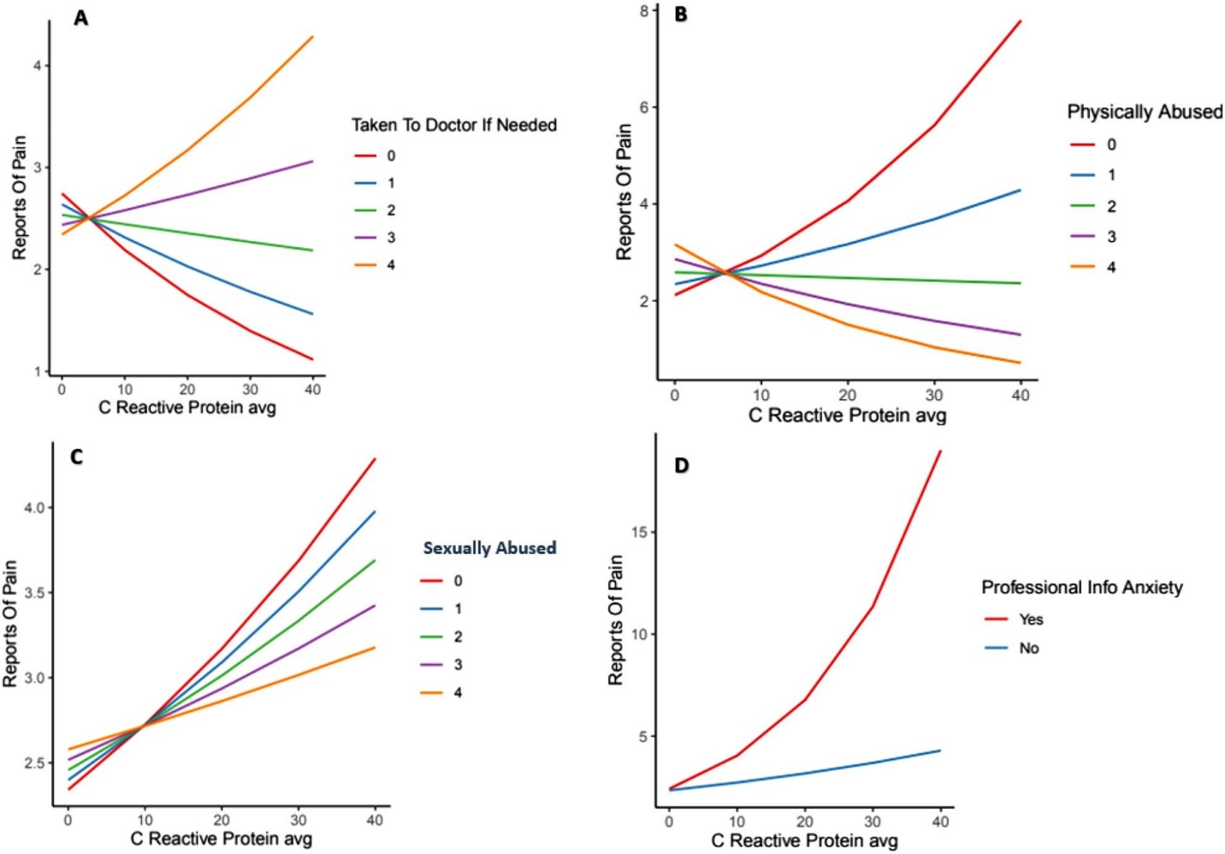
Note: 0–4 scale = never–very often true.
Simple socio-demographic adjusted analysis
Four socioeconomic variables which had sufficient coverage were available in the UKB dataset: sex (male/female), ever smoked (yes/no), alcohol use status (current, past, never), and age at recruitment (range 40–70 years). The generalized linear mixed-effects model results and corresponding simplified final model were built and compared to identify if the available data on socioeconomic factors affected the model results (see Appendix C for expanded details on the methodology). The linear mixed-effects model included age at recruitment as a random intercept, and the inclusion of a random slope (allowing the variable’s slope to vary with age at recruitment) for each dependent variable was tested. ANOVAs comparing the model with the random slope versus without for a given variable indicated that including a random slope was significant at the 95% level for ProfessionalInfoAnxiety (χ²(2) = 28.439, p < 0.001), MuscleSymptomsAnxiety (χ²(2) = 8.0571, p = 0.018) and PhysicallyAbused (χ²(2) = 17.409, p < 0.001), and thus these were included in the mixed-effects model. Other than the inclusion of socioeconomic control variables for sex, ever smoked, alcohol use, and age at recruitment as a random effect (with the given random slopes) for the mixed-effects model, the models were identical. Although the mixed effects model had a slightly better fit (AIC 8275 for the mixed effects versus AIC for the simplified final model), the coefficient estimates for all variables included in both models was very similar, and almost all variables which had significant coefficients (p < 0.05) in the simplified final model also had significant coefficients in the mixed-effects model (with the exception of TakenToDoctorIfNeeded x C_ReactiveProtein_avg). The mixed effects control variables ever smoked, sex, and alcohol drinker were not significant (p > 0.05); age at recruitment as a random effect was not assigned a significance (see Table S4 for variances and standard deviations). In this case, although the inclusion of the available socioeconomic factors in the mixed-effects model improved the fit on the data, it did not change the conclusions regarding the predictors of the number of times pain was reported.
Figure 3. 3-way interactions between: (A) CRP, sexual abuse, and physical abuse during childhood, (B) CRP, reporting anxiety to a professional x feeling hated as a child.
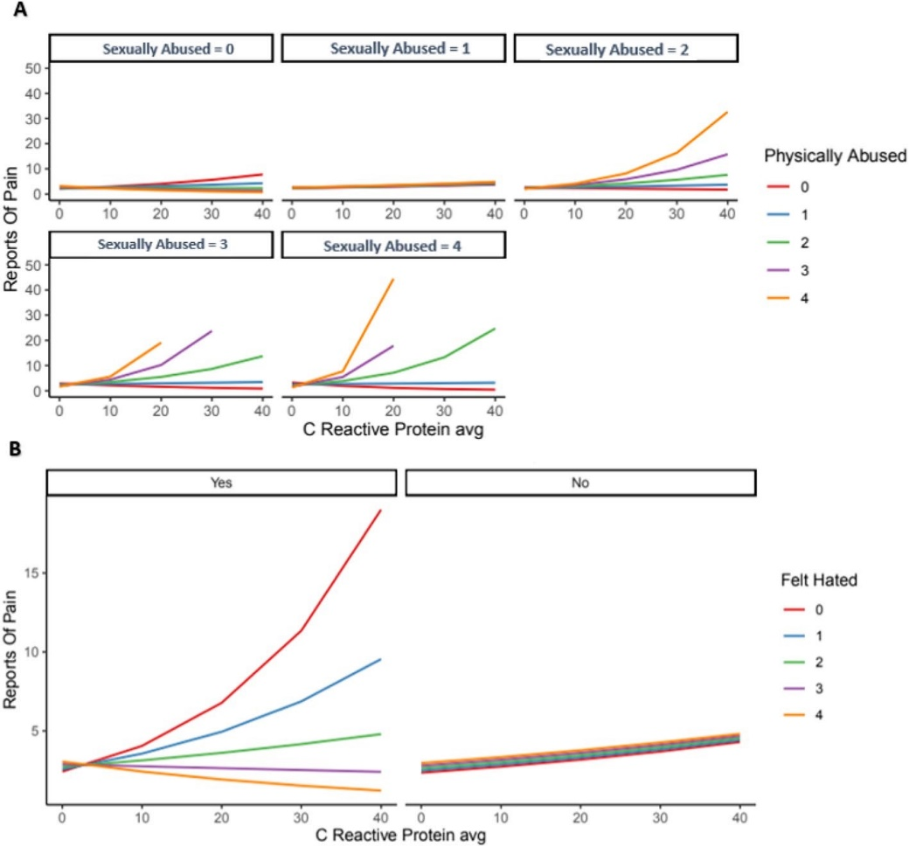
Note: 0–4 scale = never–very often true.
Discussion
The objective of this study was to examine the relationships between reported ACEs, anxiety, and chronic pain and to assess the associations between ACEs, anxiety, and CRP levels, as well as the link between CRP and chronic pain. Exploring these associations in more detail, using a Poisson regression, demonstrated some interesting main effects with three significant interactions identified in explaining chronic pain experiences. For anxiety, an increased frequency of having trouble relaxing during anxiety episodes and experiencing muscle symptoms was associated with an increase in reported chronic pain, and there was an important interaction between informing a professional about anxiety and CRP in predicting pain. With respect to ACEs, patients who reported feeling hated more frequently as a child, as well as patients who were physically or sexually abused as a child, reported more chronic pain in adulthood. With respect to the interaction analyses, the most influential interaction was between the frequency of physical abuse experienced as a child and reported muscular symptoms during anxiety. The other significant interactions were between the frequency with which they felt hated as a child and having discussed anxiety with a professional and between the reported frequency of sexual abuse in childhood and difficulties relaxing during anxiety attacks.
Some of the associations between ACEs (as were shown in Fig. 1) appear at odds with the prevailing literature, for example, sexual abuse being inversely associated with physical abuse. This may reflect variations between the present study and others in ACE definitions or study sample characteristics. Recent research by Broekhof et al. (2022) suggests that due to overlap between ACE sub-types and individual ACEs, perhaps ACEs should be assessed as a combined group rather than individually (Broekhof et al. 2022).
The findings further expand on previous research, such as multivariate analysis (Elmore & Crouch 2020), which concluded that any ACE measure was associated with a higher risk of both anxiety and depression. Children exposed to four ACEs or more had higher odds of anxiety and depression, for example, than those exposed to fewer than four ACEs. The results of the present study agree with this previous analysis but also support the assessment of the impact of ACEs on internalizing behaviours separately instead of grouping anxiety and depression outcomes together. The present results are also interesting to consider in light of a recent study (Groenewald et al. 2020) that showed that increased or chronic exposure to ACEs are key contributing drivers to chronic pain earlier in a person’s life. This study by Groenewald also demonstrated that exposure to one or more ACEs was associated with a 60%–170% increase in the likelihood of experiencing chronic pain. Taken together, it seems that the frequency of ACE exposure may be tied to chronic pain prevalence in adults.
Interestingly, addressing the second objective provided more insight into the underlying mechanisms of the associations. CRP was found to be a stronger predictor of pain for patients who reported never having experienced physical abuse, meaning that the more frequently physical abuse was reported, the weaker the relationship between chronic pain and CRP became. Similarly, CRP was a stronger predictor for patients who were not exposed to sexual abuse as children, showing that as the frequency of sexual abuse increased, CRP levels appeared to become less of a predictor. The interaction results did show a substantial divide in the effect of CRP on chronic pain. For patients who had low or infrequent availability to visit the doctor when needed as children, higher CRP levels were related to a decrease in the frequency of chronic pain reported during adulthood. In contrast, patients who had a high availability of visiting the doctor when needed showed CRP levels to be a strong predictor of chronic pain in adulthood. In addition to CRP, systemic inflammation related to elevated levels of inflammatory biomarkers such as TNF-Α, IL-6, and IL-1B has previously been linked to increased inflammatory and neuropathic pain (Morris et al. 2020). The role of inflammation in the pathogenesis of other health problems in adults may be one of the main psychobiological mechanisms underlying the relationship between ACE history and poor health outcomes. In a study by Iob et al. (2020) assessing CRP and hair cortisol, adults with three or more ACEs had a higher risk of elevated CRP levels across a 4-year period (Iob et al. 2020). Such results demonstrate how the complexities between ACEs and proinflammatory responses may persist and impact later stages of adulthood and should be factored into chronic pain screening as well. In addition, the number and specific combination of ACE types may influence CRP levels, as suggested by our contrasting individual interaction findings.
For the 3-way interactions, while CRP had a significant role in predicting chronic pain for patients with reported anxiety, this effect was much weaker for patients without anxiety. Of note, although both sexual abuse and physical abuse during childhood each decreased the effect CRP levels had on predicting chronic pain when examined individually for their interactions, when sexual abuse and physical abuse were both present, they significantly increased the effect that CRP levels had on predicting chronic pain in adulthood. This may be because those with a history of multiple traumatic experiences have higher inflammation. Prior meta-analyses of cross-sectional studies have confirmed the association of inflammation with traumatic experiences, and longitudinal studies have provided evidence supporting a bidirectional association that elevated inflammation may contribute to trauma symptoms and that trauma symptoms contribute to elevated inflammation (Wei et al. 2020).
In terms of implications for future treatment, there is some support for additive therapy with anti-inflammatory medication for treatment-resistant depression; however, this was only true for patients with low-level inflammation (CRP ≥ 3 mg/L) (Nettis et al. 2021; van Eeden et al. 2020; van Eeden et al. 2021). It may be worth examining the potential for anti-inflammatory medications for treating patients with anxiety, particularly those with elevated inflammatory markers such as CRP. It would be worth investigating a cohort of patients with anxiety who could potentially benefit from individualized therapy with anti-inflammatory drugs, such as those with chronic pain and a history of ACEs.
While interesting, the cross-sectional nature of these data suggests caution in making any definitive statements about directionality of effects. For example, pain (a potent stressor) might lead to elevated CRP levels just as much as elevated CRP could lead to heightened pain sensitivity. Future studies should consider other variables that could influence CRP levels that might confound the associations between CRP and pain (e.g., demographics, socioeconomic status, health behaviours, social isolation etc.) and exploring the impact of these factors on the analyses reported here could shed light on variables which modify how ACEs relate to chronic pain. Although more research into the relationships is needed, the results of the present study are meaningful in that they highlight that elevated CRP is potentially associated not only with childhood trauma history and adult chronic pain outcomes but also with anxiety symptomology. This suggests that it may be important to consider the underlying inflammatory component potentially present in this specific adult population (ACE history, anxiety, and chronic pain).
Limitations
The dataset used was a substantial sample size; however, some of the data generated included online questionnaires that relied on self-report. While such an approach was necessary to collect information from a larger sample, this may have affected the quality of the data due to recall bias. However, the only alternative to surveys (clinical interviews) for abuse and anxiety measures also relies on self-report and recall and would not be pragmatic in epidemiological research. Although appropriate statistical methods were used, findings related to biomarker data should be interpreted cautiously. These findings could still be affected by unmeasured or unaccounted for confounding variables. However, multiple sensitivity analyses were conducted, and the significant results appear to not be affected by biases. Finally, the dataset was primarily based in the UK, so it may not be globally generalizable across countries and cultures. However, the sample size itself was quite robust and opens opportunities for cross-cultural comparison with other large datasets.
Conclusion
The results of this analysis are meaningful in that they indicate that CRP is significantly associated not only with certain ACEs and adult chronic pain outcomes but also with anxiety symptoms. Of note, childhood abuse significantly interacted with CRP to predict pain, and there were important results on the combined effect of specific ACEs. The implications of this connection warrant further study to validate these relationships and potential mediations but are an important consideration in the underlying inflammatory components of systemic dysfunction after childhood adversity in adults with chronic pain, anxiety, and higher levels of CRP.

Chapter 3 references
Bremner, J. D. Traumatic stress: Effects on the brain. Dialogues Clin. Neurosci. 8(4), 445–461. https:// doi. org/ 10. 31887/ DCNS. 2006.8. 4/ jbrem ner (2006).
Morasco, B. J. et al. The relationship between PTSD and chronic pain: Mediating role of coping strategies and depression. Pain 154(4), 609–616. https:// doi. org/ 10. 1016/j. pain. 2013. 01. 001 (2013).
Miller, A. H. Beyond depression: The expanding role of inflammation in psychiatric disorders. World Psychiatry. 19(1), 108–109. https:// doi. org/ 10. 1002/ wps. 20723 (2020).
Nicolson, N. A., Davis, M. C., Kruszewski, D. & Zautra, A. J. Childhood maltreatment and diurnal cortisol patterns in women with chronic pain. Psychosom. Med. 72(5), 471–480. https:// doi. org/ 10. 1097/ PSY. 0b013 e3181 d9a104 (2010).
Sheng, J. A. et al. The hypothalamic-pituitary-adrenal axis: Development, programming actions of hormones, and maternal-fetal interactions. Front Behav Neurosci. 13(14), 601939. https:// doi. org/ 10. 3389/ fnbeh. 2020. 601939 (2021).
Gunnar, M. R. & Vazquez, D. Stress neurobiology and developmental psychopathology. In developmental psychopathology 2nd edn, Vol. 2 (eds Cicchetti, D. & Cohen, D. J.) (Wiley, Hoboken, 2006).
Chrousos, G. P. The hypothalamic-pituitary-adrenal axis and immune-mediated inflammation. N. Engl. J. Med. 332(20), 1351–1362. https:// doi. org/ 10. 1056/ NEJM1 99505 18332 2008 (1995).
Gunnar, M. R. & Vazquez, D. M. Low cortisol and a flattening of expected daytime rhythm: Potential indices of risk in human development. Dev. Psychopathol. 13, 515–538 (2001).
Muniz Carvalho, C. et al. Dissecting the genetic association of C-reactive protein with PTSD, traumatic events, and social support. Neuropsychopharmacology 46(6), 1071–1077 (2021).
Wei, P., Keller, C. & Li, L. Neuropeptides in gut-brain axis and their influence on host immunity and stress. Comput. Struct. Biotechnol. J. 4(18), 843–851. https:// doi. org/ 10. 1016/j. csbj. 2020. 02. 018 (2020).
Milaneschi, Y. et al. Association of inflammation with depression and anxiety: Evidence for symptom-specificity and potential causality from UK Biobank and NESDA cohorts. Mol. Psychiatry. 26(12), 7393–7402. https://d oi.org/1 0 .1038 /s 41380-021-0 1188- w (2021).
Zhuo, M. Neural mechanisms underlying anxiety-chronic pain interactions. Trends Neurosci. 39(3), 136–145. https:// doi. org/ 10. 1016/j. tins. 2016. 01. 006 (2016).
Monnat, S. M. & Chandler, R. F. Long term physical health consequences of adverse childhood experiences. Sociol. Q. 56(4), 723–752. https:// doi. org/ 10. 1111/ tsq. 12107 (2015).
Ramirez, A. H. et al. All of us research program. The all of us research program: Data quality, utility, and diversity. Patterns (NY) 3(8), 100570. https:// doi. org/ 10. 1016/j. patter. 2022. 100570 (2022).
R Core Team. R: A language and environment for statistical computing. R Foundation for Statistical Computing, Vienna, Austria (2022). https:// www.R- proje ct. org/.
Fry, A. et al. Comparison of sociodemographic and health-related characteristics of UK biobank participants with those of the general population. Am. J. Epidemiol. 186(9), 1026–1034. https:// doi. org/ 10. 1093/ aje/ kwx246 (2017).
Office for National Statistics; General Register Office for Scotland; Northern Ireland Statistics and Research Agency. 2001 Census aggregate. https:// disco ver. ukdat aserv ice. ac. uk/ doi/ 2001- census- aggre gate. Published 2005. Updated June 2016.
Broekhof, R., Nordahl, H. M., Bjørnelv, S. & Selvik, S. G. Prevalence of adverse childhood experiences and their co-occurrence in a large population of adolescents: A Young HUNT 3 study. Soc. Psychiatry Psychiatr. Epidemiol. 57(12), 2359–2366. https://d oi. org/ 10. 1007/ s00127- 022- 02277-z (2022).
Elmore, A. L. & Crouch, E. The association of adverse childhood experiences with anxiety and depression for children and youth, 8 to 17 years of age. Acad. Pediatr. 20(5), 600–608 (2020).
Groenewald, C. B., Murray, C. B. & Palermo, T. M. Adverse childhood experiences and chronic pain among children and adolescents in the United States. Pain Rep. 5(5), e839 (2020).
Morris, P. et al. A systematic review of the role of inflammatory biomarkers in acute, subacute and chronic non-specific low back pain. BMC Musculoskelet. Disord. 21, 142 (2020).
Iob, E., Lacey, R. & Steptoe, A. The long-term association of adverse childhood experiences with C-reactive protein and hair cortisol: Cumulative risk versus dimensions of adversity. Brain Behav. Immun. 87, 318–328 (2020).
Nettis, M. A. et al. Augmentation therapy with minocycline in treatment-resistant depression patients with low-grade peripheral inflammation: Results from a double-blind randomised clinical trial. Neuropsychopharmacology. 46(5), 939–948. https:// doi. org/ 10. 1038/ s41386- 020- 00948-6 (2021).
van Eeden, W. A. et al. Basal and LPS-stimulated inflammatory markers and the course of individual symptoms of depression. Transl. Psychiatry 10, 235. https:// doi. org/ 10. 1038/ s41398- 020- 00920-4 (2020).
van Eeden, W. A. et al. Basal and LPS-stimulated inflammatory markers and the course of anxiety symptoms. Brain Behav. Immun. 98, 378–387. https:// doi. org/ 10. 1016/j. bbi. 2021. 09. 001 (2021).
Long, J. S. Scott. Regression Models for Categorical and Limited Dependent Variables (Sage Publications, 1997).

Chapter 4: US-based Registered Report—An Analysis on the Impact of Childhood Adversity, Anxiety, and C-reactive Protein on Adult Chronic Pain in the Midlife in the United States (MIDUS) study
As the final part of this thesis, this study used the Midlife-Development in the United States (MIDUS) dataset to further examine relationships between reported childhood-adversity, anxiety, CRP and chronic pain, as well as how these were associated with pain medication usage in US adults. This final study explored the additional factor of pain medication usage and included multiple socio-demographic variables, which thereby addressed some of the limitations identified in the UK-based analysis described previously in Chapter 3 (e.g., a lack of scope to consider multiple socio-demographic status-related variables) and provided a comparative analysis for the findings of Chapter 3 in a different US-based sample. Structural equational-modelling and general linear-modelling regression were conducted independently by the author of this thesis with supervision from PhD supervisors (AW, LC, and GM), and all supervisors guided in directions for re-analysis and write-up/review of the publication. The introduction and methods of this chapter have been accepted in principle as a Registered Report by Psychosomatic Medicine, and published as a Registered Report Protocol in the Open Science Framework Registry: https://doi.org/10.17605/OSF.IO/3BKYC. The full article has now been submitted for publication and is currently under review with Psychosomatic Medicine:
Dalechek, D., Caes, L., McIntosh, G., & Whittaker, A.C. Stage 1 Registered Report: An Analysis on the Impact of Adverse Childhood Experiences, Anxiety, and C-reactive Protein on Adult Chronic Pain in the Midlife in the United States (MIDUS) study. Psychosomatic Medicine, under review.

Note: It is important to mention that based on the reviewers' comments for the accepted Registered Report Protocol, the term childhood adversity is used instead of adverse childhood experiences or ACEs (as in the other chapters of this thesis), as reviewers felt this term more accurately reflected the data specifically available in MIDUS.

Abstract
Objectives: This study used the Midlife-Development in the United States (MIDUS) dataset to: 1) examine relationships between reported childhood-adversity (CA), anxiety, and pain; 2) assess associations between CAs, anxiety, C-reactive protein (CRP) levels, and pain; and 3) explore how CAs, anxiety, and CRP are associated with pain medication consumption.
Methods: For objectives 1–2, structural equational-modelling (SEM) followed by general linear-modelling (GLM) regression were conducted. For objective 3, all variables from the objectives 1–2 dataset were used as possible independent variables for the exploratory regression.
Results: The SEM indicated CAs, anxiety, and CRP all played a role in predicting chronic pain. For objectives 1–2, CRP was significantly correlated with anxiety, emotional-abuse, physical-neglect, and chronic pain (n=1255). Regression results (n=1173) indicated gender, total-income, and highest-education were significant predictors of chronic pain. Significant interactions to explain chronic pain included physical-abuse/emotional-neglect, emotional-abuse/physical-abuse, physical-abuse/minimization, physical-neglect/education, CRP/income, and CRP/education. For objective 3 (n=600), there were no significant main-effects, but a large variety of interactions contributed to predicting pain-medication consumption. CAs interacting significantly to explain pain-medication consumption included emotional-abuse/physical-abuse, physical-abuse/emotional-neglect, physical-abuse/minimization, and sexual-abuse/minimization. There were also multiple significant interactions between CAs/control-variables, and for anxiety/CRP: trait-anxiety/income, CRP/income, and CRP/education.
Conclusions: Based on a large US-sample, socio-demographics played a meaningful role in predicting chronic pain in adults, and CRP was significantly correlated with anxiety, emotional-abuse, physical-neglect, multiple socio-demographic variables, and chronic pain. The influence of CAs on predicting long term medication use for chronic pain were complex and warrant further study.

Background

In recent years, there have been advances in research regarding the prevalence of adverse childhood experiences (ACEs) and resulting poor health outcomes for adults who have a history of experiencing childhood adversity (CA). The first ACE study, for example, found a strong relationship between exposure to abuse or household dysfunction during childhood and multiple health risk factors for the leading causes of death in adulthood (Felitti et al. 1998; CDC 2022). Due to this expanding field of research, CA is no longer perceived as solely a social issue, as it affects overall health and development throughout the entire lifetime of an individual.

Stress-related physiological alterations, influenced by potentially traumatic events and experiences such as ACEs, are linked with affective and physiological states including depression, inflammation, and shortened telomeres, which increase morbidity and mortality risks (Elliot et al. 2018). Some of the adult health behaviours potentially linking ACEs and these risks range from smoking and alcoholism to substance abuse such as overuse of pain medication. There is increasing evidence that ACEs are associated with persistent pain in adults, which may in turn influence self-medicating to avoid or relieve pain. For example, a 30-year prospective follow-up of a cohort of individuals with court-documented ACEs and a demographically matched control sample showed a small (partial eta squared (η²) = .01), but statistically significant increase in the risk of pain in adulthood (Bussières et al. 2020). Further, a recent systematic review documented high levels of CAs in adults with chronic pain, and showed that CAs impacted the form, presence, severity, and extent of chronic pain in adults (Nicolson et al. 2023). A 2020 US-based analysis tested the associations between ACEs and subsequent prescription pain medicine/opioid misuse outcomes in adults, and results indicated that the presence of ACEs was positively associated with prescription opioid misuse across the two state samples assessed (Merrick et al. 2020). Adults that reported three or more ACEs had increased odds of taking opioids more than prescribed and without a prescription (Merrick et al. 2020).

However, findings from recent longitudinal studies investigating the association between types of ACEs and pain have yielded inconsistent findings in the strength and direction of associations (Bussières et al. 2020), warranting more examination into the potential relationships, associations, and pathways involved. Prior reviews have also highlighted the negative impact of ACEs on psychological (anxiety, depression, self-harming), behavioural (risk taking, smoking, alcohol and drug abuse, violence), and physical health (obesity, diabetes, cancer, heart, and respiratory disease) (Hughes et al. 2017). However, the impact of CAs on persistent adult outcomes is less clear and may involve other factors such as inflammatory biomarkers and anxiety, which have received less research attention than depression. In chronic pain populations, in particular it has been shown that anxiety disorders are second only to depression as a psychological comorbidity. Clinical or pathological anxiety involves increased feelings of dread that interfere with standard functioning and may be influencing hypervigilance, potentially contributing to or exacerbating pain experiences (Woo et al. 2010). Further, elevated levels of proinflammatory cytokines such as interleukins—a downstream product of C-reactive protein (CRP) signalling, and acute-phase proteins like CRP—have been observed in the plasma of individuals who have experienced CAs or trauma, and meta-analyses of cross-sectional studies have also confirmed the association of higher inflammation with traumatic experiences (Muniz Carvalho et al. 2021). CRP is a protein that responds to inflammatory stimuli by triggering cellular reactions, making it of relevance in the biological impact of childhood trauma. A better understanding of these relationships has important implications for public health.

Aims & Hypotheses

Consequently, the overarching aim of this study was to utilize the Midlife Development in the United States (MIDUS) dataset to identify biopsychosocial pathways that may link CAs with adult chronic pain. The specific objectives are: 1) to examine the relationships between reported CAs, anxiety, and pain; 2) to assess the associations between CAs, anxiety, inflammation (measured through CRP levels), and pain; and 3) to explore how CAs, anxiety, and CRP may be associated with pain medication consumption in the United States as a proxy for chronic pain as a health outcome. To date, little evidence is available in large, representative samples that address all these associations together rather than looking at one association separately in smaller samples. This study offered a uniquely large dataset and novel analyses including all variables of interest to explore their distinctive associations. The conceptual model, based on the scattered evidence available to date, underpinning the present research questions is that CAs positively relate to adult chronic pain, with anxiety and inflammation (indexed by CRP) potentially influencing this association. It was hypothesized that CAs relate to chronic pain experience in adulthood, and that there would be positive associations between 1) CAs and anxiety, 2) CAs and CRP levels, 3) CAs and pain, and that the link between CAs and pain would be influenced by anxiety and/or CRP. Although objective 3 is exploratory, it is hypothesized that CAs, anxiety, and CRP would all be positively associated with increased pain medication consumption in the United States.

The corresponding null hypotheses (H0) are 1) there will be no significant positive association between CAs and anxiety, 2) there will be no significant positive association between CAs and CRP levels, and 3) there will be no significant positive association between CAs and pain. Further, any CAs and pain association will not be influenced by anxiety and/or CRP. For exploratory objective 3 the H0 is that CAs, anxiety, and CRP will not be associated with increased pain medication consumption in the United States.
Conceptually, it was expected that CAs relate to pain, with anxiety and inflammation potentially influencing the association (Figure 1).

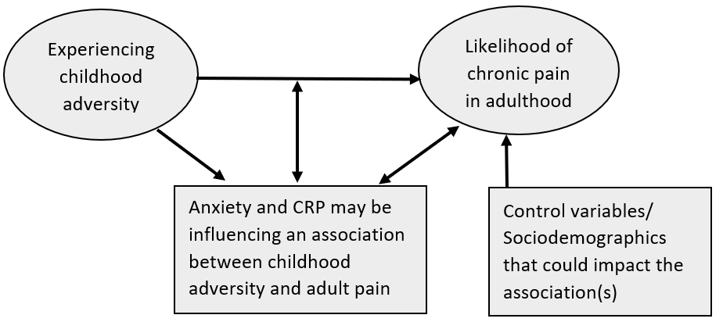
Figure 1. Conceptual model of how childhood adversity impacts adult chronic pain experience as potentially influenced by anxiety and inflammation (indexed by CRP)

Methods

Transparency Statement

All MIDUS datasets, materials, and documentation are archived at the ICPSR (http://www.icpsr.umich.edu) repository at the University of Michigan and are publicly available in a variety of formats and statistical packages. In the sections that follow, we report all measures, manipulations, and exclusions.

Dataset and Participants

The dataset used for this secondary analysis was the publicly available MIDUS longitudinal study, a national survey of more than 7,000 Americans (aged 25 to 74) that started in 1994 (Brim et al. 2020). The purpose of the MIDUS study was to investigate the role of behavioural, psychological, and social factors in understanding age-related differences in physical and mental health. With support from the National Institute on Aging, a longitudinal follow-up of the original MIDUS samples was conducted in 2004-2006. The Biomarker study aiming to facilitate analyses that integrate behavioural and psychosocial factors with biology is Project 4 of the MIDUS 2 (M2P4), containing data from 1,255 respondents, and is the focus sample of these analyses. Respondents include two distinct subsamples: the longitudinal survey sample (n = 1,054) and the Milwaukee sample (n = 201), all of whom completed the Project 1 Survey. The Milwaukee group contained individuals who participated in the baseline MIDUS Milwaukee study initiated in 2005. All research participants were admitted to or studied at the University of Wisconsin-Clinical and Translational Research Core. Biomarker data was collected at three General Clinical Research Centres (at UCLA, University of Wisconsin, and Georgetown University). Finally, to augment the self-reported data collected in Project 1, participants completed a medical history and self-administered questionnaire. Participants were excluded if they did not respond to the Child Trauma Questionnaire (CTQ) and STAI questionnaires, had not met at least one of the chronic pain criteria, or if CRP was outside of the acceptable ranges (>10% inter-assay variability). Low anxiety score or lack of ACEs was not excluded.

Measures

Childhood adversity: Within the MIDUS database, CA measures included the CTQ (11): 25 items about adverse experiences split into several categories (physical abuse, emotional abuse, sexual abuse, emotional neglect, physical neglect, minimization/denial) which comprise the 5 subscales of this measure. This was completed by participants at the biomarker collection stage. The scale ranged from 1 Never true to 5 Very often true. Unless otherwise indicated, scale scores were computed by summing across all items for which there were no missing data, with higher scores reflecting more experiences of trauma. Mean substitution was used in cases with only one missing value. For all subscales except Minimization/Denial, items marked with (R) were reverse-coded so that high scores reflect higher standing in the scale. For Minimization/Denial, the responses were coded as follows: 5 was coded as 1, 1–4 were coded as 0. This scoring reflected the tendency of the respondent to give exaggerated, desirable responses. The new scores were then added to derive the Minimization/Denial Scale Total Score.

Although the name of the CTQ includes the term “trauma”, it does not refer to all experiences that necessarily qualify as “traumatic” (Wente et al. 2023). In order to avoid potential confusion and to consider the broadness and diversity of the ACEs concept, we referred to the experiences assessed by the CTQ as “childhood adversity” (CA), not ACEs or trauma exclusively.

Anxiety: Anxiety was captured with the State-Trait Anxiety Inventory Form Y (STAI), a comprehensive 20-item instrument for measuring anxiety in adults that differentiates between the temporary condition of “state anxiety” and the more general and long-standing quality of “trait anxiety.” The essential qualities evaluated by the STAI-S Anxiety scale are feelings of apprehension, tension, nervousness, and worry (Spielberger et al. 1983). Participants responded how each item applied to them by using a range from 1 Almost never to 4 Almost always, and scores were computed by summing across all items for which there was no missing data. Higher scores reflected a higher level of anxiety. Mean substitution was used in cases with only one missing value.

Pain: Most of the pain-related information was captured via general questions about experiences with a range of different chronic condition items rather than a pain specific measure or conditions. These condition-orientated questions did not always reflect a timepoint and hence would be more difficult to include as a sign of chronic pain. Consequently, the item: “Do you have chronic pain, that is do you have pain that persists beyond the time of normal healing and has lasted anywhere from a few months to many years?” was selected as the key item to reflect chronic pain. In addition, physician-diagnosed pain was also captured and used in the analyses (see Table 1). Chronic pain was modelled as a binary variable that indicates whether the participant had or did not have chronic pain (1=yes, 0=no). A person was considered to have chronic pain if they met any of the following criteria: 1) Had any valid chronic pain diagnostic (B1SA23A/B1SA23D); Reported zero time without feeling pain in the last month (B4Q10WW1); Saw a professional about chronic pain (BACAS22); Indicated having chronic pain (B1SA15/K2Q17/BACAS15/RA1SA15); or Physician diagnosed chronic back/neck problems (K2Q1XD).
CRP: CRP was a continuous variable captured in ug/mL. The CRP bioassays were performed on blood samples (frozen serum and citrated plasma) at the Laboratory for Clinical Biochemistry Research (University of Vermont, Burlington, VT) using the BNII nephelometer from Dade Behring utilizing a particle enhanced immunonepholometric assay. Polystyrene particles were coated with monoclonal antibodies to CRP, which, in the presence of antigen (CRP) agglutinate causes an increase in the intensity of scattered light. The increase in scattered light is proportional to the amount of CRP in the sample (Tracy Lab 2009). At biomarker collection, 12-hour urine sample and fasting blood samples were collected from each participant after an overnight stay at the research site, and to ensure consistency, all samples were collected and processed using standardized procedures and then fresh and frozen samples were shipped to the MIDUS Biocore Lab for assay. Any samples falling below the assay range for CRP were re-assayed by immunoelectrochemiluminescence using a high-sensitivity assay kit (Meso Scale Diagnostics #K151STG) (MSD PI 2014). For citrated plasma, the assay range was 0.175–1100 ug/mL (inter-assay variability: 2.1–5.7%; reference range: ≤3 ug/mL), and for serum the assay range was 0.014–216ug/mL (inter-assay variability: 4.72–5.16%; reference range: <3 ug/mL). The coefficients of variance for all CRP assays were in acceptable ranges (<10%). While CRP values in excess of 10 mg/L are thought to indicate acute infectious illness (Nehring et al. 2023), CRP has gained traction in the last decade to be examined as a potential biomarker for chronic pain (Afari et al. 2011; Morris et al. 2020). Since our study involves both chronic pain whether generally self-reported (and/or defined by a particular pain disease, potentially), we did not feel it would be appropriate to exclude the cases over 10 mg/L as they may have been due to acute infection but importantly may also have been confounded by cooccurring with chronic pain.

Socio-demographics were of interest as potential confounders and were included as additional control variables in the regression. Ethical approval for this study was provided by the General University Ethics Panel, University of Stirling, Stirling, UK (#GUEP 2023 13945 9460).

Variables
For the primary objectives of the study, the specific MIDUS variables of interest or analyses are the different measures of CAs, anxiety, pain, and CRP. These are shown in Table 1.

Table 1. MIDUS variables
ID | Variable
Childhood adversity
B4QCT_EA | CTQ: Emotional Abuse
B4QCT_PA | CTQ: Physical Abuse
B4QCT_SA | CTQ: Sexual Abuse
B4QCT_EN | CTQ: Emotional Neglect
B4QCT_PN | CTQ: Physical Neglect
B4QCT_MD | CTQ: Minimization/Denial
Anxiety
B4QTA_AX | Spielberger Trait Anxiety Inventory (STAI)
Pain*
B4HSYMX | Any Symptoms and Chronic Conditions? (Yes/No)
B4HSYMN | Total number of Symptoms and Chronic Conditions
B1SA23A/ B1SA23D | Diagnosis given by physician or other health care professional about pain
B4Q10WW1 | Feeling no pain in the last month
BACAS22 | Saw physician/professional about pain
K2Q1XD | Physician diagnosed chronic back or neck problems
B1SA15/K2Q17/  BACAS15/RA1SA15 | Has chronic pain/persists beyond normal
Inflammatory biomarker
B4BCRP | Blood C-Reactive Protein (ug/mL)
Control variables
B1PRSEX | Gender
B1PRAGE_2019/ BACRAGE | Respondent's calculated age at project interview
B1STINC1/ BACTINC1 | Household total income from wage, pension, social security, and other sources
B1SRINC1/ BACRINC1 | Respondent's personal income from wage, pension, social security, and other sources
B1PB1/BACB1 | Highest level of education completed
B1PF7A/BACF7A | Racial origins (#1)
*Many pain measures were duplicated across the series of MIDUS projects and follow-ups, and some control variables were stored separately across the MIDUS projects, which is why some variables have multiple ID numbers for the same variable row.
“Household income” total included different types and different sources, based on sum of original income variables (= [B1SG8AX], [B1SG8BX], [B1SG8CX], [B1SG9AX], [B1SG9BX], [B1SG9CX], [B1SG10AX], [B1SG10BX], [B1SG10CX], AND [B1SG12]). “Total income” personally was for the respondent only, based on original income variables (= sum of [B1SG8AX], [B1SG8BX], AND [B1SG8CX]).
The specific pain diagnosis given by physician (B1SA23A/ B1SA23D) are shown in Supplemental Material, Table S1.

Analysis plans

Objectives 1 and 2

Structural equational modelling (SEM) to develop a preliminary understanding of relationships between variables was conducted, followed by general linear modelling (GLM) regression using the variables in Table 1.

All scale variables had their missing values recoded to be “NA” in R (R Core Team 2021). For the overall scale variables such as the CTQ scale variables, a value > 97 was recoded to missing, as per the MIDUS data dictionary (Ryff et al. 2021). For subscale variables, e.g., on a 1 to 5 Likert scale, a value > 7 was recoded to missing as per the data dictionary. Control variables for income had values 9999998 and -1 and racial origins had value 7 recoded as “NA” as per the MIDUS data dictionary (Ryff et al. 2021).

The relationships among CAs, anxiety, inflammation, socio-demographic factors, and chronic pain were viewed under three methodological lenses to gain insight into different aspects of their relationships. The correlation analysis computed Spearman correlation coefficients on each possible pair of variables to show how strongly and in what direction each pair was related. This provided initial insight into variable relationships and can be used to inform and cross-check the structural equation model-building process and results and the regressions. The Structural Equation Model (SEM) explored and visualised hypothetical relationships among observed and unobserved (latent) variables. It shows how observed and latent variables for CAs, anxiety, inflammation, and chronic pain, and observed socioeconomic variables directionally affected each other, something not possible with correlation or regression methods (Baron & Kenny 1986; Hopwood 2007), and is why it was selected over more standard mediation and moderation modelling. The regression model used independent variables for and specified interactions among CAs, anxiety, inflammation, and socio-demographic factors (controls) to predict chronic pain presence. This allowed for the identification of significant factors which predicted chronic pain presence. An additional exploratory regression on the subset of respondents who experienced chronic pain explored how CAs, anxiety, and inflammation predicted pain medication use for chronic pain. These three methods overall provided complementary insights. Correlations showed how pairs of variables related to each other, the SEM visualized how all observed and unobserved variables related to each other, and the regression models identified significant variables and interactions, which predicted chronic pain presence and medication use for chronic pain. Additional sensitivity analyses was conducted excluding those with CRP levels >10 to test the validity of our model. Further detailed information outlining how the analyses addressed the objectives are detailed in Supplemental Tables S2-S4.

SEM specifications

The path diagram of the planned SEM is shown in Figure 2. In this model the exogenous latent variables for anxiety, physiological response, and CAs predict the endogenous latent variable for chronic pain. Chronic pain was expected to be influenced by anxiety, physiological response, and CAs based on previous studies examining relationships among them (see Background). An individual’s physiological response to stress, level of anxiety, experience of CAs, and feeling of chronic pain cannot be directly measured; hence they were latent variables. Though these variables cannot be directly observed or measured (but are approximated through various measures), they were causally related to appropriate indicator variables present in the MIDUS data (Table 1), which were designed to measure aspects of the trait of interest.

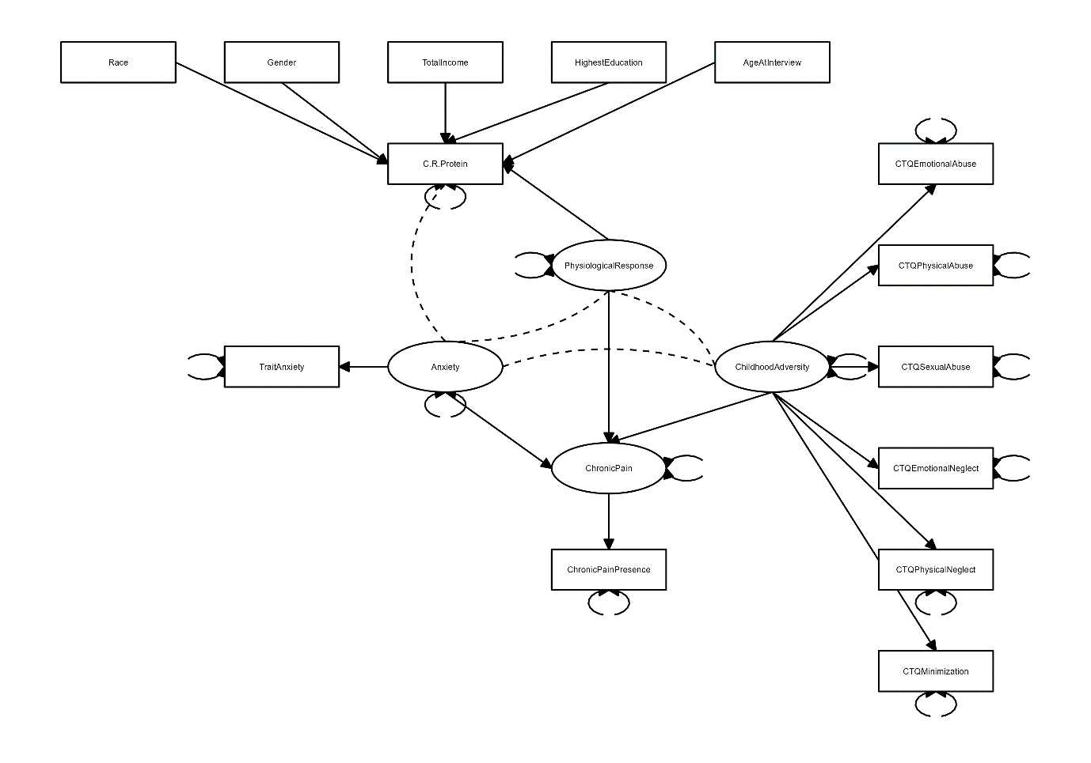
Figure 2: Path diagram of the planned SEM

The MIDUS indicator variable CRP was closely related to the physiological response to stress, the STAI to anxiety, and the reported experience of chronic pain to diagnosed chronic pain or a chronic pain disease/condition, so a single measured variable for each of these latent factors was appropriate. CAs can represent a wide variety of experiences, so a variety of representative measured variables from the MIDUS data were chosen: CTQ: Emotional Abuse, CTQ: Physical Abuse, CTQ: Sexual Abuse, CTQ: Emotional Neglect, CTQ: Physical Neglect, and CTQ: Minimization/Denial. The scale of latent factor variables is assumed and handled to be the same as the scale of the corresponding indicator variables. In the case of more than one indicator variable (such as the CA latent factor), the CTQ indicator variables are all on the same 5-point Likert scale, so this assumption held.

Indicator variables were included in the model as per their MIDUS data dictionary definition, with the exception of the reported experience of chronic pain variable. This variable was derived from the series of pain variables in Table 1. It was modelled as a binary variable that indicated if the participant did or did not have chronic pain, as detailed in the Measures description for pain.

In addition to the latent factors and associated indicator variables, socio-demographic control variables available in the MIDUS data (Table 1) were included as predictors of inflammation (CRP). These control variables were linked to CRP and the physiological response to chronic pain as an individual with worse socioeconomic circumstances was expected to have a higher degree of inflammation. The control variable for race was coded as binary variables (e.g. ‘is white race’ and ‘is black race’, the two most common categories in the data), as categorical variables with multiple categories cannot be included easily in an SEM.

The SEM was built with the ‘lavaan’ package version 0.6 (Rosseel 2021) in the R programming language, version 4.3 (R Core Team 2021). Missing data in the control and measured variables was coded according to the method detailed in the Measures and Variables sections (p8–14). The entire MIDUS sample of 1,255 participants as detailed in the Dataset and Participants section was used, with cases missing any indicator or control variables dropped from the sample. Any records where one or more parameters were missing were dropped from the regression model. For outliers in the overall scale variables such as the CTQ, a value > 97 was recoded to missing, as per the MIDUS data dictionary (Ryff et al. 2021). For subscale variables, e.g., on a 1 to 5 Likert scale, a value > 7 was recoded to missing as per the data dictionary. Control variables for income having values 9999998 and -1 and racial origins having value 7 was recoded as “NA” as per the MIDUS data dictionary (Ryff et al. 2021).

The maximum likelihood parameter estimation method built into the ‘lavaan’ package was used, as it is suitable for all-numerical data (including binary and Likert-scaled variables which will be coded numerically as integers) with complete cases (Olsson et al. 2000). The maximum likelihood method assumes data is multivariate normally distributed, and this assumption was tested on the MIDUS data. As the data were found to not be normally distributed, the ‘robust’ version of the maximum likelihood parameter estimation method was used, which does not rely on the normality assumption and provides robust standard errors and a scaled test statistic (Ke-Hai & Bentler 2007).

Exploratory objective

All variables imported into the primary objectives analysis dataset was used as possible independent variables for the pain medication regression. All scale and subscales variables were recoded per the data dictionary as previously described in the analysis plans for objective 1 and 2. Gender was recoded to a factor variable with levels Male and Female instead of numeric values. The chronic pain presence variable was derived as per the primary dataset.

The dependent variable (“did the person use medication for more than 3 months for chronic pain?”) was derived from several medication chart variables. Specifically, a person met criteria as having taken long term medication for chronic pain: if a person had taken any prescription, alternative, or over the counter medicine; or if the medicine was taken with a duration for > 3 months, and taken for ICD9 code 338 (“pain, not elsewhere classified”).

The final exploratory dataset was constructed by merging the independent and dependent variables by MIDUS-ID and taking the subset that had chronic pain (chronic pain presence variable = 1), as this was the population of interest. A logistic regression was used to predict the presence of long-term medication use for chronic pain in the subset of the study population which was identified as having chronic pain. Any records where one or more parameters were missing was dropped from the regression model. Model accuracy can be broken into sensitivity (“true positives”, how many people with chronic pain are correctly identified as taking long term medication for chronic pain) and specificity (“true negatives”, how many people with chronic pain are correctly identified as not taking long term medication for chronic pain). The dependent variable may be imbalanced, as 89% of the 651 available records did not take medication for chronic pain. To address this, model performance results were also presented in the form of a confusion matrix (true positives, true negatives, false positives, false negatives) with the sensitivity and specificity statistics reported. The regression model was tuned to maximizing sensitivity (true positives) to ensure that the model correctly predicted people taking long term medication for chronic pain.

Rationale for proposed methodology

Although SEM is a less common choice in epidemiological and health studies, a paper by Beran and Violato (2010) expressed growing concerns over the paucity of SEM models in epidemiological research, as SEM is able to analyse complex relationships among variables, including posit and testing causal relationships with non-experimental data (allowing researchers to explain the development of phenomena such as disease and health behaviours) (Beran and Violato 2010). The various applications of SEM range from analysis of simple relationships between variables to complex analyses of measurement equivalence for first and higher-order constructs, and SEM also provides a flexible framework for developing and analysing complex relationships among multiple variables (Beran and Violato 2010). This allows testing the validity of a theory using empirical models with an advantage of managing measurement error, one of the greatest limitations of most health studies. SEM can be used as an exploratory or confirmatory approach within a research design, and can provide insight into the complex nature of disease and health behaviours by examining both direct, indirect, unidirectional, and bidirectional relationships between measured and latent variables. The combination of these equations is then used to specify the pattern of possible relationships, and these relationships identified in the SEM model will then be further examined in detail via a generalized linear model (GLM). GLM procedures (both univariate and multivariate) are special cases of SEM (Graham 2008). SEM enables initial testing of multiple hypothesized paths simultaneously (i.e., when your model consists of several independent variables, dependent variables, mediators and/or moderators). However, linear regression provides insight into the amount of variance of criterion is explained by the predictor. For a simplistic model, regression alone would be sufficient, but in the present study of a complex set of relationships, for which their interrelations are unclear from previous evidence, SEM is also needed.

Anticipated outcomes and implications

It was expected that CAs related to pain, with anxiety and inflammation potentially influencing the association. However, to the authors’ knowledge no-one has looked at all of these associations together in one large sample before, thus, it is not possible to make detailed predictions of the associations beyond expecting positive associations between all variables. Hence the choice of conducting a SEM to identify the unique relations between all the variables involved, rather than hypothesizing and testing mediation or moderation at this stage. Using SEM also circumvented the problem of some of the assumptions of mediation models not being met e.g., not accounting for one or more relevant variables (Baron & Kenny 1986). These proposed analyses may help to inform clinical efforts to reduce the burden of CAs on adult outcomes across the life span. CAs should be considered in public health policies and decision-making and connect them more closely to interventions and prevention programs. There remains an unmet need for research that better specifies the pathways through which CAs influence later health outcomes and pain medicine consumption.

Results

The specific sample sizes for the three different types of analyses conducted, as described above, and socio-demographics within each sample are displayed in Table 2.

Table 2: Sample sizes and socio-demographics for each type of analysis
Objective | 1–2 | 1–2 | 1–2 | 3
Type of association | Unstructured | Structured | Predictive | Predictive
Analysis type | Correlation | Structural Equation Model | Regression predicting chronic pain presence | Regression predicting medication use for chronic pain
Variables type | - | Latent and observed | Dependent and independent | Dependent and independent
n | 1255 | 1173 | 1173 | 600
 | Mean (SD) / %
Race White  Black  Asian  Native-  American  Other | 78.7  17.2  0.2  1.4  2.5 | 79.0  17.0  0.2  1.4  2.4 | 79.0  17.0  0.2  1.4  2.4 | 64.7  31.3  0.0  1.5  2.5
Gender Female  Male | 56.8  43.2 | 56.2  43.8 | 56.2  43.8 | 60  40
Total income (USD$) | 41,577 (39,204) | 42,194 (39,446) | 42,194 (39,446) | 36,152(34,562)
Total household income (USD$) | 70,090 (58,929) | 72,177 (59,161) | 72,177 (59,161) | 61,105 (53,972)
Highest education  None/some grade school  Eighth grade/junior high school  Some high school  GED  Graduated from high school  1-2 years of college, no degree  3+ years of college, no degree  2-year/vocational college graduate  4-year/bachelor’s college graduate  Some graduate school  Master’s degree  PhD/other professional degree | 0.2  1.0  4.6  1.5  20.7  17.7  4.7  7.5  20.3  4.1  13.7  4.1 | 0.2  0.9  4.6  1.4  20.6  17.4  4.9  7.1  21.0  4.0  14.0  4.1 | 0.2  0.9  4.6  1.4  20.6  17.4  4.9  7.1  21.0  4.0  14.0  4.1 | 0.2  1.5  7.3  2.3  21.7  19.8  5.3  6.8  17.0  3.2  12.2  2.7
Age at interview | 55 (12) | 54 (12) | 54 (12) | 55 (12)

Objectives 1–2
Correlations
Relationships were initially assessed using non-parametric Spearman correlations (Figure 3). The correlation indicated that CAs (aside from minimization), anxiety and CRP were all significantly positively associated with chronic pain presence. Further, CRP was significantly correlated with anxiety (r = 0.07, gender (male: r = -0.16, female: r = 0.16), income (total household: r = -0.11, total: r = -0.12), highest education (r = -0.15), race (white: r = -0.15, Black: r = 0.16), and the presence of chronic pain (r = 0.14). Additionally, CRP was significantly correlated with two of the CTQ subscales; emotional abuse (r = 0.07) and physical neglect (r = 0.06). Relationships among these variables were explored further with the SEM and logistic regressions.
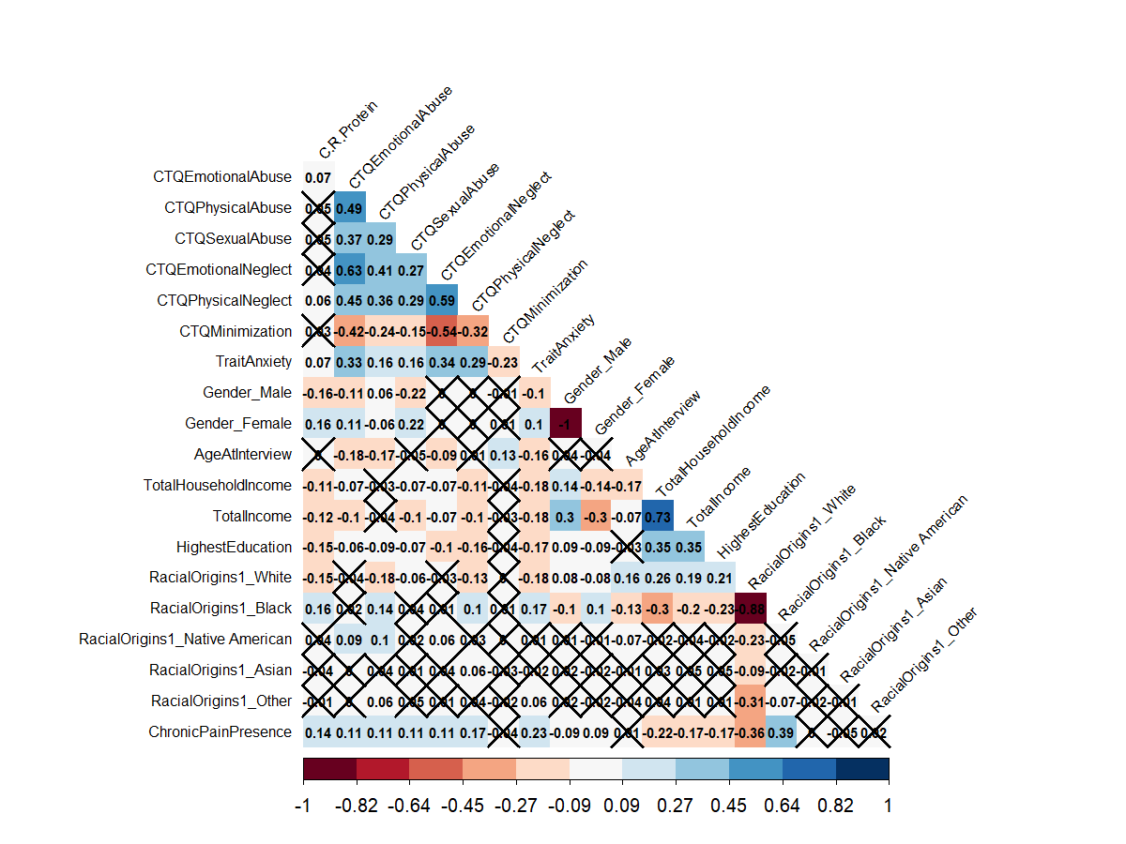
Figure 3. Heatmap of correlations between variables of interest and CRP
The X's indicate the correlation is insignificant at the 95% level. N = 1255.

SEM results

The best fitting SEM model that was achieved is displayed in Figure 4. The “Mardia’s multivariate normality test” in the R package MVN (https://cran.r-project.org/web/packages/MVN/vignettes/MVN.html) was used to calculate Mardia’s multivariate skewness and kurtosis coefficients and the corresponding significance (H0 being the data are multivariate normally distributed). Mardia’s skewness was p < 0.001 (statistic = 148020) and Mardia’s kurtosis was p < 0.001 (statistic = 469), thus, the data were not multivariate normally distributed. Therefore, the lavaan ‘robust' version of the maximum likelihood parameter estimation method (MLM), which does not assume multivariate normality was used. Based on this model, CAs, anxiety, and CRP all played a role in predicting chronic pain presence.

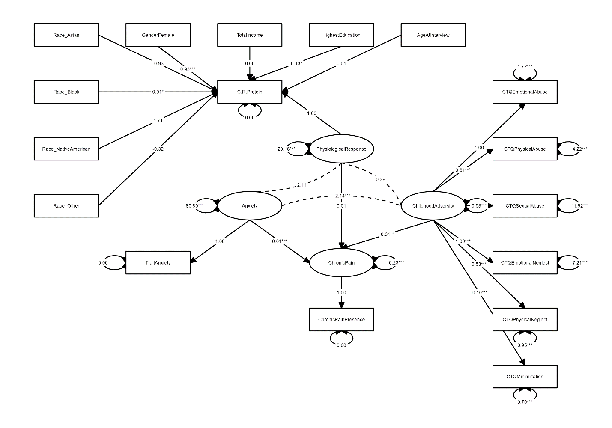
Figure 4. Final SEM

The parameters for this model were CFI: 0.989 (>0.90), RMSEA: 0.087 (<0.05), χ² = 865, df = 88, p < 0.001.

Regressions predicting chronic pain presence

A general linear model (GLM) with logit link function (logistic regression) was used to predict the binary, dependent variable of chronic pain presence. When conducting modelling against all variables of interest, the margin for error on the race variables was very large, to the extent that the interaction coefficients with race variables were not defined. Therefore, race was removed from the analyses. The results of model 1 (n = 1173) examining the effect of ACEs and anxiety on chronic pain, as well as CRP, are detailed in Table 3 and visualized in Figure 5.

None of the CAs, anxiety, or CRP significantly predicted chronic pain presence as main effects independently. However, female gender, total income, and highest education all independently contributed significantly to predicting chronic pain presence. For the socio-demographic control variables, every one-unit increase in highest education (education scale where 1 is lowest level, 12 is highest), the log odds of having chronic pain (vs not having chronic pain) decreased by 0.68. For every one-unit decrease in total income, the log odds of having chronic pain (vs not having chronic pain) increased by 0.00007. Reported female gender vs male decreased the log odds of having chronic pain by 3.06.

Table 3: CA, Anxiety, and CRP and interactions as a predictors
Variable | Estimate’ | Std. Error | z-value | p-value
(Constant) | 0.563 | 3.528 | 0.160 | 0.873
CTQ Emotional Abuse | -0.128 | 0.261 | -0.490 | 0.624
CTQ Physical Abuse | -0.054 | 0.327 | -0.166 | 0.868
CTQ Sexual Abuse | 0.237 | 0.206 | 1.149 | 0.251
CTQ Emotional Neglect | -0.238 | 0.240 | -0.992 | 0.321
CTQ Physical Neglect | 0.664 | 0.344 | 1.929 | 0.054
CTQ Minimization | 0.853 | 0.839 | 1.016 | 0.310
Trait Anxiety | 0.130 | 0.069 | 1.884 | 0.060
C-Reactive Protein | -0.353 | 0.185 | -1.912 | 0.056
Gender (Female) | -3.067 | 1.371 | -2.237 | 0.025
Age At Interview | -0.034 | 0.045 | -0.742 | 0.458
Total Household Income | 0.00002 | 0.00002 | 1.177 | 0.239
Total Income | -0.00007 | 0.00003 | -2.162 | 0.031
Highest Education | -0.680 | 0.243 | -2.799 | 0.005
Interactions
CTQ Emotional Abuse * CTQ Physical Abuse | 0.010 | 0.008 | 1.127 | 0.260
CTQ Emotional Abuse * CTQ Sexual Abuse | 0.009 | 0.008 | 1.138 | 0.255
CTQ Emotional Abuse * CTQ Emotional Neglect | 0.018 | 0.007 | 2.365 | 0.018
CTQ Emotional Abuse * CTQ Physical Neglect | -0.024 | 0.012 | -2.042 | 0.041
CTQ Emotional Abuse * CTQ Minimization | 0.021 | 0.065 | 0.318 | 0.750
CTQ Emotional Abuse * Trait Anxiety | 0.001 | 0.003 | 0.230 | 0.818
CTQ Emotional Abuse * C-Reactive Protein | 0.008 | 0.010 | 0.737 | 0.461
CTQ Emotional Abuse * Gender (Female) | 0.037 | 0.065 | 0.564 | 0.573
CTQ Emotional Abuse * Age At Interview | -0.0002 | 0.003 | -0.081 | 0.935
CTQ Emotional Abuse * Total Household Income | -0.000002 | 0.000001 | -1.742 | 0.082
CTQ Emotional Abuse * Total Income | 0.000003 | 0.000001 | 2.132 | 0.033
CTQ Emotional Abuse * Highest Education | -0.015 | 0.013 | -1.182 | 0.237
CTQ Physical Abuse * CTQ Sexual Abuse | -0.002 | 0.008 | -0.300 | 0.765
CTQ Physical Abuse * CTQ Emotional Neglect | -0.023 | 0.011 | -2.074 | 0.038
CTQ Physical Abuse * CTQ Physical Neglect | 0.010 | 0.014 | 0.704 | 0.481
CTQ Physical Abuse * CTQ Minimization | -0.010 | 0.070 | -0.148 | 0.882
CTQ Physical Abuse * Trait Anxiety | -0.004 | 0.004 | -1.087 | 0.277
CTQ Physical Abuse * C-Reactive Protein | 0.012 | 0.014 | 0.824 | 0.410
CTQ Physical Abuse * Gender (Female) | 0.053 | 0.080 | 0.660 | 0.509
CTQ Physical Abuse * Age At Interview | 0.003 | 0.004 | 0.872 | 0.383
CTQ Physical Abuse * Total Household Income | -0.0000007 | 0.000001 | -0.590 | 0.556
CTQ Physical Abuse * Total Income | -0.0000005 | 0.000002 | -0.275 | 0.784
CTQ Physical Abuse * Highest Education | 0.032 | 0.015 | 2.075 | 0.038
CTQ Sexual Abuse * CTQ Emotional Neglect | -0.003 | 0.008 | -0.460 | 0.645
CTQ Sexual Abuse * CTQ Physical Neglect | -0.001 | 0.010 | -0.061 | 0.951
CTQ Sexual Abuse * CTQ Minimization | -0.050 | 0.041 | -1.211 | 0.226
CTQ Sexual Abuse * Trait Anxiety | -0.003 | 0.003 | -1.260 | 0.208
CTQ Sexual Abuse * C-Reactive Protein | -0.004 | 0.006 | -0.589 | 0.556
CTQ Sexual Abuse * Gender (Female) | 0.037 | 0.061 | 0.602 | 0.547
CTQ Sexual Abuse * Age At Interview | -0.001 | 0.002 | -0.687 | 0.492
CTQ Sexual Abuse * Total Household Income | -0.0000007 | 0.0000007 | -0.963 | 0.335
CTQ Sexual Abuse * Total Income | 0.000001 | 0.000001 | 0.941 | 0.347
CTQ Sexual Abuse * Highest Education | -0.008 | 0.010 | -0.806 | 0.420
CTQ Emotional Neglect * CTQ Physical Neglect | 0.010 | 0.010 | 1.059 | 0.289
CTQ Emotional Neglect * CTQ Minimization | 0.082 | 0.044 | 1.860 | 0.063
CTQ Emotional Neglect * Trait Anxiety | 0.004 | 0.003 | 1.249 | 0.212
CTQ Emotional Neglect * C-Reactive Protein | -0.002 | 0.008 | -0.282 | 0.778
CTQ Emotional Neglect * Gender (Female) | -0.079 | 0.055 | -1.452 | 0.147
CTQ Emotional Neglect * Age At Interview | 0.001 | 0.003 | 0.513 | 0.608
CTQ Emotional Neglect * Total Household Income | 0.000002 | 0.0000008 | 2.570 | 0.010
CTQ Emotional Neglect * Total Income | -0.000003 | 0.000001 | -2.461 | 0.014
CTQ Emotional Neglect * Highest Education | 0.00003 | 0.011 | 0.003 | 0.998
CTQ Physical Neglect * CTQ Minimization | -0.024 | 0.070 | -0.341 | 0.733
CTQ Physical Neglect * Trait Anxiety | -0.008 | 0.004 | -1.764 | 0.078
CTQ Physical Neglect * C-Reactive Protein | 0.020 | 0.012 | 1.665 | 0.096
CTQ Physical Neglect * Gender (Female) | -0.014 | 0.081 | -0.172 | 0.863
CTQ Physical Neglect * Age At Interview | -0.004 | 0.004 | -1.176 | 0.240
CTQ Physical Neglect * Total Household Income | -0.000002 | 0.000001 | -1.516 | 0.129
CTQ Physical Neglect * Total Income | 0.000001 | 0.000002 | 0.834 | 0.404
CTQ Physical Neglect * Highest Education | -0.004 | 0.015 | -0.297 | 0.766
CTQ Minimization * Trait Anxiety | 0.001 | 0.013 | 0.039 | 0.969
CTQ Minimization * C-Reactive Protein | -0.018 | 0.024 | -0.748 | 0.454
CTQ Minimization * Gender (Female) | -0.121 | 0.184 | -0.656 | 0.512
CTQ Minimization * Age At Interview | -0.012 | 0.007 | -1.560 | 0.119
CTQ Minimization * Total Household Income | -0.000001 | 0.000003 | -0.405 | 0.686
CTQ Minimization * Total Income | -0.000003 | 0.000004 | -0.797 | 0.425
CTQ Minimization * Highest Education | -0.003 | 0.039 | -0.079 | 0.937
Trait Anxiety * C-Reactive Protein | -0.0002 | 0.003 | -0.058 | 0.954
Trait Anxiety * Gender (Female) | 0.002 | 0.019 | 0.123 | 0.902
Trait Anxiety * Age At Interview | -0.001 | 0.001 | -0.704 | 0.481
Trait Anxiety * Total Household Income | 0.0000002 | 0.0000003 | 0.686 | 0.493
Trait Anxiety * Total Income | -0.0000002 | 0.0000004 | -0.455 | 0.649
Trait Anxiety * Highest Education | 0.001 | 0.004 | 0.219 | 0.827
C-Reactive Protein * Gender (Female) | 0.108 | 0.050 | 2.186 | 0.029
C-Reactive Protein * Age At Interview | 0.001 | 0.002 | 0.748 | 0.455
C-Reactive Protein * Total Household Income | -0.0000005 | 0.0000007 | -0.727 | 0.467
C-Reactive Protein * Total Income | 0.000002 | 0.000001 | 1.506 | 0.132
C-Reactive Protein * Highest Education | 0.005 | 0.009 | 0.542 | 0.588
Gender (Female) * Age At Interview | 0.031 | 0.013 | 2.303 | 0.021
Gender (Female) * Total Household Income | -0.00001 | 0.000005 | -2.314 | 0.021
Gender (Female) * Total Income | 0.00002 | 0.000007 | 3.236 | 0.001
Gender (Female) * Highest Education | 0.133 | 0.063 | 2.110 | 0.035
Age At Interview * Total Household Income | -0.0000003 | 0.0000002 | -1.601 | 0.109
Age At Interview * Total Income | 0.0000007 | 0.0000003 | 2.346 | 0.019
Age At Interview * Highest Education | 0.007 | 0.003 | 2.575 | 0.010
Total Household Income * Total Income | 0.00000000002 | 0.00000000002 | 0.713 | 0.476
Total Household Income * Highest Education | 0.0000005 | 0.0000009 | 0.502 | 0.615
Total Income * Highest Education | 0.000002 | 0.000001 | 1.120 | 0.263
NOTES: Dependent variable: Probability of having chronic pain. N = 1173. (Dispersion parameter for binomial family taken to be 1). ‘Logit function ranging between 0 and 1.

Many significant interactions predicting chronic pain were also found. For instance, CRP levels showed a significant interaction with female gender in determining chronic pain presence. Moreover, there were various interactions between different types of CAs determining the presence of chronic pain, such as emotional abuse and emotional neglect, emotional abuse and physical neglect, and physical abuse and emotional neglect. The partial regression plots (Figure 5) indicate how these significant interactions (from Table 3) influence likelihood of chronic pain presence. The impact of emotional abuse depended on levels of emotional and physical neglect and income. At higher frequency of emotional neglect, increasing rates of emotional abuse increased the likelihood of chronic pain, whereas with lower levels of emotional neglect, increasing emotional abuse decreased the likelihood of chronic pain (Figure 5A). For increasing levels of physical neglect, increasing levels of emotional abuse decreased the likelihood of chronic pain but at lower levels of physical neglect, increasing emotional abuse had little impact on the risk of chronic pain (Figure 5B). Lastly, for high levels of annual income, increasing levels of emotional abuse were related to increased chronic pain likelihood (Figure 5C). The interaction between physical abuse and emotional neglect also had a non-linear effect on chronic pain (Figure 5D). At low rates of emotional neglect, increasing levels of physical abuse increased the likelihood of chronic pain, but at higher frequency of emotional neglect, the opposite is observed: with increasing levels of physical abuse the likelihood of chronic pain decreased. For the socio-demographic control variable interactions, with increasing levels of education, increased levels of physical abuse were associated with increased likelihood of chronic pain (Figure 5E), and the opposite occurred for the lowest education levels, with the impact appearing to switch around at middle education level. An interesting contrast appeared when looking at the interactions between emotional neglect and the entire household income (Figure 5F) compared to only the participant’s total income (Figure 5G). For increasing levels of household income, an increased rate of emotional neglect was related to more chronic pain incidence. However, for increasing levels of high personal income, high levels of emotional neglect were related to lesser chronic pain incidence. The opposite was found for the lowest level of income, with no impact of emotional neglect found at the second-to-lowest income level ($50,000). Finally, for female participants, increasing CRP increased the likelihood of chronic pain whereas CRP made no difference to chronic pain prediction among males (Figure 5H).
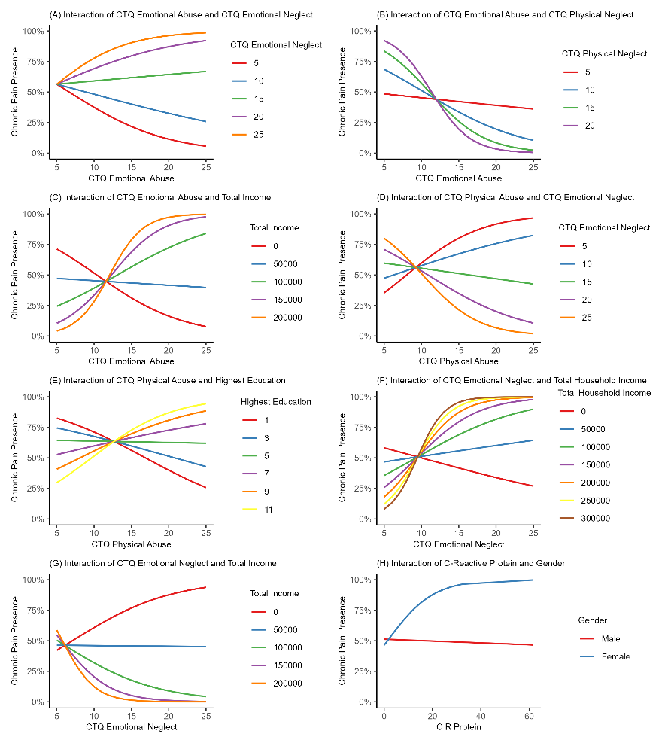
Figure 5. Partial regressions of significant interactions on probability of chronic pain presence
Notes: The likelihood of chronic pain presence increases as the y-axis increases to 100%. Incomes are annual USD ($).

To help validate the results, a sensitivity analysis was also conducted in a subset of participants (n=1121) excluding 52 participants with a CRP level ≥ 10, which is sometimes associated with acute infection (Supplemental Table S5); however, no major differences arose.

Objective 3

Exploratory pain medication analysis

The regression confusion matrix sensitivity (“true positives”) was 45.8% and specificity (“true negatives”) was 98.5%. For comparison, a model was run with only the significant predictors and pairwise interactions (including corresponding predictors for the significant pairwise interactions), with a sensitivity of 15.3% and specificity of 98.9%. The confusion matrix for both models is presented in Supplemental Table S6. From this, we can infer that the influence of CAs on long-term medication use for chronic pain is complex. Selected interactions relevant to the objectives overall are shown in Table 4 and the eight significant interactions are visualized in Figure 6. The full table of all interactions is in Supplemental Table S7.

Table 4: Long term medication use for chronic pain (significant regression coefficients only)
Variable | Estimate | Std. Error | z-value | p-value
(Constant) | -3.236 | 4.231 | -0.765 | 0.444
CTQ Emotional Abuse | 0.275 | 0.126 | 2.175 | 0.030
CTQ Physical Abuse | -0.529 | 0.309 | -1.710 | 0.087
CTQ Sexual Abuse | 0.349 | 0.295 | 1.184 | 0.236
CTQ Emotional Neglect | -0.186 | 0.189 | -0.985 | 0.325
CTQ Physical Neglect | -0.336 | 0.183 | -1.836 | 0.066
CTQ Minimization | 0.776 | 0.689 | 1.126 | 0.260
Trait Anxiety | 0.109 | 0.095 | 1.143 | 0.253
C-Reactive Protein | -0.308 | 0.169 | -1.815 | 0.069
Gender (Female) | -4.208 | 1.461 | -2.880 | 0.004
Age At Interview | 0.087 | 0.056 | 1.537 | 0.124
Total Household Income | 0.00004 | 0.00002 | 2.025 | 0.043
Total Income | -0.0001 | 0.00004 | -3.150 | 0.002
CTQ Emotional Abuse * CTQ Physical Abuse | -0.030 | 0.013 | -2.291 | 0.022
CTQ Physical Abuse * CTQ Sexual Abuse | -0.010 | 0.008 | -1.208 | 0.227
CTQ Physical Abuse * CTQ Emotional Neglect | 0.050 | 0.016 | 3.197 | 0.001
CTQ Physical Abuse * CTQ Minimization | -0.278 | 0.128 | -2.176 | 0.030
CTQ Physical Abuse * Trait Anxiety | 0.009 | 0.005 | 1.610 | 0.107
CTQ Sexual Abuse * CTQ Minimization | 0.164 | 0.088 | 1.858 | 0.063
CTQ Sexual Abuse * Trait Anxiety | -0.006 | 0.004 | -1.594 | 0.111
CTQ Sexual Abuse * Gender (Female) | 0.281 | 0.181 | 1.554 | 0.120
CTQ Sexual Abuse * Total Household Income | -0.000007 | 0.000003 | -2.620 | 0.009
CTQ Sexual Abuse * Total Income | 0.000006 | 0.000003 | 1.838 | 0.066
CTQ Sexual Abuse * Highest Education | -0.025 | 0.019 | -1.307 | 0.191
CTQ Emotional Neglect * Highest Education | -0.032 | 0.018 | -1.818 | 0.069
CTQ Physical Neglect * Total Household Income | -0.000003 | 0.000002 | -1.909 | 0.056
CTQ Physical Neglect * Total Income | 0.000009 | 0.000003 | 2.696 | 0.007
CTQ Physical Neglect * Highest Education | 0.035 | 0.026 | 1.352 | 0.176
Trait Anxiety * Age At Interview | -0.002 | 0.002 | -1.583 | 0.113
Trait Anxiety * Total Income | 0.000001 | 0.0000006 | 1.841 | 0.066
C-Reactive Protein * Total Household Income | -0.000003 | 0.000001 | -2.083 | 0.037
C-Reactive Protein * Highest Education | 0.049 | 0.022 | 2.170 | 0.030
Gender (Female) * Total Household Income | 0.00003 | 0.00001 | 2.172 | 0.030
Gender (Female) * Total Income | -0.00002 | 0.00002 | -0.987 | 0.323
Gender (Female) * Highest Education | 0.261 | 0.140 | 1.872 | 0.061
Dependent variable: Probability of taking long term medication for chronic pain (N = 600). Null deviance: 383.69 on 599 degrees of freedom. Residual deviance: 303.66 on 565 degrees of freedom AIC: 373.66.

Emotional abuse, female gender, total household and total (personal) income independently significantly predicted medication use for chronic pain. For emotional abuse, with each one unit increase the log odds of taking medication for chronic pain increased by 0.275. For every one-unit change in total income, the log odds of medication use for chronic pain increased by 0.00004 for total household income but decreased by 0.0001 for total personal income. Female gender vs male decreased the log odds of medication use for chronic pain by 4.208.

The main CAs interacting with each other significantly to predict pain medication use included emotional abuse and physical abuse, physical abuse and emotional neglect, and physical abuse and minimization. Significant interactions between CAs and the control variables included sexual abuse and total household income, and physical neglect and total income. CRP interactions with control variables, were CRP and total household income, and CRP and highest education. Finally, the control variables significantly interacting with each other were gender and income total household income. These interactions are explained in more detail below (Figure 6).

For the visualized regressions, lower rates of physical abuse paired with increased occurrence of emotional abuse led to a moderate increase in pain medication use, but there was no impact at other rates of physical abuse (Figure 6A). At the highest rates of emotional neglect and increasing physical abuse, the likelihood of taking pain medication for chronic pain greatly increased (Figure 6B), however, this gradually lost impact at lower emotional neglect rates. Interestingly, only the highest rate of minimization, interacting with the lowest rates of physical abuse, had a slight increase in pain medication for chronic pain use (Figure 6C), with all other rates showing little impact and no impact at physical abuse levels above 7.5. At the lowest level of household income, an increasing frequency of sexual abuse increased the likelihood of taking pain medication for chronic pain (Figure 6D); but at all other household income levels there was little influence of sexual abuse. At the lowest level of total personal income, there was no impact of increasing physical neglect on the likelihood of taking pain medication, while for all other levels of income, higher levels of physical neglect were related with an increased chance of taking pain medication (Figure 6E). At the lowest household income, increasing CRP level slightly decreased the likelihood of taking pain medication for chronic pain (Figure 6F), while for all other income levels there was little influence of CRP on medication intake. At the highest education level, increasing CRP increased the likelihood of taking pain medication, but at the other education levels, only an increase in CRP from 0 to 5 made any difference, and this was in the form of a decrease in medication for pain usage (Figure 6G). Finally, male gender at the lowest total household income level meant a slightly increased likelihood of pain medication usage compared to reported female gender (Figure 6H), but this impact gradually disappeared as total household income increased.
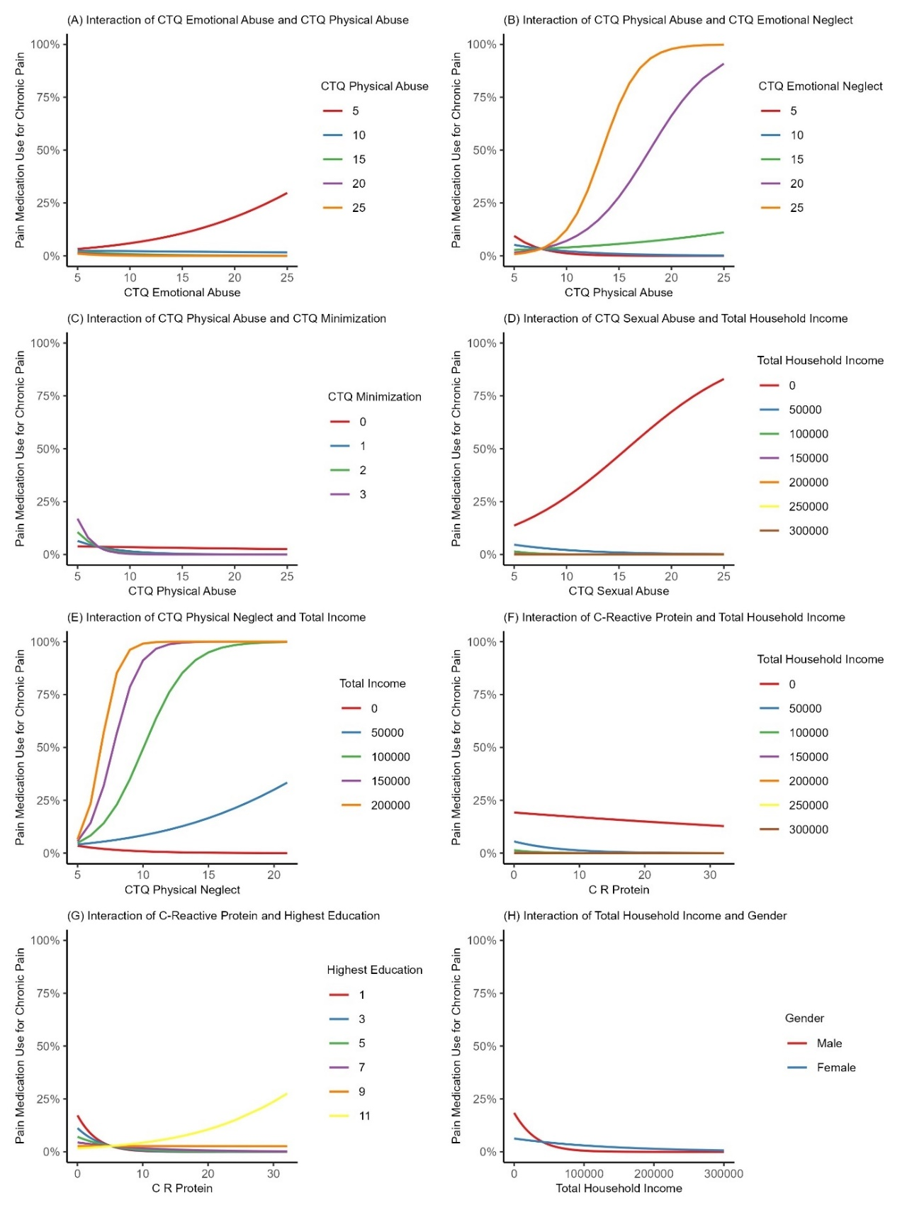
Figure 6. Partial regressions of long-term medication use for chronic pain
Note: The likelihood of medication use for chronic pain presences increase as the y-axis increases to 100%.

Discussion

Using the MIDUS dataset, this study examined the relationships between reported CAs, anxiety, and pain; assessed the associations between CAs, anxiety, inflammation via CRP levels, and pain; and explored how CAs, anxiety, and CRP were potentially associated with pain-medication consumption. None of the CAs, anxiety, or CRP significantly predicted chronic pain presence independently, but the several interactions were significant and offer unique insight into previously held assumptions surrounding ACEs, mental health, and whether socio-demographic variables significantly impact on the effects of these.

For the primary objective analysis, a number of variables were significant, including control variables gender (female), total income, and highest education. While none of the CAs or anxiety significantly predicted chronic pain presence independently, various significant interactions predicting chronic pain were found. For instance, there were significant interactions between different types of CAs determining the presence of chronic pain, as well as several significant interactions between CAs and socio-demographic variables. Of the main predictors, those that did not interact with each other or any of the socio-demographic control variables in predicting pain presence were sexual abuse, physical neglect, minimization, and trait anxiety.

These findings illustrate the complexity around how CAs and socio-demographic variables impact the likelihood of developing chronic pain, where it is not a simple equation of more CAs and/or lower socioeconomic status leading to more pain. Consequently, there is a need in clinical practice to gather detailed insights on CA history and socio-demographic situation when assessing a patient with chronic pain, particularly as the present results contradicted some prior research. Although the findings did match with previous evidence showing how ACEs impact the presence of chronic pain, the lack of an interaction with anxiety or direct impact of anxiety on chronic pain presence was surprising and contrasted with existing literature (Sachs-Ericsson et al. 2017; King 2021). For example, in one study, mediation analyses demonstrated that ACEs (verbal and sexual abuse, parental psychopathology, and early parental loss) were linked to increased anxiety and mood disorders (Sachs-Ericsson et al. 2017). Another study demonstrated that four types of CAs were associated with higher prevalence rates of six different mood and anxiety-related disorders, and self-reported generalized anxiety disorder was specifically associated with physical abuse, emotional abuse, and maternal battering (King 2021). As demonstrated by various studies (both basic and clinical), ACEs have a profound impact on the development and function of the nervous system (Nemeroff 2016), which we have yet to fully comprehend in terms of adult mental health outcomes such as anxiety. These results highlight that although some physiological and behavioural adaptations may start to show earlier in life, the outcomes for psychological and physical health may not arise until decades later for adults with a history of CAs, making it even harder to properly account for all variables potentially playing a role, such as in their co-occurring chronic pain and anxiety. Previous research has also shown that anxiety is associated with chronic pain (Zhang et al. 2024), and that ACEs relate directly to chronic pain or indirectly via anxiety (Tidmarsh et al. 2022). This also contrasts with the present findings, which showed that CAs and chronic pain interactions with anxiety were not significant. This suggests the mental health outcomes of individuals with a history of CAs and chronic pain are indeed complex and may not always interact as previously assumed.

For the secondary objective analysis of how CRP may be an important underlying factor in the association between ACEs and pain, CRP was indeed significantly correlated with two of the CTQ subscales; emotional abuse and physical neglect. The regression results indicated gender, total-income, and highest-education were also significant predictors of chronic pain. Significant interactions to explain chronic pain included CAs interacting with each other and CRP with socio-demographic variables such as income and education level. These findings differ from those of a Denmark cross-sectional and prospective study of 73,131 individuals, where higher CRP level predicted greater psychological distress, depression symptoms, or risk of hospitalization (with depression) 4 to 12 years later in young, middle-aged, or older adults (Wium-Andersen et al. 2013). Contrary to previous CRP research, the Danish study did not find that the association disappeared when adjusting for confounding variables such as BMI and chronic disease (Wium-Andersen et al. 2013). In this way, the present results differed in that anxiety did not have an impact in any of the regression interactions, while socio-demographic variables did play a substantial role. Although the correlations had indicated CRP, CAs (aside from minimization), and anxiety were all significantly positively associated with chronic pain presence, this does not imply a causal relationship nor accounts for the complex interactions that can be identified with linear regressions, and hence should be interpreted with caution. These results highlight the complexity of studying how CRP may be associated with, influencing, or interacting with mental health and/or chronic pain outcomes, and how socio-demographic factors need to be included too.

Lastly, regarding the third objective, our results on the influence of CAs on long term medication use for chronic pain were also complex. The only variables with a direct impact on predicting medication for chronic pain usage were emotional abuse, male gender, and income (both household and personal income). Again, as seen for the primary objective, the impact of individual CAs was dependent on other CAs and participants’ socio-demographics. Multiple CA variables significantly interacted with each other, and interactions between CAs and the socio-demographic variables were found too.

Additionally, there were a couple of significant anxiety or CRP interactions with socio-demographic variables. A recent study found that for adults with chronic pain, ACEs were associated with more pain complications and pain catastrophizing, with both independently increasing the risk of early treatment attrition (Tidmarsh et al. 2022). Historical epidemiology research has shown that ACEs increase the risk for an adult to develop substance use/abuse disorders (Ande et al. 2002; Dube et al. 2003). Of note, beyond opioid dependence—a prevalent issue in the US (Stein et al. 2022)—ACEs were also more prevalent among cocaine-dependent adults (Medrano et al. 2002) as compared with the general population. In addition, a recent systematic review found that all 20 studies included showed statistical associations between ACEs and either lifetime or current opioid use-related behaviours, but only five demonstrated a significant gradient effect of the number of ACEs increasing with increasing risk of opioid use-related behaviours (Regmi et al. 2023). The present significant interactions between various CAs further highlights the complexity of this issue as the interactions revealed that the impact goes beyond an additive effect of more CAs leading to more pain medication use. These results highlight how complex CA outcomes are in regard to adult pain, and how pain management and ultimately, pain prevention, needs to account for more trauma-informed approaches to care. Although our understanding of these associations remains obscured by complexities, the need for CA history or ACE screening to be implemented into pain treatment decisions, pain screening, and pain assessment as an important consideration remains warranted.

Further, a history of CAs should be considered in public health policies and decision-making and connect CAs more directly to interventional and preventative programs, including pain management and treatment algorithms. There remains an unmet need for research that better specifies the pathways through which CAs influence later health outcomes and pain medicine consumption, which could be explored more in future studies. In particular, CA or ACE-informed care should be implemented into pain management considerations such that CRP levels could be examined as part of this treatment selection and decision-making process. Overall, this study adds to the continuously developing body of research examining the lasting effects of CAs or childhood trauma exposure on health outcomes and adult behaviours across the lifespan, and added some surprising insight into how socio-demographic variables may be involved and thus need to be more strongly considered as potentially contributing factors in both research and clinical settings.

Of note, across all analyses, the CA of neglect in some form (emotional or physical) was often significant, highlighting its importance in being more substantially acknowledged and screened for as a type of childhood trauma. While neglect is on the official ACEs list, there remains a paucity of research on the prevalence of neglect in general populations. In a meta-analysis by Stoltenborgh et al. (2013), only 13 studies about emotional neglect were identified, which is drastically low compared to other ACE domains such as childhood sexual abuse, which yielded over 200 publications. (Stoltenborgh et al. 2013). Additionally, to date, there is no established questionnaire to measure emotional neglect consistently, which has likely influenced the lack of data on neglect prevalence overall, and past research has shown that a low number of overall suspected cases of child abuse or neglect are actually reported by healthcare providers (Eads 2013). Thus, the results of the present analyses may help to inform clinical efforts to better predict the potential burden of CAs on adult outcomes across the lifespan and offers insights into the assumptions that are currently held around the relationship between ACEs and anxiety, such as an increased number of ACEs previously being associated with likelihood of anxiety or depression (Elmore & Crouch 2020).

Limitations

Although a dominant theme of the MIDUS biomarker project was to investigate protective or harmful roles that behavioural and psychosocial factors may have in resilience and recovery from health challenges, the research was not targeted towards any specific diseases or conditions, given that psychosocial factors have relevance across multiple health endpoints. Additionally, even though the MIDUS sample was based on a probability sample, minorities and those with lower income levels and less educational attainment are underrepresented in the sample. However, this study offered value as a large, longitudinal US-based sample with consideration of multiple socio-demographic variables. While a variety of intersections between race, gender, class, and income may be associated with higher risks of fair or poor self-rated health, they are usually inconsistent (Veenstra 2011). Such interactions make firm conclusions difficult and were too broad for the scope of this study but should be considered in future research.

Conclusions

Based on a large US sample of adults, the results showed that socio-demographic variables played a substantial role in predicting chronic pain experience in adults, with female gender, total income, and highest education all significant. Significant interactions for predicting chronic pain experience included CAs interacting with each other, CAs with income and education; and CRP with income and education levels. The influence of CAs on predicting long term medication use for chronic pain was complex, with significant interactions between a number of CAs, CRP with total household income and with highest education, and a number of CAs and socio-demographics. Across all analyses, the CA of neglect in some form was significant, highlighting its importance in being acknowledged as a type of childhood trauma. Although the results warrant further study, these analyses may help to inform clinical efforts and improve screening practices to reduce the burden of CAs on adult outcomes across the lifespan.
Chapter 4 References
Afari N, Mostoufi S, Noonan C, Poeschla B, Succop A, Chopko L, et al. C-reactive protein and pain sensitivity: findings from female twins. Ann Behav Med. 2011;42(2):277-83. doi: 10.1007/s12160-011-9297-6, PMID 21785898.
Anda, R. F., C.L. Whitfield, V.J. Felitti, D. Chapman, V.J. Edwards, S.R. Dube, D.F. Williamson. Adverse childhood experiences, alcoholic parents, and later risk of alcoholism and depression Psychiatr. Serv., 53; 2002, pp. 1001-1009
Baron RM, Kenny DA. The moderator-mediator variable distinction in social psychological research: conceptual, strategic, and statistical considerations. J Pers Soc Psychol. 1986;51(6):1173-82. doi: 10.1037//0022-3514.51.6.1173, PMID 3806354.
Beran TN, Violato C. Structural equation modeling in medical research: a primer. BMC Res Notes. 2010;3:267. doi: 10.1186/1756-0500-3-267, PMID 20969789.
Bernstein DP, Stein JA, Newcomb MD, Walker E, Pogge D, Ahluvalia T, et al. Development and validation of a brief screening version of the Childhood Trauma Questionnaire. Child Abuse Negl. 2003;27(2):169-90. doi: 10.1016/s0145-2134(02)00541-0. PMID 12615092.
Brim OG, Baltes PB, Bumpass LL, Cleary PD, Featherman DL, Hazzard WR, et al. Midlife in the United States (MIDUS 1). Inter-university Consortium for Political and Social Research [distributor]; 1995-1996 [cited 2020-9-28]. Available from: https://doi.org/10.3886/ICPSR02760. v19.
Bussières A, Hartvigsen J, Ferreira ML, Ferreira PH, Hancock MJ, Stone LS et al. Adverse childhood experience and adult persistent pain and disability: protocol for a systematic review and meta-analysis. Syst Rev. 2020;9(1):215. doi: 10.1186/s13643-020-01474-8, PMID 32943108.
Centers for Disease Control and Prevention (CDC). Adverse childhood experiences (ACEs); 2022. Available from: https://www.cdc.gov/violenceprevention/aces/index.html.
CRP data reported by Tracy Lab. University of Vermont; August 20, 2009.
Dube, S. R., V.J. Felitti, M. Dong, D.P. Chapman, W.H. Giles, R.F. Anda. Childhood abuse, neglect, and household dysfunction and the risk of illicit drug use: the adverse childhood experiences study. Pediatrics, 111; 2003, pp. 564-572.
Eads, K. Breaking Silence: Underreported Child Abuse in the Healthcare Setting. Journal of Health Ethics, 2013; 9(1). http://dx.doi.org/10.18785/ojhe.0901.01.
Elliot AJ, Turiano NA, Infurna FJ, Lachman ME, Chapman BP. Lifetime trauma, perceived control, and all-cause mortality: results from the Midlife in the United States Study. Health Psychol. 2018;37(3):262-70. doi: 10.1037/hea0000585, PMID 29369676.
Elmore AL, Crouch E. The Association of Adverse Childhood Experiences With Anxiety and Depression for Children and Youth, 8 to 17 Years of Age. Acad Pediatr. 2020 Jul;20(5):600-608. doi: 10.1016/j.acap.2020.02.012.
Felitti VJ, Anda RF, Nordenberg D, Williamson DF, Spitz AM, Edwards V, et al. Relationship of childhood abuse and household dysfunction to many of the leading causes of death in adults. The adverse childhood experiences (ACE) Study. Am J Prev Med. 1998;14(4):245-58. doi: 10.1016/s0749-3797(98)00017-8, PMID 9635069.

Graham JM. The General Linear Model as structural equation modeling. J Educ Behav Stat. 2008;33(4):485-506. doi: 10.3102/1076998607306151.
Hopwood CJ. Moderation and mediation in structural equation modeling: applications for early intervention research. J Early Interv. 2007;29(3):262-72. doi: 10.1177/105381510702900305.
Hughes K, Bellis MA, Hardcastle KA, Sethi D, Butchart A, Mikton C, et al. The effect of multiple adverse childhood experiences on health: a systematic review and meta-analysis. Lancet Public Health. 2017;2(8):e356-66. doi: 10.1016/S2468-2667(17)30118-4, PMID 29253477.
Ke-Hai Y, Bentler PM. ’Robust procedures in structural equation modeling.’ Handbook of latent variable and related models. North-Holland; 2007. p. 367-97.
King AR. Childhood adversity links to self-reported mood, anxiety, and stress-related disorders. J Affect Disord. 2021 Sep 1;292:623-632. doi: 10.1016/j.jad.2021.05.112.
Medrano, M. A., J.P. Hatch, W.A. Zule, D.P. Desmond (2002). Psychological distress in childhood trauma survivors who abuse drugs. Am. J. Drug Alcohol Abuse, 28, 2002; pp. 1-13.
Merrick MT, Ford DC, Haegerich TM, Simon T. Adverse childhood experiences increase risk for prescription opioid misuse. J Prim Prev. 2020;41(2):139-52. doi: 10.1007/s10935-020-00578-0, PMID 31989435.
Morris P, Ali K, Merritt M, Pelletier J, Macedo LG. A systematic review of the role of inflammatory biomarkers in acute, subacute and chronic non-specific low back pain. BMC Musculoskelet Disord. 2020;21(1):142. doi: 10.1186/s12891-020-3154-3, PMID 32126991.
MSD product insert (PI). Vascular Injury Panel 2 (human) Kits: V-Plex, August 2014.
Muniz Carvalho C, Wendt FR, Maihofer AX, Stein DJ, Stein MB, Sumner JA, et al. Dissecting the genetic association of C-reactive protein with PTSD, traumatic events, and social support. Neuropsychopharmacology. 2021;46(6):1071-7. doi: 10.1038/s41386-020-0655-6, PMID 32179874.
Nehring SM, Goyal A, Patel BC. C reactive protein. StatPearls [Internet]. Updated 2023 July 10:2024 Jan-.
Nemeroff CB. Paradise Lost: The Neurobiological and Clinical Consequences of Child Abuse and Neglect. Neuron. 2016 Mar 2;89(5):892-909.
Nicolson KP, Mills SEE, Nicolson KP, Mills SEE, Senaratne DNS, Colvin LA, Smith BH. What is the association between childhood adversity and subsequent chronic pain in adulthood? A systematic review. BJA Open. 2023;6:100139. doi: 10.1016/j.bjao.2023.100139, PMID 37588177.
Olsson UH, Foss T, Troye SV, Howell RD. The performance of ML, GLS, and WLS estimation in structural equation modeling under conditions of misspecification and nonnormality. Structural Equation Modeling: A Multidisciplinary Journal. 2000;7(4):557-95. doi: 10.1207/S15328007SEM0704_3.
R Core Team. R: A Language and Environment for Statistical Computing. Vienna, Austria: R Foundation for Statistical Computing; 2021. Available from: https://www.R-project.org.
Regmi, S., Kedia, S. K., Ahuja, N. A., Lee, G., Entwistle, C., & Dillon, P. J. Association Between Adverse Childhood Experiences and Opioid Use-Related Behaviors: A Systematic Review. Trauma, Violence, & Abuse, 2023; 0(0). https://doi.org/10.1177/15248380231205821.
Rosseel Y. lavaan: an R package for Structural Equation Modeling. J Stat Softw. 2012;48(2):1-36. doi: 10.18637/jss.v048.i02.
Ryff CD, Almeida DM, Ayanian JZ, Carr DS, Cleary PD, Coe C. et al. Midlife in the United States (MIDUS 2). Inter-university Consortium for Political and Social Research [distributor]; 2004-2006 [cited 2021-9-15]. Available from: https://doi.org/10.3886/ICPSR04652. v8.
Sachs-Ericsson NJ, Sheffler JL, Stanley IH, Piazza JR, Preacher KJ. When Emotional Pain Becomes Physical: Adverse Childhood Experiences, Pain, and the Role of Mood and Anxiety Disorders. J Clin Psychol. 2017 Oct;73(10):1403-1428. doi: 10.1002/jclp.22444.
Spielberger CD. State–Trait Anxiety Inventory for Adults (STAI-AD) [Database record]. PsycTESTS; 1983.
Stein, B.D., Sherry, T.B., O’Neill, B. et al. Rapid Discontinuation of Chronic, High-Dose Opioid Treatment for Pain: Prevalence and Associated Factors. J GEN INTERN MED 2022; 37, 1603–1609. https://doi.org/10.1007/s11606-021-07119-3.
Stoltenborgh M, Bakermans-Kranenburg MJ, van IJzendoorn MH. The neglect of child neglect: a meta-analytic review of the prevalence of neglect. Soc Psychiatry Psychiatr Epidemiol. 2013;48(3):345–55.
Tidmarsh LV, Harrison R, Ravindran D, Matthews SL, Finlay KA. The Influence of Adverse Childhood Experiences in Pain Management: Mechanisms, Processes, and Trauma-Informed Care. Front Pain Res (Lausanne). 2022 Jun 10;3:923866.
Veenstra G. Race, gender, class, and sexual orientation: intersecting axes of inequality and self-rated health in Canada. Int J Equity Health. 2011 Jan 17;10:3. doi: 10.1186/1475-9276-10-3.
Wente VM, Retz-Junginger P, Crombach A, Retz W, Barra S. The suitability of the childhood trauma questionnaire in criminal offender samples. Int J Environ Res Public Health. 2023;20(6):5195. doi: 10.3390/ijerph20065195, PMID 36982104.
Wium-Andersen MK, Ørsted DD, Nielsen SF, Nordestgaard BG. Elevated C-reactive protein levels, psychological distress, and depression in 73, 131 individuals. JAMA Psychiatry. 2013 Feb;70(2):176-84. doi: 10.1001/2013.jamapsychiatry.
Woo AK. Depression and anxiety in pain. Rev Pain. 2010;4(1):8-12. doi: 10.1177/204946371000400103, PMID 26527193.
Zhang Q, Sun H, Xin Y, Li X, Shao X. Studies on Pain Associated with Anxiety or Depression in the Last 10 Years: A Bibliometric Analysis. J Pain Res. 2024 Jan 5;17:133-149. doi: 10.2147/JPR.S436500.

Chapter 5: Discussion
Although several factors, such as childhood adversity, have been identified that may increase an individual’s predisposition or vulnerability to an anxiety or a stress disorder and potential physical consequences such as chronic pain, the biological mechanisms underpinning these disorders are not yet fully understood (Kennedy & Niedzwiedz 2021). The two overarching aims of this thesis were first, to summarise the existing literature on the relationship between ACEs and anxiety and chronic pain experiences in adults. Second, to examine these associations, as well as the potential impact of inflammatory biomarker CRP, within large, representative cohorts. An exploratory analysis also examined medication use for chronic pain. Across all studies, it was hypothesised that there would be a significant association between ACEs, anxiety, and chronic pain experiences, and that CRP may also relate to some or all of these variables. The findings from this thesis partially supported the initial hypotheses in that both ACEs and anxiety influenced chronic pain experience in adults based on the systematic literature review, meta-analysis, and UK-based study that included CRP, but anxiety did not seem to play a meaningful role in the US-based study which also accounted for socio-demographic variables and pain medication use. The results of these analyses add to the existing literature and expand the understanding of the potential relationships involved in ACEs, anxiety, and CRP and how they impact chronic pain experiences in adults. An overview of the specific findings and their implications from each study is discussed below.

Systematic Review Findings
From the systematic review in Chapter 2, the narrative summary indicated there was a significant association between childhood adversities, anxiety, and chronic pain experiences in adults. The meta-analyses showed moderate associations between anxiety and chronic pain as well as between ACEs and anxiety and found that participants who experienced ACEs are almost twice as likely to present with chronic pain during adulthood. This is in line with past research that has clearly indicated long-term effects of ACEs on a variety of developmental problems, negative adult health outcomes (both psychological and physical), risky health behaviours, increased healthcare use, and higher financial burden (Bussières et al. 2020). Additionally, patients who experience chronic pain may struggle with functioning in daily life and with keeping up with social activity, which is more commonly attributed to mental health issues like anxiety versus the daily experience of being in pain (Dueñas et al., 2016). The review portion of this thesis was original in attempting to summarise the associations between all three variables, particularly indicating that anxiety could be influencing the association between ACEs and chronic pain. Studies featuring ACE prevalence and their long-term effects are informative for understanding the differences in the impact of one ACE compared to multiple ACEs. However, a gap remains on implementing practical changes with the insight gained from such studies. For example, in policy and work settings ACE-related information could be incorporated and applied via offering discrete screening options for employees on risk factors and providing appropriate accommodations if present.

UK Biobank Findings
The UK analyses of the Biobank data in Chapter 3 showed three statistically significant interactions were found to predict pain; frequency of physical abuse and reported muscular symptoms during anxiety, frequency in which they felt hated and having discussed anxiety with a professional, and, reported frequency of sexual abuse and difficulties relaxing during anxiety attacks. This was in line with recent research on adult patients seeking acute treatment for an anxiety disorder (i.e., panic disorder, social phobia, or generalized anxiety disorder), which showed that in patients with comorbid anxiety disorders or with comorbid depression, those presenting with panic disorder demonstrated higher frequency of childhood physical or sexual abuse (Safren et al. 2022). However, this study did not include pain as an outcome of childhood abuse and anxiety disorders. Another study demonstrated that posttraumatic stress symptoms moderate the relationship between ACEs and anxiety and depressive symptoms in youth with chronic pain (Nelson et al. 2021), however, this study paired anxiety and depression together. These studies highlight the paucity of research specifically examining ACE history and anxiety in predicting chronic pain risk in adults.
Additionally, the Biobank data showed that the frequency of sexual abuse and informing a professional about anxiety significantly interacted to predict elevated CRP. For correlations, the largest was between elevated CRP and the number of times pain was reported over the years. Finally, several ACEs (physical abuse, sexual abuse, and whether taken to a doctor) were found to significantly interact with CRP level to predict pain.
However, the UK-based analysis also revealed interesting implications for the underlying mechanisms of the associations studied. CRP was found to be a stronger predictor of pain for patients who reported never having experienced physical abuse, meaning that the more frequently physical abuse was reported, the weaker the relationship between CRP and chronic pain became. Similarly, CRP was a stronger predictor for patients who were not exposed to sexual abuse as children, showing that as the frequency of sexual abuse increased, CRP levels appeared to become less of a predictor. The interaction results did show an interesting divide in the effect of CRP on chronic pain, in that for patients who had low or infrequent availability to visit the doctor when needed as children (higher adversity), lower not higher CRP levels were related to an increased frequency of chronic pain reported during adulthood. In contrast, patients who had a high availability of visiting the doctor when needed (lower adversity) showed higher CRP levels to be a strong predictor of chronic pain in adulthood. These findings were not aligned with expectations that childhood abuse would link to higher CRP and a higher frequency of reported pain. In previous studies individuals with any type of childhood abuse experience showed greater rises in inflammation over time, and this was emphasised in those who had physical and emotional abuse history (Renna et al. 2021). In the present analysis, only the frequency of sexual abuse and informing a professional about anxiety significantly interacted to predict elevated CRP. For the doctor visit availability discrepancy, it is possible that while one may assume less hospital visits implies neglect and more visits as having this need met, it may be the children who frequently went to the doctor perhaps had to do so due to poor health or abuse severity. However, this cannot be assumed or confirmed from the retrospective database, as the questionnaires were limited in scope and did not capture detailed context.
In addition to CRP, systemic inflammation indexed through elevated levels of inflammatory biomarkers such as TNF-Α, IL-6, and IL-1B has previously been linked to increased inflammatory and neuropathic pain (Morris et al. 2020). The role of inflammation in the pathogenesis of other health problems in adults may be one of the main psychobiological mechanisms underlying the relationship between ACE history and later health outcomes. As shown in a study by Iob et al. (2020) assessing CRP and hair cortisol, for example, adults with three ACEs or more had a higher risk of elevated CRP levels across a 4-year period of follow-up. Such results demonstrate how the complexities between ACEs and proinflammatory responses may persist and impact later stages of adulthood and should be factored into chronic pain screening. This could perhaps be done so in the form of including inflammatory markers in accompanying bloodwork for such visits. In addition, the number and specific combination of ACE types may influence CRP levels, as suggested by the contrasting individual interaction findings, which suggests perhaps ACEs should be examined as a group or a whole instead of individually.

MIDUS Findings
The results of the US analyses of the MIDUS dataset in Chapter 4 did corroborate some of the patterns of the UK analyses, but also showed many unique findings. The similarities were that the SEM indicated childhood adversity, anxiety, and CRP all played a role in predicting chronic pain, and the regressions for both had significant interactions between different ACEs to predict chronic pain. The Spearman correlations assessment showed CRP was significantly correlated with anxiety, emotional-abuse, physical-neglect, multiple socio-demographic variables, and chronic pain. There were various interesting significant interactions between ACEs, CRP, and socio-demographic variables to explain chronic pain, such as physical abuse and emotional neglect, emotional abuse and physical abuse, physical-abuse and minimization, CRP and income, and CRP and education.
One of the key differences between the Biobank findings and MIDUS was that anxiety was not a significant predictor of chronic pain in any of the regression interactions that considered socio-demographic status, also contrasting with prior research (e.g., Davies et al. 2009). Thus, while anxiety may be associated and even correlated with ACEs, pain, and inflammation, it appears to lose its impact when considered alongside multiple socio-demographic predictor variables of importance. A potential explanation for this can be found in research which has shown that whether anxiety is significant or not in regard to ACE history is dependent on the type of anxiety disorder, for example that panic disorder was significant but not social phobia (Sefran e al. 2022). This indicates that perhaps we need to investigate the differences between panic disorder, social phobia, or generalized anxiety disorder, and also account for them as distinctly different forms of anxiety in future research in this field. Further studies will be needed to enhance understanding of these complex interactions impacting chronic pain experiences. Although the MIDUS study did not support the significance of anxiety, interactions between multiple ACEs did predict chronic pain significantly.
The influence of childhood adversity on long term medication use for chronic pain was also complex, as the only variables with a direct impact on predicting medication for chronic pain usage were emotional abuse, gender, and income (both total household and personal income). As with the regressions, the impact of individual childhood adversity variables was dependent on other childhood adversity variables and the wider socio-demographic context. Additionally, there were a couple significant CRP interactions with socio-demographic variables but not with childhood adversity variables, highlighting the nuanced complexities of these associations as compared to the UK Biobank results and other existing literature to date. A recent systematic review found that all 20 studies included showed statistical associations between ACEs and either lifetime or current opioid use-related behaviours, but only five demonstrated a significant gradient effect of the number of ACEs increasing with increasing risk of opioid use-related behaviours (Regmi et al., 2023). The significant interactions between various childhood adversity variables found in the present analyses further highlight the complexity of this issue as it is not just an addition of more childhood adversity leading to more medication use. These results highlighted how complex childhood adversity predictors are in regard to adult pain, and how pain management and ultimately, pain prevention, needs to account for more trauma-informed approaches to appropriately care for this adult population. While the understanding of these associations remains obscured by complexities, the need for childhood adversity history or ACE screening to be implemented into pain treatment decisions, pain screening, and pain assessment as an important consideration remains warranted.

Differences in UK Biobank and US MIDUS studies
Population
Although the UK-based study had limited capacity to include socio-demographics, prior research has not caused their inclusion to alter the significant associations as was the case with my US-based study. A comparison between the complex differences in socio-demographic extremes for the US versus the UK in the context of mental health, childhood trauma exposure, and pain appears scarce, but there are some noteworthy studies to consider for context. While the UK did have a poverty rate of 22% in 2021/2022 (JRF, 2024), a global assessment deemed US poverty rates were substantially higher and more extreme than those found in 25 other nations, including the UK (Rank & Hirschl 2024). This is of importance, as an expansive general population survey study of 24 countries with a combined sample of 68,894 adults across six continents assessing exposure to 29 traumatic event types found that lower education did appear to increase trauma exposure risk (Benjet et al. 2016). However, this was nuanced by the type of traumatic event, and the study did not account for poverty versus higher income levels or pain outcomes (Benjet et al. 2016). Over a decade ago, a US community low-income cohort study that followed children from birth through to 1st grade showed that greater socio-demographic risk was associated with increased likelihood of trauma exposure, and combined, these variables were associated with the development of more severe symptoms of PTSD (Enlow et al. 2013). This study demonstrated trauma exposure mediated the association between socio-demographic risk and PTSD-related symptomology in full, which supported similar research showing increased rates of mental health burden in disadvantaged populations may partially be attributed to increased trauma exposure rates. Additionally, a US study by the CDC analysed 2016 National Health Interview Survey data, which concluded roughly 20% or 50 million US adults had chronic pain, with higher prevalences reported for women, older adults, those not currently employed, adults living in poverty, adults with public-based health insurance, and rural residents (Dahlhamer et al. 2018). In regard to more recent world events, an online survey conducted in 152 countries to assess the risks of PTSD symptoms during the COVID-19 pandemic found that most socio-demographic factors, excluding age, were linked to post-traumatic stress symptoms in teens and younger adults during the initial wave of COVID-19 (Folayan et al. 2024).
Taken together, these findings suggest that children living in disadvantaged socio-demographic conditions should be flagged at heightened risk for ACEs and early life trauma, as well as chronic pain later in life. Thus, studies such as these and mine should be used to better identify risk factors for children, potentially prevent repeated trauma exposures, and to provide more effective early intervention or treatment to help prevent or ideally, reverse the negative cascade effect characterized by developmental disruption, maladaptation, negative health outcomes, and psychopathology across the lifespan. To mirror the relevance of neglect findings across all three studies, it would be worth reconsidering how we classify socio-demographic disadvantages as separate variables from trauma, as it is clear poverty could be considered a form of childhood adversity or developmental trauma.
Analyses
Poisson distribution is typically used to describe the probability of a number of events happening within a given time or space interval, to model a variety of events, or to describe the distribution of rare events in a large population. The Poisson distribution is often used to describe situations in which an event occurs repeatedly at a constant rate of probability; when you are observing a high volume of binary events with a very low probability of success. What should be a symmetrical binomial distribution gets skewed because you cannot actually observe less than zero events. That skewness is described by the Poisson distribution. As the dependent variable for the UK analysis (i.e., chronic pain) was count data, a Poisson regression model was determined to be the most suitable. Additionally, various applications of SEM range from analysis of simple relationships between variables to complex analyses of measurement equivalence for first and higher-order constructs, and SEM also provides a flexible framework for developing and analysing complex relationships among multiple variables. This allows testing the validity of a theory using empirical models with an advantage of managing measurement error, one of the greatest limitations of most health studies. SEM can be used as an exploratory or confirmatory approach within a research design, and can provide insight into the complex nature of disease and health behaviours by examining both direct, indirect, unidirectional, and bidirectional relationships between measured and latent variables. The combination of these equations is then used to specify the pattern of possible relationships, and these relationships identified in the SEM model are then further examined in detail via a generalized linear model (GLM). GLM procedures (both univariate and multivariate) are special cases of SEM. SEM enables initial testing of multiple hypothesized paths simultaneously (i.e., when your model consists of several independent variables, dependent variables, mediators and/or moderators). However, linear regression provides insight into the amount of variance of a criterion is explained by the predictor. For a simplistic model, regression alone would be sufficient, but in both the UK and US studies, which involved complex sets of relationships for which their interrelations are unclear from previous evidence, SEM was also needed.
For the US MIDUS study, this novel approach was taken a step further. The relationships among CAs, anxiety, inflammation, socio-demographic factors, and chronic pain were viewed under three methodological lenses to gain insight into different aspects of their relationships. The correlation analysis computed Spearman correlation coefficients on each possible pair of variables to show how strongly and in what direction each pair was related. This provided initial insight into variable relationships and was used to inform and cross-check the structural equation model-building process and results, and the regressions. The SEM explored and visualised hypothetical relationships among observed and unobserved (latent) variables. It showed how observed and latent variables for CAs, anxiety, inflammation, and chronic pain, and observed socio-economic variables directionally affected each other, something not possible with correlation or regression methods, and is why it was selected over more standard mediation and moderation modelling for the final study analysis. The regression model used independent variables for and specified interactions among CAs, anxiety, inflammation, and socio-demographic factors (controls) to predict chronic pain presence, which allowed for the identification of significant factors which accurately predicted chronic pain presence.

Important findings across the three studies
The Impact of Neglect
An interesting finding across the present studies was that neglect, whether emotional or physical, played a significant role in predicting the presence of chronic pain, as well as elevated CRP for the biomarker analyses. Based on the systematic literature review and meta-analysis, the nature of ACE reporting indicates a shift to potentially include more measures on not only physical and emotional abuse, but also neglect categories. This may provide valuable insight into any underlying changes associated with neglect and how that may overlap with the neurophysiological basis of anxiety as well, particularly in the context of adults with chronic pain that seems resistant to standard models of treatment.
As mentioned, neglect is a somewhat more recent addition to how trauma has been defined during childhood, and although neglect is on the official ACEs list and incorporated in some of the checklist measures of ACEs, there remains a paucity of research on the prevalence of neglect in general populations. In a meta-analysis by Stoltenborgh et al. (2013), only 13 studies about emotional neglect were identified, which is drastically low compared to other ACE domains such as sexual abuse, which yielded over 200 publications (Stoltenborgh et al. 2013). Additionally, to date, there remains no standardised process to measure emotional neglect consistently across clinical settings or research studies. Even though items on neglect are included in the commonly used established questionnaires, often studies focus only on abuse-specific categories (physical abuse, sexual abuse, etc.); this has likely influenced the lack of data on neglect prevalence overall thanks to unclear and inconsistent tracking. Thus, the results of the present analyses may offer insights into potential assumptions that are currently held around the relationship between ACEs and anxiety, as well as indicating a need to more consistently capture the prevalence and impact of neglect.
Inflammation Effects
Regarding inflammation, while inflammatory dysregulation has long been suggested to have a role in the pathophysiology of mental health conditions and issues (Goldsmith et al. 2016), most studies have focused on depression (Howren et al., 2009; Mac Giollabhui et al. 2021). Of note, increased inflammatory effects have been identified in people with cumulative ACEs, even three decades after exposure (Chen & Lacey 2018; Danese et al. 2007). Typical confounding factors (low socio-economic status, smoking, diet), however, had no impact on this relationship (Danese et al. 2007), despite having a documented substantial impact on immune function and increasing inflammatory activity (Danese & Lewis 2017). In the UK-based biomarker analysis, the frequency of sexual abuse and informing a professional about anxiety significantly interacted to predict elevated levels of CRP, and based on correlation analysis, CRP and the number of times pain was reported over the years was the largest. Additionally, ACEs (physical abuse, sexual abuse, and whether taken to a doctor) significantly interacted with CRP to predict pain in complex ways, such that the interaction to predict chronic pain was significant, but not elevated CRP.
The present US-based biomarker analysis contributes to this conflicting evidence by showing several significant main effects of socio-economic or socio-demographic variables, such as between anxiety and income, and CRP with both income and education. Some evidence has shown that lower socio-economic status and ACEs were significantly associated with inflammation, HPA axis dysfunction, and the development of neurological, progressive, inflammatory, and autoimmune diseases in adults (Morris et al. 2019). This socio-economic deprivation and ACEs study also detailed bidirectional mechanisms of epigenetic changes to autoimmune-related gene expression, and how inflammation levels might be influenced by genetic factors (Morris et al. 2019). Another study of over 13,000 adults, the Brazilian Longitudinal Study of Adult Health, demonstrated a linear increase in CRP levels with increasing adverse socio-economic circumstances and experiences across the lifespan (Camelo et al. 2014).
Additionally, a study of over 1000 Dutch adults examined depressive and anxiety disorders as covariates that may confound the association between chronic musculoskeletal-related pain and functioning of the HPA-axis via cortisol measurement. They found that none of the cortisol measures assessed were significantly associated with chronic pain with depressive/anxiety disorders (Generaal et al. 2014). The only significant difference for cortisol at awakening between those with depression/anxiety compared to those without was found when adjusting for socio-demographic status (Generaal et al. 2014), implying the nuances of inflammatory reactions should include socio-demographics. As with the present MIDUS study, prior research to date indicates chronic pain and ACE populations tend to have depression and/or anxiety and inflammation at higher rates than the general population. However, mental health status ultimately does not appear to be the main important underlying factor to explain their pain experiences, particularly when socio-demographics are accounted for.

Combined findings implications
Overall, the results of the three studies conducted during this PhD built upon each other in a complimentary and substantial way. The systematic review and meta-analysis held value by summarising the scattered evidence to date on the associations between ACEs, anxiety, and adult chronic pain, and thereby also establishing the relevance of the topic. The UK Biobank analysis examined these three variables plus the potential impact of inflammation via CRP, but also identified a need to further explore such associations while taking into account socio-demographic variables. The US-based MIDUS biomarker analysis was able to examine a variety of socio-demographic variables, which resulted in some surprising contradictions to prior assumptions held in trauma research. For example, although it was previously noted that anxiety could be a potential mediator in the association between ACEs and chronic pain, the results of the MIDUS analyses indicated this path is more complex and determined by people’s socio-demographic context rather than anxiety. Indeed, while anxiety may be correlated with ACEs, adult chronic pain, and elevated inflammation, there is a lack of substantial evidence for a causal association as the influence of anxiety lost significant impact when socio-demographic variables were considered.
The present results overall demonstrate the complexities of the impact of ACEs on physiological stress responses and how it remains impactful regardless of poor health behaviours, socio-demographic variables, and even environmental risk factors. Both the UK and US studies suggested the mechanisms of the impact of ACEs on chronic pain may indeed include both inflammation and anxiety, although anxiety’s impact disappears when adjusting for socio-demographic status. Hence, further analyses are warranted to confirm and clarify the significant relationships as mediating or moderating, which was beyond the scope of the already complex multivariate analyses reported here. Thus, a better understanding of the complex and nuanced interactions between behavioural, neural, and immune processes on the development of adult chronic pain is needed as a prerequisite to guide and improve trauma-informed care for pain management in the future, and also highlights the importance of adjusting for socio-demographic status.

Limitations
The limitations of each study within this thesis are detailed in the specific chapters. However, there were some overarching limitations which should be considered. First, all the studies relied on self-report which is susceptible to recall bias, but including only data from individuals with specific diagnoses, e.g., of anxiety or chronic pain conditions, would likely underestimate any associations between these variables, given that many individuals may not seek medical help for anxiety and/or chronic pain (Clark et al. 2017). Further, the only alternative to surveys (clinical interviews) for abuse and anxiety measures also relies on self-report and recall and would not be pragmatic in epidemiological research. Second, although appropriate statistical methods were used throughout, findings related to biomarker data should be interpreted cautiously. Across both Biobank and MIDUS, these findings could still be affected by unmeasured or unaccounted for confounding variables. However, multiple sensitivity analyses were conducted, and the significant results appear to not be affected by biases in the Biobank analysis and revealed important interactions with socio-demographics in the MIDUS analyses. Third, even though the Biobank and MIDUS samples were based on probability sampling, minorities and those with lower income levels and educational attainment are likely underrepresented in both. However, the value of large, longitudinal samples were valuable, and multiple socio-demographic variables were examined as controls in the US-based sample, which added validity.

Recommendations for Future Research and Practice
To overcome the limitations discussed above there are several research implications which should be considered. First, in future research of this type, it is recommended that both diagnosis of anxiety, and self-report measures of ACEs and anxiety, be included to maximise potential understanding of the associations between these factors and chronic pain. However, well-validated standardised commonly used measures should be implemented where possible to enable comparison of associations across studies. Further, studies incorporating ACE assessment should measure neglect as well as abuse, and seek to standardise the assessment of a broader range of pain outcomes. Finally, the age range in the included articles in the systematic review was somewhat limited, and it would be of value for studies to examine whether the impact of ACEs on anxiety and chronic pain is maintained well into older adulthood, i.e., in those aged 65+ years.
Despite the growing data on the prevalence of ACEs, many healthcare providers remain uncomfortable treating and recognising trauma, particularly in the paediatric setting when the opportunity for intervention and prevention is still possible. In a hospital-wide survey in the US assessing healthcare provider’s comfort with trauma-informed care, less than 40% of staff members felt sufficiently equipped to screen for ACEs and only 34% felt they could make an informed, appropriate referral to follow-up trauma services. Additionally, 80.5% felt the resources available for identified survivors of trauma, ACEs, or violence were inadequate (Slater, 2021). While not everyone who has had an ACE is going to develop anxiety and/or chronic pain, screening for all of these factors could be a useful tool for assessing a patient’s future risk and potentially improving the current attempts at establishing pathways for individualized, tailored care.
Besides the overall implications of ACE-informed care, the way pain is addressed in healthcare settings remains problematic. Although chronic pain treatments and opioid abuse have been a topic of interest for decades, the underlying mechanisms of pain need to be better understood overall, otherwise outcomes are unlikely to change, and treatments will continue to fall short (Phillips et al. 2017). By examining the potential influence ACEs and anxiety has in altering neurobiology, and thus nerve behaviour, new options could be developed. For example, it is historically known how impactful mirror‐therapy was for veterans and other individuals with phantom‐limb syndrome (Chan et al. 2019), particularly as it required no medication or surgery. While this study had a very specific target population, it would be beneficial to examine the feasibility of similar approaches of perception‐based treatment options and more cognitive behavioural approaches to potentially improve resilience in place of opioid prescriptions for individuals with co-occurring anxiety and pain, particularly when considering the biological predispositions (i.e., vulnerability) that may be present due to those who also have a history of childhood adversity or ACEs.
Healthcare providers and educators should also understand how much the effects of anxiety and chronic pain can be on everyday functioning, general health, and life quality, especially when compounded by the experience of ACEs. Patients who are in chronic pain may struggle with daily life and social activity, which are often perceived of as due to anxiety (Dueñas et al., 2016). Healthcare providers and educators need better insight into the complexities and diversification of the impact of childhood trauma history and anxiety are on experiences like chronic pain, as well as better tools to address these when patients disclose or report. Those who work in mental health with adults who suffer from anxiety would benefit from research data on links between a history of adversity and chronic pain, so they can better support their patients and help them achieve realistic outcomes in adult life. If it becomes understood that nerve dysfunction and pain due to ACEs and/or anxiety are a permanent biological alteration that in part occurred due to early life adversity, care can be shifted to individualised management, perception control, and acceptance instead of cures and costly treatment options that fail to target the core issues. With statistical and clinical significance to support the complex relationships between childhood adversity, anxiety, and chronic pain, clinical providers will be more inclined to shift their standard care models. Hopefully with the informative data gathered through this thesis on this connection, future research will examine new treatment options altogether, and screening measures and questionnaires can be improved to reflect these nuances.
Finally, regarding the most prevalent significant results identified for socio-demographic variables, it was income and education level that stood out. Historically, several mostly cross-sectional studies indicated that childhood socio-economic adversity was associated with increased inflammation in adults (Miller et al. 2009, Fraga et al. 2015, Jousilahti et al. 2003, Hemingway et al. 2003) and in children (Chen et al. 2006, Chen et al. 2003, Slopen et al. 2013). Based on prior research, lower education and income level appeared to be two main socio-economic factors associated with increased inflammation in adults (Panagiotakos et al. 2005, Fraga et al. 2015, Ranjit et al. 2007, Steinvil et al. 2008), as was demonstrated in the present MIDUS analysis with CRP levels specifically. It is worth considering that if both childhood and adult adverse socio-economic status impact inflammation levels across the lifespan (Kelly-Irving et al. 2013, Ben-Shlomo et al. 2002), how these aspects could be integrated appropriately into current screening measures appropriately. As the present studies also revealed multiple significant results for neglect (emotional or physical) as either an ACE or a childhood adversity variable, perhaps lower income status and lower educational opportunity could be carefully factored into current questionnaires covering neglect as a form of childhood trauma.

Conclusions
In conclusion, the present thesis showed that both ACEs and anxiety influenced chronic pain experience in adults based on the systematic literature review, meta-analysis, and UK-based analysis that also included CRP. However, anxiety did not seem to play a meaningful role in the US-based study, which also accounted for socio-demographic variables and evaluated the impact on pain medication usage. This suggests that future research and practice should focus on comprehensively accounting for the nuanced complexities in the association between ACEs and chronic pain experiences, and in particular the influence of socio-demographic variables.

Chapter Five references
Benjet C, Bromet E, Karam EG, et al. The epidemiology of traumatic event exposure worldwide: results from the World Mental Health Survey Consortium. Psychological Medicine. 2016;46(2):327-343.
Ben-Shlomo Y, Kuh D. A life course approach to chronic disease epidemiology: conceptual models, empirical challenges and interdisciplinary perspectives. Int J Epidemiol. 2002;31(2):285–293.
Camelo LV, Giatti L, Neves JA, Lotufo PA, Bensenor IM, Chor D, Griep RH, da Fonseca MJ, Vidigal PG, Kawachi I, Schmidt MI, Barreto SM. Life course socioeconomic position and C-reactive protein: mediating role of health-risk behaviors and metabolic alterations. The Brazilian Longitudinal Study of Adult Health (ELSA-Brasil) PLoS One. 2014;9(10):e108426.
Chen M, Lacey RE. Adverse childhood experiences and adult inflammation: findings from the 1958 british birth cohort. Brain Behav Immun. (2018) 69:582–90. doi: 10.1016/j.bbi.2018.02.007.
Chen E, Hanson MD, Paterson LQ, Griffin MJ, Walker HA, Miller GE. Socioeconomic status and inflammatory processes in childhood asthma: the role of psychological stress. J Allergy Clin Immunol. 2006;117(5):1014–1020.
Chen E, Fisher EB, Bacharier LB, Strunk RC. Socioeconomic status, stress, and immune markers in adolescents with asthma. Psychosom Med. 2003;65(6):984–992.
Dahlhamer J, Lucas J, Zelaya, C, et al. Prevalence of Chronic Pain and High-Impact Chronic Pain Among Adults — United States, 2016. MMWR Morb Mortal Wkly Rep 2018;67:1001–1006.
Danese A, Pariante CM, Caspi A, Taylor A, Poulton R. Childhood maltreatment predicts adult inflammation in a life-course study. Proc Natl Acad Sci USA. (2007) 104:1319–24. doi: 10.1073/pnas.0610362104.
Danese A, Lewis JS. Psychoneuroimmunology of early-life stress: the hidden wounds of childhood trauma? Neuropsychopharmacology. (2017) 42:99–114. doi: 10.1038/npp.2016.198.
Davies KA, Silman AJ, Macfarlane GJ, Nicholl BI, Dickens C, Morriss R, Ray D, McBeth J. The association between neighbourhood socio-economic status and the onset of chronic widespread pain: results from the EPIFUND study. Eur J Pain. 2009 Jul;13(6):635-40. doi: 10.1016/j.ejpain.2008.07.003.
Dueñas M, Ojeda B, Salazar A, Mico JA, Failde I. A review of chronic pain impact on patients, their social environment and the health care system. J Pain Res. 2016 Jun 28;9:457-67.
Enlow MB, Blood E, Egeland B. Socio-demographic risk, developmental competence, and PTSD symptoms in young children exposed to interpersonal trauma in early life. J Trauma Stress. 2013 Dec;26(6):686-94.
Folayan, M.O., Zuñiga, R.A.A., Ellakany, P. et al. Socio-economic factors associated with post-traumatic stress symptoms among adolescents and young people during the first wave of the COVID-19 pandemic. Sci Rep. (2024) 14:2276.
Fraga S, Marques-Vidal P, Vollenweider P, Waeber G, Guessous I, Paccaud F, Barros H, Stringhini S. Association of socioeconomic status with inflammatory markers: a two cohort comparison. Prev Med. 2015;71:12–19.
Generaal E, Vogelzangs N, Macfarlane GJ, Geenen R, Smit JH, Penninx BW, Dekker J. Reduced hypothalamic-pituitary-adrenal axis activity in chronic multi-site musculoskeletal pain: partly masked by depressive and anxiety disorders. BMC Musculoskelet Disord. 2014 Jul 9;15:227.
Goldsmith D.R., Rapaport M.H., Miller B.J. A meta-analysis of blood cytokine network alterations in psychiatric patients: comparisons between schizophrenia, bipolar disorder and depression. Mol. Psychiatr. 2016;21:1696–1709.
Hemingway H, Shipley M, Mullen MJ, Kumari M, Brunner E, Taylor M, Donald AE, Deanfield JE, Marmot M. Social and psychosocial influences on inflammatory markers and vascular function in civil servants (the Whitehall II Study) Am J Cardiol. 2003;92(8):984–987.
Howren M.B., Lamkin D.M., Suls J. Associations of depression with C-reactive protein, IL-1, and IL-6: a meta-analysis. Psychosom. Med. 2009;71:171–186.
John Rowntree Foundation (JRF). UK Poverty 2024 [report]. https://www.jrf.org.uk/uk-poverty-2024-the-essential-guide-to-understanding-poverty-in-the-uk#:~:text=More%20than%201%20in%205,around%201%20in%206)%20pensioners. Accessed 12 October 2024.
Jousilahti P, Salomaa V, Rasi V, Vahtera E, Palosuo T. Association of markers of systemic inflammation, C reactive protein, serum amyloid A, and fibrinogen, with socioeconomic status. J Epidemiol Community Health. 2003;57(9):730–733.
Kelly-Irving M, Mabile L, Grosclaude P, Lang T, Delpierre C. The embodiment of adverse childhood experiences and cancer development: potential biological mechanisms and pathways across the life course. Int J Public Health. 2013;58(1):3–11.
Kennedy E, Niedzwiedz CL. The association of anxiety and stress-related disorders with C-reactive protein (CRP) within UK Biobank. Brain Behav Immun Health. 2021 Dec 27;19:100410. doi: 10.1016/j.bbih.2021.100410.
King AR. Childhood adversity links to self-reported mood, anxiety, and stress-related disorders. J Affect Disord. 2021 Sep 1;292:623-632. doi: 10.1016/j.jad.2021.05.112. Epub 2021 Jun 6.
Mac Giollabhui N., Ng T.H., Ellman L.M., Alloy L.B. The longitudinal associations of inflammatory biomarkers and depression revisited: systematic review, meta-analysis, and meta-regression. Mol. Psychiatr. 2021;26:3302–3314.
Miller GE, Chen E, Fok AK, Walker H, Lim A, Nicholls EF, Cole S, Kobor MS. Low early-life social class leaves a biological residue manifested by decreased glucocorticoid and increased proinflammatory signaling. Proc Natl Acad Sci U S A. 2009;106(34):14716–14721.
Morris G, Berk M, Maes M, Carvalho AF, Puri BK. Socioeconomic Deprivation, Adverse Childhood Experiences and Medical Disorders in Adulthood: Mechanisms and Associations. Mol Neurobiol. 2019 Aug;56(8):5866-5890.
Nemeroff CB. Paradise Lost: The Neurobiological and Clinical Consequences of Child Abuse and Neglect. Neuron. 2016 Mar 2;89(5):892-909.
Panagiotakos DB, Pitsavos C, Manios Y, Polychronopoulos E, Chrysohoou CA, Stefanadis C. Socio-economic status in relation to risk factors associated with cardiovascular disease, in healthy individuals from the ATTICA study. Eur J Cardiovasc Prev Rehabil. 2005;12(1):68–74.
Ranjit N, Diez-Roux AV, Shea S, Cushman M, Ni H, Seeman T. Socioeconomic position, race/ethnicity, and inflammation in the multi-ethnic study of atherosclerosis. Circulation. 2007;116(21):2383–2390.
Rank M, and Hirschl T. Poverty Facts and Myths: Fact 4. https://confrontingpoverty.org/poverty-facts-and-myths/americas-poor-are-worse-off-than-elsewhere. Accessed 12 October 2024.
Regmi, S., Kedia, S. K., Ahuja, N. A., Lee, G., Entwistle, C., & Dillon, P. J. (2023). Association Between Adverse Childhood Experiences and Opioid Use-Related Behaviors: A Systematic Review. Trauma, Violence, & Abuse, 0(0). https://doi.org/10.1177/15248380231205821.
Renna ME, Peng J, Shrout MR, Madison AA, Andridge R, Alfano CM, Povoski SP, Lipari AM, Malarkey WB, Kiecolt-Glaser JK. Childhood abuse histories predict steeper inflammatory trajectories across time. Brain Behav Immun. 2021 Jan;91:541-545. doi: 10.1016/j.bbi.2020.11.012.
Safren SA, Gershuny BS, Marzol P, Otto MW, Pollack MH. History of childhood abuse in panic disorder, social phobia, and generalized anxiety disorder. J Nerv Ment Dis. 2002 Jul;190(7):453-6.
Slater, L. (2021). How to identify and address childhood trauma in primary care settings: AACAP 2021. https://pro.psycom.net/news-research/conference-coverage/aacap-how-to-identify-and-address-childhood-trauma-in-primary-care-settings.
Slopen N, Kubzansky LD, McLaughlin KA, Koenen KC. Childhood adversity and inflammatory processes in youth: a prospective study. Psychoneuroendocrinology. 2013;38(2):188–200.
Steinvil A, Shirom A, Melamed S, Toker S, Justo D, Saar N, Shapira I, Berliner S, Rogowski O. Relation of educational level to inflammation-sensitive biomarker level. Am J Cardiol. 2008;102(8):1034–1039.
Stoltenborgh M, Bakermans-Kranenburg MJ, van IJzendoorn MH. The neglect of child neglect: a meta-analytic review of the prevalence of neglect. Soc Psychiatry Psychiatr Epidemiol. 2013;48(3):345–55.
Tidmarsh LV, Harrison R, Ravindran D, Matthews SL, Finlay KA. The Influence of Adverse Childhood Experiences in Pain Management: Mechanisms, Processes, and Trauma-Informed Care. Front Pain Res (Lausanne). 2022 Jun 10;3:923866.

Supplemental Materials
Contents:
Chapter 2 Supplemental
Chapter 3 Supplemental
Chapter 4 Supplemental
Supplemental Publications

Chapter 2 supplemental
Appendix A. Search strategies
PubMed
Simple scoping search:
"Pain"[Title] OR "Chronic pain"[Title]) AND ("Anxiety"[Mesh] AND "Childhood adversity"[Title] OR "ACE"[Title] OR "abuse"[Title] "ELA"[Title])
Full search strategy:
(((((child OR child's OR children OR children's OR stepchild OR stepchildren OR step-child OR step-children OR kid OR kids OR girl OR girls OR boy OR boys OR teenage* OR youth* OR youngster* OR adolescent* OR adolescence OR preschool* OR pre-school* OR kindergarten* OR "elementary school" OR "junior high" OR "middle school" OR "high school" OR high-schooler* OR elementary-school OR junior-high OR middle-school OR high-school OR juvenile* OR minors[tiab] OR childhood OR pediatric* OR pediatrician* OR paediatric* OR paediatrician*) AND (assault* OR abus* OR maltreatment* OR molest* OR rape OR raped OR rapes OR raping OR Sodom* OR trauma[tiab] OR traumas[tiab] OR traumatic[tiab] OR violen* OR crime OR criminal OR victim* OR pedophil* OR paedophil* OR incest* OR "adverse life event" OR "adverse life events" OR adversity OR "adverse experiences" OR "adverse experience")) OR ("Child Abuse"[Mesh] OR "Adult Survivors of Child Abuse"[Mesh]))) AND ((Anxie* OR anxio* OR neuroses OR neurosis OR Neuroti* OR agoraphobi* OR "Neurocirculatory Asthenia" OR Obsess* OR Panic OR Phobi* OR ((Traumatic OR "past trauma" OR "past traumas" OR "childhood trauma" OR “ELA” OR “ACE” OR Combat OR Post-Traumatic OR posttraumatic OR combat-related OR combat-associated OR combat-induced OR post-combat ) AND (mental OR psychiat* OR psycholog* OR thought OR thoughts OR ideation OR stress OR stressful OR stresses)) OR PTSD ))) AND ((pain OR painful OR pains OR chronic pain OR persistent pain OR long term pain OR Pained OR Paining OR pain-free OR analges* OR ache OR aches OR aching OR ached OR Suffer* OR Sore OR Soreness OR Affliction* OR Agony OR Agonies OR Agonizing OR Agonising OR Discomfort* OR Hurt* OR Twing* OR Irritat* OR neuralg* OR neuropath* OR fibromyalg* OR headach* OR migrain* OR paresthes* OR dysesthes* OR allodyni* OR hyperalgesi* OR algesi*))
Filters:
Filters applied: Clinical Study, Clinical Trial, Dataset, Evaluation Study, Journal Article, Meta-Analysis, Observational Study, Randomized Controlled Trial, Systematic Review, Technical Report, Humans, English, Adult: 19+ years.
EBSCOhost Research Databases
Databases: PsycInfo; MEDLINE; PsycArticles
Search:
( chronic pain or persistent pain or long term pain ) AND ( childhood trauma or childhood abuse or early life trauma or adverse childhood experiences ) AND ( anxiety disorders or anxiety or generalized anxiety disorder )

Appendix B: Quality assessment
Table D1. Quality appraisal tools of interest
Organization | Tool | Study types
The Joanna Briggs Institute (JBI) | JBI critical appraisal checklist | Randomized controlled trial  Non-randomized experimental study  Cohort study  Case-control study  Cross-sectional study  Prevalence data  Case reports  Economic evaluation  Qualitative study  Text and expert opinion papers  Systematic reviews and research syntheses
The National Institutes of Health (NIH) | NIH quality assessment tool | Controlled intervention study  Cohort study  Cross-sectional study  Case-control study  Before-after (Pre-post) study with no control group  Case-series (Interventional)  Systematic review and meta-analysis
The Critical Appraisal Skills Programme (CASP) | CASP checklist | Randomized controlled trial  Cohort study  Case-control study  Cross-sectional study  Diagnostic test study  Clinical prediction rule  Economic evaluation  Qualitative study  Systematic review

The link to access the full JBI package of resources and example checklists can be viewed at: https://jbi-global-wiki.refined.site/space/MANUAL/4685874/Downloadable+PDF+-+current+version?attachment=/rest/api/content/4685874/child/attachment/att4691824/download&type=application/pdf.
The standard checklist questions applicable to Table D2 of the initial 87 studies extracted included:
1. Is the review question clearly and explicitly stated?
2. Were the inclusion criteria appropriate for the review question?
3. Was the search strategy appropriate?
4. Were the sources and resources used to search for studies adequate?
5. Were the criteria for appraising studies appropriate?
6. Was critical appraisal conducted by two or more reviewers independently?
7. Were there methods to minimize errors in data extraction?
8. Were the methods used to combine studies appropriate?
9. Was the likelihood of publication bias assessed?
10. Were recommendations for policy and/or practice supported by the reported data?
11. Were the specific directives for new research appropriate?
Table D2. JBI Assessment of Studies
Study  (Authors, Year, Title) | Decision to Include:  Yes (Y)  No (N)  Revisit (R) | JBI Checklist*  Scores: Yes (Y), No (N), Unsure (U), Not applicable (NA)
 |  | 1 | 2 | 3 | 4 | 5 | 6 | 7 | 8 | 9 | 10 | 11
Abdin et al. 2020 | Y | Y | Y | Y | Y | U | Y | Y | Y | Y | Y | Y
Alhalal et al. 2018 | Y | Y | Y | Y | Y | Y | Y | Y | Y | Y | Y | U
Almeida et al. 2012 | Y | Y | Y | Y | Y | Y | Y | U | Y | Y | N | Y
Alonso et al. 2011 | Y | Y | Y | Y | U | Y | Y | Y | Y | Y | NA | Y
Amone-P’Olak et al. 2015 | Y | Y | Y | U | Y | Y | Y | Y | Y | N | Y | Y
Bayram et al. 2014 | Y | Y | Y | N | Y | Y | Y | Y | Y | Y | Y | U
Benseñor et al. 2003 | Y | Y | Y | Y | U | Y | Y | Y | Y | N | Y | Y
Brennenstuhl &Fuller-Thomson 2015 | Y | Y | Y | Y | U | Y | Y | Y | Y | Y | Y | Y
Brown et al. 2018 | Y | Y | Y | Y | Y | Y | Y | U | Y | Y | N | N
Buist et al. 2011 | Y | Y | Y | U | Y | Y | Y | Y | Y | Y | Y | Y
Caravaca-Sánchez et al. 2019 | Y | Y | Y | U | Y | Y | Y | Y | Y | Y | N | Y
Carpenter et al. 2012 | Y | Y | Y | U | N | Y | Y | Y | Y | Y | Y | Y
Chiu et al. 2017 | Y | Y | Y | Y | U | Y | Y | Y | Y | Y | Y | Y
Coles et al. 2015 | Y | Y | Y | Y | Y | U | Y | Y | Y | Y | Y | Y
Corsini-Munt et al. 2017 | Y | Y | Y | Y | Y | Y | Y | Y | Y | Y | N | Y
Cougle et al. 2010 | Y | Y | Y | Y | U | Y | Y | Y | Y | Y | N | Y
Craner & Lake 2021 | Y | Y | Y | Y | U | Y | Y | Y | Y | Y | N | Y
De Roa et al. 2018 | Y | Y | Y | Y | Y | Y | Y | Y | Y | Y | U | N
Dennis et al. 2019 | Y | Y | Y | U | Y | Y | Y | NA | Y | Y | Y | N
Drukker et al. 2020 | Y | Y | Y | Y | U | Y | Y | Y | Y | N | Y | Y
Fowler et al. 2020 | Y | Y | Y | Y | U | Y | Y | Y | Y | Y | N | Y
Fuller-Thomson et al. 2010 | Y | Y | Y | Y | Y | Y | Y | U | Y | Y | Y | Y
Fuller-Thomson et al. 2015 | Y | Y | Y | U | Y | Y | Y | Y | N | Y | Y | Y
Fuller-Thomson et al. 2016 | Y | Y | Y | Y | U | Y | Y | Y | Y | Y | N | Y
Generaal et al. 2016 | Y | Y | Y | U | Y | Y | Y | Y | Y | Y | NA | N
Golde et al. 2020 | Y | Y | Y | Y | U | Y | Y | Y | Y | Y | N | Y
Green et al. 2001 | Y | Y | Y | Y | U | Y | Y | Y | Y | Y | U | N
Hart-Johnson & Green, 2012 | Y | Y | Y | Y | Y | N | Y | Y | Y | Y | Y | U
Hellou et al. 2017 | Y | Y | Y | Y | U | Y | Y | U | Y | Y | Y | Y
Hughes et al. 2016 | Y | Y | Y | Y | U | Y | Y | Y | Y | N | Y | Y
Jones et al. 2009 | Y | Y | Y | Y | N | Y | Y | Y | Y | Y | Y | Y
Kamiya et al. 2016 | Y | Y | Y | Y | Y | U | Y | Y | Y | Y | Y | N
Kascakova et al. 2020 | Y | Y | Y | Y | N | N | Y | Y | N | Y | N | Y
Kelly et al. 2011 | Y | Y | Y | Y | U | Y | Y | Y | Y | Y | N | Y
Korkmaz et al. 2020 | Y | Y | Y | Y | Y | Y | Y | Y | Y | Y | Y | Y
Kovacs et al. 2016 | Y | Y | Y | Y | N | U | Y | Y | Y | Y | Y | Y
Krantz et al. 2019 | Y | Y | Y | Y | Y | Y | Y | U | Y | Y | N | Y
Lai et al. 2016 | Y | Y | Y | Y | U | Y | Y | Y | Y | Y | Y | Y
Landa et al. 2020 | Y | Y | Y | Y | Y | Y | Y | Y | Y | Y | Y | N
Lazary et al. 2016 | Y | Y | Y | Y | U | Y | Y | Y | Y | NA | Y | Y
Lee et al. 2009 | Y | Y | Y | Y | U | Y | Y | Y | Y | Y | N | Y
Leisner et al. 2014 | Y | Y | Y | Y | U | Y | Y | Y | Y | Y | N | Y
Loevinger et al. 2012 | Y | Y | Y | Y | N | Y | Y | U | Y | Y | Y | Y
Maatta et al. 2019 | Y | Y | Y | U | Y | N | Y | Y | Y | Y | Y | Y
Macedo et al. 2019 | Y | Y | Y | Y | U | Y | Y | Y | Y | Y | Y | N
Mall et al. 2015 | Y | Y | Y | Y | Y | U | Y | Y | Y | Y | NA | Y
McCall-Hosenfeld et al. 2014 | Y | Y | Y | N | U | Y | Y | Y | Y | Y | Y | Y
McHugh et al. 2020 | Y | Y | Y | Y | Y | Y | Y | Y | Y | Y | Y | NA
Mehta et al. 2017 | Y | Y | Y | Y | Y | Y | Y | Y | Y | U | Y | N
Merdler-Rabinowicz et al. 2018 | Y | Y | Y | N | Y | Y | Y | U | Y | Y | NA | Y
Nacak et al. 2017 | Y | Y | Y | Y | Y | Y | Y | Y | Y | N | Y | Y
Naliboff et al. 2015 | Y | Y | Y | U | N | Y | Y | Y | Y | Y | Y | N
Nicol et al. 2016 | Y | Y | Y | Y | U | Y | Y | Y | Y | Y | Y | N
Nicolson et al. 2010 | Y | Y | Y | Y | U | Y | Y | Y | Y | Y | N | Y
Noteboom et al. 2021 | Y | Y | Y | Y | Y | Y | Y | Y | Y | Y | U | Y
Nygaard et al. 2019 | Y | Y | Y | N | Y | Y | Y | Y | Y | Y | Y | Y
Ottenhoff et al. 2019 | Y | Y | Y | Y | N | Y | Y | Y | Y | Y | Y | Y
Park et al. 2014 | Y | Y | Y | Y | U | Y | Y | Y | Y | Y | N | Y
Park et al. 2016 | Y | Y | Y | U | Y | Y | Y | N | Y | Y | Y | Y
Piontek et al. 2021 | Y | Y | Y | Y | U | Y | Y | Y | Y | Y | Y | N
Poli-Neto et al. 2018 | Y | Y | Y | Y | Y | Y | Y | U | Y | Y | Y | N
Rehan et al. 2017 | Y | Y | Y | Y | Y | Y | N | Y | Y | Y | Y | NA
Romans et al. 2002 | Y | Y | Y | Y | Y | Y | Y | U | Y | Y | Y | Y
Sachs-Ericsson et al. 2017 | Y | Y | Y | Y | U | Y | Y | Y | Y | Y | NA | U
Sansone et al. 2006 | Y | Y | Y | Y | Y | Y | Y | Y | Y | Y | Y | Y
Schrepf et al. 2018 | Y | Y | Y | Y | U | Y | Y | Y | Y | N | Y | Y
Scott et al. 2011 | Y | Y | Y | Y | N | Y | Y | Y | Y | Y | Y | U
Sigurdardottir et al. 2012 | Y | Y | N | Y | U | Y | Y | Y | Y | Y | Y | Y
Slavic & Irwin 2014 | Y | Y | Y | Y | Y | Y | NA | Y | Y | Y | Y | NA
Sprang et al. 2020 | Y | Y | Y | Y | U | Y | Y | Y | Y | Y | N | Y
Steine et al. 2017 | Y | Y | Y | U | Y | Y | Y | Y | Y | Y | Y | Y
Teicher et al. 2006 | Y | Y | Y | Y | U | Y | Y | Y | Y | Y | Y | Y
Teicher et al. 2010 | Y | Y | Y | Y | U | Y | Y | Y | Y | Y | N | Y
Tekin et al. 2015 | Y | Y | Y | Y | Y | Y | U | Y | Y | N | Y | Y
Tesarz et al. 2016 | Y | Y | Y | Y | Y | Y | Y | U | Y | Y | N | Y
Tietjen 2009c | Y | Y | Y | U | Y | Y | Y | Y | Y | Y | N | Y
Tietjen et al. 2009 | Y | Y | Y | Y | U | Y | Y | Y | Y | Y | Y | Y
Tietjen et al. 2009b | Y | Y | Y | Y | U | Y | Y | Y | Y | Y | N | Y
Tietjen et al. 2015 | Y | Y | Y | U | N | Y | Y | Y | Y | Y | Y | Y
Tietjen et al. 2017 | Y | Y | Y | Y | Y | Y | Y | Y | Y | Y | Y | U
Van der Feltz-Cornelis et al. 2020 | Y | Y | Y | Y | Y | N | Y | Y | Y | Y | Y | NA
Von Korff et al. 2009 | Y | Y | Y | Y | Y | U | Y | Y | Y | Y | N | Y
Williams et al. 2019 | Y | Y | Y | Y | U | Y | Y | Y | Y | Y | Y | N
Yeung et al. 2016 | Y | Y | Y | Y | Y | U | Y | Y | Y | N | Y | Y
You et al. 2019 | Y | Y | Y | Y | NA | Y | Y | Y | Y | Y | Y | Y
Yücel et al. 2002 | Y | Y | Y | Y | U | Y | Y | Y | Y | Y | Y | Y
Zlotnick et al. 2017 | Y | Y | Y | Y | Y | NA | Y | Y | Y | Y | Y | Y
*1. Is the review question clearly and explicitly stated? 2. Were the inclusion criteria appropriate for the review question? 3. Was the search strategy appropriate? 4. Were the sources and resources used to search for studies adequate? 5. Were the criteria for appraising studies appropriate? 6. Was critical appraisal conducted by two or more reviewers independently? 7. Were there methods to minimize errors in data extraction? 8. Were the methods used to combine studies appropriate? 9. Was the likelihood of publication bias assessed? 10. Were recommendations for policy and/or practice supported by the reported data? 11. Were the specific directives for new research appropriate?
Link to full JBI resources: https://jbi-global-wiki.refined.site/space/MANUAL/4685874/Downloadable+PDF+-+current+version?attachment=/rest/api/content/4685874/child/attachment/att4691824/download&type=application/pdf

Appendix C. Meta-analysis
Data Extraction Tables:

Chapter 3 Supplemental
Appendix A. Additional statistical background
A two-way ANOVA was initially conducted to accommodate multiple independent variables. The independent variables were anxiety and history of childhood adversity, and the dependent variables were eight different pain measures (as listed in Table S1). The assumption of normality of residuals was violated, so ultimately, ANOVA was not recommended as the best model for this study. For transparency, the results of this failed ANOVA are displayed in Table S1.
Table S1. Results of failed ANOVA testing
 | Df | SS | MS | F | P | eta-squared | partial  eta-squared
ProfessionalInfoAnxiety | 1 | 632 | 632.2 | 303.892 | < 0.001 | 0.0005 | 0.0005
TroubleRelaxing | 1 | 535 | 534.8 | 257.082 | < 0.001 | 0.0045 | 0.0047
MuscleSymptomsAnxiety | 1 | 445 | 444.9 | 213.865 | < 0.001 | 0.0076 | 0.0078
FeltHated | 1 | 99 | 99.4 | 47.77 | < 0.001 | 0.0009 | 0.0009
PhysicallyAbused | 1 | 37 | 36.9 | 17.719 | < 0.001 | 0.0006 | 0.0006
SexuallyAbused | 1 | 35 | 34.6 | 16.64 | < 0.001 | 0.0006 | 0.0006
FeltLoved | 1 | 13 | 12.6 | 6.05 | < 0.001 | 0.0002 | 0.0002
TakenToDoctorIfNeeded | 1 | 2 | 1.6 | 0.749 | < 0.001 | 0.0000 | 0.0000
Residuals | 24163 5 | 268 | 2.1

Regression analysis background:
After determining ANOVA was an inappropriate model, it was assessed that Poisson regression made the best fit due to the count data of the UKB. Count data are discrete and left-censored at zero (that is, counts usually cannot be less than zero). Count data are often very skewed and produce skewed residuals if a parametric approach is attempted.
In ordinary least square (OLS) regression, the R2 statistic measures the amount of variance explained by the regression model. The value of R2 ranges in [0,1], with a larger value indicating that more variance is explained by the model (a higher value is better).
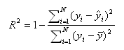
N is the number of observations in the model, y is the dependent variable, y-bar is the mean of the y values, and y-hat is the value predicted by the model. The numerator of the ratio is the sum of the squared differences between the actual y values and the predicted y values. The denominator of the ratio is the sum of squared differences between the actual y values and their mean.
The three main ways to interpret R2 are as follows.
- explained variable: how much variability is explained by the model
- goodness-of-fit: how well the model fits the data
- correlation: the correlations between the predictions and true values

For logistic regression, there have been many proposed pseudo-R2. A nonexhaustive list is shown below.
- Efron’s R2
- McFadden’s R2
- McFadden’s Adjusted R2
- Cox & Snell R2
- Nagelkerke/Cragg & Uhler’s R2
- McKelvey & Zavoina R2
- Count R2
- Adjusted Count R2

For this study, Cragg & Uhler’s was conducted:
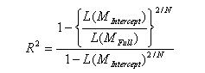
Nagelkerke or Cragg & Uhler’s adjusts Cox & Snell’s approach so that the range of possible values extends to 1. To achieve this, the Cox & Snell R-squared is divided by its maximum possible value, 1-L(M_{Intercept})^{2/N}. Then, if the full model perfectly predicts the outcome and has a likelihood of 1, Nagelkerke/Cragg & Uhler’s R-squared = 1. When L(M_{full}) = 1, then R² = 1; when L(M_{full}) = L(M_{intercept}), then R² = 0.
When analyzing data with a logistic regression, an equivalent statistic to R-squared does not exist. The model estimates from a logistic regression are maximum likelihood estimates arrived at through an iterative process. They are not calculated to minimize variance, so the OLS approach to goodness-of-fit does not apply. However, to evaluate the goodness-of-fit of logistic models, several pseudo R-squareds have been developed.
The interpretation of an OLS R-squared is relatively straightforward: “the proportion of the total variability of the outcome that is accounted for by the model”. In building a model, the aim is usually to predict variability. The outcome variable has a range of values, and you are interested in knowing what circumstances correspond to what parts of the range [25].
Appendix B. Additional results
Stepwise regression was used to select the best fitting model (i.e., the combination of variables and interactions that better explain the dependent variable (Reports of Pain). This is displayed in Table S2.
Table S2. Poisson regression models: primary objective

Variable | β | 95% CI |  | Std. Error | z value | P-value
 |  | Low | Upper
(Intercept) | 0.5612 | 0.5141 | 0.6083 | 0.0240 | 23.361 | < 0.001
ProfessionalInfoAnxietyYes | 0.0604 | 0.0312 | 0.0894 | 0.0148 | 4.066 | < 0.001
TroubleRelaxing | 0.0424 | 0.0266 | 0.0581 | 0.0081 | 5.257 | < 0.001
MuscleSymptomsAnxietyYes | 0.1937 | 0.1626 | 0.2246 | 0.0158 | 12.266 | < 0.001
FeltHated | 0.0157 | -0.0003 | 0.0318 | 0.0082 | 1.915 | 0.055
PhysicallyAbused | 0.0300 | 0.0180 | 0.0420 | 0.0061 | 4.912 | < 0.001
SexuallyAbused | 0.0076 | -0.0137 | 0.0289 | 0.0109 | 0.702 | 0.483
FeltLoved | -0.0101 | -0.0192 | -0.0011 | 0.0046 | -2.196 | 0.028
TakenToDoctorIfNeeded | -0.0039 | -0.0127 | 0.0049 | 0.0045 | -0.871 | 0.384
TroubleRelaxing X SexuallyAbused | 0.0107 | 0.0012 | 0.0201 | 0.0048 | 2.226 | 0.026
PhysicallyAbused X SexuallyAbused | -0.0076 | -0.0157 | 0.0004 | 0.0041 | -1.863 | 0.063
MuscleSymptomsAnxietyYes X PhysicallyAbused | -0.0260 | -0.0452 | -0.0069 | 0.0098 | -2.668 | 0.008
ProfessionalInfoAnxietyYes X FeltHated | -0.0176 | -0.0337 | -0.0015 | 0.0082 | -2.137 | 0.032
TroubleRelaxing X FeltHated | 0.0067 | -0.0011 | 0.0144 | 0.0039 | 1.687 | 0.092
Null deviance: 20064 on 24163 degrees of freedom. Residual deviance: 19199 on 24150 degrees of freedom. AIC: 78978.
Since our dependent variable was count data, a Poisson model was determined to be the most suitable, and the practical assumption of variance and mean being equals were also met (variance: 2.15; mean: 2.04). The model significantly predicted the number of times pain was reported through the years (χ²(13) = 864.96, p < 0.001, pseudo-R² (Cragg-Uhler) = 0.04).
SEM results
The exploratory factor analysis (EFA) results of the Kaiser-Meyer-Olkin (KMO) index calculation are shown in Table S3. A minimum KMO index of 0.5 was needed for EFA, and since all the variables were above the 0.5 threshold, it was determined that the EFA was adequate.
Table S3. Measure of sampling adequacy (MSA) for each variable
MuscleSymptomsAnxiety | ProfessionalInfoAnxiety | FeltHated
0.63 | 0.64 | 0.66
PhysicallyAbused | FeltLoved | SexuallyAbused
0.71 | 0.63 | 0.69
TakenToDoctorIfNeeded | TroubleRelaxing | ReportsOfPain
0.62 | 0.79 | 0.80
C_ReactiveProtein_avg
0.72
Kaiser-Meyer-Olkin factor adequacy. Call: KMO (r = proteinDF_numerics). Overall Measure of Sampling Adequacy = 0.67.

The second-step results of the parallel analysis suggested that the number of factors was four and the number of components was two (shown in Figure S1). After examining the results, it was determined that a good starting point would be exploring three factors, and the PCA approach was used since it produced higher eigenvalues for the first three factors/components.
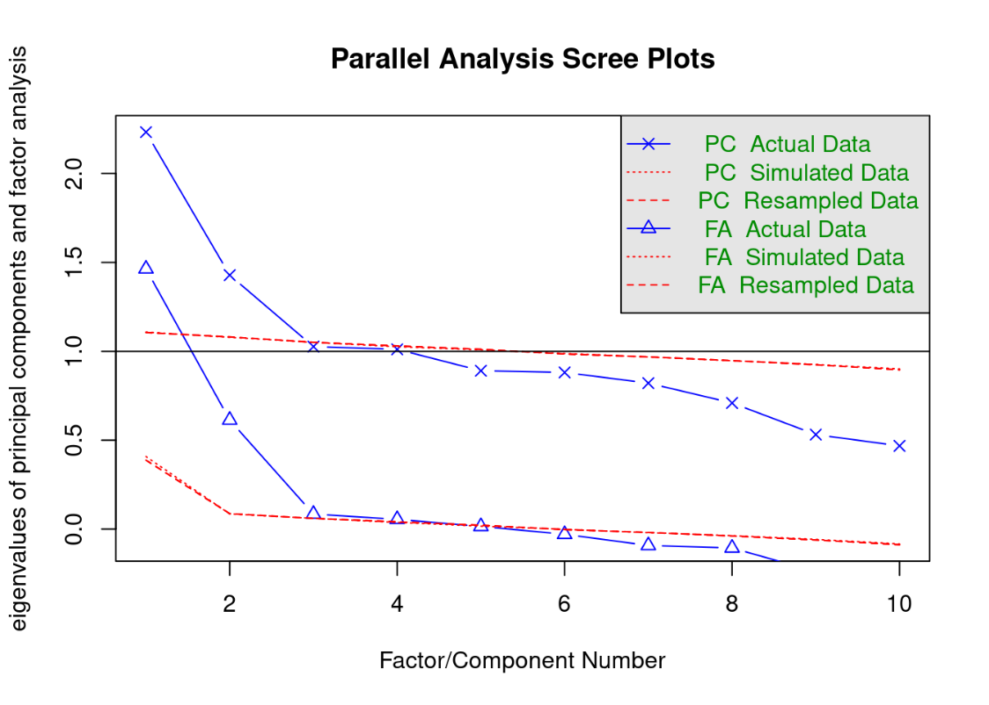
Figure S1. Parallel Analysis Scree Plots
FA, factor analysis; PC, principal component.

Performing a hierarchical cluster analysis also indicated that a 3-factor structure was a sensible solution, as demonstrated in Figure S2.
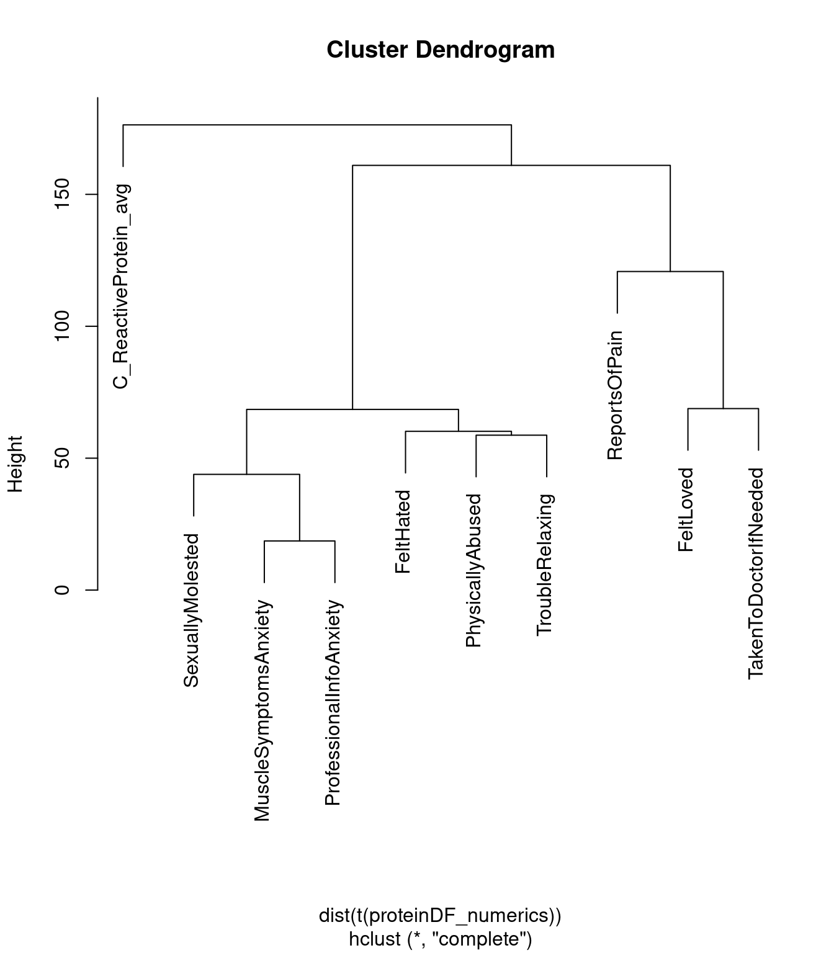
Figure S2. Cluster Dendrogram

The results of the factor analysis with three factors showed a mean item complexity = 1.3 (the test of the hypothesis that three components were sufficient). The root mean square of the residuals (RMSR) was 0.11 with an empirical chi-square of 2362.57 (probability < 0). The fit based upon the off-diagonal values was 0.5.

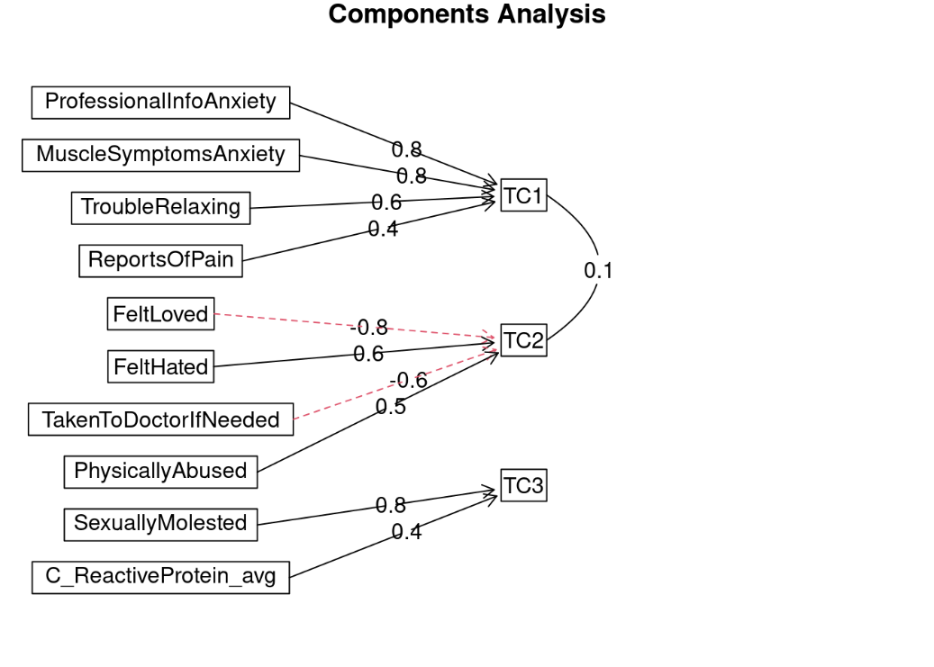
Figure S3. Component analysis
Bold-line arrows represent main factor loadings, and dashed red lines represent cross-loadings.

SEM for chronic pain and relevant UKB variables
Based on the visualizations in the component analysis (Figure S3), the variables tended to show three main groups: one related to anxiety, another related to childhood adversity, and the final one containing CRP in isolation along with history of sexual abuse. Some variables were ultimately excluded to improve the goodness of fit. In particular, discussing anxiety with a professional and sexual abuse experience both decreased the fit considerably. Our assumption in the case of sexual abuse is that it is not a commonly reported experience in databases available for CRP levels, so the limited experiences may have dominated over the rest of the variables. For discussing anxiety with a professional, it is not clear why including it reduced the fit, but it may be worth exploring in future modelling. The final best fit achieved is shown in the following diagram (Figure S4).
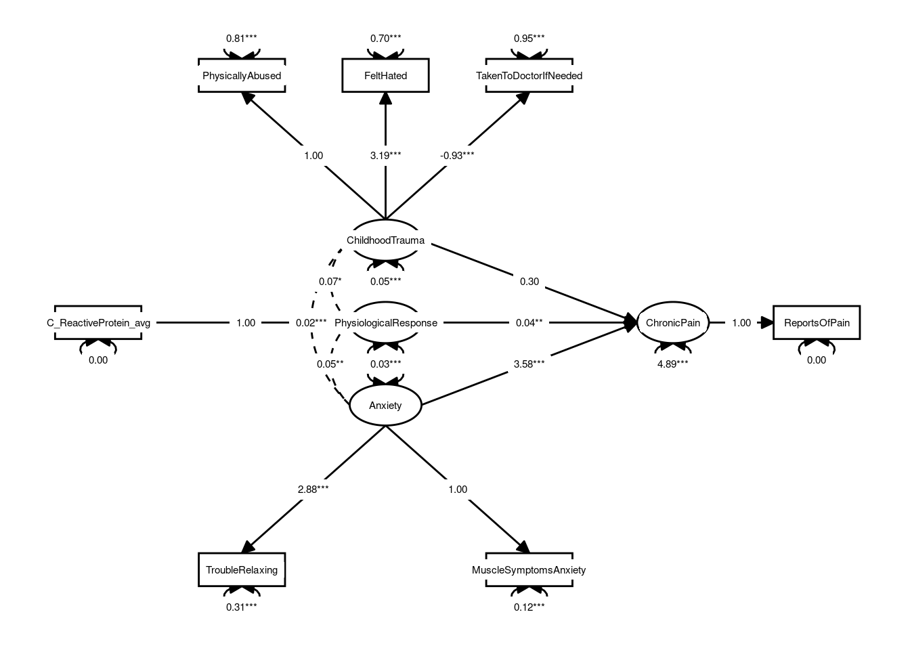
Figure S4. Diagram illustrating the best fit for the SEM
This model has the following fit parameters: (in parentheses are the necessary values for a good fit) CFI: 0.975 (> 0.90), TFI: 0.948 (> 0.90), RMSE: 0.026 (< 0.05), χ² / df = 2.36 (< 3).

This model considered subjective reports of anxiety as measurements of anxiety, modelled as a latent construct. Anxiety had a strong association with chronic pain. It could be suggested that CRP levels are part of a larger physiochemical response that is associated with chronic pain. Childhood trauma is modelled as measured by physical abuse, feeling hated as a child, and lack of availability of medical care when needed during childhood. Additionally, in this model, chronic pain was a latent variable measured only by the number of reports of pain over the years. Based on this, anxiety, childhood abuse, and CRP were indeed predictors of chronic pain. Childhood abuse, however, does not predict it very well when compared with the other two variables. Anxiety was by far the best predictor of chronic pain according to the SEM.

Individual effects of anxiety and ACEs
As shown in Figure S5, patients who reported feeling hated more frequently as a child reported more chronic pain in adulthood (part D). The frequency of physical abuse suffered as a child had an influence on chronic pain during adulthood, increasing how often chronic pain was reported (part C). Patients who reported being sexually abused more frequently as children had a slightly increased number of chronic pain experiences reported (part A). Patients who reported being taken to the doctor more frequently as children displayed slightly fewer reports of chronic pain during adulthood (part B). An increased report of having trouble relaxing during anxiety episodes was associated with an increase in the reported frequency of chronic pain (part E). Patients who experienced muscle symptoms during anxiety episodes reported more chronic pain than those who did not experience muscular symptoms with anxiety (part F). These partial regression plots show the estimated relationship between the response and an explanatory variable after accounting for the other variables in the model (the bold line/dots show the association between variables; the shaded area represents confidence or the uncertainty around the functional estimate).
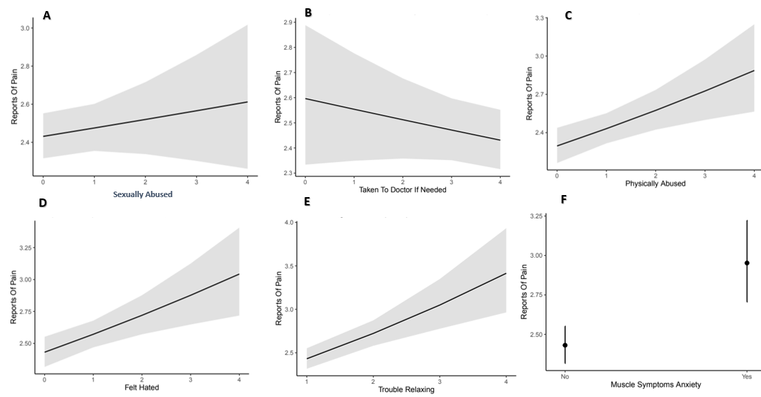
Figure S5. A) Partial regression plot on the association between sexual abuse frequency x chronic pain, B) Association between being taken to the doctor when needed as a child x chronic pain, C) Association between physical abuse in childhood and chronic pain in adulthood, D) Association between reports of feeling hated during childhood x chronic pain in adulthood, E) Influence of trouble relaxing on reported chronic pain, F) Association between experiencing muscular symptoms during anxiety episodes and chronic pain

Appendix C. Socio-demographic and health behaviour adjusted analysis
Expanded methods
Four socioeconomic variables which had sufficient coverage were available in the dataset: sex (male/female), ever smoked (yes/no), alcohol use status (current, past, never), and age at recruitment (range 40-70 years). These were merged by participant ID to the CRP sample dataset of 2,007 records. Five records with missing ever smoked status were dropped for a total of 2002 records in the modelling dataset. These variables were selected based on a high level of participant responses (~500,000 of the original cases responded on these variables, versus under ~3000 by adding ethnicity filters). Variables such as employment status and ethnicity reduced the case number to a sample too small to warrant analysis, and thus were excluded from this analysis.
A simplified version of the final model was created and compared against a corresponding stratified version with the available socioeconomic variables to identify how socioeconomic factors may affect the results. The simplified model was created by dropping non-significant interactions and variables. The stratified version was fit with a generalized linear mixed-effects model in R, with a Poisson distribution family. For the generalized linear mixed-effects model, sex, ever smoked, and alcohol use were included as fixed effects controls as per standard model building practice (estimated variance on random effects with few levels is imprecise). Age at recruitment was included as a random effect with random intercept (the model intercept was allowed to vary by age at recruitment). In addition, random slopes were included for those dependent variables where an ANOVA indicated the random slope was significant vs the model without.
Results recap (Table S4)
The generalized linear mixed-effects model results and corresponding simplified final model were built and compared to identify if the available data on socioeconomic factors affected the model results.
- The mixed effects model improves the model fit (AIC 8275 mixed effects vs AIC 8320 GLM)
- The mixed effects control variables ever_smoked, sex, and alcohol drinker are not significant
- All variables which are significant in the simplified final model GLM are still significant in the mixed-effects model
- Coefficient estimates are generally smaller and standard errors larger in the mixed-effects model (e.g. 0.21 vs 0.20 muscle symptoms anxiety, 0.10 vs 0.09 trouble relaxing, etc.), however this is only a very slight difference
  - This suggests conclusions are robust to the available socioeconomic data

Table S4. Socio-demographic and health behaviour adjusted analysis results
 | Simplified Final Model |  |  |  | Mixed-Effects Model
 |  |  |  |  | Fixed Effects |  |  |  |  | Random Effects (AgeAtRecruit)
Variable | β | Std. Error | z value | P-value | β | Std. Error | z value | P-value | Variance |  | Std. deviation
(Intercept) | 0.8587 | 0.0710 | 12.091 | < 0.001 | 0.8930 | 0.0803 | 11.118 | < 0.001 | 0.0174 |  | 0.1319
ProfessionalInfoAnxietyYes | 0.0249 | 0.0415 | 0.601 | 0.548 | 0.0381 | 0.0561 | 0.680 | 0.496 | 0.0354 |  | 0.1882
TroubleRelaxing | 0.0961 | 0.0174 | 5.529 | < 0.001 | 0.0888 | 0.0183 | 4.856 | < 0.001
MuscleSymptomsAnxietyYes | 0.2134 | 0.0373 | 5.719 | < 0.001 | 0.1998 | 0.0497 | 4.024 | < 0.001 | 0.0253 |  | 0.1602
FeltHated | 0.0530 | 0.0156 | 3.401 | 0.001 | 0.0504 | 0.0159 | 3.160 | 0.002
PhysicallyAbused | 0.0786 | 0.0200 | 3.930 | < 0.001 | 0.0755 | 0.0269 | 2.805 | 0.005 | 0.0085 |  | 0.0924
SexuallyAbused | 0.0940 | 0.0266 | 3.527 | < 0.001 | 0.0745 | 0.0274 | 2.720 | 0.007
TakenToDoctorIfNeeded | -0.0431 | 0.0164 | -2.633 | 0.008 | -0.0405 | 0.0167 | -2.426 | 0.015
C_Reactive_Protein_avg | -0.0075 | 0.0145 | -0.517 | 0.605 | -0.0034 | 0.0147 | -0.231 | 0.818
PhysicallyAbused X SexuallyAbused | -0.0854 | 0.0181 | -4.727 | < 0.001 | -0.0743 | 0.0186 | -3.990 | < 0.001
ProfessionalInfoAnxietyYes X C_ReactiveProtein_avg | 0.0394 | 0.0104 | 3.769 | < 0.001 | 0.0392 | 0.0108 | 3.624 | < 0.001
PhysicallyAbused X C_ReactiveProtein_avg | -0.0136 | 0.0043 | -3.168 | 0.002 | -0.0135 | 0.0044 | -3.035 | 0.002
SexuallyAbused X C_ReactiveProtein_avg | -0.0183 | 0.0062 | -2.957 | 0.003 | -0.0156 | 0.0063 | -2.476 | 0.013
TakenToDoctorIfNeeded X C_ReactiveProtein_avg | 0.0083 | 0.0036 | 2.291 | 0.022 | 0.0066 | 0.0037 | 1.764 | 0.078
PhysicallyAbused X SexuallyAbused X C_ReactiveProtein_avg | 0.0196 | 0.0044 | 4.502 | < 0.001 | 0.0172 | 0.0045 | 3.808 | < 0.001
ProfessionalInfoAnxietyNo X FeltHated X C_ReactiveProtein_avg | 0.0029 | 0.0046 | 0.633 | 0.527 | 0.0023 | 0.0047 | 0.490 | 0.624
ProfessionalInfoAnxietyYes X FeltHated X C_ReactiveProtein_avg | -0.0174 | 0.0046 | -3.750 | < 0.001 | -0.0171 | 0.0049 | -3.491 | < 0.001
EverSmokedYes |  |  |  |  | -0.0100 | 0.0283 | -0.354 | 0.723
SexMale |  |  |  |  | -0.0536 | 0.0282 | -1.902 | 0.057
AlcoholDrinkerNever |  |  |  |  | 0.0631 | 0.0984 | 0.641 | 0.522
AlcoholDrinkerPrevious |  |  |  |  | 0.1226 | 0.0705 | 1.739 | 0.082
Simplified final model: Null deviance: 3018 on 2001 degrees of freedom. Residual deviance: 2770 on 1985 degrees of freedom. AIC: 8320.
Mixed-effects model: Deviance: 8213. Residual degrees of freedom: 1971. AIC: 8275.

Chapter 4 supplemental
Appendix A
Table S1. Specific diagnosis given by physician (B1SA23A/ B1SA23D)
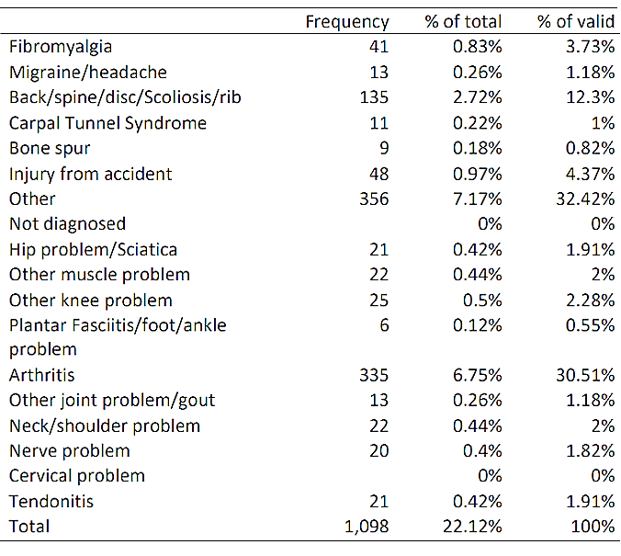

Table S2: Open Science Framework Stage 1 Registered Report questions
1) What is the main question being addressed in your study?  Why is it important that we answer this question? What’s the big picture? | To identify biopsychosocial pathways that may link childhood adversity with adult chronic pain. The specific objectives are: 1) to examine the relationships between reported childhood adversity, anxiety, and pain; 2) to assess the associations between childhood adversity, anxiety, inflammation (measured through CRP levels), and pain; and 3) to explore how childhood adversity, anxiety, and CRP may be associated with pain medication consumption in the United States. | p 5-6
2) Describe the key independent and dependent variable(s), specifying how they will be measured.  Ensure that they are defined precisely | Independent variables: Childhood adversity, anxiety, and CRP  Measures of the independent variables: Childhood Trauma Questionnaire (CTQ), State-Trait Anxiety Inventory Form Y (STAI), and blood C-reactive Protein (CRP)  Dependent Variables: chronic pain in adulthood, and pain medication use  Measures of the dependent variables: Specific pain-related questions designed for the purpose of MIDAS | p6  p8-9  p6  p9
3) What are your hypotheses? | It is hypothesized that childhood adversity relates to chronic pain experience in adulthood, and that there will be positive associations between 1) childhood adversity and anxiety, 2) childhood adversity and CRP levels, 3) childhood adversity and pain, and that the link between childhood adversity and pain will be influenced by anxiety and/or CRP. Although objective 3 is exploratory, it is hypothesized that childhood adversity, anxiety, and CRP will all be positively associated with increased pain medication consumption in the United States.  The corresponding H0 are 1) there will be no significant positive association between childhood adversity and anxiety, 2) there will be no significant positive association between childhood adversity and CRP levels, and 3) there will be no significant positive association between childhood adversity and pain. Furthermore, any childhood adversity and pain association will not be influenced by anxiety and/or CRP. For exploratory objective 3 the H0 is that childhood adversity, anxiety, and CRP will not be associated with increased pain medication consumption in the United States. | p6
4) How many and which conditions will participants/samples be assigned to? | The MIDUS core national sample was based on a nationally representative random-digit dialing (RDD) sample of non-institutionalized, English-speaking adults, aged 25 to 74, selected from working telephone banks in the coterminous United States. City-specific oversamples were also included to increase racial and geographic representativeness. The sampling and selection of participants in the non-survey projects (cognitive, daily stress, biomarker, neuroscience) was contingent upon eligibility criteria specific to each project. For the purposes of our retrospective study, a stratified randomization sample will be taken from the overall MIDUS sampling selection based on which participants have data available for the variables of interest as noted in Table 1. | P7
5) How many observations will be collected and what rule will you use to terminate data collection? | Not applicable (as data are secondary).
6) What are your study inclusion criteria?  How will participants/samples be recruited/included and under what specific rules? | Childhood adversity: Participants had to have responded to the CTQ at the biomarker collection stage sample of MIDUS. Participants reporting no adverse childhood experiences (ACEs) will not be excluded.  Anxiety: Participants had to have responded to STAI items. Low scores will not be excluded.  Pain: A person was considered to have chronic pain if they met any of the following criteria: 1) Had any valid chronic pain diagnostic (B1SA23A/B1SA23D); Reported zero time without feeling pain in the last month (B4Q10WW1); Saw a professional about chronic pain (BACAS22); Indicated having chronic pain (B1SA15/K2Q17/BACAS15/RA1SA15); or Physician diagnosed chronic back/neck problems (K2Q1XD).  CRP: Participants had to have provided plasma and serum samples at the biomarker collection stage. For citrated plasma, the assay range was 0.175–1100 ug/mL (inter-assay variability: 2.1–5.7%; reference range: ≤3 ug/mL), and for serum the assay range was 0.014–216ug/mL (inter-assay variability: 4.72–5.16%; reference range: <3 ug/mL). | P8-10
7) What are your data exclusion criteria? | Participants will be excluded if they did not respond to the CTQ and STAI questionnaires, have not met chronic pain criteria, and if CRP was outside of the acceptable ranges (>10%). For objective 1 and 2 analyses: Cases missing any indicator (see Table S4) or control variables (Table 1) will be dropped from the sample. For objective 3 (exploratory): Any records where one or more parameters were missing will be dropped from the regression model. In the overall scale variables such as the CTQ, a value > 97 will be recoded to missing, as per the MIDUS data dictionary (Ryff et al. 2021). For subscale variables, e.g., on a 1 to 5 Likert scale, a value > 7 will be recoded to missing as per the data dictionary. Control variables for income having values 9999998 and -1 and racial origins having value 7 will be recoded as “NA” as per the MIDUS data dictionary (Ryff et al. 2021). | P11
8) What positive controls or quality checks will confirm that the obtained results are able to provide a fair test of the stated hypothesis? | For objective 1 and 2 analyses: If the data is found to not be normally distributed, the ‘robust’ version of the maximum likelihood parameter estimation method will be used, which does not rely on the normality assumption and provides robust standard errors and a scaled test statistic (Yuan & Bentler 2007). Socio-demographics were of interest as potential confounders and will be included as additional control variables in the regression.  For objective 3 (exploratory): If the dependent variable is imbalanced, such as due to a high number of the available records did not including medication data for chronic pain, model performance results will also be presented in the form of a confusion matrix (true positives, true negatives, false positives, false negatives) with the sensitivity and specificity statistics reported to address this. For comparison checks for update modelling in this case, a model will also be run with only the significant predictors and pairwise interactions (including corresponding predictors for the significant pairwise interactions). | P12-14
9) Specify exactly which analyses you will conduct to examine the main question/hypothesis(es) | See Tables S3 & S4 below.  Utilizing SEM analyses allows testing theory validity using empirical models with an advantage of managing measurement error. To additionally address and minimize potential bias in our proposed analysis, robustness testing of the SEM goodness of fit specifically using the root mean square error approximation (RMSEA), comparative fit index (CFI), and Akaike information criterion (AIC) thresholds will be conducted. To account for the possibility the of variable imbalance, model performance results will also be presented in the form of a confusion matrix (true positives, true negatives, false positives, false negatives) with the sensitivity and specificity statistics reported. The regression model will be tuned to maximizing sensitivity (true positives) to ensure that the model correctly predicts the outcomes. Resulting associations will then be tested in General Linear Modelling with logit link function (Logistic regression), such as by first examining the potential effect of ACEs, anxiety, and CRP on chronic pain. If any of the regression models cannot be fitted, then relationships will be assessed using Spearman correlations instead. Finally, additional sensitivity analyses will also be conducted excluding those with CRP levels greater than 10 mg/l from the regression analyses (to test the model validity; p<0.05).
10) Are you proposing to collect new data or analyse existing data? | Existing data will be used (see Data verification details p. 20-21). | p.20-21

Table S3: Analyses Planner
Question | Hypothesis | Sampling plan (e.g.  power analysis) | Analysis Plan | Interpretation given  different outcomes
1) to examine the relationships between reported childhood adversity, anxiety, and pain; | It is hypothesized that childhood adversity relates to chronic pain experience in adulthood, and that there will be positive associations between childhood adversity and anxiety. | Post hoc power analysis, as applicable. Sampling N/A as this is a retrospective study using existing data | Structural equational modelling (SEM) as shown in Figure 2, followed by general linear modelling (GLM). The SEM will be built with the ‘lavaan’ package version 0.6 (Rosseel 2012) in the R. The maximum likelihood parameter estimation method built into the ‘lavaan’ package will be used, as it is suitable for all-numerical data (including binary and Likert-scaled variables which will be coded numerically as integers) with complete cases (Olsson et al. 2000).  IVs: Childhood adversity (CTQ), anxiety (, STAI); DVs: chronic pain in adulthood. | We will use the SEM to develop a preliminary understanding of relationships between variables, followed by GLM regression using the variables in Table 1. If repeated iterations of the best SEM model fit cannot be achieved, controls and other variables will be reconsidered. If any of the regression models cannot be fitted, then relationships will be assessed using Spearman correlations instead.
2) to assess the associations between childhood adversity, anxiety, inflammation (measured through CRP levels), and pain; | There will be positive associations between childhood adversity and CRP levels. The link between childhood adversity and pain will be influenced by anxiety and/or CRP. | Post hoc power analysis, as applicable. Sampling N/A as this is a retrospective study using existing patient records | SEM as noted above and in Figure 2, GLM, spearman correlations, and sensitivity analysis.  IVs: Childhood adversity (CTQ), anxiety (STAI), CRP (blood CRP); DVs: chronic pain in adulthood  (per specific pain questions). | We expect the SEM to help explore and visualize the hypothetical relationships and show how observed and latent variables for childhood adversity, anxiety, inflammation, and chronic pain, and observed socioeconomic variables directionally affect each other.  We expect the GLM to show the potential effect of ACEs, anxiety, and CRP on predicting chronic pain experience. If Spearman correlation is needed, we expect the coefficients on each possible pair of variables showing how strongly and in what direction each pair is related.  Additional sensitivity analyses will be conducted excluding those with CRP levels >10 to test the validity of the model.
3) to explore how childhood adversity, anxiety, and CRP may be associated with pain medication consumption in the United States as a proxy for chronic pain as a health outcome. | Although objective 3 is exploratory, it is hypothesized that childhood adversity, anxiety, and CRP will all be positively associated with increased pain medication consumption in the United States. | Post hoc power analysis, as applicable. Sampling N/A as this is a retrospective study using existing patient records | An additional exploratory regression on the subset of respondents who experience chronic pain.  IVs: Childhood adversity (CTQ), anxiety (STAI), CRP (blood CRP); DVs: chronic pain in adulthood, pain medication use  (per specific pain questions).  All variables will also be tested as possible independent variables for the pain medication regression. | We will conduct exploratory regression and expect it will show how or if childhood adversity, anxiety, and inflammation predict pain medication usage for chronic pain.

Table S4. Desiderata for Structural Equation Modelling
Checklist item | Supporting text from report | Section (B = Background, M = Method) page.
1. Substantive theories that led to the model(s) being investigated are synthesized; a set of a priori specified competing models is generally preferred. | Chronic pain is expected to be influenced by anxiety, physiological response, and childhood adversity based on previous studies examining relationships among them (see Background section). | B, M  p.4-5, 14
2. Path diagrams are presented to facilitate the understanding of the conceptual model(s) and the specification of the statistical model(s). | The path diagram of the planned SEM is shown in Figure 2. In this model the exogenous latent variables for anxiety, physiological response, and childhood adversity predict the endogenous latent variable for chronic pain. | M  p.14
3. If applicable, latent factors are defined and their status as latent (vs. emergent) is justified. | An individual’s physiological response to stress, level of anxiety, experience of childhood adversity, and feeling of chronic pain cannot be directly measured; hence they are latent variables. Though these variables cannot be directly observed or measured (but are approximated through various measures), they are causally related to appropriate indicator variables present in the MIDUS data (Table 1), which were designed to measure aspects of the trait of interest. | M  p.14
4. Measured variables are defined and, if applicable, their appropriateness as indicator variables of associated factors is justified. | Though these variables cannot be directly observed or measured (but are approximated through various measures), they are causally related to appropriate indicator variables present in the MIDUS data (Table 1), which were designed to measure aspects of the trait of interest.  Indicator variables are included in the model as per their MIDUS data dictionary definition, with the exception of the reported experience of chronic pain variable. This variable is derived from the series of pain variables in Table 1. It is modelled as a binary variable that indicates if the participant did or did not have chronic pain, as detailed in the Measures description for pain. | M  p.14  p15
5. Latent factors are indicated by a sufficient number of appropriate measured variables; how the latent factors are given scale within the model(s) is addressed. | Childhood adversity can represent a wide variety of experiences, so a variety of representative measured variables from the MIDUS data were chosen: CTQ: Emotional Abuse, CTQ: Physical Abuse, CTQ: Sexual Abuse, CTQ: Emotional Neglect, CTQ: Physical Neglect, and CTQ: Minimization/Denial. The scale of latent factor variables is assumed and handled to be the same as the scale of the corresponding indicator variables. In the case of more than one indicator variable (childhood adversity latent factor), the CTQ indicator variables are all on the same 5-point Likert scale, so this assumption holds. | M  p.15
6. How theoretically relevant control variables are integrated into the model is explained. | In addition to the latent factors and associated indicator variables, socio-economic control variables available in the MIDUS data (Table 1) are included as predictors of inflammation (CRP). These control variables are linked to CRP and the physiological response to chronic pain as an individual with worse socio-economic circumstances is expected to have a higher degree of inflammation. The control variable for race will be coded as binary variables (e.g. ‘is white race’ and ‘is black race’, the two most common categories in the data), as categorical variables with multiple categories cannot be included easily in an SEM. | M  p.16
7. Sampling method(s) and sample size(s) are explicated and justified. | The entire MIDUS sample of 1,255 participants as detailed in the Dataset and Participants section is used, with cases missing any indicator or control variables dropped from the sample. The maximum likelihood parameter estimation method built into the ‘lavaan’ package will be used, as it is suitable for all-numerical data (including binary and Likert-scaled variables which will be coded numerically as integers) with complete cases (Olsson et al. 2000). The maximum likelihood method assumes data is multivariate normally distributed, and this assumption will be tested on the MIDUS data. If the data is found to not be normally distributed, the ‘robust’ version of the maximum likelihood parameter estimation method will be used, which does not rely on the normality assumption and provides robust standard errors and a scaled test statistic (Yuan & Bentler 2007). | M  p.16
8. The treatment of missing data and outliers is addressed. | Missing data in the control and measured variables is coded according to the method detailed in the Analysis Plan section. The entire MIDUS sample of 1,255 participants as detailed in the Dataset and Participants section is used, with cases missing any indicator or control variables dropped from the sample. Any records where one or more parameters are missing will be dropped from the regression model.  For outliers in the overall scale variables such as the CTQ, a value > 97 will be recoded to missing, as per the MIDUS data dictionary (Ryff et al. 2021). For subscale variables, e.g., on a 1 to 5 Likert scale, a value > 7 will be recoded to missing as per the data dictionary. Control variables for income having values 9999998 and -1 and racial origins having value 7 will be recoded as “NA” as per the MIDUS data dictionary (Ryff et al. 2021). | M  p.16
9. The name and version of the utilized software package is reported; the parameter estimation method is justified and its underlying assumptions are addressed. | The SEM will be built with the ‘lavaan’ package version 0.6 (Rosseel 2012) in the R programming language, version 4.3 (R Core Team 2021).  The maximum likelihood parameter estimation method built into the ‘lavaan’ package will be used, as it is suitable for all-numerical data (including binary and Likert-scaled variables which will be coded numerically as integers) with complete cases (Olsson et al. 2000). | M  p.16

Appendix B Sensitivity analysis
Table S5: CRP as a predictor along with its interactions, sensitivity analysis with participants with CRP ≥ 10.0 excluded
Variable | Estimate | Std. Error | z-value | p-value | Sig
(Constant) | 0.563 | 3.528 | 0.160 | 0.873
CTQ Emotional Abuse | -0.128 | 0.261 | -0.490 | 0.624
CTQ Physical Abuse | -0.054 | 0.327 | -0.166 | 0.868
CTQ Sexual Abuse | 0.237 | 0.206 | 1.149 | 0.251
CTQ Emotional Neglect | -0.238 | 0.240 | -0.992 | 0.321
CTQ Physical Neglect | 0.664 | 0.344 | 1.929 | 0.054 | .
CTQ Minimization | 0.853 | 0.839 | 1.016 | 0.310
Trait Anxiety | 0.130 | 0.069 | 1.884 | 0.060 | .
C-Reactive Protein | -0.353 | 0.185 | -1.912 | 0.056 | .
Gender (Female) | -3.067 | 1.371 | -2.237 | 0.025 | *
Age At Interview | -0.034 | 0.045 | -0.742 | 0.458
Total Household Income | 0.00002 | 0.00002 | 1.177 | 0.239
Total Income | -0.00007 | 0.00003 | -2.162 | 0.031 | *
Highest Education | -0.680 | 0.243 | -2.799 | 0.005 | **
CTQ Emotional Abuse * CTQ Physical Abuse | 0.010 | 0.008 | 1.127 | 0.260
CTQ Emotional Abuse * CTQ Sexual Abuse | 0.009 | 0.008 | 1.138 | 0.255
CTQ Emotional Abuse * CTQ Emotional Neglect | 0.018 | 0.007 | 2.365 | 0.018 | *
CTQ Emotional Abuse * CTQ Physical Neglect | -0.024 | 0.012 | -2.042 | 0.041 | *
CTQ Emotional Abuse * CTQ Minimization | 0.021 | 0.065 | 0.318 | 0.750
CTQ Emotional Abuse * Trait Anxiety | 0.001 | 0.003 | 0.230 | 0.818
CTQ Emotional Abuse * C-Reactive Protein | 0.008 | 0.010 | 0.737 | 0.461
CTQ Emotional Abuse * Gender (Female) | 0.037 | 0.065 | 0.564 | 0.573
CTQ Emotional Abuse * Age At Interview | -0.0002 | 0.003 | -0.081 | 0.935
CTQ Emotional Abuse * Total Household Income | -0.000002 | 0.000001 | -1.742 | 0.082 | .
CTQ Emotional Abuse * Total Income | 0.000003 | 0.000001 | 2.132 | 0.033 | *
CTQ Emotional Abuse * Highest Education | -0.015 | 0.013 | -1.182 | 0.237
CTQ Physical Abuse * CTQ Sexual Abuse | -0.002 | 0.008 | -0.300 | 0.765
CTQ Physical Abuse * CTQ Emotional Neglect | -0.023 | 0.011 | -2.074 | 0.038 | *
CTQ Physical Abuse * CTQ Physical Neglect | 0.010 | 0.014 | 0.704 | 0.481
CTQ Physical Abuse * CTQ Minimization | -0.010 | 0.070 | -0.148 | 0.882
CTQ Physical Abuse * Trait Anxiety | -0.004 | 0.004 | -1.087 | 0.277
CTQ Physical Abuse * C-Reactive Protein | 0.012 | 0.014 | 0.824 | 0.410
CTQ Physical Abuse * Gender (Female) | 0.053 | 0.080 | 0.660 | 0.509
CTQ Physical Abuse * Age At Interview | 0.003 | 0.004 | 0.872 | 0.383
CTQ Physical Abuse * Total Household Income | -0.0000007 | 0.000001 | -0.590 | 0.556
CTQ Physical Abuse * Total Income | -0.0000005 | 0.000002 | -0.275 | 0.784
CTQ Physical Abuse * Highest Education | 0.032 | 0.015 | 2.075 | 0.038 | *
CTQ Sexual Abuse * CTQ Emotional Neglect | -0.003 | 0.008 | -0.460 | 0.645
CTQ Sexual Abuse * CTQ Physical Neglect | -0.001 | 0.010 | -0.061 | 0.951
CTQ Sexual Abuse * CTQ Minimization | -0.050 | 0.041 | -1.211 | 0.226
CTQ Sexual Abuse * Trait Anxiety | -0.003 | 0.003 | -1.260 | 0.208
CTQ Sexual Abuse * C-Reactive Protein | -0.004 | 0.006 | -0.589 | 0.556
CTQ Sexual Abuse * Gender (Female) | 0.037 | 0.061 | 0.602 | 0.547
CTQ Sexual Abuse * Age At Interview | -0.001 | 0.002 | -0.687 | 0.492
CTQ Sexual Abuse * Total Household Income | -0.0000007 | 0.0000007 | -0.963 | 0.335
CTQ Sexual Abuse * Total Income | 0.000001 | 0.000001 | 0.941 | 0.347
CTQ Sexual Abuse * Highest Education | -0.008 | 0.010 | -0.806 | 0.420
CTQ Emotional Neglect * CTQ Physical Neglect | 0.010 | 0.010 | 1.059 | 0.289
CTQ Emotional Neglect * CTQ Minimization | 0.082 | 0.044 | 1.860 | 0.063 | .
CTQ Emotional Neglect * Trait Anxiety | 0.004 | 0.003 | 1.249 | 0.212
CTQ Emotional Neglect * C-Reactive Protein | -0.002 | 0.008 | -0.282 | 0.778
CTQ Emotional Neglect * Gender (Female) | -0.079 | 0.055 | -1.452 | 0.147
CTQ Emotional Neglect * Age At Interview | 0.001 | 0.003 | 0.513 | 0.608
CTQ Emotional Neglect * Total Household Income | 0.000002 | 0.0000008 | 2.570 | 0.010 | *
CTQ Emotional Neglect * Total Income | -0.000003 | 0.000001 | -2.461 | 0.014 | *
CTQ Emotional Neglect * Highest Education | 0.00003 | 0.011 | 0.003 | 0.998
CTQ Physical Neglect * CTQ Minimization | -0.024 | 0.070 | -0.341 | 0.733
CTQ Physical Neglect * Trait Anxiety | -0.008 | 0.004 | -1.764 | 0.078 | .
CTQ Physical Neglect * C-Reactive Protein | 0.020 | 0.012 | 1.665 | 0.096 | .
CTQ Physical Neglect * Gender (Female) | -0.014 | 0.081 | -0.172 | 0.863
CTQ Physical Neglect * Age At Interview | -0.004 | 0.004 | -1.176 | 0.240
CTQ Physical Neglect * Total Household Income | -0.000002 | 0.000001 | -1.516 | 0.129
CTQ Physical Neglect * Total Income | 0.000001 | 0.000002 | 0.834 | 0.404
CTQ Physical Neglect * Highest Education | -0.004 | 0.015 | -0.297 | 0.766
CTQ Minimization * Trait Anxiety | 0.001 | 0.013 | 0.039 | 0.969
CTQ Minimization * C-Reactive Protein | -0.018 | 0.024 | -0.748 | 0.454
CTQ Minimization * Gender (Female) | -0.121 | 0.184 | -0.656 | 0.512
CTQ Minimization * Age At Interview | -0.012 | 0.007 | -1.560 | 0.119
CTQ Minimization * Total Household Income | -0.000001 | 0.000003 | -0.405 | 0.686
CTQ Minimization * Total Income | -0.000003 | 0.000004 | -0.797 | 0.425
CTQ Minimization * Highest Education | -0.003 | 0.039 | -0.079 | 0.937
Trait Anxiety * C-Reactive Protein | -0.0002 | 0.003 | -0.058 | 0.954
Trait Anxiety * Gender (Female) | 0.002 | 0.019 | 0.123 | 0.902
Trait Anxiety * Age At Interview | -0.001 | 0.001 | -0.704 | 0.481
Trait Anxiety * Total Household Income | 0.0000002 | 0.0000003 | 0.686 | 0.493
Trait Anxiety * Total Income | -0.0000002 | 0.0000004 | -0.455 | 0.649
Trait Anxiety * Highest Education | 0.001 | 0.004 | 0.219 | 0.827
C-Reactive Protein * Gender (Female) | 0.108 | 0.050 | 2.186 | 0.029 | *
C-Reactive Protein * Age At Interview | 0.001 | 0.002 | 0.748 | 0.455
C-Reactive Protein * Total Household Income | -0.0000005 | 0.0000007 | -0.727 | 0.467
C-Reactive Protein * Total Income | 0.000002 | 0.000001 | 1.506 | 0.132
C-Reactive Protein * Highest Education | 0.005 | 0.009 | 0.542 | 0.588
Gender (Female) * Age At Interview | 0.031 | 0.013 | 2.303 | 0.021 | *
Gender (Female) * Total Household Income | -0.00001 | 0.000005 | -2.314 | 0.021 | *
Gender (Female) * Total Income | 0.00002 | 0.000007 | 3.236 | 0.001 | **
Gender (Female) * Highest Education | 0.133 | 0.063 | 2.110 | 0.035 | *
Age At Interview * Total Household Income | -0.0000003 | 0.0000002 | -1.601 | 0.109
Age At Interview * Total Income | 0.0000007 | 0.0000003 | 2.346 | 0.019 | *
Age At Interview * Highest Education | 0.007 | 0.003 | 2.575 | 0.010 | *
Total Household Income * Total Income | 0.00000000002 | 0.00000000002 | 0.713 | 0.476
Total Household Income * Highest Education | 0.0000005 | 0.0000009 | 0.502 | 0.615
Total Income * Highest Education | 0.000002 | 0.000001 | 1.120 | 0.263
NOTES: Dependent variable: Probability of having chronic pain. N = 1121. Signif. codes: 0 ‘***’ 0.001 ‘**’ 0.01 ‘*’ 0.05 ‘.’ 0.1 ‘ ’ 1 (Dispersion parameter for binomial family taken to be 1).
Appendix C Additional analyses
Table S6: Regression confusion matrix
Overall regression |  | Actual medication use for chronic pain
 |  | FALSE | TRUE
Predicted medication use for chronic pain | FALSE | 533 | 32
 | TRUE | 8 | 27
Significant interactions only matrix |  | Actual medication use for chronic pain
 |  | FALSE | TRUE
Predicted medication use for chronic pain | FALSE | 535 | 50
 | TRUE | 6 | 9

Table S7. Long-term medication use for chronic pain
Variable | Estimate | Std. Error | z-value | p-value | Sig
(Constant) | -5.886 | 10.773 | -0.546 | 0.585
CTQ Emotional Abuse | -0.269 | 0.764 | -0.352 | 0.725
CTQ Physical Abuse | -0.540 | 1.098 | -0.492 | 0.623
CTQ Sexual Abuse | 1.118 | 0.684 | 1.634 | 0.102
CTQ Emotional Neglect | 0.047 | 0.742 | 0.063 | 0.950
CTQ Physical Neglect | -0.908 | 0.954 | -0.952 | 0.341
CTQ Minimization | 3.285 | 2.563 | 1.282 | 0.200
Trait Anxiety | 0.166 | 0.187 | 0.885 | 0.376
C-Reactive Protein | -0.647 | 0.581 | -1.113 | 0.266
Gender (Female) | -6.500 | 4.746 | -1.370 | 0.171
Age At Interview | 0.263 | 0.123 | 2.145 | 0.032 | *
Total Household Income | 0.0001 | 0.00007 | 1.613 | 0.107
Total Income | -0.0002 | 0.0001 | -2.082 | 0.037 | *
Highest Education | -0.522 | 0.840 | -0.621 | 0.534
CTQ Emotional Abuse * CTQ Physical Abuse | -0.043 | 0.025 | -1.735 | 0.083 | .
CTQ Emotional Abuse * CTQ Sexual Abuse | 0.002 | 0.024 | 0.064 | 0.949
CTQ Emotional Abuse * CTQ Emotional Neglect | 0.014 | 0.018 | 0.753 | 0.451
CTQ Emotional Abuse * CTQ Physical Neglect | 0.003 | 0.032 | 0.099 | 0.921
CTQ Emotional Abuse * CTQ Minimization | 0.065 | 0.180 | 0.359 | 0.719
CTQ Emotional Abuse * Trait Anxiety | 0.005 | 0.008 | 0.557 | 0.578
CTQ Emotional Abuse * C-Reactive Protein | -0.040 | 0.027 | -1.479 | 0.139
CTQ Emotional Abuse * Gender (Female) | 0.126 | 0.193 | 0.654 | 0.513
CTQ Emotional Abuse * Age At Interview | 0.007 | 0.008 | 0.892 | 0.372
CTQ Emotional Abuse * Total Household Income | 0.000002 | 0.000003 | 0.500 | 0.617
CTQ Emotional Abuse * Total Income | -0.000001 | 0.000005 | -0.317 | 0.751
CTQ Emotional Abuse * Highest Education | -0.039 | 0.034 | -1.150 | 0.250
CTQ Physical Abuse * CTQ Sexual Abuse | -0.031 | 0.020 | -1.594 | 0.111
CTQ Physical Abuse * CTQ Emotional Neglect | 0.076 | 0.034 | 2.228 | 0.026 | *
CTQ Physical Abuse * CTQ Physical Neglect | -0.047 | 0.037 | -1.265 | 0.206
CTQ Physical Abuse * CTQ Minimization | -0.626 | 0.244 | -2.569 | 0.010 | *
CTQ Physical Abuse * Trait Anxiety | 0.019 | 0.010 | 1.817 | 0.069 | .
CTQ Physical Abuse * C-Reactive Protein | 0.052 | 0.040 | 1.282 | 0.200
CTQ Physical Abuse * Gender (Female) | -0.239 | 0.257 | -0.930 | 0.352
CTQ Physical Abuse * Age At Interview | -0.002 | 0.012 | -0.165 | 0.869
CTQ Physical Abuse * Total Household Income | 0.000004 | 0.000004 | 1.069 | 0.285
CTQ Physical Abuse * Total Income | -0.000009 | 0.000006 | -1.414 | 0.157
CTQ Physical Abuse * Highest Education | 0.047 | 0.047 | 1.001 | 0.317
CTQ Sexual Abuse * CTQ Emotional Neglect | 0.029 | 0.029 | 0.996 | 0.319
CTQ Sexual Abuse * CTQ Physical Neglect | 0.025 | 0.026 | 0.982 | 0.326
CTQ Sexual Abuse * CTQ Minimization | 0.340 | 0.152 | 2.239 | 0.025 | *
CTQ Sexual Abuse * Trait Anxiety | -0.018 | 0.007 | -2.445 | 0.015 | *
CTQ Sexual Abuse * C-Reactive Protein | -0.040 | 0.023 | -1.725 | 0.085 | .
CTQ Sexual Abuse * Gender (Female) | 0.399 | 0.235 | 1.698 | 0.090 | .
CTQ Sexual Abuse * Age At Interview | -0.009 | 0.005 | -1.621 | 0.105
CTQ Sexual Abuse * Total Household Income | -0.00001 | 0.000003 | -3.335 | 0.001 | ***
CTQ Sexual Abuse * Total Income | 0.00001 | 0.000005 | 2.597 | 0.009 | **
CTQ Sexual Abuse * Highest Education | -0.056 | 0.032 | -1.731 | 0.084 | .
CTQ Emotional Neglect * CTQ Physical Neglect | -0.006 | 0.033 | -0.197 | 0.844
CTQ Emotional Neglect * CTQ Minimization | -0.092 | 0.172 | -0.533 | 0.594
CTQ Emotional Neglect * Trait Anxiety | -0.013 | 0.011 | -1.216 | 0.224
CTQ Emotional Neglect * C-Reactive Protein | 0.054 | 0.031 | 1.739 | 0.082 | .
CTQ Emotional Neglect * Gender (Female) | 0.197 | 0.198 | 0.995 | 0.320
CTQ Emotional Neglect * Age At Interview | -0.004 | 0.008 | -0.506 | 0.613
CTQ Emotional Neglect * Total Household Income | 0.000002 | 0.000003 | 0.655 | 0.513
CTQ Emotional Neglect * Total Income | -0.000001 | 0.000004 | -0.335 | 0.737
CTQ Emotional Neglect * Highest Education | -0.073 | 0.036 | -2.001 | 0.045 | *
CTQ Physical Neglect * CTQ Minimization | 0.275 | 0.237 | 1.161 | 0.245
CTQ Physical Neglect * Trait Anxiety | 0.009 | 0.013 | 0.718 | 0.473
CTQ Physical Neglect * C-Reactive Protein | -0.033 | 0.031 | -1.039 | 0.299
CTQ Physical Neglect * Gender (Female) | -0.122 | 0.255 | -0.478 | 0.632
CTQ Physical Neglect * Age At Interview | -0.003 | 0.009 | -0.278 | 0.781
CTQ Physical Neglect * Total Household Income | -0.000008 | 0.000003 | -2.793 | 0.005 | **
CTQ Physical Neglect * Total Income | 0.00002 | 0.000006 | 2.719 | 0.007 | **
CTQ Physical Neglect * Highest Education | 0.136 | 0.045 | 3.054 | 0.002 | **
CTQ Minimization * Trait Anxiety | 0.001 | 0.031 | 0.020 | 0.984
CTQ Minimization * C-Reactive Protein | -0.041 | 0.084 | -0.488 | 0.626
CTQ Minimization * Gender (Female) | -0.023 | 0.592 | -0.038 | 0.970
CTQ Minimization * Age At Interview | -0.034 | 0.025 | -1.381 | 0.167
CTQ Minimization * Total Household Income | 0.000004 | 0.00001 | 0.371 | 0.710
CTQ Minimization * Total Income | -0.00001 | 0.00002 | -0.745 | 0.456
CTQ Minimization * Highest Education | -0.137 | 0.133 | -1.030 | 0.303
Trait Anxiety * C-Reactive Protein | -0.004 | 0.007 | -0.561 | 0.575
Trait Anxiety * Gender (Female) | 0.035 | 0.054 | 0.647 | 0.518
Trait Anxiety * Age At Interview | -0.004 | 0.002 | -1.750 | 0.080 | .
Trait Anxiety * Total Household Income | -0.0000007 | 0.0000008 | -0.866 | 0.387
Trait Anxiety * Total Income | 0.000003 | 0.000001 | 1.867 | 0.062 | .
Trait Anxiety * Highest Education | 0.008 | 0.011 | 0.727 | 0.467
C-Reactive Protein * Gender (Female) | 0.023 | 0.152 | 0.148 | 0.882
C-Reactive Protein * Age At Interview | 0.002 | 0.005 | 0.489 | 0.625
C-Reactive Protein * Total Household Income | -0.000006 | 0.000003 | -2.084 | 0.037 | *
C-Reactive Protein * Total Income | 0.000003 | 0.000004 | 0.753 | 0.451
C-Reactive Protein * Highest Education | 0.101 | 0.034 | 2.949 | 0.003 | **
Gender (Female) * Age At Interview | -0.038 | 0.042 | -0.892 | 0.373
Gender (Female) * Total Household Income | 0.00005 | 0.00002 | 2.555 | 0.011 | *
Gender (Female) * Total Income | -0.00006 | 0.00003 | -2.133 | 0.033 | *
Gender (Female) * Highest Education | 0.622 | 0.215 | 2.897 | 0.004 | **
Age At Interview * Total Household Income | -0.0000008 | 0.0000006 | -1.274 | 0.203
Age At Interview * Total Income | 0.000002 | 0.000001 | 1.432 | 0.152
Age At Interview * Highest Education | -0.004 | 0.009 | -0.412 | 0.680
Total Household Income * Total Income | 0.0000000001 | 0.00000000009 | 1.359 | 0.174
Total Household Income * Highest Education | -0.000002 | 0.000003 | -0.577 | 0.564
Total Income * Highest Education | -0.0000008 | 0.000005 | -0.152 | 0.879
Dependent variable: Probability of taking long term medication for chronic pain (N = 600). Signif. codes: 0 ‘***’ 0.001 ‘**’ 0.01 ‘*’ 0.05 ‘.’ 0.1 ‘ ’ 1. (Dispersion parameter for binomial family taken to be 1). Null deviance: 385.69 on 599 degrees of freedom. Residual deviance: 242.11 on 508 degrees of freedom AIC:

Supplemental publications
Protocol publication: PROSPERO 2021
Published: https://www.crd.york.ac.uk/prospero/display_record.php?ID=CRD42021257706
Citation
Danielle Dalechek, Anna Whittaker, Line Caes, Gwenne McIntosh. Anxiety, history of childhood adversity, and experiencing chronic pain in adulthood: a systematic literature review. PROSPERO 2021 CRD42021257706 Available from: https://www.crd.york.ac.uk/prospero/display_record.php?ID=CRD42021257706
Review question
Is there a relationship between anxiety, childhood adversity, and chronic pain experiences in adulthood?
Searches
Sources: PubMed: MEDLINE, PsycINFO, PsycARTICLES; Embase, and OpenGrey.
The following search restrictions will be applied:
Language of publication: English;
Participants: Human;
Dates: last 20 years.
Additional search strategy information can be found in the attached PDF document (link provided below).
Types of study to be included
Inclusion criteria:
Cross-sectional, interventional, longitudinal, applicable grey literature reviews, which explicitly report on anxiety, ACEs, and chronic pain or possible relationships between these variables.
Condition or domain being studied
Anxiety, including symptoms and disorders.
A history of childhood adverse experiences (ACEs) or trauma.
Chronic pain experiences.
Early-life adversities lay a critical foundation for health outcomes later in life, and there are already higher rates of chronic pain in adolescents who have reported one or more ACEs. A challenging feature when considering the public health implications of anxiety, ACEs, and pain is that chronic pain tends to be multifaceted in terms of psychosocial effects. The experience of living with chronic pain requires considerable emotional resilience. Financially, pain is a major factor that affects psychological stress in workers, and the cost of pain‐related lost productivity was $335 billion in the United States (Sakamoto et al., 2019). This makes the annual cost of pain greater than lifestyle diseases (such as heart disease, cancer, diabetes). While anxiety can be a normal response in stressful situations, it shifts to being an indicator of underlying disease when feelings transition to excessive, all-consuming, and interfering with daily living. Anxiety can induce chronic pain by activating astrocytes in the anterior cingulate cortex region. The mechanism proposed is that anxiety increases the central sensitivity of pain by regulating corticotropin‐releasing and inflammatory factors (Gu et al., 2019; Du et al., 2019).
Participants/population
The target population is adults who experience chronic pain (with anxiety and reported childhood adversity).
Primary subjects to include adults 18 years of age and older.
Inclusion criteria:
Adults at least 18 years of age with:
• Self-reported or diagnosed chronic pain (I.e., pain lasting for more than 3 months);
• Reported history of childhood adversity as exposure or adversity score;
• Reported anxiety diagnosis or symptoms (at any point across the lifespan).
Exclusion criteria:
Less than 18 years of age with:
• No anxiety;
• No chronic pain;
• No childhood adversity.
Intervention(s), exposure(s)
Inclusion criteria:
• Chronic pain experiences;
• Assessed history of self-reported childhood adversity and anxiety.
Comparator(s)/control
None.
Context
This review aims to focus on self-reported or clinically diagnosed chronic pain in adults with a history of childhood adversity and later anxiety, whether diagnosed or self-reported. While childhood adversity and depression have been explored in the context of chronic pain, no study has examined how anxiety may instead be the associated factor influencing pain outcomes, particularly when considering the systemic changes trauma during developmental years can permanently alter by adulthood. Being a review of existing data, the context of data reported may not always be provided to determine official diagnoses.
Main outcome(s)
The primary outcome will be the relationship between the variables of anxiety and a history of childhood adversity (measured by self-report or objectively) and the variable of chronic pain in adults (measured by self-report or objectively).
Measures of effect
Not applicable.
Additional outcome(s)
None.
Measures of effect
Not applicable.
Data extraction (selection and coding)
Search results will be downloaded to Rayyan reference management software.
Studies will be selected in accordance with the eligibility criteria outlined above.
Titles and abstracts of search hits will be screened against the inclusion criteria by one author, reviewed, and irrelevant studies excluded.
Articles retained at this stage will undergo full text review with further studies being excluded.
The full texts of papers that cannot be excluded during the initial screening will be assessed independently and the dataset of included papers finalized.
Disagreements in the screening process will be resolved by consensus or another reviewer based on the availability of my three supervisors.
Data will then be extracted from the studies selected for inclusion.
Risk of bias (quality) assessment
Quality will be assessed via the Joanna Briggs Institute critical appraisal checklist.
Strategy for data synthesis
It is most likely that a best-evidence synthesis which takes account of both the association and study quality will be the most appropriate. This approach has been used previously in systematic reviews of health outcomes.
The data are reviewed and three levels of evidence are considered:
1. strong evidence: consistent (i.e. at least 75% of studies show results in the same direction) results in >= 2 high quality studies;
2. moderate evidence: consistent results in one high quality study and at least one weak quality study; or consistent results in >= 2 weak quality studies;
3. Insufficient evidence: only one available study; or inconsistent results in >=2 studies.
Analysis of subgroups or subsets
Being a review of existing data, the context of data reported may not always be provided to determine official diagnoses. With that in mind, studies will be analysed with consideration for subgrouping such as self-reported pain versus objective/diagnosed pain. Subgroups for anxiety disorder versus anxiety symptomology will also be examined. If the information permits, ethnicity and sex will also be explored.
Contact details for further information
Danielle Dalechek
defd911@gmail.com
Organisational affiliation of the review
University of Stirling
https://www.stir.ac.uk/
Review team members and their organisational affiliations
Ms Danielle Dalechek. University of Stirling
Professor Anna Whittaker. University of Stirling
Dr Line Caes. University of Stirling
Dr Gwenne McIntosh. University of Stirling
Collaborators
Professor Anna Whittaker. University of Stirling
Dr Line Caes. University of Stirling
Dr Gwenne McIntosh. University of Stirling
Type and method of review
Epidemiologic, Systematic review
Anticipated or actual start date
15 August 2021
Anticipated completion date
15 December 2021
Funding sources/sponsors
University of Stirling is the sponsor
Conflicts of interest
Language
English
Country
Scotland
Stage of review
Review Ongoing
Subject index terms status
Subject indexing assigned by CRD
Subject index terms
Adult; Adult Survivors of Child Adverse Events; Anxiety; Anxiety Disorders; Child; Child Health; Chronic Pain; Humans; Mental Disorders; Mental Health; Pain; Risk Factors
Date of registration in PROSPERO
10 August 2021
Date of first submission
06 August 2021
Versions
10 August 2021

University of Stirling special issue 2022/2023
Article Published: https://spark.stir.ac.uk/issues/issue-8/issue-8-anxiety-dalechek
Anxiety and Pain: Mental Health is also Physical
Abstract: The primary objective of this retrospective analysis was to investigate the relationship between chronic pain and anxiety diagnosis. The secondary objective was to examine migraine occurrence in those with or without anxiety It was hypothesized a relationship would be significant for both. The ReCenter database used was the PROMIS Profiles-HUI data, which included the data of 3000 randomly selected adults, age 18 or over. Identifying as female increased the odds of reporting anxiety by 39.9%. Age was negatively correlated with the presence of anxiety. It was found that having anxiety increased the chance of migraine occurrence, particularly for patients identified as female. Overall, there were some significant associations between pain experiences and anxiety, specifically with general health and pain caused by emotional tension. This information could be useful to future research and treatment outcomes when considering the challenges and disparities in treating chronic pain, including gender.
Background
During traumatic and intense experiences, the brain is in a heightened state of stress and this stress can have drastic impacts over time. To date, the existing research has focused on behaviour, emotional development, mental, and physical health after stress. However, there has not been enough data to support a direct link between anxiety specifically and the experience of chronic pain without depression acting as a mediator. The long-term impacts of hyperarousal experienced in high anxiety and stress are not fully understood when considering pain, although studies on depression and PTSD have previously been examined in this context.
Clinically and historically, the term anxiety is attributed to multiple words; “anxiety” (French: anxiété; German: Angst) being defined as the anticipation of future threat, distinguished from “fear” (peur; Furcht) — the emotional response to a real or perceived imminent threat. Further, the term “worry” (souci; Sorge) in DSM-5 adds an additional nuance by referring to the cognitive aspects of apprehensive expectation (Crocq, 2015). From an evolutionary perspective, anxiety was considered to be biologically adaptive in that it promotes survival by engaging an individual to avoid danger or harmful stimuli.
Despite the common assumption that anxiety is a relatively new disorder, it was mentioned as early as in the Tusculan Disputations by Cicero (106 BC to 43 BC). He wrote that “affliction (molestia), worry (sollicitudo), and anxiety (angor) are called disorders (aegritudo)”, on account of the connection between a troubled mind and a diseased body. This text also showed that anxious affect is distinguished distinctly from sadness, and that anxiety was defined as a medical illness (aegritudo)” (Crocq, 2015). It is important to consider how the historical perspectives on these states could influence current perceptions, particularly in healthcare settings.
A difficult feature when considering the societal and public health implications of anxiety and pain is that chronic pain is multifaceted in terms of its socio-psychological effects, and this should be considered when evaluating the issue (Sakamoto et al., 2019). Living with chronic pain requires significant emotional resilience and tends to deplete emotional reserve, and patients often report feelings of stagnancy or having their life on pause as a consequence of their chronic pain. This also corresponds with data from a study showing that it was the pain interference in daily life rather than the pain intensity having the biggest impact on levels of daily functioning for patients (Gentili et al., 2019). In a study to examine the source of physical guarding behaviour, it was found that anxiety, not pain, directly predicted guarding behaviour in participants. Pain only predicted guarding indirectly when mediated by anxiety, confirming aspects of the fear and avoidance model (Olugbade et al., 2019). This implies that physical, pain-related guarding should potentially be addressed for anxiety versus attempts aimed exclusively at chronic pain reduction.
Another study examined the potential neuroscience behind pain, depression, and anxiety, concluding that anxiety induced chronic pain by activating astrocytes in the anterior cingulate cortex (ACC) region. The mechanism proposed is that anxiety could actively increase the central sensitivity of pain by regulating corticotropin-releasing and inflammatory factors such as IL-1, IL-6, IL-10, TNF-α, and noradrenaline, which all could play a role in increasing the feeling or experience of pain (Gu et al., 2019).
Additionally, emotional factors, trauma, and infection can trigger both serositis and musculoskeletal pain (Capobianco et al., 2017), which are all important factors in inflammatory conditions where autoimmune dysfunction occurs. Pathogen‐associated molecular patterns (PAMPs) released by decayed cells or by invading organisms elicit an inflammatory reaction in the peritoneal cavity, which occurs with conditions such as endometriosis. Furthermore, a sustained inflammation response is also associated with IBS and migraine, so there appears to be a possible link between stress, anxiety, bodily inflammation malfunction, and pain.
Unfortunately, these issues are compounded by disparities in healthcare settings and how different patients may be treated depending on gender identity. In a study examining the experiences of women seeking care for pain, when providers did not give any diagnoses, women typically reported feeling that their bodily self-knowledge was dismissed and their symptoms were attributed to psychosomatic causes (Braksmajer 2018). In a study that examined trends in cardiovascular health over time by race and sex, there were consistent disparities in cardiovascular health for non‐Hispanic Black and Mexican‐American women as compared with non‐Hispanic White women, showing more than just gender discrimination (Pool et al. 2017). These highlight a gap in acknowledging the pain experiences of those who identify as women.
Men also experience bias in the healthcare setting for symptom acknowledgement, such as with fibromyalgia (FM) a serious condition that affects approximately four million people in the United States, and remains historically underdiagnosed in men. In a study seeking to understand the multiple impacts of fibromyalgia on men in regard to interactions in society and the U.S. health system, thematic analyses showed that men with FM have negative experiences with their physical and mental health, quality of life, relationships, and careers as a result of FM (Muraleetharan et al. 2018). Thus, the first step to acknowledging this gap in evaluating every patient more comprehensively should initially include a validation of the patient's pain and associated mental health (Braksmajer 2018).
Rationale
In terms of financial impact, pain is a major factor affecting psychological stress in workers, and the cost of pain-related lost productivity ranged from an estimated $299 to $335 billion in the United States alone (Sakamoto et al., 2019). This makes the annual cost of pain greater than lifestyle diseases (such as heart disease, cancer, diabetes), which are more commonly perceived to have larger economic losses. Chronic pain treatments and opioid abuse have been a topic for decades, but until the underlying mechanisms of pain are understood, outcomes and patient experiences are unlikely to change.
For this project in particular, it could be informative for health care providers and educators to better understand how deeply imbedded into general health and quality of life the impact of anxiety and chronic pain can be and why they should not be treated independently. Patients who are in chronic pain often struggle with daily life and social activity, which are often attributed to anxiety. The two have a complex relationship, and considerations of health disparities and biases further confound this. Hopefully, data obtained by this study could lead to better patient treatment options and experiences, higher quality of life despite the chronic pain, and lower costs annually.
Objectives
The objective of this project is to investigate the relationship between chronic pain and anxiety diagnosis. Without the insight into the underlying permanent changes and dysfunction that may occur biologically, treatment options and success of treatment will continue to lack. The secondary objective is to look at whether or not these factors influence migraine occurrence. It was hypothesized that a relationship would exist between anxiety and migraine. Gender differences were also examined.

Methods
This study was completed in an online, electronic setting as a retrospective analysis utilizing existing literature and data. Article screening criteria focused on adversity, trauma outcomes, comorbidities, chronic illness, and neuroanatomical changes due to trauma, anxiety, and stress. The primary database used for this analysis was the PROMIS Profiles-HUI. The published literature was collected via PubMed, the CDC, and the PROMIS database. Primary studies, in English, which investigated patients with a history of anxiety as well as papers exploring the outcomes of trauma, stress, and chronic pain, were included. Publication bias was evaluated, and sensitivity analyses were conducted to ensure data quality.
This study aimed to confirm a relationship between anxiety and chronic pain. Prior research results confirm similar correlations, such as between trauma and emotional issues, or stress and hippocampal volume changes in the brain. In addition, a further relationship between anxiety and migraine was examined. The target project population specifics included:
- Adults who experience chronic pain (with or without anxiety)
- Subjects for inclusion were adults 18 years of age and older
- Exclusion Criteria were subjects less than 18 years of age
Data collection
The dataset used for this retrospective study was the “ReCenter Patient-Reported Outcomes Measurement Information System (PROMIS®)”, a data source compiled using the Health Utilities Index, PROMIS Global items, and the PROMIS profiles, which assessed fatigue, physical function, depression, anxiety, ability to participate in social roles and activities, sleep disturbance, pain interference, and pain intensity. Additional PROMIS items from each bank were also included (Hays et al., 2016). PROMIS data was collected between 2015-2016, with a recruitment sample of 3000 randomly selected adults (18 or older) who completed an online survey on a diverse range of health measures.
Information on participants who selected yes or no for anxiety diagnosis were included, as well as variables for chronic pain measurement (pain interference, pain interfered with social life, are any of your activities inhibited by migraine, rate of pain on average, pain level now to pain level at worst). Demographics on reported gender were also considered. Information on other conditions will not be included, since the focus is on anxiety and pain and this study is limited in its scope and time.
The time range of this study was roughly 4 months (August 2019 to December 2019). Data extraction was completed by the first week of October, and the data was synthesized at the end of October. Results and conclusions were summarized by November, and the final report was done by mid-December of 2019.
Analysis methods
Variables
Primary:
- Dependent variable: Diagnosed with anxiety, not diagnosed with anxiety (Qclinic01a, 16)
- Independent variables include the following 5 pain measures:
  - How intense is your average pain? (QPAINQU8, scale is 1-5, no pain to severe)
  - In the last 7 days, how much did pain interfere with your enjoyment of life? (QPAININ3, scale is 1-5, not at all to very much)
  - In the past 7 days, how often did you feel emotionally tense because of your pain? (QPAININ11r1, scale 1-5, never to always)
  - In the past 7 days, how much did pain interfere with your ability to participate in social activities? (QPAININ31, 1-5, not at all to very much)
  - In the past week, how would you rate your overall health? (QHUI16, 1-5, poor to excellent)
Secondary:
- For those with/without anxiety, how many experienced migraines (Qclinic01a_16), and does it compare to primary results when including additional factors?
An additional compare of reported gender (Qsocio03) and age (Qsocio02) was included for both.
Sample size
3000 randomly selected adults, age 18 or over. Target amounts for diversity in the sample were met, both for race and age. 1458 male, 1542 female.
Data analysis
A logistic regression model was performed for the primary objective due to its binary dependent variable and multiple (5) independent variables. Some of the independent variables are 1 to 5 in terms of least to worst, and others were coded as least to great. Additional covariates were examined to confirm these associations and show potential differences. SAS statistical software was used. The independent variable was anxiety/no anxiety, and the dependent variables were five different pain measures.
Data protection
Databases from the CDC are protected by Public Law 107-174 (No FEAR Act). All data relevant to this project is stored on a password protected laptop that is locked up when not in use, and is only accessible to myself (as the acting study staff). No personal identifiers are present in the data used.
Results
A total of 3000 randomly selected adults (18 or older) were recruited and completed the PROMIS survey. Of these, a reported 1458 identified as male, 1542 female. It was hypothesized that participants with anxiety would experience more pain measures than participants without anxiety. Additionally, anxiety and migraine were assessed with covariates in mind.
Reporting as female increased the odds of anxiety by 39.9%, holding the rest of the variables constant. Age was negatively correlated with the presence of anxiety; for every unit increase in age there was a corresponding 2.2% decrease in the odds of reporting anxiety.
For examining migraine, women had twice the odds of reporting migraine compared to men. There was no significant relationship to age regarding migraine occurrence.
Table 1: Original logistic regression analysis results
Parameter | Estimate | Standard Error | Chi-Square | Pr > ChiSq | Odds Ratio  (95% CI)
Intercept | -0.8156 | 0.2588 | 9.9292 | 0.0016 | -
QPAINQU8 | -0.0313 | 0.0640 | 0.2391 | 0.6249 | 0.969 (0.855, 1.099)
QPAININ3 | 0.0266 | 0.0636 | 0.1750 | 0.6757 | 1.027 (0.907, 1.163)
QPAININ11r1 | 0.3214 | 0.0610 | 27.7109 | <.0001 | 1.379 (1.223, 1.554)
QPAININ31 | -0.0828 | 0.0607 | 1.8580 | 0.1729 | 0.921 (0.817,1.037)
QHUI16 | -0.3233 | 0.0503 | 41.2455 | <.0001 | 0.724 (0.656, 0.799)

Of the five dependent variables, only the experience of emotional tension as a result of pain (QPAININ11r1) and overall health (QHUI16) were statistically significant in regard to the dependent variable of anxiety status.
The odds ratio of 1.379 indicates that for every unit increase in the pain scale (emotional tension), there was a corresponding 37.9% increase in odds of having anxiety, with all the other variables held constant. This means that of the 5 independent variables, experiencing pain due to emotional tension was the most significant potential association with having an anxiety diagnosis.
There was a negative association between anxiety and overall health, with the odds ratio estimate being 0.724. The inverse of this odds ratio (1/0.724 = 1.381) means that for every unit increase in overall health there is a corresponding 38.1% increase in odds of not having anxiety, holding the rest of the variables constant.
Table 2: Additional covariates (age and gender) analysis results
Parameter | Estimate | Standard Error | Chi-Square | Pr > ChiSq | Odds Ratio  (95% CI)
Intercept | -0.4036 | 0.5238 | 0.5939 | 0.4409 | -
Qsocio03 | -0.1369 | 0.0489 | 7.8405 | 0.0051 | 0.459 (0.368, 0.571)
Qsocio02 | -0.0181 | 0.00325 | 31.1730 | <.0001 | 0.993 (0.987, 1.000)

Women had a higher incidence of anxiety, with 362 out of 1541 (or 23.49%) reported to have diagnosed anxiety. Men had 281 out of 1458 (or 19.27%) reported to have anxiety. Adjusting for the covariates in the model, we observed similar results to the primary objective model without the covariates.
Anxiety diagnosis was still statistically associated with two variables in the model at 95% confidence level: the presence of emotional tension because of pain, and overall health. There was a positive association with anxiety and pain (emotional tension). The odds ratio of 1.346 indicated that for every unit increase in the pain scale (emotional tension), there was a corresponding 34.6% increase in odds of having anxiety, with all the other variables held constant.
There was still a negative association between anxiety and overall health. As with the original model, the remaining 3 independent variables were not statistically significant.
Table 3: Migraine analysis results
Parameter | Estimate | Standard Error | Chi-Square | Pr > ChiSq | Odds Ratio  (95% CI)
Intercept | -1.4253 | 0.1421 | 100.6566 | <.0001 | -
Qclinic01a_16 | -0.4435 | 0.0551 | 64.8484 | <.0001 | 0.412 (0.332, 0.511)
Qsocio03 | -0.3981 | 0.0535 | 55.4068 | <.0001 | 0.451 (0.366, 0.556)
Qsocio02 | -0.00209 | 0.00294 | 0.5042 | 0.4777 | 0.998 (0.992, 1.004)

Based on the results from this logistic regression model, migraine prevalence (Qclinic01a_16) is significantly associated with anxiety prevalence. In the model, the odds ratio for migraine (yes) vs anxiety (no) is 0.412. Getting the inverse of the odds ratio (1/0.412 = 2.427), suggests the odds of having migraine increased almost 2.5 times among people who suffer from anxiety, versus those who do not, even with age and gender held constant.
The reported gender covariate also emerged significant in the model, with odds ratio of 0.451. Getting the inverse of the odds ratio (1/0.451 = 2.217), and reversing our reference category to women, we can say that women have twice the odds of reporting migraine compared to men, with all the other variables held constant, highlighting a substantial burden for women in healthcare settings and general quality of life.
Discussion
There were some limitations to this study. Weaknesses/Issues can occur with:
- Combining the findings of different countries, due to varied and different levels of comprehension across translated questioning, particularly in health-related terminology (such as more nuanced measures of pain)
- Bias from the available literature relevant to this study. This occurs because researchers tend to publish studies that show a significant effect and may not take the time to write up negative findings.

For the primary objective, the results were mixed. For overall health and emotional tension caused by pain, there was an association with anxiety diagnosis. However, the remaining three pain variables (Average Pain, Interference on Social Activity, and Interference on Enjoyment) were not statistically associated with anxiety. This was still included in the added covariates analysis, however, because it was deemed important to help contextualize the analysis results and to examine possible gender differences.
When examining migraine prevalence in those with or without anxiety, having migraine could indeed be inferred to have a relationship with concurrent anxiety diagnosis. This was even stronger for patients reported as female. Overall, there were some inferable associations between pain experiences and anxiety, particularly when considering gender.
Based on the logistic regression performed, Anxiety Diagnosis was statistically associated with two variables at the 95% confidence level (Emotional Tension and Overall Health), but not with the other three (Average Pain, Interference on Social Activity, and Interference on Enjoyment). This means that of the 5 independent variables, feeling emotionally tense due to pain had the most significant association with having anxiety. Overall health being better was correlated most strongly with not having anxiety.
For migraine, the odds of having migraine increased almost 2.5 times among people who suffer anxiety compared to those without, even when age and gender were held constant. While each analysis result addressed the research questions and objectives, not every variable was significant. Still, it felt important to include the non-significant variables in the follow-up covariates to further test for possible associations that may have existed when looking exclusively at age or gender.
These results provide useful insight into future research objectives, which could look more closely into the impact of anxious or emotional tension in the body and daily pain issues when making healthcare treatment decisions and in general patient screening. If pain impact has more to do with having anxiety than with the chronic pain itself, treatment approaches could shift dramatically based on this new information and better assessments could be implemented to address the issue more comprehensively; inclusive of anxiety and pain together as opposed to independently. In addition, migraine and anxiety could be examined for their association to chronic pain and patient quality of life. The noted differences in reported gender also highlight the need for treatment approaches to address the potential gender differences in experiencing and feeling pain.
Conclusions
The results of this study highlight a need to examine the gender differences not only in pain experience, but also in the physical symptoms of anxiety. It is possible that the combination of migraine and anxiety diagnosis influence chronic pain interference in overall quality of life and health of patients presenting with pain.

References
Braksmajer A. (2018) Struggles for medical legitimacy among women experiencing sexual pain: A qualitative study. Women Health. Apr;58(4):419-433. doi: 10.1080/03630242.2017.1306606.
Brown, R. C., Plener, P. L., Braehler, E., Fegert, J. M., & Huber-Lang, M. (2018). Associations of adverse childhood experiences and bullying on physical pain in the general population of Germany. Journal of pain research, 11, 3099–3108. doi:10.2147/JPR.S169135
Capobianco, A. , Cottone, L. , Monno, A. , Manfredi, A. A. and Rovere‐Querini, P. (2017), The peritoneum: healing, immunity, and diseases. Journal of Pathology, 243: 137-147. doi:10.1002/path.4942
Cella, David. (2017) "PROMIS Profiles-HUI data", https://doi.org/10.7910/DVN/P7UKWR, Harvard Dataverse, V1
Crocq M. A. (2015) A history of anxiety: from Hippocrates to DSM. Dialogues in clinical neuroscience, 17(3), 319–325.
Diagnostic and Statistical Manual of Mental Disorders (2013). 5th ed. Arlington, VA: American Psychiatric Association.
Du, H. X., Chen, X. G., Zhang, L., Liu, Y., Zhan, C. S., Chen, J., … Liang, C. Z. (2019) Microglial activation and neurobiological alterations in experimental autoimmune prostatitis-induced depressive-like behavior in mice. Neuropsychiatric disease and treatment, 15, 2231–2245. doi:10.2147/NDT.S211288
Gentili, C., Rickardsson, J., Zetterqvist, V., Simons, L. E., Lekander, M., & Wicksell, R. K. (2019) Psychological Flexibility as a Resilience Factor in Individuals with Chronic Pain. Frontiers in psychology, 10, 2016. doi:10.3389/fpsyg.2019.02016
Gu, Damin, Zhou, Minmin, Han, Chao, Lei, Daoyun, Xie, Songhui, Yuan, Yanbo, & Ma, Tieliang. (2019) Preoperative anxiety induces chronic postoperative pain by activating astrocytes in the anterior cingulate cortex region. Revista da Associação Médica Brasileira, 65(9), 1174-1180. Epub October 10, 2019. https://dx.doi.org/10.1590/1806-9282.65.9.1174
Harvie, D., Broeker, M., Smith, R., Meulders, A., Madden, J., & Moseley, G.L. (2014) Bogus visual feedback alters movement-evoked pain onset in people with neck pain. Psychological science. 26(4):385-92. https://doi.org/10.1177%2F0956797614563339
Hays, Ron D., et al. (2016) Using Linear Equating to Map PROMIS® Global Health Items and the PROMIS-29 V2.0 Profile Measure to the Health Utilities Index Mark 3. PharmacoEconomics 34.10: 1015-1022. doi: 10.1007/s40273-016-0408-x
Muraleetharan D, Fadich A, Stephenson C, Garney W. (2018) Understanding the Impact of Fibromyalgia on Men: Findings From a Nationwide Survey. American Journal of Men’s Health. Jul;12(4):952-960. doi: 10.1177/1557988317753242.
Olugbade, T., Bianchi-Berthouze, N., & Williams, A. (2019) The relationship between guarding, pain, and emotion. Pain reports, 4(4), e770. doi:10.1097/PR9.0000000000000770
Sakamoto, Y., Oka, T., Amari, T., and Simo, S. (2019) Factors Affecting Psychological Stress in Healthcare Workers with and without Chronic Pain: A Cross-Sectional Study Using Multiple Regression Analysis. Medicina, 55(10), 652; https://doi.org/10.3390/medicina55100652

Abstract and presentation: APS 2023 (Puerto Rico)
Accepted abstract:
Background: There remains a lack of understanding on the complex pathways linking adverse childhood experiences (ACEs) to poor adult health outcomes such as chronic pain. Despite a clear link between ACEs and anxiety, the role of anxiety in this pathway to chronic pain is not yet understood. Potentially, inflammatory markers such as C-Reactive Protein (CRP) are involved.
Objective: First, to examine the relationships between reported ACEs, anxiety, and chronic pain. Second, to assess the associations between ACEs, anxiety, and CRP levels, and also the link between CRP and chronic pain.
Methods: The first analysis involved data from 24,172 adults who participated in the UK Biobank (UKB). Poisson regressions were conducted to assess the relationships between ACEs, anxiety, and chronic pain. Second, in the sample of participants with CRP data who also met inclusion (n = 2007), similar models were run between ACEs, anxiety, and CRP, as well as CRP and chronic pain.
Results: In the first analysis, three statistically significant interactions were found to predict chronic pain: the frequency of physical abuse experienced as a child x reported muscular symptoms during anxiety (p < 0.01); the frequency in which they felt hated as a child x having discussed anxiety with a professional (p = 0.028), and the reported frequency of sexual abuse x difficulties relaxing during anxiety attacks (p = 0.028). For the second analysis, the frequency of sexual abuse in childhood and informing a professional about anxiety significantly interacted to predict elevated CRP. When examining potential correlations, the largest significant correlation was between the number of times pain was reported over the years (p < 0.01) and CRP, followed by the reported frequency of sexual abuse in childhood (p < 0.05) and CRP. Finally, ACEs (physical abuse, sexual abuse, whether taken to a doctor when needed as a child) significantly interacted with CRP to predict pain.
Conclusion: Our findings illustrate that ACEs significantly interact with anxiety and CRP to predict the occurrence of chronic pain in adults.
Implications: Although the implications of the results warrant further study, it may be worth investigating a cohort of patients with anxiety that could potentially benefit from individualized therapy with anti-inflammatory drugs, such as those with chronic pain and a history of ACEs.
Presented poster:
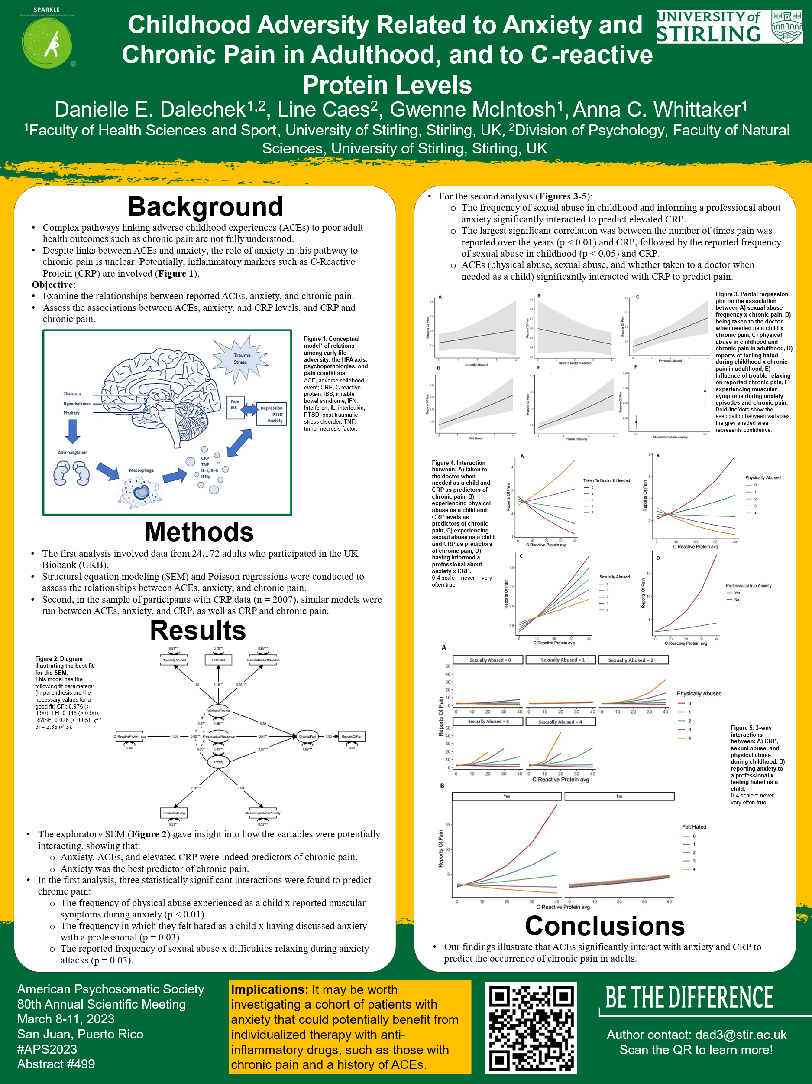

Abstract and oral presentation: SPaRC 2022
Accepted abstract:
Background: When considering factors that may impact chronic pain experiences in adulthood, adverse childhood experiences (ACEs) and anxiety experience should be considered, but the role of anxiety in the complex pathways linking ACEs to adult chronic pain outcomes is unclear.
Objective: To summarize the existing literature on the relationship between anxiety and childhood adversity on chronic pain experience in adults.
Methods: This systematic review examined adults (≥18 years) with a reported history of childhood adversity, self-reported and/or diagnosed anxiety, and chronic pain. Databases searched included PubMed, Medline, PsychInfo, and PsychARTICLES; focused on studies which investigated patients with anxiety, childhood trauma outcomes, stress, and chronic pain.
Results: The strength of the reported association (strong, moderate, weak) were assigned to each study. The narrative summary of results indicated a significant association between ACEs, anxiety, and chronic. Of 52 selected studies, 78.9% had a moderate-strong association. For ACE prevalence, the majority (50%) reported experiencing sexual abuse, followed by physical abuse 46.2%. Other common ACEs reported were emotional abuse (33.4%), emotional neglect (25%), and physical neglect (23.1%). Interestingly, the majority of studies still indicated an association between anxiety and chronic pain when excluding childhood adversity, although not as substantial.
Conclusion: The results of the systematic review indicated there was a meaningful association between ACEs, anxiety, and chronic pain experiences in adults.
Relevance for patient care: The results of this study are important in showing not only an association between childhood adversity and adult chronic pain outcomes, but also with anxiety symptomology. This is an important consideration in patient care, particularly as a potential screening measure in health settings when patients present with both chronic pain and anxiety. Additionally, it is worthwhile to note the high rate of reported childhood sexual abuse in this population, which contrasted prior research gaps in reporting of this ACE.
Oral presentation (slides):
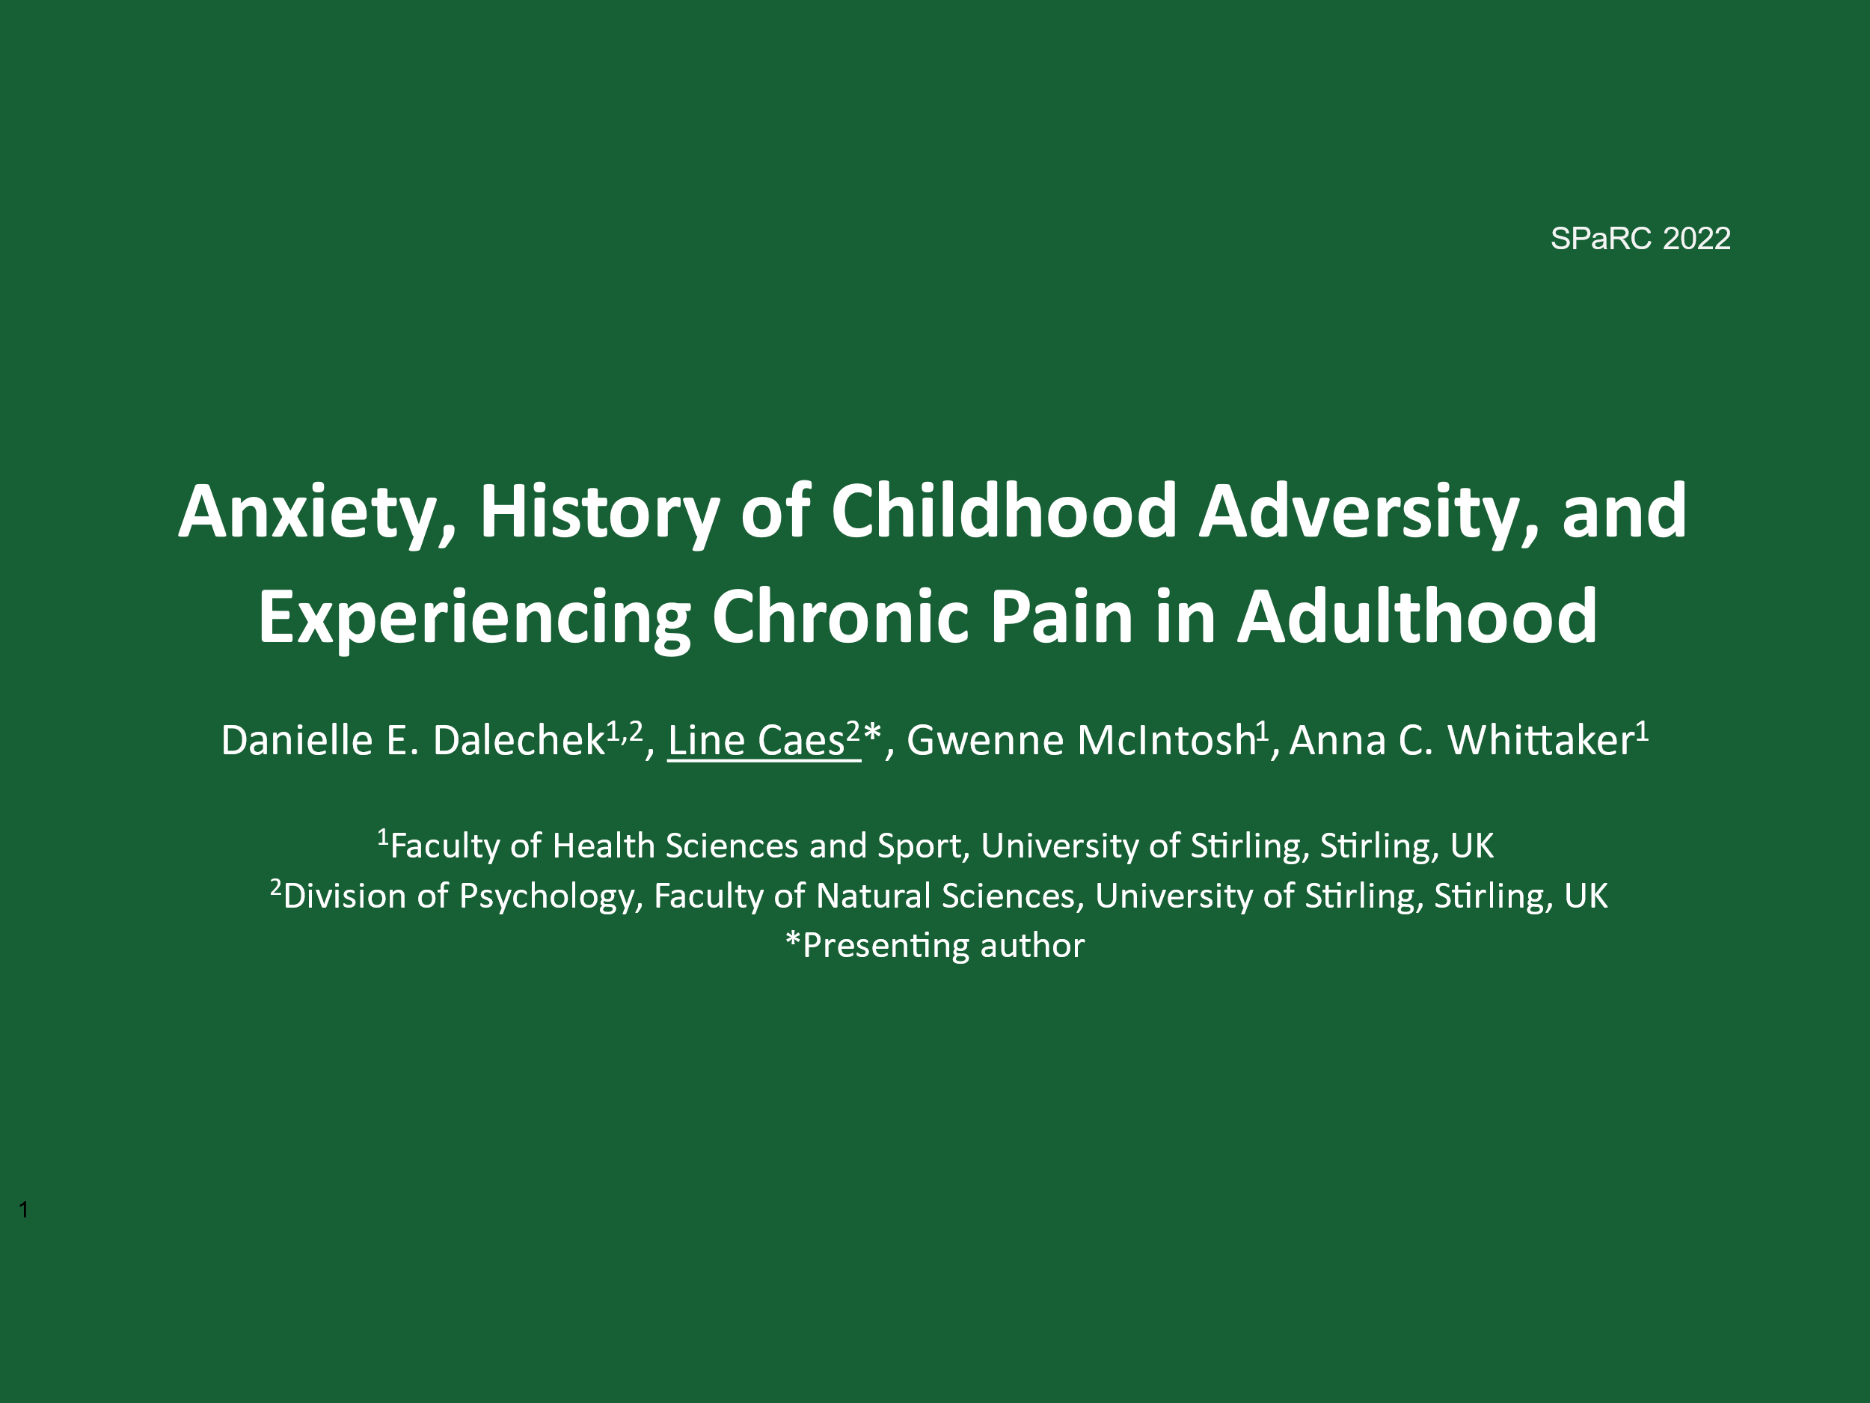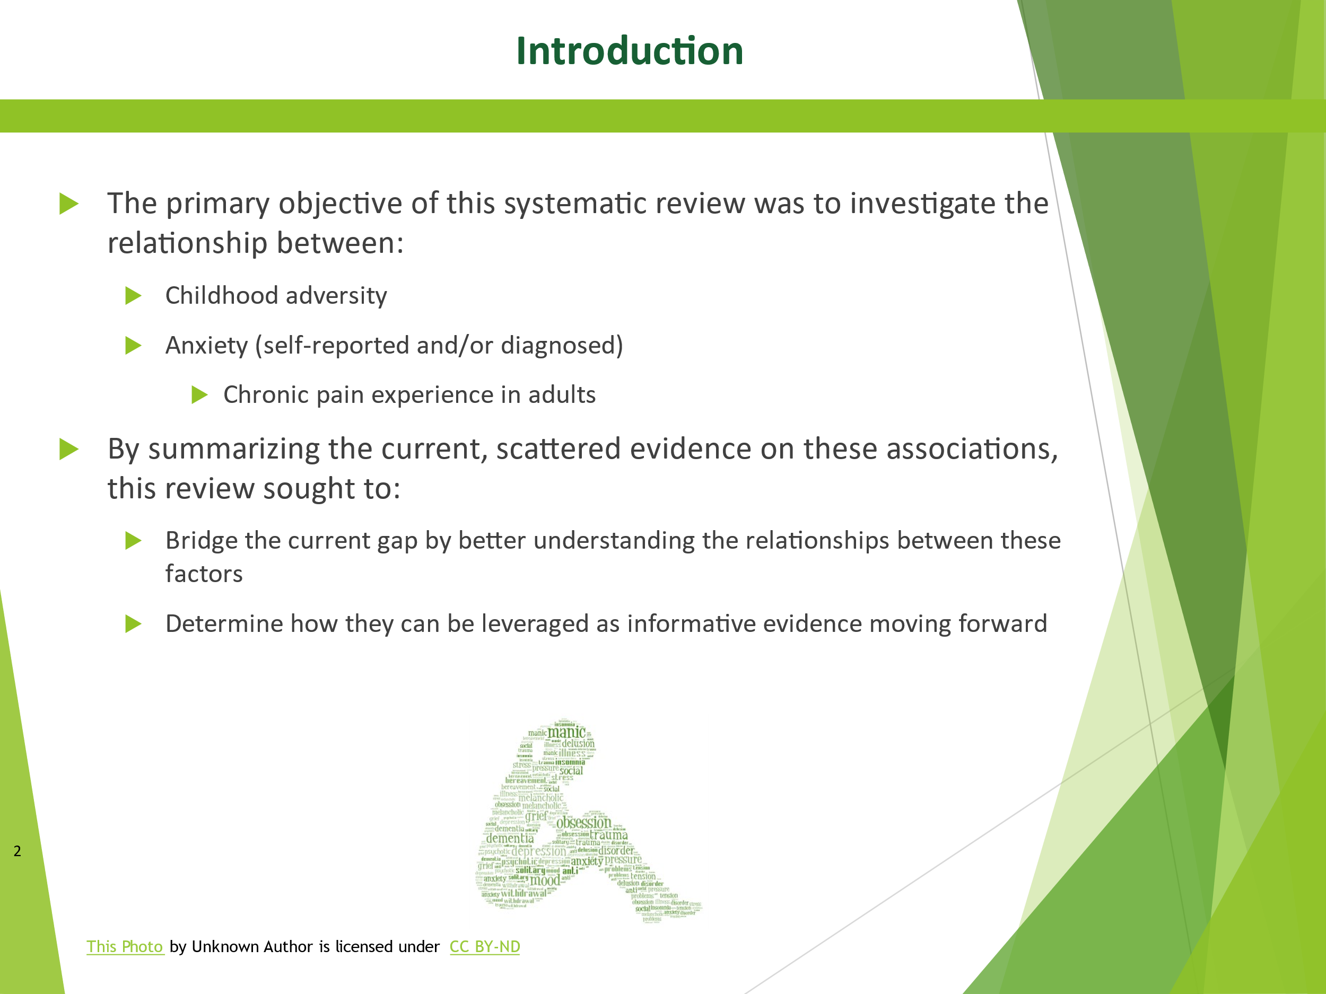
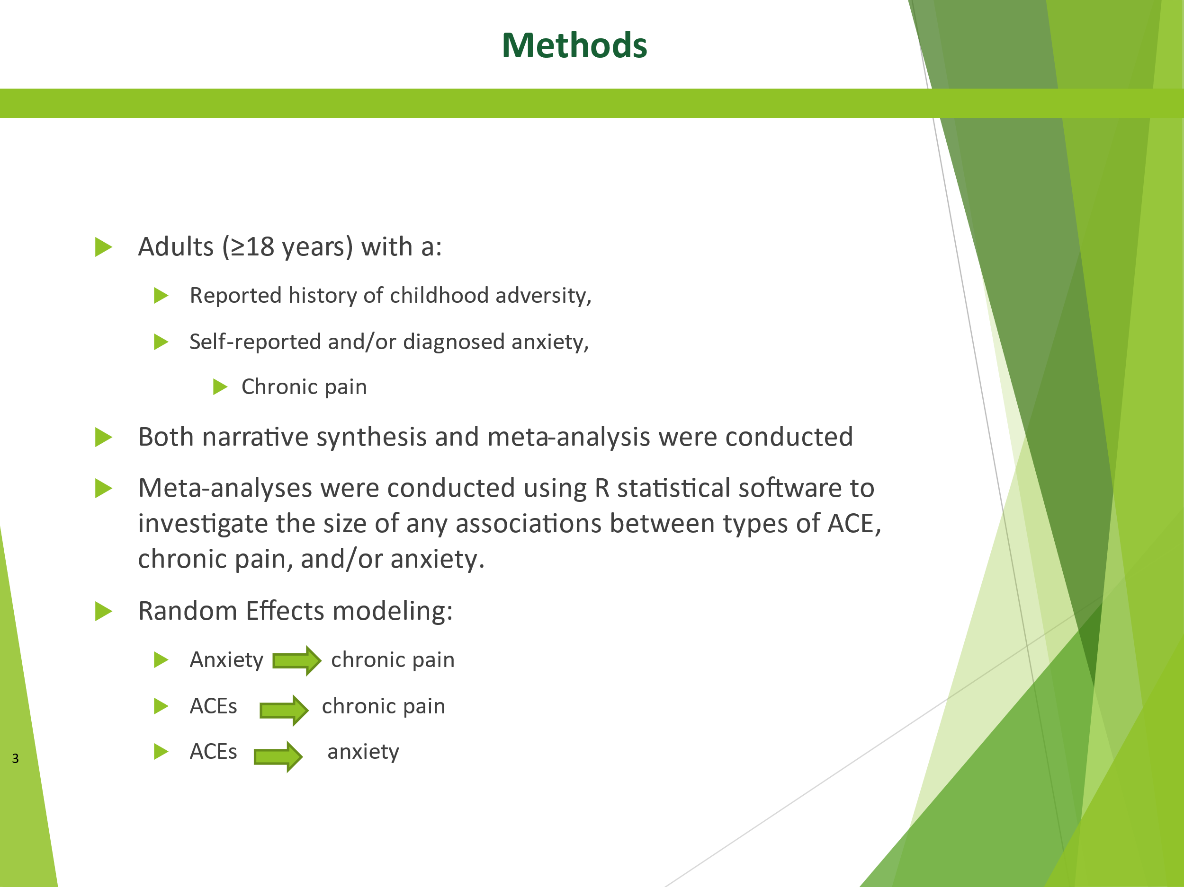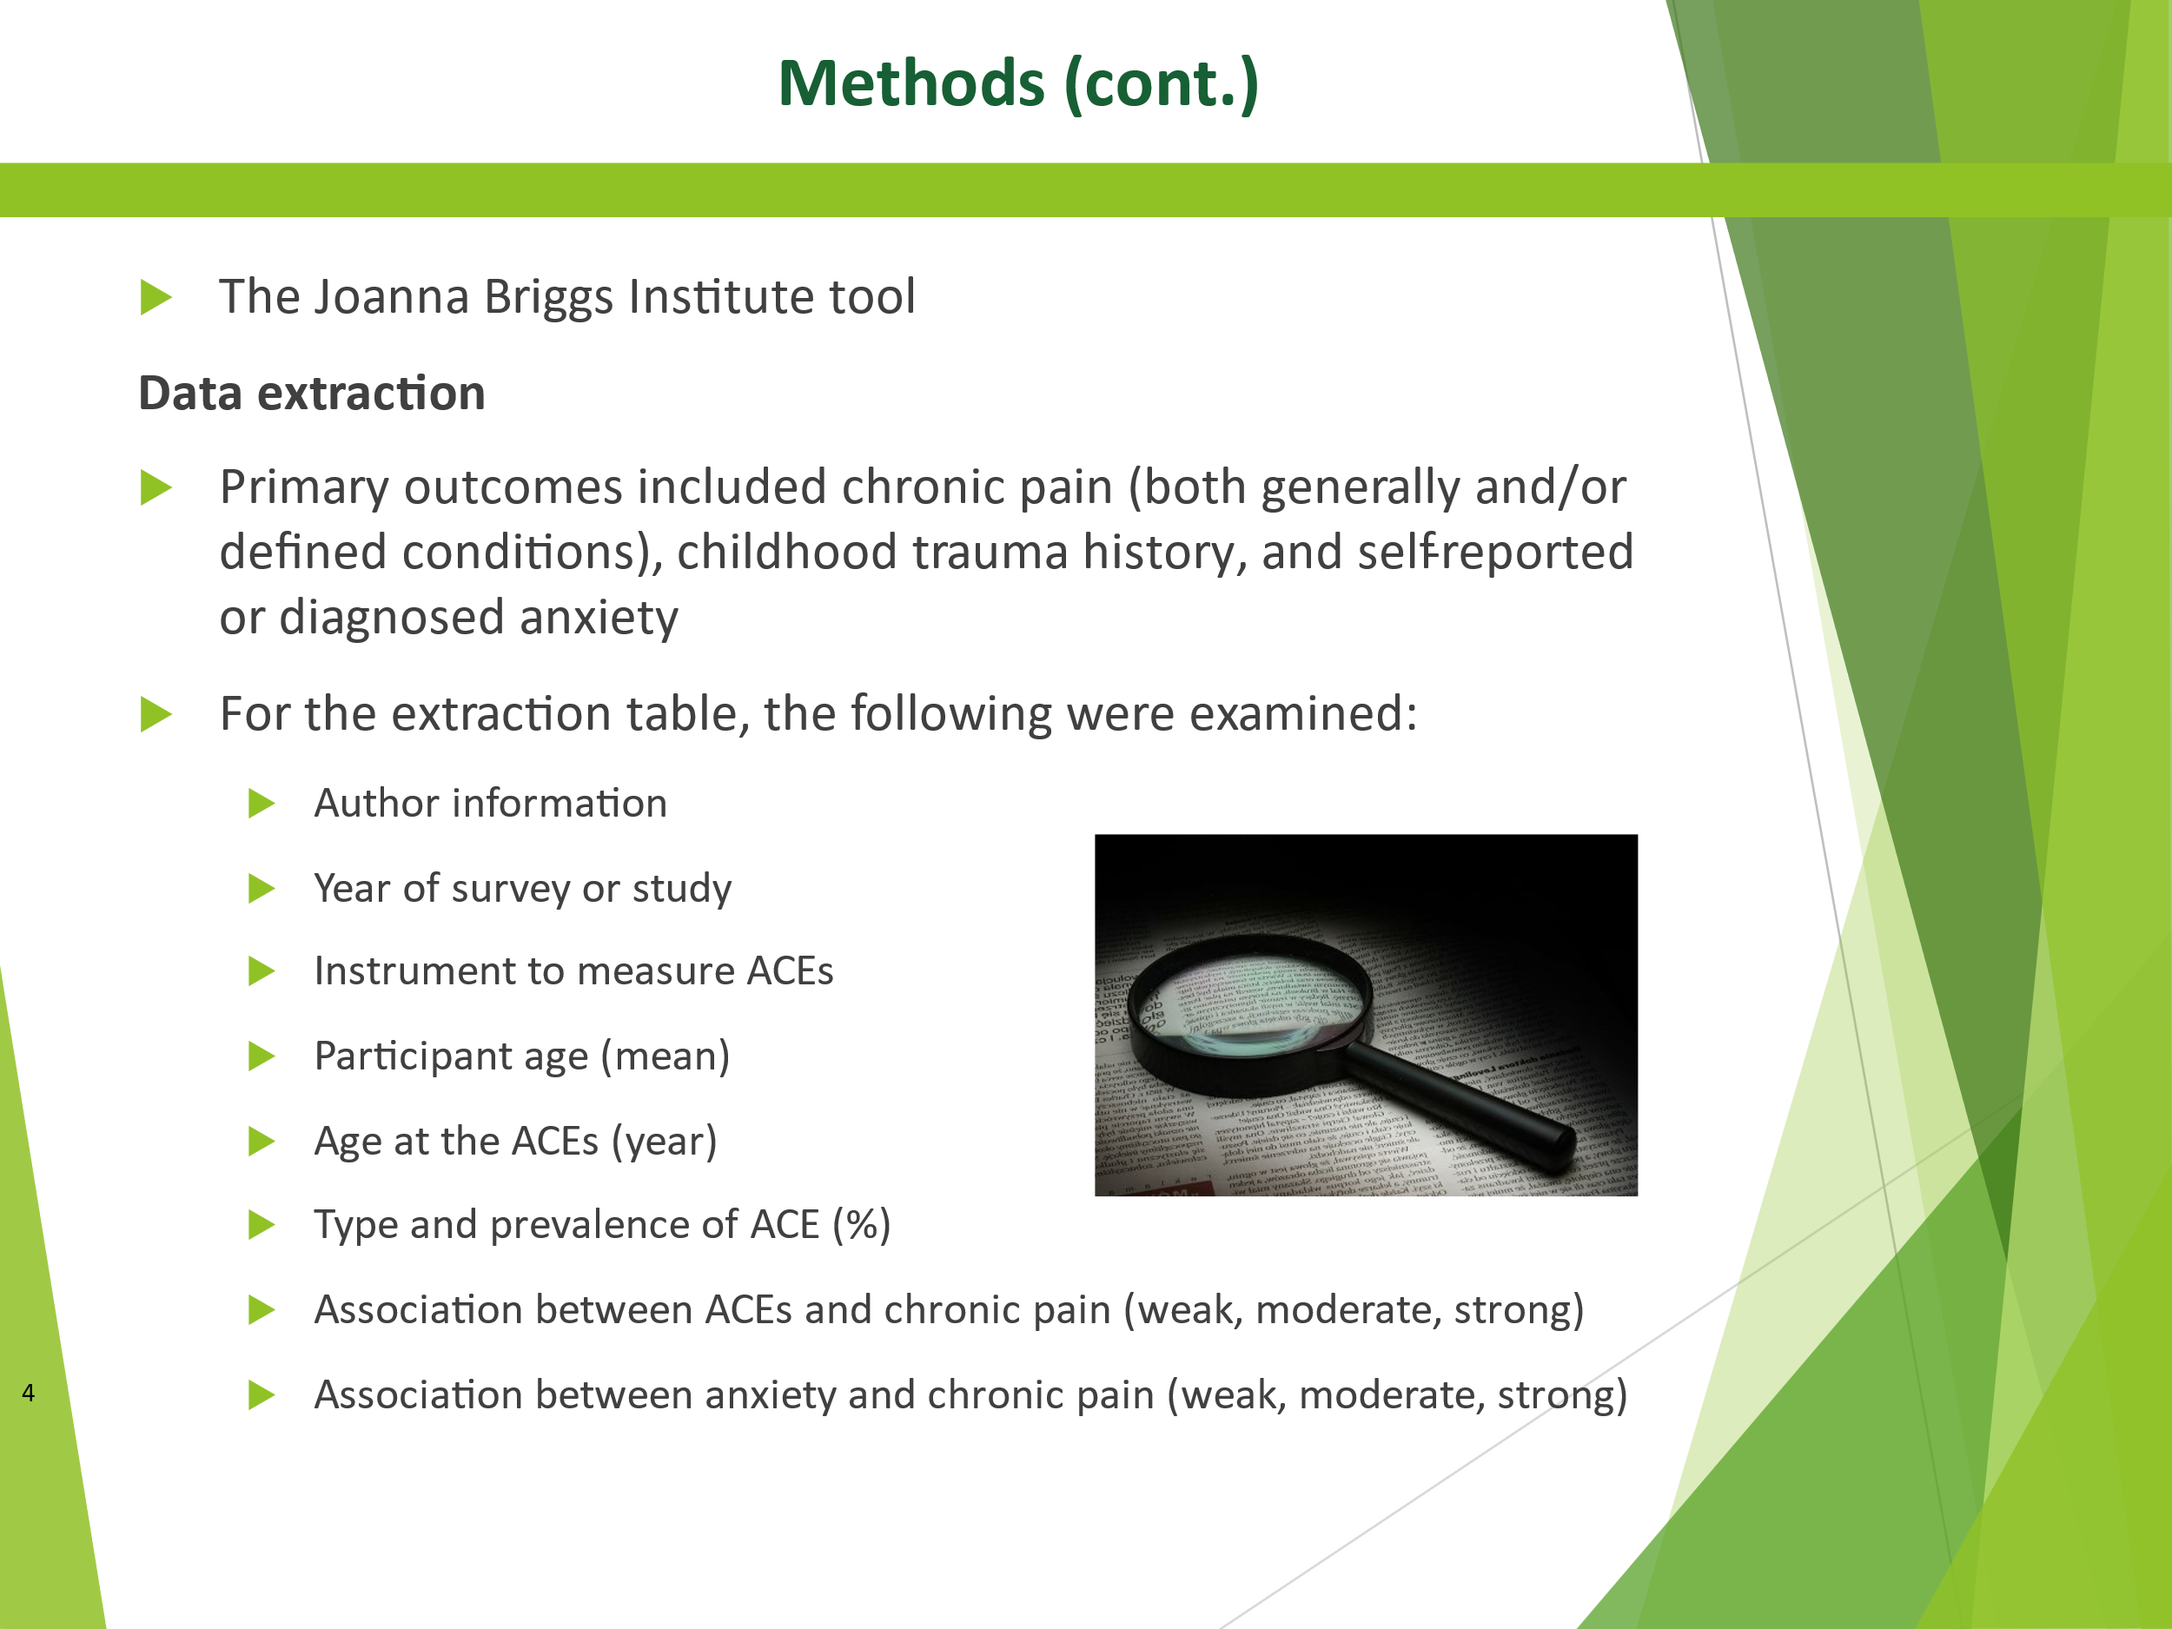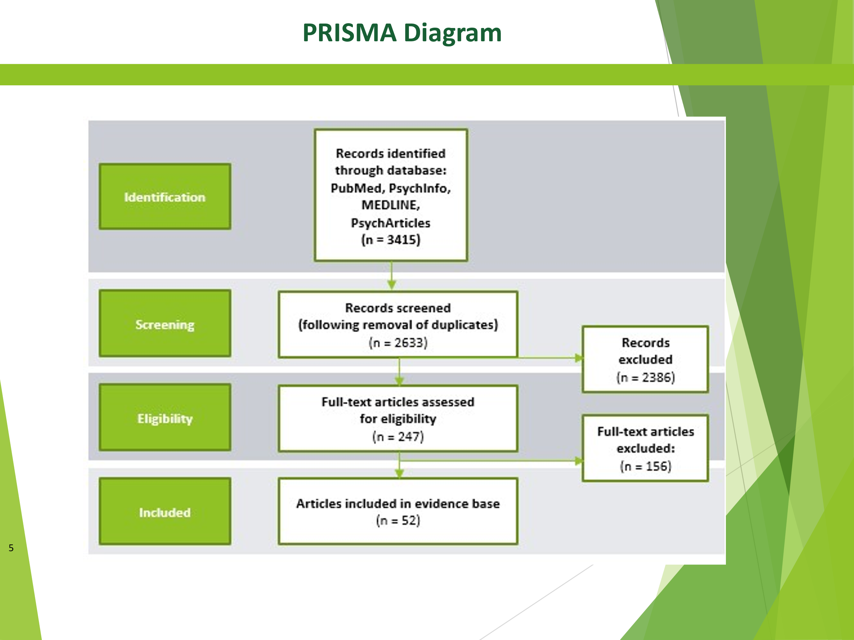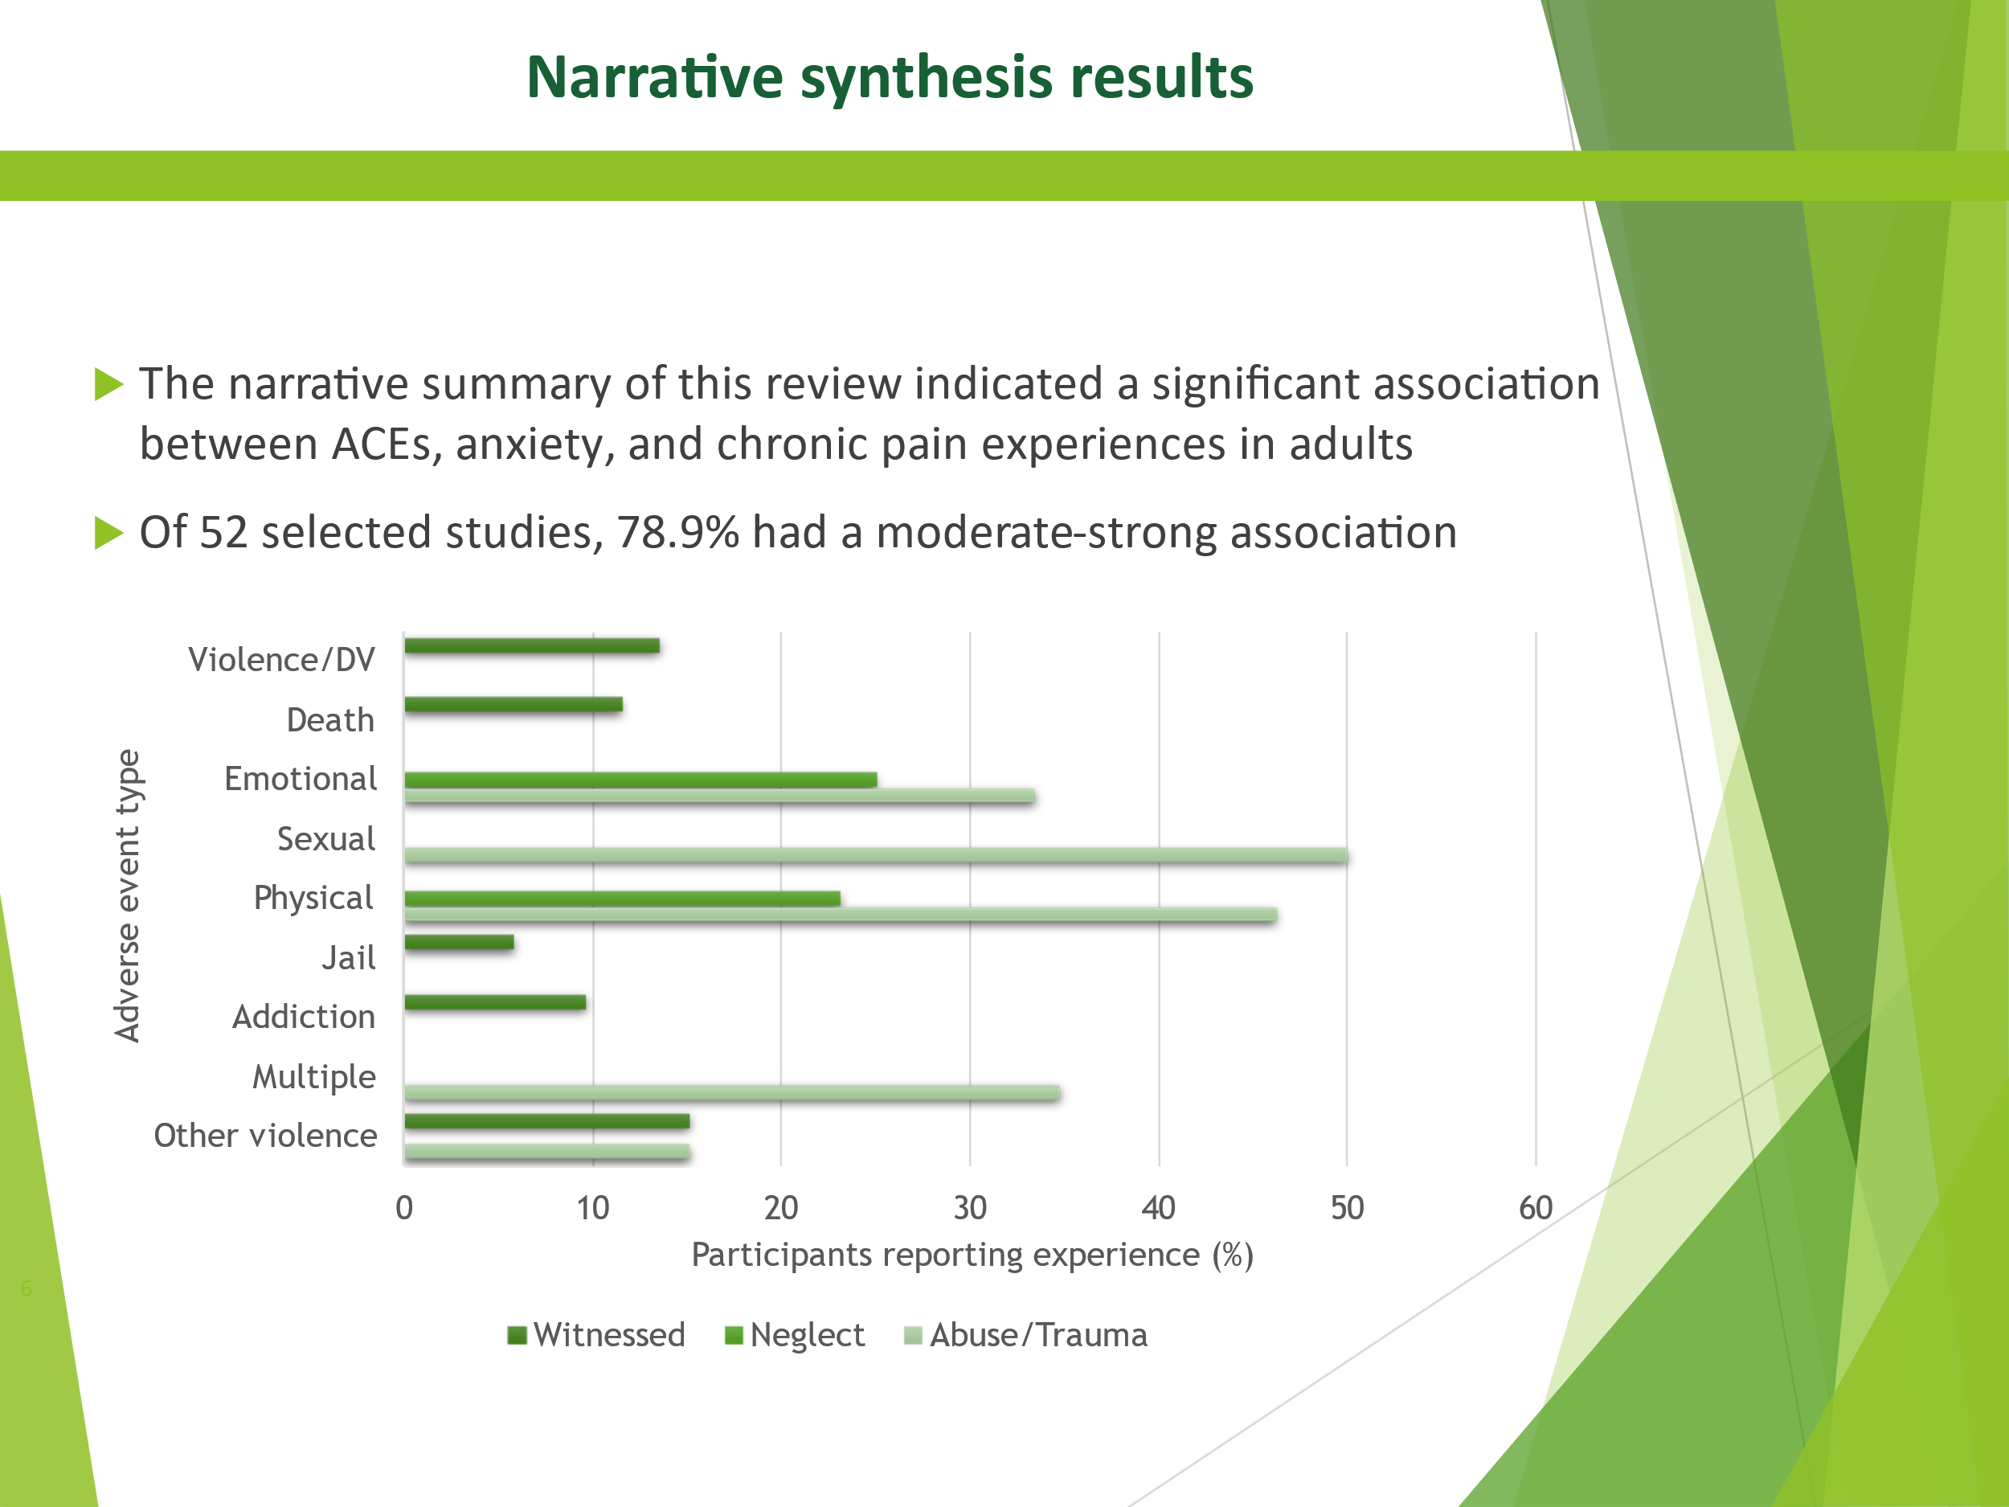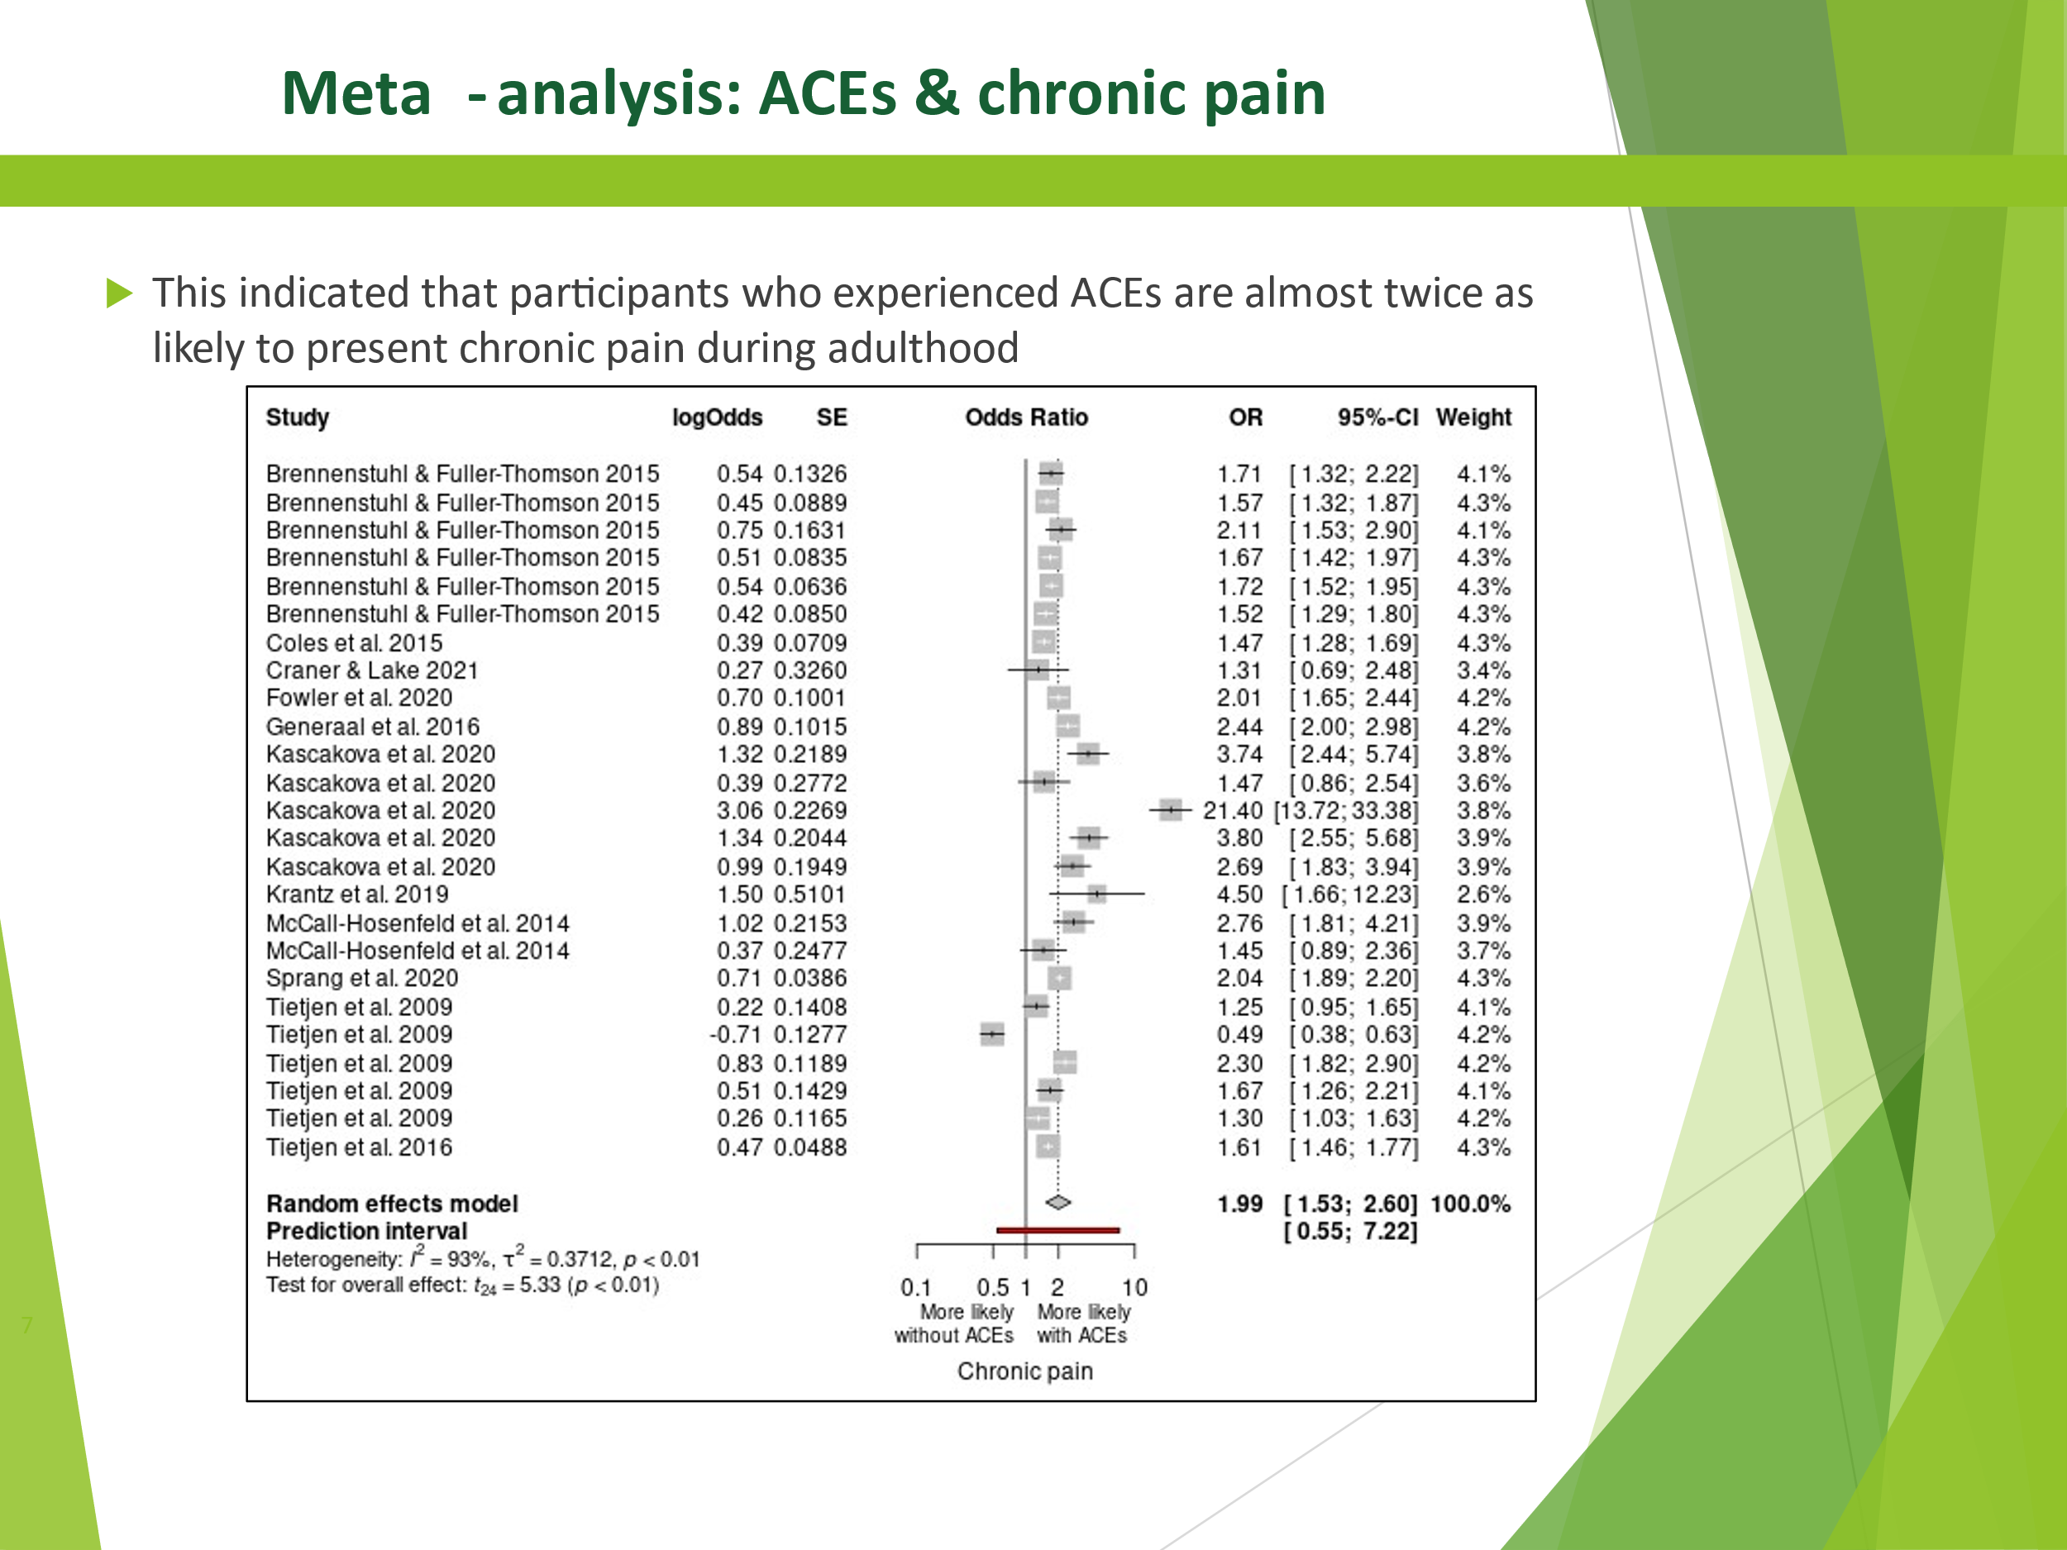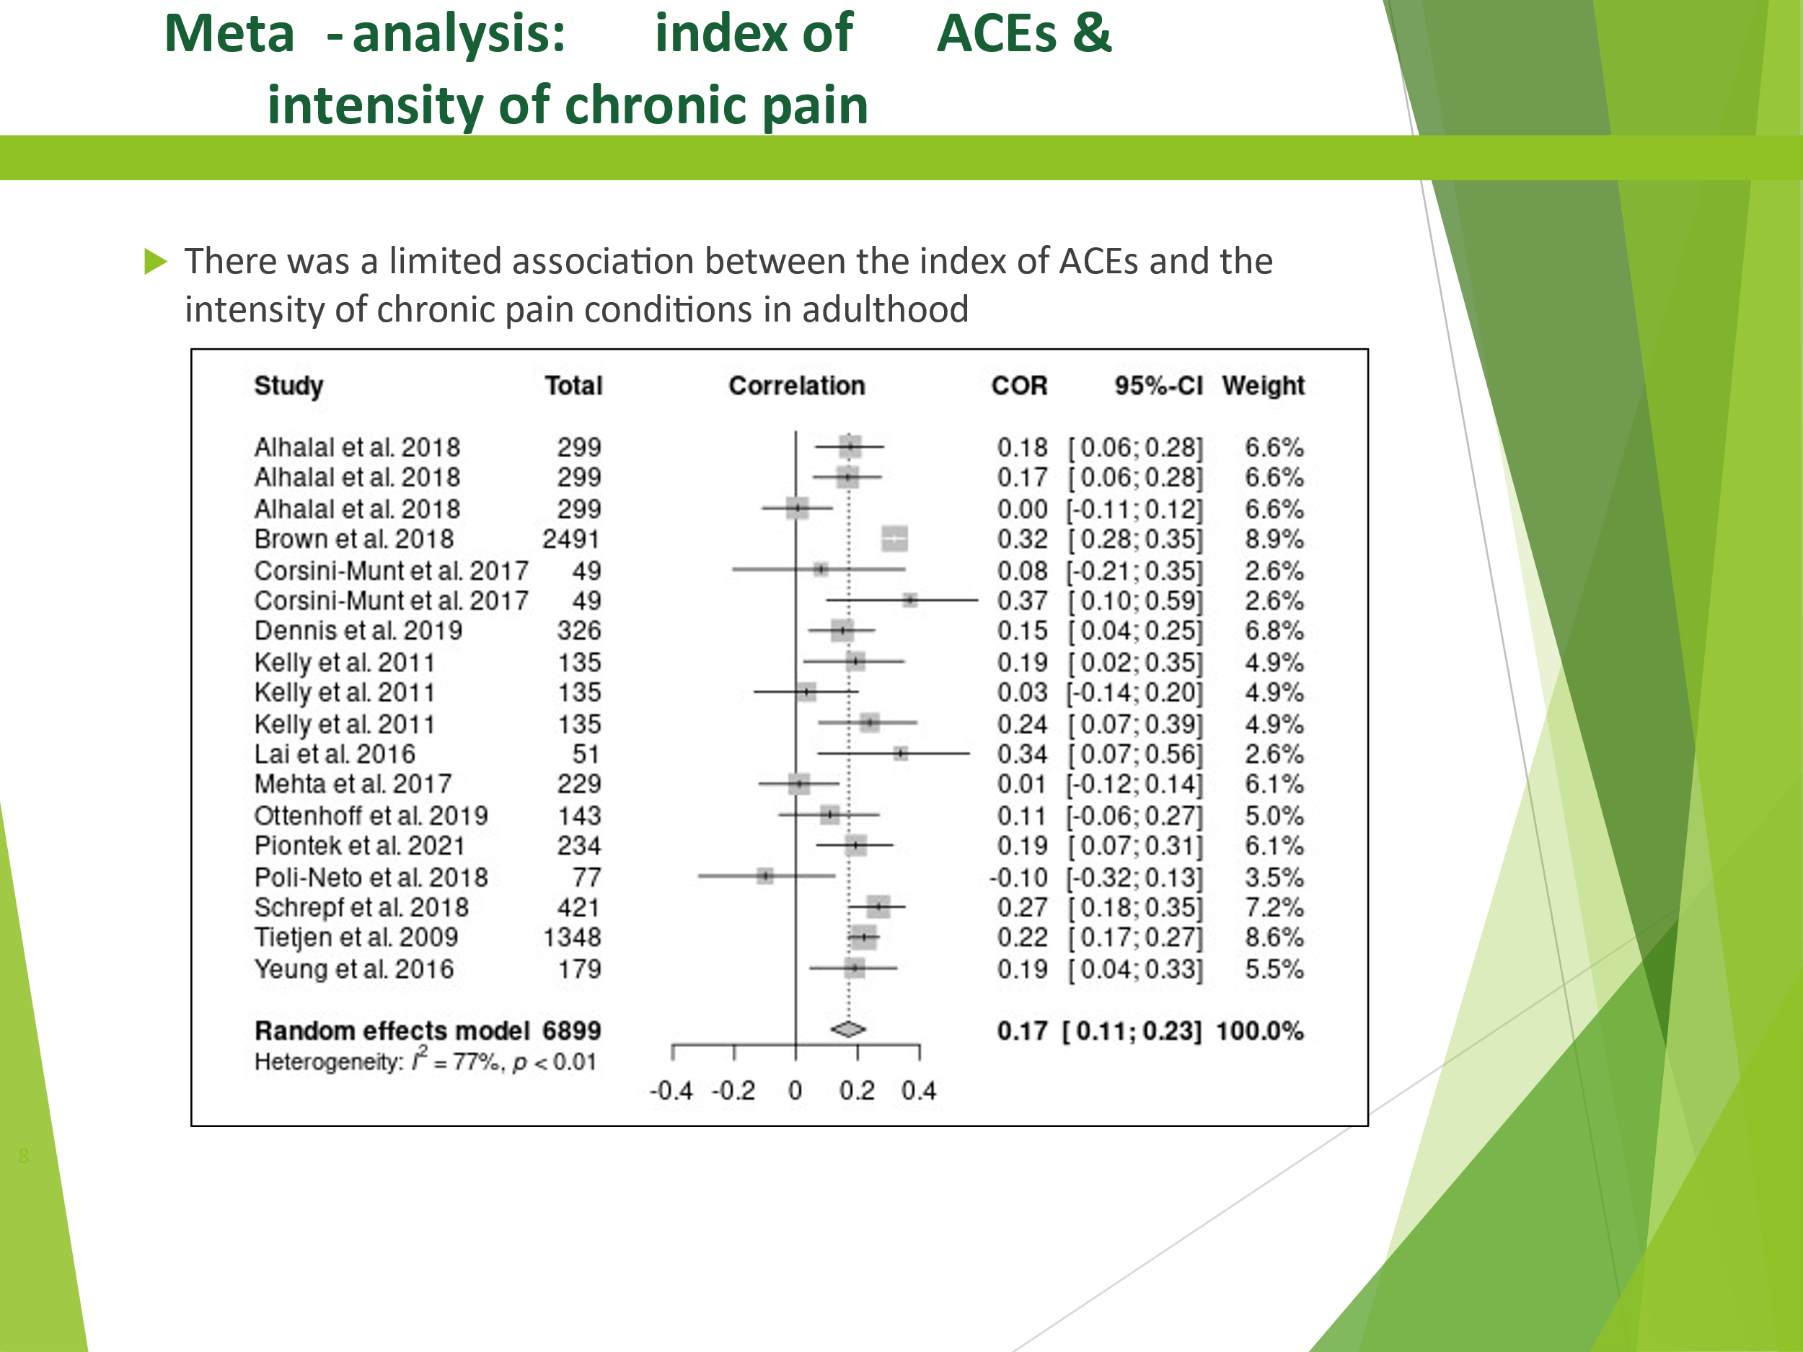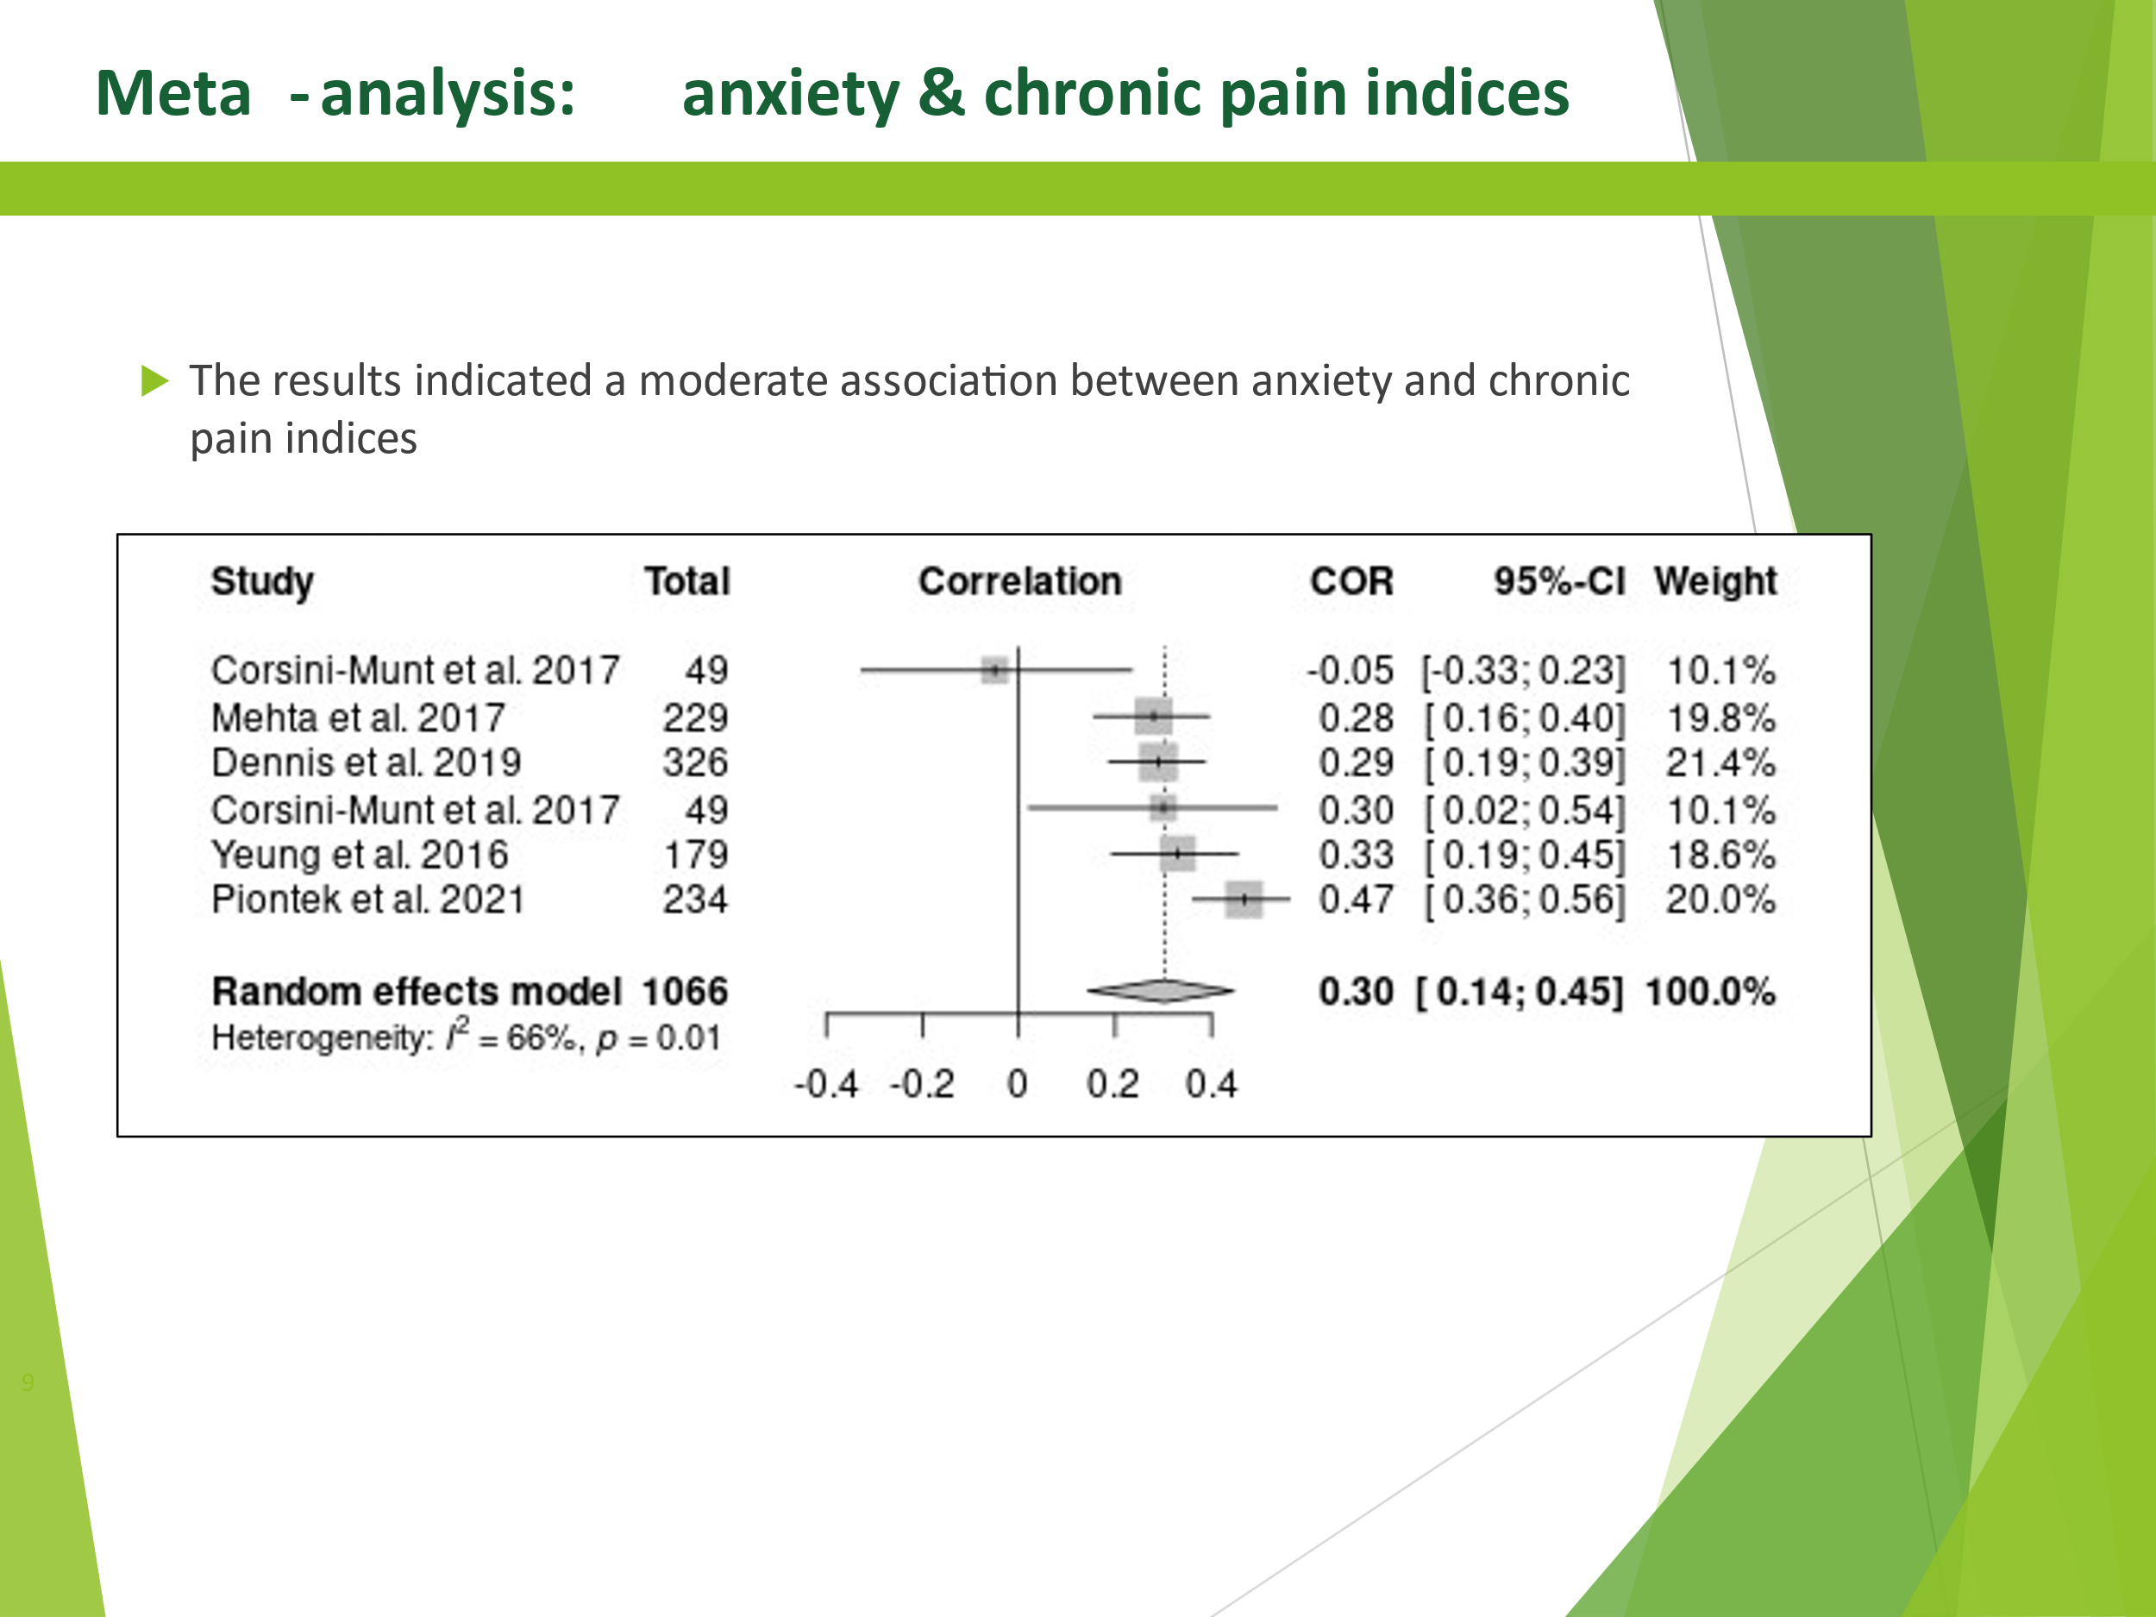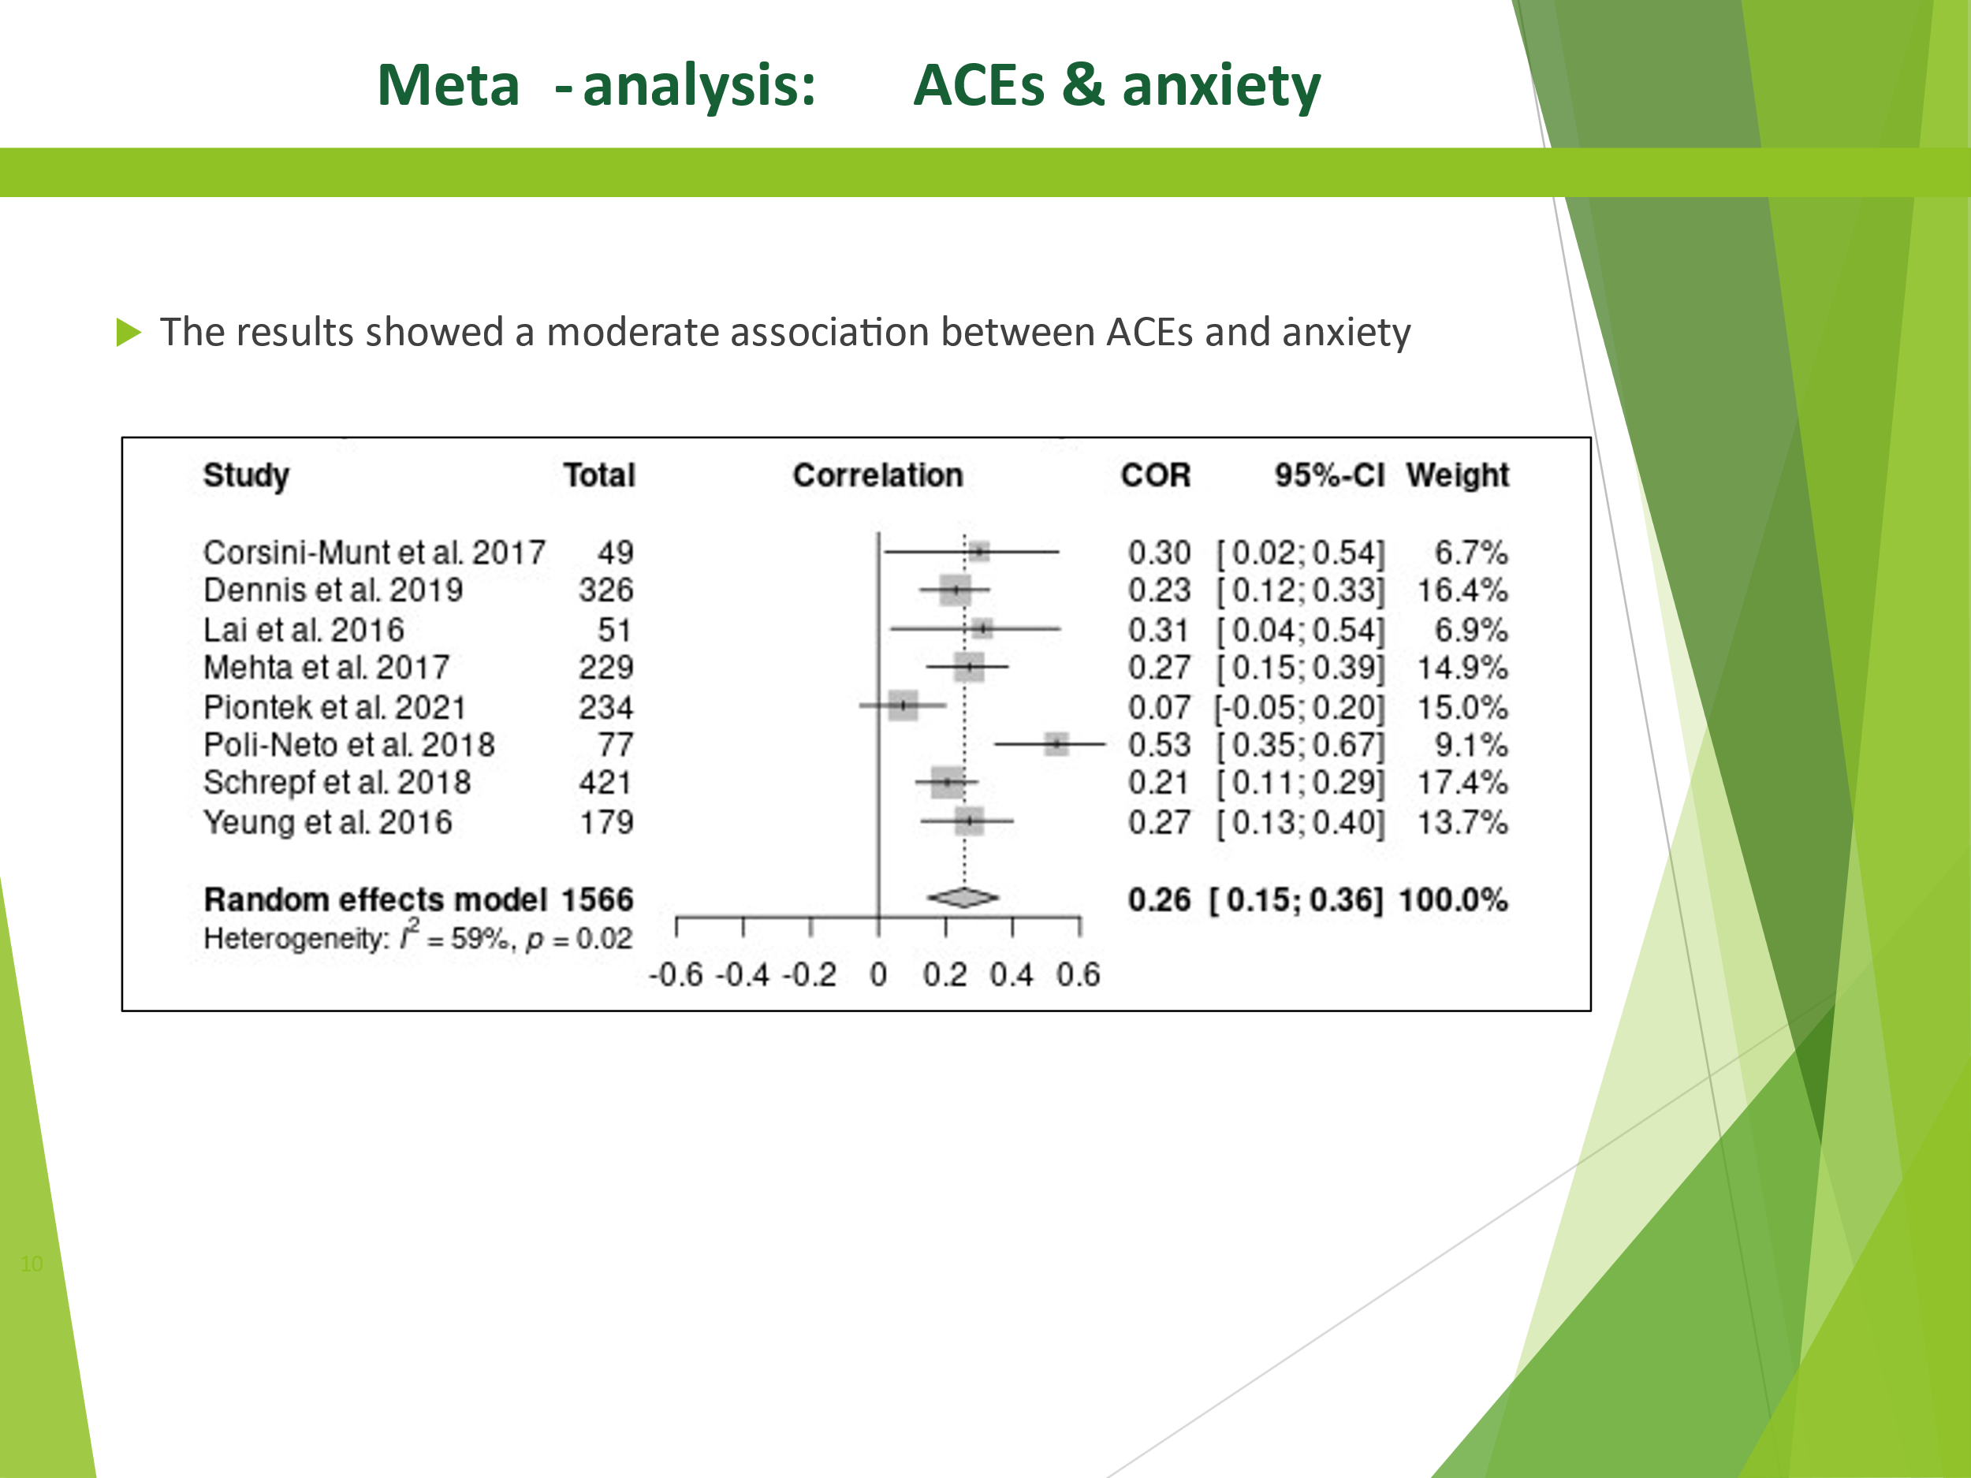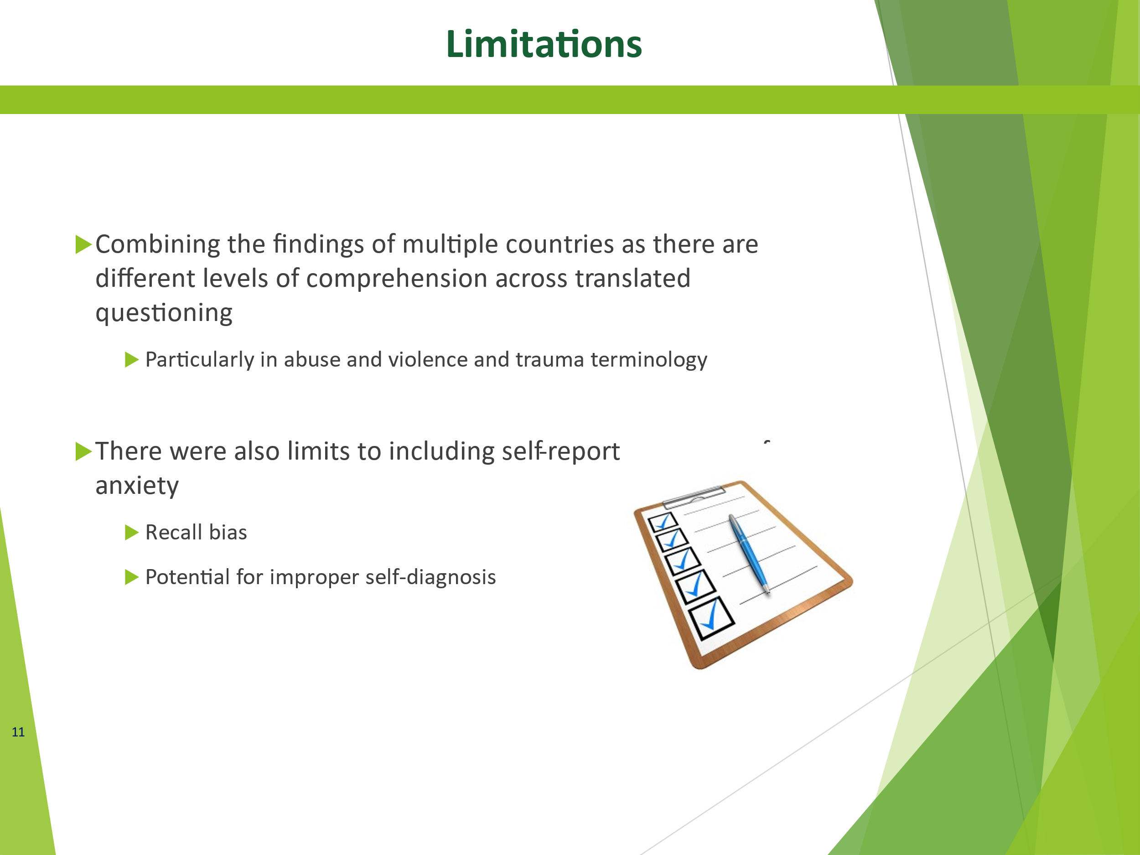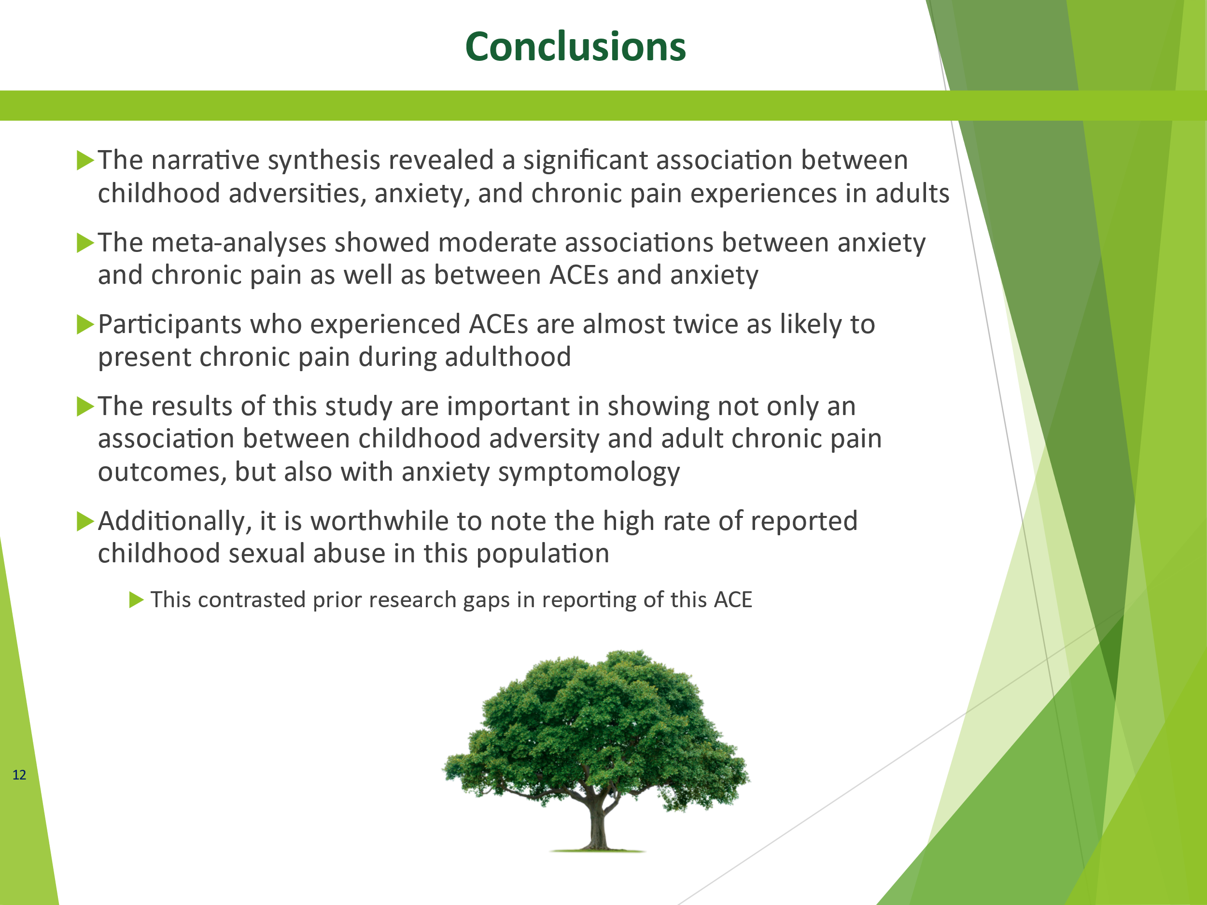

Abstract (accepted, not presented): EFIC 2023
Background and aims: When considering factors that may impact chronic pain experiences in adulthood, adverse childhood experiences (ACEs) and anxiety experience should be considered, but the role of anxiety in the complex pathways linking ACEs to adult chronic pain outcomes is unclear. The objective of this study was summarize the existing literature on the relationship between anxiety and childhood adversity on chronic pain experience in adults. Methods: This systematic review examined adults (≥ 18 years) with a reported history of childhood adversity, self-reported and/or diagnosed anxiety, and chronic pain. Both narrative synthesis and meta-analysis were conducted. Results: The narrative summary of this review indicated a significant association between ACEs, anxiety, and chronic pain experiences in adults. Of 52 selected studies, 78.9% reported a moderate-strong association. For ACE prevalence, the majority (50%, SD 16.01) reported experiencing sexual abuse, closely followed by physical abuse 46.2% (SD 20.7). Other common ACEs reported were emotional abuse (33.4% (SD 17.17)), emotional neglect (25% (SD 21.02)), and physical neglect (23.1% (SD 22.44)). Meta-analyses showed moderate associations between anxiety and chronic pain (r = 0.30; 95%CI = (0.14, 0.45), p < 0.01) as well as between ACEs and anxiety (r = 0.26; 95%CI = (0.15, 0.36), p < 0.01), and that participants who experienced ACEs are almost twice as likely to present chronic pain during adulthood (OR = 1.99; 95%CI= (1.53, 2.60), p < 0.01). Conclusions: The results of the systematic review and meta-analysis indicated there was a meaningful association between ACEs, anxiety, and chronic pain experiences in adults.

