PREVALENCE AND INSIGHTS ON THE PARASITIC DINOFLAGELLATE HEMATODINIUM SP. INFECTION IN THE NORWAY LOBSTER, NEPHROPS NORVEGICUS

THESIS SUBMITTED TO THE UNIVERSITY OF STIRLING FOR THE DEGREE OF DOCTOR OF PHILOSOPHY
IN
AQUACULTURE

BY
IRENE MARTIN MOLTO
BSc in Biology
MSc in Aquaculture
MSc in Marine Biology
PGDE Biology & Science

HEALTH RESEARCH GROUP
INSTITUTE OF AQUACULTURE, FACULTY OF NATURAL SCIENCES
UNIVERSITY OF STIRLING
UNITED KINGDOM

JULY 2024


Supervisors’ declaration

This is to certify that this thesis for the degree of Doctor of Philosophy entitled “Prevalence and insights on the parasitic dinoflagellate Hematodinium sp. infection in the Norway lobster, Nephrops norvegicus” submitted to the University of Stirling (UK), is an original work carried out by Irene Martín Moltó under our supervision.

…………………………………
Dr Amaya Albalat
Institute of Aquaculture, Faculty of Natural Sciences, University of Stirling
Stirling, Scotland, UK
July 2024

…………………………………
Professor Simon MacKenzie
Head of Institute of Aquaculture
Institute of Aquaculture, Faculty of Natural Sciences, University of Stirling
Stirling, Scotland, UK
July 2024

Declaration

I, the undersigned, hereby declare that this thesis has been composed entirely by me and has not been submitted for any other degree. The work presented in this thesis, except where specifically acknowledged, is the result of my own investigations which have been done by me independently.

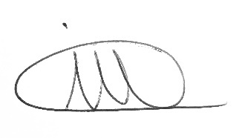

……………………………………………………
Irene Martín Moltó
Stirling, UK
July 2024

Authors contributions
University of Stirling
- Irene Martin Molto – Thesis author; lead author of Publications 1 and 2.
- Professor Amaya Albalat – Main thesis supervisor; participated in all sample collections; secured project funding; provided extensive thesis feedback and corrections; contributed to the writing of Publications 1 and 2.
- Professor Simon MacKenzie – Secured project funding and contributed to the writing of Publications 1 and 2.
- Dr. Ben Clokie – Provided training in statistical analysis and bioinformatics for the microbiome chapter (Chapter 3); offered feedback on microbiome data interpretation; contributed to the writing of Publication 2.
- Dr. Ahmed Elsheshtawy – Supported statistical and bioinformatics training for Chapter 3; provided feedback on microbiome analysis; contributed to Publication 2.
- Dr. Bruce McAdam – Provided training in R coding and statistical analysis for Chapter 2.
- Jacquie Ireland – Supported DNA extractions and laboratory safety training.
- Dr. John Taggart – Provided training and feedback on DNA extraction protocols.
- Debbie Faichney – Delivered histology laboratory training.
- Fiona Muir – Provided virology laboratory training.
- Dr. Matthew Sprague – Conducted lipid analysis training and supported data interpretation for Chapter 4.
- Dr. Monica Betancour –supported data interpretation for Chapter 4.

CEFAS
- Professor Grant Stentiford – Secured project funding; participated in Chapter 3 sampling; provided feedback on Chapter 2; contributed to the writing of Publications 1 and 2.
- Dr. David Bass – Secured project funding; participated in Chapter 3 sampling; provided feedback on Chapter 2; supported microbiome and primer design training for Chapter 3; contributed to the writing of Publications 1 and 2.
- Mickael Teixeira Alves – Provided training in statistical modelling for Chapter 2.
- Chantelle Hooper – Supported microbiome laboratory training.
- Dr. Georgia Ward – Supported microbiome laboratory training.
- Dr. Kelly Bateman – Assisted with histology interpretation; participated in sampling for Chapter 3; contributed to Publication 2.
- Richard Hazelgrove – Processed histology samples.
- Stuart Ross – Provided training and processed samples for Transmission Electron Microscopy.
University of Glasgow
- Professor Douglas Neil – Provided feedback on Chapter 2 and contributed to the writing of Publication 1.
University of Galway
- Dr. Christopher J. Coates – Contributed to the writing of Publication 1.
Other
- Mrs Irene Pont Trullen- Artist of Figure 1.1 and Figure 1.7.

Acknowledgements
I extend my deepest gratitude to my supervisors, Dr. Amaya Albalat, Professor Simon Mackenzie, Dr. Grant Stentiford, and Dr. David Bass, for their exceptional guidance and unwavering support throughout my PhD journey. Their expertise and commitment have been the foundation of my success.
Special thanks to my shadow mentors, Dr. Ben Clokie and Dr. Ahmed Elsheshtawy, for their invaluable mentorship and assistance. Ahmed's constant support and insightful conversations have been particularly significant.
I also sincerely thank Dr. Bruce McAdam and Mickael Teixeira Alves for their contributions to statistical analysis and R programming, and Dr. Matthew Sprague, Dr. Richard Broughton, and the NAS staff for their assistance in lipid analysis. My appreciation extends to Prof. Douglas Neil, Dr. Sebastian Gornik, Dr. Nicholas Beevers, and Dr. Hazel for their external advice and feedback.
I am grateful to Assoc. Profs. Monica Betancourt and Sonia Rey Planellas for their inspiring conversations and support, and to Emily Burnette and Silvere Santos for their dedication during live experiments.
My heartfelt thanks to the Institute of Aquaculture and the University of Stirling for the opportunity to serve as a teaching assistant, which ignited my passion for education. I appreciate the support from Jacquie Ireland, Dr. John Taggart, Fiona Muir, Debbie Faichney, Charles Harrower, and Jane Lewis.
At CEFAS, I thank Rose Keer, Chantelle Hooper, Diana Minardi, Dr. Georgia Ward, Lyndsay, Dr. Corey Holt, and the histopathology team led by Dr. Kelly Bateman for their swift processing of samples during the pandemic.
Reflecting on this journey, I am grateful for the experiences and support from Ian Wightman, the captain of Eilidh Anne, and fellow students and colleagues at the University of Stirling, including Dr. Athina Papadopoulou, Chiara, Dr. Simao Zacarias, Dr. Arsenio Hilinganye, Dr. Anastasios Baltadakis, Dr. Claudia Tschesche, Dr. Wesley Malcorpos, Dr. Shankar Mandal, Jessica di Toro, Dr. Chris Payne, Dr. Carolina Fernández, Dr. Ana Corrochano, Lewis Warren, Rosie Allshire, Tim Whise, Dr. Callum Howard, Dr. Samuel Pourtney, Dr. Charlotte Bolton, Dr. Bernat Morro, and Gayatri Kachh.
Special gratitude goes to my husband Mark Hyde for his unwavering support and encouragement. Lastly, I dedicate this work to my friends and family in Valencia, especially my beloved mother, whose love and encouragement have been my guiding light. Te quiero mucho.
I proudly declare the completion of this thesis without a single cup of coffee, contrary to the predictions of my fellow PhD scholars.

Dedicatory

For Lucas, Mark, Cruz, Kimba, Brodie and Ona because I love them.

Peer-reviewed publications
- Molto-Martin, I., Neil, D.M., Coates, C.J., Mackenzie, S., Bass, D., Stentiford, G.D., Albalat, A., 2024. Infection of Norway lobster (Nephrops norvegicus) by the parasite Hematodinium sp.: insights from 30 years of field observations. Royal Society Open Science 11.
https://doi.org/10.1098/rsos.231147
- Martin, I., Elsheshtawy, A., Clokie, B.G.J. , Mackenzie, S., Bass, D., Stentiford, G.D., Albalat, A. (2025). Microbiome dynamics associated with Hematodinium sp. infection in Norway lobster (Nephrops norvegicus). Animal Microbiome 7(1): 62.
https://doi.org/10.1186/s42523-025-00416-w

Scientific conferences and meetings
- ARCH-UK Finfish And Shellfish Microbiome Workshop: Poster Presentation, November 2018, Jurys Inn Aberdeen Airport, Argyll Road Aberdeen, Scotland, UK.
- Institute of Aquaculture PhD Symposium: Poster and Oral Presentation, October 2019, Institute of Aquaculture, University of Stirling, UK.

Trainings and workshops
- TARCH-UK Finfish And Shellfish Microbiome Workshop, November 2018, Jurys Inn Aberdeen Airport, Argyll Road Aberdeen, Scotland, UK.
- ARCH-UK Proteomics Workshop, November 2019, Institute of Aquaculture, University of Stirling, UK.
- Teaching Assistant Course, 25th January 2019, University of Stirling Academic Development, Stirling, UK.
- Demonstrator within the Faculty of Natural Sciences – Institute of Aquaculture, University of Stirling (27 September 2021 to 17 December 2021).
- Part-time Lecturer within the Faculty of Natural Sciences - Institute of Aquaculture, University of Stirling. (08 November 2021 to 31 July 2022).

Grants
- Fishmongers’ Company Fish And Fisheries Programme Academic Sponsorship (2020). Funding value of £3,340.

List of abbreviations

Abbreviation | Meaning
% | Percentage
×g | Centrifugal force
°C | Degree Celsius
µg mL⁻¹ | Micrograms per millilitre
µm | Micrometer
18S | small subunit of the ribosomal RNA (rRNA)
A+B | early post-moult
AHPND | Acute Hepatopancreatic Necrosis Disease
AMPs | Antimicrobial peptides
ANOVA | Analysis of variance
ASVs | Amplicon Sequence Variants
AWERB | Animal Welfare and Ethical Review Body
BBS | Blue Body Syndrome
BCM | Body colour method
bp | Base pair
C | Intermoult
cDNA | Complementary DNA
CEFAS | Centre for Environment, Fisheries, Aquaculture, Science
CL | Carapace length
cm | Centimetre
CSA | Clyde Sea Area
Ct | Cycle threshold
D | pre-moult
DGGE | Denaturing gradient gel electrophoresis
DNA | Deoxyribonucleic Acid
DO | Dissolved oxygen
DSF | Davidson’s Saltwater Fixative
EB | Elution Buffer
EDTA | Ethylenediaminetetraacetic acid
ELISA | Enzyme-Linked Immunosorbent Assay
ESD | Epizootic shell disease
FDR | False discovery rate
FISH | Fluorescent in situ hybridization
FSC | Field Studies Council
g | Gram
g/L | Grams per litre
GSI | Gonadosomatic index
H&E | haematoxylin and eosin
hrs | Hours
HSI | Hepatic somatic index
HTS | High-Throughput Sequencing
IoA | Institute of Aquaculture
ITS1 | Internal transcriber 1
Kg | Kilogram
LFC | Largs-Fairly Channel
M | Molar
MF | methyl farnesoate
mg | Milligram
Mg L^{–1} | Milligrams per litre
midx | moult index
min | Minute
mM | Millimolar
mm | millimetres
MRCs | Mitochondrion-rich cells
mRNA | Messenger Ribonucleic acid
ms | moult stage
N | Number
NaCl | Sodium chloride
NCBI | National Centre for Biotechnology Information
NEG | negative
ng | Nanogram
NMDS | Non-metric multidimensional scaling
OBIS | Ocean Biodiversity Information System
OTUs | Operational Taxonomic Units
p | P-value
PCOA | Principal component analysis
PCR | Polymerase chain reaction
PERMANOVA | Permutational multivariate analysis of variance
pH | Potential of hydrogen
PM | pleopod method
POS | positive
ps | pleopod stage
ps2 | pleopod stages 1-4 combined
PUFAs | Polyunsaturated fatty acids
qPCR | Quantitative polymerase chain reaction
R² | Coefficient of determination
RAS | Recirculating aquaculture system
Rf | Reference
RNA | Ribonucleic acid
rRNA | Ribosomal ribonucleic acid
RT | Room temperature
s | Seconds
SCFAs | Short-chain fatty acids
SD | Standard deviation
SDS | Sodium Dodecyl sulfate
SOM | Size at onset of sexual maturity
SOP | Standard operating procedure
SRB | sulfate-reducing bacteria
TAE | Tris acetate EDTA
TEM | Transmission electron microscopy
US | United States
v/v | Volume/volume
vidx | vigour index
w/v | Weight per volume
WFS | White Faeces Syndrome
WSSV | White Spot Syndrome Virus
μg | Microgram
μL | Microlitre

Abstract
Hematodinium sp. poses a significant threat to shellfish fisheries and aquaculture worldwide, causing morbidity and mortality events in various decapod species. The study focuses on the Clyde Sea Area (CSA) population of Nephrops and aims to elucidate key aspects of the Hematodinium-Nephrops pathosystem. This research confirms that Hematodinium sp. infection levels in the CSA align with previous data using body colouration and pleopod examination methods (Beevers et al., 2012; Stentiford et al., 2001a). This confirms that Hematodinium sp. is endemic to the region, with infection rates peaking in spring and summer and declining in autumn. The study highlights a correlation between infection severity and Nephrops size, with smaller individuals being more susceptible to disease progression. Female Nephrops, exhibiting behaviours such as burrow emergence and synchronized moulting in spring, are particularly prone to acquiring infection. the
Building upon this knowledge, previously unexamined aspects of Nephrops microbiome dynamics were explored in both Hematodinium-negative individuals and those infected by Hematodinium sp. The analysis revealed that even at subpatent levels, infected lobsters exhibit significant changes in haemolymph microbiome richness and composition, indicating a rapid and persistent microbial response to Hematodinium sp. infection. The infection decreased haemolymph bacterial richness and increased opportunistic bacteria, while the gut microbiome shifted towards polysaccharide-degrading genera. This study also established a baseline for “healthy” microbiomes in Nephrops, with Proteobacteria dominating both haemolymph (46.1%) and gut (26.7%) microbiomes, a pattern consistent with other crustaceans. The haemolymph contained beneficial genera like Bifidobacterium and Lactobacillus, alongside opportunistic pathogens such as Pseudomonas. The gut featured diverse genera, including sulphate-reducing bacteria and the key member Candidatus Bacilloplasma, capable of influencing immune responses.
Furthermore, the lipid dynamics between Hematodinium sp. and Nephrops were analysed, revealing clear similarities in lipid profiles between the parasite spores and the host hepatopancreas. This may indicate that the parasite relies on scavenging host-derived lipids for survival and possibly pathogenesis. Hematodinium sp. macrospores accumulate energy-rich lipids such as triacylglycerols, DHA, and EPA, which likely enhance membrane fluidity, motility, and stress resistance, thereby aiding in their survival and transmission of Hematodinium sp..
Future investigations should build upon these insights by incorporating comprehensive monitoring of Hematodinium sp. progression in captivity and exploring the environmental and biological cues that trigger sporulation. Additionally, further research into the specific mechanisms of lipid utilization and the roles of different spore types will advance the understanding of host-parasite interactions.

Table of contents
I. Supervisors’ declaration 2
II. Declaration 3
III. Authors contributions 4
IV. Acknowledgements 6
V. Dedicatory 8
VI. Peer-reviewed publications 9
VII. Scientific conferences and meetings 9
VIII. Trainings and workshops 9
IX. Grants 10
X. List of abbreviations 11
XI. Abstract 15
XII. Table of contents 17
XIII. List of figures 22
XIV. List of tables 32
1. General introduction 36
1.1. Nephrops norvegicus (Linnaeus, 1758): biology, ecology and behaviour 36
1.1.1. An introduction to the species Nephrops norvegicus 36
1.1.2. Distribution and habitat 39
1.1.3. Nephrops life cycle 40
1.1.4. Feeding ecology 43
1.1.5. Moulting 44
1.2. Nephrops Fishery 44
1.3. Hematodinium 49
1.3.1. Genetic diversity of Hematodinium 50
1.3.2. Description of the parasite Hematodinium. 51
1.3.3. Life cycle of Hematodinium 52
1.3.4. Hematodinium diagnosis in Nephrops 59
1.4. Infection dynamics of Hematodinium sp. 63
1.5. Effect of Hematodinium sp. in Nephrops norvegicus 66
1.5.1. Hematodinium pathology in Nephrops 66
1.5.2. Immune response to Hematodinium infection 67
1.6. Microbiome within the context of health and disease 68
1.6.1. The microbiome of decapod crustaceans 68
1.6.2. The pathobiome of decapod crustaceans 71
1.7. Aims and objectives 73
2. Prevalence of Hematodinium sp. in Norway lobsters (Nephrops norvegicus) from the Clyde Sea area 75
2.1. Abstract 75
2.2. Introduction 75
2.3. Material and Methods 80
2.3.1. Ethics statement 80
2.3.2. Sample collection 81
2.3.3. Body colour method (BCM) examination 82
2.3.4. Pleopod method (PM) examination 83
2.3.5. Female Nephrops 85
2.3.6. Statistical analysis 85
2.4. Results 86
2.4.1. Nephrops population trends 86
2.4.2. Prevalence of Hematodinium sp. in the CSA 94
2.4.3. Variables associated with Hematodinium sp. patent infection 97
2.4.4. Infection and size 99
2.4.5. Infection and moult 103
2.4.6. Infection and sex 103
2.4.7. Nephrops females 103
2.4.8. Female Nephrops infected with Hematodinium sp. 108
2.5. Discussion 111
2.5.1. The prevalence of Hematodinium infections in Nephrops in the CSA 111
2.5.2. Factors affecting infection and disease progression 112
2.5.3. The effects of Hematodinium sp. infection on the hepatopancreas of female Nephrops 114
2.5.4. The effects of Hematodinium sp. infection on the gonads of female Nephrops 115
2.6. Conclusions 117
3. Characterisation of haemolymph and gut microbiomes of Nephrops norvegicus 118
3.1. Abstract 118
3.2. Introduction 119
3.3. Methods and Materials 122
3.3.1. Ethics statement 122
3.3.2. Sample collection 122
3.3.3. Tissue histology 123
3.3.4. DNA extraction 124
3.3.5. Molecular detection of Hematodinium sp. 124
3.3.6. Bacterial 16S rRNA amplicon sequencing 125
3.3.7. Bioinformatics 125
3.4. Results 127
3.4.1. Prevalence of Hematodinium sp. in Nephrops norvegicus from the Clyde Sea Area (CSA): The 'Prevalence-Set' 127
3.4.2. Infection profiles on samples from the ‘pathobiome-set’ 131
3.4.3. Composition of the haemolymph and gut microbiomes in 'healthy' Nephrops (Hematodinium-free) 141
3.4.4. Pathobiome associated with advanced levels of Hematodinium sp. infection 143
3.4.5. Pathobiome associated with Hematodinium sp. disease progression according to the PM 148
3.4.6. Pathobiome associated with subpatent levels of Hematodinium sp 151
3.5. Discussion 153
3.5.1. Haemolymph and gut microbiomes of N. norvegicus 153
3.5.2. Changes in the microbiome linked to Hematodinium sp. infection 156
3.6. Conclusions 160
4. Sporulation dynamics and host lipid dependency of Hematodinium sp. infecting Nephrops norvegicus 161
4.1. Abstract 161
4.2. Introduction 162
4.3. Materials and Methods 165
4.3.1. Ethics statement 165
4.3.2. Acquisition of live Hematodinium infected Nephrops 165
4.3.3. Animal husbandry and experimental conditions 166
4.3.4. Collection of spores and hepatopancreas 167
4.3.5. Hepatosomatic index 167
4.3.6. Histopathology 168
4.3.7. Electron microscopy 168
4.3.8. Water content 169
4.3.9. Total lipid extraction and lipid class analysis 169
4.3.10. Fatty Acid Analysis: FAME preparation and gas chromatography 170
4.3.11. Statistical analysis 170
4.4. Results 171
4.4.1. Summary of experimental animals and lipid analysis subsets 171
4.4.2. Sporulation observations 174
4.4.3. Histology and electron microscopy 176
4.4.4. Body indices and lipid content in Nephrops hepatopancreas and spores 183
4.4.5. Fatty acid composition in total lipid 186
4.4.6. Lipid class 194
4.4.7. Fatty acid composition according to lipid class composition 199
4.4.8. Anova comparisons 214
4.5. Discussion 218
4.6. Conclusions 223
5. General discussion 224
5.1. Summary and insights provided by main findings 224
5.2. Future work in this research area 227
6. References 232
7. Appendices 279
7.1. Supplementary data chapter 2 279
7.2. Supplementary data chapter 3 285
7.3. Supplementary data chapter 4 304

List of figures
Figure 1.1 A) Dorsal and B) lateral view of Nephrops norvegicus. C) Ventral view of Nephrops norvegicus male and female. Differences between male and female pleopods are labelled. Artist: Pont-Trullen, I. 38
Figure 1.2 Species records for Nephrops norvegicus in the OBIS database. Source: Johnson et al. (2013). 39
Figure 1.3 Life cycle of Nephrops norvegicus. Source: Powell and Eriksson (2013) after (Santucci, 1926). 42
Figure 1.4 Map of the Clyde Sea Area (CSA) on the west coast of Scotland. The boundary of the CSA is depicted by a black line running from the southern end of the Mull of Kintyre to Corsewall Point. Source: Scottish Government (2021). 46
Figure 1.5 Landings of the main demersal fish species and Nephrops in the CSA since 1960. Source: McIntyre et al. (2012). 47
Figure 1.6 The global distribution and diversity of the parasitic dinoflagellate Hematodinium. Note blue dots (Hematodinium perezi); red dots (Hematodinium australis); pink dots (other unclassified Hematodinium species). Source: Li et al. (2021a). 49
Figure 1.7 Developmental cycle of in vitro-cultured Hematodinium sp. derived from Nephrops norvegicus. Adapted from Appleton and Vickerman (1998). Artist: Pont-Trullen, I. 54
Figure 1.8 Morphological observation of the in vitro life stages of Hematodinium sp. isolated from Nephrops norvegicus A) Clump colony; B) Ameboid/ filamentous trophonts; C) Ameboid/ filamentous trophonts dividing by dinomitosis; D) Gorgonlock trophont colony; E) substrate adhesion of ameboid trophont F) arachnoid trophont; G) arachnoid sporont; H) sporoblast (sb) releasing microspore-like structures (black arrows). Author: Martín, I. 55
Figure 1.9 Mature (4-day-old) dinospores from primary in vitro cultures. Scanning electron microscopy. (A) Macrospore (B) Microspore C) Image of spores being released from a heavily infected Nephrops norvegicus during sporulation (black arrow highlights spore cloud). Source: Appleton and Vickerman (1998) and (Appleton, 1996). 56
Figure 1.10 Mature (4-day-old) dinospores from primary in vitro cultures: Ultrastructural Insights. (A and B) Transmission Electron Microscopy Longitudinal Sections. (A) Macrospore: Notice the transverse flagellum base (tf), distanced from the condensed chromosome-bearing nucleus (n). Abundant cytoplasmic components include lipid droplets (l), peripheral vacuoles (v), and trichocysts (tr). (B) Microspore: The nucleus is entirely filled with condensed chromosomes (chr), with corrugation on the dinospore surface due to swollen alveoli (al). The refractile body (rb) within the posterior vacuole is not distinctly visible. (C) Enhanced Visualization: Refractile body (rb) a cytoplasmic inclusion clearly discernible in this light micrograph of a glutaraldehyde-fixed microspore, 3 weeks after sporogenesis. Differential Interference Contrast. Source: Appleton and Vickerman (1998). 58
Figure 1.11 Ultrastructural features of freshly sporulated dinospores: Microscopic Insights. (A) Longitudinal section of freshly sporulated microspore. Annotated features include a flagellum (f), amphiesmal alveoli (arrow) (a), lipid globules (l), flagellar hair vesicle (fhv), internal trichocysts, and vacuoles (va). Captured through Transmission Electron Micrograph. (B) Transverse section of macrospore. Annotated features include the nucleus (n), lipid globules (l), a granular matrix organelle (gmo), and an internal trichocyst (t). Examined via Transmission Electron Micrograph. Scale bar: 1 µm. Source: Beevers (2010). 58
Figure 1.12 Dorsal (A) and ventral (B) view of uninfected Nephrops (U) and infected Nephrops (I) from the CSA. Source: Beevers (2010). 61
Figure 1.13 Hematodinium infection severity categorized on a five-point scale using the pleopod method. Bar = 0.5 mm. Source: Field and Appleton (1995). 61
Figure 1.14 Nephrops captured near Little Cumbrae in the CSA from February 1998 to November 2000 as determined by pleopod method (PM). Adapted from Stentiford et al. (2001a). 64
Figure 1.15 Prevalence of patent Hematodinium sp. infection (the percentage of individuals who were classified as positive by the pleopod method) and sub-patent Hematodinium sp. infection (the percentage of individuals who were classified as positive by the western blot immunoassay method but negative by the pleopod method). Source: Stentiford et al. (2001d) 65
Figure 1.16 Prevalence of Hematodinium infection in the CSA as determined by PCR, ELISA and pleopod method (PM) of diagnosis. Adapted from: Beevers et al. (2012). 66
Figure 2.1 Map of the Clyde Sea Area (CSA) indicating the sampling transects conducted during November 2018- October 2019. Asterisk (*) indicates a second sampling conducted that same date. 82
Figure 2.2 Hematodinium infection severity categorized on a four-point scale using the pleopod method (PM) (Field and Appleton 1995). Bar = 0.5 mm. 84
Figure 2.3 Sex ratio distribution found in the monthly samples of Nephrops captured from the CSA site between November 2018 and September 2019. 87
Figure 2.4 Mean CL (mm) of males and females found in the monthly samples of Nephrops captured from the CSA site between November 2018 and September 2019 88
Figure 2.5 (A) Overall percentage (%) of mature (CL ≥ 26 mm for females; ≥ 29mm for males) and immature (CL < 26 mm for females; < 29mm for males) Nephrops in the monthly samples captured from the CSA site between November 2018 and September 2019. (B) Percentage (%) of mature/immature males. (C) Percentage (%) of mature/immature females. 89
Figure 2.6 Percentage (%) of (A-C) Moult index (hard, soft, jelly); (D-F) Moult stage (post-moult; inter-moult, and pre-moult); for the sexes combined (A,D), males (B,E) and females (C,F) in the monthly samples of Nephrops captured from the CSA site between November 2018 and September 2019. 91
Figure 2.7 (A) Distribution of carapace length (CL) (males and females combined), according to moult stages (post-moult; inter-moult, and pre-moult). (B) Male carapace length distribution by moult stage. (C) Female carapace length distribution by moult stage. Each graph shows the number of individuals (count) per carapace length size for each moult stage, providing insight into the absolute abundance and size distribution of Nephrops in different moult stages. 93
Figure 2.8 Overall percentage (%) of patent infection according to body-colour (BCM), and pleopod method (PM-stages 1-4) in monthly samples of Nephrops (males and females combined) captured from the CSA site between November 2018 and September 2019. 95
Figure 2.9 Percentage (%) of patent infection by sex and diagnostic method (body-colour/pleopod methods) in monthly samples of Nephrops captured from the CSA site between November 2018 and September 2019. 95
Figure 2.10 A) Overall percentage (%) of patent infection severity (S0-S4) according to pleopod method (PM). B) Male percentage (%) of patent infection (PM). C) Female percentage (%) of patent infection (PM). 96
Figure 2.11 Mean carapace length (mm) of non-infected (negative (NEG)) and infected (positive (POS)) Nephrops (both sexes combined), based on: A) BCM-negative vs BCM-positive individuals, using the body-colour method (BCM); B) PM-negative vs PM-positive individuals, representing the combined infection stages S1–S4 identified by the pleopod method (PM); C) The individual infection stages S0–S4, as determined by the pleopod method (PM). 100
Figure 2.12 Mean carapace length (mm) of non-infected (negative (NEG) and infected (positive (POS)) female and male Nephrops, based on: A) BCM-negative vs BCM-positive individuals, using the body-colour method (BCM); B) PM-negative vs PM-positive individuals, representing the combined infection stages S1–S4 identified by the pleopod method (PM); C) The individual infection stages S0–S4, as determined by the pleopod method (PM). 101
Figure 2.13 Size distribution of Nephrops females and males with infection, based on body colour (BCM) and pleopod method (PM-stages 1-4 combined). S0/NEG are Hematodinium negative by pleopod method (PM). 102
Figure 2.14 The percentage of egg-bearing females (berried) found in samples (n=892; including PM-infected and PM-negative females) collected from the CSA site between November 2018 and September 2019. 104
Figure 2.15 A) Mean body weight (g); B) hepatosomatic index (HSI); C) gonadosomatic index (GSI) of female Nephrops collected from the CSA site between November 2018 and September 2019. 105
Figure 2.16 The percentages of female Nephrops at the different gonad stages, collected from the CSA site between November 2018 and September 2019. (number of observations S0, n=115; S1, n=34; S2, n=40; S3/4, n=115; S5, n=26) 106
Figure 2.17 Mean values of (A) the hepatosomatic index (HSI) and (B) the gonadosomatic index (GSI) of female Nephrops at the different stages of gonadal development. (number of observations S0, n=115; S1, n=34; S2, n=40; S3/4, n=115; S5, n=26) 107
Figure 2.18 The hepatosomatic (HSI) (A-C) and the gonadosomatic (GSI) (D-F) indices of female Nephrops in relation to infection status evaluated by BCM and PM. 110
Figure 3.1 A) Percentage distribution of patent infection based on body-colour method (BCM) and pleopod method (PM) Stages 1-4. B) Distribution of pleopod patent infection percentage across different pleopod stages (prevalence-set). 130
Figure 3.2 A) Distribution of patent infection percentage by sex and diagnostic method (body-colour/pleopod method). B) Distribution of pleopod patent infection percentage across different pleopod stages and sex (prevalence-set). 130
Figure 3.3 Progression of Hematodinium sp. infection in the gills of N. norvegicus, shown across infection stages 0 to 4 (A–E), based on the pleopod method (PM). F) High-magnification image of the gills at stage 1 of infection (PM). Haemocytes (red arrows), mononucleated Hematodinium cells (blue arrow), and multinucleated Hematodinium cells (black arrow) are visible. Note: No evidence of host cellular response or melanisation is observed. 135
Figure 3.4 Progression of Hematodinium sp. infection in the heart of N. norvegicus, shown across infection stages 0 to 4 (A–E), based on the pleopod method (PM). F) High-magnification image of the heart at stage 2 of infection (PM). Haemocytes (red arrows), mononucleated Hematodinium cells (blue arrow), and multinucleated Hematodinium cells (black arrow) are visible. Note: No evidence of host cellular response or melanisation is observed. 136
Figure 3.5 Progression of Hematodinium sp. infection in the hepatopancreas of N. norvegicus, shown across infection stages 0 to 4 (A–E), based on the pleopod method (PM). F) High-magnification image of the hepatopancreas at stage 1 of infection (PM). Haemocytes (red arrows), mononucleated Hematodinium cells (blue arrow), and multinucleated Hematodinium cells (black arrow) are visible. Note: No evidence of host cellular response or melanisation is observed. 137
Figure 3.6 Progression of Hematodinium sp. infection in the muscle of N. norvegicus, shown across infection stages 0 to 4 (A–E), based on the pleopod method (PM). F) High-magnification image of the muscle at stage 1 of infection (PM). Haemocytes (white arrows), mononucleated Hematodinium cells (blue arrow), and multinucleated Hematodinium cells (black arrow) are visible. Note: No evidence of host cellular response or melanisation is observed. 138
Figure 3.7 Progression of Hematodinium sp. infection in the female gonad of N. norvegicus, shown across infection stages 0 to 4 (A–E), based on the pleopod method. F) High-magnification image of a female gonad at stage 2 of infection (PM). Haemocytes (white arrows), mononucleated Hematodinium cells (blue arrow), and multinucleated Hematodinium cells (black arrow) are visible. Note: No evidence of host cellular response or melanisation is observed. 139
Figure 3.8 Progression of Hematodinium sp. infection in the male gonad of N. norvegicus, shown across infection stages 0 to 4 (A–E), based on the pleopod method. F) High-magnification image of a male gonad at stage 2 of infection (PM). Haemocytes (red arrows), mononucleated Hematodinium cells (blue arrow), and multinucleated Hematodinium cells (black arrow) are visible. Note: No evidence of host cellular response or melanisation is observed. 140
Figure 3.9 Relative abundance (%) of the microbial composition at phylum level observed in the (A) haemolymph and (B) gut of “healthy” Nephrops norvegicus, Hematodinium-negative individuals confirmed by several methods: BCM, PM, PCR and histology (n=45). 142
Figure 3.10 Comparison of haemolymph and gut microbial communities between ‘Hematodinium-free’ Nephrops (tested negative by BCM, PM, PCR, histology; n=22) and Nephrops at advanced levels of infection (confirmed positive by BCM and PM stages 3-4; n=22). Alpha-diversity metrics of the haemolymph (A-B) and gut (D-E) comparisons are shown. Each dot represents an individual sample, and **p < 0.001. Principal Coordinate Analysis (PCoA) plots based on Bray-Curtis similarity matrix are depicted for the haemolymph (C) and gut (F) microbial communities. The ellipses represent the distribution of samples around the group centroid and illustrate the variation within each group. Colours correspond to the respective group classification (green: negative; red: positive). 145
Figure 3.11 A) Significant genera (p-value<0.01) observed in the haemolymph microbiota between ‘Hematodinium-free’ (NEG) and BCM and PM stages 3-4 positive (POS) Nephrops (n=22). Unclassified or uncultured bacterial genera include WD260, subgroup 5, 13, 15, RCP2-54, JG30-KF-AS9, and Blrii41. 146
Figure 3.12 Significant genera (p-value<0.01) observed in the gut microbiota between ‘Hematodinium-free’ (NEG) and BCM and PM stages 3-4 positive (POS) Nephrops (n=22). Unclassified or uncultured bacterial genera include Clostridia UCG-014 and NK4A214. 147
Figure 3.13 Comparison of haemolymph and gut microbial communities of Nephrops norvegicus through the progression of Hematodinium sp. infection, based on the pleopod method scoring system (stages 1-4; n=10). Alpha-diversity metrics for the haemolymph (A-B) and gut (D-E) comparisons are depicted. Principal Coordinate Analysis (PCoA) plots based on Bray-Curtis similarity matrix are shown for the haemolymph (C) and gut (F) microbial communities. The ellipses represent the spread of samples around the centroid of each infection stage group and are coloured to indicate the corresponding infection stage. 149
Figure 3.14 Comparison of haemolymph and gut microbial communities of Hematodinium-free Nephrops norvegicus (confirmed negative by BCM, PM, PCR, histology; n=18) and subpatent-infected Nephrops (confirmed positive by PCR and histology but negative according to BCM and PM; n=18). Alpha-diversity metrics for the haemolymph (A-B) and gut (D-E) comparisons are depicted. Principal Coordinate Analysis (PCoA) plots based on Bray-Curtis similarity matrix are shown for the haemolymph (C) and gut (F) microbial communities. The ellipses represent the distribution of samples around the group centroid and illustrate the variation within each group. Colours correspond to the respective group classification (green: negative; red: positive). 152
Figure 4.1 A) Nephrops with high infection levels kept in individual sporulation tanks (28 cm (L) x 11 cm (W)), each containing 1.5 L of artificial seawater. B) Control holding tank (50 L) with non-infected Nephrops. 167
Figure 4.2 Hematodinium sp. macrospores observed under light microscopy. A) Living macrospores obtained from in vivo sporulation in Nephrops norvegicus, with some showing a long anterior flagellum (white arrows) and a pronounced keel (black arrows), characteristic of mature macrospores. sb: sporoblast debris. B) Additional view of in vivo-derived macrospores using light microscopy. C) Living macrospores from in vitro sporulation. Morphological features, including the anterior flagellum (white arrows) and keel (black arrows), are consistent with in vivo observations.Source: Appleton and Vickerman (1998) 177
Figure 4.3 Electron microscopy of Hematodinium sp. macrospores obtained from in vivo sporulation events. A–B) Ultrastructural features include nucleus (n), chromosomes (chr), vacuoles (v), flagellar hair vesicles (fhv), trichocysts (tr), lipid droplets (l), and electron-dense deposits within vacuoles (vd). Autophagosome-like structures (ap) are also present and may indicate early degenerative changes. 178
Figure 4.4Electron microscopy of Hematodinium sp. trophonts within the hepatopancreas tissue of Nephrops norvegicus. A) mononucleated, B) binucleated, C) trinucleated, and D) multinucleated trophont cells. An alveolate surface (al) delineates the outer structure of each cell. Visible cellular components include the nucleus (n), chromosomes (chr), trichocysts (tr), autophagosome-like structures (ap) indicative of potential early degenerative changes, lipid droplets (l), and vacuoles (v). 179
Figure 4.5 Hepatopancreas tissue of a Nephrops norvegicus individual (SP56) following sporulation of Hematodinium sp. parasites. A) Overview showing disruption of hepatopancreatic ducts and surrounding connective tissue. B) Higher magnification of the same tissue highlighting the presence of mononucleated Hematodinium trophonts (black arrow). Note: No residual macrospores are observed. 180
Figure 4.6 Male gonad tissue of a Nephrops norvegicus individual (SP56) following sporulation of Hematodinium sp. parasites. A) Overview showing disruption of connective tissue within the gonad, while the vas deferens appears comparatively less affected. B) Higher magnification of the same tissue highlighting the presence of mononucleated Hematodinium trophonts (black arrow). Note: No residual macrospores are observed. 181
Figure 4.7 Muscle tissue of a Nephrops norvegicus individual (SP56) following sporulation of Hematodinium sp. parasites. A) Overview showing disruption of connective tissue between muscle fibres and infiltration by Hematodinium parasites. B) Higher magnification of the same tissue highlighting the presence of mononucleated trophonts (black arrow). Note: No residual macrospores are observed in the tissue. 182
Figure 4.8 Hepatosomatic index (HSI, %) in Nephrops norvegicus infected with Hematodinium sp. A) HSI in individuals classified as BCM-positive (POS, n = 29), BCM-negative (NEG, n = 3), and sporulated (n = 3). B) HSI based on pleopod method (PM) classification: stage 0 (n = 2), stage 1 (n = 5), stage 2 (n = 5), stage 3 (n = 11), stage 4 (n = 9), and sporulated (PM stages 3 and 4; n = 3) 184
Figure 4.9 Lipid percentage (%) in Nephrops norvegicus according to infection classification. A) Body colour method (BCM): BCM-positive (POS, n = 32) and BCM-negative (NEG, n = 11). B) Pleopod method (PM) classification: stage 0 (n = 6), stage 1 (S1, n = 10), stage 2 (S2, n = 6), stage 3 (S3, n = 10), stage 4 (S4, n = 8), sporulated (PM stages 3 and 4; n = 3), and spores (n = 3). 185
Figure 4.10 Barplot depicting the average FAMES (%) in total lipids found in the hepatopancreas of Nephrops at different stages of Hematodinium sp. infection (stage 0-4) as classified by the PM, along with the hepatopancreas of the host that sporulated and the released spores (macrospores). 192
Figure 4.11 Fatty acid composition (in total lipid) in Nephrops hepatopancreas at different stages of infection (stages 0-4) and after sporulation and in spores released from sporulated animals. Limit of detection: 0.16. 193
Figure 4.12 Barplot depicting the mean lipid classes (%) in total lipids found in the hepatopancreas with different levels of Hematodinium sp. infection (stage 0-4) as classified by the PM, along with the hepatopancreas of the host that sporulated and the released spores (macrospores). 197
Figure 4.13 Barplot depicting the mean FAMES (%) in the polar fraction of the total lipids found in the hepatopancreas with different levels of Hematodinium sp. infection (stage 0-4) as classified by the PM, along with the hepatopancreas of the host that sporulated and the released spores (macrospores). 205
Figure 4.14 Fatty acid composition (according to the polar fraction of the total lipid) in Nephrops hepatopancreas at different stages of infection (stages 0-4) and after sporulation and in spores released from sporulated animals. Hepatopancreas: Comparing Hematodinium sp. Infection (stages 0-4) as classified by the PM, Sporulated Individuals, and released macrospores. Limit of detection: 0.16. 206
Figure 4.15 Barplot depicting the average FAMES (%) in the neutral fraction of the total lipids found in the hepatopancreas with different levels of Hematodinium sp. infection (stage 0-4) as classified by the PM, along with the hepatopancreas of the host that sporulated and the released spores (macrospores). 212
Figure 4.16 Fatty Acid Composition (according to the neutral fraction of the total lipid) in Nephrops hepatopancreas at different stages of infection (stages S 0-4) and after sporulation and in spores released from sporulated animals. Hepatopancreas: Comparing Hematodinium sp. Infection (Stages 0-4) as classified by the PM, Sporulated Individuals, and released macrospores. Limit of detection: 0.16. 213

List of tables
Table 1.1 Diagram showing the timing of key events in the reproductive cycle of female Nephrops in the Clyde Sea Area (CSA) (adapted from (Smith, 2021)). 41
Table 1.2 The detection thresholds (number of parasites per mL of haemolymph) of the main tests used to diagnose Hematodinium infection in Nephrops. 60
Table 2.1 Binomial Generalised Linear Models applied to BCM prevalence levels. 98
Table 2.2 Binomial Generalised Linear Models applied to positive pleopod stages 1-4 (ʻps2ʼ). 98
Table 3.1 Summary data for the ‘prevalence-set’ of Nephrops norvegicus collected from the Clyde Sea Area. 128
Table 3.2 Summary data for the ‘pathobiome-set’ of Nephrops norvegicus collected from the Clyde Sea Area. 132
Table 4.1. Summary of Nephrops norvegicus used in the study and lipid analysis subsets. Overview of experimental animals held in tanks, showing sex distribution, infection status based on body colour method (BCM) and pleopod method (PM), moult stage, and size class. The table also details the subsets selected for total fatty acid methyl ester (FAME) and lipid class analyses, as well as for neutral and polar lipid fraction analyses. Percentages are calculated relative to totals within each subgroup 172
Table 4.2 Table showing the four sporulated Nephrops. (ms=moult stage, EG=empty gut; BCM= body colour method; PM=pleopod method; CL=carapace length, NA= not available). 175
Table 4.3 Fatty acid composition in total lipids (% of total fatty acids) in oil extracted from N. norvegicus hepatopancreas with different levels of Hematodinium sp. infection sampled from the Clyde Sea area. Macrospores (n=3). 188
Table 4.4 Lipid class (% of total lipid) in oil extracted from N.norvegicus hepatopancreas and from Hematodinium macrospores. Samples were obtained from the hepatopancreas of N. norvegicus individuals showing varying levels of Hematodinium sp. infection (stages S0–S4), classified according to the pleopod method (PM). These individuals had not reached sporulation (non-sporulated). Additional samples were collected from the hepatopancreas of three individuals that had undergone sporulation (sporulated group, n = 3, PM stage 3-4). During these sporulation events, Hematodinium sp. macrospores were evacuated through the gills of the host and subsequently isolated and analysed. All Nephrops were collected from the Clyde Sea area. SD=standard deviation; n.d=not detected. 195
Table 4.5 Anova comparison of lipid class composition of macrospores compared to host hepatopancreas and the hepatopancreas of Nephrops with different levels of Hematodinium sp. infection according to the pleopod method. 198
Table 4.6 Fatty acid composition according to the polar fraction of the total lipids (% of total fatty acids) in oil extracted from N.norvegicus hepatopancreas and from Hematodinium macrospores. Samples were obtained from the hepatopancreas of N. norvegicus individuals showing varying levels of Hematodinium sp. infection (stages S0–S4), classified according to the pleopod method (PM). These individuals had not reached sporulation (non-sporulated). Additional samples were collected from the hepatopancreas of three individuals that had undergone sporulation (sporulated group, n = 3, PM stage 3-4). During these sporulation events, Hematodinium sp. macrospores were evacuated through the gills of the host and subsequently isolated and analysed. All Nephrops were collected from the Clyde Sea area. SD=standard deviation; n.d=not detected. 201
Table 4.7 Fatty acid composition according to the neutral fraction of the total lipids (% of total fatty acids) in oil extracted from N.norvegicus hepatopancreas and from Hematodinium macrospores. Samples were obtained from the hepatopancreas of N. norvegicus individuals showing varying levels of Hematodinium sp. infection (stages S0–S4), classified according to the pleopod method (PM). These individuals had not reached sporulation (non-sporulated). Additional samples were collected from the hepatopancreas of three individuals that had undergone sporulation (sporulated group, n = 3, PM stage 3-4). During these sporulation events, Hematodinium sp. macrospores were evacuated through the gills of the host and subsequently isolated and analysed. All Nephrops were collected from the Clyde Sea area. SD=standard deviation; n.d=not detected. 208
Table 4.8 Anova comparison of fatty acid composition of macrospores compared to host hepatopancreas and the hepatopancreas of Nephrops with different levels of Hematodinium sp. infection according to the pleopod method: analysis of total fatty acid composition, and fatty acid composition in neutral and polar fraction of the total lipid. ns=no significant. 214
Table 4.9 Anova comparison of fatty acid composition of hepatopancreas with different levels of Hematodinium sp. infection. according to the pleopod method vs the hepatopancreas of sporulated animals: analysis of total fatty acid composition, and fatty acid composition in neutral and polar fraction of the total lipid. 217
List of supplementary tables
Table S2. 1 Sampling dates, trawl start and end times, coordinates (decimal degrees) for the start and end of each trawling transect, and corresponding start and end depths. Rows marked with an asterisk (*) indicate a second trawl conducted on the same date due to an insufficient number of Nephrops norvegicus collected during the initial trawl. 279
Table S2. 2 Summary data of prevalence dataset from the Clyde Sea Area November 2018 - October 2019 280
Table S2. 3 Other regression models used in this study. Binomial Generalised Linear Models and cumulative link mixed models. 284

Table S3. 1 The core microbiome of haemolymph of apparent “healthy” Nephrops norvegicus (tested negative for Hematodinium sp. by BCM, PM, PCR, histology, n=45). 285
Table S3. 2 The core microbiome of gut of apparent “healthy” Nephrops norvegicus (tested negative for Hematodinium sp. by BCM, PM, PCR, histology, n=45). 288
Table S3. 3 List of significantly different genera in the haemolymph microbiome of Nephrops norvegicus between 'Hematodinium-free' (Negative by BCM, PM, PCR, and Histology; n=22) and Hematodinium positive (Positive by BCM, Pleopod Stages 3 and 4; n=22) (Wilcox rank-sum, p < 0.05). 289
Table S3. 4 List of significantly different genera in the gut microbiome of Nephrops norvegicus between 'Hematodinium-free' (Negative by BCM, PM, PCR, and Histology; n=22) and Hematodinium positive (Positive by BCM, Pleopod Stages 3 and 4; n=22) (Wilcox rank-sum, p < 0.05). 298

Table S4. 1 Sporulation Events in Nephrops norvegicus from the CSA (2020) 304

General introduction

Nephrops norvegicus (Linnaeus, 1758): biology, ecology and behaviour

An introduction to the species Nephrops norvegicus
The Norway lobster, Nephrops norvegicus (Linnaeus, 1758), is a benthic crustacean that belongs to the order Decapoda in the class Malacostraca. Also known as the Dublin Bay prawn, scampi, or langoustine, Nephrops stands out with its elongated body, vibrant orange colour, slender claws, and distinct black kidney-shaped eyes (Figure 1.1). Nephrops exhibits sexual dimorphism, distinguished by the location of genital apertures (gonopores) and the morphology of the first pair of pleopods (as depicted in Figure 1.1C).
The digestive system includes the cardiac and pyloric stomach andthe hepatopancreas. The decapod crustacean's gut consists of three main sections: foregut, midgut, and hindgut, facilitating efficient processing of diverse diets (Ceccaldi, 1989; McGaw and Curtis, 2013). The hepatopancreas, a large organ located in the cephalothorax, acts as both liver and pancreas, producing digestive enzymes and storing nutrients. It plays a pivotal role in breaking down complex molecules for digestion and nutrient absorption (Wang et al., 2014; Welden et al., 2015). Additionally, the hepatopancreas stores excess lipids and glycogen for energy utilization during periods of fasting or low food availability (Huang et al., 2020b).
The Nephrops circulatory system, initially categorized as open, is now considered "partially closed". The heart gives rise to seven arteries, forming five arterial systems, branching into capillary-like vessels (~50 mm) distributing haemolymph (McMahon and Burnett, 1990). Sinuses collect haemolymph between tissues, draining into lacunae, and multiple veins return it to the heart (for a comprehensive review refer to McGaw (2005)). Haemolymph, crucial for crustacean physiology, transports nutrients, gases, and waste products (Fredrick and Ravichandran, 2012). Haemocyanin, a copper-containing protein in haemolymph, binds and transports oxygen, while haemocytes play a vital role in the immune response (Liu et al., 2020b). Respiratory structures, the gills, extract oxygen from water and expel carbon dioxide. They also contribute to ion transport, haemolymph osmoregulation, acid-base equilibrium, and ammonia excretion (Henry et al., 2012).
Other essential systems include the nervous system (Herberholz, 2007; Mulloney and Smarandache-Wellmann, 2012), excretory system (green glands) (Hobbs and Lodge, 2009), and reproductive system, responsible for producing eggs in females and sperm in males (Mouat, 2002; Powell and Eriksson, 2013). These anatomical elements, coupled with the muscular system and sensory organs, ensure efficient locomotion and environmental perception (Gaten et al., 2013).
Figure 1.1 A) Dorsal and B) lateral view of Nephrops norvegicus. C) Ventral view of Nephrops norvegicus male and female. Differences between male and female pleopods are labelled. Artist: Pont-Trullen, I.

Distribution and habitat
Nephrops norvegicus is found extensively across the continental shelves of the North-East Atlantic, the Mediterranean, and the Adriatic seas (see Figure 1.2) (Aguzzi et al., 2004b; Bell et al., 2013; Johnson et al., 2013). The distribution of Nephrops is primarily determined by the availability of suitable muddy sediment (fine cohesive sediments), which serves as the habitat for constructing their burrows (Aguzzi et al., 2023; Johnson et al., 2013; Melaku Canu et al., 2020). As a result, the overall distribution of N. norvegicus exhibits significant fragmentation. European waters are home to over 30 genetically and geographically distinct populations of N. norvegicus, with the majority of these populations being physically isolated due to extensive areas of unsuitable sediment (Bell et al., 2013). N. norvegicus has been documented within a depth range of 4 to 754 meters, occurring in waters with temperatures ranging from 6.4 to 17.3°C. Typically, N. norvegicus is found in marine environments with salinities between 31.8 PSU and 38.8 PSU, where dissolved oxygen (DO) concentrations are relatively high, ranging from 5.9 to 9.4 mg O₂/dm³ (Johnson et al., 2013). However, there have been records of N. norvegicus found at greater depths, reaching up to 800 meters, as well as in areas with lower salinities. These observations indicate that N. norvegicus exhibits broad environmental tolerances (Johnson et al., 2013).
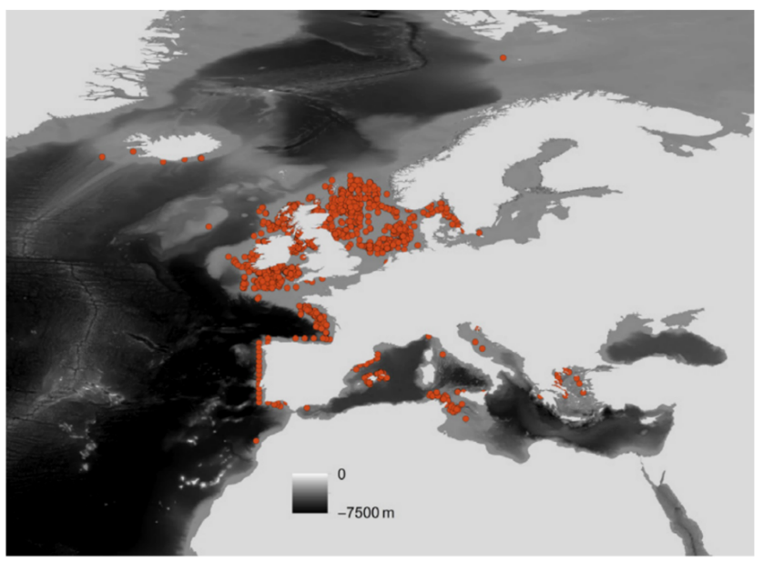
Figure 1.2 Species records for Nephrops norvegicus in the OBIS database. Source: Johnson et al. (2013).

Nephrops life cycle
The life cycle of Nephrops exhibits notable variations across its geographical range. In areas such as the Clyde Sea Area (CSA), the Mediterranean, the Iberian Peninsula, the Bay of Biscay, the Irish Sea, and the majority of the North Sea, populations adhere to an annual breeding cycle. Key events in the reproductive cycle of female Nephrops are outlined in Table 1.1. However, in regions around Iceland and the Faroe Islands, where water temperatures are lower, Nephrops populations follow a biennial breeding cycle (Bell et al., 2013). Lower temperatures result in a significantly longer incubation period, leading to a delay in the hatching season, which overlaps with the spawning season. As a result, females inhabiting colder regions are unable to complete the reproductive cycle within a single year.
Nephrops reaches sexual maturity between 2 to 3 years of age. Size at onset of sexual maturity (SOM) can be reached by males, typically measuring ≥29 mm in carapace length, as well as females with a carapace length of approximately ≥26 mm (Queirós et al., 2013; Tuck et al., 2000; Watts et al., 2016). During late spring, sexually mature individuals undergo moulting, followed by mating shortly after the moulting process (Farmer, 1974). Copulation typically takes place at night, within 24 to 48 hours after the female's moulting. Sperm are shed along with the cuticle of the spermatheca during moulting. Consequently, females need to engage in re-mating with each ovarian cycle (Becker et al., 2020). Fertilized eggs are carried by the female on her abdomen for a period of 8 to 9 months until they hatch the following year. The specific process of fertilization in Nephrops has not been extensively studied; however, it occurs externally in a similar manner to Homarus americanus H. Milne Edwards, 1837 (Becker et al., 2020). It has been observed that multiple paternity can occur, particularly in highly exploited populations (Becker et al., 2020). During the embryonic development phase, females tend to remain within their burrows. Shortly after releasing their eggs, females moult and mate, marking the initiation of a new reproductive cycle.
After hatching, newly born larvae, known as zoea, spend several weeks as planktonic drifters, progressing through three larval stages before undergoing metamorphosis into benthic post larvae (Powell and Eriksson, 2013), as depicted in Figure 1.3. The pelagic stages of Nephrops larvae, specifically stages I to III, have a duration of around 50 days, which can vary depending on the temperature conditions (de Figueiredo and Vilela, 1972; Dickey-Collas et al., 2000; Johnson and Johnson, 2013). Larvae that are dispersed to unsuitable sediment patches are unable to reach adulthood. On the other hand, individuals that disperse to suitable Nephrops habitats encounter various density-dependent factors, including direct competition for space and cannibalism. However, those individuals who manage to survive and successfully transition into adulthood adopt a relatively sedentary lifestyle.
Table 1.1 Diagram showing the timing of key events in the reproductive cycle of female Nephrops in the Clyde Sea Area (CSA) (adapted from (Smith, 2021)).

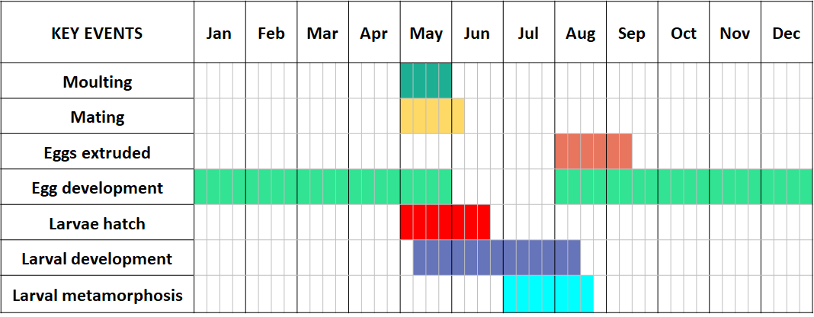
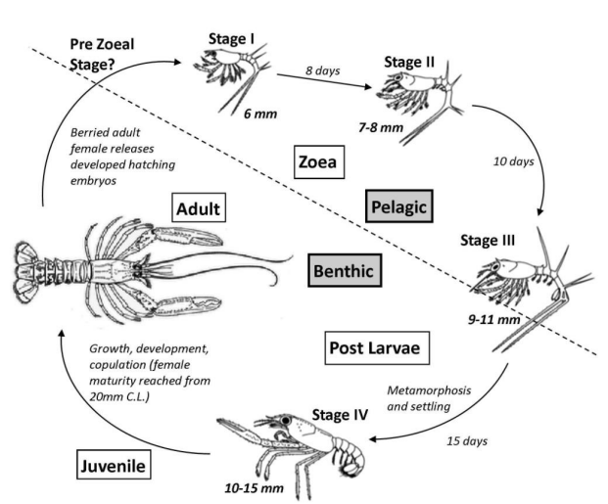
Figure 1.3 Life cycle of Nephrops norvegicus. Source: Powell and Eriksson (2013) after (Santucci, 1926).

Feeding ecology
The feeding ecology of Nephrops norvegicus is linked to its biological rhythms, encompassing behavioural and physiological patterns influenced by various factors such as environmental conditions and its own activity cycle (Aguzzi et al., 2004a; Aguzzi and Sardà, 2008). This opportunistic predator or scavenger exhibits non-selective and euryphagous feeding habits (Cristo and Cartes, 1998), with a diverse diet including other crustaceans, fish, and molluscs (Bell et al., 2013). Recent DNA metabarcoding studies have revealed that Dinoflagellata, Chlorophyta, and Bacillariophyta constitute nearly 50% of the identified prey items, indicating a strong association with suspension feeding. Additionally, the detection of fish species with high fisheries discard rates suggests a significant reliance on active foraging strategies (Shum et al., 2023).The photoperiod directly modulates emergence duration, likely synergizing with seasonal changes in food inputs driven by fluctuations in primary production (Heussner et al., 2006; Rotllant et al., 2014). Nephrops alter their feeding patterns in response to light levels, with increased foraging at dawn and dusk (Power et al., 2019). Larger individuals emerge more frequently, presumably due to higher food requirements and better defence against predators (Bell et al., 2013). Abiotic factors such as tidal movements and cloud cover also play a role in influencing emergence patterns (Bell et al., 2013).
Sex-related differences in emergence rhythmicity impact the catchability of ovigerous or berried females, particularly during egg-carrying seasons (Poulsen, 1946; Sardà, 1995; Thomas and Figueiredo, 1965). Ovigerous females tend to remain inside their burrows, protecting their offspring (Aguzzi et al., 2023), and forage less, providing natural protection against trawlers. As a result, male Nephrops dominate trawler catches for the majority of the year and experience greater exploitation compared to females (Bell et al., 2013). Nephrops actively protects near-burrow areas from intruding conspecifics. Territorial behaviour in Nephrops, influenced by high-density areas, significantly impacts feeding opportunities near burrows, with the distance from the burrow to the food source being a crucial determinant in feeding behaviour (Aguzzi et al., 2004a; Santana et al., 2020; Shum et al., 2023). Norway lobsters rely on both physical combat and urinary chemo signals to navigate dominance relationships. Dominant males emit urine during fights, which subordinates detect and use to adjust their behaviour, promoting more peaceful resolution in repeated encounters (Katoh et al., 2008).

Moulting
The moult cycle, which governs the life of crustaceans, involves a series of changes in both physiology and behaviour that enable their growth (Castro et al., 2003). In a study by Philp and Marteinsdottír (2013) focused on Nephrops, the moulting process was examined in detail. The process of moulting involves two primary factors: the increase in size known as moult increment, and the length of time between consecutive moults, referred to as the intermoult period. Temperature, light, and to some extent, salinity are the main factors influencing the frequency of moulting (Farmer, 1973). The moulting, mating, and burrowing behaviours of Nephrops are closely interconnected. There is a noticeable peak in female emergence between March and July. During this period, females emerge from their burrows to engage in activities such as feeding, moulting, and mating after the completion of the egg-brooding period (Milligan et al., 2013). Adult male Nephrops typically moult once or twice a year, usually in late winter or spring. Recently moulted males can be found throughout the year, indicating that the moulting season in males is less synchronous than in females (Milligan et al., 2013).

Nephrops Fishery
Nephrops are subject to extensive fishing efforts across their geographical distribution. Fisheries targeting Nephrops can be found in various regions, including the North Sea, the Irish Sea, the Mediterranean, the Bay of Biscay, the Skagerrak, and the Kattegat (Bell et al., 2013). One notable fishing ground is located in the Clyde Sea Area (CSA) on the western coast of Scotland. Nephrops captured from the CSA contribute approximately 20% of the total catch in Scotland and over 7% of the overall European catch (McIntyre et al., 2012).
The CSA, encompasses an approximate area of 3600 km² (McIntyre et al., 2012). This region comprises the Firth of Clyde, the Clyde Estuary, and various fjordic sea lochs. The boundary of the CSA extends from the Mull of Kintyre to Corsewall Point, as depicted in Figure 1.4. The CSA is characterised by a diverse range of habitats that provide a suitable environment for a wide array of animal species. Notably, populations of megafauna such as seals, dolphins, whales, and basking sharks are found in this area. Many of these species and habitats hold national or international significance and are protected under legislation aimed at conserving marine biodiversity (McIntyre et al., 2012).
The primary method of capturing Nephrops is through trawlers (Marine Scotland, 2020). However, creel fisheries using baited traps also play a significant role, particularly along the west coast of Scotland. In the CSA, creeling is limited to the upper sea-lochs of the CSA, and as a result, creel-caught Nephrops constitute only a small fraction of the overall catch, amounting to less than 5% (Beevers, 2010). In 2023, Scottish vessels landed approximately 20,515 tonnes of Nephrops, generating a total revenue of £80.7 million. Trawling accounted for the majority of the catch, with 19,000 tonnes valued at £64 million, while creeling contributed 1,474 tonnes, amounting to £16 million.
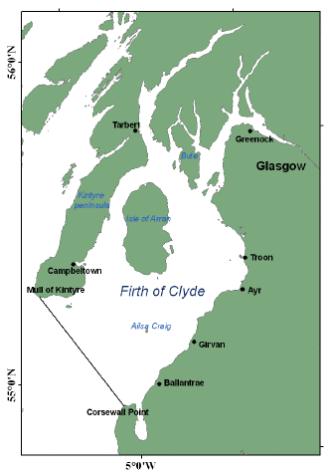
Figure 1.4 Map of the Clyde Sea Area (CSA) on the west coast of Scotland. The boundary of the CSA is depicted by a black line running from the southern end of the Mull of Kintyre to Corsewall Point. Source: Scottish Government (2021).

In the past, the CSA has played a significant role in sustaining important fisheries, such as herring, haddock, and cod. However, since 1990s there has been a significant shift in the species composition of the catch. The decline in landings of demersal species like haddock, cod, saithe, and whiting in the CSA, as illustrated in Figure 1.5, has been attributed to overfishing. This overfishing transformed the CSA into what was described as a "marine desert" by Howarth et al. (2014). However, the overall biomass of fish in the CSA has remained relatively stable over time (McIntyre et al., 2012). Nonetheless, overfishing has resulted in a significant decrease in the average size of demersal fish (Heath and Speirs, 2012; Hunter et al., 2016; Molfese et al., 2014). Consequently, the demersal fish stocks in the CSA are presently unable to sustain commercial catches due to the scarcity of large marketable individuals within the population. Furthermore, the decline in the size of these large predatory species may have also reduced their influence as predators over Nephrops populations.

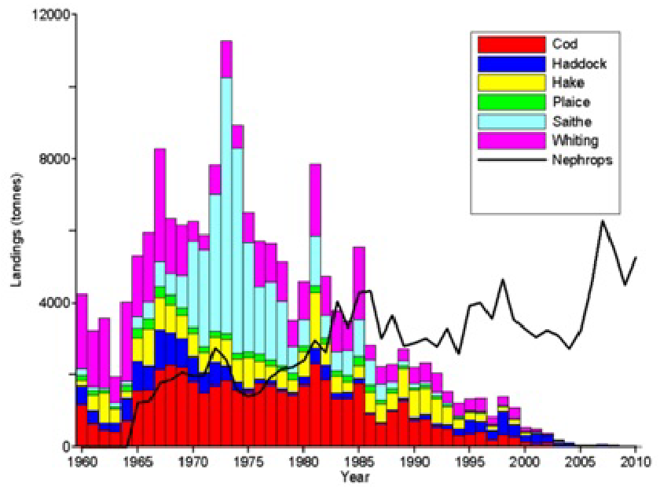
Figure 1.5 Landings of the main demersal fish species and Nephrops in the CSA since 1960. Source: McIntyre et al. (2012).
A noticeable decline in landings of larger predatory fish species has coincided with a consistent increase in landings of Nephrops and other shellfish species. This shift in targeted species is a common pattern observed in heavily exploited marine ecosystems (Howarth et al., 2014). Presently, Nephrops has become the most valuable species landed in Scotland, with the CSA contributing to approximately 84% of the total weight and 87% of the total value (Howarth et al., 2014). The remaining percentage comprises other invertebrates like scallops, crabs, and lobsters. Since 2003, the only demersal fish landings in the CSA have been incidental catches from the Nephrops fishery (Heath and Speirs, 2012).
Recent studies highlight the continued ecological significance and management challenges in the Clyde Sea Area (CSA). Stewart et al. (2020) discussed the historical degradation of benthic habitats due to intensive bottom trawling and scallop dredging, emphasizing the need for spatial protection to support demersal fish recovery. Lawrence and Fernandes (2021) further documented limited recovery in the size and age structure of key demersal species, such as cod and haddock, despite reduced fishing pressure, suggesting that ecosystem resilience remains constrained by habitat quality and historical overexploitation. Complementing these findings, Coram et al. (2022) evaluated community-led marine protection efforts, including no-take zones and locally managed areas, demonstrating their potential to enhance biodiversity and rebuild ecological functions within the CSA. Together, these studies reaffirm the ecological importance of the CSA while advocating for more ambitious, ecosystem-based management strategies.

Hematodinium
Hematodinium is an endoparasitic dinoflagellate that belongs to the family Syndiniceae, order Syndinida, and class Dinophyceae. Dinoflagellates are a diverse group of mostly marine, single-celled protists, typically characterized by two flagella and complex cell coverings. While many are free-living and contribute to primary production in marine ecosystems, others, like Hematodinium, are parasitic. Hematodinium is exclusively found infecting marine crustaceans (Shields, 1994). The discovery of Hematodinium was firstly reported by Chatton and Poisson (1930), who described its presence in green shore crabs (Carcinus maenas) and harbour crabs (Liocarcinus depurator) along the coasts of Normandy and France. Since then, similar Hematodinium spp. parasites have been identified in over 40 crustacean species, both commercially and non-commercially important, across various regions worldwide (see Figure 1.6) (Li et al., 2021a; Stentiford and Shields, 2005).
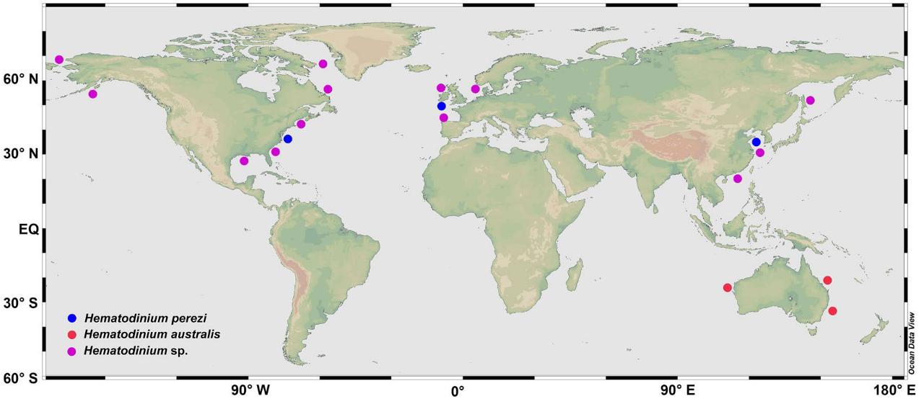
Figure 1.6 The global distribution and diversity of the parasitic dinoflagellate Hematodinium. Note blue dots (Hematodinium perezi); red dots (Hematodinium australis); pink dots (other unclassified Hematodinium species). Source: Li et al. (2021a).

Genetic diversity of Hematodinium
At present, there are only two defined species of this genus: Hematodinium perezi and Hematodinium australis and one undefined species (Hematodinium sp.) (Li et al., 2021a). The species “australis” is distinguished from its counterparts by distinct morphological traits—such as a larger trophont and ovoid plasmodium—as well as by its geographic isolation, being primarily found in Australian waters. In contrast, other species like H. perezi have a broader global distribution (Hudson and Shields, 1994) (see Figure 1.6). Host species that are commonly affected by Hematodinium include various crab species, such as snow crabs (Chionoecetes opilio), blue crabs (Callinectes sapidus), and king crabs (Paralithodes spp.). For H.perezi, at least three genotypes (I, II, III) have been identified based on the ITS1 sequences (Small, 2012). Genotype I was found to infect harbour crab (Liocarcinus depurator) in the English Channel, Genotype II reported in Chinese swimming crab (Portunus trituberculatus) and mud crab (Scylla paramamosain) of the east coast of China (Li et al., 2013; Small, 2012; Xu et al., 2010), and Genotype III reported in blue crab (Callinectes sapidus) and other crustacean hosts in the east coast of the U.S. (Pagenkopp Lohan et al., 2012). Xiao et al. (2016) reported a novel strain of H. perezi in ridgetail white prawns (Exopalaemon carinicauda) from Zhejiang province, which diverged from the three known genotypes. This study also revealed the presence of up to 8 ITS haplotypes within populations of H. perezi (genotype II) along the coast of China.
Crustaceans residing in deep, stenohaline waters, such as snow crab (Chionoecetes opilio), tanner crab (Chionoecetes bairdi), grooved tanner crab (Chionoecetes tanneri) and Norway lobsters (Nephrops norvegicus), are infected by yet another genotype of Hematodinium distinct from H. perezi and H. australis (Hanif et al., 2013; Jensen et al., 2010) (see Figure 1.6). This species, however, is yet to be formally identified and is therefore referred to as Hematodinium sp.
The genetic diversity and detailed genetic variation within Hematodinium sp. are not yet fully understood. Molecular studies of ITS1 region sequences from Hematodinium sp. infecting Norway lobsters (Nephrops norvegicus), edible crabs (Cancer pagurus), hermit crabs (Pagurus bernhardus), and snow crabs (Chionoecetes opilio) suggest that these hosts are all infected by the same species of Hematodinium sp. (Small et al., 2007b).
Various authors have suggested intra-host genotypic diversity, indicating the presence of multiple genetic types or phylogroups of Hematodinium sp. in an individual host animal (Eigemann et al., 2010; Jensen et al., 2010; Pagenkopp Lohan et al., 2014; Small et al., 2007b; Xiao et al., 2016). This suggests that multiple species or strains of the parasite could be infecting the same host.
Varying degrees of host specificity have also been suggested by Hamilton et al. (2010), who found that different Hematodinium ribotypes or clades infect distinct host species based on analyses of internal transcribed spacers.
Subsequent studies have suggested genetic mixing and the occurrence of sexual reproduction in H. perezi (III), although the specific locations and timing of sexual reproduction within the parasite's life cycle are still unknown. Sexual reproduction is believed to occur in most free-living dinoflagellates (Pagenkopp Lohan et al., 2014) and has been associated with environmental stress (Lee et al., 2021; Lin et al., 2022).
With the expansion of crustacean aquaculture, the emergence of new species or strains of pathogens is anticipated (Stentiford and Shields, 2005). A recent study conducted in China identified five new host species for H. perezi in polyculture ponds (Huang et al., 2021). These newly identified hosts include mudflat crab (Helice tientsinensis), fiddler Crab (Uca arcuate), Japanese shore crab (Hemigrapsus penicillatus), Chinese crab (Helice wuana), and Japanese mud crab (Macrophthalmus japonica) (Huang et al., 2019; Li et al., 2021b). The most recently updated list of Hematodinium hosts can be found in the review by Alimin et al. (2023).

Description of the parasite Hematodinium.
Species within the genus Hematodinium sp. possess characteristic features typical of dinoflagellates, including a dinokaryon structure, a pellicle, naked gymnodinoid, athecate dinospores, and dinomitosis (unique mitosis) (Stentiford and Shields, 2005). However, unlike other planktonic dinoflagellates, the parasitic Hematodinium sp. primarily resides within the haemolymph or haemocoel of affected organs and tissues. Throughout its life cycle, Hematodinium sp. exhibits various shapes, with the ameboid trophonts (vegetative stage) being the most observed stage within the haemolymph of infected organisms (Appleton and Vickerman, 1998; Stentiford et al., 2003). Within the haemolymph, the parasite undergoes multiplication until the cell density reaches a critical point that triggers the production of dinospores (see section 1.3.3.1). The high concentration of parasitic cells in the haemolymph leads to the milky-white appearance of the haemolymph (Field et al., 1992). The exact cause of spore release remains unclear; it is speculated that spores may be released in response to the accumulation of toxic metabolites in the host's haemocoel, high parasite densities or when host reserves have been severely depleted (Appleton and Vickerman, 1998; Beevers, 2010). While not confirmed, a molecular examination of Hematodinium sp. suggested that the moulting hormone methyl farnesoate (MF) may play a role in parasite proliferation (Gornik et al., 2015). Due to the absence of an essential isoprenoid pathway (DOXP pathway), Hematodinium sp. was suggested to rely on scavenging isoprenoids directly from the host's haemolymph, with the likely source being the moult hormone methyl farnesoate. Following sporulation events, only a few parasite cells typically remain within the host (Appleton and Vickerman, 1998).

Life cycle of Hematodinium
Hematodinium spp. exhibit complex life cycle, and the current understanding primarily stems from in vitro cultures. The initial successful cultivation of the parasite in vitro was achieved by Appleton and Vickerman (1998). In-vitro, Hematodinium sp. undergoes a distinctive developmental cycle characterized by alternating trophonts and sporont stages, as illustrated in Figure 1.7 and Figure 1.8. To summarize, dinospores develop into filamentous trophonts, which further differentiate into "gorgonlocks," filamentous colonies. These gorgonlocks colonies then attach to a substrate and develop into a "clump" colony. Subsequently, these colonies progress into "arachnoid" trophonts, leading to growth and sporogony, resulting in the production of sporoblasts. These sporoblasts develop into either macro-dinospores or micro-dinospores, initiating a new cycle (Appleton and Vickerman, 1998).
Sporogenesis occurs synchronously, leading to the release of spores through the gills (Appleton and Vickerman, 1998). In vitro, circulating sporoblasts give rise to dinospores over a period of days to weeks. Sporoblasts undergo fission, often forming spherical masses of multinucleate cells that eventually break up, releasing spore mother cells. Each spore mother cell is capable of producing four or more flagellated dinospores (Appleton and Vickerman, 1998). Alternatively, sporoblasts generate a branched network of filaments with scattered nuclei along their length, firmly attached to the substratum (see Figure 1.7). These attached syncytia are known as secondary sporonts (Appleton and Vickerman, 1998).
Currently, there is a scarcity of information regarding the natural life cycle of the parasite. While some of the morphological forms observed in vitro resemble those described in vivo (Figure 1.7 and Figure 1.8), it cannot be fully excluded that some structures may represent artefacts resulting from culture conditions. The involvement of an alternate or reservoir host in the life cycle remains uncertain (Pagenkopp Lohan et al., 2012).
Figure 1.7 Developmental cycle of in vitro-cultured Hematodinium sp. derived from Nephrops norvegicus. Adapted from Appleton and Vickerman (1998). Artist: Pont-Trullen, I.
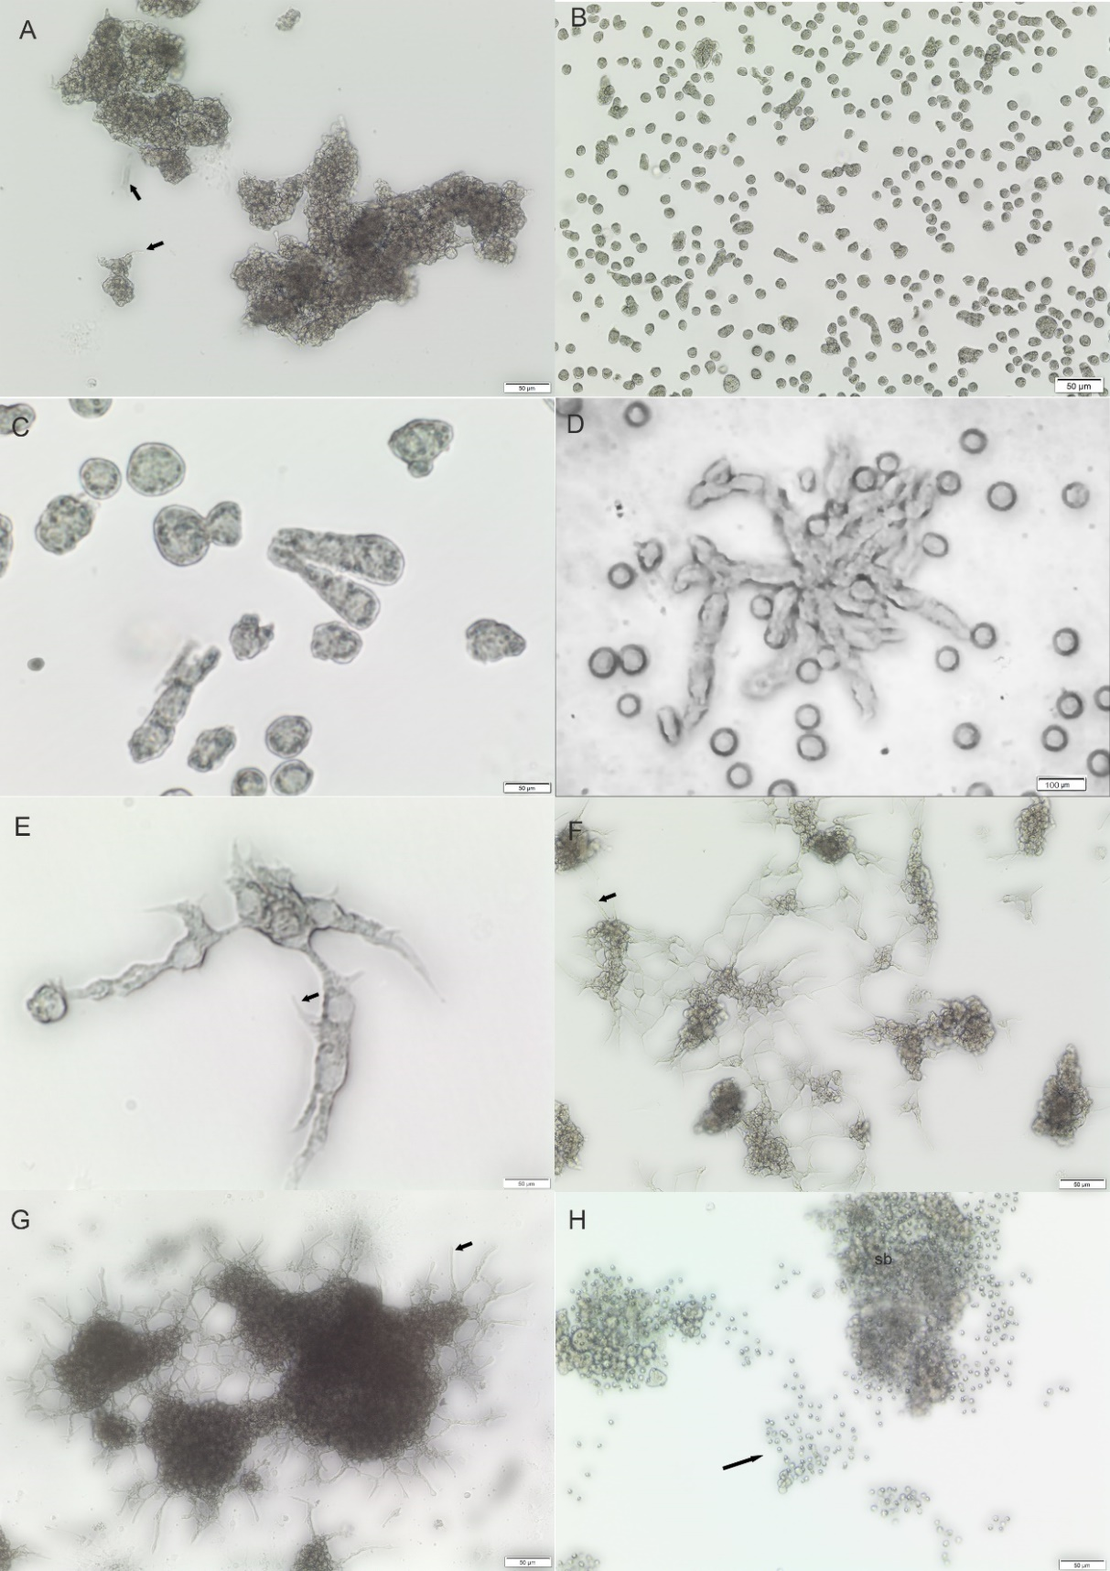
Figure 1.8 Morphological observation of the in vitro life stages of Hematodinium sp. isolated from Nephrops norvegicus A) Clump colony; B) Ameboid/ filamentous trophonts; C) Ameboid/ filamentous trophonts dividing by dinomitosis; D) Gorgonlock trophont colony; E) substrate adhesion of ameboid trophont F) arachnoid trophont; G) arachnoid sporont; H) sporoblast (sb) releasing microspore-like structures (black arrows). Author: Martín, I.

Dinospores
Depending on their size, dinospores can be categorized as macrospores (16-20 μm in length) or microspores (11-14 μm in length), with microspores exhibiting faster swimming speeds compared to macrospores (Appleton and Vickerman, 1998). Dinospores are flagellated and contain a single nucleus (refer to Figure 1.9). Both types of spores possess two flagella (longitudinal and transverse) and exhibit a corkscrew swimming pattern similar to that observed in free-living dinoflagellate species (Appleton, 1996; Beevers, 2010). Macrospores and microspores have the ability to survive outside the host, approximately 73 days and 52 days respectively (Meyers et al., 1987). Appleton and Vickerman (1998) reported a survival rate of 58 days for microspores and 90 days for macrospores. During this period, dinospores are thought to act as infective stages (Frischer et al., 2006; Li et al., 2010). Hematodinium sp. dinospores are released from heavily infected host through the gills in a mass sporulation event (Appleton, 1996; Beevers, 2010; Frischer et al., 2006; Huchin-Mian et al., 2018; Li et al., 2010; Love et al., 1993; Meyers et al., 1987; Shields and Squyars, 2000; Stentiford et al., 2002), resulting in high dinospore densities (approximately 1.6 x 10⁸ in blue crabs) (Shields and Squyars, 2000; Wheeler et al., 2007) (refer to Figure 1.9).
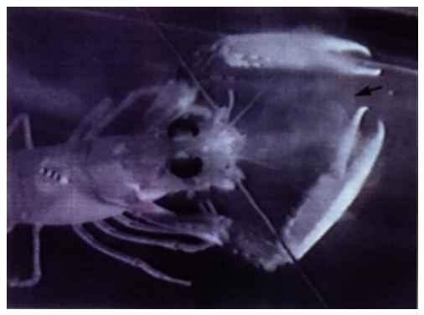
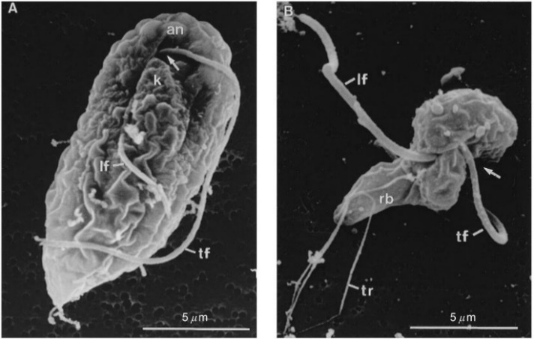
Figure 1.9 Mature (4-day-old) dinospores from primary in vitro cultures. Scanning electron microscopy. (A) Macrospore (B) Microspore C) Image of spores being released from a heavily infected Nephrops norvegicus during sporulation (black arrow highlights spore cloud). Source: Appleton and Vickerman (1998) and (Appleton, 1996).

Appleton and Vickerman (1996) proposed different roles for the two spore phenotypes, suggesting that microspores are more immediately infective and have a greater dispersion capability due to their faster swimming speed. In contrast, macrospores serve as resting stages in the sediment, which constitutes the habitat of Nephrops. The factors responsible for determining the production of specific spore phenotypes are still uncertain. However, it has been observed that macrospores are the prevailing phenotype in Nephrops, whereas microspores are more frequently found in tanner crab (Chionoecetes bairdi) (Love et al., 1993). Figure 1.10 illustrates microspores and macrospores produced in vitro (Appleton and Vickerman, 1998), and Figure 1.11 shows naturally sporulated macrospores and microspores in vivo (Beevers, 2010).

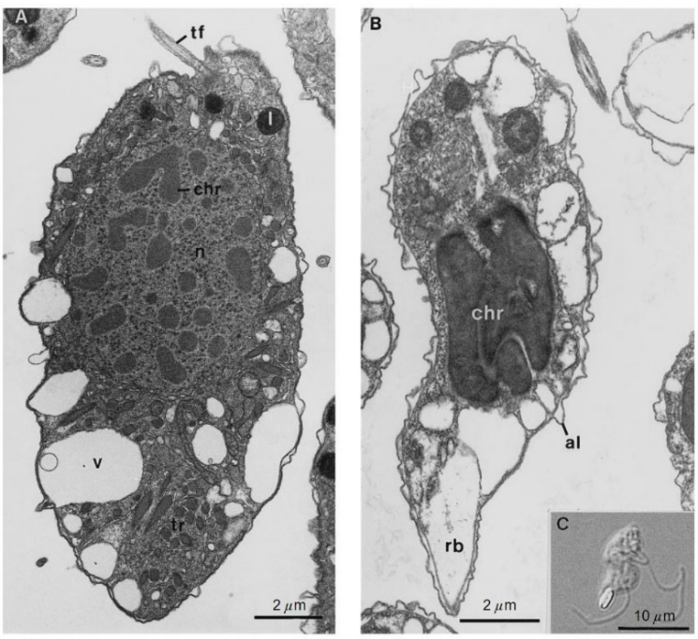
Figure 1.10 Mature (4-day-old) dinospores from primary in vitro cultures: Ultrastructural Insights. (A and B) Transmission Electron Microscopy Longitudinal Sections. (A) Macrospore: Notice the transverse flagellum base (tf), distanced from the condensed chromosome-bearing nucleus (n). Abundant cytoplasmic components include lipid droplets (l), peripheral vacuoles (v), and trichocysts (tr). (B) Microspore: The nucleus is entirely filled with condensed chromosomes (chr), with corrugation on the dinospore surface due to swollen alveoli (al). The refractile body (rb) within the posterior vacuole is not distinctly visible. (C) Enhanced Visualization: Refractile body (rb) a cytoplasmic inclusion clearly discernible in this light micrograph of a glutaraldehyde-fixed microspore, 3 weeks after sporogenesis. Differential Interference Contrast. Source: Appleton and Vickerman (1998).
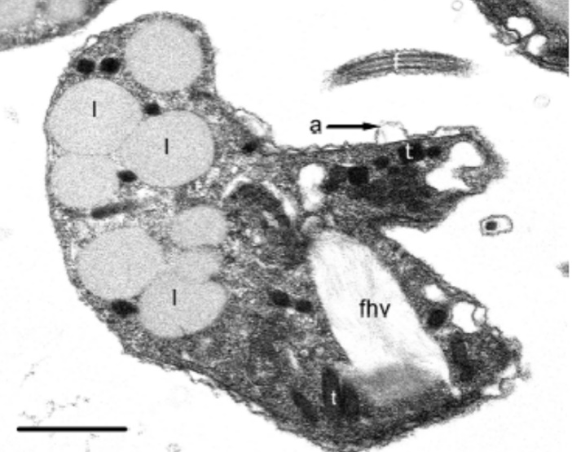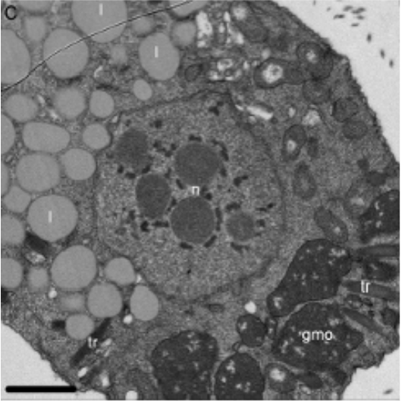
B
A
Figure 1.11 Ultrastructural features of freshly sporulated dinospores: Microscopic Insights. (A) Longitudinal section of freshly sporulated microspore. Annotated features include a flagellum (f), amphiesmal alveoli (arrow) (a), lipid globules (l), flagellar hair vesicle (fhv), internal trichocysts, and vacuoles (va). Captured through Transmission Electron Micrograph. (B) Transverse section of macrospore. Annotated features include the nucleus (n), lipid globules (l), a granular matrix organelle (gmo), and an internal trichocyst (t). Examined via Transmission Electron Micrograph. Scale bar: 1 µm. Source: Beevers (2010).

Hematodinium transmission
The transmission pathways of Hematodinium spp. remain unclear, but waterborne transmission is considered the most probable route (Huang et al., 2021; Li et al., 2011; Stentiford and Shields, 2005). Dinospores are believed to act as infective stages in the water column (Frischer et al., 2006; Pagenkopp Lohan et al., 2012). They can enter Nephrops either through the gills or via breaks in the integument (Hanif et al., 2013). Another possible entry point for dinospores is through the softened exoskeleton of recently moulted individuals (Pagenkopp Lohan et al., 2012). Seasonal patterns of Hematodinium sp. outbreaks suggest that this is the most likely source of parasite transmission.
Both macro and micro-dinospores of Hematodinium sp. can cause infection when inoculated into tanner crab (Chionoecetes bairdi) (Eaton et al., 1991; Shields et al., 2017). H. perezi was transmitted naturally to juvenile Atlantic blue crab (Callinectes sapidus) by "sentinel" deployments in endemic areas of the parasite. Other potential transmission routes include passive ingestion of dinospores through suspension-feeding (Briggs and McAliskey, 2002) or direct ingestion of infected individuals (Shields, 1994). Some experiments have successfully shown that the consumption of infected tissue can transmit the disease, at least in green shore crab (Carcinus maenas) (Sheppard et al., 2003; Walker et al., 2009). However, other studies have failed to confirm this as a transmission pathway (Butler et al., 2014; Li et al., 2011). Alternate hosts may play a significant role in transmitting the parasite by acting as a reservoir and a source of Hematodinium. Consequently, the alternative hosts may be accountable for harbouring the disease when the prevalence of Hematodinium sp. in Nephrops is at its lowest (Hamilton et al., 2011).

Hematodinium diagnosis in Nephrops
Different diagnostic techniques are employed to detect Hematodinium sp. in Nephrops, and each method has its own specific detection threshold, as presented in Table 1.2.

Table 1.2 The detection thresholds (number of parasites per mL of haemolymph) of the main tests used to diagnose Hematodinium infection in Nephrops.
Method | Detection Threshold | Reference
Body-colour | 5 x10⁷ | (Field, 1992)
Pleopod-S4 | 8 x10⁷ | (Appleton, 1996)
Pleopod-S3 | 5.2 x10⁷ | (Appleton, 1996)
Pleopod-S2 | 1.4 x10⁷ | (Appleton, 1996)
Pleopod-S1 | 2.4 x10⁶ | (Appleton, 1996)
Western blot Immunoassay | 2 x10⁵ | (Stentiford et al., 2001d)
Enzyme-Linked Immunosorbent Assay (ELISA) | 5 x10⁴ | (Small et al., 2002)
Polymerase Chain Reaction (PCR) | 3 x10 | (Gruebl et al., 2002)
PCR | 3 x10⁴ | (Beevers, 2010)
PCR | 1 parasite in 300,000 hemocytes | (Small et al., 2007a)
Quantitative PCR (qPCR) | 13 gene copies per reaction | (Hanif et al., 2013)
qPCR | 10 copies of 18S rRNA gene per reaction | (Nagle et al., 2009)
Immunofluorescence Assay (IFA) and Western blot | 2.5 x10¹ | (Gornik et al., 2013)

Body-colour method
The examination of body coloration is a quick field method to assess Hematodinium sp. infection in Nephrops. Heavily infected individuals exhibit an unusual yellow/orange body colour, as depicted in Figure 1.12. Additionally, infected animals may display decolouration or pigment loss in their extremities and opacity of the musculature between the arm joints. This body-colour assessment method was initially introduced by Field (1992). However, visual assessment under-reports 48%-50% of infections (Stentiford et al., 2001a) as it can only identify infections in individuals with a parasite load of 5.2∙10⁷ parasites per mL of haemolymph or above.
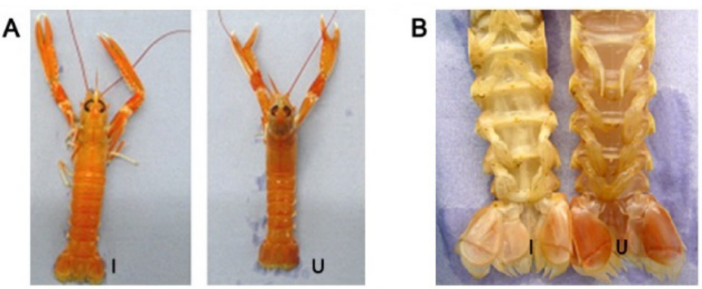
Figure 1.12 Dorsal (A) and ventral (B) view of uninfected Nephrops (U) and infected Nephrops (I) from the CSA. Source: Beevers (2010).

Pleopod method
The pleopod method, described by Field and Appleton (1995), utilizes low-power microscopy to assess Hematodinium sp. infection. This technique involves examining the degree of parasite aggregation beneath the cuticle of the pleopods. Infection severity is scored on a five-point scale (0 = uninfected; 1-4 = infected), as illustrated in Figure 1.13. The pleopod method has proven to be useful for monitoring infection progression and assessing prevalence (Beevers, 2010; Field, 1992; Stentiford, 2000). However, this method is partly subjective, particularly for cases of light infections and it can only identify infections in individuals with a parasite load of 2.4∙10⁶ parasites per mL of haemolymph and above.
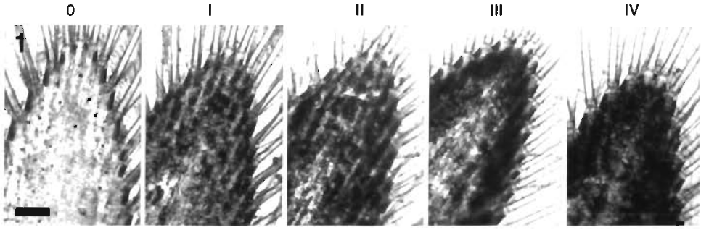
Figure 1.13 Hematodinium infection severity categorized on a five-point scale using the pleopod method. Bar = 0.5 mm. Source: Field and Appleton (1995).

Polymerase chain reaction (PCR) and real-time quantitative polymerase chain reaction (RT-qPCR)
Polymerase chain reaction (PCR) is widely employed for the molecular detection of Hematodinium. Multiple primer sets have been designed for Hematodinium spp. detection (Frischer et al., 2006; Gruebl et al., 2002; Hamilton et al., 2010; Hamilton et al., 2009; Hamilton et al., 2011; Hanif et al., 2013; Hudson and Adlard, 1995; Jensen et al., 2010; Li et al., 2010; Small et al., 2006). These primers typically target a partial sequence of the 18S gene within the ribosomal RNA (rRNA) gene complex, as well as the ITS1 sequence located 256 to 277 base pairs downstream of the 18S/ITS1 boundary (Beevers, 2010). The real-time quantitative polymerase chain reaction (RT-qPCR) assay, employing either the Hematodinium sp. 18S rRNA gene (Frischer et al., 2006; Nagle et al., 2009), or the ITS2 (Hanif et al., 2013), has proven effective in detecting Hematodinium, offering exceptional sensitivity and a quantitative measure of infection. Despite its advantages, reported instances of qPCR inhibition and specificity issues, particularly with the 18S region, warrant consideration (Hanif et al., 2013). On the other hand, primer design based on the small subunit rRNA gene lacked the necessary species specificity to differentiate non-Hematodinium sp. dinoflagellate species in environmental samples (Li et al., 2010; Small et al., 2007a) .

Histology, electron microscopy and smears
Traditional methods for detecting Hematodinium infections in crustaceans include histological examination, electron microscopy, and haemolymph smears (Appleton, 1996; Davies et al., 2022; Nagle et al., 2009; Pestal et al., 2003; Shields et al., 2015; Small et al., 2007a). Histology involves analysing tissue sections—such as gills, hepatopancreas, and heart—stained with dyes like Haematoxylin and Eosin to identify parasite stages and assess tissue damage. While this method provides comprehensive insights, it may not detect early or low-intensity infections and requires sacrificing the host. Notably, some studies have reported that histology can be more sensitive than PCR in detecting Hematodinium infections in hemolymph (Davies et al., 2022; Hamilton et al., 2007). Electron microscopy offers detailed imagery crucial for confirming the parasite's identity and understanding its developmental stages; however, it is resource-intensive and necessitates specialized equipment and expertise, limiting its routine diagnostic application. Conversely, haemolymph smears are non-destructive; they involve spreading a drop of haemolymph on a slide, staining it (e.g., with neutral red), and examining it under a microscope to detect Hematodinium cells. ​This technique allows for rapid, cost-effective screening suitable for field studies; however, its accuracy depends on the examiner's expertise and may be less effective in identifying low-level infections. Additionally, prompt processing of haemolymph samples is crucial to prevent clotting, which can hinder accurate examination. Studies have shown that haemolymph smears can provide diagnostic accuracy comparable to histology and PCR, though each method has its limitations (Ní Chualáin and Robinson, 2011; Stentiford and Shields, 2005).

Other methods
Additional diagnostic techniques that have the capability to detect low-level (sub-patent) Hematodinium sp. infections include western blot immunoassay (Gornik et al., 2013; Stentiford et al., 2001d), enzyme-linked immunosorbent assays (ELISA) (Small et al., 2002) and indirect fluorescent antibody technique (IFAT) (Field and Appleton, 1996; Gornik et al., 2013)

Infection dynamics of Hematodinium sp.
The presence of Hematodinium sp. in the CSA was first documented in the early 1980s, and a comprehensive study of this phenomenon was conducted by Field (1992). Following the initial report, extensive studies have been conducted (Beevers et al., 2012; Field and Appleton, 1996; Field et al., 1992; Field et al., 1998; Small, 2004; Stentiford et al., 2001a; Stentiford et al., 2001d), establishing the Clyde Sea Area as one of the best-studied Nephrops-Hematodinium pathosystems globally. Long-term monitoring of Nephrops has identified a peak in Hematodinium sp. patent infection prevalence during late winter and early spring, with minimal occurrences in summer and autumn, as depicted in Figure 1.14.
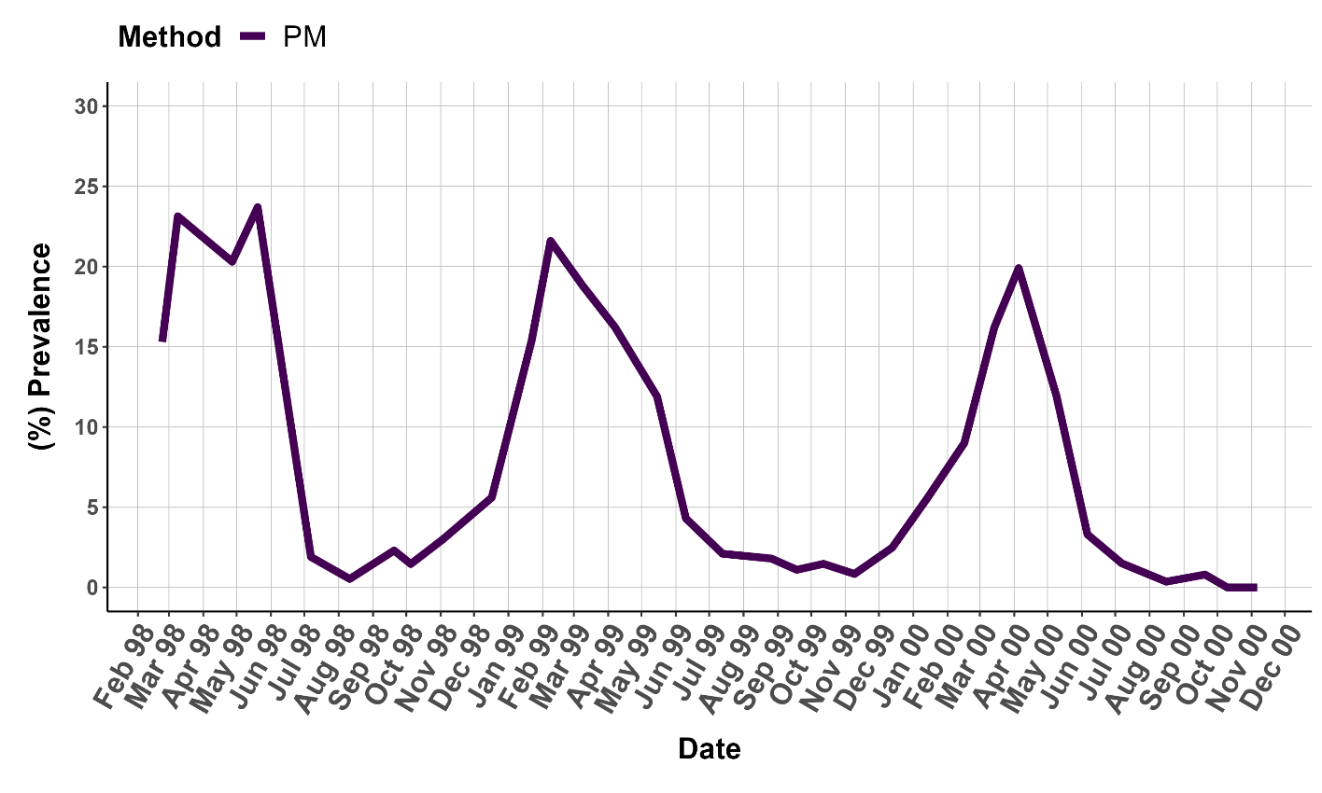
Figure 1.14 Nephrops captured near Little Cumbrae in the CSA from February 1998 to November 2000 as determined by pleopod method (PM). Adapted from Stentiford et al. (2001a).

In the same location, using a western blot immunoassay technique revealed a peak in sub-patent level infections during late autumn and winter (Stentiford et al., 2001d), as depicted in Figure 1.15. The amplitude of this sub-patent infection peak was comparable to the peak of patent infections observed in the following spring. These findings led researchers to conclude that infection, both sub-patent and patent, occurred within a single year (Stentiford et al., 2001d).
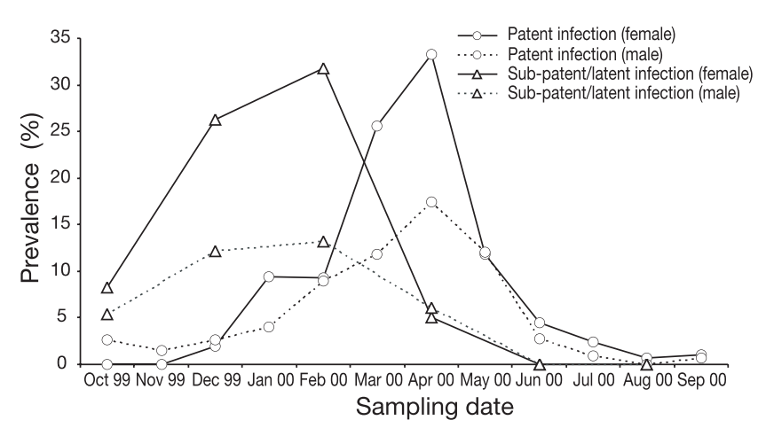
Figure 1.15 Prevalence of patent Hematodinium sp. infection (the percentage of individuals who were classified as positive by the pleopod method) and sub-patent Hematodinium sp. infection (the percentage of individuals who were classified as positive by the western blot immunoassay method but negative by the pleopod method). Source: Stentiford et al. (2001d)

Subsequent studies using PCR and ELISA diagnostic methods by Beevers (2010) revealed that Hematodinium sp. is present at sub-patent levels throughout the entire year, as depicted in Figure 1.16. Consequently, only the patent infection can be classified as a seasonal occurrence. The identification of sub-patent infection during late winter/early spring, coinciding with the peak prevalence of patent infections, challenges the prevailing notion that infection, sub-patent stages, and patent stages all happen within a single year. These observations raise the possibility that infections persist at low levels for an extended duration (>1 year) before manifesting as patent infections (Smith, 2021).
Hematodinium sp. prevalence in the CSA has not been monitored since the last study a decade ago (Beevers et al., 2012), highlighting the need for updated data.

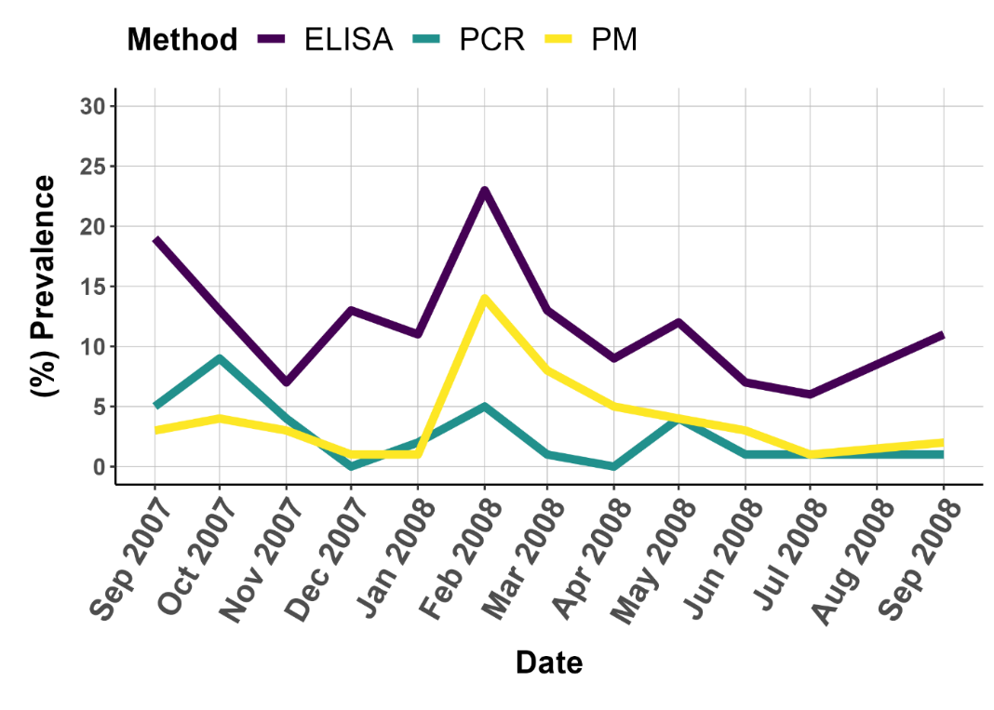
Figure 1.16 Prevalence of Hematodinium infection in the CSA as determined by PCR, ELISA and pleopod method (PM) of diagnosis. Adapted from: Beevers et al. (2012).

Effect of Hematodinium sp. in Nephrops norvegicus

Hematodinium pathology in Nephrops
Infection by Hematodinium sp. induces a range of physiological and pathological changes in the haemolymph and tissues in Nephrops. As the infection progresses, the number of circulating haemocytes decreases, and negative biochemical alterations occur in the haemolymph (Alimin et al., 2024; Field and Appleton, 1995; Shields and Squyars, 2000; Stentiford and Shields, 2005). Eventually, the haemolymph becomes densely populated with parasites, resulting in an elevated rate of oxygen demand, suppression of the haemolymph's oxygen-carrying capacity, and subsequent respiratory dysfunction (Shields et al., 2003; Taylor et al., 1996). Additionally, Hematodinium sp. infection affects carbohydrate, lipid, and amino acid metabolism (Shields et al., 2003). In advanced stages of the infection, parasites consume substantial amounts of nutrients from the host, resulting in significantly reduced glycogen levels in the muscle and hepatopancreas (Stentiford et al., 2001b; Stentiford et al., 2000b). Marine dinoflagellates, including Hematodinium sp., rely on lipids for essential functions. More generally, in dinoflagellates, lipids contribute to structural stability, metabolic activities, and adaptive functions (Aranda et al., 2016; Wisecaver and Hackett, 2011). Notably, lipid-like droplets in Hematodinium sp. spores suggest potential energy reserves during transition to seawater (Appleton, 1996; Meyers et al., 1987), and potential involvement in buoyancy. Furthermore, Beevers (2010) study on the fatty acid composition revealed remarkable similarities in the profiles of Hematodinium sp. macrospores and Nephrops hepatopancreas. This suggests a potential reliance of Hematodinium sp. on scavenging fatty acids from its host.

Histopathological examinations have revealed severe tissue alterations and the presence of Hematodinium sp. parasite cells obstructing haemal spaces (Field et al., 1995). Infected individuals also exhibit enlarged spacing between hepatopancreatic tubules compared to uninfected lobsters (Field and Appleton, 1995). In the gonads, infiltration of parasite cells in the ovaries' haemal spaces has been observed, resulting in the degradation and potential pressure necrosis of developing oocytes (Mouat, 2002). Hematodinium infection hinders ovarian development and maturation, possibly due to the breakdown of ovarian tissue caused by pressure necrosis and apoptosis (Briggs and McAliskey, 2002; Mouat, 2002). Infected females displayed undeveloped or resorbed ovaries, likely attributed to the nutritional constraints imposed by the parasite burden. In contrast, the testes exhibit less degradation despite the presence of parasites in the haemal spaces, with intact collecting tubules and visible sperm (Mouat, 2002).

Immune response to Hematodinium infection
The host's immune response to Hematodinium sp. infection remains a subject of study. Immunomodulatory effects were identified at both post-transcriptional and translational levels in haemocytes of the Chinese swimming crab (Portunus trituberculatus) upon H. perezi challenge (Li et al., 2022).
One study suggested the uptake of Hematodinium sp. by phagocytes in Norway lobster (Nephrops norvegicus) (Field and Appleton, 1995). However, as reviewed by Rowley et al. (2015) Hematodinium may have the capacity to evade the immune defences of the host. Observations on Hematodinium-infected green shore crabs (Carcinus maenas) revealed no signs of haemocyte reactivity towards infection, implying the absence of a cell-driven immune response at both early and advanced stages of infection (Davies et al., 2022).

Microbiome within the context of health and disease
The term 'microbiome' was coined in 1988 to describe the microbial associates of plants (Whipps et al., 1988). It refers to a distinct microbial community that inhabits a specific habitat with unique physiochemical properties (Berg et al., 2020). The study of the microbiome has since gained significant interest. The microbiome may play a crucial role in maintaining animal health, providing functions such as nutrient processing and protection against pathogens and diseases (Abt and Pamer, 2014; Belkaid and Timothy, 2014; Chow et al., 2010; Nyholm and Graf, 2012). Host-associated microbes, also known as symbionts, provide a form of defence for the host by directly and indirectly conferring resistance against invading pathogens (Abt and Pamer, 2014; Khan et al., 2021). These microbial communities have coevolved with their hosts, establishing a mutually beneficial relationship known as host-microbial symbiosis. Symbionts effectively outcompete pathogens by consuming essential nutrients and energy sources required for the pathogens to grow and establish themselves. Furthermore, symbionts can indirectly stimulate and enhance host immune cells, leading to the basal expression of host defence factors (Sassone-Corsi and Raffatellu, 2015), thus contributing to the development of both innate and adaptive immunity in the host (Thaiss et al., 2016; Zelante et al., 2013). Alternatively, symbionts can produce bioactive compounds, such as peptides, bacteriocins and microcin’s, or their precursors, which contribute to the host's defensive chemistry (Hammami et al., 2013; Rebuffat, 2012; Thaiss et al., 2016).

The microbiome of decapod crustaceans
The advancement of high-throughput sequencing has made studying the gut and haemolymph microbiota possible in decapod research. Numerous studies have focused on describing the gut microbiota of aquatic decapod crustacean species reared under various culture conditions (Chen et al., 2023; Foysal et al., 2022; Meziti et al., 2012). The gut microbiota, also known as the gut microbiome, refers to the microorganisms inhabiting the digestive tract and interacting with the host organism. The gut microbiome plays a crucial role in crustacean species, influencing digestion, nutrition, growth, reproduction, immune system function, and disease susceptibility (Diwan et al., 2022).
The microorganisms residing within the haemolymph are known as the haemolymph microbiota or haemolymph microbiome. Traditionally, the haemolymph of “healthy” invertebrates was considered to be sterile (Wang and Wang, 2015) .However, several studies have shown that crustacean haemolymph is not sterile and contains bacteria (Givens et al., 2013; Ooi, 2018; Ooi et al., 2019; Quinn et al., 2013; Zhang et al., 2020a). Bacteria in the haemolymph of spiny lobster (Panulirus ornatus) can enhance host health by regulating immune responses, producing antimicrobial agents, and outcompeting pathogens (Ooi et al., 2019). Soluble lectins, vital for immune recognition (Fredrick and Ravichandran, 2012; Ohtsubo and Marth, 2006), contribute to pathogen detection and perform functions like agglutination, opsonization, and gene expression modulation (Ahmmed et al., 2022; Liu et al., 2022; Sánchez-Salgado et al., 2017). These mechanisms are pivotal in suppressing haemolymph microbiota growth.
The haemolymph and gut microbiota in crustaceans are shaped by several factors. In the gut, diet primarily drives specific microbial growth (Cao et al., 2020; Foysal et al., 2020; Huang et al., 2020a; Huang et al., 2016; Shao et al., 2019; Zeng et al., 2017; Zhang et al., 2020b), alongside the influence of host genetics on colonization and immune interactions (Tzeng et al., 2015). Age (Fan et al., 2019; Ooi et al., 2017; Xiong et al., 2017a; Xiong et al., 2017b; Zhu et al., 2016) and environmental aspects like geography (Chen et al., 2017a), climate, and seasonality contribute to gut diversity. Habitat significantly impacts both gut and haemolymph microbes (Foysal, 2023; Holt et al., 2021; Holt et al., 2020; Lokmer and Mathias Wegner, 2014; Md Zoqratt et al., 2018; Ooi et al., 2019; Tubiash et al., 1975; Tzeng et al., 2015; Zhao et al., 2018). Within the haemolymph, antimicrobial peptides (AMPs) and lectins control the proliferation of haemolymph microbiota (González et al., 2020; Wang and Wang, 2015), while host stress, infection, and interactions with other organisms affect the composition of both the haemolymph and the gut (Hernández-Pérez et al., 2022; Liu et al., 2020a; Oetama et al., 2016). Environmental stress has the potential to disrupt intestinal barriers, compromise immune responses, and elevate the likelihood of pathogen infiltration (Duan et al., 2019; Hsiao et al., 2013; Li and Chen, 2008; Wang et al., 2019; Yu et al., 2020). Understanding these factors is important for understanding host-microbe dynamics and their ecological impact.
Various investigations in different crustacean species consistently identify Proteobacteria as a prominent constituent of gut microbiota (Holt, 2019; Holt et al., 2021; Huang et al., 2016; Ooi, 2018; Ooi et al., 2017; Wei et al., 2019), with diet and rearing conditions exerting a notable influence over gut microbiota (Cornejo-Granados et al., 2018), leading to disparities between wild and cultured crustaceans (Meziti et al., 2012). Captivity reduces microbial diversity compared to their wild counterparts, impacting host performance (Cornejo-Granados et al., 2018; Oetama et al., 2016; Rungrassamee et al., 2014). In the haemolymph, Proteobacteria dominate in spiny lobster (Panulirus ornatus), Atlantic blue crab (Callinectes sapidus) and Chinese mitten Crab (Eriocheir sinensis), alongside Bacteroidetes (Givens et al., 2013; Kong et al., 2023; Ooi, 2018; Ooi et al., 2019). In mud crabs (Scylla serrata) and whiteleg shrimp (Litopenaeus vannamei) Escherichia/Shigella and Halomonas have been reported as the primary bacterial groups in their haemolymph (Zhang et al., 2018).
Studies in Norway lobster (Nephrops norvegicus), utilizing 16S rDNA clone libraries and pyrosequencing, have revealed the prevalence of dominant Proteobacteria, including Gammaproteobacteria, Epsilonproteobacteria, and Tenericutes, within the gut (Meziti and Kormas, 2013; Meziti et al., 2012; Meziti et al., 2010). Yet, a seasonal shift occurs moving from Gammaproteobacteria to Mollicutes (Meziti et al., 2010). Meziti et al. (2010) studied year-long gut microbial changes in Nephrops and observed a distinct pattern of bacterial shifts over time, indicating the presence of specialized bacterial communities. Another study by Meziti et al. (2012), analysed gut bacteria in experimentally reared Nephrops fed with different diets and starved animals. Fed animals had lower diversity due to more stable bacterial communities. Dominant bacteria varied between reared and wild animals, highlighting rearing's effect.

The pathobiome of decapod crustaceans
The pathobiome concept, originating from human studies, emphasizes the disruption of a “healthy” gut microbiome leading to dysbiosis, marked by low-diversity microbial communities and altered metabolic states (Bass et al., 2019; Defazio et al., 2014; Krezalek et al., 2016), making the gut susceptible to harmful pathogens (Bass et al., 2019; Defazio et al., 2014; Krezalek et al., 2016). This understanding extends to aquatic animals, emphasizing dysbiosis as a contributor to diseases and highlighting the importance of maintaining microbial equilibrium (Egan and Gardiner, 2016). The pathobiome framework challenges conventional disease models by specifying roles of certain microbiome members in pathogenesis (Sweet and Bulling, 2017), encompassing the collective microbial community and its genetic potential associated with a specific disease (Bass et al., 2019).
Changes in the microbiome might serve as indicators of disease onset and severity, emphasizing the need to comprehend their contribution to disease development (Durack and Lynch, 2019). Imbalances or specific microbial species can promote pathogen growth, weakening the host's immune response (Belkaid and Timothy, 2014; Wu and Wu, 2012; Zheng et al., 2020). Exploring distinct microbial signatures associated with disease severity allows targeted approaches for disease management and microbiome restoration (De Vos et al., 2022; Durack and Lynch, 2019; Vijay and Valdes, 2022).
Parasites can influence the microbiome through various mechanisms, including vectoring or reservoirs of microbes, driving defensive microbe evolution, competing with host microbiota, and inducing immune responses (Dheilly et al., 2015) (see section 1.6). Distinct microbial abundance differences have been noted between “healthy” and diseased crustaceans (Li et al., 2012), with reduced gut bacterial diversity correlating to increased disease (Holt et al., 2021). Numerous studies have examined the impact of the microbiome on influencing the health and disease dynamics of economically significant tropical decapod species, as thoroughly discussed in the comprehensive review by Holt et al. (2021). The microbiome can either predispose the host to disease or undergo changes as a result of the disease, highlighting its dual role in influencing susceptibility and reflecting disease progression dynamics (Hou et al., 2022).
In Pacific whiteleg shrimp (Penaeus vannamei) infected with white spot syndrome virus (WSSV), gut microbiota shifts included increased Proteobacteria and Fusobacteria, and potential pathogens like Arcobacter, and decreased Bacteroidetes and Tenericutes, while overall richness and diversity remained unaffected (Wang et al., 2019). The same species infected with white faeces syndrome (WFS) showed increased Candidatus Bacilloplasma and Phascolarctobacterium, while Paracoccus and Lactococcus spp. decreased, reflecting disease severity (Hou et al., 2018). The rise of Candidatus Bacilloplasma in WFS-infected shrimp was linked to reduced diversity, consistent with findings in WFS-infected guts (Huang et al., 2020c). Cotton shrimp-like disease (CLS) exhibited no bacterial diversity differences, but higher richness, with increased Tenacibaculum and trace Rickettsiaceae. Phylum-level gut microbiota resembled “healthy” individuals, but disease-related networks showed reduced interspecies interaction (Zhou et al., 2019). Blue body syndrome' (BBS) in whiteleg shrimp (Penaeus vannamei) had no discernible differences in gut composition or alpha diversity compared to “healthy” individuals. However, non-metric multidimensional scaling (NMDS) analysis revealed a distinct gut microbiota pattern in BBS-infected individuals, potentially indicating compromised environmental filtering (Liang et al., 2020).
Compared to studies on gut microbiome, data on microbiome changes in the haemolymph within the context of disease are limited. Research on the haemolymph microbiota of the mud crab (Scylla paramamosain) suggests a significant correlation between the specific composition and structure of the microbiota and the host's ability to resist pathogens (Zhang et al., 2018). Similarly, the microbiota structure within the haemolymph of the Chinese mitten crab (Eriocheir sinensis) was observed to change in response to external pathogens, resulting in the disappearance or emergence of specific bacterial taxa (Kong et al., 2023). These findings mirror an earlier study where the gut microbiota of the mud crab (Scylla paramamosain) was also affected following challenges with WSSV or Aeromonas hydrophila (Lin et al., 2020).
In conclusion, microbiome exploration in Norway lobster (Nephrops norvegicus) haemolymph and gut using High-Throughput Sequencing (HTS) technology remains largely unknown. Despite extensive studies on microbiomes in various crustacean hosts, specific microbial associates within the haemolymph and gut of Nephrops, including interactions with Hematodinium sp., have yet to be comprehensively examined using advanced technology.

Aims and objectives
Since the 1980s, the parasitic dinoflagellate Hematodinium sp. has been identified as a driver of mortality in wild populations of Nephrops in the Clyde Sea Area (CSA). Since the last sampling a decade ago (Beevers et al., 2012), there has been a lack of updated information on the prevalence of Hematodinium sp. infection in Nephrops populations within the CSA. It is key to determine if the infection is still present, and if so, whether its prevalence has increased, decreased, or remained stable over time.
Host-parasite interactions involve host, microorganisms and parasite-associated microorganisms that contribute to phenotypic changes. Understanding the role of the microbiome, including investigating the pathobiome associated with Hematodinium sp. infection in Nephrops, is crucial for comprehending disease progression. To understand Hematodinium sp. infection in Nephrops, it is necessary to establish the “healthy” bacterial baseline microbiome in the host. This baseline knowledge will serve as a reference for identifying changes in the microbiome composition caused by Hematodinium sp. infection and its potential implications for host health.
While it is known that Hematodinium significantly depletes the nutrients of its host to fuel its own growth, understanding the lipid metabolic interconnections between Nephrops and Hematodinium sp. is of great importance. Examining the specific types and quantities of lipids scavenged by the parasite from the host during the progression of the disease will offer valuable insights into the strategies employed by the parasite to acquire nutrients.
As such, the objectives were:
- To update prevalence values of patent infection of Hematodinium sp. in Nephrops in the CSA over an entire annual cycle using the BCM and PM methodologies, and to evaluate further host traits associated with patent infection (Chapter 2).
- To characterize the “healthy” bacterial baseline microbiome in the gut and haemolymph of Nephrops using High-Throughput Sequencing (HTS) and to investigate the presence of a pathobiome associated with Hematodinium sp. infection, aiming to understand their potential contributions to the phenotypic changes resulting from Hematodinium sp. infection (Chapter 3).
- To characterize the lipid composition, including the lipid class and fatty acid composition, in both spores and the hepatopancreas of Hematodinium-infected and non-infected Nephrops, including sporulated individuals. (Chapter 4).

Prevalence of Hematodinium sp. in Norway lobsters (Nephrops norvegicus) from the Clyde Sea area

Abstract
The Norway lobster, Nephrops norvegicus, is an important benthic decapod species and supports valuable fisheries across Europe. Nephrops are susceptible to infection by Hematodinium sp., an endoparasitic dinoflagellate that causes morbidity and mortality. From an epizootiological perspective, the Clyde Sea Area (CSA; west of Scotland) is the best-studied Hematodinium–Nephrops pathosystem, with historical data available between 1988 and 2008. We have revisited this pathosystem by curating and updating prevalence values, differentiating host traits associated with disease exposure and progression. Prevalence from a 2018/2019 survey (involving 1739 lobsters) revealed that Hematodinium sp. still mounts a synchronized patent infection in the CSA; hence this pathogen can be considered as enzootic in this location. We highlight for the first time that Nephrops size is associated with high severity infection, while females are more exposed to Hematodinium sp. More generally, Hematodinium sp. patent infections peak in spring/summer and reach their nadir during autumn. We contend that Hematodinium must be considered one of the most important pathogens of decapod crustaceans in temperate waters.

Introduction
The Norway lobster, Nephrops norvegicus (Linnaeus, 1758), is a benthic crustacean of the order Decapoda (Class: Malacostraca), also known as Dublin Bay prawn, scampi, and langoustine. The species is distributed widely across the continental shelves of the North-East Atlantic, the Mediterranean and the Adriatic seas. N. norvegicus (hereafter, Nephrops) distribution is limited by the extent of suitable muddy sediment in which animals construct burrows (Johnson et al., 2013). At dawn and dusk Nephrops emerge from their burrows to feed for short periods of time (Aguzzi et al., 2021). Most Nephrops are caught by trawlers (Bell et al., 2013), but creel fisheries (baited traps) are also locally important, particularly on the West Coast of Scotland. In 2019, the Scottish fleet landed 23,000 tonnes of trawled Nephrops, with the West Coast of Scotland contributing 8,029 tonnes (Marine Scotland, 2020). In the UK, Nephrops represents the second most valuable fished species (£91m at first sale), the most valuable shellfish stock and the only shellfish species subject to quota (Letschert et al., 2021; Marine Scotland, 2020; Sea Food Scotland, 2021).
Worldwide decapod populations are susceptible to an infectious disease caused by the endoparasitic dinoflagellate Hematodinium (Li et al., 2021a; Stentiford and Shields, 2005). Hematodinium belongs to the family Syndiniceae, order Syndinida, Class Dinophyceae. At present, there are only two defined species of this genus: Hematodinium perezi and Hematodinium australis (Chatton and Poisson, 1930; Hudson and Shields, 1994). The Hematodinium species associated with Nephrops in the West Coast of Scotland is a separate species from the two previously described (Stentiford and Shields, 2005), and is yet to be formally identified, so will therefore be referred to as Hematodinium sp. Only marine crustaceans have been reported to be infected with Hematodinium species (Shields, 1994). To date, the presence of Hematodinium has been reported in over 40 commercially important crustacean species around the world (reviewed by Li et al. (2021a); Stentiford and Shields (2005)). High levels of infection by Hematodinium parasites in crustacean species cause economic losses through increased mortality and by making the product unmarketable (Albalat et al., 2012; Meyers et al., 1987).
The Clyde Sea Area (CSA), on the West Coast of Scotland is one of the best studied Hematodinium-Nephrops pathosystems (Beevers et al., 2012; Field and Appleton, 1996; Field et al., 1992; Field et al., 1998; Small, 2004; Stentiford et al., 2001a; Stentiford et al., 2001d). The first study reporting the presence of Hematodinium sp. infection in this area was in the early 1990s by Field, who reported prevalence levels above 80% (Field et al., 1992). However, prevalence values reported thereafter were at a lower but more relatively constant level of around 25-30% (Beevers et al., 2012; Stentiford et al., 2001a).
Biological rhythms or seasonality can confer an advantage for the survival, dispersion and perpetuation of parasites (Reece et al., 2017) including Hematodinium sp.. During the peak of Hematodinium sp. infection, a large proportion of heavily infected animals sporulate, resulting in a mass release of parasitic spores mainly via the gills, which ultimately causes the death of the host. According to their size, dinospores can be classified as macrospores (16-20 µm long) or microspores (11-14 µm long) (Appleton, 1996; Appleton and Vickerman, 1996). Macrospores and microspores can survive outside the host (approximately 73 days for macrospores and 52 days for microspores (Meyers et al., 1987) and are thought to be the infective stages for the disease (Frischer et al., 2006). Therefore, spores are most likely present in the environment in large numbers up until early June. The transmission routes for Hematodinium sp. remain unknown, yet waterborne transmission may be the most effective pathway (Huang et al., 2021; Li et al., 2021a; Stentiford and Shields, 2005). Dinospores may enter Nephrops via the gills, via damage, such as punctures in the integument (Hanif et al., 2013) or through the softened exoskeleton of recently moulted individuals (Pagenkopp Lohan et al., 2012).
From an epidemiological perspective, the occurrence of Hematodinium sp. in the CSA is characterised by an annual seasonal peak of apparent infection that takes place during the late winter and early spring (Beevers et al., 2012; Stentiford et al., 2001a). However, studies have shown that there are different levels of infection. For instance, infection in Nephrops cannot be detected visually if the number of Hematodinium sp. cells present in the haemolymph and organs is low (< 20% of the haemolymph cells are parasite cells). This is defined as sub-patent infection. As the infection intensifies, aggregations of parasite cells within the pleopod can be detected using low power light microscopy, a detection method (the so-called ‘pleopod method’ (PM)), that categorises infection intensity based on a 4-point scale (Field and Appleton, 1995). Ultimately, hyperpigmentation in the carapace also develops, so that heavily infected animals can be visually recognized using this so-called ‘body colour method’ (BCM). It comprises abnormally yellow/orange body colouration, frequently accompanied by decolouration within the chelipeds, opacity of the musculature between the cheliped joints and a milky-white appearance of the haemolymph (Field, 1992). The condition detected by both BCM and by PM is defined as patent infection (Beevers et al., 2012).
In early studies, the BCM and PM were used to diagnose Hematodinium sp. prevalence in the CSA (Field et al., 1998; Stentiford et al., 2001a), but with the development of more sensitive diagnostic methods, it has become clear that only the patent infection can be classed as a seasonal event (Beevers et al., 2012). A western blot immunoassay technique was first used by Stentiford et al. (2001d) to detect sub-patent Hematodinium sp. prevalence in the CSA. In that study, Hematodinium sp. prevalence was detected during autumn months for the first time. Moreover, in a later study Beevers et al. (2012) found low-level sub-patent infection throughout the entire year using highly sensitive PCR and ELISA methods.
Hematodinium sp. infection has continued to be found in CSA populations at relatively high incidence levels since its discovery in the late 1980s (Beevers et al., 2012; Field et al., 1998). The highest overall patent (pleopod-derived) prevalence values recorded in these studies were 84% (March 1991) (Field, 1992); 23.70% (May 1998), 21.60% (February 1999), and 19.90% (April 2000), (Stentiford et al., 2001a); and 14% (February 2008), (Beevers et al., 2012). The highest sub-patent ELISA-derived prevalence values were 20% (March 2003) (Small, 2004), 23% (February 2008) (Beevers et al., 2012) and up to 28% by PCR and ELISA method combined (February 2008) (Beevers et al., 2012).
When considering prevalence values, it is relevant to bear in mind that burrow emergence patterns are also influenced by Hematodinium sp. infection (see section 1.1.4). Compared to uninfected Nephrops, individuals at advanced stages of infection spend significantly more time outside their burrows (Field et al., 1998; Stentiford et al., 2001c). Infected individuals may spend more time hunting for food due to the high energy demands of Hematodinium sp. infection. Nephrops also exhibit a progressive loss of swimming ability with a reduction in tail flips, swim bouts, and total distance travelled as the infection progresses (Stentiford et al., 2000a). Additionally, infected animals are less likely to recover from exhaustive swimming than “healthy” animals (Stentiford et al., 2015). As a result of these various changes in behaviour, individuals at advanced stages of infection might be more susceptible to capture both by natural predators (e.g. cod) and by fishing gear (e.g. bottom trawls). In the latter case, an analysis of the catch may lead to an overestimation of the prevalence of patently-infected Nephrops in the whole natural population (Beevers et al., 2012; Stentiford et al., 2001c). However, the fact that infected Nephrops would also be more exposed to predatory effects may to some extent counteract such potential overestimation (Stentiford et al., 2001a).
Patent infection of Nephrops with Hematodinium sp. appear to be fatal possibly due to a combination of factors. These include the disruption of gas transport, tissue oxygen deprivation, depletion of energy reserves, and dysregulated immune responses caused by the uncontrolled growth of the parasite in Nephrops haemolymph (Coates et al., 2023; Field et al., 1992; Rowley et al., 2015) (see section 1.5). The prevalence of Hematodinium sp. in decapod crustaceans, including Nephrops, has been associated with both size and sex, with smaller individuals generally being more susceptible to infection (Davies et al., 2019; Eaton et al., 1991; Field et al., 1992; Hamilton et al., 2009; Smith, 2021). Additionally, there is evidence suggesting that moulting may play a significant role in the disease (Field et al., 1992; Field et al., 1998; Messick and Shields, 2000; Meyers et al., 1987; Stentiford et al., 2001a). In the CSA, Hematodinum sp. sporulation peaks in late spring, which coincides closely with the main moulting season for Nephrops (see section 1.4). Therefore, it has been hypothesized that the softened exoskeleton of recently-moulted individuals may facilitate the entry of Hematodinium sp. dinospores (dispersal stages) into the host (Pagenkopp Lohan et al., 2012). Intermoult intervals increase with size, so that smaller individuals might be more susceptible to infection since they moult more frequently (Field et al., 1992). The increased prevalence of Hematodinium sp. among female Nephrops has been explained by the differing moulting periods between the sexes. Females in the CSA have a more defined moulting peak in the spring (Field et al., 1992) compared to males, which have no defined peak. A sharp peak in infection prevalence has been associated with an increase in synchrony in moult timing between males and females. In contrast, if male and female moulting times are completely separate, there is an extended ‘plateau’ of infection prevalence (Stentiford et al., 2001a). However, the extent to which moulting, size, and sex influence the susceptibility of Nephrops to Hematodinium sp. or the likelihood of developing severe infections remains unclear.
Although Hematodinium sp. prevalence has been reported to be higher in females, little is known about the effects of Hematodinium sp. on gonad development and reproductive capability. Mouat (2002) found that the ovaries of patently infected females (according to the BCM) did not show any development even in mature, moulted individuals. Parasite cells filled the haemal spaces of the ovaries of infected females and multinucleate filamentous plasmodial cells were observed attached to basal laminae. In addition, Mouat (2002) reported substantial tissue disruption and evidence that ovarian development had been halted. Similar observations were reported by Briggs and McAliskey (2002) in infected female Nephrops (according to the BCM) from the Irish Sea. Developing vitellogenic oocytes were visible in infected females, but they were degraded and showed signs of pressure necrosis. Developing oocytes indicate that ovarian maturation had begun prior to patent infection. The infection seems to cause apoptosis in germ cells as well as degradation of oocytes (Mouat, 2002). The pathology of the testes in Hematodinium-infected male Nephrops differs from that described for the female ovaries. The testes of heavily infected males showed no sign of disruption, and sperm were visible in the tubules (Mouat, 2002).
According to Mouat (2002), the effects of Hematodinium sp. infection on the ovaries of females could prevent 30-40% of breeding females from reproducing in a given year. Future recruitment of Nephrops in the CSA may be adversely affected by this. However, so far all of these studies have based on the BCM used on catches at the time of infection peak, and no information is available on ovary status at the earlier stages of infection.
The aim of the present study was to update prevalence measures for patent infection of Hematodinium sp. in Nephrops in the CSA over an entire annual cycle using the BCM and PM methodologies, and to evaluate further host traits associated with patent infection. The updated prevalence values will allow us to determine whether the infection has persisted for a significant period (30 years) and might therefore be regarded with a high degree of confidence as truly enzootic rather than epidemic. Particular attention has been paid to the effect of Hematodinium sp. infection on female Nephrops at each of the four stages of infection (detectable by PM), in order to assess any impacts on their reproductive capacity.

Material and Methods

Ethics statement
The study protocol was approved by the University of Stirling Animal Welfare and Ethical Review Body (AWERB (18/19) 039).

Sample collection
Trawls were conducted monthly from November 2018 to October 2019 (12 months) aboard the commercial vessel Eilidh Anne GK2. The main capture site was the Largs-Fairly Channel (LFC) in the CSA, Scotland (see Figure 2.1 and supplementary Table S2. 1). Nephrops were caught at depths of between 22-74 m, using a commercial net of 86 mm diamond mesh and 3 mm compact twine size. The average trawling time was 84.5 ± 20.5 min. All trawls in this study occurred during crepuscular periods (dawn for all months except July, where samples were collected at dusk). Nephrops were separated from by-catch on-board, and a random subset of 150 animals was retained for the individual assessment of sex, carapace length (CL), damage, shell hardness, infection (by BCM) and vigour index (Albalat et al., 2017). CL (mm) was measured from the rim of the eye socket to the posterior mid-point of the carapace using a calliper. To assign size at onset of sexual maturity (SOM) (Queirós et al., 2013; Tuck et al., 2000; Watts et al., 2016), females with CLs <26 mm were classified as immature and females with CLs ≥26 mm were classified as mature. Males with CLs <29 mm were classified as immature, while males with CLs ≥29 mm were classified as mature. Carapace hardness (moult index “midx”) was estimated by squeezing the sides of the carapace just behind the head (Milligan et al., 2009).

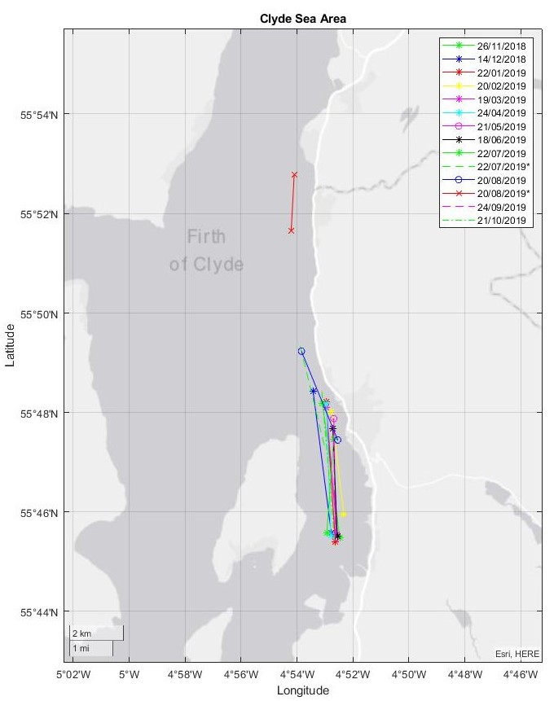
Figure 2.1 Map of the Clyde Sea Area (CSA) indicating the sampling transects conducted during November 2018- October 2019. Asterisk (*) indicates a second sampling conducted that same date.

Body colour method (BCM) examination
Nephrops that are heavily infected with Hematodinium sp. can be rapidly assessed in the field by a trained observer capable of recognising apparent changes in the animal's appearance (Figure 2.2). In general, this consists of an abnormally yellow/orange body colouration, a discolouration/pigment loss within extremities, opacity of the musculature between the limb joints and a milky-white appearance of the haemolymph (Field, 1992).
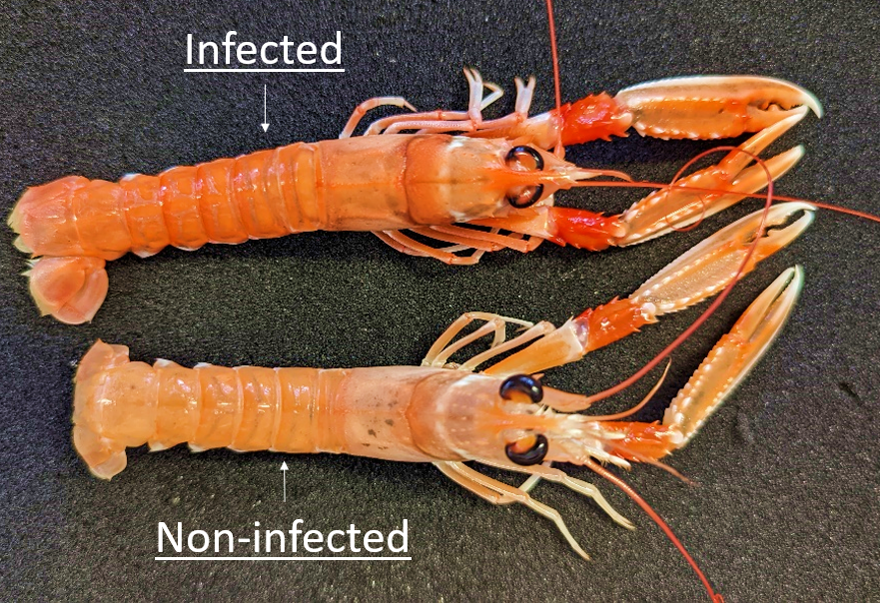
Figure 2.2 Hematodinium infected and non-infected Nephrops based on body colour method (BCM) (Field, 1992). Infected individuals possess an abnormal orange colouration compared to “healthy” non-infected individuals which have a more natural pale-orange colouration. Source: I, Martin.
Animals were directly placed in individual codified plastic bags and were kept and transported on ice to the University of Stirling.

Pleopod method (PM) examination
On arrival at the University of Stirling, a pleopod sample from each animal was taken for microscope examination. To this end, the second pair of pleopods (both left and right) were cut and frozen at -20°C to prevent bacterial colonisation. Samples were processed within 72 h, but longer storage periods (months) have been shown not to alter the quality of the samples (White and Rochette 2019). Pleopods were placed on slides with 0.4 µl of Nephrops saline: NaCl, 27.99 g/L; KCl, 0.95 g/L; CaCl₂ 2.014 g/L; MgSO₄, 2.465 g/L; Na₂SO₄, 0.554 g/L; HEPES, 1.92 g/L, pH 7.8) (Appleton and Vickerman, 1998) and photographed using an Olympus camera mounted on a light microscope.
Moult stage (ms) was evaluated by examination of pleopod morphology from the microscopic images for each individual animal, following the categorisation by Philp and Marteinsdottír (2013). In this case, animals were classified as early post-moult (A+B), intermoult (C) or pre-moult (D).
Photographs were also examined for parasite aggregation using the so-called ‘pleopod method’ (PM) described by Field et al. (1992), where dense aggregations of the parasite appeared as darkened areas, and these could be categorised on a scale from 0-4 (Figure 2.2). Due to the subjectivity of this score-based method, images that could not be unambiguously assigned to one of the four categories were scored by a second independent observer. Finally, at the end of the one-year sampling, all images were re-evaluated by the two observers. Cross-examination was done to avoid inconsistencies over time.
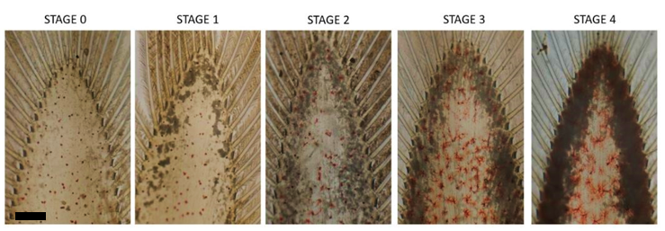
Figure 2.2 Hematodinium infection severity categorized on a four-point scale using the pleopod method (PM) (Field and Appleton 1995). Bar = 0.5 mm.

Female Nephrops
For each month, samples consisting of 20-30 female Nephrops were taken from the original 150 sample subset (n=330 total for the whole sampling period). These animals were screened for patent infection by BCM and PM. The following parameters were recorded for each female: total weight (excluding first pereiopods or chelipeds), gonad and hepatopancreas weight (n=292), and maturity stage. Ovary maturation stage was also recorded using the scale by Farmer (1974), which is based on the ovary colour. Females were classified as immature (stage 0, white ovary), early maturing (stage 1, cream ovary), late-maturing (stage 2, pale green ovary), mature (stage 3/4, dark green ovary) and with reabsorbing ovaries (stage 5, mottled green and cream ovary). The study also documented all berried females. Values of gonadosomatic index [GSI = (gonad wet weight)/ (body wet weight) x 100] and hepatosomatic index [HSI = (hepatopancreas weight)/ (body wet weight) x 100] were calculated.

Statistical analysis
Statistical analysis was performed in RStudio Version 4.1.2. As some pleopod stages were under-represented (number of observations from Stage 0 to Stage 4: 1510, 165, 31, 22, 11), a new pleopod status "ps2" was created, combining stages 1-4 into a unique pleopod status (stage 0 "Negative" and stage 1-4 "Positive"). Multivariate analysis with mixed quantitative variables (carapace length “CL”) and categorical variables (date, sex, moult index “midx” or moult stage “ms”) were executed to identify patterns in the data associated with Hematodinium sp. prevalence based on BCM and PM. Two Binomial Generalised Linear Models, or binomial GLMM (glmer function in the lme4 R package (Bates et al., 2015); were applied using either BCM or PM (1-4 stages combined; “ps2”), ‘date’ as a random factor and the remaining variables (CL, sex and moult stage or moult index) as fixed factors.
Standard methods to compare the means of two or more groups were executed to evaluate differences in CL between males and females in relation to infection (based on BCM and PM), moult index (hard, soft, jelly), moult stage (inter-moult, pre-moult, and post-moult), and date. Homogeneity of variance was tested using either Levene test (“leveneTest”) (Fox and Weisberg, 2019) or Shapiro test (“shapiro.test”) (Royston, 1982). t-test (“t.test”) (Student, 1908) was used to compare the mean of two groups if homogeneity of variance was achieved (parametric), otherwise Wilcoxon test (“wilcox.test()”) (Hollander et al., 2013) was implemented (non-parametric). Similarly, ANOVA (“aov()” or “anova()”) (Chambers and Hastie, 1992) was used to compare multiple groups (parametric) and Kruskal-Wallis (“kruskal.test()”) (Hollander et al., 2013) to compare multiple groups (non-parametric). Percentage data such as the HSI and the GSI within the female population, were arcsine transformed prior to applying any statistical analysis. P values < 0.05 were considered significant.

Results

Nephrops population trends
The sex ratio of Nephrops trawled from November 2018 to September 2019, including both patently infected animals by BCM and PM and non-infected animals (by PM), is depicted in Figure 2.3. During the period from November to April, males were the predominant gender in the trawl catch, accounting for 62% to 71% of the specimens. However, from May to August, the percentage of females exceeded that of males, with values ranging from 79% to 84%. Overall, the number of males (n=847) and females (n=892) examined in this study was relatively similar. Additional information regarding the sex ratio can be found in supplementary Table S2. 2.
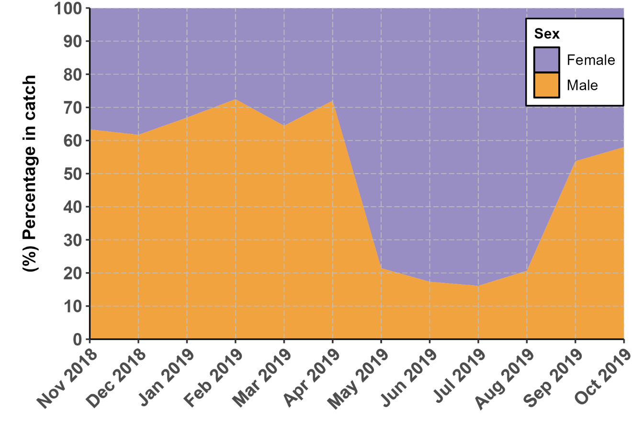
Figure 2.3 Sex ratio distribution found in the monthly samples of Nephrops captured from the CSA site between November 2018 and September 2019.

Female carapace length (CL) ranged from 18.3 to 59.3 mm, while males had CL measurements ranging from 19.6 to 56.6 mm. The distribution of CL for each sex throughout the sampling period can be observed in Figure 2.4. During the winter, the majority of females (81.8%) had a CL less than 30 mm, whereas during the summer, the majority (86.2%) had a CL greater than 30 mm. Notably, significant differences in carapace length were observed across all four seasons (Kruskal-Wallis: cl ~ season, data=res; df=3; P=2.2e-16) (refer to supplementary Table S2. 2), dates (Kruskal-Wallis: cl ~ date, data=res; df=11; P=2.2e-16), and between sexes (Wilcoxon: cl ~ sex, data=res; df=1; P=7.3e-05).
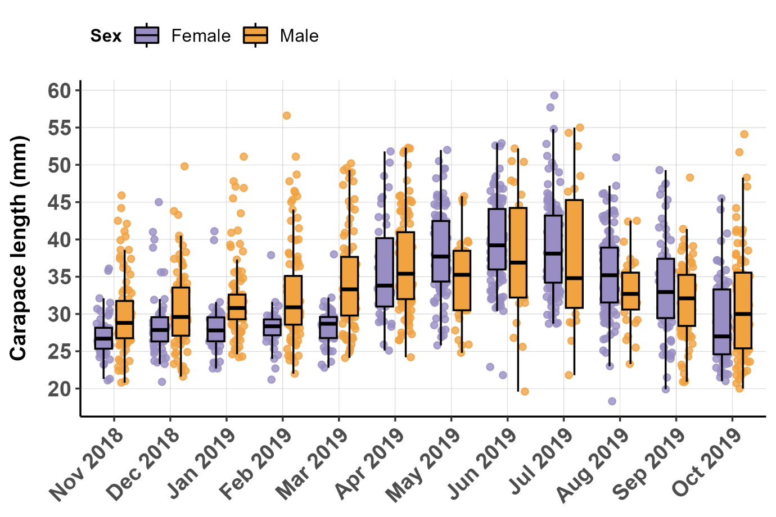

Figure 2.4 Mean CL (mm) of males and females found in the monthly samples of Nephrops captured from the CSA site between November 2018 and September 2019

The distribution of mature and immature individuals across the sampling period is presented in Figure 2.5 and supplementary Table S2. 2. Mature individuals were prevalent throughout the year, with female individuals reaching 100% maturity in July. Among males, immature specimens were observed at all sampling points, with November having the highest proportion of immature individuals (51.58%).

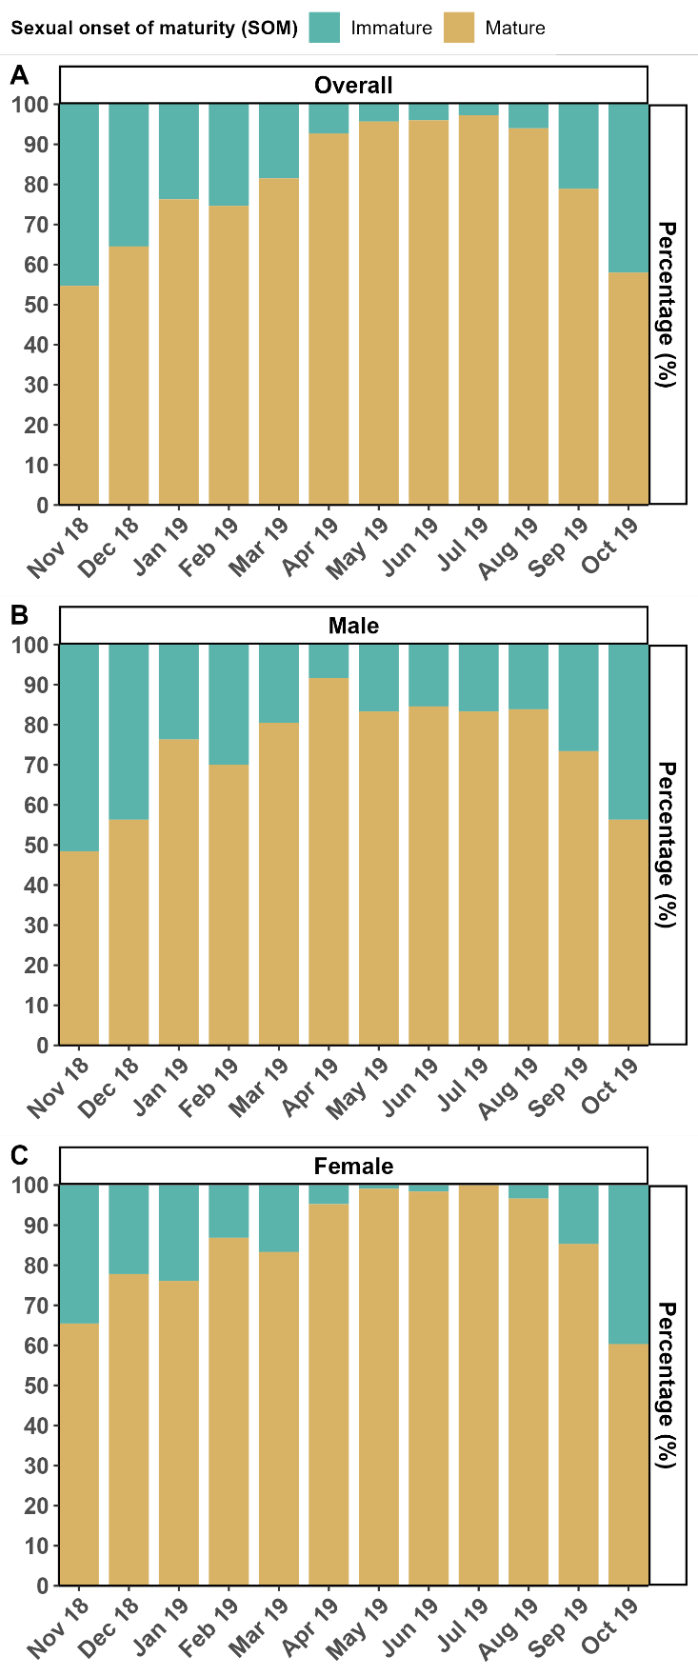
Figure 2.5 (A) Overall percentage (%) of mature (CL ≥ 26 mm for females; ≥ 29mm for males) and immature (CL < 26 mm for females; < 29mm for males) Nephrops in the monthly samples captured from the CSA site between November 2018 and September 2019. (B) Percentage (%) of mature/immature males. (C) Percentage (%) of mature/immature females.

Three categories of moulting based on carapace hardness (moult index) were observed in the sampled population: hard (83.6%), soft (14.1%), and jelly (2.3%) (Figure 2.6A-C). The majority of trawled individuals belonged to the 'hard' category for both males (91.7%) and females (75.9%). However, in May, the 'soft' category was more prevalent among females, accounting for 60% of the individuals. Females exhibited a notable synchronization of moulting during this month, whereas males did not show such synchrony. There were more females classified as 'soft' and 'jelly' compared to males. The peak occurrence of 'jelly' females was in April (14.2%), while 'jelly' males peaked in August (6.5%), indicating distinct moulting timings.
The moult stage determined by examining pleopod morphology under light microscopy is depicted in Figure 2.6D-F. Throughout the year, the intermoult stage was predominant, accounting for 81.7% of males and 69% of females. However, during the spring and summer months, there were notable occurrences of pre-moult and post-moult individuals (Figure 2.6D). Females exhibited strong synchrony in moulting based on their moult stage, with a peak in pre-moult individuals in April (30.9%) and a peak in post-moult individuals in May (71.8%) (Figure 2.6F). For males, the highest abundances of pre-moult and post-moult individuals were observed in July, accounting for 33.3% and 25%, respectively (Figure 2.6E). While there may be some subtle synchronization in male moulting during July, the timing differs between the sexes.

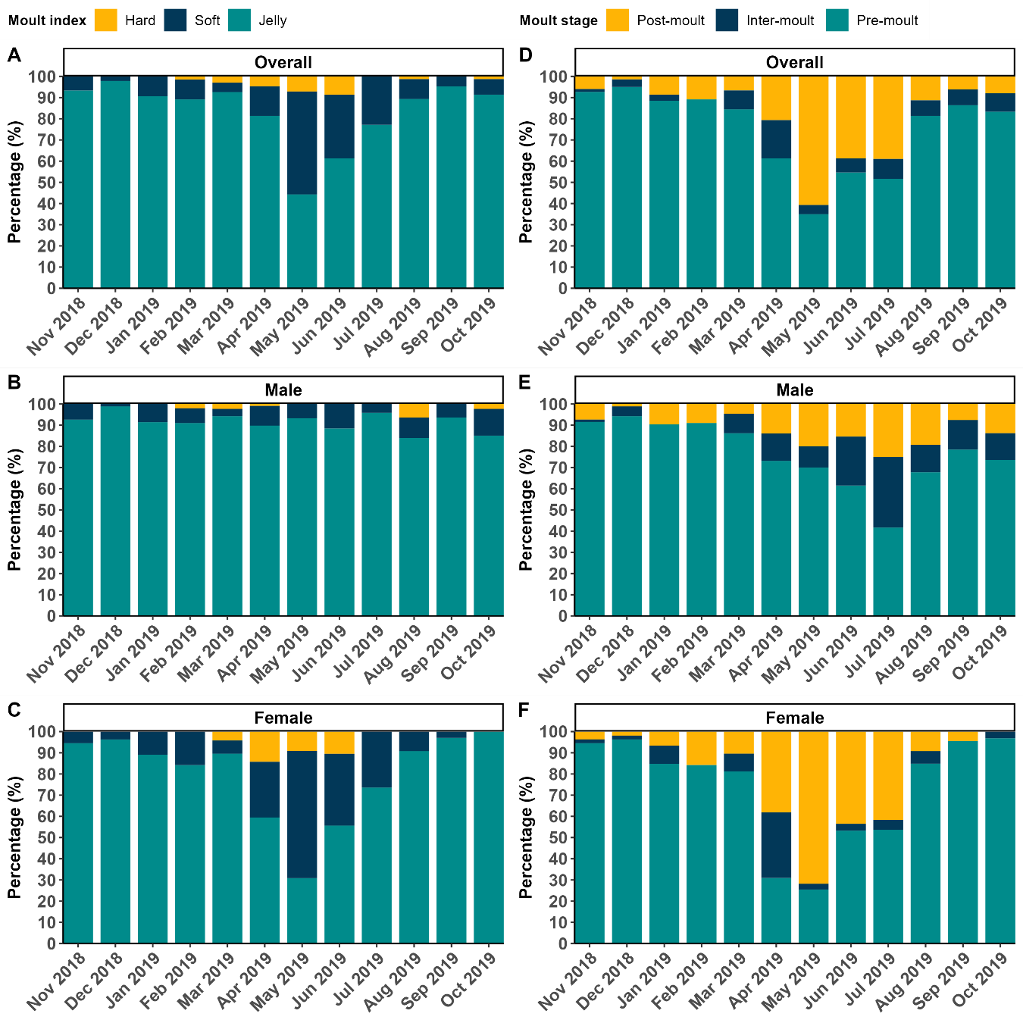
Figure 2.6 Percentage (%) of (A-C) Moult index (hard, soft, jelly); (D-F) Moult stage (post-moult; inter-moult, and pre-moult); for the sexes combined (A,D), males (B,E) and females (C,F) in the monthly samples of Nephrops captured from the CSA site between November 2018 and September 2019.

The distribution of moult stages according to size and sex is depicted in Figure 2.7. Animals in the intermoult, pre-moult, and post-moult stages exhibited progressively increasing mean carapace lengths (CL) of 32.5 ± 6.4 mm, 34.3 ± 7.2 mm, and 37.9 ± 7.1 mm, respectively. There were significant differences in CL among all the moult stages (2-way ANOVA: cl ~ ms + sex, data = res; df(ms) = 2; df(sex) = 1; n = 1739; F(ms) = 87.85, p<0.05), indicating variations in size throughout the moulting process. However, no significant differences in CL were observed between sexes within each moult stage (2-way ANOVA: cl ~ ms + sex, data = res; df(ms) = 2; df(sex) = 1; n = 1739; F(sex) = 2.79; p>0.05), suggesting that males and females displayed similar size distributions within specific moult stages.

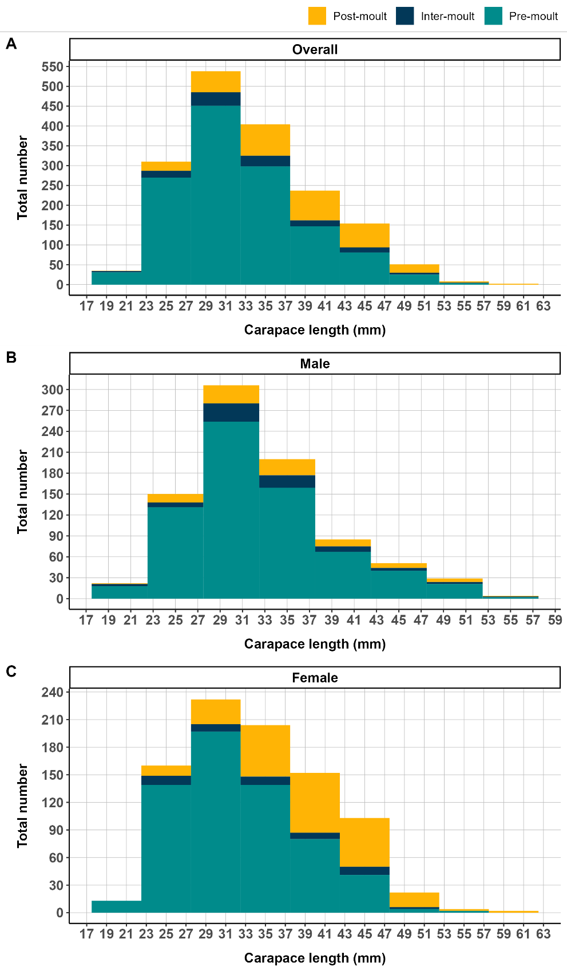
Figure 2.7 (A) Distribution of carapace length (CL) (males and females combined), according to moult stages (post-moult; inter-moult, and pre-moult). (B) Male carapace length distribution by moult stage. (C) Female carapace length distribution by moult stage. Each graph shows the number of individuals (count) per carapace length size for each moult stage, providing insight into the absolute abundance and size distribution of Nephrops in different moult stages.

Prevalence of Hematodinium sp. in the CSA
BCM and PM were used to assess the prevalence of patent Hematodinium sp. infection in all screened animals from the CSA. PM-positive animals were detected consistently throughout the year, indicating the presence of infection. In contrast, BCM-based infection was observed only from January to May. The peak of patent infection occurred in March, with 15.6% prevalence based on BCM and 33.3% prevalence based on PM (Figure 2.8). Additionally, PM revealed a second peak of infection in July (21.5%).
During the peak of patent infection, female Nephrops exhibited higher infection levels compared to males. In March, female infection rates reached 20.83% by BCM and 45.83% by PM, while males displayed infection rates of 12.64% by BCM and 26.44% by PM (Figure 2.9). For further information on patent infection based on BCM and PM, refer to supplementary Table S2. 2.
To evaluate the severity of Hematodinium sp. infection, a 4-point scale was employed using the pleopod method (PM). The distribution of infection stages throughout the sampling period is illustrated in Figure 2.10. The disease progressed during the winter months and peaked in March, with more advanced infection stages present in the catch. Stage 1 infections were observed throughout the year, while stages 3 and 4 were limited to the period between January and May (Refer to Figure 2.10 and supplementary Table S2. 2 for more details).

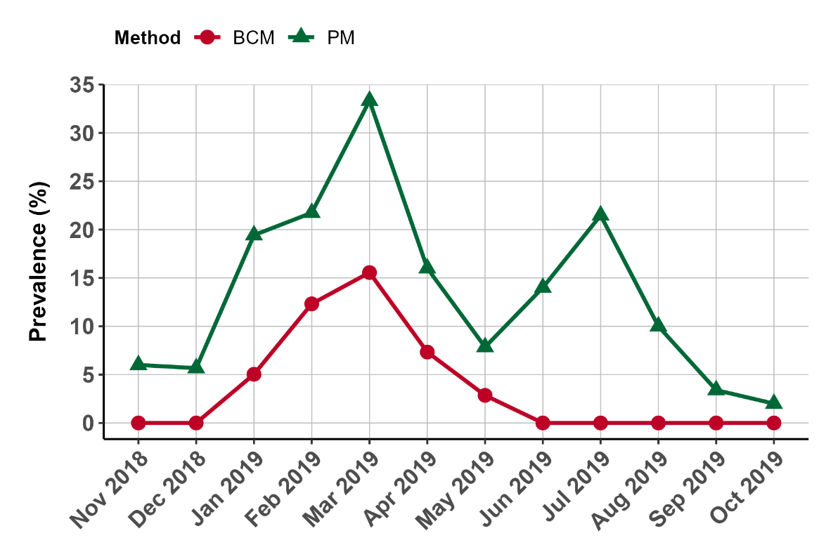
Figure 2.8 Overall percentage (%) of patent infection according to body-colour (BCM), and pleopod method (PM-stages 1-4) in monthly samples of Nephrops (males and females combined) captured from the CSA site between November 2018 and September 2019.
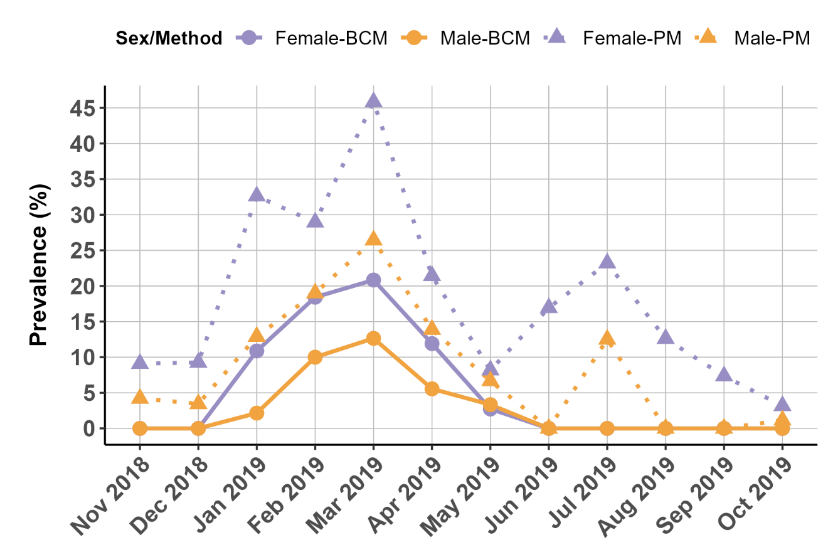
Figure 2.9 Percentage (%) of patent infection by sex and diagnostic method (body-colour/pleopod methods) in monthly samples of Nephrops captured from the CSA site between November 2018 and September 2019.

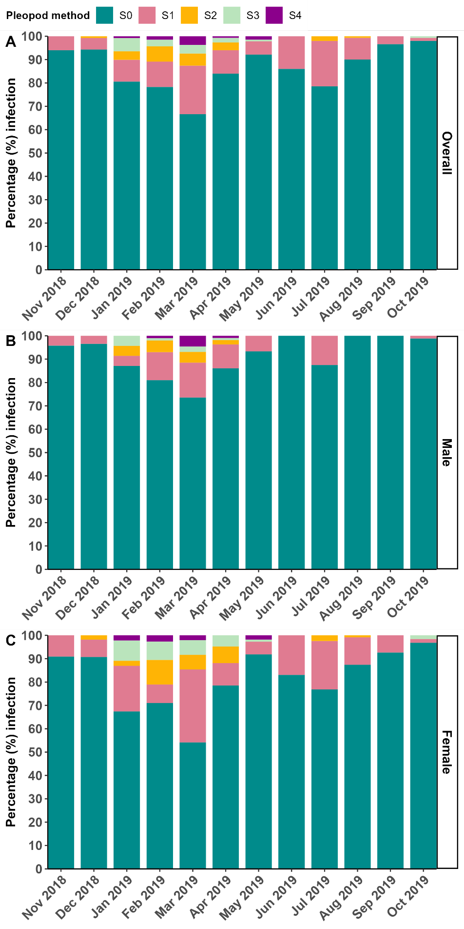
Figure 2.10 A) Overall percentage (%) of patent infection severity (S0-S4) according to pleopod method (PM). B) Male percentage (%) of patent infection (PM). C) Female percentage (%) of patent infection (PM).

Variables associated with Hematodinium sp. patent infection
The findings of the Binomial Generalised Linear Models (glmer, Bates et al. (2015)) for BCM are displayed in Table 2.1. Since moult was determined using two different methods, the models were run twice: once with moult recorded as 'moult index' and another with moult recorded as 'moult stage', the later can be found in supplementary Table S2. 3. The analysis revealed that BCM infection was associated with a decrease in carapace length (CL) and positively associated with the moult index category "soft" (glmer 1-glmer 3) (Table 2.1). However, there was no association between moult stage (ms) and BCM infection. Nested models were then used to simplify the model by removing non-significant effects from successive models. Both factors (moult index-soft and CL) remained significant from glmer1-glmer3 as well as individually in glmer4 and glmer5 (Table 2.2). Binomial Generalised Linear Models, (glmer) (Bates et al., 2015) were applied to the prevalence data according to the PM, with positive infection defined as pleopod stages 1-4 (ʻps2ʼ). As per this model, males have a lower infection risk according to the PM (ʻps2ʼ) (Table 2.2).

Table 2.1 Binomial Generalised Linear Models applied to BCM prevalence levels.
Binomial Generalised  Linear Models | Factors | Estimate | SE | z value | Pr(>|z|) | Sign
(Body-colour infection ) family="binomial"
glmer1 | CL | -0.236 | 0.058 | -4.100 | 4.13E-05 | ***
bc ~CL+ sex+ midx + som+ date | midx S | 1.071 | 0.393 | 2.721 | 6.50E-03 | **
glmer2 | CL | -0.236 | 0.058 | -4.100 | 4.13E-05 | ***
bc ~CL+ sex+ midx + date | midx S | 1.071 | 0.393 | 2.721 | 6.50E-03 | **
glmer3 | CL | -0.178 | 0.036 | -4.874 | 1.09E-06 | ***
bc~ CL + midx+ date | midx S | 1.084 | 0.386 | 2.807 | 0.00499 | **
glmer4 | CL | -0.175 | 0.036 | -4.873 | 1.1E-06 | ***
bc ~ CL + date
glmer5 | (Intercept) | -6.427 | 1.167 | -5.506 | 3.67E-08 | ***
bc ~ midx + date | midx S | 1.012 | 0.377 | 2.687 | 0.0072 | **
SE = standard error; CL = carapace length; midx= moult index; midx S= moult index soft. Date as random factor.

Table 2.2 Binomial Generalised Linear Models applied to positive pleopod stages 1-4 (ʻps2ʼ).
Binomial Generalised Linear Models | Factors | Estimate | SE | z value | Pr(>|z|) | Sign
(Pleopod infection) family="binomial"
glmer1 | (Intercept) | -2.055 | 0.492 | -4.176 | 2.96E-05 | ***
ps2 ~CL+ sex+ midx + som + date | Sex M | -0.964 | 0.182 | -5.304 | 1.13E-07 | ***
glmer2 | (Intercept) | -1.606 | 0.334 | -4.810 | 1.51E-06 | ***
ps2 ~ sex+ midx + som + date | Sex M | -0.903 | 0.174 | -5.200 | 1.99E-07 | **
glmer3 | (Intercept) | -1.811 | 0.280 | -6.465 | 1.01E-10 | ***
ps2 ~ sex+ midx + date | Sex M | -0.878 | 0.172 | -5.104 | 3.33E-07 | ***
glmer4 | (Intercept) | -1.811 | 0.280 | -6.465 | 1.01E-10 | ***
ps2 ~ sex + date | Sex M | -0.915 | 0.170 | -5.392 | 6.96E-08 | ***
SE = standard error; ps2=pleopod stages 1-4 combined; CL = carapace length; midx= moult index; Sex M= male Nephrops. Date as a random factor.

Infection and size
The analysis revealed that patently-infected Nephrops (BCM-positive) had a mean carapace length (CL) of 29.2 ± 3.8 mm, which was significantly smaller than that of BCM-negative individuals with a mean CL of 33.8 ± 6.9 mm (Wilcoxon; cl~ bc, data=res, df=1; P= 9.3e-08) (Figure 2.11A). This difference in size between BCM-positive and BCM-negative individuals remained significant when examining males (Wilcoxon; P= 5.1e-7) and females (Wilcoxon; P= 0.021) separately (Figure 2.12A).
On the other hand, no significant differences in size were observed between PM-negative (non-patent) (33.5 ± 6.8 mm) and PM-positive (patent) (34.1 ± 7.2 mm) Nephrops when considering the combined sexes and combining infection stages (t-test: cl~ ps2, data=res, df=1; P= 0.27) (Figure 2.11B). Similarly, no significant differences in size were found between PM-positive and PM-negative males (Wilcoxon; P= 0.86) or females (Wilcoxon; P= 0.71) (Figure 2.12B). However, carapace lengths were significantly different among the different infection stages (Kruskal-Wallis: cl~ ps, data=res, df=4; P= 2.0e-6) (Figure 2.11C). Figure 2.12C illustrates the carapace lengths for each individual infection stage and sex. Notably, only females displayed significant differences between stage 0 and stages 1, 3, and 4, as well as between stage 1 and stages 2, 3, and 4 (Figure 2.12C).

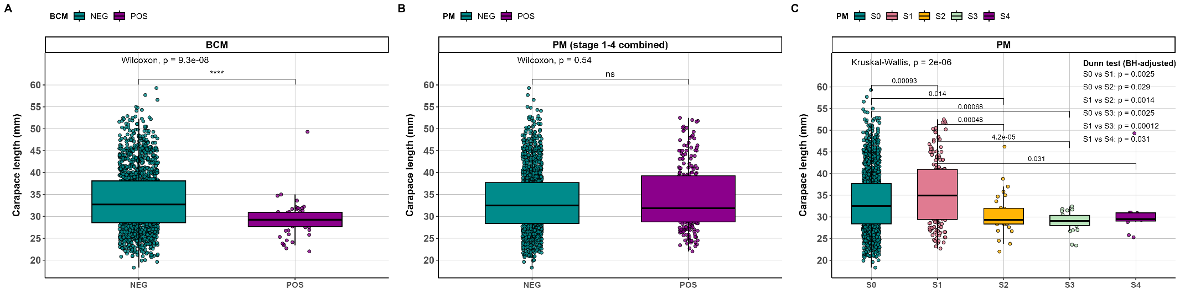

Figure 2.11 Mean carapace length (mm) of non-infected (negative (NEG)) and infected (positive (POS)) Nephrops (both sexes combined), based on: A) BCM-negative vs BCM-positive individuals, using the body-colour method (BCM); B) PM-negative vs PM-positive individuals, representing the combined infection stages S1–S4 identified by the pleopod method (PM); C) The individual infection stages S0–S4, as determined by the pleopod method (PM).
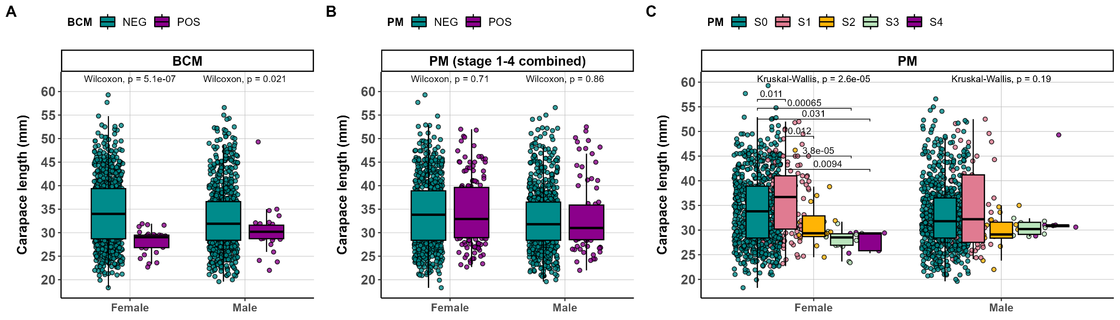
Figure 2.12 Mean carapace length (mm) of non-infected (negative (NEG) and infected (positive (POS)) female and male Nephrops, based on: A) BCM-negative vs BCM-positive individuals, using the body-colour method (BCM); B) PM-negative vs PM-positive individuals, representing the combined infection stages S1–S4 identified by the pleopod method (PM); C) The individual infection stages S0–S4, as determined by the pleopod method (PM).

The size distribution of patently-infected and non-patent individuals based on BCM and PM is shown in Figure 2.13. The top panels show that patent infection (BCM positive) peaked in Nephrops with a carapace length (CL) ranging from 22 to 32 mm. In contrast, the bottom panels, representing the PM results, reveal a wider size distribution of animals at infection stage 1 for both males (24.1-52.5 mm) and females (22.7-52 mm). As the infection stage increased, this size distribution narrowed, and all males and females at stage 3 had a CL below 32.5 mm. Therefore, the data suggest that disease progression, rather than prevalence, may be associated with smaller individuals.
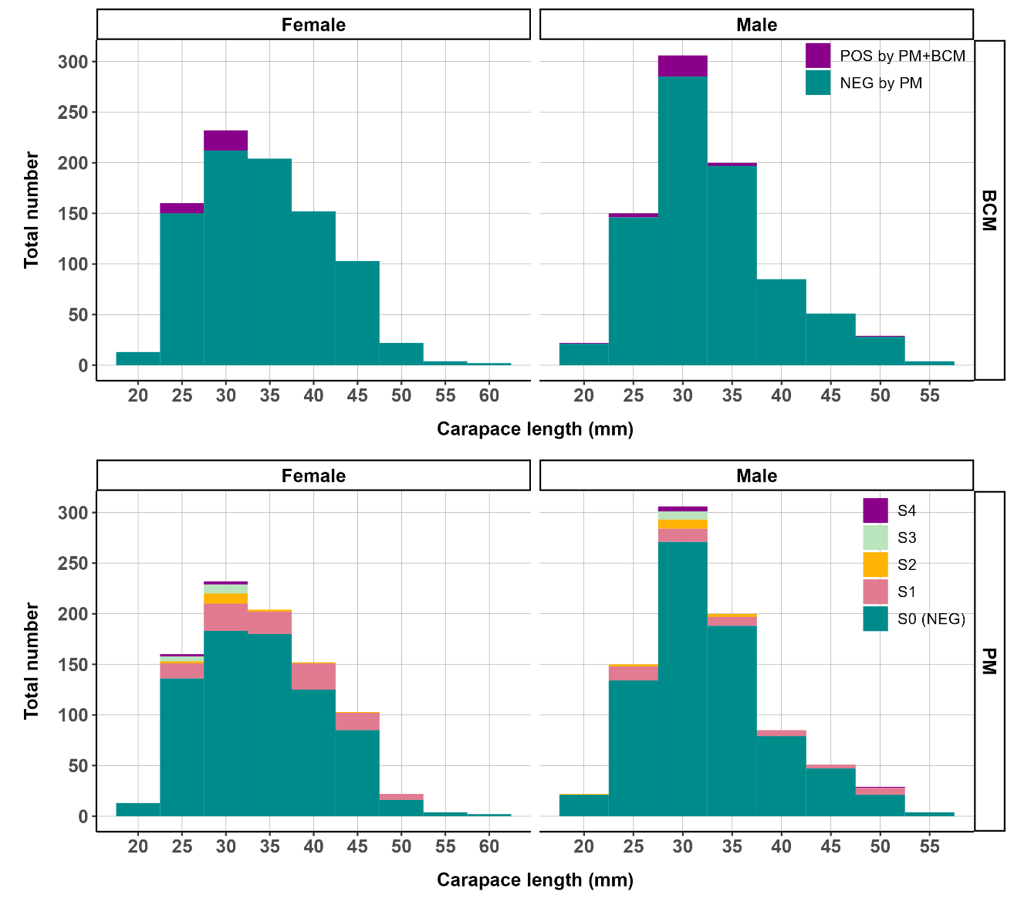

Figure 2.13 Size distribution of Nephrops females and males with infection, based on body colour (BCM) and pleopod method (PM-stages 1-4 combined). S0/NEG are Hematodinium negative by pleopod method (PM).

Infection and moult
The role of a soft exoskeleton in acquiring Hematodinium sp. infection appears to be significant. The moult index, based on carapace hardness, was found to be a significant factor according to PM ("ps2"-stages 1-4 combined) (Kruskal-Wallis: ps2~midx, data=res, df=2; p<0.05). "Soft" individuals, as determined by the moult index, were more susceptible to PM infection ("ps2"-stages 1-4 combined) compared to "hard" individuals (Wilcoxon; p<0.05). However, when the p-value was corrected using the Bonferroni method, these differences became non-significant (Wilcoxon; p>0.05). The moult index was not a significant factor when considering the different infection stages by PM (ANOVA; ps~midx, data=res, df=2;p>0.05). Similarly, the moult index was not a significant factor in BCM infection (ANOVA; bc~midx, data=res, df=2; p>0.05). Furthermore, the moult stage, evaluated by examining pleopod morphology under a microscope, was not a significant factor in BCM infection (ANOVA; bc~ms, data=res, df=2; P = 0.814), PM infection ("ps2"-stages 1-4 combined) (ANOVA; ps2~ms, data=res, df=2; p>0.05), or PM at individual stages (ANOVA; ps~ms, data=res, df=2; p>0.05).

Infection and sex
There was no significant difference in infection levels based on BCM between the sexes (t-test: bcsex, data=res; df=1; P=0.838). However, infection based on PM ("ps2"-stages 1-4 combined) was found to be significantly higher in females (Wilcox: ps2~sex, data=res; df=1; p<0.05). Furthermore, when considering the different infection stages by PM, females also exhibited significantly higher infection levels (Wilcox: ps~sex, data=res; df=1; p<0.05). These findings suggest that females are more susceptible to acquiring patent pleopod infection compared to males.

Nephrops females
In this study, a total of 892 female Nephrops were examined, including both PM-infected and PM-negative individuals. Among these, 84 females (9.4%) were found to be carrying eggs. The seasonal variation in the proportion of berried females in the catch is illustrated in Figure 2.14. The size distribution of these berried females ranged from 24.5 mm to 47.4 mm, with a mean carapace length (CL) of 34.5 ± 5.1 mm. It is worth noting that only one berried female had a carapace length below 26 mm. All berried females were in the inter-moult stage and exhibited gonad stages 0, 1, or 5. Among the 84 berried females, none were found to be BCM-infected, while only 8 (9.5%) were infected with PM at stage 1 of infection.
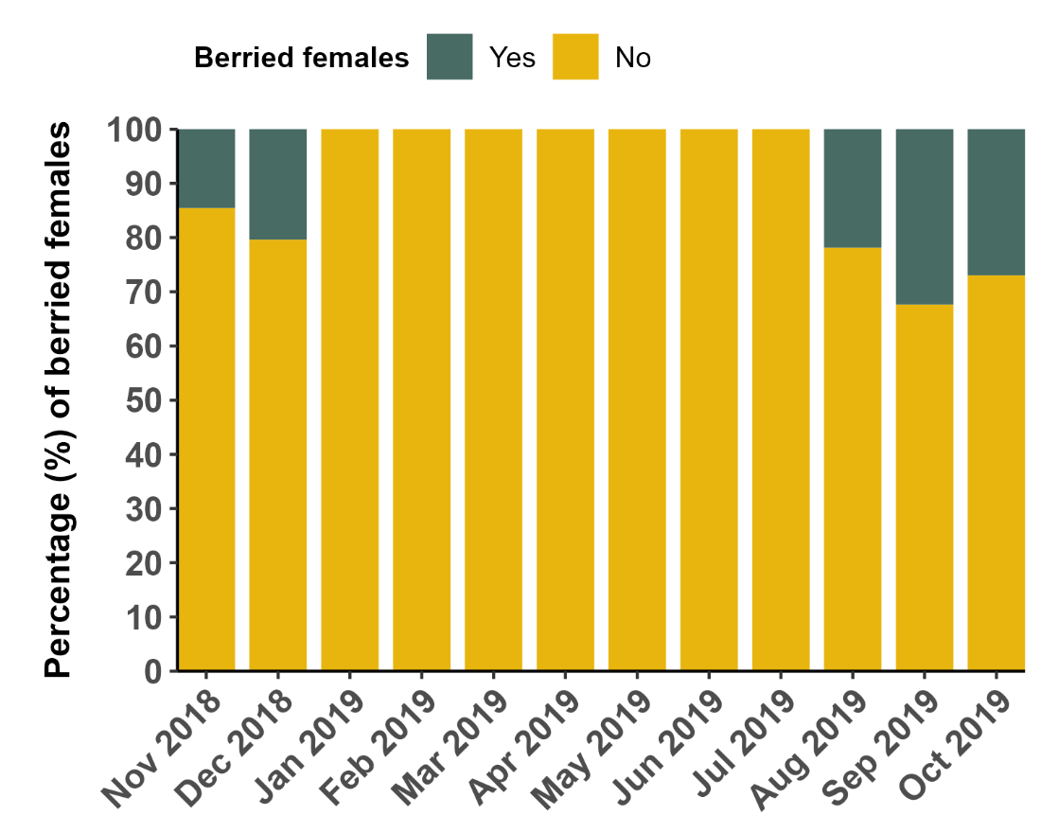
Figure 2.14 The percentage of egg-bearing females (berried) found in samples (n=892; including PM-infected and PM-negative females) collected from the CSA site between November 2018 and September 2019.
The mean body weight of female Nephrops (n=330) was recorded as 20.7± 12.9 g. Figure 2.15A-C, presents the monthly measurements of body weight, HSI (n=292), and gonadosomatic index (GSI) (n=330) of these females, respectively. Notably, a substantial increase in female body weight is observed starting from April, which can be attributed to the emergence of larger mature females from their winter burrows. Throughout the year, HSI values exhibit fluctuations, with relatively similar month-to-month variations during the first half of the year. The highest HSI value is observed in June (7.60 ± 1 (%)), followed by a subsequent decrease. In contrast, GSI values show a different pattern, with relatively lower values during the winter months. However, from April onwards, GSI increases rapidly, reaching its peak in July (at 7.21 ± 2.62 (%)), before subsequently declining to lower levels.

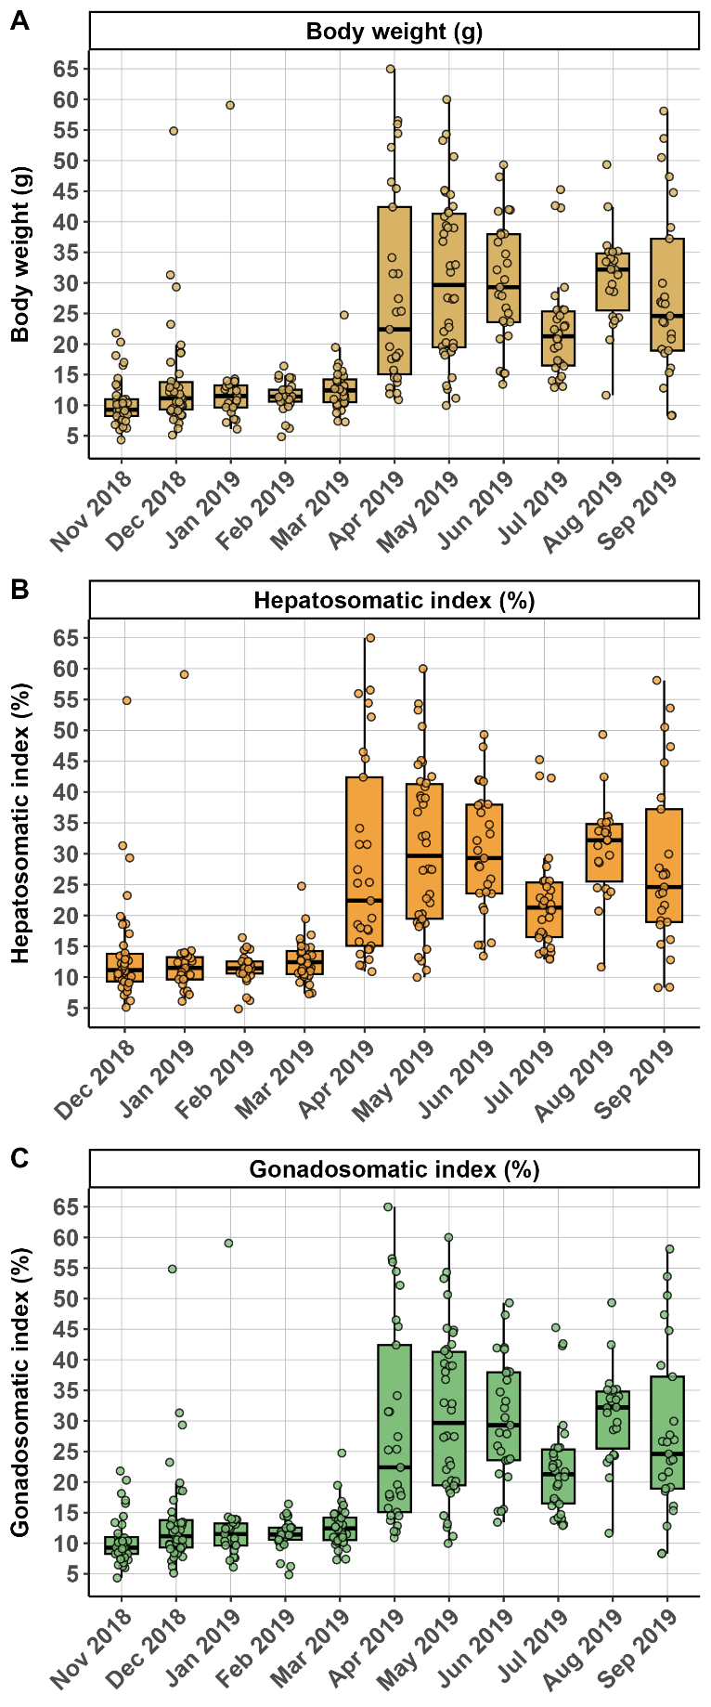

Figure 2.15 A) Mean body weight (g); B) hepatosomatic index (HSI); C) gonadosomatic index (GSI) of female Nephrops collected from the CSA site between November 2018 and September 2019.

Figure 2.16 illustrates the ovarian cycle observed over the course of eleven months of sampling. In the winter months, females displayed immature ovaries. However, during the first half of the year (February to July), there was a progression in the maturation cycle. By April, more than 65% of the females had green ovaries (stages 3/4), indicating that they were fully mature and prepared for mating. In July, as many as 90% of the sampled females had ovaries at stage 3 or higher. Interestingly, a higher proportion of females captured in the latter half of the year exhibited spent ovaries, suggesting recent spawning activity.

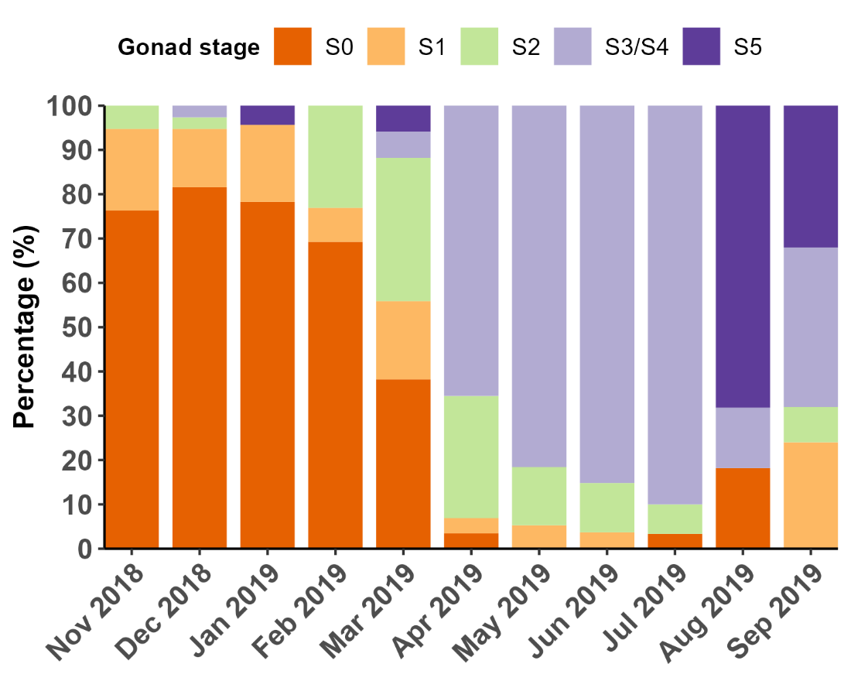
Figure 2.16 The percentages of female Nephrops at the different gonad stages, collected from the CSA site between November 2018 and September 2019. (number of observations S0, n=115; S1, n=34; S2, n=40; S3/4, n=115; S5, n=26)

Considering the data relative to the ovarian cycle, there was a significant increase in GSI as the ovaries progressed through maturation stages S2 to S5 (Kruskal-Wallis: gsi~gs, data=res; df=4; P=1.2e-4). Conversely, HSI showed a significant decrease (Kruskal-Wallis: hsi~gs, data=res; df=4; P=2.2e-16) (Figure 2.15 and Figure 2.17). The notable increase in GSI observed from April to July 2019 (Figure 2.15C) coincided with a higher prevalence of gonad stages 3-4 during that period (Figure 2.16). Both GSI and HSI values exhibited a significant decline in August and September (Figure 2.15), corresponding to the reabsorption phase of the ovaries (gonad stage 5, Figure 2.16).
While the most rigorous approach would involve comparing GSI and HSI across both gonad stage and sampling month simultaneously, this was not feasible due to the relatively low number of samples per group. Additionally, the gonad stage already reflects an element of temporal progression within the ovarian cycle and thereby introduces some degree of seasonal structure into the analysis. However, this is not an ideal substitute for a fully factorial temporal comparison, and results should be interpreted with this limitation in mind.
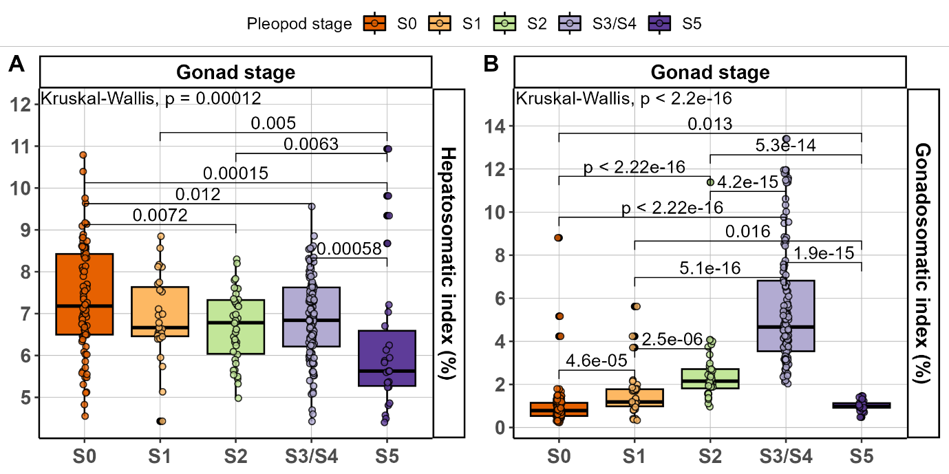
Figure 2.17 Mean values of (A) the hepatosomatic index (HSI) and (B) the gonadosomatic index (GSI) of female Nephrops at the different stages of gonadal development. (number of observations S0, n=115; S1, n=34; S2, n=40; S3/4, n=115; S5, n=26)

Female Nephrops infected with Hematodinium sp.
Among the 330 females whose gonads were examined, 12 (3.6%) were BCM-infected and 59 (17.9%) PM-infected. From the PM-infected, 47 (79.7%) were at stage 1; 6 (10.2%) were at stage 2, and 6 (10.2%) were at stage 3 of infection. Females with PM stages 2 and 3 had undeveloped gonads (stage 0) and were primarily detected between February and March, which were also the dominant months for low-level infections (PM-stage 1). Females captured between June and August also showed signs of PM stage 1 infection.
Female Nephrops that were infected with Hematodinium sp. (BCM-positive) exhibited a noticeable presence of a dense milky fluid within the body cavity, which was filled with Hematodinium sp. cells. The average hepatosomatic index (HSI) for BCM-positive females was 8.48 ± 6.87%, which was significantly higher compared to BCM-negative females (6.87 ± 1.14%) (t-test: hsibc, data=res FH; df=1; P=0.018). Similarly, PM-positive females (combined stages 1-4, referred to as "ps2") exhibited an average HSI of 7.35 ± 1.39%, which was significantly higher than PM-negative females (6.84 ± 1.12%) (Wilcoxon: hsi~ps2, data=res FH; df=1; P=0.013). Furthermore, there were significant variations in HSI among different infection stages (Kruskal-Wallis: hsi~ps, data=res FH; df=1; P=7.60e-4). (Figure 2.18C).
The gonadosomatic index (GSI) was significantly lower in BCM-positive females (Wilcoxon: gsi~bc, data=res FG; df=1; P=6e-05) with a value of 0.712 ± 0.24%, compared to BCM-negative females (2.89 ± 2.76%). On the other hand, PM-positive females (combined stages 1-4, referred to as "ps2") had similar GSI values (2.40 ± 2.74%) to PM-negative females (2.90 ± 2.74%) (t-test: gsi~ps2, data=resFG; df=1; P=0.21). However, significant differences in GSI were observed among the different infection stages (Kruskal-Wallis: gsi~ps, data=res FG; df=1; P=1.70e-4) (Figure 2.18F).
Among the 12 BCM-positive females analysed, 11 had undeveloped white ovaries at stage 0, while one female had fully mature ovaries at stage 5. Females infected with PM at stages ≥ 2 also exhibited undeveloped white ovaries at stage 0. Specifically, females at stage 2 of infection were captured in February 2019, and females at stage 3 of infection were captured between January and April 2019. Figure 2.18 provides a visual representation of GSI and HSI in relation to the infection.

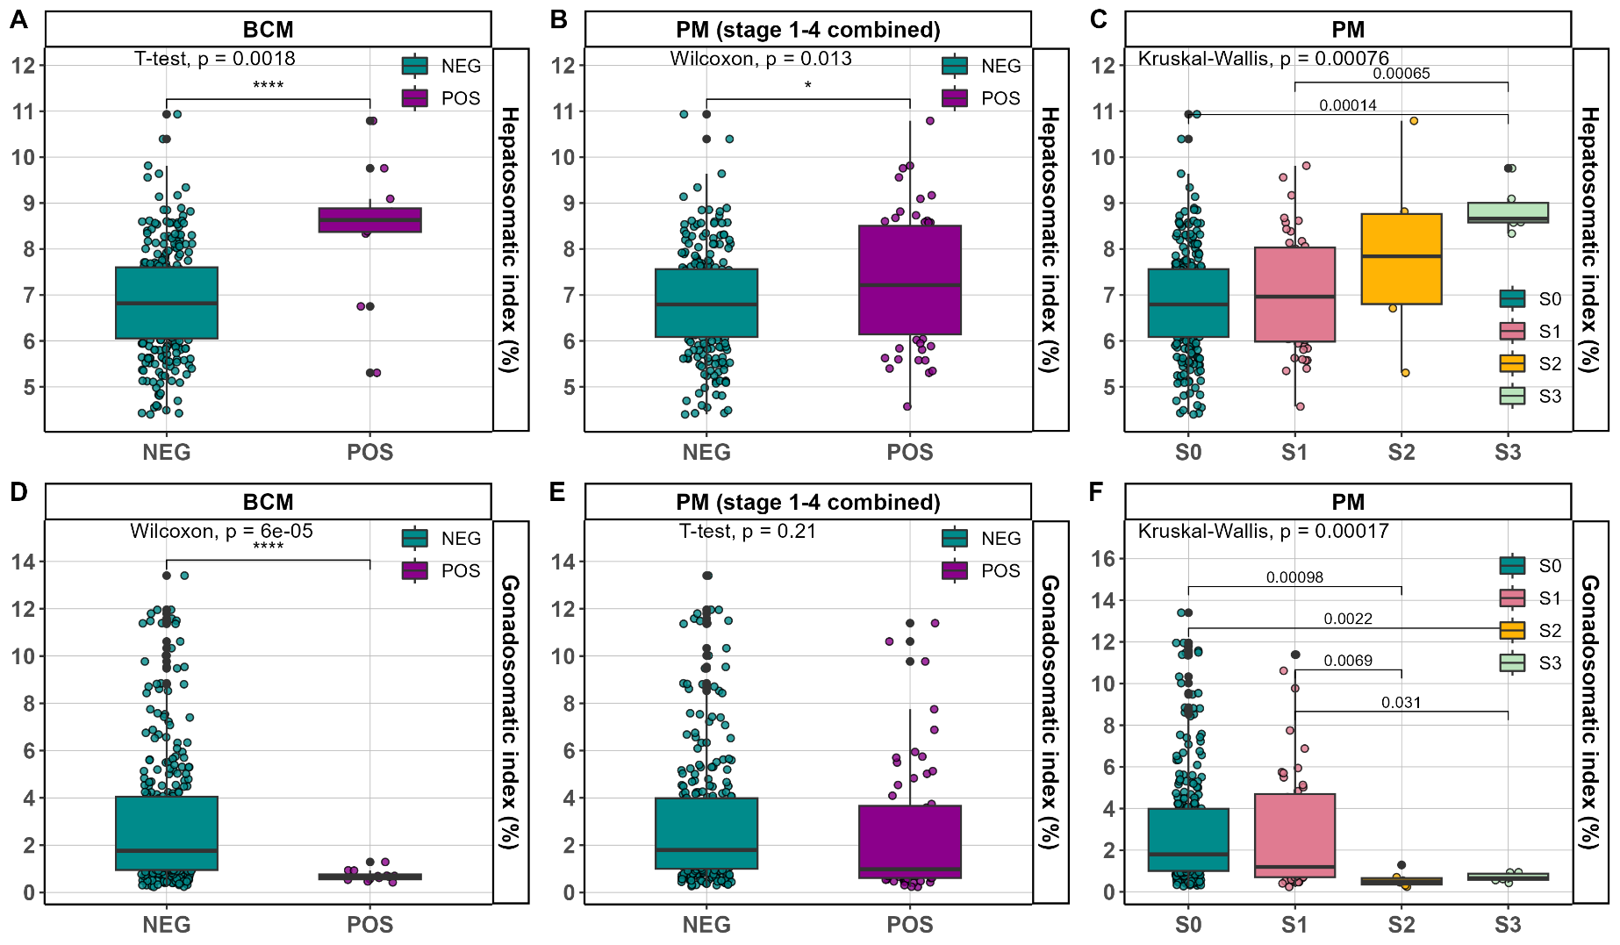
Figure 2.18 The hepatosomatic (HSI) (A-C) and the gonadosomatic (GSI) (D-F) indices of female Nephrops in relation to infection status evaluated by BCM and PM.

Discussion

The prevalence of Hematodinium infections in Nephrops in the CSA
The Hemodinium-Nephrops system, involving Hematodinium sp. infections in Nephrops norvegicus within the CSA (Clyde Sea Area), has been the subject of extensive research over the past three decades, with prevalence data available since the 1980s. This system has been thoroughly documented and is globally recognized as one of the most extensively studied.
The findings of this research indicate that the patent infection associated with Hematodinium sp. exhibits a pronounced seasonal pattern within the CSA. Prevalence values during the peak of infection, characterized by high prevalence and severity, are mostly in line with previous data sets (Beevers et al., 2012; Briggs and McAliskey, 2002; Field et al., 1992; Field et al., 1998; Stentiford et al., 2001a). In this study, the primary peak of infection occurred in March (15.6% BCM; 33.3% PM; high prevalence, high severity), as measured by BCM and PM (Figure 2.8). This was followed by a smaller peak (21.5% PM; high prevalence, low severity) four months later, toward the end of the summer period. The presence of this bimodal high prevalence peak was previously documented by Field et al. (1995), although it may not always be evident or detected (Stentiford et al., 2001a). A bimodal prevalence pattern has also been observed in the Atlantic blue crab (Callinectes sapidus) infected with H. perezi (Messick and Shields, 2000; Sheppard et al., 2003).
The data obtained in this study provides confirmation that Hematodinium sp. infections are not only present but also persistent within the Nephrops population in the CSA. There seems to exist an equilibrium between the impact of the parasite on the host, leading to a considerable percentage of annual mortality, and the resilience of the host population, which prevents a complete decimation, possibly due to high rates of reproduction (Beevers, 2010). These findings, along with the data from previous studies and the present study, offer the necessary level of detail to observe long-term trends in Hematodinium sp. prevalence within the CSA. Such trends can be compared to 'susceptible-infected-recovered/removed' (SIR) epidemiological model, which have been employed in analysing analogous epidemiological and endemic transitions (Cantrell et al., 2020; Davies et al., 2020; Giménez-Romero et al., 2021; McCallum et al., 2017; Swinton et al., 2002). While this study does not investigate the specifics of how Nephrops hosts sustain Hematodinium sp. at their current levels, the data presented here can serve as a foundation for comprehensive mathematical modelling exercises. It becomes evident, however, from the collective body of research, that Hematodinium sp. likely plays a significant role in regulating the host population dynamics (Ebert, 2005).

Factors affecting infection and disease progression
In this study it was observed that the presence of the parasite in the pleopod (PM-positive) is significantly associated with the sex of the host, with females being more vulnerable and prone to Hematodinium sp. infections in general (Table 2.2) (Stentiford and Shields, 2005). During the spring season, there is a notable increase in the number of female individuals in the catch. This coincides with their emergence from burrows to engage in feeding, synchronized moulting, and mating activities following the completion of the egg-brooding period (Beevers, 2010; Milligan et al., 2009; Tuck, 1997; Watts et al., 2016). Consequently, females dominate the catches during this period, accounting for up to 78% of the catch (Figure 2.3) (Beevers et al., 2012; Stentiford et al., 2001a).
Although the precise transmission mechanism of Hematodinium sp. remains unknown, it is widely believed that waterborne (horizontal) transmission between hosts is the most plausible pathway (Davies et al., 2019; Huang et al., 2021; Stentiford and Shields, 2005). During the peak severity period (March-April), Hematodinium sp. dinospores are released and likely remain available in the environment for approximately 60-90 days (Appleton and Vickerman, 1998; Meyers et al., 1987). These dinospores may enter the host through various means, including gills or breaks in the integument (Hanif et al., 2013; Messick and Shields, 2000; Shields and Squyars, 2000), passive suspension-feeding (Briggs and McAliskey, 2002) or direct ingestion of infected individuals, as hypothesised in blue crabs (Callinectes sapidus) (see section 1.3.3.2).
Considering the perspective of parasite exposure, the timing of Hematodinium sp. spore presence in the environment (March to July) coincides with the emergence of females and their moulting (ecdysis) process in Nephrops. It is worth noting that female moulting is highly synchronized compared to males (Figure 2.6). Consequently, females, particularly those undergoing moulting, are more likely to be exposed and susceptible to Hematodinium sp., at least to lower severity levels.
Previous research has indicated that smaller animals have a higher vulnerability to Hematodinium sp. infection (Beevers et al., 2012; Field et al., 1992; Stentiford et al., 2001a). Size-related intermoult intervals increase with size, and therefore smaller individuals may be more susceptible to infection and disease progression since they moult more frequently (Field et al., 1992; Lycett et al., 2018; Stentiford et al., 2001a). However, the analysis takes a step further by examining the severity of infection (measured using the PM) in relation to the size (CL) of each individual. This reveals, for the first time, that the progression of the disease from low to high severity, rather than inherent susceptibility, is linked to the size of Nephrops. The findings (Figure 2.12) clarify this point by showing that small-sized individuals are not exclusively associated with low severity patent infection (PM-positive; S1), indicating that animals of all sizes are exposed and susceptible to Hematodinium sp. (Figure 2.13). However, smaller animals are more likely to develop high severity infections to the extent that their survival might be compromised (BCM-positive) (Table 2.1). To better understand these factors, it is crucial to have data available at the individual level. Therefore, it is recommended that future studies share prevalence data with this level of detail. By curating previous datasets and making individual-level data from current surveys accessible, it is possible to effectively monitor the dynamics of the disease in great detail.
The underlying mechanism by which smaller individuals are more likely to develop high severity infection remains unknown. A recent study involving a shore crab-Hematodinium pathosystem suggests that Hematodinium sp. is not associated with a significant suppression of the host's immune system, but rather with a lack of reactivity of the host's haemocytes towards the parasite (Davies et al., 2022). However, it is plausible that larger hosts, which are generally more immune-competent than their smaller counterparts, may possess humoral-mediated defence mechanisms that enable them to counteract the proliferation of Hematodinium sp. during the early stages of parasite settlement.
The factors behind the synchronized seasonal patterns in parasites infecting hosts, such as Nephrops, which reside in deep waters, remain unknown. This is particularly intriguing considering the absence of external cues available to the parasites. An obligatory metabolic coupling with the host could serve as a potential explanation for the synchronized multiplication of parasites. Gornik et al. (2015) proposed this theory based on the argument that Hematodinium sp., lacking plastid organelles, relies on obligatory metabolic scavenging from its host. In this case, certain host metabolites, like Methyl farnesoate, necessary for the host's preparation for moulting in spring, might be crucial for parasite multiplication. These metabolic interactions could, to some extent, account for the observed synchronicity of the patent infection.

The effects of Hematodinium sp. infection on the hepatopancreas of female Nephrops
The hepatopancreas, a crucial organ in crustaceans responsible for nutrient absorption and storage (Wu et al., 2020) acts as a reservoir for essential lipids, which provide substantial energy during critical phases like starvation, moulting, maturation, or reproduction, including ovarian development (Rosa et al., 2003; Wang et al., 2014). The state of "starvation" in Nephrops can be assessed by measuring the reduction in the hepatosomatic index (HSI) (Watts et al., 2016). The study on female Nephrops revealed temporal variations in HSI, which align with previous research conducted on this species (Albalat et al., 2016; Rosa et al., 2003; Rosa and Nunes, 2002; Rosa and Nunes, 2004). During the months of April and May, many females emerge from their burrows after hatching their eggs, so their nutritional status may reflect a long period of burrow residence but not starvation (Santana et al., 2020; Watts et al., 2016). Factors contributing to the reduced HSI include lower food availability and decreased consumption of the available food. In situations where nutrition is limited, females will utilize the lipids stored in their hepatopancreas as a last resort (Watts et al., 2016). However, in this study, an increase in HSI was observed throughout ovarian maturation, suggesting that the hepatopancreatic resources are not depleted (Rosa and Nunes, 2002). Following the attainment of sexual maturity, females allocate less energy to growth and prioritize reproduction. Consequently, mature females exhibit slower growth rates compared to mature males. To meet the nutritional demands of egg rearing and spawning, females possess a greater amount of hepatopancreatic tissue than males (Farmer, 2009).
In this study, a significant increase in the hepatosomatic index (HSI) was observed in infected females compared to non-infected. The presence of numerous parasite cells of Hematodinium sp. in the haemocoel spaces within the hepatopancreas results in an overall increase in mass, as evidenced by the elevated HSI in infected individuals (Fazhan et al., 2020). However, it is noteworthy that these parasites never infiltrate the tubules as per observation of histological sections (see section 3.4.2 and section 4.3.6), indicating that the structural integrity of certain hepatopancreatic tubules may remain intact and potentially functional (Fazhan et al., 2020). The preservation of the host's hepatopancreas function is crucial for the survival of Hematodinium sp., as it may serve as their primary site for nutrient absorption.

The effects of Hematodinium sp. infection on the gonads of female Nephrops
Ovary reabsorption in Nephrops is a common yet poorly understood phenomenon (Bailey and Chapman, 1983; Becker et al., 2018; Becker et al., 2020; Tuck et al., 1997). It has been suggested that adverse environmental factors, deprivation of sexual hormones, overexploitation, and/or starvation may contribute to ovary reabsorption in female Nephrops (Bailey and Chapman, 1983; Becker et al., 2018; Becker et al., 2020; Tuck et al., 1997). In addition, certain infectious diseases, have been identified as potential causes of gonad resorption or halted gonad development in crustacean species like the long-legged spider crab (Macropodia longirostris) (Hartnoll, 1962). A similar effect has been observed in female Nephrops infected with Hematodinium sp. (Briggs and McAliskey, 2002; Mouat, 2002).
In the present study, the impact of Hematodinium sp. infection on female Nephrops gonads was examined. The results show that the Gonadosomatic Index (GSI) was significantly lower in visibly infected females compared to non-infected individuals (Figure 2.18). This decrease in GSI is likely attributed to the disintegration of ovarian tissue and loss of its structural integrity (Mouat 2002). Furthermore, advanced stages of infection (PM stage 3) resulted in a complete failure of gonad development in females (Figure 2.18). This could be attributed to factors such as nutrient depletion, metabolic exhaustion, and tissue disruption caused by the increased parasite burden (Briggs and McAliskey, 2002; Mouat, 2002). However, there was also much earlier disruption of the gonads than previously thought, since PM stage 2 infected females failed to develop gonads (Figure 2.18).
Subsequent histology examination of infected female gonads sections at different stages of infection (refer to section 3.4.2) revealed a gradual increase in tissue damage and parasite density starting from stage 1. Even at stage 2 of Hematodinium sp. infection, the haemal spaces of the ovaries were almost fully colonized by the parasite cells, although not as intensely as in stages 3 and 4. These findings suggest that gonad reabsorption may be triggered by parasite density, and this process may begin as early as stage 2 of infection.
Given the potential detrimental effects of Hematodinium sp. infection on Nephrops reproductive potential, further research is recommended to effectively manage Nephrops stocks in the CSA. Fisheries sustainability relies on the long-term reproductive viability of populations, making it crucial to regularly monitor the reproductive potential of each stock to detect any changes (Becker et al., 2020). Hematodinium sp. infection during its peak may lead to the loss of 30-40% of breeding females contributing to reproduction in a given year (Mouat, 2002). To ensure robust fishery management targets that account for such events, it is important to investigate the mechanisms driving gonad resorption rates. Careful management of Nephrops stocks, including the removal of heavily infected individuals, can help mitigate the impact of the parasite while maintaining fishers' quotas. This approach not only benefits the fishery but also helps reduce the parasite load in the environment.

Conclusions
In conclusion, the findings demonstrate that the prevalence of Hematodinium sp. infection in the CSA is generally consistent with previous data sets obtained through the body colour and pleopod methods (Beevers et al., 2012; Stentiford et al., 2001a). It can be confirmed that Hematodinium sp. is enzootic (endemic) in this region, with a peak in the number of infected lobsters during spring and summer (high prevalence and intensity), followed by a decline in autumn. Importantly, the study highlights that the severity of infection is significantly associated with the size of Nephrops, while the biology of female Nephrops, characterized by burrow emergence and synchronized moulting in the spring, makes them more susceptible to Hematodinium sp. infection.
Furthermore, these findings reveal that female Nephrops experience halted gonad development as early as stage 2 of pleopod infection. This interruption in reproductive development could significantly reduce the breeding population of Nephrops, thereby jeopardizing the long-term viability of fisheries in the area. To gain further insights into this crucial pathosystem, future research should focus on investigating the abiotic and/or biotic cues utilized by the parasite for synchronized patent infection, as well as mapping host-parasite interactions during the early stages of infection. Such studies would provide valuable additions to the understanding of this important pathosystem.

Characterisation of haemolymph and gut microbiomes of Nephrops norvegicus

Abstract
The parasite Hematodinium sp. causes morbidity and seasonal mortality events in more than 40 decapod species globally and is therefore, now recognised as a significant threat to the future sustainability of shellfish fisheries and aquaculture worldwide. Among these, Norway lobster (Nephrops norvegicus), an important benthic decapod that supports the most valuable shellfish fishery in the UK, experiences yearly seasonal Hematodinium sp. patent infections. Currently, little is known about the N. norvegicus microbiome and its potential role during Hematodinium sp. infection. Therefore, in this study the microbiome dynamics of N. norvegicus associated with Hematodinium sp. infection and disease progression in the haemolymph and gut were investigated. N. norvegicus were sampled from the Clyde Sea Area, Scotland during the peak of the Hematodinium sp. patent infection. The presence and intensity of Hematodinium sp. infection were determined using the body colour method (BCM), pleopod method (PM), histology (heart, gonads, hepatopancreas, gills and muscle) and molecular tools (PCR). Marked shifts in the bacterial richness of the haemolymph and significant alterations in the overall bacterial community composition of both tissues were observed in infected lobsters. These changes, observed even at subpatent levels of infection (only positive by PCR), indicate a prompt and persistent microbiome shift associated with Hematodinium sp. infection. This study offers the first insights into the pathobiome of N. norvegicus due to Hematodinium sp. infection and disease that in turn provides a foundation for further studies on the pathogenesis of this important parasitic disease.

Introduction
Understanding the mechanisms sustaining parasite success is of considerable importance in both fundamental and applied biology. This has significant implications for the interpretation of epidemiological investigations. The traditional view of host-parasite interactions as a simple binary relationship has recently changed. It is now recognised that the microbiome can play a crucial role in the phenotypic changes caused by parasitic activity (Bass et al., 2019; Dheilly et al., 2015; Drew et al., 2021). Parasites, acting as carriers or sources of microorganisms drive the evolution of protective microbial agents. This process includes resource competition within the host microbiota, creating niches for different microbes, altering the host environment to support or hinder other microorganisms, and triggering immune responses that affect the entire microbial ecosystem (Dheilly et al., 2015). In this web of interactions, the microbiome plays a pivotal role in shaping the effective strategies employed by parasites.
Monitoring and characterizing bacterial communities can be a potential tool to mitigate emerging diseases. However, defining a potentially “healthy” bacterial baseline microbiome requires extensive sampling of multiple “healthy” individuals (Infante-Villamil et al., 2021). High-throughput sequencing (HTS) has made it cost-effective to characterize bacterial communities and has expanded the understanding of how microbes can influence host health (Infante-Villamil et al., 2021). The relationship between a host and its microbiome are difficult to visualise, with blurred lines between commensal microorganisms and pathogens (Egan and Gardiner, 2016). In the context of host-parasite interactions, these relationships become even more complicated, as both hosts and parasites rely on a delicate equilibrium for survival.
Dinoflagellates belonging to the Hematodinium genus encompass three distinct species: Hematodinium perezi, Hematodinium australis, and Hematodinium sp. These parasitic organisms infect a wide array of crustacean hosts globally, encompassing more than 40 distinct species (Li et al., 2021a; Stentiford and Shields, 2005). Hematodinium parasites have economic implications, as their presence can significantly reduce market value and necessitate the removal of affected animals, leading to considerable financial losses (Albalat et al., 2012). The Nephrops-Hematodinium system, situated in the Clyde Sea Area (CSA) along the West Coast of Scotland, stands as a globally recognised host-parasite system, extensively investigated in various studies (Beevers, 2010; Beevers et al., 2012; Field, 1992; Field et al., 1992; Hamilton et al., 2007; Smith, 2021; Stentiford et al., 2001a; Stentiford, 2000). Infected Nephrops exhibit distinct visual indicators, including carapace hyperpigmentation, evident through the body colour method (BCM) (Field, 1992; Stentiford and Neil, 2011) (see section 1.3.4.1), and a milky-white appearance of the haemolymph. As the infection progresses, parasites accumulate within the pleopod cuticle. Using low-power light microscopy to analyse the pleopods, a 4-point scale, known as the pleopod method (PM), is employed to categorize the disease's severity (Field, 1992) (see section 1.3.4.2). The progression of infection involves the rapid proliferation of distinct parasite morphotypes within the haemolymph and tissues, including the hepatopancreas. This proliferation leads to a reduction in circulating immune cells, known as haemocyte counts (Hoppes, 2011). Advanced colonization results in lethargy and morbidity among infected animals, attributed to factors like metabolic exhaustion, depletion of nutrients, and systemic organ failure (Bell et al., 2013; Stentiford, 2000; Stentiford et al., 2000b; Taylor et al., 1996), along with localized tissue necrosis, including muscle tissue (Stentiford and Neil, 2000), infections of this nature often prove fatal (Rowley et al., 2015).
Numerous investigations have explored the role of the microbiome in shaping the health and disease dynamics of economically important tropical decapod species, as comprehensively reviewed by Holt et al. (2021). Pathogenesis often begins with interactions between the gut microbiota and the host immune system, usually due to reduced bacterial diversity or an imbalance in specific microbial taxa (Holt et al., 2020). Hematodinium infections induce a substantial pathological alteration in the host's physiology, particularly within the haemolymph. A large parasite population changes the normally clear haemolymph, making it thicker and milky or cream-like (as documented by Small (2012)). While traditional understanding maintained that the haemolymph of “healthy” invertebrates was free of microbes, recent research now demonstrates that the haemolymph of crustaceans is anything but sterile (Jung et al. (2021). Instead, it hosts a wide variety of bacterial components. Notably, bacteria in crustacean haemolymph can benefit host health. These effects include the regulation of immune responses, the synthesis of antimicrobial compounds, and the competitive exclusion of pathogens (Alimin et al., 2024).
Despite the growing number of microbiome studies in different crustacean species, there is still a significant gap in understanding the complete microbiota composition and diversity associated with 'healthy' states.' This lack of knowledge presents significant challenges in accurately identifying potentially invasive and pathogenic microorganisms (Quinn et al., 2013). Even in well-documented diseases like Hematodinium infection, uncertainties remain about how the pathogen impacts or interacts with microbial communities. These interactions could influence the host's metabolic processes or make the host more susceptible to infection by one or more pathogens.
The central aim of this study was to thoroughly characterize the haemolymph and gut microbiomes of Nephrops norvegicus, with a specific focus on investigating the possible existence of a pathobiome linked to Hematodinium sp. infection, particularly in the context of disease progression. To achieve this objective, specimens of Nephrops norvegicus were collected from the CSA during the peak of Hematodinium sp. patent infection in March 2020. The assessment of Hematodinium sp. infection employed a comprehensive methodology, incorporating techniques such as the body colour method (BCM), pleopod method (PM), histological analysis of key organs (heart, gonads, hepatopancreas, gills, and muscle), and molecular approaches such as polymerase chain reaction (PCR). Through the utilization of 16S rRNA amplicon sequencing, the microbiomes of both the haemolymph and gut were comprehensively characterized. Alongside the inquiry into the potential existence of a pathobiome linked to Hematodinium sp., the valuable insights gained from the microbiome analysis were used to explore the concept of immune evasion.

Methods and Materials

Ethics statement
The study protocol was approved by the University of Stirling Animal Welfare and Ethical Review Body (AWERB (18/19) 196).

Sample collection
A total of n=349 Nephrops norvegicus were trawled from the Clyde Sea Area (55°45.482N, 4°53.375W) aboard the commercial vessel Eilidh Anne GK2 on the 9th of March 2020. A non-targeted subset of animals consisting of n=149 Nephrops was selected and placed on ice. This set, referred to as the "prevalence-set," was used to determine the prevalence of Hematodinium sp. infection at that specific time. Another set of n=200 Nephrops, classified on-board the vessel based on their visual appearance (targeting BCM positive and negative), were placed in running seawater and transported live to the Field Studies Council (FSC) Millport facilities. Animals from this sub-set were kept in tanks with running seawater and are referred to as the ‘pathobiome-set’. Data collected from the ‘prevalence-set’ included sex, carapace length (CL), and moult stage. The level of Hematodinium sp. infection in the ‘prevalence-set’ was determined by employing the body colour method (BCM) and pleopod method (PM), as per the 4-stage criteria established by Field and Appleton (1995) _ENREF_90. The same information was recorded for animals in the ‘pathobiome-set’. However, in this subset, additional samples were taken for molecular analyses (PCR detection of Hematodinium sp. in the haemolymph), microbiome investigation (haemolymph and gut) and histological analysis (heart, gonads, hepatopancreas, gills, and muscle). Haemolymph samples (0.5 mL) were obtained from the base of the fifth pereopod using a sterile syringe coupled with a 25-gauge needle. This needle was previously rinsed with marine anticoagulant (0.45 M NaCI; 0.1 M glucose; 30 mM trisodium citrate; 26 mM citric acid, and 10 mM EDTA; pH 4.6) (Söderhäll and Smith, 1983),which was autoclaved after preparation, and samples were subsequently fixed in molecular-grade ethanol.

Tissue histology
Sections of gonads, heart, hepatopancreas, gills and muscle were placed into histological cassettes and submerged in Davidson’s Saltwater Fixative (DSF) (Hopwood, 1996). After a 24-hour period, samples were transferred to 70% industrial methylated spirit and sent to CEFAS (Centre for Environment, Fisheries, and Aquaculture Science) Weymouth Laboratory (UK) for further processing and analysis. Fixed samples were processed to wax using a vacuum infiltration processor following standard protocols (Stentiford et al., 2012; Stentiford et al., 2003). Sections were cut at a thickness of 3 to 5 μm on a rotary microtome and then mounted onto glass slides before staining with haematoxylin and eosin (HE). Stained sections were analysed using light microscopy (Nikon Eclipse E800) and digital images were captured using the Lucia™ Screen Measurement System (Nikon) and SLIDEVIEW TM VS200 Research Slide Scanner (Olympus Life Science). Tissue histology was conducted on n=122 samples, serving as an additional tool to PCR for screening the presence of Hematodinium sp. in tissues from the ‘pathobiome-set’. The presence of Hematodinium sp. infection in tissues was evaluated using a simple scoring system (0 and 1). In this system, a score of 0 indicates no visible presence of Hematodinium sp., whereas a score of 1 denotes the presence of parasites in the tissue.

DNA extraction
DNA from the haemolymph (n=195) and gut (n=200) of the ‘pathobiome-set’ was extracted using the Promega Maxwell® RSC Tissue DNA Kit (Promega, United Kingdom) following the manufacturer's protocol. Prior to extraction, ethanol was removed from the samples by freeze-drying. Dried samples were resuspended in 700 µL of Lifton's buffer for haemolymph and 600 µl for gut samples and then shaken using a bead beater for 2 mins at a speed of 500 rpm. Subsequently, samples were centrifuged for 2 mins at 9,000 rpm, and 20 µl of Proteinase K (10 ug/mL) was added. The samples were digested overnight at 57°C before extraction. DNA was then eluted in 100 µl of elution buffer (EB). The purity and concentration of the extracted DNA were evaluated using a NanoDrop ND-1000 Spectrophotometer (Thermo Fisher Scientific, United Kingdom). Concentrations were further confirmed using a Qubit 2.0 Fluorometer (Thermo Fisher Scientific, United Kingdom).

Molecular detection of Hematodinium sp.
Screening for the presence of Hematodinium sp. in haemolymph samples was performed using PCR amplification of the ITS1 region. Specific primers were designed using the representative sequence DQ871209 of Hematodinium sp. from Nephrops as a template in Primer3 software (Rozen and Skaletsky, 2000). The forward primer HSPP-F1 (5’GGAAGTTTAGTGAACCTTATCAC’3, Tm= 68.2°C) and the reverse primer HSPP-R1 (5’CAGCCTTTTCCAGTTTCTGGAAG’3, Tm= 71.8°C) were selected for the amplification of Hematodinium sp. PCR was performed in a total reaction volume of 25 µl, using GoTaq® Green Master Mix (Promega, UK). Positive and negative controls were run alongside all screening PCR reactions. The PCR was conducted on a Systemics™ PCR machine using the following thermal profile: initial denaturation at 94°C for 5 mins, then 35 cycles of denaturation at 94°C for 30s, annealing at 56°C for 30s and extension at 72°C for 1 min 30 s, with a final extension of 72°C for 5 mins. A 5 µL aliquot of each PCR product was checked using 1.5 % agarose gel containing 0.1 μg/mL ethidium bromide in Tris-Acetate-EDTA (TAE) buffer. Images were captured with a BioRad™ gel documentation system. For sequence verification, the PCR amplicons were purified using a WIZARD clean-up kit, in accordance with the manufacturer's instructions, and subsequently sent for sequencing to Eurofins Genomics, UK. The resulting sequences were nucleotide BLAST (blastn) in GenBank, with the top hit identified as Hematodinium spp. (data not included).

Bacterial 16S rRNA amplicon sequencing
The extracted DNA was dispatched to Novogene (Cambridge, United Kingdom) for the preparation of 16S rRNA amplicon libraries and subsequent sequencing. Among the initial pool of n=195 haemolymph samples, a subset of n=122 (equivalent to 63%) successfully met Novogene's stringent quality control criteria, thus qualifying for the subsequent stages of library preparation and sequencing. This cohort was paralleled by a corresponding set of gut samples (n=122), which underwent the same processes. Amplification of the V4 hypervariable region of the bacterial 16S rRNA gene (approximately 292 base pairs) was achieved through the utilization of specific primers: 515F (GTGCCAGCMGCCGCGGTAA) and 806R (GGACTACHVGGGTWTCTAAT). The sequencing phase was executed by Novogene, employing an Illumina paired-end platform (Illumina PE250 platform) in conjunction with an S4 flowcell on an Illumina Novaseq system (Illumina, United States).

Bioinformatics
Data processing was executed on a Debian Linux (version 10) system, utilizing an HP workstation equipped with 32 processors. For the processing of raw paired-end (PE) fastq files, a tailored Python pipeline was devised, integrating Mothur's Standard Operating Procedure (SOP) (Schloss et al., 2009) along with the SILVA reference database (Quast et al., 2013). This comprehensive pipeline encompassed sequence cleansing, operational taxonomic units (OTUs) clustering, and taxonomic classifications (Elsheshtawy et al., 2021). To enhance the efficiency of high-throughput analysis of numerous sample sets, the pipeline was compartmentalized into discrete tasks. Sequential execution of each task was accomplished by employing Mothur in batch mode. Python scripts were employed to generate the requisite Mothur commands for individual sample fastq files and their corresponding mock fastqs. Statistical analyses were conducted in R Studio (Version R-4.1.2), using the Phyloseq package to compute alpha diversity (McMurdie and Holmes, 2013). Before evaluating group differences, the homogeneity of variance in alpha-diversity indices was verified using the Shapiro-Wilk test (Royston, 1982). For normally distributed data, one-way ANOVA was applied to analyse alpha diversity indices, followed by pairwise comparisons via t-tests. Alternatively, for non-normally distributed data, the Kruskal-Wallis test was applied, and further pairwise comparisons used the Wilcoxon test (rank-sum test). The Benjamini and Hochberg (BH) correction (Benjamini and Hochberg, 1995) was employed for p-value adjustment, with statistical analysis conducted using the rstatix package (Kassambara, 2020). All figures were generated using the R packages ggpubr and ggplot2 (Kassambara, 2020; Wickham, 2016). Beta-diversity comparisons were computed using the Bray-Curtis pairwise distances with Vegan (Oksanen et al., 2014) and Phyloseq packages, and visualized using Principal Coordinate Analysis (PCoA). Group differences were calculated using the Vegan package's non-parametric permutational multivariate ANOVA (PERMANOVA) with 1,002 permutations. An adjusted p-value less than 0.05 was deemed statistically significant. The core microbiome and shared communities were identified using the ampvis2 package (Andersen et al., 2018). Both the observed and abundant OTUs (the top 80% of reads) in both tissues were defined as the core communities. The average abundance of each OTU in all the samples from a given tissue was computed, divided by the total abundance of all OTUs in that tissue. Cumulative OTU read abundance for each tissue was calculated, with OTUs having the top 80% of reads considered abundant. The Wilcoxon rank-sum test was used for comparisons of the same taxa in different groups, followed by BH false discovery rate (FDR) correction with a 0.05 p-value.

Results

Prevalence of Hematodinium sp. in Nephrops norvegicus from the Clyde Sea Area (CSA): The 'Prevalence-Set'
The body colour (BCM) and pleopod method (PM) were used to evaluate the levels of patent Hematodinium sp. infection at the time of this work in the area of study (CSA). According to the BCM, around 17% of Nephrops showed a high intensity level of infection (BCM) (Figure 3.1A) and up to around 26% were infected according to the PM) (Figure 3.1B). No significant differences in patent infection were found between sexes. Full information on the data collected from the ‘prevalence-set’ is available in Table 3.1.
Males constituted the majority (69.1%) of the trawl composition and exhibited a significantly larger carapace length (Anova, P= 1.9e-06) compared to females (31.8 ± 2.7 mm for males; 27.7 ± 2.7 mm for females). The size distribution for males during this month ranged from 23 to 49.7 mm, while for females it ranged from 23.8 to 36.7 mm. The population consisted mainly of mature individuals, accounting for 67.1% of the total, whereas only 37.9% of the males and 21.7% of the females were immature (Queirós et al., 2013; Tuck, 1997; Watts et al., 2016). Both males and females were predominantly categorized as 'hard' (93.2% for males and 84.8% for females). Regarding the moult stage, the majority of the population (71.8%) was in the inter-moult stage, followed by 20.8% in the pre-moult stage and 7.4% in the post-moult stage. In the CSA, females undergo synchronous moulting during the spring months, as discussed in Chapter 2, section 2.5. Hence, during March 2020, a relatively higher proportion of females were observed in the pre-moult stage (23.9%) and post-moult stage (10.9%).

Table 3.1 Summary data for the ‘prevalence-set’ of Nephrops norvegicus collected from the Clyde Sea Area.
Parameters | Female |  | Male |  | Total
Parameters | N | % | N | % | N | %
Sex | 46 | 30.9 | 103 | 69.1 | 149 | 100
Body colour method (BCM)
Negative (BCM) | 37 | 29.8 | 87 | 70.2 | 124 | 83.2
Positive (BCM) | 9 | 36 | 16 | 64 | 25 | 16.8
Pleopod method (PM)
S0 | 34 | 30.6 | 77 | 69.4 | 111 | 74.5
S1 | 4 | 21.1 | 15 | 79 | 19 | 12.8
S2 | 3 | 37.5 | 5 | 62.5 | 8 | 5.4
S3 | 5 | 50 | 5 | 50 | 10 | 6.7
S4 | 1 | 100 | 0 | 0 | 1 | 0.7
S1-4 | 12 | 31.6 | 26 | 68.4 | 38 | 25.5
Moult parameters
Hard (H) | 39 | 28.9 | 96 | 71.1 | 135 | 90.6
Soft (S) | 7 | 50 | 7 | 50 | 14 | 9.4
RM (recently moulted) | 5 | 45.5 | 6 | 54.6 | 11 | 7.4
IM (inter-moult) | 28 | 27.8 | 73 | 72.3 | 101 | 67.8
A+B | 5 | 45.5 | 6 | 54.6 | 11 | 7.4
C | 28 | 27.7 | 73 | 72.3 | 101 | 67.8
D | 13 | 35.1 | 24 | 64.9 | 37 | 24.8
Size parameter
Immature | 10 | 20.4 | 39 | 79.6 | 49 | 32.9
Mature | 36 | 36 | 64 | 64 | 100 | 67.1
S (23-25mm) | 5 | 62.5 | 3 | 37.5 | 8 | 5.4
M (25-30mm) | 33 | 43.4 | 43 | 56.6 | 76 | 51.0
L (30-50mm) | 8 | 12.3 | 57 | 87.7 | 65 | 43.6

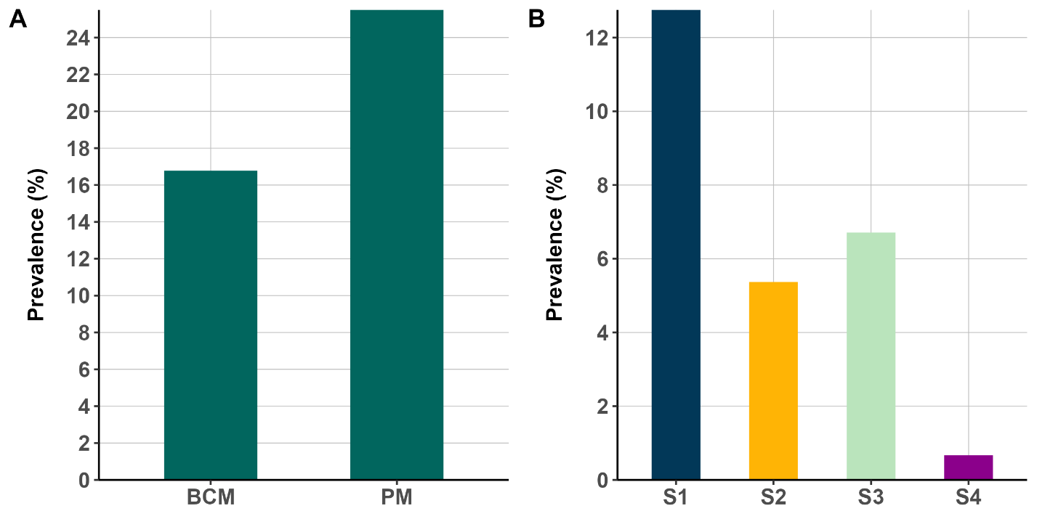
Figure 3.1 A) Percentage distribution of patent infection based on body-colour method (BCM) and pleopod method (PM) Stages 1-4. B) Distribution of pleopod patent infection percentage across different pleopod stages (prevalence-set).

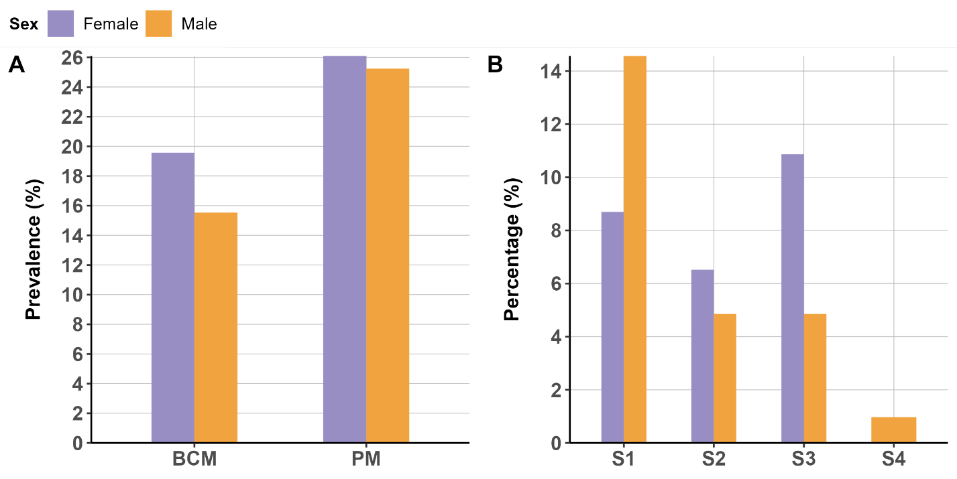
Figure 3.2 A) Distribution of patent infection percentage by sex and diagnostic method (body-colour/pleopod method). B) Distribution of pleopod patent infection percentage across different pleopod stages and sex (prevalence-set).

Infection profiles on samples from the ‘pathobiome-set’
To probe the potential existence of a pathobiome linked to Hematodinium sp. infection, a selected cohort of 200 Nephrops individuals was drawn from the catch. The selection was based on their visible characteristics, including both those with and without visible signs of disease (BCM positive and negative). These animals underwent rigorous processing procedures, ensuring the simultaneous capture of relevant data and biological samples for subsequent analyses conducted on the same day. However, following DNA extraction from the haemolymph, a refined subset of n=122 samples successfully met stringent quality control criteria and subsequently underwent in-depth analysis. Within this scrutinized subset (n=122), 44.3% were BCM positive (n=54), while 55.7% were BCM negative (n=68). Among the specimens yielding a BCM-negative result, a total of n=66 were subsequently corroborated as negative using the pleopod method (PM). Yet, after histological and molecular screening, a subset of n=45 (out of the initial n=66) were definitively ascertained to be 'Hematodinium-free,' a determination derived from both histological and PCR assessments.
The histological analysis revealed a strong correlation between the observed level of infection in the tissue sections and the pleopod scoring. The gonads, the heart and the hepatopancreas were the most frequently colonised tissue, followed by gills and muscle (Figure 3.3-Figure 3.8). In heavily infected Nephrops, Hematodinium sp. cells occluded the haemocoel spaces, causing the rupture of the tissue. No signs of cell-directed response or melanisation were observed in response to Hematodinium sp. and no co-infections were visually apparent either. Hematodinium sp. trophonts presented a variety of oval shapes and could have one or more nuclei. Information concerning the distribution of samples among diverse categories based on distinct methodologies employed for determining Hematodinium sp. infection severity is summarized in Table 3.2.
Table 3.2 Summary data for the ‘pathobiome-set’ of Nephrops norvegicus collected from the Clyde Sea Area.
Parameters | Female |  | Male |  | Total
Parameters | N | % | N | % | N | %
Sex | 56 | 45.9 | 66 | 54.1 | 122 | 100
Body colour method (BCM)
Negative (BCM) | 29 | 42.6 | 39 | 57.4 | 68 | 55.7
Positive (BCM) | 27 | 50 | 27 | 50 | 54 | 44.3
Pleopod method (PM)
S0 | 28 | 42.4 | 38 | 57.6 | 66 | 54.1
S1 | 5 | 41.7 | 7 | 58.3 | 12 | 9.8
S2 | 11 | 52.4 | 10 | 47.6 | 21 | 17.2
S3 | 4 | 36.4 | 7 | 63.6 | 11 | 9.0
S4 | 8 | 66.7 | 4 | 33.3 | 12 | 9.8
S1-4 | 28 | 50 | 28 | 50 | 56 | 45.9
Molecular diagnostic (PCR)
Negative (PCR) | 20 | 35.7 | 28 | 42.4 | 48 | 39.3
Positive (PCR) | 36 | 64.3 | 38 | 57.6 | 74 | 60.7
Histology
Negative (Histology) | 19 | 38.8 | 30 | 61.2 | 49 | 40.16
Positive (Histology) | 37 | 50.7 | 36 | 49.3 | 73 | 59.8
Negative (gill) | 22 | 40.7 | 32 | 59.3 | 54 | 44.3
Positive (gill) | 34 | 50 | 34 | 50 | 68 | 55.7
Negative (gonad) | 24 | 54.6 | 20 | 45.5 | 44 | 36.1
Positive (gonad) | 27 | 71.1 | 11 | 29 | 38 | 31.2
Negative (heart) | 22 | 40.7 | 32 | 59.3 | 54 | 44.3
Positive (heart) | 30 | 50.9 | 29 | 49.2 | 59 | 48.4
Negative (hepatopancreas) | 23 | 41.8 | 32 | 58.2 | 55 | 45.1
Positive (hepatopancreas) | 33 | 49.4 | 34 | 50.8 | 67 | 54.9
Negative (muscle) | 23 | 44.2 | 29 | 55.8 | 52 | 42.6
Positive (muscle) | 33 | 47.1 | 37 | 52.9 | 70 | 57.4
Histology/PCR
Histology/PCR (Negative / Negative) | 18 | 40 | 27 | 60 | 45 | 36.9
Histology/PCR (Positive / Negative) | 2 | 66.7 | 1 | 33.3 | 3 | 2.5
Histology/PCR (Negative / Positive) | 1 | 25 | 3 | 75 | 4 | 3.3
Histology/PCR (Positive / Positive) | 35 | 50 | 35 | 50 | 70 | 57.4
Moult stage
Hard (H) | 45 | 42.9 | 60 | 57.1 | 105 | 86.1
Soft (S) | 11 | 64.7 | 6 | 35.3 | 17 | 13.9
RM (recently-moulted) | 17 | 54.8 | 14 | 45.2 | 31 | 25.4
IM (inter-moult) | 39 | 42.9 | 52 | 57.1 | 91 | 74.6
B | 11 | 68.8 | 5 | 31.3 | 16 | 13.1
C | 39 | 43.3 | 51 | 56.7 | 90 | 73.8
D | 6 | 37.5 | 10 | 62.5 | 16 | 13.1
Size range
Immature | 13 | 25 | 39 | 75 | 52 | 42.6
Mature | 43 | 61.4 | 27 | 38.6 | 70 | 57.4
S (22.6-25mm) | 8 | 88.9 | 1 | 11.1 | 9 | 7.4
M (25-30mm) | 42 | 46.2 | 49 | 53.9 | 91 | 74.6
L (30-38.90mm) | 6 | 27.3 | 16 | 72.7 | 22 | 18.0

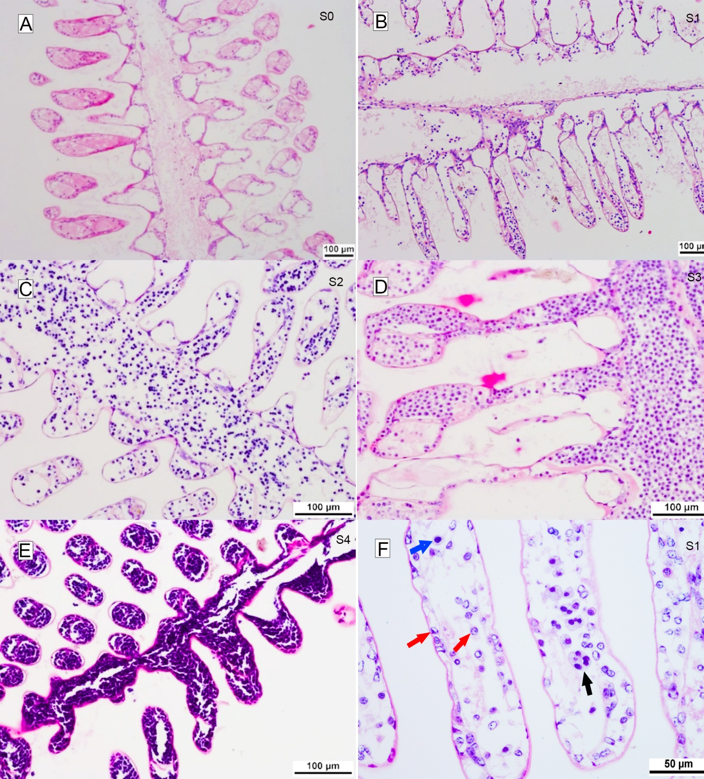
Figure 3.3 Progression of Hematodinium sp. infection in the gills of N. norvegicus, shown across infection stages 0 to 4 (A–E), based on the pleopod method (PM). F) High-magnification image of the gills at stage 1 of infection (PM). Haemocytes (red arrows), mononucleated Hematodinium cells (blue arrow), and multinucleated Hematodinium cells (black arrow) are visible. Note: No evidence of host cellular response or melanisation is observed.

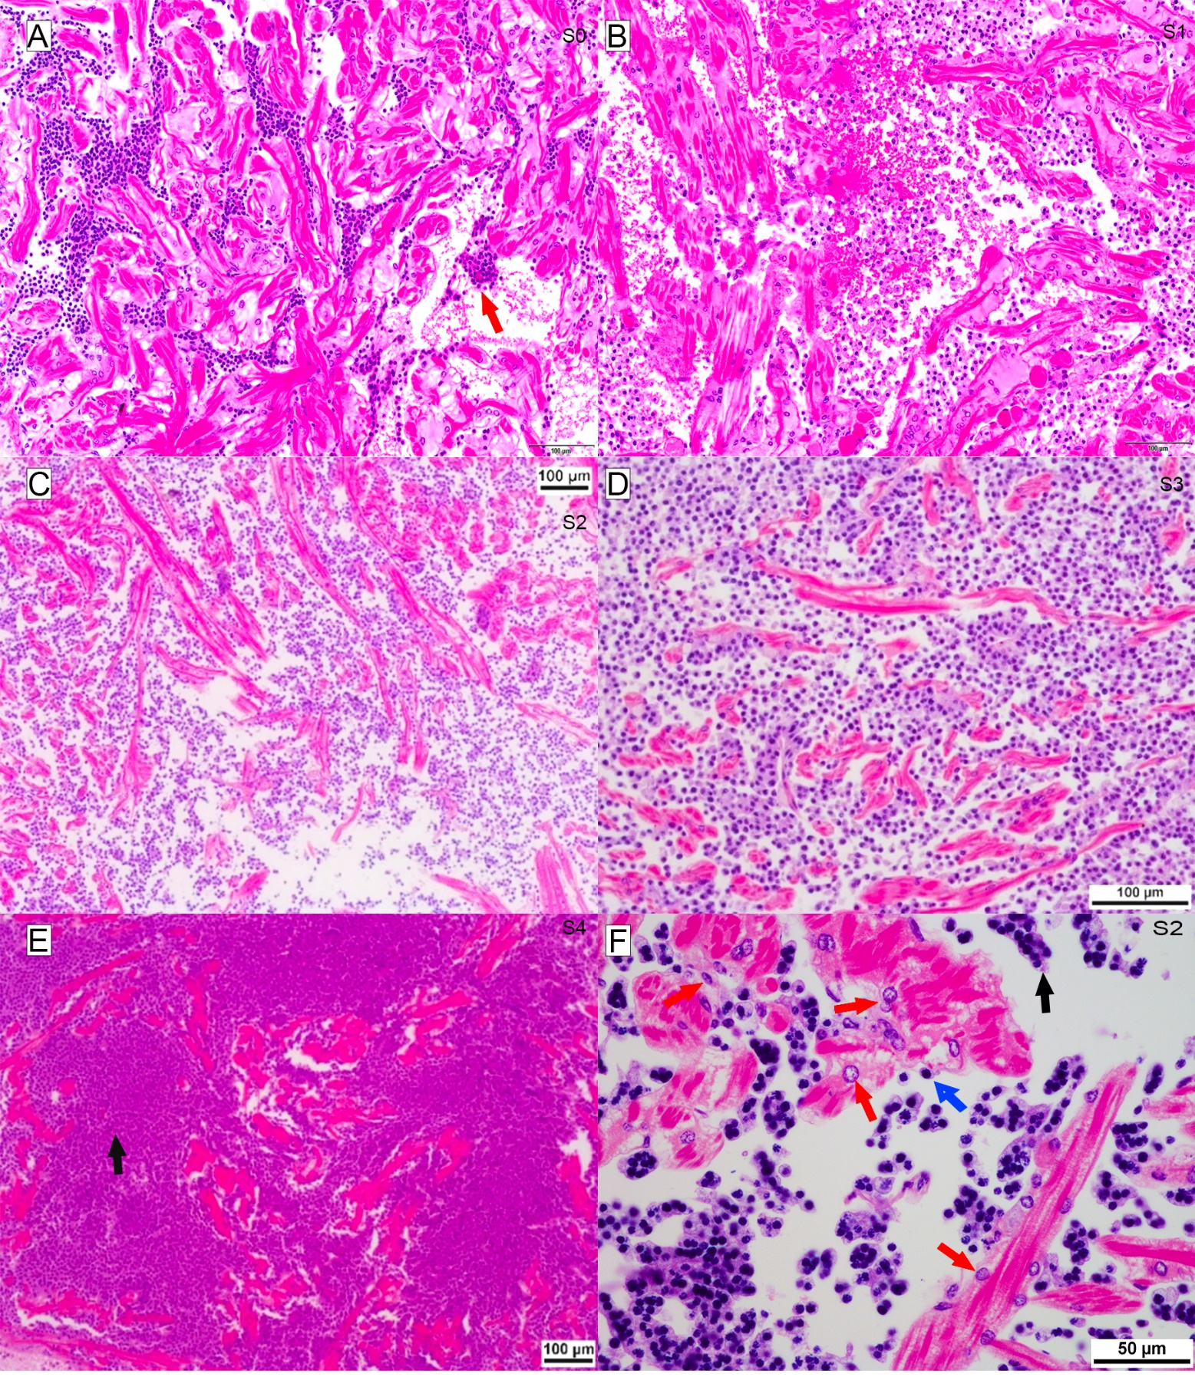
Figure 3.4 Progression of Hematodinium sp. infection in the heart of N. norvegicus, shown across infection stages 0 to 4 (A–E), based on the pleopod method (PM). F) High-magnification image of the heart at stage 2 of infection (PM). Haemocytes (red arrows), mononucleated Hematodinium cells (blue arrow), and multinucleated Hematodinium cells (black arrow) are visible. Note: No evidence of host cellular response or melanisation is observed.

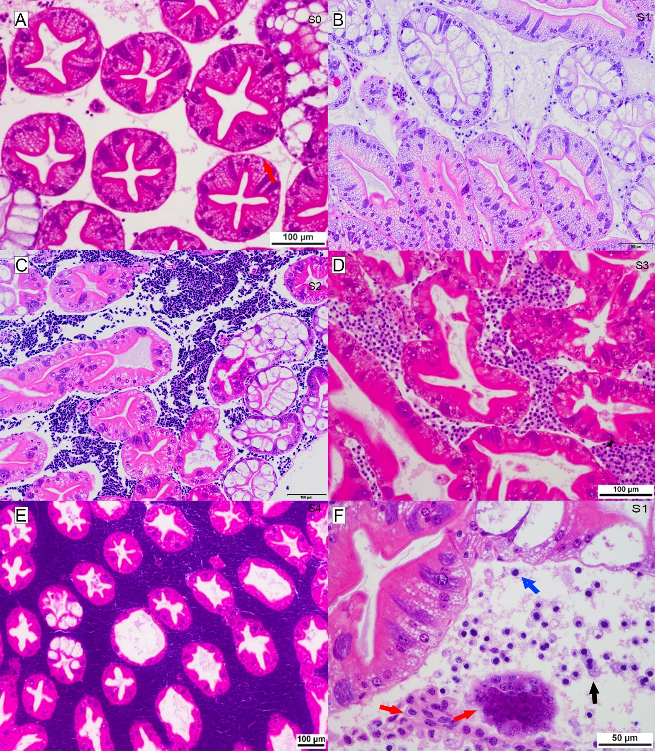
Figure 3.5 Progression of Hematodinium sp. infection in the hepatopancreas of N. norvegicus, shown across infection stages 0 to 4 (A–E), based on the pleopod method (PM). F) High-magnification image of the hepatopancreas at stage 1 of infection (PM). Haemocytes (red arrows), mononucleated Hematodinium cells (blue arrow), and multinucleated Hematodinium cells (black arrow) are visible. Note: No evidence of host cellular response or melanisation is observed.

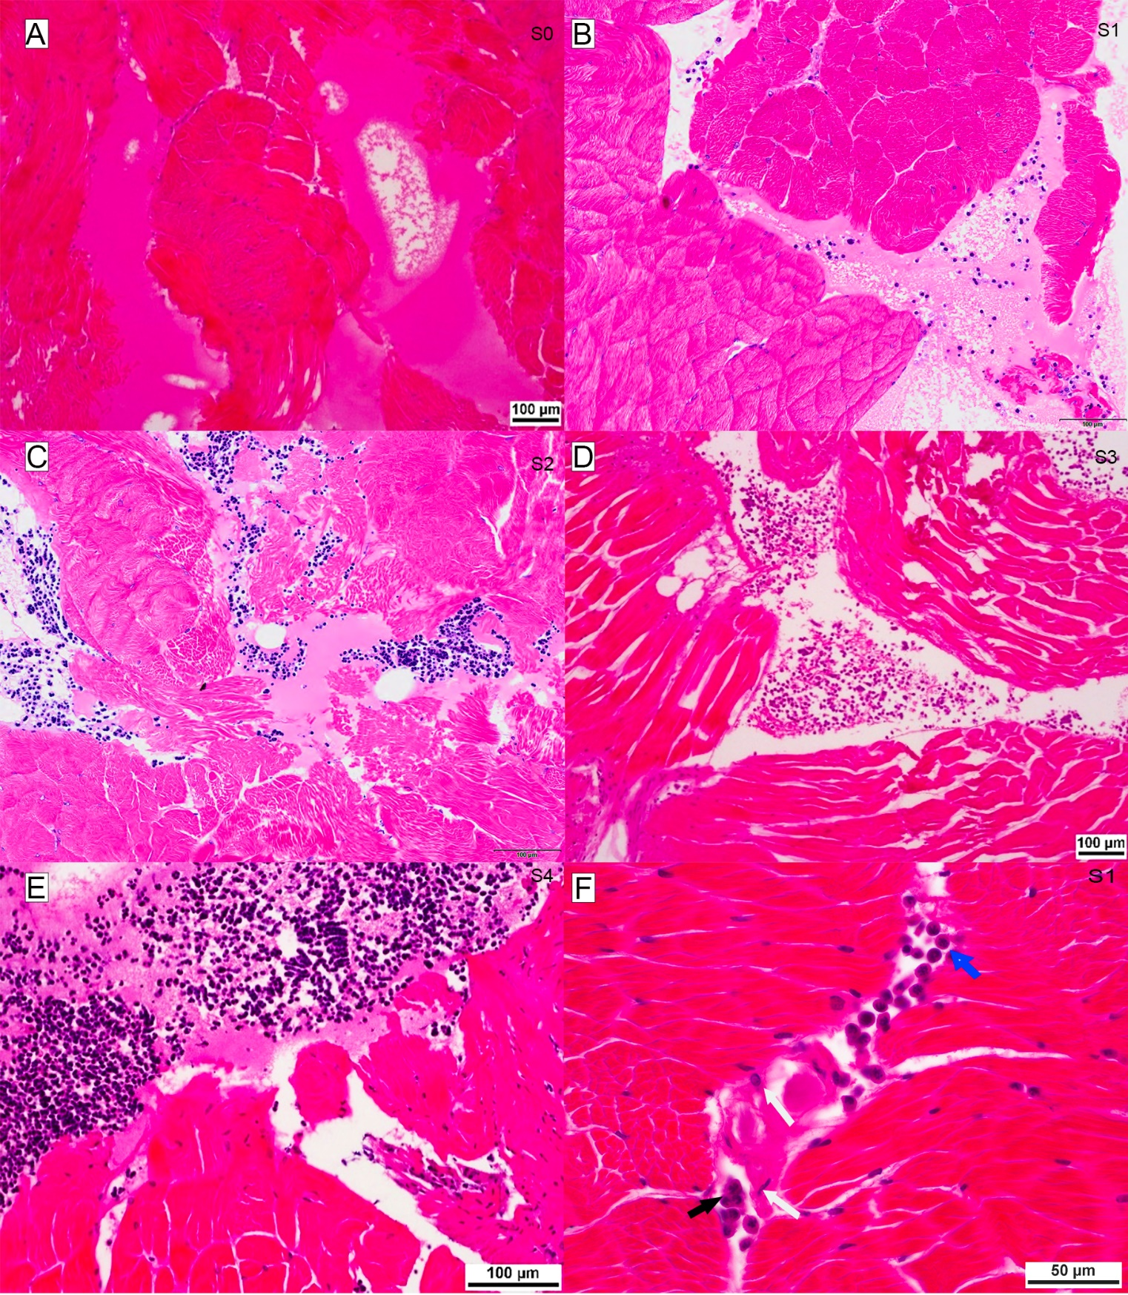
Figure 3.6 Progression of Hematodinium sp. infection in the muscle of N. norvegicus, shown across infection stages 0 to 4 (A–E), based on the pleopod method (PM). F) High-magnification image of the muscle at stage 1 of infection (PM). Haemocytes (white arrows), mononucleated Hematodinium cells (blue arrow), and multinucleated Hematodinium cells (black arrow) are visible. Note: No evidence of host cellular response or melanisation is observed.
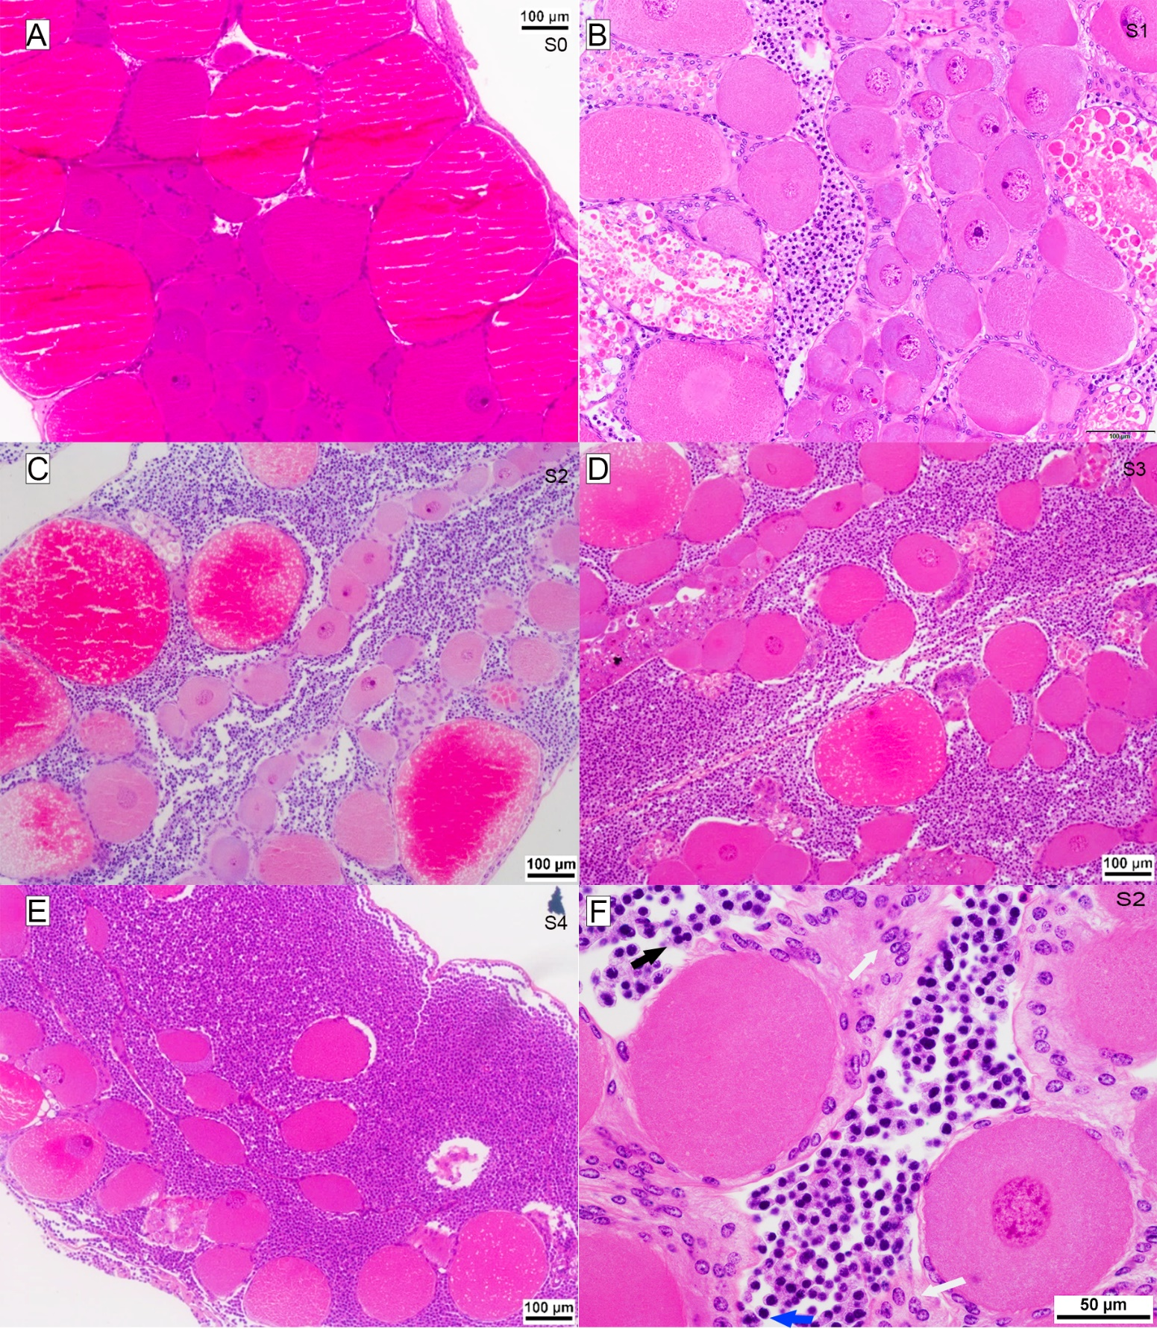
Figure 3.7 Progression of Hematodinium sp. infection in the female gonad of N. norvegicus, shown across infection stages 0 to 4 (A–E), based on the pleopod method. F) High-magnification image of a female gonad at stage 2 of infection (PM). Haemocytes (white arrows), mononucleated Hematodinium cells (blue arrow), and multinucleated Hematodinium cells (black arrow) are visible. Note: No evidence of host cellular response or melanisation is observed.
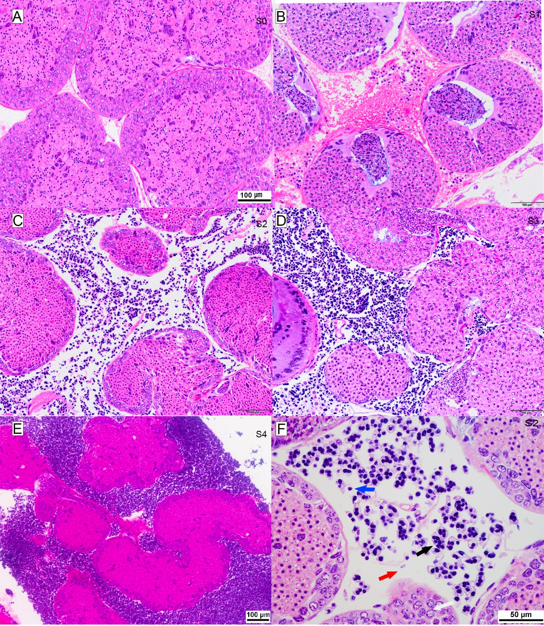
Figure 3.8 Progression of Hematodinium sp. infection in the male gonad of N. norvegicus, shown across infection stages 0 to 4 (A–E), based on the pleopod method. F) High-magnification image of a male gonad at stage 2 of infection (PM). Haemocytes (red arrows), mononucleated Hematodinium cells (blue arrow), and multinucleated Hematodinium cells (black arrow) are visible. Note: No evidence of host cellular response or melanisation is observed.

Composition of the haemolymph and gut microbiomes in 'healthy' Nephrops (Hematodinium-free)
The haemolymph and gut microbiomes of n=45 “healthy” Nephrops (Hematodinium-free by BCM, PM, histology tissue screening and haemolymph-PCR) were examined to characterise the structure of microbial communities and identify their core microbiome. The most dominant phyla in the haemolymph samples were Proteobacteria (46.1±12.4%), Firmicutes (36.7±13.0%), Bacteroidota (8.1±3.7%) and Actinobacteria (3±1.2%) (Figure 3.9A). In the gut, the dominant phyla were Proteobacteria (26.7±9%), Desulfobacterota (17.6±7.1%), Bacteroidota (14.5±4.1%), Fusobacteriota (12.9±5.7%), Firmicutes (10.0±8.5%), Verrucomicrobiota (9.5±6.1%), Spirochaetota (4.3±3.3%) and Campylobacterota (2.4±1.6%) (Figure 3.9B). The family Lachnospiraceae (13.7±6.6%) was most abundant in the haemolymph, while unclassified Alphaproteobacteria (13.3±7.2%) was the most abundant in the gut. The core haemolymph microbiome, representing 48.5% of total reads, consisted of 31 genera belonging to 26 families within 4 phyla (Proteobacteria, Firmicutes, Bacteroidota and Actinobacteriota) (supplementary Table S3. 1). On the other hand, the gut core microbiome, comprising 83.1% of the total reads, included 15 genera within 13 families spanning 8 phyla (Proteobacteriota, Desulfobacterota, Bacteroidota, Fusobacteriota, Firmicutes, Verrucomicrobiota, Spirochaetota and Campylobacterota) (supplementary Table S3. 2).

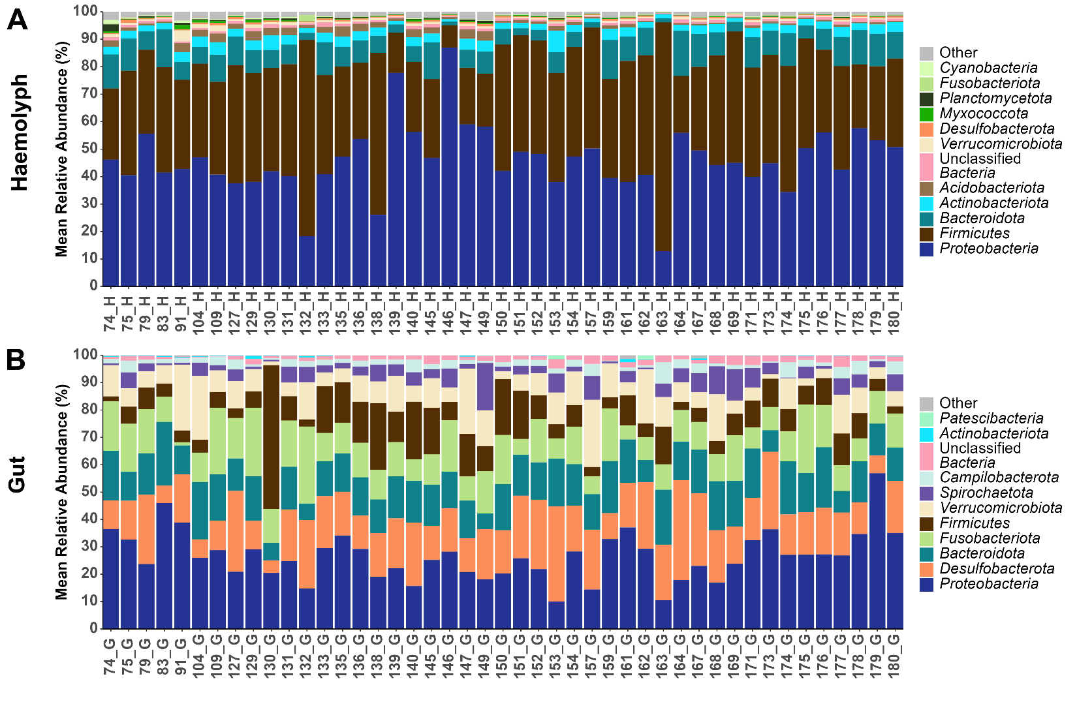
Figure 3.9 Relative abundance (%) of the microbial composition at phylum level observed in the (A) haemolymph and (B) gut of “healthy” Nephrops norvegicus, Hematodinium-negative individuals confirmed by several methods: BCM, PM, PCR and histology (n=45).

Pathobiome associated with advanced levels of Hematodinium sp. infection
The initial objective was to investigate differences associated with advanced stages of Hematodinium sp. infection. To accomplish this, the microbiome data of 'Hematodinium-free' Nephrops (confirmed as negative across all methods), was compared with data from Nephrops identified as positive for BCM and PM stages 3-4, (n=22), (see sections 1.3.4.1 and 1.3.4.2). Alpha-diversity metrics were computed, focusing on the Chao1 index to quantify microbial richness and the Inverse Simpson index to assess microbial diversity and evenness. The examination showed a noticeable decrease in bacterial community richness within the haemolymph of Nephrops during advanced infection stages, supported by a significant reduction in the Chao1 index (t-test, p-value<0.008) (Figure 3.10A). Conversely, no significant alterations were discernible in relation to microbial diversity and evenness, as indicated by the Inverse Simpson index (Wilcoxon-test, p=0.84) (Figure 3.10B). The Bray-Curtis dissimilarity index was utilised to compute beta diversity, facilitating the examination of variations in the overall composition of microbial communities. These outcomes were visually represented in the Principal Coordinate Analysis (PCoA) matrix, illustrated in Figure 3.10C. Remarkably substantial discrepancies emerged between 'Hematodinium-free' Nephrops and those in advanced stages of infection (PERMANOVA, p-value<0.006; Figure 3.10C), leading to a more tightly cohesive clustering within the 'Hematodinium-free' samples.
In contrast, the gut exhibited no discernible differences in microbial richness (Chao1 index) or diversity and evenness (Inverse Simpson index) between 'Hematodinium-free' Nephrops and those in advanced infection stages (Figure 3.10D-E). However, it's worth highlighting that the 'Hematodinium-free' samples displayed a more tightly grouped pattern in the PCoA (axis 1), and the PERMANOVA analysis showed significant differences between the two groups (PERMANOVA, p-value<0.001; Figure 3.10F).
Furthermore, distinct bacterial genera were identified with varying levels of abundance when contrasting 'Hematodinium-free' Nephrops with those in advanced stages of infection (Figure 3.11 and Figure 3.12). Notably, a total of 145 genera in the haemolymph and 88 in the gut displayed significant differences (Wilcoxon, p-value< 0.05; supplementary Table S3. 3-Table S3. 4). Among these, a total of 18 genera in the haemolymph and 12 in the gut exhibited significant differences (Wilcoxon, p-value< 0.01; Figure 3.11 and Figure 3.12, respectively). Importantly, in the haemolymph, certain genera showed a consistent decrease in abundance in Nephrops at advanced infection stages. This decrease was seen in genera like Romboutsia, Niastella, and Amphritea. On the other hand, in the gut, it was noticed that there was a significant increase in particular genera, like Muribaculaceae, Fusobacterium, and Dubosiella, in Nephrops at advanced infection stages.

Figure 3.10 Comparison of haemolymph and gut microbial communities between ‘Hematodinium-free’ Nephrops (tested negative by BCM, PM, PCR, histology; n=22) and Nephrops at advanced levels of infection (confirmed positive by BCM and PM stages 3-4; n=22). Alpha-diversity metrics of the haemolymph (A-B) and gut (D-E) comparisons are shown. Each dot represents an individual sample, and **p < 0.001. Principal Coordinate Analysis (PCoA) plots based on Bray-Curtis similarity matrix are depicted for the haemolymph (C) and gut (F) microbial communities. The ellipses represent the distribution of samples around the group centroid and illustrate the variation within each group. Colours correspond to the respective group classification (green: negative; red: positive).
Figure 3.11 A) Significant genera (p-value<0.01) observed in the haemolymph microbiota between ‘Hematodinium-free’ (NEG) and BCM and PM stages 3-4 positive (POS) Nephrops (n=22). Unclassified or uncultured bacterial genera include WD260, subgroup 5, 13, 15, RCP2-54, JG30-KF-AS9, and Blrii41.
Figure 3.12 Significant genera (p-value<0.01) observed in the gut microbiota between ‘Hematodinium-free’ (NEG) and BCM and PM stages 3-4 positive (POS) Nephrops (n=22). Unclassified or uncultured bacterial genera include Clostridia UCG-014 and NK4A214.

Pathobiome associated with Hematodinium sp. disease progression according to the PM
To understand how the microbiome interacts with the progression of Hematodinium sp. infection, a full comparative analysis using samples collected at different infection stages was conducted, categorized by the pleopod method (PM) (see section 2.3.4). As illustrated in Figure 3.13, no statistically significant differences were discernible concerning bacterial community richness, diversity, or evenness throughout the progression of disease stages (S1-S4), both within the haemolymph and the gut. Furthermore, the application of Principal Coordinate Analysis (PCoA) utilizing the Bray-Curtis dissimilarity matrix did not reveal any prominent clustering patterns (Figure 3.13C). However, the gut microbiome data showed a significant difference, indicating considerable variation as per the PERMANOVA analysis (PERMANOVA, p-value<0.047; Figure 3.13F).

Figure 3.13 Comparison of haemolymph and gut microbial communities of Nephrops norvegicus through the progression of Hematodinium sp. infection, based on the pleopod method scoring system (stages 1-4; n=10). Alpha-diversity metrics for the haemolymph (A-B) and gut (D-E) comparisons are depicted. Principal Coordinate Analysis (PCoA) plots based on Bray-Curtis similarity matrix are shown for the haemolymph (C) and gut (F) microbial communities. The ellipses represent the spread of samples around the centroid of each infection stage group and are coloured to indicate the corresponding infection stage.

Pathobiome associated with subpatent levels of Hematodinium sp
In the final analysis, 'Hematodinium-free' samples were compared with those that tested positive solely through PCR and histology but were classified as negative according to the PM. In this particular analysis, the haemolymph of subpatent-positive individuals exhibited a significant reduction in bacterial species richness (Chao1, t-test, p-value 0.0027; Figure 3.14A), while no significant differences were observed in terms of diversity or evenness (Figure 3.14B). Conversely, no variations in gut bacterial richness, diversity, or evenness were evident (Figure 3.14D-E). However, as shown in Figure 3.14F, the clustering of 'Hematodinium-free' gut samples became more distinct, with the PERMANOVA analysis revealing a significant difference (PERMANOVA, p-value<0.0018)
Figure 3.14 Comparison of haemolymph and gut microbial communities of Hematodinium-free Nephrops norvegicus (confirmed negative by BCM, PM, PCR, histology; n=18) and subpatent-infected Nephrops (confirmed positive by PCR and histology but negative according to BCM and PM; n=18). Alpha-diversity metrics for the haemolymph (A-B) and gut (D-E) comparisons are depicted. Principal Coordinate Analysis (PCoA) plots based on Bray-Curtis similarity matrix are shown for the haemolymph (C) and gut (F) microbial communities. The ellipses represent the distribution of samples around the group centroid and illustrate the variation within each group. Colours correspond to the respective group classification (green: negative; red: positive).

Discussion

Haemolymph and gut microbiomes of N. norvegicus
This study represents a novel effort aimed at a comprehensive characterization of both the haemolymph and gut microbiomes in Nephrops. Through the utilization of high-throughput 16S rRNA gene amplicon sequencing, the research aimed to describe the taxonomic composition and core microbial communities that inhabit the haemolymph and gut of visibly “healthy” Nephrops individuals not detected as being infected by Hematodinium sp. using the methods employed. The establishment of a baseline “healthy” bacterial microbiome within the host serves as a reference for identifying changes in the microbiome composition caused by Hematodinium sp. infection and its potential implications for host health.
Proteobacteria were the dominant phylum in both the haemolymph and gut, comprising approximately 46.1% in the haemolymph and 26.7% in the gut. These findings are consistent with previous investigations conducted on a range of crustaceans and aquatic invertebrates (Givens et al., 2013; González et al., 2020; Kong et al., 2023; Li et al., 2019b; Lokmer et al., 2016; Scanes et al., 2021). In addition, the phyla Actinobacteriota, Bacteroidota, Desulfobacterota, Firmicutes, Fusobacteria, and Verrucomicrobiota were present in both the haemolymph and the gut. These phyla are also typically reported among other crustacean microbiomes (Ding et al., 2017; Ooi et al., 2017; Rungrassamee et al., 2014; Wang et al., 2019). Proteobacteria are well-known for their ability to form symbiotic relationships, especially with marine organisms. In the case of Nephrops, both the haemolymph and gut provide favourable environments for Proteobacteria to thrive. Nephrops feeding behaviours and frequent interactions with the marine environment are likely responsible for introducing a wide range of microorganisms, including Proteobacteria, into their haemolymph and gut. The presence of Proteobacteria in both gut and haemolymph suggests niche adaptability; while some may be commensal or mutualistic, others could be opportunistic or pathogenic. Moreover, considering Nephrops is a burrowing decapod crustacean inhabiting benthic environments, predominantly muddy substrates, the prevalence of phyla commonly observed in sediment samples, including Actinobacteria, Acidobacteria, Chloroflexi, and Firmicutes, is not unexpected (Huang et al., 2020a; Meziti et al., 2010).
The investigation into the core microbiome of the haemolymph revealed the existence of potentially advantageous genera, including Bifidobacterium, Lactobacillus, Faecalibacterium, and Subdoligranulum. These genera have been observed in the “healthy” gut microbiomes of crustaceans and have been associated with the well-being of cultured shrimp (Cornejo-Granados et al., 2017). They also possess the ability to generate enzymes that facilitate the fermentation of indigestible carbohydrates into short-chain fatty acids (SCFAs) (Flint et al., 2012), essential for maintaining gut health (Al Bander et al., 2020; Lin et al., 2021). SCFAs have been recognised for their anti-inflammatory and immunomodulatory properties (Tan et al., 2014). It is possible that these bacterial genera serve a similar function in the haemolymph, with their presence indicating the potential for taxa translocation between the gut and haemolymph (Zhang et al., 2020a). Among the core haemolymph genera, the presence of opportunistic aquatic pathogens, including the Pseudomonas, Enterobacter, and Acinetobacter genera was also detected.
In contrast, the core gut microbiome comprises a diverse range of genera, including those associated with anoxic marine environments, as well as potential pathogens. Notably, among these are sulfate-reducing bacteria (SRB), represented by genera such as Desulfocapsa, Desulfovibrio, and Desulfotalea, which may also contribute to digestion organic matter (OM) (Liang et al., 2023). Another significant finding was the presence of the Carboxylicivirga genus within the core gut community. This newly recognised genus, typically found in marine sediment (Zhang et al., 2021), was also identified in the core gut microbiomes of other species, including the mud crab (Scylla paramamosain) (Li et al., 2012; Wei et al., 2019), and the European lobster Homarus gammarus (Holt et al., 2020), however, its role in both the environment and its host remains relatively unexplored (Yang et al., 2014).
Consistent with Foysal (2023)’s meta-analysis of essential gut bacteria in decapod crustaceans, Candidatus Bacilloplasma was identified as one of the key members of the core gut community. Duan et al. (2021) documented the prevalence of Candidatus Bacilloplasma in the “healthy” intestine of whiteleg shrimp (Litopenaeus vannamei), highlighting its positive correlation with various pattern recognition receptors and thus emphasizing its potential influence on host immune responses. In contrast, an increased presence of Candidatus Bacilloplasma has been observed in infected individuals with White Faeces Syndrome (WFS), which has been associated with a reduced richness/diversity (Hou et al., 2018; Huang et al., 2020c). Moreover, Candidatus Bacilloplasma has the ability to interact with pathogenic Vibrio strains, potentially leading to either an enhancing or inhibitory effect on the dynamics of infection (Chen et al., 2017b).
Vibrio and Photobacterium, both belonging to the Proteobacteria phylum, are frequently encountered within the core gut community of aquatic invertebrates, whether “healthy” or infected with disease. Some species within these genera are known as opportunistic pathogens, making them significant threats in aquaculture (de Souza Valente and Wan, 2021; Rungrassamee et al., 2014; Vaseeharan et al., 2007). Vibrio, known for causing Vibriosis, often produce chitinolytic enzymes (Sugita and Ito, 2006), which could account for their prevalence in chitin-rich environments such as the gut of crustaceans, where they find a suitable source of nourishment (Sugita and Ito, 2006). However, even seemingly harmless Vibrio strains have demonstrated virulent behaviour in immunocompromised shrimp such as black tiger shrimp, (Penaeus monodon) (Manilal et al., 2010) and whiteleg shrimp (Litopenaeus vannamei), as evidenced by their increased presence in diseased animals compared to their “healthy” counterparts (Dong et al., 2021; Gopal et al., 2005). No significant variations in Vibrio levels were detected in relation to Hematodinium sp. infection in either the gut or the haemolymph of Nephrops. Additionally, Psychrilyobacter, a bacterial genus utilizing sugars, amino acids, and peptone as carbon sources, was identified within the core gut microbiome. It has also been prominently observed in the gut microbiomes of the deep-sea hydrothermal vent crab (Austinograe sp.) (Zhang et al., 2017) and green mud crab (Scylla paramamosain) (Wei et al., 2019). Psychrilyobacter production of H₂ and acetate as primary fermentation byproducts suggests a potential role in facilitating adaptation to hypoxic conditions (Zhang et al., 2017).

Changes in the microbiome linked to Hematodinium sp. infection
Outbreaks of Hematodinium infections have been reported in both wild and farmed crab populations (Wang et al., 2017). Within the Clyde Sea Area, the prevalence of Hematodinium sp. infections in Nephrops has been monitored since the late 1980s. In this region, the prevalence of Hematodinium sp. infections exhibits a distinct seasonal peak during the spring season, while the application of more sensitive diagnostic methods has shown the continuous presence of subpatent infection levels throughout the entire year (Beevers et al., 2012). Consistent with prior research and data from the previous year, this study results further emphasize an increased infection peak during this specific period (March; 17% BCM; 26% PM; high prevalence, high severity). From a pathological perspective, the initial stages of infection manifest with minimal changes in haemocyte counts and a moderate presence of the parasite within tissues. However, as the infection progresses into advanced stages, there is a notable proliferation of the parasite across diverse tissue types, leading to a state of metabolic exhaustion and muscle necrosis (Stentiford et al., 2001b; Stentiford et al., 2000).
These findings indicate that Hematodinium sp. infection does not seem to influence bacterial diversity and evenness in either the gut or the haemolymph. However, a significant decrease in bacterial community richness was observed in the haemolymph. While overall diversity was preserved, a noticeable change in the overall bacterial community structure was observed in both the gut and haemolymph of heavily infected individuals. Interestingly, this shift was identified even in the early stages of subpatent infection, where animals tested positive only by PCR. The fact that these changes occur at such an early stage and persist as the disease progresses indicates that the microbiome reacts swiftly to Hematodinium sp. infection, and that these disruptions endure as the disease advances.
Since Hematodinium primarily inhabits and proliferates within the haemolymph, causing a decline in haemocyte counts and transforming the haemolymph into a white milky fluid, noticeable alterations in the richness of the microbial community within the haemolymph were evident from the early phases and advanced phases of infection. A similar trend of reduced richness has previously been reported in cases of shrimp affected by white faeces syndrome (WFS) (Huang et al., 2020c; Munkongwongsiri et al., 2022). Additionally, a significant dysbiosis in the overall bacterial community composition of the haemolymph was apparent, with the analysis of different genera highlighting a notable reduction in the abundance of over 100 genera in the infected group. Notably, within this group, genera like Blautia, Lachnospiraceae unclassified, and Cellulosilyticum, all belonging to the Lachnospiraceae family, displayed decreased presence. Lachnospiraceae are cellulose-degrading bacteria capable of fermenting polysaccharides to short-chain fatty acids and have been identified in the “healthy” microbiomes of various species, including the Chinese mitten crab (Eriocheir sinensis) (Su et al., 2020; Vacca et al., 2020). Similarly, Peptostreptococcaceae (Acetoanaerobium, Intestinibacter, Paeniclostridium, Peptostreptococcaceae unclassified, Romboutsia), known for their significant fermentative metabolic capabilities, exhibited noticeable reduction. This family was also described in green mud crab (Scylla paramamosain) (Lin et al., 2022). In contrast, the haemolymph of Hematodinium-positive individuals displayed an increased abundance of genera such as Rhodovulum, Tessaracoccus, Chryseobacterium, Sphingobacterium, Wolinella, Rurimicrobium, Calditerrivibrio, Butyrivibrio, Crenothrix, Hydrogenophilus, and Xanthomonas. Rhodovulum has been linked with responses to thermal stress (Pootakham et al., 2019), whereas some Tessaracoccus spp. have more recently gained recognition as likely human pathogens (Seck et al., 2016).
While the alpha diversity indices of the gut microbiome showed no significant changes, a remarkable shift in the overall composition of the gut community was observed. This finding is in line with Wang et al. (2019) study, which reported no substantial alterations in gut microbial richness and diversity during white spot syndrome virus (WSSV) infection in whiteleg shrimp (Litopenaeus vannamei). However, they did detect a significant variation in beta diversity, indicating a notable change in community composition. Similarly, no substantial variations in gut community composition or alpha diversity were observed between 'blue body syndrome' (BBS)-infected and “healthy” whiteleg shrimp (Litopenaeus vannamei) individuals. Nevertheless, the NMDS analysis did reveal a distinct pattern distinguishing infected individuals from their non-infected counterparts within the gut microbiota (Liang et al., 2020). The gut of infected Nephrops exhibited a substantial increase in the abundance of more than 80 genera. Notably, during advanced Hematodinium sp. infections, animals display lethargy and a state of deterioration attributed to parasite-induced metabolic exhaustion and nutrient depletion (Rowley et al., 2015). Despite their weakened condition, heavily infected animals continue to ingest food, as observed from the findings of stomach contents being either full or partially full. However, their dietary choices might be more constrained, resulting in a reduced inclination to act as predators and an increased reliance on plant-based and suspension feeding, potentially influenced by seasonal patterns and food availability. This shift in feeding behaviour could potentially account for the elevated relative abundance of bacterial families capable of degrading complex polysaccharides (such as Prevotellaceae, Bacteroidaceae, Muribaculaceae, Lachnospiraceae, Akkermansiaceae) in infected individuals compared to their non-infected counterparts. Interestingly, the sustained feeding behaviour exhibited by infected animals could potentially contribute to the lack of shifts in microbial richness as the infection progresses. Additionally, significant increases in the abundance of Erysipelotrichaceae and Hydrogenophilaceae were noticed within the gut of Hematodinium-infected Nephrops. Among these, members of the family Erysipelotrichaceae—including Dubosiella, Faecalibaculum, Ileibacterium, and Turicibacter—have gained recognition for their strong immunogenicity and their positive association with host inflammation in humans and cattle (Ellerbroek, 2018; Zhong et al., 2020). These taxa are prominently enriched in herbivore/omnivore species. Turicibacter has been described previously in American lobster (Homarus americanus) infected with Epizootic shell disease (ESD) (Meres, 2016). The increased presence of Hydrogenophilus could be attributed to its ability to thrive under environmental stress and nutrient scarcity (Arai et al., 2018). Dubosella is involved in reducing oxidative stress, improving vascular endothelial function, and redistributing gut microbiota (Liu et al., 2023). Conversely, the abundance of genera such as Desulforhopalus, Lentisphaeria unclassified, Desulfovibrionaceae unclassified, Peptoclostridium, and unclassified Verrucomicrobiota generaP.palmC41 demonstrated a marked decrease in Hematodinium-infected Nephrops. Peptoclostridium is involved in carbohydrate fermentation, whereas Desulforhopalus and Desulfovibrionaceae are associated with sulphur metabolism (Ward et al., 2021). Changes in the abundance of these genera provide further support for the hypothesis that infected animals tend to rely more on a diet of detritivores and suspensivores.
The microbiome holds significant importance in crustacean species, exerting influence over the host immune system and facilitating interactions that can trigger defensive responses against a range of pathogens (Diwan et al., 2022). The host's immune response to Hematodinium sp. infection remains a subject of continuing debate. Immunomodulatory effects have been identified at both post-transcriptional and translational levels of haemocytes upon exposure of the Chinese swimming crab (Portunus trituberculatus) to Hematodinium perezi challenge (Li et al., 2022). In contrast, observations on Hematodinium-infected green shore crabs (Carcinus maenas) present a different perspective. In these crabs, disease progression did not correlate with an increase in secondary infections, and no signs of haemocyte reactivity towards the infection were detected. This implies the absence of a cell-driven immune response at both early and advanced infection stages (Davies et al., 2022). Research conducted by Rowley et al. (2015) suggests that Hematodinium may have the capacity to elude the immune defences of the host, at least in edible crab (Cancer pagurus). Likewise, the histological results from this study indicate an absence of host reaction to Hematodinium sp.. The onset and progression of infections caused by protozoan parasites such as Giardia, Entamoeba, and Cryptosporidium are influenced by complex interactions between the microbiota, the parasites themselves, and the host immune system. (Ulusan Bagci and Caner, 2022). Although the underlying mechanisms are complex, they present an intriguing area for exploration, suggesting a possible interaction between microbial changes and immune responses. This interaction, along with the microbiome's potential impact on parasite virulence (Bär et al., 2015), warrants further investigation in future studies. Hence, an imbalance in the microbial community (dysbiosis) might potentially contribute to infection or act as a predisposing factor (Xiong et al., 2015). Future research should prioritize elucidating the fundamental mechanisms that govern the interaction between the host, its microbiome, and the parasite.

Conclusions
In conclusion, this study offers a comprehensive and advanced characterization of the haemolymph and gut microbiomes of 'healthy' Nephrops in the Clyde Sea Area, Scotland. It sheds light on the taxonomic composition and core communities of these two tissues. Furthermore, it examines the fluctuations of haemolymph and gut microbiomes during the peak of Hematodinium infection. The findings highlight the potential impact of infection on microbiomes, evident through changes in haemolymph bacterial richness and a notable shift in the relative abundance of specific genera in both tissues, suggesting potential dysbiosis. These alterations, observed even at the initial infection stages, indicate a swift and persistent microbiome response to the parasitic infection. The modifications in microbial community composition that correspond to the infected condition also offer intriguing prospects for exploration of the potential role of the microbiome in host-parasite interactions. However, the mechanisms behind these observed changes require further investigation. This calls for a more comprehensive exploration of the functional roles and interactions of the identified microbiota, along with an exploration of the host's immune response, to gain a complete understanding of the complex dynamics characterizing the interplay among host, microbiome, and parasite in Nephrops.

Sporulation dynamics and host lipid dependency of Hematodinium sp. infecting Nephrops norvegicus

Abstract
The parasitic dinoflagellate Hematodinium sp. infects a wide range of decapod crustaceans, including the Norway lobster (Nephrops norvegicus), which supports one of the most valuable shellfish fisheries in Europe. Two morphologically distinct spore types—macrospores and microspores—are believed to be the primary infectious stages driving Hematodinium transmission. However, the biological processes underpinning sporulation in natural hosts and the parasite’s reliance on host-derived resources remain poorly understood. This study investigated the in vivo sporulation dynamics of Hematodinium sp. in Nephrops norvegicus from the Clyde Sea Area (CSA), focusing on the morphological characterisation of spores and the host–parasite lipid interactions. Sporulation events were observed under controlled laboratory conditions in individuals with advanced infections, and ultrastructural analyses confirmed the presence of mature macrospores. Lipid profiling revealed a strong compositional overlap between macrospores and the host hepatopancreas, with macrospores exhibiting enrichment in energy-dense lipids such as triacylglycerols and polyunsaturated fatty acids (DHA and EPA). These findings suggest that Hematodinium sp. actively exploits host lipid reserves to support sporogenesis, enhancing spore survival. This study provides novel insights into the reproductive biology of Hematodinium sp. and highlights lipid scavenging as a potential mechanism of host exploitation. Future research should aim to identify the environmental and physiological cues that initiate sporulation and to clarify the respective roles of macrospores and microspores in the parasite’s transmission cycle.

Introduction
Parasitic dinoflagellates, particularly the genus Hematodinium, possess the ability to produce and release motile bi-flagellated spores (Cachon and Cachon, 1987; Shields, 1994). These spores, referred to as "swarmers," are believed to act as independent infective stages, allowing them to spread and infect new hosts (Frischer et al., 2006; Li et al., 2021a; Stentiford and Shields, 2005).
Hematodinium sp. enters the underlying tissues, including the haemocoel, and multiplies within various tissues and organ systems, such as the heart, hepatopancreas, connective tissue, and haemolymph (Rowley et al., 2015; Stentiford and Shields, 2005). The parasite continues to multiply in the haemolymph and tissues, leading to a high cell density, which serves as a trigger for spore generation (Appleton and Vickerman, 1998; Beevers, 2010). While not fully proven, molecular evidence suggests that methyl farnesoate, a hormone involved in the moulting process, may be necessary for the parasite's multiplication (Gornik et al., 2015) (see section 1.3.3).This proliferation of parasitic cells gives the haemolymph a milky-white appearance. Eventually, parasite multiplication leads to sporulation event(s). The trigger for the parasite to exit its host via spore release is not known, although two plausible explanations include the accumulation of toxic metabolites in the host's haemocoel or a depletion of the host's reserves (Beevers, 2010; Shields et al., 2003; Taylor et al., 1996).
During the sporulation process, spores are released from the host as a visible cloud, a phenomenon reported in various species, including Nephrops (Appleton, 1996), edible crab (Cancer pagurus) (Stentiford et al., 2002), snow crab (Chionoecetes opilio) (Meyers et al., 1987), and tanner crab (Chionoecetes bairdi) (Love et al., 1993), among others. As a result of sporulation events, the number of parasite cells remaining within the host significantly decreases (Appleton and Vickerman, 1998).
The exact transmission mechanism of Hematodinium sp. remains unknown, although waterborne transmission is considered a likely pathway (Huang et al., 2021; Li et al., 2021a; Li et al., 2011; Stentiford and Shields, 2005). Dinospores can enter Nephrops through various routes, including the gills, breaks in the integument (Hanif et al., 2013), suspension-feeding (Briggs and McAliskey, 2002) or ingestion of infected individuals (Shields, 1994). Additionally, alternate hosts may serve as reservoirs and contribute to the parasite's transmission (Pagenkopp Lohan et al., 2012). In the Clyde Sea Area (CSA), Hematodinium sp. sporulation peaks in late spring (March), ahead of Nephrops female’s primary moulting season (May-June). This temporal correlation suggests that recently-moulted individuals, with softened exoskeletons, may be more susceptible to penetration by Hematodinium sp. spores (Pagenkopp Lohan et al., 2012).
Dinospores in Nephrops can be categorized into two types: macrospores (16–20 μm in length) and microspores (11–14 μm in length), with microspores exhibiting faster swimming speeds compared to macrospores (Appleton and Vickerman, 1998). Both types of spores are equipped with two flagella, one longitudinal and one transverse, and they swim in a characteristic corkscrew pattern.
Prolonged Hematodinium sp. parasitism severely compromises the host, ultimately leading to its death following sporulation (Appleton, 1996). The presence of a high parasite burden in hosts like edible crabs (Cancer pagurus) results in their exhibiting signs of lethargy and near-death condition (Rowley et al., 2015). This phenomenon arises from the parasites' rapid proliferation, which depletes the host's resources in both edible crabs (Cancer pagurus) and blue crabs (Callinectes sapidus) (Rowley et al., 2015; Shields et al., 2003; Shields and Squyars, 2000). As the parasite load intensifies in advanced infections, it leads to muscle necrosis (Stentiford and Neil, 2000) and a state of "metabolic exhaustion" and a systemic organ failure (Shields et al., 2003; Taylor et al., 1996). This state is marked by a substantial decrease in plasma proteins, including haemocyanin, which serves dual roles as a respiratory pigment and an immunologically active molecule (Coates and Nairn, 2014).
Sporulation represents a significant investment of resources for the parasite as it involves complete evacuation of the Hematodinium sp. parasite in the form of spores from the host (Beevers, 2010). Understanding the survival of spores in the sea and their ability to locate new hosts is crucial. Survival experiments have been conducted in vitro, demonstrating that Hematodinium sp. spores can survive for an average of 58 days for microspores and 90 days for macrospores (Appleton and Vickerman, 1998). Similar results were reported by Meyers et al. (1987).
Lipids play diverse and vital roles in cell and organism biology, serving as the main structural components of biomembranes, anchoring proteins and glycoconjugates, acting as signalling molecules, and contributing to energy storage through cellular lipid droplets and plasma lipoproteins (Ramakrishnan et al., 2013; van der Meer-Janssen et al., 2010). Typically, pathogens actively target lipid-rich host environments (Tanowitz et al., 2011; van der Meer-Janssen et al., 2010) or manipulate the host to increase lipid availability (Gilk, 2012; Lingelbach and Joiner, 1998; Meester et al., 2011; Naderer and McConville, 2011; Singh et al., 2012), enabling them to interfere with host cell processes, facilitating their survival and replication, and contributing to their pathogenesis (Mondal et al., 2009; Ramakrishnan et al., 2013; van der Meer-Janssen et al., 2010).
Earlier investigations have reported the presence of noticeable lipid-like droplets within the cytoplasm of Hematodinium sp. trophonts and spores, indicating their potential function as energy reserves during the spores' shift to seawater (Appleton, 1996; Meyers et al., 1987). Lipid droplets are vital for maintaining lipid and energy balance in cells (Jarc and Petan, 2019; Olzmann and Carvalho, 2019). Research indicates that various pathogens have interactions with lipid droplets (Kumar et al., 2006; Melo et al., 2003).
The hepatopancreas is a key organ for lipid storage in decapods and holds a crucial function in lipid metabolism (Cavalli et al., 2000; Johnston et al., 2003; Wang et al., 2014) (see section 1.1.1). Additionally, observations made during this study agree with reports by other authors indicating that Hematodinium sp. parasites preferentially target the heart, gonads and hepatopancreas, which are lipid-rich tissues (Stentiford and Neil, 2011). However, it is not known if Hematodinium sp. targets specific lipid and/or fatty acids to direct to the spores or if lipid profiles in Hematodinium sp. spores reflect the lipid composition available in the host.
This study aims to investigate the lipid metabolic dependency of Hematodinium sp. upon its host Nephrops. To this end, in this research the types of lipids scavenged by the parasite from the host during disease progression and the spores naturally generated by Hematodinium sp. spores will be examined and a comparison made between these profiles and the host lipid profiles. Through these investigations, insights into the parasite's nutrient acquisition needs, its impact on the host's lipid metabolism, and its overall success are sought. To achieve this, the lipid class and fatty acid profiles (total and within each lipid class fraction) of both spores (once released naturally to the environment) and the hepatopancreas in sporulated and non-sporulated animals infected with different levels of patent Hematodinium sp. infection using pleopod method, were analysed.

Materials and Methods

Ethics statement
This protocol was approved by the University of Stirling Animal Welfare and Ethical Review Body (AWERB (15/16) 78).

Acquisition of live Hematodinium infected Nephrops
Nephrops were trawled from the Clyde Sea Area (55°45.482N, 4°53.375W) aboard the commercial vessel Eilidh Anne GK2 between end of January and March 2020. Animals were caught in three separate trawls conducted on January 28, 2020, February 25, 2020, and March 10, 2020. Onboard, Nephrops were separated from bycatch and sorted into different tubes sets according to the body colour method (BCM) initially separating visually infected from non-visually infected. Nephrops were then transported to Scotprime Seafoods Ltd, where they were kept in running seawater for 24 hours. Animals were transported to the University of Stirling in an insulated water container (model SP-BI220 - Sanderson Plastic Products). On arrival, Nephrops were tagged and evaluated for sex, carapace length (CL), damage and shell hardness. A pleopod sample was collected from each Nephrops in order to determine pleopod staging (pleopod method, PM) and moult stage (Philp and Marteinsdottír, 2013). Individually tagged animals were classified into three categories and kept in separate tanks: non-infected (stage 0; n=32), low to moderate infection (stages 1-2, PM; n= 45) and heavily infected (stages 3-4, PM; n=42).
A total of n=119 animals, consisting of n=64 males and n=55 females, were captured and kept in tanks for this study (Table 4.1).

Animal husbandry and experimental conditions
Tanks were held in a cold room at temperature between 8°C-12°C on a 12:12 light/dark photoperiod cycle. Every day, nitrate, nitrite, ammonia, and pH levels were measured. Aerators were provided for all tanks. Throughout the experiment, the animals were not fed. Heavily infected Nephrops (stages 3-4, PM; n=42) were individually placed into the ‘sporulation tanks’ (28cm (L) x 11 (W) cm) (Figure 4.1A) containing 1.5 L of artificial seawater (Instant Ocean® Sea Salt), 33-35 PSU (practical salinity units), and maintained at a pH 7.6-8.4. The water was replaced every 24 hours until sporulation occurred. A 50 L tank was used to hold infected animals (stages 1-2, PM; n=45). A second 50 L holding tank filled with natural seawater was used for non-infected/control animals (stages 0, PM; n=32). Artificial seawater was used to replace 40% of the total volume daily. To prevent attacks and cannibalism in the 50 L holding tanks, small dividers were used (Figure 4.1B). Furthermore, tank enrichment using short segments of pipeline were introduced as shelter.
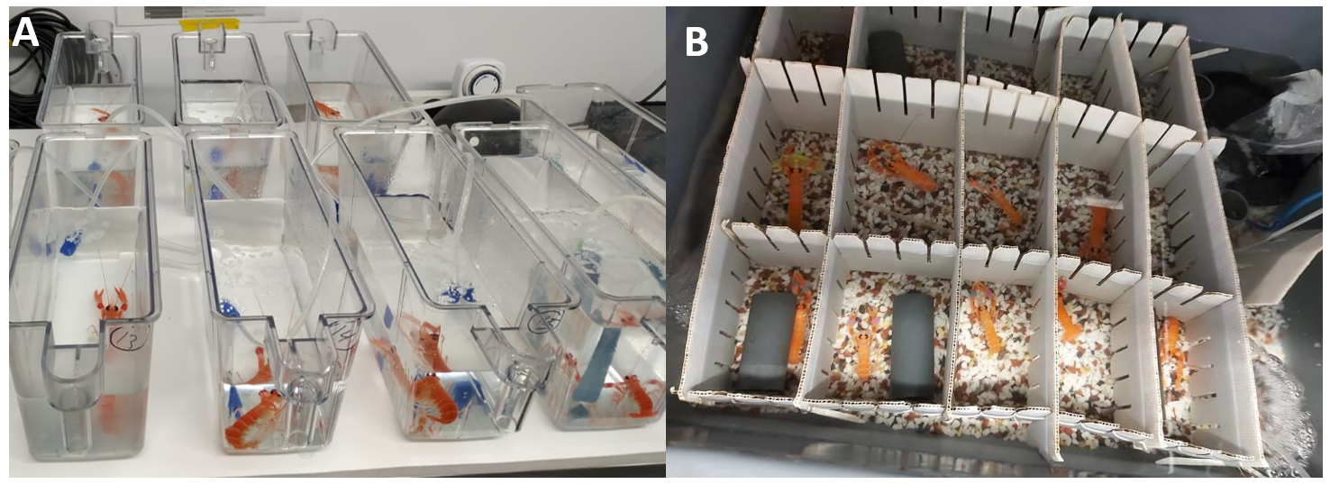
Figure 4.1 A) Nephrops with high infection levels kept in individual sporulation tanks (28 cm (L) x 11 cm (W)), each containing 1.5 L of artificial seawater. B) Control holding tank (50 L) with non-infected Nephrops.

Collection of spores and hepatopancreas
During sporulation events, live spores were released, causing the water to become white-cloudy. To ensure the complete evacuation of spores from the host, the animals were transferred to clean tanks every hour and monitored for approximately four hours for any additional spore release. The spore collection method described by Beevers (2010) was followed with some modifications. Spores were collected by sub-aliquoting the artificial seawater containing spores into 50 mL falcon tubes, which were then washed three times with artificial seawater by spinning at 400 x g for 5 min at 4°C. Washed spores were resuspended in 1 ml of artificial seawater and stored at -80°C for further analysis. Animals that sporulated usually died (n=3) within hours, while those that survived sporulation (n=1) were euthanised after 24 h.

Hepatosomatic index
Hepatosomatic index was measured from BCM-negative individuals (n=3), BCM-positive individuals (n=26), and sporulated individuals (n=4). Among the individuals classified as BCM-negative, only two were identified as negative or stage 0 by the PM method, while the remaining individual exhibited a stage 1 PM infection. Within the BCM-positive group, the distribution was as follows: stage 1 (n=4), stage 2 (n=5), stage 3 (n=11), and stage 4 (n=9). Among sporulated animals, three individuals were categorized as stage 3, and one individual was classified as stage 4.
Hepatosomatic index (HSI) was calculated using the following formula:
$$HSI= \frac{Hepatopancreas wet weight(g)}{Body wet weight(g)}×100$$

Histopathology
The hepatopancreas from sporulated animals (n=4) was dissected, weighed, and subsequently stored at -80°C for future use. Similarly, portions of the hepatopancreas were sampled from two distinct groups: BCM-negative individuals (n=12) and BCM-positive individuals (non-sporulated) (n=28). Among the individuals classified as BCM-negative, only seven were identified as negative or stage 0 by the PM method, while the remaining individuals (n=5) exhibited a stage 1 PM infection. Within the BCM-positive group, the distribution was as follows: stage 1 (n=4), stage 2 (n=6), stage 3 (n=10), and stage 4 (n=8). Among sporulated animals, three individuals were categorized as stage 3, and one individual was classified as stage 4.
From the excised hepatopancreas, a small portion was taken and placed in Davidson's seawater fixative for 24 h, followed by transfer to 70% ethanol. All sample processing was conducted at CEFAS (Centre for Environment, Fisheries, and Aquaculture Science).
Subsequently, the sections obtained from the samples were stained with haematoxylin and eosin (H&E). Standard light microscopy was employed to analyse the stained sections, and digital images were captured using the LuciaTM Screen Measurement System from Nikon.

Electron microscopy
In the electron microscopy analysis, the hepatopancreas of individuals infected with Hematodinium sp., identified as positive by both the BCM and PM methods (n=11), along with macrospores (n=2), obtained specifically from two individuals in stage 3 of PM infection were scrutinised. Among the BCM-positive samples, the distribution across infection PM stages was as follows: stage 1 (n=2), stage 2 (n=4), stage 3 (n=3), and stage 4 (n=2).
The preservation of spores (n=2) and hepatopancreas tissue (n=11) followed the procedure outlined in Stentiford et al. (2003).Click or tap here to enter text.. Small tissue blocks measuring 2 mm³ were fixed in a solution containing 2.5% glutaraldehyde, 0.1 M sodium cacodylate buffer (pH 7.4), and 1.75% sodium chloride at room temperature (RT) for 2 h. After fixation, the tissue samples were rinsed in a buffer solution of 0.1 M sodium cacodylate with 1.75% sodium chloride (pH 7.4) and then post-fixed for 1 h at 4°C in a mixture of 1% osmium tetroxide and 1.75% potassium ferrocyanide in 0.1 M sodium cacodylate buffer. Tissue samples were subsequently washed in three changes of 0.1 M sodium cacodylate buffer (pH 7.4) and stained with 0.5% aqueous uranyl acetate for 1 h. To prepare for embedding, samples underwent dehydration using a graded series of acetone and were embedded in epoxy resin 812 (Agar Scientific-pre-mix kit 812). Thick sections were stained with toluidine blue to facilitate identification of suitable target areas when viewed under a light microscope. Ultrathin sections measuring 70 to 90 nm, obtained from these selected areas, were mounted on uncoated copper grids and stained with uranyl acetate and Reynolds' lead citrate. The sections were then examined using a JEOL 1210 transmission electron microscope.

Water content
Subsamples of both the spores (n=4) and hepatopancreas (n=43) were subjected to freeze-drying using a lyophiliser (Alpha 1-4 LSCbasic - Martin Christ, Germany) for a minimum of 24 h. Dry matter content was determined by calculating the difference between the initial wet weight of the samples and their weight after freeze-drying.

Total lipid extraction and lipid class analysis
All chemicals were obtained from Fisher Scientific, Loughborough, United Kingdom unless otherwise indicated. A Folch extraction method was used to extract total lipids from Nephrops hepatopancreas (n=43) and Hematodinium sp. spores (n=4) (Folch et al., 1957). Extracted lipids were then resuspended in chloroform: methanol (2:1,v/v) with butylated hydroxytoluene (BHT) (Sigma-Aldrich,Dorset, UK) (0.01%,w/v) to a final concentration of 10 mg/mL and frozen at −25°C until further use. The lipid classes were separated for analytical purposes. Total lipids were loaded onto 20cm × 20cm thin-layer chromatography plates (Merck, Darmstadt, Germany) and eluted with a solvent mixture composed of isohexane: diethyl ether: glacial acetic acid (80:20:1,v/v/v). Following visualizing with 2.7 dichlorofluoresce, total neutral lipids and total polar lipids were recovered by eluting the scraped off silica with chloroform: methanol (2:1,v/v) until further use for fatty acid analysis.
The lipid classes in total lipid samples were determined using a high-performance thin-layer chromatography (HPTLC) technique (Tocher and Harvie, 1988). To visualize lipid classes, samples were charred for 15 min at 160°C after spraying them with 3% (w/v) aqueous cupric acetate containing 8% phosphoric acid, and then quantified them by densitometry using the CAMAG-3 TLC Scanner with winCATS Planar Chromatography Manager (Version Firmware 1.14.16; CAMAG, Muttenz, Switzerland). The identity of individual classes was confirmed by comparing the reference (Rf) values of known standards with those of the samples.

Fatty Acid Analysis: FAME preparation and gas chromatography
Fatty acid methyl esters (FAMEs) from total lipid or total neutral and polar lipid fractions were prepared by acid-catalysed transesterification of total lipid as in Christie and Han (2010). FAMEs were separated and quantified by a gas liquid chromatography (GLC) (Fisons GC-8160, Thermo Scientific, Milan, Italy) equipped with a 30 mm × 0.32 mm i.d. × 0.25 μm ZB-wax column (Phenomenex, Cheshire, UK), fitted with “on column” injection and flame ionisation detection. Hydrogen was used as the carrier gas, and the temperature programming was from 50 to 150°C increasing at 40°C·min⁻¹, followed by a gradient of 2°C·min⁻¹ to a final temperature of 230°C. Individual FAMEs were identified by comparison with known standards (Supelco 37 FAME mix, Sigma-Aldrich Ltd., Poole, UK). The data were collected and processed using Chromcard for Windows Version 1.19 (Thermoquest Italia S.p.A, Milan, Italy).

Statistical analysis
Statistical analysis was performed in RStudio Version 4.1.2.. Homogeneity of variance was tested using either Levene test (“leveneTest”) (Fox and Weisberg, 2019) or Shapiro test (“shapiro.test”) (Royston, 1982). t-test (“t.test”) (Student, 1908) was used to compare the mean of two groups if homogeneity of variance was fulfilled (parametric), otherwise Wilcoxon test (“wilcox.test()”) (Hollander et al., 2013) was carried out (non-parametric). Similarly, ANOVA (“aov()” or “anova()”) (Chambers and Hastie, 1992) was used to compare multiple groups (parametric) and Kruskal-Wallis (“kruskal.test()”) (Hollander et al., 2013) to compare multiple groups (non-parametric) depending on the homogeneity of variance. P values < 0.05 were considered statistically significant. Percentage data were arcsine transformed prior to statistical analysis using the following formula in R version 4.2.2: Data<- (asin(sqrt((data)/100)))*(180/3.141592654)

Results

Summary of experimental animals and lipid analysis subsets
Data from Table 4.1 provides an overview of the Nephrops norvegicus used in the experiment, including sex, infection status, moult stage, and size class. It also outlines the subsets of individuals selected for total lipid and lipid class analysis, as well as those used for neutral and polar fraction analysis. The composition of these subsets reflects the broader population held in tanks during the study.

Table 4.1. Summary of Nephrops norvegicus used in the study and lipid analysis subsets. Overview of experimental animals held in tanks, showing sex distribution, infection status based on body colour method (BCM) and pleopod method (PM), moult stage, and size class. The table also details the subsets selected for total fatty acid methyl ester (FAME) and lipid class analyses, as well as for neutral and polar lipid fraction analyses. Percentages are calculated relative to totals within each subgroup
Parameter | Holding tanks |  |  |  |  |  | Total fames and lipid class |  |  |  |  |  | Neutral and polar fraction
Parameter | Female |  | Male |  | Total |  | Female |  | Male |  | Total |  | Female |  | Male |  | Total
Parameter | F | F% | M | M% | T | Total % | F | F% | M | M% | T | Total % | F | F% | M | M% | T | Total %
Sex | 55 | 46.2 | 64 | 53.8 | 119 |  | 21 | 48.8 | 22 | 51.2 | 43 |  | 13 | 54.2 | 11 | 45.8 | 24
Body colour method
BCM negative | 16 | 36.4 | 28 | 23.5 | 44 | 37 | 4 | 33.3 | 8 | 18.6 | 12 | 27.9 | 2 | 40 | 3 | 60 | 5 | 20.8
BCM positive | 39 | 52 | 36 | 30.3 | 75 | 63 | 17 | 60.7 | 14 | 32.6 | 28 | 65.1 | 11 | 57.9 | 8 | 42.1 | 19 | 79.2
Pleopod method (PM)
S0 | 12 | 37.5 | 20 | 62.5 | 32 | 26.9 | 3 | 42.9 | 4 | 57.1 | 7 | 16.3 | 2 | 50 | 2 | 50 | 4 | 17
S1 | 13 | 52 | 12 | 48 | 25 | 21 | 5 | 55.6 | 4 | 44.4 | 9 | 20.9 | 3 | 75 | 1 | 25 | 4 | 17
S2 | 9 | 45 | 11 | 55 | 20 | 16.8 | 3 | 50 | 3 | 50 | 6 | 14 | 2 | 40 | 3 | 60 | 5 | 20.8
S3 | 12 | 44.4 | 15 | 55.6 | 27 | 22.7 | 3 | 30 | 7 | 70 | 10 | 23 | 2 | 50 | 2 | 50 | 4 | 17
S4 | 9 | 60 | 6 | 40 | 15 | 12.6 | 6 | 75 | 2 | 25 | 8 | 19 | 3 | 75 | 1 | 25 | 4 | 17
ps2 (S1-S4) | 43 | 49 | 44 | 51 | 87 | 73.1 | 11 | 44 | 14 | 56 | 25 | 58.1 | 7 | 53.8 | 6 | 46.2 | 13 | 54.2
Sporulation
sporulated | 1 | 25 | 3 | 75 | 4 | 3.4 | 1 | 33.3 | 2 | 66.7 | 3 | 7 | 1 | 33.3 | 2 | 66.7 | 3 | 12.5
spore | 1 | 25 | 3 | 75 | 4 | 3.4 | 1 | 33.3 | 2 | 66.7 | 3 | 7 | 1 | 33.3 | 2 | 66.7 | 3 | 12.5
Moult stage
B | 2 | 66.7 | 1 | 33.3 | 3 | 2.5 | 1 | 50 | 1 | 50 | 2 | 4.7 | 1 | 100 | 0 | 0 | 1 | 2.3
C | 46 | 48.4 | 49 | 51.6 | 95 | 79.8 | 19 | 50 | 19 | 50 | 38 | 88.4 | 12 | 54.5 | 10 | 45.5 | 22 | 51.2
D | 7 | 33.3 | 14 | 66.7 | 21 | 17.6 | 1 | 33.3 | 2 | 66.7 | 3 | 7 | 0 | 0 | 1 | 100 | 1 | 2.3
Size
S (22.1-25mm) | 19 | 76 | 6 | 24 | 25 | 21 | 7 | 70 | 3 | 30 | 10 | 23.3 | 4 | 67 | 2 | 33 | 6 | 14
M (25-30mm) | 30 | 45.5 | 36 | 54.5 | 66 | 55.5 | 13 | 54.2 | 11 | 45.8 | 24 | 55.8 | 8 | 67 | 4 | 33 | 12 | 27.9
L (30-35.3mm) | 6 | 21.4 | 22 | 78.6 | 28 | 23.5 | 1 | 11.1 | 8 | 88.9 | 9 | 20.9 | 1 | 17 | 5 | 83 | 6 | 14

Sporulation observations
Out of the n=42 animals categorised as being at an advanced stage of infection (stages 3-4, PM; n=42) (Table 4.1), only n=4 individuals underwent sporulation, comprising 3 males and 1 female (CL 27 ± 3.4 mm) (Table 4.2). The sporulation events occurred over a period of 4 to 24 days during the captive period. Each sporulation event lasted between 1 to 3 h, during which visible spores were observed exiting the host. After this period, no further spores were observed, and it was noted that, in most cases (3 out of 4), the animals typically died immediately after sporulation. Unfortunately, one animal (SP11), sporulated over the weekend and exhibited signs of degradation upon examination, leading to its exclusion from the analysis.
Links to videos capturing the sporulation events using an Apple iPhone 11 are provided in supplementary Table S4. 1.

Table 4.2 Table showing the four sporulated Nephrops. (ms=moult stage, EG=empty gut; BCM= body colour method; PM=pleopod method; CL=carapace length, NA= not available).
Sample ID | Arrival date | Sporulation date | Death date | Days in captivity | Sex | ms | Gut content | BCM | PM | CL (mm) | Body weight (g) | Total spore  wet weight  (g) | Spore wet weight/body weight (%)
SP11 | 28.01.20 | 21.02.20 | 21.02.20 | 24 | M | C1 | EG | POS | 3 | 24.9 | NA | 0.30 | NA
SP47 | 25.02.20 | 29.02.20 | 29.02.20 | 4 | M | C1 | EG | POS | 3 | 32.5 | 18.36 | 3.79 | 21
SP56 | 25.02.20 | 07.03.20 | 07.03.20 | 11 | M | C1 | EG | POS | 3 | 23.6 | 6.14 | 0.92 | 15
SP91 | 10.03.20 | 15.03.20 | 16.03.20 | 7 | F | C1 | EG | POS | 4 | 25.0 | 7.97 | 1.78 | 22

Histology and electron microscopy
The individuals that underwent sporulation produced spores with the macrospore phenotype based on the descriptions provided by Appleton and Vickerman (1998). Figure 4.2 shows a fresh macrospore preparation with traces of the sporoblast cells. Transmission electron microscopy images in Figure 4.3. provide visual representations of this phenotype. No instances of sporulation involving a mixture of the two phenotypes were observed. The macrospores were distinguished by the presence of presumably large lipid droplets within the cytoplasm, occupying approximately 40% of the cell, as described by Beevers (2010). Additionally, the macrospores exhibited trichocysts and flagellar hair vesicles. Hematodinium sp. trophonts shared similar characteristics with macrospores, although they displayed diverse shapes and varying numbers of nuclei, and did not present a flagellar hair vesicle, as shown in Figure 4.4.
The tissues of individuals that underwent sporulation exhibited signs of parasite evacuation and tissue disruption. Figure 4.5 shows the hepatopancreas of a sporulated animal, Figure 4.6 illustrates the male gonad and Figure 4.7 shows the muscle of a sporulated animal). Notably, no visible macrospores were identified within the tissues after sporulation, and the remaining parasite cells observed appeared to be in the form of trophonts. (Refer to section 3.4.2 for the categorization of non-sporulated Nephrops according to PM stages 0-4).

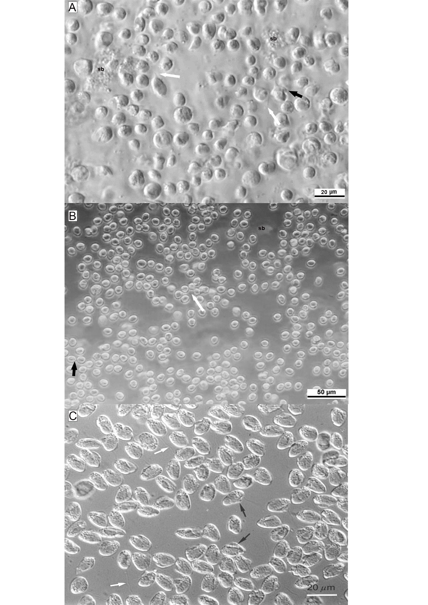
Figure 4.2 Hematodinium sp. macrospores observed under light microscopy.
A) Living macrospores obtained from in vivo sporulation in Nephrops norvegicus, with some showing a long anterior flagellum (white arrows) and a pronounced keel (black arrows), characteristic of mature macrospores. sb: sporoblast debris.
B) Additional view of in vivo-derived macrospores using light microscopy.
C) Living macrospores from in vitro sporulation. Morphological features, including the anterior flagellum (white arrows) and keel (black arrows), are consistent with in vivo observations.Source: Appleton and Vickerman (1998)

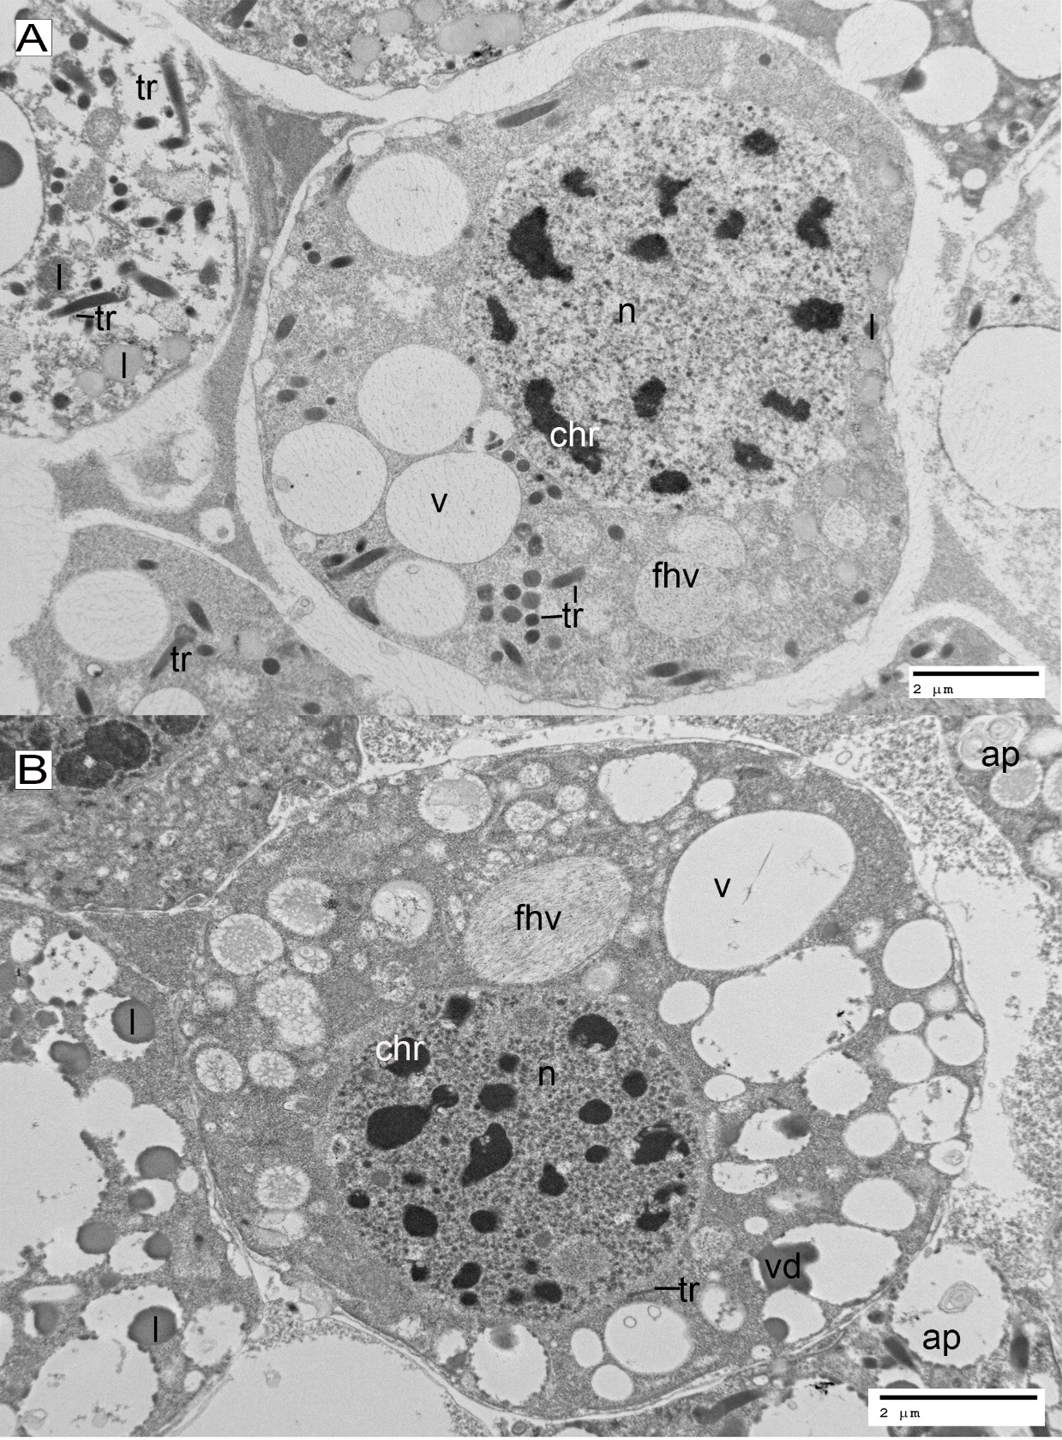
Figure 4.3 Electron microscopy of Hematodinium sp. macrospores obtained from in vivo sporulation events. A–B) Ultrastructural features include nucleus (n), chromosomes (chr), vacuoles (v), flagellar hair vesicles (fhv), trichocysts (tr), lipid droplets (l), and electron-dense deposits within vacuoles (vd). Autophagosome-like structures (ap) are also present and may indicate early degenerative changes.

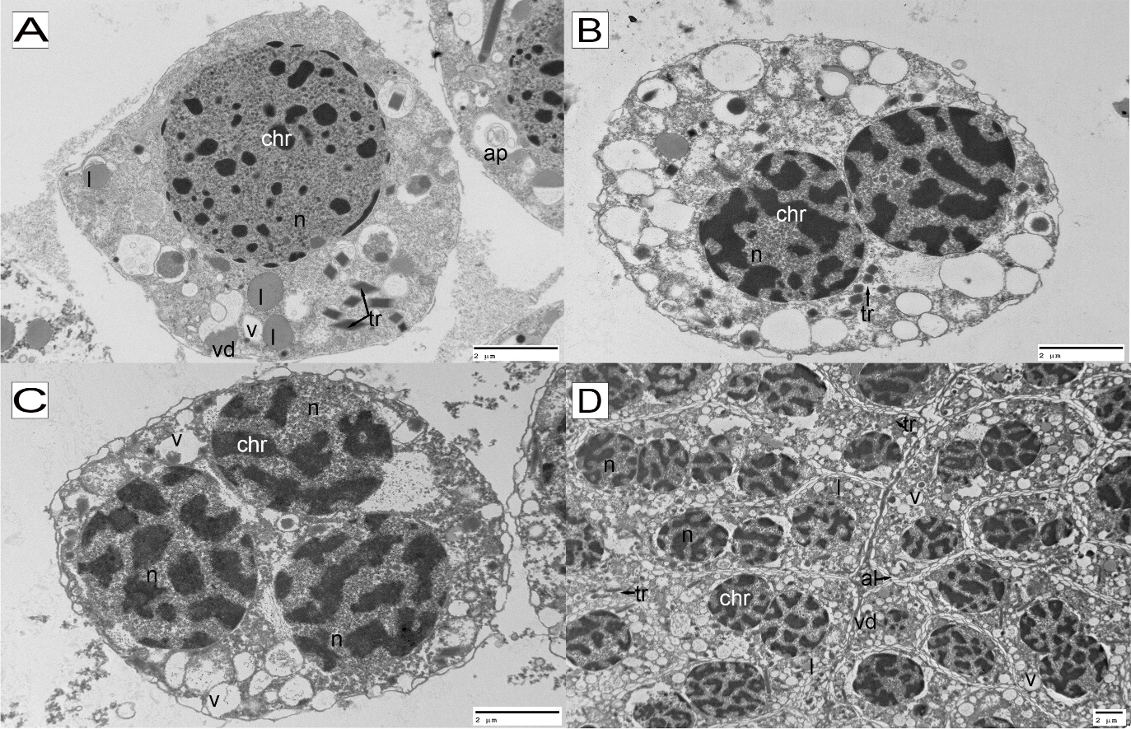
Figure 4.4Electron microscopy of Hematodinium sp. trophonts within the hepatopancreas tissue of Nephrops norvegicus. A) mononucleated, B) binucleated, C) trinucleated, and D) multinucleated trophont cells. An alveolate surface (al) delineates the outer structure of each cell. Visible cellular components include the nucleus (n), chromosomes (chr), trichocysts (tr), autophagosome-like structures (ap) indicative of potential early degenerative changes, lipid droplets (l), and vacuoles (v).

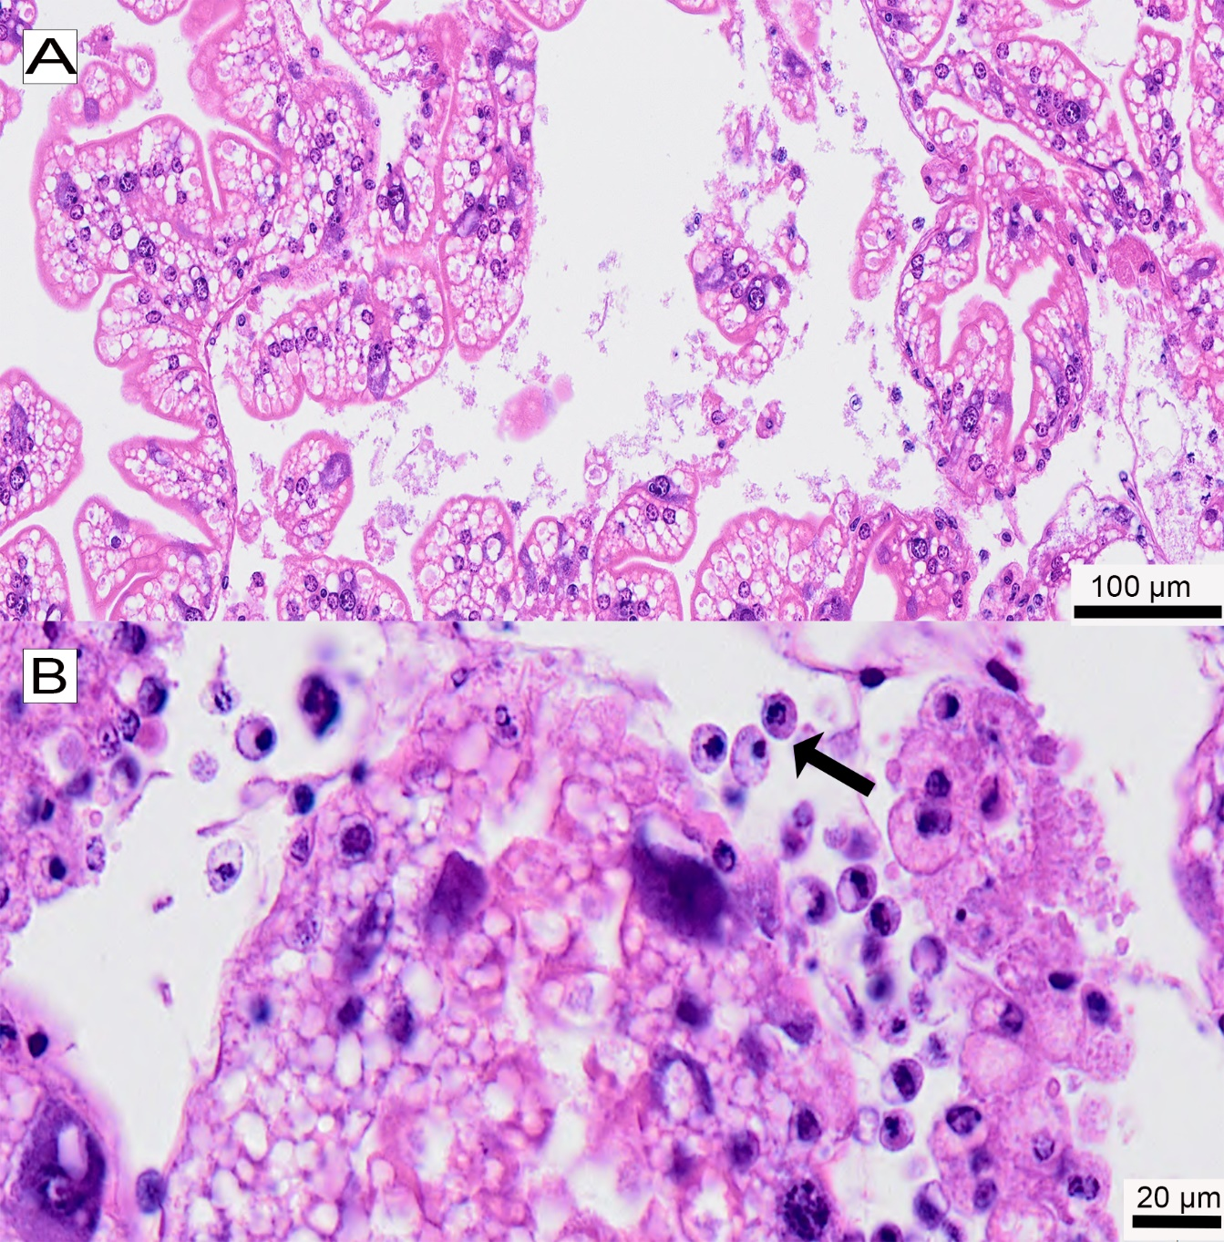
Figure 4.5 Hepatopancreas tissue of a Nephrops norvegicus individual (SP56) following sporulation of Hematodinium sp. parasites. A) Overview showing disruption of hepatopancreatic ducts and surrounding connective tissue. B) Higher magnification of the same tissue highlighting the presence of mononucleated Hematodinium trophonts (black arrow). Note: No residual macrospores are observed.

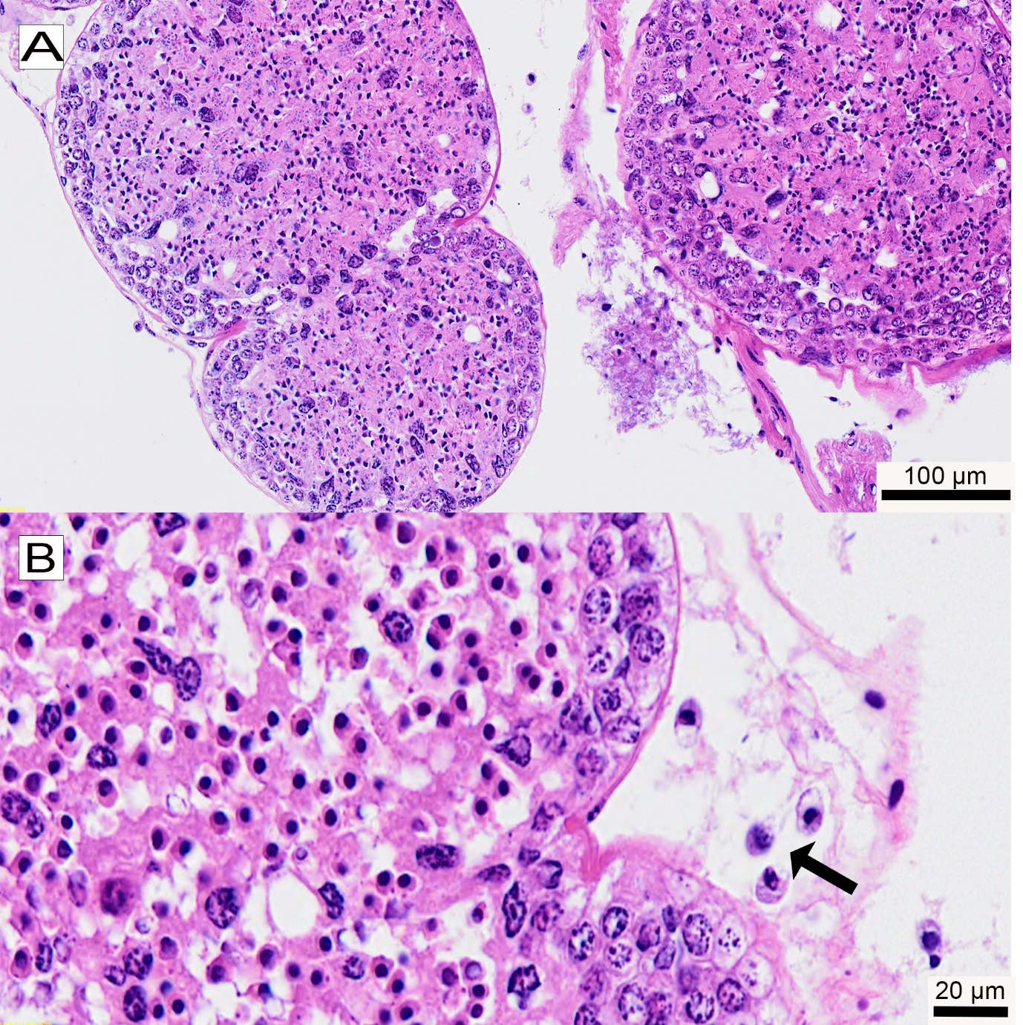
Figure 4.6 Male gonad tissue of a Nephrops norvegicus individual (SP56) following sporulation of Hematodinium sp. parasites. A) Overview showing disruption of connective tissue within the gonad, while the vas deferens appears comparatively less affected. B) Higher magnification of the same tissue highlighting the presence of mononucleated Hematodinium trophonts (black arrow). Note: No residual macrospores are observed.

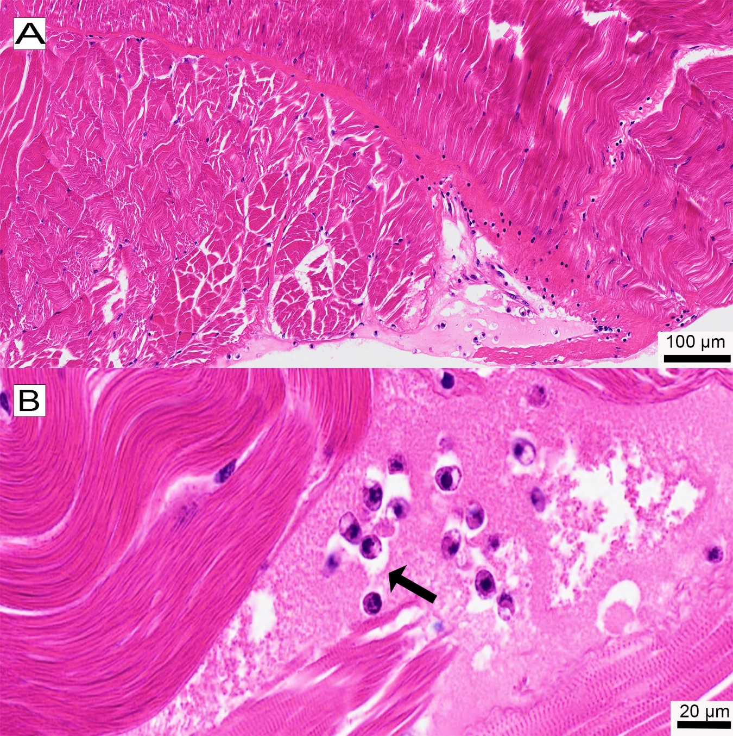
Figure 4.7 Muscle tissue of a Nephrops norvegicus individual (SP56) following sporulation of Hematodinium sp. parasites. A) Overview showing disruption of connective tissue between muscle fibres and infiltration by Hematodinium parasites. B) Higher magnification of the same tissue highlighting the presence of mononucleated trophonts (black arrow). Note: No residual macrospores are observed in the tissue.

Body indices and lipid content in Nephrops hepatopancreas and spores
Data on body weight and hepatosomatic index (HSI) were collected from BCM-negative (n=3) individuals, BCM-positive (n=26) individuals, and sporulated individuals (n=3). Neither the body weight nor the HSI exhibited a significant difference between infected and non-infected individuals (p>0.05) using both the BCM and PM diagnostic methods (Figure 4.8).
Lipid percentages were analysed in the hepatopancreas of Nephrops, including individuals from Hematodinium BCM negative (n=11) and BCM positive (n=29) groups, as well as macrospores (n=3) and the sporulated host hepatopancreas (n=3). Among the BCM-negative group, only 6 individuals were classified as stage 0, while the remaining individuals (n=5) were categorized as stage 1. In the BCM-positive group, the distribution of stages for PM infection was as follows: stage 1 (n=5), stage 2 (n=6), stage 3 (n=10), and stage 4 (n=8). The three sporulated host hepatopancreas analysed exhibited a PM stage 3. As shown in Figure 4.9, no significant variations were observed in the lipid content among the different levels of Hematodinium sp. infection or between the spores and the host hepatopancreas. However, Figure 4.9A illustrates considerable variability in HSI between individuals, while Figure 4.9B shows fluctuations in lipid content across different pleopod stages. Notably, there is minimal variability in lipid content within the spores, suggesting a consistent targeting of a specific lipid quantity (Figure 4.9B).
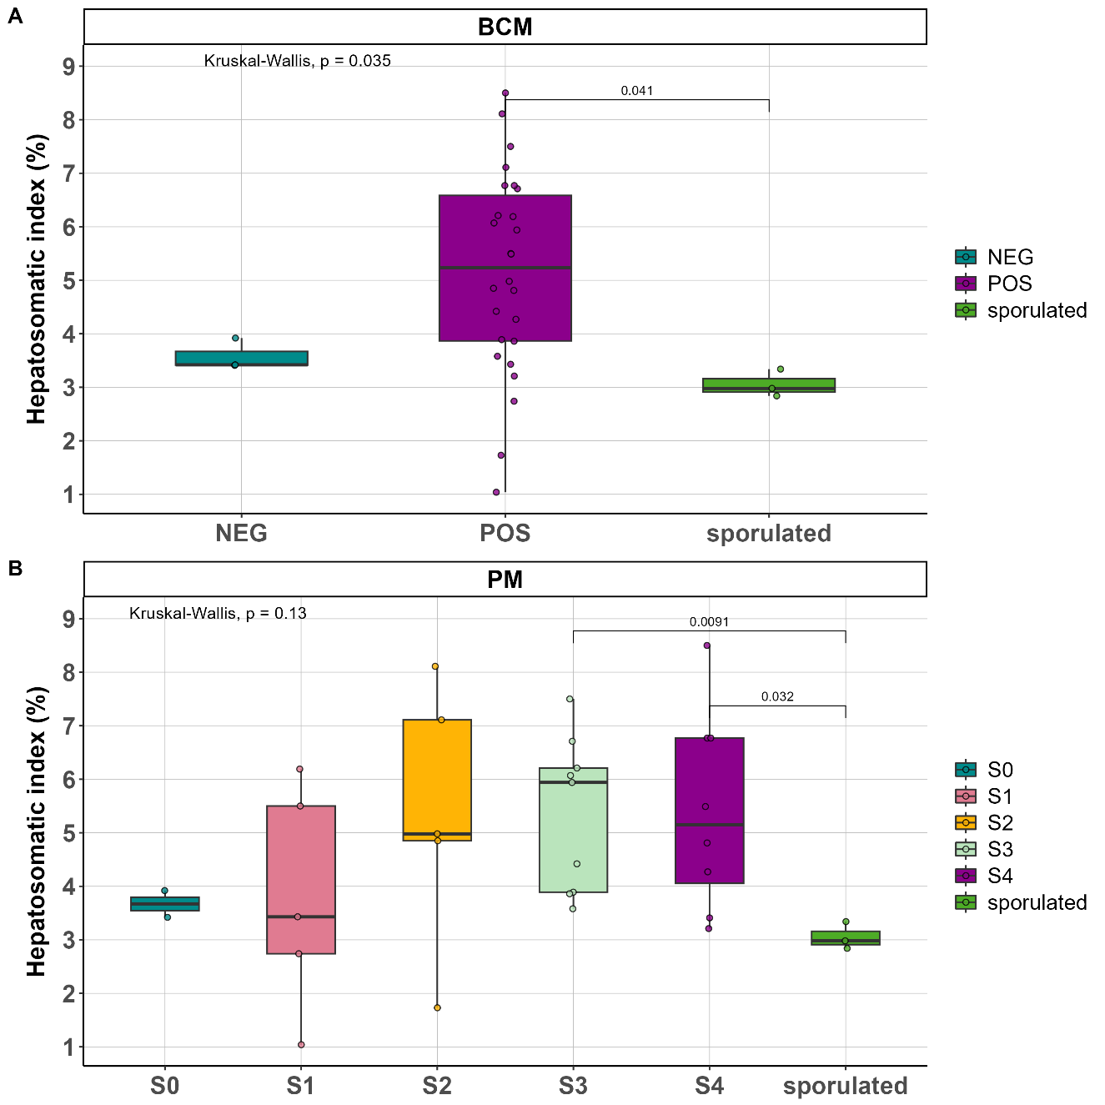

Figure 4.8 Hepatosomatic index (HSI, %) in Nephrops norvegicus infected with Hematodinium sp. A) HSI in individuals classified as BCM-positive (POS, n = 29), BCM-negative (NEG, n = 3), and sporulated (n = 3). B) HSI based on pleopod method (PM) classification: stage 0 (n = 2), stage 1 (n = 5), stage 2 (n = 5), stage 3 (n = 11), stage 4 (n = 9), and sporulated (PM stages 3 and 4; n = 3)

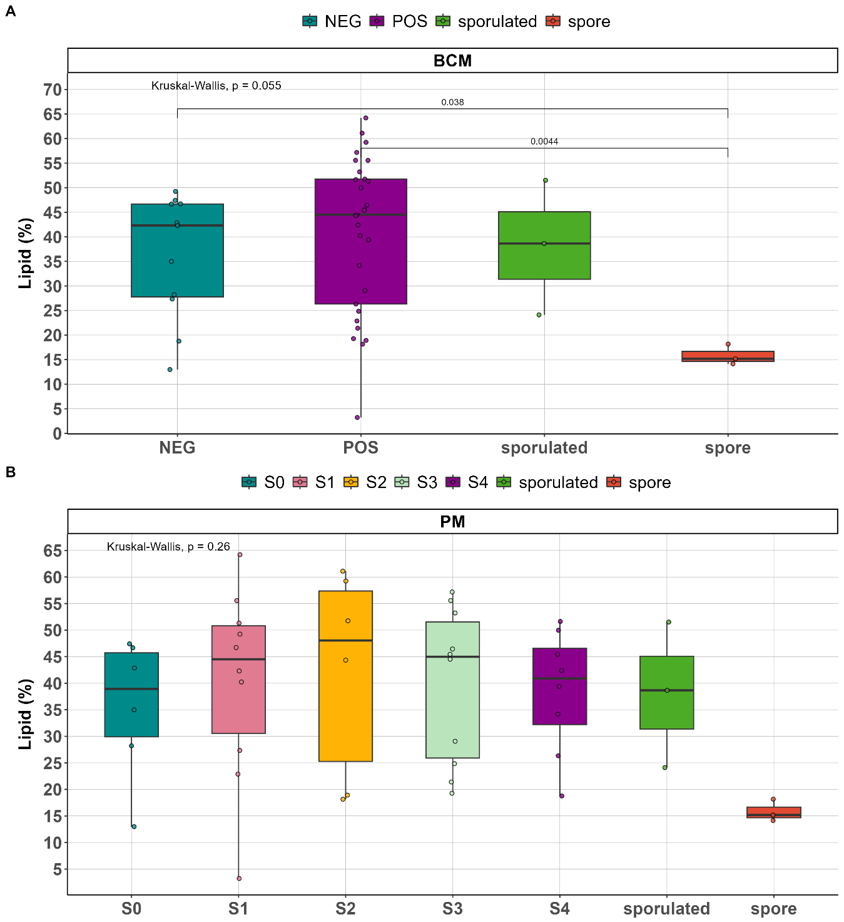
Figure 4.9 Lipid percentage (%) in Nephrops norvegicus according to infection classification. A) Body colour method (BCM): BCM-positive (POS, n = 32) and BCM-negative (NEG, n = 11). B) Pleopod method (PM) classification: stage 0 (n = 6), stage 1 (S1, n = 10), stage 2 (S2, n = 6), stage 3 (S3, n = 10), stage 4 (S4, n = 8), sporulated (PM stages 3 and 4; n = 3), and spores (n = 3).

Fatty acid composition in total lipid
The fatty acid composition of Hematodinium sp. macrospores, hepatopancreas from Nephrops according to pleopod staging (stage 1-4 by PM), and from non-patently infected individuals (stage 0 by PM), are provided in Table 4.3.
In general, all samples were remarkably similar. Monounsaturated fatty acids constituted a significant proportion, ranging from 43% to 50%, across all samples. Saturated fatty acids were found to be the second most prevalent, making up approximately 24% to 25% of the total composition. Following this, (n-3) long-chain polyunsaturated fatty acids (PUFAs) accounted for around 15% to 20%, while (n-6) fatty acids comprised approximately 7.7% to 10% of the lipid composition. Interestingly, macrospores exhibited a significantly higher abundance of (n-3) PUFAs, representing approximately 27% of their lipid composition, and a significantly lower content of (n-6) fatty acids, comprising only 4.7% (Figure 4.10).
Lipid profiles were characterized by dominant groups of fatty acids: oleic acid (18:1n-9), vaccenic acid (18:1n-7), and palmitoleic acid (POA, 16:1n-7) were consistently present at high levels in all samples. The most abundant saturated fatty acids were palmitic acid (16:0) and stearic acid (18:0). The major n-3 PUFAs identified were eicosapentaenoic acid (EPA, 20:5n-3) and docosahexaenoic acid (DHA, 22:6n-3) while arachidonic acid (ARA, 20:4n-6), linoleic acid (18:2n-6), and eicosadienoic acid (EDA, 20:2n-6) were the main n-6 PUFAs, with the last two being more predominant in the host hepatopancreas and to a lesser extent in macrospores (Figure 4.11).
The macrospores exhibited consistent and significant differences compared to both the host hepatopancreas and the hepatopancreas of infected Nephrops at various levels of Hematodinium sp. infection (stage 0-4) in terms of total (n-3) PUFAs content, particularly docosahexaenoic acid (DHA, 22:6n-3) and eicosapentaenoic acid (EPA, 20:5n-3), were significantly higher in macrospores. Conversely, the (n-6) fatty acid eicosadienoic acid (EDA, 20:2n-6) showed a significant decrease in macrospores. Among the monounsaturated fatty acids, palmitoleic acid (16:1n-7) was significantly higher in macrospores, while eicosenoic acid (20:1n-11) and gondoic acid (20:1n-9) were significantly decreased. Additionally, saturated stearic acid (18:0) was also significantly lower in macrospores. Further information, including detailed results and corresponding p-values, can be found in Table 4.8.
.
Table 4.3 Fatty acid composition in total lipids (% of total fatty acids) in oil extracted from N. norvegicus hepatopancreas with different levels of Hematodinium sp. infection sampled from the Clyde Sea area. Macrospores (n=3).
fatty acid | S0 | S1 | S2 | S3 | S4 | sporulated | macrospore
fatty acid | mean ± sd | mean ± sd | mean ± sd | mean ± sd | mean ± sd | mean ± sd | mean ± sd
14:0 | 1.69 ± 0.47 | 1.83 ± 0.48 | 1.74 ± 0.55 | 1.72 ± 0.24 | 1.74 ± 0.26 | 1.44 ± 0.14 | 1.95 ± 0.21
iso 15:0 | 0.6 ± 0.2 | 0.56 ± 0.12 | 0.53 ± 0.14 | 0.65 ± 0.14 | 0.67 ± 0.12 | 0.78 ± 0.4 | 0.62 ± 0.32
Anteiso 15:0 | 0.29 ± 0.12 | 0.24 ± 0.08 | 0.23 ± 0.07 | 0.32 ± 0.11 | 0.32 ± 0.07 | 0.46 ± 0.35 | 0.58 ± 0.23
15:0 | 0.66 ± 0.14 | 0.59 ± 0.12 | 0.6 ± 0.09 | 0.62 ± 0.1 | 0.71 ± 0.12 | 0.69 ± 0.12 | 0.5 ± 0.14
iso 16:0 | 0.52 ± 0.18 | 0.42 ± 0.13 | 0.45 ± 0.17 | 0.5 ± 0.17 | 0.55 ± 0.12 | 0.62 ± 0.28 | 0.41 ± 0.18
16:0 DMA | 0.51 ± 0.35 | 0.26 ± 0.14 | 0.22 ± 0.18 | 0.3 ± 0.15 | 0.31 ± 0.08 | 0.42 ± 0.21 | 0 ± 0
Anteiso 16:0 | 0.07 ± 0.05 | 0.14 ± 0.07 | 0.13 ± 0.07 | 0.1 ± 0.07 | 0.07 ± 0.06 | 0.1 ± 0.02 | 0.09 ± 0.04
16:0 | 12.92 ± 1 | 12.97 ± 1.5 | 13.36 ± 1.02 | 12.58 ± 1.27 | 12.49 ± 0.95 | 11.85 ± 0.29 | 14.42 ± 0.94
iso 17:0 | 1.1 ± 0.35 | 0.91 ± 0.28 | 0.91 ± 0.33 | 1.05 ± 0.38 | 1.08 ± 0.22 | 1.17 ± 0.4 | 0.91 ± 0.32
Anteiso 17:0 | 0.84 ± 0.36 | 0.72 ± 0.26 | 0.79 ± 0.5 | 0.87 ± 0.39 | 0.91 ± 0.24 | 1.11 ± 0.41 | 1.9 ± 0.47
17:0 | 0 ± 0 | 0 ± 0 | 0 ± 0 | 0 ± 0 | 0 ± 0 | 0 ± 0 | 0 ± 0
iso 18:0 | 0.58 ± 0.17 | 0.49 ± 0.12 | 0.41 ± 0.15 | 0.49 ± 0.2 | 0.52 ± 0.09 | 0.54 ± 0.18 | 0.41 ± 0.17
Anteiso 18:0 | 0.32 ± 0.15 | 0.25 ± 0.09 | 0.22 ± 0.07 | 0.27 ± 0.1 | 0.3 ± 0.08 | 0.29 ± 0.03 | 0.14 ± 0.12
18:0 DMA | 0.39 ± 0.26 | 0.23 ± 0.08 | 0.25 ± 0.2 | 0.32 ± 0.18 | 0.28 ± 0.08 | 0.35 ± 0.13 | 0.07 ± 0.13
18:0 | 3.63 ± 0.86 | 3.38 ± 0.52 | 3.39 ± 0.5 | 3.36 ± 0.3 | 3.34 ± 0.36 | 3.55 ± 0.26 | 1.26 ± 0.08
iso 19:0 | 0.18 ± 0.07 | 0.18 ± 0.06 | 0.16 ± 0.04 | 0.19 ± 0.08 | 0.17 ± 0.06 | 0.23 ± 0.03 | 0 ± 0
19:0 | 0.24 ± 0.14 | 0.22 ± 0.08 | 0.17 ± 0.11 | 0.24 ± 0.13 | 0.25 ± 0.1 | 0.3 ± 0.07 | 0.47 ± 0.04
20:0 DMA | 0.06 ± 0.09 | 0.05 ± 0.05 | 0.06 ± 0.09 | 0.04 ± 0.07 | 0.11 ± 0.15 | 0.14 ± 0.07 | 0 ± 0
20:0 | 0.43 ± 0.09 | 0.44 ± 0.07 | 0.41 ± 0.06 | 0.46 ± 0.08 | 0.48 ± 0.06 | 0.45 ± 0.07 | 0.98 ± 0.14
22:0 | 0.22 ± 0.14 | 0.3 ± 0.07 | 0.26 ± 0.07 | 0.3 ± 0.06 | 0.33 ± 0.08 | 0.32 ± 0.11 | 0.21 ± 0.02
24:0 | 0.01 ± 0.02 | 0.01 ± 0.02 | 0.01 ± 0.02 | 0.02 ± 0.03 | 0.03 ± 0.04 | 0.01 ± 0.03 | 0 ± 0
total saturated | 25.27 ± 1.98 | 24.19 ± 1.69 | 24.32 ± 1.53 | 24.41 ± 1.54 | 24.67 ± 1.64 | 24.82 ± 2.73 | 24.92 ± 0.89
16:1n-9 | 0.26 ± 0.08 | 0.25 ± 0.05 | 0.29 ± 0.02 | 0.28 ± 0.04 | 0.27 ± 0.06 | 0.28 ± 0.01 | 0.44 ± 0.04
16:1n-7 | 5.17 ± 0.91 | 5.24 ± 1.24 | 5.64 ± 1.18 | 4.88 ± 0.67 | 5.38 ± 0.94 | 4.29 ± 1.16 | 10.26 ± 0.84
16:1 | 0.28 ± 0.06 | 0.27 ± 0.04 | 0.29 ± 0.07 | 0.29 ± 0.06 | 0.33 ± 0.05 | 0.36 ± 0.12 | 0.22 ± 0.09
17:1 | 0.69 ± 0.21 | 0.54 ± 0.13 | 0.58 ± 0.14 | 0.6 ± 0.13 | 0.65 ± 0.14 | 0.57 ± 0.02 | 0.71 ± 0.16
18:1 DMA | 0.14 ± 0.14 | 0.11 ± 0.07 | 0.09 ± 0.11 | 0.12 ± 0.09 | 0.1 ± 0.07 | 0.15 ± 0.06 | 0 ± 0
18:1 | 0.39 ± 0.15 | 0.33 ± 0.08 | 0.31 ± 0.09 | 0.35 ± 0.09 | 0.38 ± 0.09 | 0.36 ± 0.11 | 0.22 ± 0.2
18:1n-9 | 15.23 ± 2.61 | 17.28 ± 2.17 | 17.54 ± 3 | 17.78 ± 3.68 | 15.4 ± 0.55 | 15.98 ± 3.37 | 19.22 ± 1.57
18:1n-7 | 6.47 ± 1.09 | 7.82 ± 1.56 | 6.66 ± 1.03 | 6.81 ± 0.6 | 7.56 ± 1.21 | 8.42 ± 0.9 | 6.23 ± 0.2
18:1 | 0.53 ± 0.14 | 0.52 ± 0.12 | 0.49 ± 0.12 | 0.57 ± 0.21 | 0.59 ± 0.12 | 0.61 ± 0.11 | 0.38 ± 0.14
20:1n-11 | 3.22 ± 1.08 | 3.05 ± 0.7 | 2.55 ± 0.76 | 3.04 ± 0.79 | 3.55 ± 0.28 | 4.07 ± 0.91 | 0.93 ± 0.15
20:1n-9 | 3.76 ± 1.57 | 4.33 ± 1.05 | 3.64 ± 1.12 | 3.9 ± 0.92 | 3.47 ± 1.08 | 3.68 ± 0.75 | 1.26 ± 0.18
20:1n-7 | 2.37 ± 1.27 | 3.2 ± 1.27 | 2.51 ± 0.72 | 2.74 ± 0.78 | 3.55 ± 0.94 | 4.64 ± 1.23 | 2.62 ± 0.12
20:1 NMID | 0.26 ± 0.1 | 0.32 ± 0.11 | 0.27 ± 0.08 | 0.31 ± 0.09 | 0.37 ± 0.11 | 0.41 ± 0.09 | 0.12 ± 0.2
22:1n-11 | 6.63 ± 4.24 | 4.77 ± 3.79 | 4.24 ± 2.29 | 5 ± 1.76 | 4.87 ± 3.16 | 3.34 ± 2.27 | 0.65 ± 0.18
22:1n-9cis | 0.8 ± 0.47 | 0.97 ± 0.36 | 0.73 ± 0.2 | 0.85 ± 0.35 | 0.81 ± 0.33 | 0.71 ± 0.23 | 0.52 ± 0.11
22:1 NMID | 0.73 ± 0.25 | 0.92 ± 0.31 | 0.78 ± 0.2 | 0.86 ± 0.3 | 0.99 ± 0.35 | 1.27 ± 0.37 | 0 ± 0
24:1n-9 | 0.35 ± 0.11 | 0.32 ± 0.1 | 0.34 ± 0.08 | 0.37 ± 0.09 | 0.32 ± 0.12 | 0.3 ± 0.13 | 0.01 ± 0.03
total monounsaturated | 47.26 ± 6.69 | 50.24 ± 2.5 | 46.94 ± 4.1 | 48.74 ± 3.04 | 48.6 ± 3.39 | 49.44 ± 3.7 | 43.8 ± 0.81
18:2n-6 | 2.31 ± 1.18 | 2.59 ± 0.88 | 3.87 ± 2.26 | 3.38 ± 1.66 | 2.47 ± 0.88 | 2.6 ± 0.81 | 0.84 ± 0.43
18:3n-6 | 0.15 ± 0.04 | 0.13 ± 0.02 | 0.13 ± 0.02 | 0.13 ± 0.03 | 0.16 ± 0.02 | 0.12 ± 0.01 | 0.09 ± 0.01
20:2n-6 | 1.18 ± 0.24 | 1.44 ± 0.57 | 1.15 ± 0.17 | 1.34 ± 0.32 | 1.61 ± 0.28 | 1.91 ± 0.42 | 0.33 ± 0.07
20:3n-6 | 0.16 ± 0.02 | 0.2 ± 0.05 | 0.21 ± 0.03 | 0.19 ± 0.03 | 0.22 ± 0.05 | 0.28 ± 0.04 | 0.09 ± 0.01
20:4n-6 | 3.22 ± 1.6 | 2.24 ± 0.52 | 2.42 ± 0.89 | 2.59 ± 0.91 | 3.11 ± 0.65 | 3.31 ± 0.85 | 2.49 ± 0.57
22:4n-6 | 0.75 ± 0.32 | 0.57 ± 0.24 | 0.49 ± 0.23 | 0.71 ± 0.37 | 0.77 ± 0.18 | 0.78 ± 0.13 | 0.26 ± 0.1
22:5n-6 | 0.58 ± 0.11 | 0.57 ± 0.11 | 0.58 ± 0.07 | 0.58 ± 0.04 | 0.69 ± 0.1 | 0.73 ± 0.04 | 0.59 ± 0.39
total n6 | 8.36 ± 1.83 | 7.74 ± 1.45 | 8.85 ± 2.68 | 8.92 ± 1.56 | 9.03 ± 1.27 | 9.73 ± 1.89 | 4.67 ± 1.14
18:3n-3 | 0.75 ± 0.37 | 0.91 ± 0.19 | 1.23 ± 0.66 | 1.02 ± 0.45 | 0.79 ± 0.27 | 0.74 ± 0.17 | 0.24 ± 0.08
18:4n-3 | 0.37 ± 0.13 | 0.53 ± 0.17 | 0.61 ± 0.22 | 0.43 ± 0.17 | 0.36 ± 0.08 | 0.26 ± 0.14 | 0.31 ± 0.06
20:3n-3 | 0.25 ± 0.03 | 0.32 ± 0.06 | 0.28 ± 0.03 | 0.29 ± 0.02 | 0.33 ± 0.06 | 0.37 ± 0.05 | 0.09 ± 0.01
20:4n-3 | 0.31 ± 0.05 | 0.4 ± 0.08 | 0.44 ± 0.11 | 0.35 ± 0.09 | 0.34 ± 0.04 | 0.33 ± 0.07 | 0.23 ± 0.05
20:5n-3 | 7.94 ± 2.75 | 6.63 ± 1.68 | 7.58 ± 0.7 | 6.64 ± 1.23 | 6.56 ± 0.93 | 5.99 ± 0.61 | 13.46 ± 1.18
21:5n-3 | 0.2 ± 0.04 | 0.24 ± 0.06 | 0.25 ± 0.05 | 0.2 ± 0.07 | 0.19 ± 0.08 | 0.15 ± 0.14 | 0.31 ± 0.11
22:5n-3 | 1.36 ± 0.45 | 1.12 ± 0.21 | 1.19 ± 0.27 | 1.18 ± 0.19 | 1.25 ± 0.16 | 1.15 ± 0.16 | 1.2 ± 0.15
22:6n-3 | 7.3 ± 1.51 | 7.07 ± 1.2 | 7.65 ± 0.65 | 7.17 ± 0.76 | 7.22 ± 0.42 | 6.34 ± 0.44 | 10.62 ± 0.47
total n3 | 18.48 ± 4.22 | 17.2 ± 2.78 | 19.24 ± 0.85 | 17.28 ± 1.73 | 17.04 ± 1.25 | 15.34 ± 1.35 | 26.45 ± 1.34
16:2 | 0.12 ± 0.02 | 0.16 ± 0.04 | 0.18 ± 0.05 | 0.14 ± 0.03 | 0.16 ± 0.09 | 0.12 ± 0.02 | 0.05 ± 0.01
16:3 | 0.06 ± 0.04 | 0.08 ± 0.06 | 0.11 ± 0.07 | 0.07 ± 0.05 | 0.04 ± 0.05 | 0.05 ± 0.05 | 0.04 ± 0.01
16:4 | 0.12 ± 0.02 | 0.13 ± 0.02 | 0.15 ± 0.03 | 0.12 ± 0.02 | 0.12 ± 0.01 | 0.12 ± 0.01 | 0.07 ± 0
22:2 NMID | 0.33 ± 0.24 | 0.25 ± 0.14 | 0.2 ± 0.11 | 0.31 ± 0.19 | 0.33 ± 0.1 | 0.38 ± 0.09 | 0 ± 0
total other | 0.62 ± 0.22 | 0.62 ± 0.18 | 0.65 ± 0.09 | 0.65 ± 0.18 | 0.66 ± 0.12 | 0.67 ± 0.04 | 0.16 ± 0.01
DHA/EPA | 0.99 ± 0.31 | 1.1 ± 0.23 | 1.02 ± 0.15 | 1.1 ± 0.13 | 1.12 ± 0.15 | 1.06 ± 0.11 | 0.79 ± 0.08
n-3/n-6 PUFA | 2.23 ± 0.29 | 2.32 ± 0.69 | 2.34 ± 0.67 | 2 ± 0.47 | 1.91 ± 0.23 | 1.63 ± 0.41 | 5.93 ± 1.67

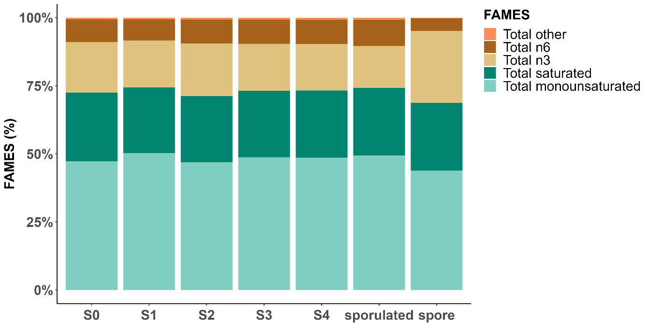
Figure 4.10 Barplot depicting the average FAMES (%) in total lipids found in the hepatopancreas of Nephrops at different stages of Hematodinium sp. infection (stage 0-4) as classified by the PM, along with the hepatopancreas of the host that sporulated and the released spores (macrospores).

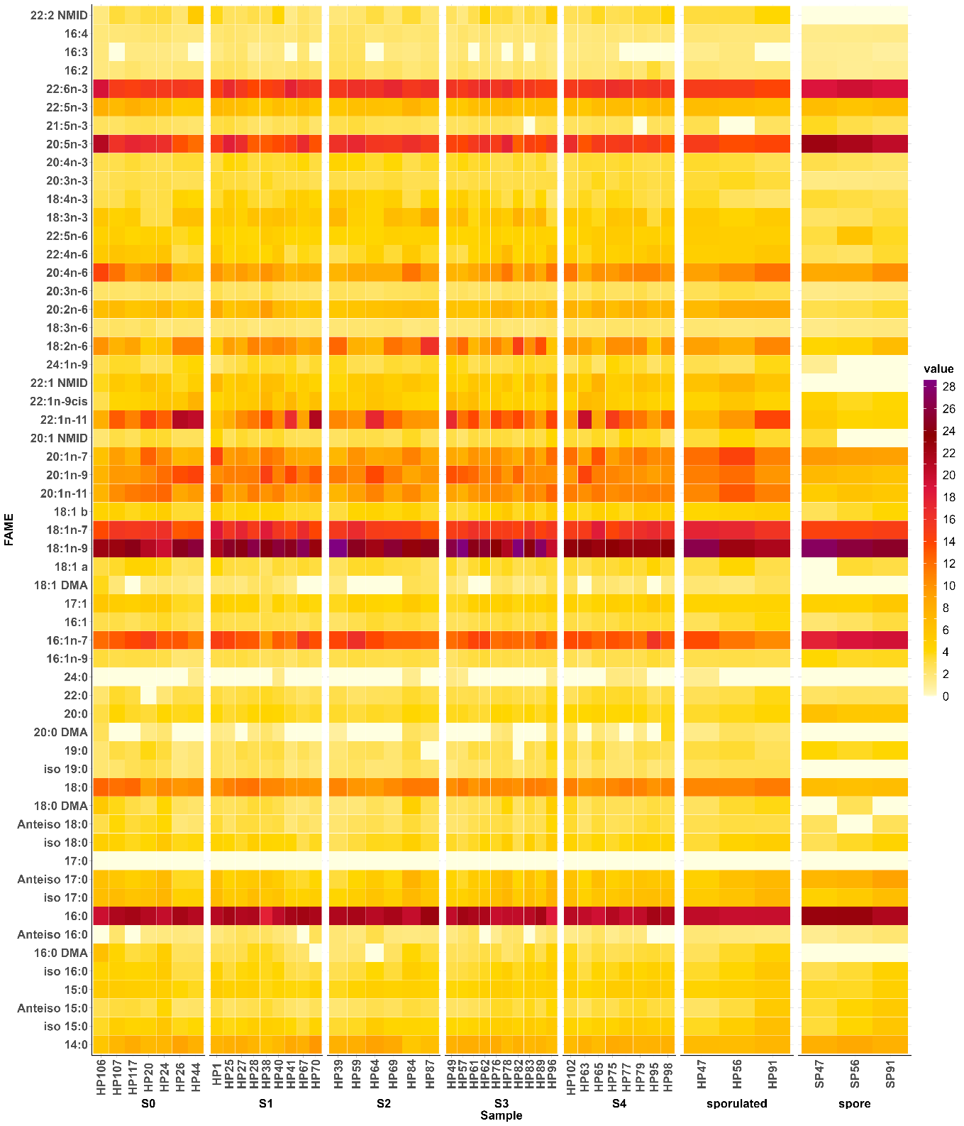
Figure 4.11 Fatty acid composition (in total lipid) in Nephrops hepatopancreas at different stages of infection (stages 0-4) and after sporulation and in spores released from sporulated animals. Limit of detection: 0.16.

Lipid class
The lipid class profiles in all samples were dominated by triacylglycerol’s (~50% in hepatopancreas; ~33% in macrospores), followed by phosphatidylcholine (~11-15% in hepatopancreas; ~22% in macrospores), wax/sterol esters (~4-10% in hepatopancreas; ~8% in macrospores), and cholesterol/sterol (~8-11% in hepatopancreas; ~6% in macrospores) (Figure 4.12).
The lipid class profiles of macrospores showed high similarity to those of the host hepatopancreas. However, the levels of phosphatidylcholine in the macrospore (approximately 23%) were higher than in the hepatopancreas (around 12%). Nevertheless, this difference was not deemed statistically significant due to the considerable variability observed across the samples (Table 4.4). However, significant differences were observed in the levels of two lipid classes between the macrospores and the host hepatopancreas, namely unknown polar lipids (t-test, p=0.01) which were significantly higher in the macrospores (Table 4.5) and cholesterol/sterol (t-test, p=0.045) (Table 4.4 and Figure 4.12), which was significantly lower in the macrospores.
Similarly, when comparing macrospores to hepatopancreas with varying levels of infection across all infection stages (stage 0 – stage 4; PM), macrospores showed notably increased levels of unknown polar lipids (Anova, p=1.75E⁻⁰⁵) (Figure 4.12 and Table 4.5 ). Additionally, phosphatidylglycerol levels were significantly lower in stage 3 of infection compared to the macrospore (ANOVA, p = 0.0451).
Within the hepatopancreas itself, there were no significant differences in the lipid class profile with respect to different Hematodinium sp. infection levels, except for the pigmented materials. Notably, stage 1 exhibited higher levels of pigmented material compared to stages 2, 3, and 4 (Table 4.4 and Table 4.5).
Table 4.4 Lipid class (% of total lipid) in oil extracted from N.norvegicus hepatopancreas and from Hematodinium macrospores. Samples were obtained from the hepatopancreas of N. norvegicus individuals showing varying levels of Hematodinium sp. infection (stages S0–S4), classified according to the pleopod method (PM). These individuals had not reached sporulation (non-sporulated). Additional samples were collected from the hepatopancreas of three individuals that had undergone sporulation (sporulated group, n = 3, PM stage 3-4). During these sporulation events, Hematodinium sp. macrospores were evacuated through the gills of the host and subsequently isolated and analysed. All Nephrops were collected from the Clyde Sea area. SD=standard deviation; n.d=not detected.
Lipid class composition (% total lipid) | S0 | S1 | S2 | S3 | S4 |  | sporulated |  |  | spore
Lipid class composition (% total lipid) | mean ± sd | mean ± sd | mean ± sd | mean ± sd | mean ± sd |  | mean ± sd |  |  | mean ± sd
Lysophosphatidylcholine | 0.03 ± 0.08 | 0.04 ± 0.13 | 0.27 ± 0.34 | 0.19 ± 0.31 |  | 0.05 ± 0.09 |  | 0.53 ± 0.92 | 0.4 ± 0.44
Sphingomyelin | 0.41 ± 0.48 | 0.34 ± 0.41 | 0.52 ± 0.64 | 0.33 ± 0.24 |  | 0.32 ± 0.47 |  | 0.43 ± 0.4 | 1.53 ± 0.23
Phosphatidylcholine | 15.39 ± 6.08 | 10.34 ± 6.3 | 11.35 ± 8.27 | 11.91 ± 4.64 |  | 12.6 ± 3.44 |  | 11.78 ± 6.45 | 22.8 ± 1.81
Phosphatidylserine | 1.57 ± 1.87 | 1.05 ± 0.93 | 1.5 ± 1.75 | 1.2 ± 0.9 |  | 1.39 ± 0.98 |  | 1.38 ± 1.43 | 1.07 ± 0.06
Phosphatidylinositol | 3.75 ± 2.44 | 2.53 ± 1.51 | 2.64 ± 2.41 | 2.4 ± 1.17 |  | 2.84 ± 0.97 |  | 2.82 ± 1.8 | 3.5 ± 0.72
Phosphatidic acid/ Phosphatidylglycerol/ cardiolipin | 1.17 ± 1.76 | 0.89 ± 0.83 | 1.19 ± 1.4 | 0.69 ± 1 |  | 0.85 ± 0.84 |  | 1.9 ± 1.22 | 4.1 ± 0.66
Phosphatidylethanolamine | 9.01 ± 4.87 | 4.02 ± 2.57 | 6.22 ± 4.18 | 7.53 ± 3.3 |  | 7.59 ± 1.8 |  | 7.7 ± 3.79 | 6.3 ± 0.4
Pigmented material | 1.21 ± 1.06 | 2.39 ± 1.41 | 0.86 ± 0.29 | 0.62 ± 0.26 |  | 0.7 ± 0.27 |  | 0.81 ± 0.33 | 1.33 ± 0.29
Unknown polar lipid* | 0.18 ± 0.47 | 0.49 ± 1.17 | 0.11 ± 0.27 | 0.11 ± 0.35 |  | 0 ± 0 |  | 0 ± 0 | 2.9 ± 0.7
Unknown glycolipid | 0 ± 0 | 0.21 ± 0.63 | 0 ± 0 | 0 ± 0 |  | 0 ± 0 |  | 0 ± 0 | 0 ± 0
Total polar lipids | 32.74 ± 16.58 | 22.3 ± 10.77 | 24.65 ± 18.9 | 24.98 ± 10.31 |  | 26.34 ± 8.26 |  | 27.36 ± 14.47 | 43.93 ± 3.46
Diacylglycerol | 1.25 ± 1.62 | 3.19 ± 1.95 | 2.78 ± 1.98 | 1.62 ± 1.1 |  | 1.35 ± 0.73 |  | 2.9 ± 4.03 | 4.87 ± 0.93
Cholesterol/sterols | 9 ± 3.35 | 8.86 ± 3.3 | 9.14 ± 3.52 | 8.37 ± 2.12 |  | 8.55 ± 1.93 |  | 10.58 ± 2.17 | 6.2 ± 0.62
Free fatty acids | 2 ± 2.68 | 6.08 ± 7.24 | 4.32 ± 2.3 | 4.29 ± 3.79 |  | 3.36 ± 2.33 |  | 4.55 ± 6.99 | 3.07 ± 2.89
Unknown neutral lipid | 0 ± 0 | 0 ± 0 | 0 ± 0 | 0.04 ± 0.13 |  | 0 ± 0 |  | 0 ± 0 | 0 ± 0
Triacylglycerols | 50.28 ± 19.38 | 54.83 ± 11.56 | 53.27 ± 23.9 | 52.13 ± 15.97 |  | 52.66 ± 10.88 |  | 45.03 ± 15.47 | 33.9 ± 5.16
Wax/Sterol esters | 4.72 ± 1.12 | 5.22 ± 2.33 | 5.84 ± 2.54 | 8.56 ± 3.17 |  | 7.74 ± 3.5 |  | 9.58 ± 1.64 | 8.03 ± 2.04
Total Neutral lipids | 67.26 ± 16.58 | 78.18 ± 9.93 | 75.35 ± 18.9 | 75.02 ± 10.31 |  | 73.66 ± 8.26 |  | 72.64 ± 14.47 | 56.07 ± 3.46

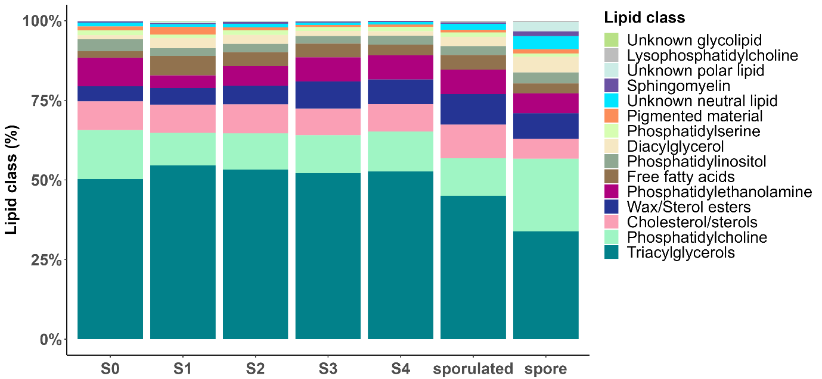
Figure 4.12 Barplot depicting the mean lipid classes (%) in total lipids found in the hepatopancreas with different levels of Hematodinium sp. infection (stage 0-4) as classified by the PM, along with the hepatopancreas of the host that sporulated and the released spores (macrospores).

Table 4.5 Anova comparison of lipid class composition of macrospores compared to host hepatopancreas and the hepatopancreas of Nephrops with different levels of Hematodinium sp. infection according to the pleopod method.
Lipid class | comparison | test | p value adjusted | anova p value
Phosphatidylglycerol | spore-S3 | ANOVA + TukeyHSD | 1.83E-02 | 4.51E-02
pigment | S1-S3 | ANOVA + TukeyHSD | 9.62E-05 | 1.90E-04
pigment | S1-S4 | ANOVA + TukeyHSD | 6.78E-04 | 1.90E-04
pigment | S1-S2 | ANOVA + TukeyHSD | 1.11E-02 | 1.90E-04
unknown polar lipid | spore-sporulated | ANOVA + TukeyHSD | 1.25E-04 | 1.75E-05
unknown polar lipid | spore-S0 | ANOVA + TukeyHSD | 3.83E-05 | 1.75E-05
unknown polar lipid | spore-S1 | ANOVA + TukeyHSD | 1.28E-04 | 1.75E-05
unknown polar lipid | spore-S2 | ANOVA + TukeyHSD | 4.54E-05 | 1.75E-05
unknown polar lipid | spore-S3 | ANOVA + TukeyHSD | 8.52E-06 | 1.75E-05
unknown polar lipid | spore-S4 | ANOVA + TukeyHSD | 4.25E-06 | 1.75E-05

Fatty acid composition according to lipid class composition
The lipid analysis revealed that both the polar (Figure 4.13) and neutral fractions (Figure 4.15) of the total lipids were predominantly composed of monounsaturated fatty acids (~25-42% in polar; ~51-56% in neutral), followed by saturated (~24-32% in polar; ~27-29% in neutral), (n-3) PUFAs (~19-29% in polar; ~8-13% in neutral), and (n-6) PUFAs (~7-11% in polar; ~4-8% in neutral). Notably, in the polar fraction, the macrospores showed an increase in total (n-3) PUFAs (~40%) compared to the host hepatopancreas and the hepatopancreas with varying levels of Hematodinium sp. infection (stage 0-4).
The polar fraction of the total lipids exhibited a profile similar to that of the overall lipid composition, with notable dominance of palmitic acid (16:0), oleic acid (18:1n-9), EPA (20:5n-3), and DHA (22:6n-3) (Figure 4.14). Similarly, the neutral fraction was also characterized by high levels of palmitic and oleic acids, alongside EPA (20:5n-3) and palmitoleic acid (16:1n-7) and vaccenic acid (18:1n-7) (Figure 4.16). For detailed fatty acid composition, refer to Table 4.6 for the polar lipid fraction and Table 4.7 for the neutral lipid fraction. Overall, a remarkable similarity was observed across all samples in both the polar and neutral fractions. However, the analysis also revealed several significant differences in both the polar and neutral fractions in specific major fatty acid components.
Polar fraction- The macrospores displayed consistent and significant differences in comparison to both the sporulated host hepatopancreas and the hepatopancreas of infected Nephrops at various stages of Hematodinium sp. infection (stage 0-4) (Table 4.6). Specifically, the levels of (n3) PUFA, such as docosahexaenoic acid (DHA, 22:6n-3), were significantly higher in macrospores. Moreover, eicosapentaenoic acid (EPA, 20:5n-3) also showed higher levels in macrospores, though significant differences were only observed between the macrospores and hepatopancreas at stage 1 of Hematodinium sp. infection.
Regarding (n-6) fatty acids, eicosadienoic acid (EDA, 20:2n-6), was significantly lower in macrospores compared to the host hepatopancreas and hepatopancreas with different levels of Hematodinium sp. infection, except for PM stage 2 where no significant differences were found.
Furthermore, monounsaturated Anteiso 17:0 was significantly higher in macrospores, while gondoic acid (20:1n-9) was significantly lower. Additionally, saturated stearic acid (18:0) was also found to be significantly lower in macrospores.
Moreover, the total (n6) PUFA and arachidonic acid (ARA, 20:4n-6) were significantly lower in the macrospores when compared to the host hepatopancreas (Table 4.8).
Additionally, I found that palmitoleic acid (16:1n-7) was significantly lower in Hematodinium-infected hepatopancreas in stage 3 compared to stage 2 (Table 4.9).

Table 4.6 Fatty acid composition according to the polar fraction of the total lipids (% of total fatty acids) in oil extracted from N.norvegicus hepatopancreas and from Hematodinium macrospores. Samples were obtained from the hepatopancreas of N. norvegicus individuals showing varying levels of Hematodinium sp. infection (stages S0–S4), classified according to the pleopod method (PM). These individuals had not reached sporulation (non-sporulated). Additional samples were collected from the hepatopancreas of three individuals that had undergone sporulation (sporulated group, n = 3, PM stage 3-4). During these sporulation events, Hematodinium sp. macrospores were evacuated through the gills of the host and subsequently isolated and analysed. All Nephrops were collected from the Clyde Sea area. SD=standard deviation; n.d=not detected.

Polar fraction of the total lipids | S0 | S1 | S2 | S3 | S4 | sporulated | spore
Polar fraction of the total lipids | mean ± sd | mean ± sd | mean ± sd | mean ± sd | mean ± sd | mean ± sd | mean ± sd
14:0 | 0.53 ± 0.56 | 0.53 ± 0.56 | 0.59 ± 0.38 | 0.37 ± 0.42 | 0.38 ± 0.33 | 0.65 ± 0.29 | 1.74 ± 0.7
iso 15:0 | 0.16 ± 0.14 | 0.16 ± 0.14 | 0.35 ± 0.2 | 0.14 ± 0.18 | 0.22 ± 0.14 | 0.34 ± 0.22 | 0.67 ± 0.31
Anteiso 15:0 | 0.1 ± 0.07 | 0.1 ± 0.07 | 0.24 ± 0.21 | 0.08 ± 0.09 | 0.14 ± 0.07 | 0.27 ± 0.13 | 0.59 ± 0.22
15:0 | 0.47 ± 0.4 | 0.47 ± 0.4 | 0.74 ± 0.27 | 0.36 ± 0.44 | 0.6 ± 0.33 | 0.73 ± 0.29 | 0.77 ± 0.19
iso 16:0 | 0.32 ± 0.16 | 0.32 ± 0.16 | 0.56 ± 0.23 | 0.18 ± 0.22 | 0.39 ± 0.16 | 0.45 ± 0.23 | 0.49 ± 0.17
16:0 DMA | 0.53 ± 0.31 | 0.53 ± 0.31 | 0.6 ± 0.43 | 0.21 ± 0.2 | 0.6 ± 0.27 | 0.7 ± 0.42 | 0 ± 0
Anteiso 16:0 | 0.28 ± 0.11 | 0.28 ± 0.11 | 0.39 ± 0.44 | 0.3 ± 0.28 | 0.31 ± 0.29 | 0.61 ± 0.54 | 0.15 ± 0.02
16:0 | 15.62 ± 4.99 | 15.62 ± 4.99 | 13.76 ± 3.9 | 11.4 ± 5.44 | 9.39 ± 5.6 | 9.98 ± 7.84 | 12.76 ± 10.08
iso 17:0 | 1.06 ± 0.18 | 1.06 ± 0.18 | 1.42 ± 0.48 | 0.86 ± 0.24 | 1.11 ± 0.28 | 1.13 ± 0.44 | 0.88 ± 0.26
Anteiso 17:0 | 0.84 ± 0.2 | 0.84 ± 0.2 | 1.25 ± 0.7 | 0.77 ± 0.23 | 1.02 ± 0.26 | 1.04 ± 0.36 | 3.13 ± 0.39
17:0 | 1.11 ± 0.17 | 1.11 ± 0.17 | 1.03 ± 0.63 | 1.03 ± 0.17 | 1.16 ± 0.47 | 1.35 ± 0.2 | 0.6 ± 0.11
iso 18:0 | 1 ± 0.12 | 1 ± 0.12 | 0.9 ± 0.2 | 0.78 ± 0.15 | 0.84 ± 0.15 | 0.92 ± 0.23 | 1.12 ± 0.31
Anteiso 18:0 | 0.35 ± 0.22 | 0.35 ± 0.22 | 0.37 ± 0.07 | 0.29 ± 0.17 | 0.33 ± 0.07 | 0.34 ± 0.04 | 0 ± 0
18:0 DMA | 0.7 ± 0.32 | 0.7 ± 0.32 | 0.66 ± 0.47 | 0.4 ± 0.18 | 0.72 ± 0.26 | 0.57 ± 0.49 | 0 ± 0
18:0 | 7.17 ± 1.35 | 7.17 ± 1.35 | 5.98 ± 1.03 | 7.13 ± 1.17 | 6.66 ± 0.87 | 7.31 ± 1.26 | 1.28 ± 0.17
iso 19:0 | 0.14 ± 0.12 | 0.14 ± 0.12 | 0.16 ± 0.11 | 0.13 ± 0.09 | 0.13 ± 0.06 | 0.15 ± 0.04 | 0 ± 0
19:0 | 0.22 ± 0.2 | 0.22 ± 0.2 | 0.23 ± 0.14 | 0.24 ± 0.04 | 0.18 ± 0.12 | 0.27 ± 0.06 | 0.09 ± 0.08
20:0 DMA | 0.09 ± 0.08 | 0.09 ± 0.08 | 0.2 ± 0.19 | 0.05 ± 0.09 | 0.19 ± 0.1 | 0.08 ± 0.14 | 0 ± 0
20:0 | 0.43 ± 0.07 | 0.43 ± 0.07 | 0.32 ± 0.08 | 0.38 ± 0.07 | 0.38 ± 0.12 | 0.29 ± 0.03 | 0.18 ± 0.02
22:0 | 0.36 ± 0.12 | 0.36 ± 0.12 | 0.31 ± 0.21 | 0.29 ± 0.21 | 0.43 ± 0.06 | 0.32 ± 0.16 | 0.03 ± 0.06
24:0 | 0.05 ± 0.09 | 0.05 ± 0.09 | 0.12 ± 0.2 | 0.03 ± 0.05 | 0.03 ± 0.06 | 0 ± 0 | 0 ± 0
total saturated | 31.5 ± 4.58 | 31.5 ± 4.58 | 30.17 ± 3.43 | 25.41 ± 5.74 | 25.22 ± 4.16 | 27.5 ± 6.22 | 24.48 ± 8.34
16:1n-9 | 0.17 ± 0.14 | 0.17 ± 0.14 | 0.61 ± 0.34 | 0.17 ± 0.21 | 0.41 ± 0.39 | 0.5 ± 0.19 | 0.25 ± 0.07
16:1n-7 | 3.86 ± 1.77 | 3.86 ± 1.77 | 4.85 ± 0.5 | 2.08 ± 1.25 | 3.6 ± 1.17 | 3.5 ± 0.77 | 5.3 ± 0.87
16:1 | 0.15 ± 0.11 | 0.15 ± 0.11 | 0.3 ± 0.08 | 0.1 ± 0.12 | 0.21 ± 0.07 | 0.28 ± 0.17 | 0.21 ± 0.08
17:1 | 0.7 ± 0.17 | 0.7 ± 0.17 | 0.99 ± 0.22 | 0.73 ± 0.28 | 0.85 ± 0.29 | 0.8 ± 0.21 | 0.3 ± 0.26
18:1 DMA | 0.12 ± 0.18 | 0.12 ± 0.18 | 0.21 ± 0.19 | 0.08 ± 0.14 | 0.22 ± 0.08 | 0.09 ± 0.16 | 0 ± 0
18:1 | 0.41 ± 0.05 | 0.41 ± 0.05 | 0.37 ± 0.22 | 0.26 ± 0.2 | 0.31 ± 0.07 | 0.29 ± 0.07 | 0.2 ± 0.07
18:1n-9 | 17.52 ± 3.26 | 17.52 ± 3.26 | 12.66 ± 7.36 | 17.94 ± 3.82 | 14.17 ± 2.69 | 14.11 ± 1.74 | 14.16 ± 1.47
18:1n-7 | 7.72 ± 1.4 | 7.72 ± 1.4 | 7.59 ± 1.06 | 7.41 ± 1.38 | 7.22 ± 0.62 | 8.73 ± 0.74 | 5.97 ± 0.94
18:1 | 0.64 ± 0.18 | 0.64 ± 0.18 | 0.53 ± 0.3 | 0.62 ± 0.19 | 0.7 ± 0.12 | 0.69 ± 0.18 | 0.52 ± 0.08
20:1n-11 | 2.09 ± 0.47 | 2.09 ± 0.47 | 1.66 ± 0.28 | 1.67 ± 0.58 | 1.87 ± 0.46 | 1.52 ± 0.77 | 0.18 ± 0.04
20:1n-9 | 2.98 ± 0.27 | 2.98 ± 0.27 | 1.75 ± 0.7 | 2.7 ± 1.13 | 2.12 ± 1.24 | 1.9 ± 0.49 | 0.41 ± 0.09
20:1n-7 | 1.89 ± 0.54 | 1.89 ± 0.54 | 1.81 ± 0.51 | 1.29 ± 0.52 | 1.7 ± 0.18 | 1.64 ± 0.24 | 1.98 ± 0.42
20:1 NMID | 0.21 ± 0.04 | 0.21 ± 0.04 | 0.11 ± 0.11 | 0.08 ± 0.1 | 0.18 ± 0.04 | 0.18 ± 0.05 | 0 ± 0
22:1n-11 | 1.99 ± 1.93 | 1.99 ± 1.93 | 0.91 ± 0.5 | 0.86 ± 0.46 | 1.11 ± 1.15 | 0.49 ± 0.19 | 0 ± 0
22:1n-9cis | 0.29 ± 0.19 | 0.29 ± 0.19 | 0.17 ± 0.1 | 0.27 ± 0.03 | 0.2 ± 0.08 | 0.2 ± 0.06 | 0.1 ± 0.1
22:1 NMID | 0.55 ± 0.24 | 0.55 ± 0.24 | 0.41 ± 0.13 | 0.36 ± 0.27 | 0.42 ± 0.04 | 0.5 ± 0.17 | 0.31 ± 0.27
24:1n-9 | 0.26 ± 0.23 | 0.26 ± 0.23 | 0.1 ± 0.2 | 0.07 ± 0.08 | 0.08 ± 0.12 | 0 ± 0 | 0 ± 0
total monounsaturated | 41.55 ± 4.32 | 41.55 ± 4.32 | 35.05 ± 7.34 | 36.71 ± 5.89 | 35.38 ± 5.03 | 35.43 ± 1.74 | 29.88 ± 2.96
18:2n-6 | 0.86 ± 0.18 | 0.86 ± 0.18 | 1.14 ± 0.25 | 1.42 ± 1.25 | 0.77 ± 0.4 | 1.5 ± 1.12 | 0.61 ± 0.34
18:3n-6 | 0.17 ± 0.15 | 0.17 ± 0.15 | 0.16 ± 0.12 | 0.18 ± 0.14 | 0.16 ± 0.09 | 0.18 ± 0 | 0.09 ± 0.08
20:2n-6 | 0.98 ± 0.33 | 0.98 ± 0.33 | 0.94 ± 0.54 | 1.05 ± 0.42 | 1.13 ± 0.28 | 1.41 ± 0.36 | 0.21 ± 0.07
20:3n-6 | 0.19 ± 0.08 | 0.19 ± 0.08 | 0.32 ± 0.28 | 0.44 ± 0.34 | 0.18 ± 0.03 | 0.32 ± 0.06 | 0 ± 0
20:4n-6 | 4.18 ± 1.36 | 4.18 ± 1.36 | 5.37 ± 2.08 | 4.95 ± 0.95 | 6.11 ± 1.18 | 6.47 ± 2.15 | 2.78 ± 0.63
22:4n-6 | 0.67 ± 0.29 | 0.67 ± 0.29 | 0.72 ± 0.3 | 0.75 ± 0.3 | 0.6 ± 0.16 | 0.71 ± 0.22 | 0.27 ± 0.11
22:5n-6 | 0.42 ± 0.08 | 0.42 ± 0.08 | 0.51 ± 0.16 | 0.51 ± 0.11 | 0.56 ± 0.06 | 0.57 ± 0.09 | 0.68 ± 0.09
total n6 | 7.46 ± 2.11 | 7.46 ± 2.11 | 9.16 ± 3.23 | 9.3 ± 2.74 | 9.49 ± 1.54 | 11.17 ± 3.88 | 4.64 ± 1.2
18:3n-3 | 0.34 ± 0.07 | 0.34 ± 0.07 | 0.37 ± 0.12 | 0.47 ± 0.26 | 0.38 ± 0.04 | 0.48 ± 0.17 | 0.2 ± 0.06
18:4n-3 | 0.18 ± 0.16 | 0.18 ± 0.16 | 0.23 ± 0.13 | 0.25 ± 0.17 | 0.19 ± 0.13 | 0.16 ± 0.08 | 0.11 ± 0.1
20:3n-3 | 0.24 ± 0.05 | 0.24 ± 0.05 | 0.17 ± 0.09 | 0.23 ± 0.02 | 0.23 ± 0.04 | 0.27 ± 0.05 | 0 ± 0
20:4n-3 | 0.28 ± 0.09 | 0.28 ± 0.09 | 0.29 ± 0.04 | 0.41 ± 0.03 | 0.3 ± 0.06 | 0.29 ± 0.01 | 0.2 ± 0.03
20:5n-3 | 8.91 ± 6.52 | 8.91 ± 6.52 | 13.38 ± 1.66 | 15.1 ± 2.7 | 15.51 ± 1.76 | 14.5 ± 0.43 | 19.14 ± 2.85
21:5n-3 | 0.15 ± 0.1 | 0.15 ± 0.1 | 0.26 ± 0.11 | 0.49 ± 0.32 | 0.23 ± 0.04 | 0.17 ± 0.01 | 0.12 ± 0.13
22:5n-3 | 1.16 ± 0.36 | 1.16 ± 0.36 | 1.47 ± 0.58 | 1.35 ± 0.35 | 1.57 ± 0.3 | 1.46 ± 0.09 | 1.3 ± 0.14
22:6n-3 | 8.15 ± 2.58 | 8.15 ± 2.58 | 9.28 ± 2.1 | 10.19 ± 2.11 | 11.43 ± 1.81 | 8.35 ± 0.83 | 19.68 ± 3.41
total n3 | 19.41 ± 7.01 | 19.41 ± 7.01 | 25.44 ± 3.74 | 28.49 ± 3.77 | 29.84 ± 2.74 | 25.68 ± 1.4 | 40.76 ± 5.75
16:2 | 0.03 ± 0.03 | 0.03 ± 0.03 | 0.04 ± 0.04 | 0.02 ± 0.03 | 0.01 ± 0.01 | 0.06 ± 0.1 | 0.24 ± 0.06
16:3 | 0.02 ± 0.03 | 0.02 ± 0.03 | 0.05 ± 0.05 | 0.03 ± 0.04 | 0.01 ± 0.02 | 0.03 ± 0.06 | 0 ± 0
16:4 | 0 ± 0 | 0 ± 0 | 0.04 ± 0.06 | 0 ± 0 | 0.05 ± 0.06 | 0.13 ± 0.15 | 0 ± 0
22:2 NMID | 0.03 ± 0.04 | 0.03 ± 0.04 | 0.04 ± 0.06 | 0.04 ± 0.06 | 0.01 ± 0.02 | 0 ± 0 | 0 ± 0
total other | 0.08 ± 0.1 | 0.08 ± 0.1 | 0.18 ± 0.18 | 0.08 ± 0.09 | 0.08 ± 0.09 | 0.22 ± 0.23 | 0.24 ± 0.06
DHA/EPA | 0.72 ± 0.17 | 12.92 ± 24.52 | 0.69 ± 0.11 | 0.68 ± 0.11 | 0.74 ± 0.14 | 0.58 ± 0.04 | 1.03 ± 0.1
n-3/n-6 PUFA | 3.24 ± 0.53 | 2.69 ± 0.98 | 2.96 ± 0.72 | 3.34 ± 1.28 | 3.2 ± 0.5 | 2.46 ± 0.69 | 9.18 ± 2.55

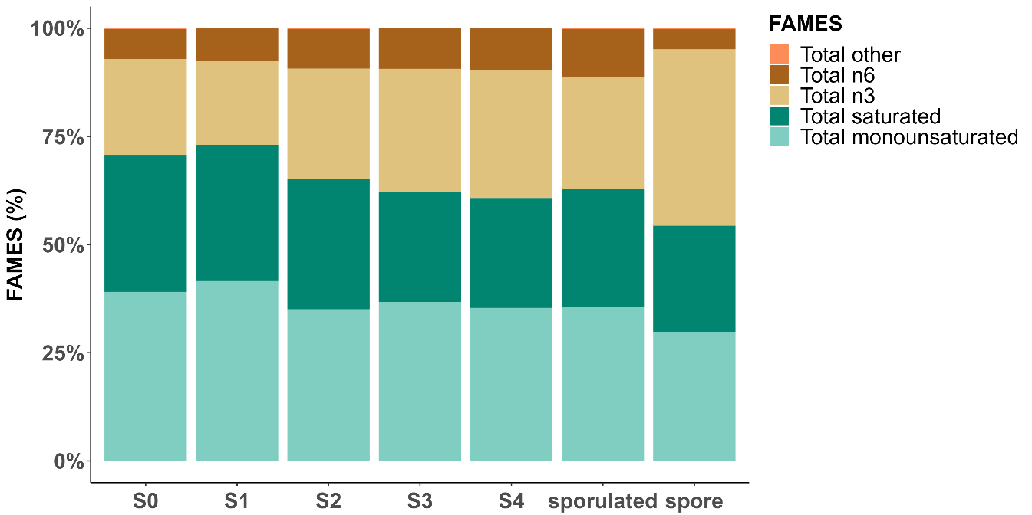
Figure 4.13 Barplot depicting the mean FAMES (%) in the polar fraction of the total lipids found in the hepatopancreas with different levels of Hematodinium sp. infection (stage 0-4) as classified by the PM, along with the hepatopancreas of the host that sporulated and the released spores (macrospores).
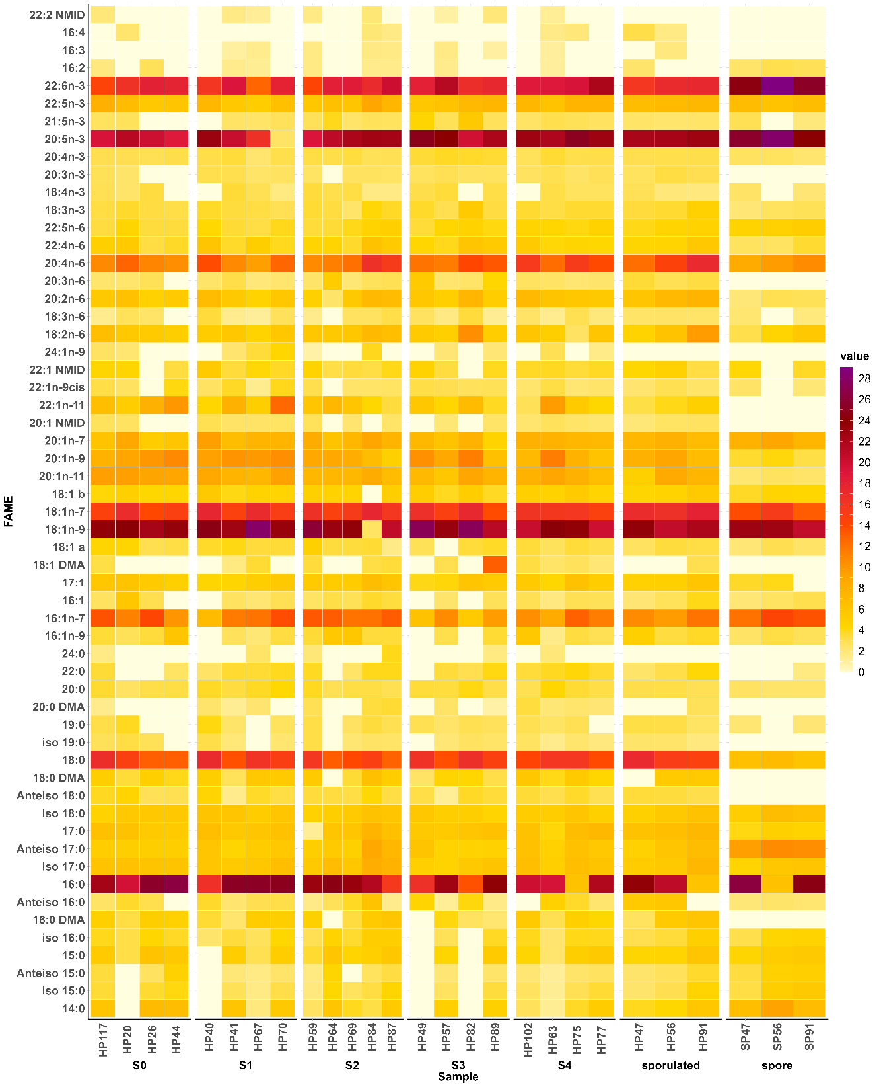
Figure 4.14 Fatty acid composition (according to the polar fraction of the total lipid) in Nephrops hepatopancreas at different stages of infection (stages 0-4) and after sporulation and in spores released from sporulated animals. Hepatopancreas: Comparing Hematodinium sp. Infection (stages 0-4) as classified by the PM, Sporulated Individuals, and released macrospores. Limit of detection: 0.16.

Neutral fraction- The macrospores exhibited significant differences in comparison to both the host hepatopancreas and the hepatopancreas of infected Nephrops at various stages of Hematodinium sp. infection (stage 0-4) (Table 4.7). Specifically, significant increases were observed in arachidic acid (20:0) and palmitoleic acid (16:1n-7) levels in the macrospores, while EDA (20:2n-6) was significantly lower.
Furthermore, in the macrospores, oleic acid (18:1n-9) was significantly higher compared to its host and the hepatopancreas at all levels of Hematodinium sp. infection, except for stage 3, where no significant difference was found compared to the macrospores. Conversely, saturated stearic acid (18:0) was significantly lower in macrospores compared to the host hepatopancreas and all levels of Hematodinium sp. infection, except stage 1. Moreover, EPA (20:5n-3) exhibited a significant increase in the macrospores compared to the host hepatopancreas, while eicosenoic acid (20:1n-11) was significantly decreased (Table 4.8). For further anova analysis see Table 4.9.
Table 4.7 Fatty acid composition according to the neutral fraction of the total lipids (% of total fatty acids) in oil extracted from N.norvegicus hepatopancreas and from Hematodinium macrospores. Samples were obtained from the hepatopancreas of N. norvegicus individuals showing varying levels of Hematodinium sp. infection (stages S0–S4), classified according to the pleopod method (PM). These individuals had not reached sporulation (non-sporulated). Additional samples were collected from the hepatopancreas of three individuals that had undergone sporulation (sporulated group, n = 3, PM stage 3-4). During these sporulation events, Hematodinium sp. macrospores were evacuated through the gills of the host and subsequently isolated and analysed. All Nephrops were collected from the Clyde Sea area. SD=standard deviation; n.d=not detected.
Neutral fraction of the total lipids | S0 | S1 | S2 | S3 | S4 | sporulated | spore
Neutral fraction of the total lipids | mean ± sd | mean ± sd | mean ± sd | mean ± sd | mean ± sd | mean ± sd | mean ± sd
14:0 | 1.79 ± 0.8 | 1.95 ± 0.64 | 1.93 ± 0.55 | 1.71 ± 0.53 | 1.48 ± 1.05 | 0.7 ± 0.92 | 2.12 ± 0.43
iso 15:0 | 0.54 ± 0.04 | 0.54 ± 0.11 | 0.77 ± 0.31 | 0.65 ± 0.28 | 0.67 ± 0.41 | 0.9 ± 0.6 | 0.63 ± 0.3
Anteiso 15:0 | 0.28 ± 0.07 | 0.26 ± 0.05 | 0.42 ± 0.23 | 0.32 ± 0.14 | 0.36 ± 0.22 | 0.64 ± 0.55 | 0.64 ± 0.23
15:0 | 0.66 ± 0.06 | 0.61 ± 0.07 | 0.87 ± 0.26 | 0.66 ± 0.26 | 0.82 ± 0.42 | 0.83 ± 0.12 | 0.61 ± 0.1
iso 16:0 | 0.47 ± 0.17 | 0.4 ± 0.16 | 0.7 ± 0.37 | 0.46 ± 0.25 | 0.64 ± 0.3 | 0.7 ± 0.32 | 0.49 ± 0.21
16:0 DMA | 0.13 ± 0.1 | 0.16 ± 0.08 | 0.15 ± 0.1 | 0.17 ± 0.03 | 0.3 ± 0.14 | 0.35 ± 0.05 | 0.14 ± 0.05
Anteiso 16:0 | 0.56 ± 0.17 | 0.6 ± 0.19 | 0.57 ± 0.21 | 0.65 ± 0.09 | 0.74 ± 0.1 | 0.85 ± 0.3 | 0.98 ± 0.11
16:0 | 15.35 ± 1.09 | 15.11 ± 1.84 | 14.99 ± 1.67 | 13.3 ± 2.68 | 13.28 ± 1.19 | 12.7 ± 1.14 | 15.38 ± 1.28
iso 17:0 | 1.1 ± 0.32 | 0.98 ± 0.36 | 1.46 ± 0.62 | 1.04 ± 0.31 | 1.31 ± 0.4 | 1.55 ± 0.64 | 1.13 ± 0.41
Anteiso 17:0 | 0.77 ± 0.25 | 0.74 ± 0.28 | 1.46 ± 1 | 0.77 ± 0.19 | 1.12 ± 0.38 | 1.5 ± 0.59 | 1.73 ± 0.63
17:0 | 0.62 ± 0.21 | 0.55 ± 0.12 | 0.73 ± 0.21 | 0.6 ± 0.13 | 0.72 ± 0.18 | 0.75 ± 0.09 | 0.45 ± 0.07
iso 18:0 | 0.58 ± 0.06 | 0.59 ± 0.18 | 0.66 ± 0.21 | 0.5 ± 0.07 | 0.61 ± 0.07 | 0.69 ± 0.24 | 0.36 ± 0.06
Anteiso 18:0 | 0.33 ± 0.15 | 0.29 ± 0.14 | 0.38 ± 0.14 | 0.31 ± 0.08 | 0.38 ± 0.13 | 0.39 ± 0.03 | 0.27 ± 0.17
18:0 DMA | 0.05 ± 0.09 | 0.09 ± 0.09 | 0.06 ± 0.05 | 0.1 ± 0.03 | 0.08 ± 0.11 | 0.21 ± 0.03 | 0.09 ± 0.01
18:0 | 3.44 ± 1.32 | 3.07 ± 0.27 | 3.14 ± 0.39 | 3.26 ± 0.34 | 3.57 ± 0.47 | 3.73 ± 0.2 | 1.89 ± 0.17
iso 19:0 | 0.18 ± 0.11 | 0.2 ± 0.13 | 0.15 ± 0.11 | 0.16 ± 0.03 | 0.14 ± 0.2 | 0.29 ± 0.06 | 0.11 ± 0.02
19:0 | 0.31 ± 0.17 | 0.33 ± 0.18 | 0.42 ± 0.2 | 0.3 ± 0.06 | 0.36 ± 0.21 | 0.44 ± 0.07 | 0.69 ± 0.1
20:0 DMA | 0 ± 0 | 0 ± 0 | 0 ± 0 | 0 ± 0 | 0 ± 0 | 0 ± 0 | 0 ± 0
20:0 | 0.48 ± 0.06 | 0.48 ± 0.1 | 0.5 ± 0.17 | 0.54 ± 0.05 | 0.62 ± 0.12 | 0.59 ± 0.14 | 1.48 ± 0.32
22:0 | 0.21 ± 0.16 | 0.25 ± 0.09 | 0.21 ± 0.13 | 0.29 ± 0.05 | 0.25 ± 0.17 | 0.36 ± 0.13 | 0.38 ± 0.09
24:0 | 0.02 ± 0.04 | 0.01 ± 0.02 | 0.01 ± 0.02 | 0.02 ± 0.04 | 0 ± 0 | 0 ± 0 | 0 ± 0
total saturated | 27.87 ± 1.74 | 27.2 ± 0.4 | 29.59 ± 4.09 | 25.8 ± 4.74 | 27.47 ± 4.14 | 28.19 ± 3.5 | 29.55 ± 0.8
16:1n-9 | 0.23 ± 0.07 | 0.27 ± 0.05 | 0.33 ± 0.08 | 0.29 ± 0.08 | 0.25 ± 0.16 | 0.35 ± 0.05 | 0.68 ± 0.07
16:1n-7 | 6.01 ± 0.86 | 6.35 ± 1.45 | 7.42 ± 1.65 | 5.75 ± 1.46 | 6.16 ± 0.81 | 4.65 ± 1.69 | 13.13 ± 0.62
16:1 | 0.28 ± 0.06 | 0.3 ± 0.05 | 0.43 ± 0.11 | 0.32 ± 0.08 | 0.38 ± 0.13 | 0.45 ± 0.17 | 0.26 ± 0.1
17:1 | 0.66 ± 0.21 | 0.65 ± 0.12 | 0.8 ± 0.12 | 0.67 ± 0.16 | 0.7 ± 0.18 | 0.69 ± 0.07 | 0.91 ± 0.21
18:1 DMA | 0.01 ± 0.03 | 0 ± 0 | 0 ± 0 | 0.01 ± 0.02 | 0 ± 0 | 0 ± 0 | 0 ± 0
18:1 | 0.58 ± 0.21 | 0.45 ± 0.06 | 0.47 ± 0.02 | 0.44 ± 0.18 | 0.49 ± 0.1 | 0.46 ± 0.13 | 0.37 ± 0.07
18:1n-9 | 14.19 ± 1.47 | 16.03 ± 3.16 | 14.15 ± 1.66 | 17.23 ± 2.44 | 13.57 ± 1.69 | 14.94 ± 4.5 | 23.72 ± 2.09
18:1n-7 | 7.44 ± 1.17 | 8.78 ± 1.5 | 8.3 ± 0.93 | 8.83 ± 0.45 | 8.42 ± 0.62 | 9.91 ± 1.07 | 7.14 ± 0.54
18:1 | 0.52 ± 0.09 | 0.57 ± 0.14 | 0.55 ± 0.33 | 0.6 ± 0.08 | 0.62 ± 0.19 | 0.77 ± 0.14 | 0.44 ± 0.09
20:1n-11 | 4.12 ± 0.94 | 3.68 ± 1.11 | 3.68 ± 1.3 | 3.86 ± 0.91 | 3.88 ± 2.37 | 5.29 ± 1.08 | 1.28 ± 0.11
20:1n-9 | 5.22 ± 2.24 | 5.04 ± 1.44 | 3.73 ± 1.65 | 5.6 ± 1.8 | 4.45 ± 2.26 | 4.11 ± 0.67 | 1.71 ± 0.28
20:1n-7 | 2.96 ± 1.52 | 3.53 ± 1.41 | 4.28 ± 1.64 | 3.46 ± 0.28 | 4.59 ± 1.75 | 6.4 ± 1 | 3.07 ± 0.29
20:1 NMID | 0.33 ± 0.07 | 0.38 ± 0.15 | 0.48 ± 0.17 | 0.39 ± 0.08 | 0.44 ± 0.08 | 0.58 ± 0.1 | 0.06 ± 0.06
22:1n-11 | 10.7 ± 6.98 | 7.11 ± 5.67 | 4.59 ± 2.62 | 6.67 ± 3.89 | 7.18 ± 5.06 | 3.94 ± 3.8 | 0.21 ± 0.19
22:1n-9cis | 1.01 ± 0.72 | 1.08 ± 0.49 | 0.75 ± 0.28 | 1.19 ± 0.61 | 0.91 ± 0.54 | 0.82 ± 0.3 | 0.8 ± 0.32
22:1 NMID | 0.8 ± 0.23 | 0.9 ± 0.42 | 1.14 ± 0.39 | 0.89 ± 0.12 | 1.01 ± 0.36 | 1.52 ± 0.28 | 0 ± 0
24:1n-9 | 0.22 ± 0.14 | 0.22 ± 0.08 | 0.16 ± 0.1 | 0.25 ± 0.09 | 0.16 ± 0.13 | 0.2 ± 0.25 | 0 ± 0
total monounsaturated | 55.28 ± 5.18 | 55.34 ± 1.08 | 51.27 ± 1.47 | 56.45 ± 4.91 | 53.23 ± 5.26 | 55.07 ± 2.36 | 53.79 ± 2.26
18:2n-6 | 0.64 ± 0.12 | 0.67 ± 0.1 | 0.8 ± 0.05 | 1.24 ± 1.14 | 0.79 ± 0.13 | 1.21 ± 0.45 | 0.89 ± 0.54
18:3n-6 | 0.19 ± 0.11 | 0.22 ± 0.01 | 0.26 ± 0.11 | 0.18 ± 0.08 | 0.31 ± 0.15 | 0.18 ± 0.03 | 0.14 ± 0
20:2n-6 | 1.11 ± 0.16 | 1.25 ± 0.39 | 1.36 ± 0.28 | 1.36 ± 0.16 | 1.71 ± 0.31 | 2.17 ± 0.66 | 0.4 ± 0.09
20:3n-6 | 0.14 ± 0.09 | 0.13 ± 0.04 | 0.13 ± 0.07 | 0.15 ± 0.02 | 0.09 ± 0.11 | 0.25 ± 0.06 | 0.08 ± 0.01
20:4n-6 | 1.8 ± 0.72 | 1.71 ± 0.57 | 2.17 ± 0.38 | 1.62 ± 0.32 | 2.67 ± 0.56 | 2.39 ± 0.27 | 1.94 ± 0.42
22:4n-6 | 0.5 ± 0.27 | 0.48 ± 0.32 | 0.52 ± 0.16 | 0.54 ± 0.19 | 0.69 ± 0.16 | 0.72 ± 0.15 | 0.21 ± 0.07
22:5n-6 | 0.3 ± 0.1 | 0.36 ± 0.13 | 0.37 ± 0.13 | 0.39 ± 0.05 | 0.5 ± 0.05 | 0.5 ± 0.06 | 0.13 ± 0.04
total n6 | 4.69 ± 1.41 | 4.81 ± 1.46 | 5.62 ± 0.79 | 5.48 ± 1.48 | 6.77 ± 1.12 | 7.42 ± 1.56 | 3.79 ± 1.13
18:3n-3 | 0.26 ± 0.04 | 0.24 ± 0.06 | 0.33 ± 0.02 | 0.42 ± 0.22 | 0.3 ± 0.03 | 0.33 ± 0.06 | 0.26 ± 0.06
18:4n-3 | 0.32 ± 0.1 | 0.44 ± 0.17 | 0.36 ± 0.33 | 0.42 ± 0.15 | 0.3 ± 0.09 | 0.2 ± 0.08 | 0.38 ± 0.09
20:3n-3 | 0.24 ± 0.05 | 0.28 ± 0.04 | 0.19 ± 0.18 | 0.32 ± 0.04 | 0.32 ± 0.03 | 0.4 ± 0.06 | 0.09 ± 0
20:4n-3 | 0.23 ± 0.04 | 0.27 ± 0.07 | 0.23 ± 0.22 | 0.3 ± 0.04 | 0.26 ± 0.07 | 0.22 ± 0.09 | 0.19 ± 0.05
20:5n-3 | 5.19 ± 2.04 | 4.9 ± 1.21 | 5.8 ± 1.55 | 4.62 ± 0.75 | 5.13 ± 0.43 | 3.15 ± 1.51 | 7.86 ± 1.13
21:5n-3 | 0.1 ± 0.08 | 0.13 ± 0.1 | 0.18 ± 0.11 | 0.18 ± 0.03 | 0.1 ± 0.11 | 0.13 ± 0.12 | 0.27 ± 0.09
22:5n-3 | 0.99 ± 0.4 | 0.88 ± 0.12 | 1.03 ± 0.08 | 0.94 ± 0.3 | 1.07 ± 0.33 | 0.77 ± 0.19 | 0.81 ± 0.01
22:6n-3 | 4.34 ± 0.32 | 4.89 ± 0.75 | 4.81 ± 1.93 | 4.47 ± 0.62 | 4.65 ± 1.05 | 3.37 ± 0.87 | 2.82 ± 1.47
total n3 | 11.69 ± 2.36 | 12.04 ± 1.66 | 12.94 ± 4.08 | 11.67 ± 1.12 | 12.13 ± 1.37 | 8.57 ± 2.54 | 12.67 ± 2.45
16:2 | 0.08 ± 0.06 | 0.18 ± 0.16 | 0.11 ± 0.11 | 0.14 ± 0.04 | 0.05 ± 0.06 | 0.13 ± 0.01 | 0.08 ± 0.01
16:3 | 0.1 ± 0.21 | 0.04 ± 0.07 | 0.06 ± 0.1 | 0.06 ± 0.08 | 0 ± 0 | 0.03 ± 0.05 | 0.03 ± 0.05
16:4 | 0.07 ± 0.05 | 0.12 ± 0.03 | 0.09 ± 0.08 | 0.11 ± 0.03 | 0.13 ± 0.12 | 0.12 ± 0.01 | 0.09 ± 0
22:2 NMID | 0.21 ± 0.06 | 0.28 ± 0.25 | 0.33 ± 0.18 | 0.29 ± 0.12 | 0.21 ± 0.15 | 0.48 ± 0.21 | 0 ± 0
total other | 0.47 ± 0.3 | 0.62 ± 0.18 | 0.58 ± 0.22 | 0.59 ± 0.12 | 0.39 ± 0.19 | 0.75 ± 0.19 | 0.2 ± 0.06
DHA/EPA | 0.95 ± 0.39 | 1.04 ± 0.26 | 0.81 ± 0.17 | 0.98 ± 0.16 | 0.91 ± 0.22 | 1.18 ± 0.36 | 0.35 ± 0.14
n-3/n-6 PUFA | 2.57 ± 0.45 | 2.68 ± 0.87 | 2.38 ± 0.94 | 2.26 ± 0.64 | 1.84 ± 0.44 | 1.24 ± 0.6 | 3.6 ± 1.35

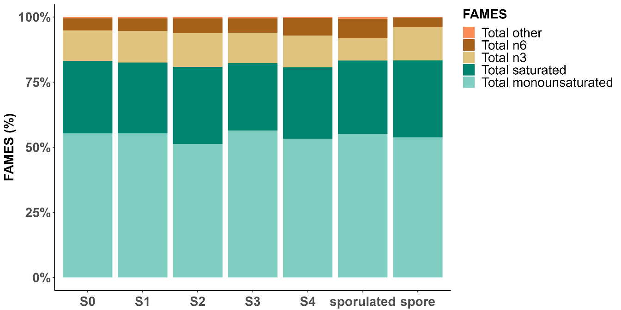
Figure 4.15 Barplot depicting the average FAMES (%) in the neutral fraction of the total lipids found in the hepatopancreas with different levels of Hematodinium sp. infection (stage 0-4) as classified by the PM, along with the hepatopancreas of the host that sporulated and the released spores (macrospores).

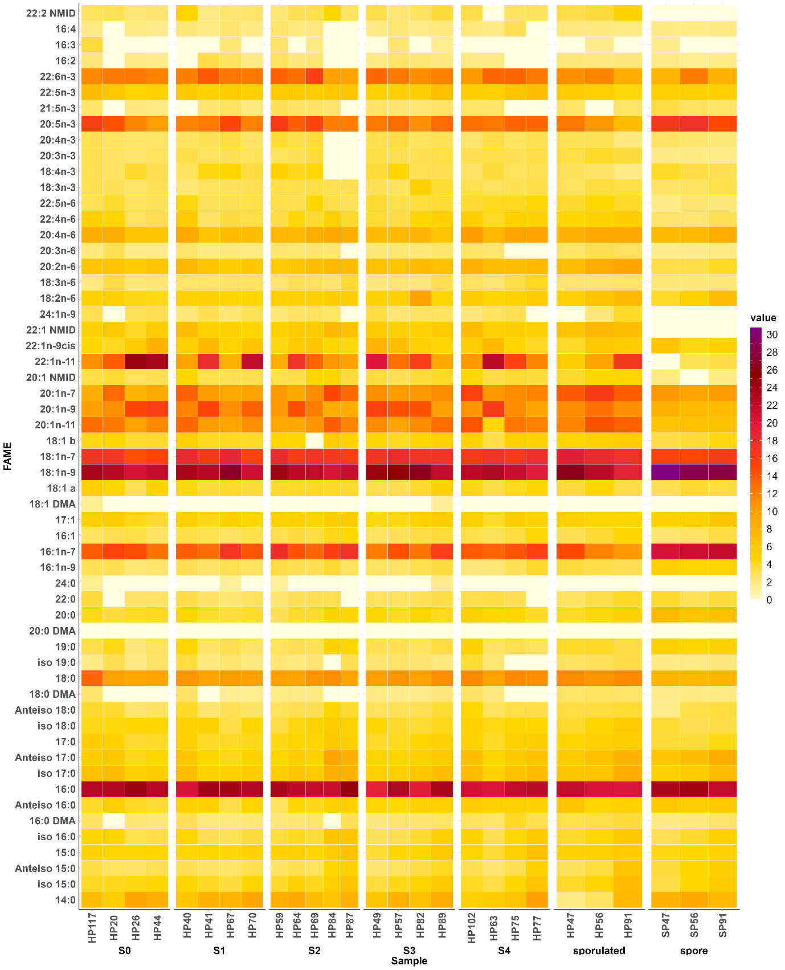
Figure 4.16 Fatty Acid Composition (according to the neutral fraction of the total lipid) in Nephrops hepatopancreas at different stages of infection (stages S 0-4) and after sporulation and in spores released from sporulated animals. Hepatopancreas: Comparing Hematodinium sp. Infection (Stages 0-4) as classified by the PM, Sporulated Individuals, and released macrospores. Limit of detection: 0.16.

Anova comparisons

Table 4.8 Anova comparison of fatty acid composition of macrospores compared to host hepatopancreas and the hepatopancreas of Nephrops with different levels of Hematodinium sp. infection according to the pleopod method: analysis of total fatty acid composition, and fatty acid composition in neutral and polar fraction of the total lipid. ns=no significant.
fatty acid | Total |  |  |  |  |  |  | Polar |  |  |  |  |  |  | Neutral
fatty acid | p-value | S0 | S1 | S2 | S3 | S4 | host | p-value | S0 | S1 | S2 | S3 | S4 | host | p-value | S0 | S1 | S2 | S3 | S4 | host
14:0 | ns | ns | ns | ns | ns | ns | ns | ns | ns | ns | ns | ns | ns | ns | ns | ns | ns | ns | ns | ns | ns
iso 15:0 | ns | ns | ns | ns | ns | ns | ns | ns | ns | ns | ns | ns | ns | ns | ns | ns | ns | ns | ns | ns | ns
Anteiso 15:0 | 0.01 | ns | 0.01 | 0.01 | ns | ns | ns | ns | ns | ns | ns | ns | ns | ns | ns | ns | ns | ns | ns | ns | ns
15:0 | ns | ns | ns | ns | ns | ns | ns | ns | ns | ns | ns | ns | ns | ns | ns | ns | ns | ns | ns | ns | ns
iso 16:0 | ns | ns | ns | ns | ns | ns | ns | ns | ns | ns | ns | ns | ns | ns | ns | ns | ns | ns | ns | ns | ns
16:0 DMA | 1.02E-04 | 2.25E-05 | 3.50E-03 | 0.02 | 5.35E-04 | 4.74E-04 | 1.07E-03 | 0.01 | 0.02 | 0.04 | 0.03 | ns | 0.02 | 0.02 | ns | ns | ns | ns | ns | ns | ns
Anteiso 16:0 | ns | ns | ns | ns | ns | ns | ns | ns | ns | ns | ns | ns | ns | ns | ns | ns | ns | ns | ns | ns | ns
16:0 | ns | ns | ns | ns | ns | ns | ns | ns | ns | ns | ns | ns | ns | ns | ns | ns | ns | ns | ns | ns | ns
iso 17:0 | ns | ns | ns | ns | ns | ns | ns | ns | ns | ns | ns | ns | ns | ns | ns | ns | ns | ns | ns | ns | ns
Anteiso 17:0 | 7.56E-03 | 0.01 | 2.27E-03 | 0.01 | 0.01 | 0.03 | ns | 2.00E-05 | 2.03E-05 | 3.61E-05 | 3.92E-04 | 1.82E-05 | 1.65E-04 | 4.01E-04 | ns | ns | ns | ns | ns | ns | ns
17:0 | ns | ns | ns | ns | ns | ns | ns | ns | ns | ns | ns | ns | ns | ns | ns | ns | ns | ns | ns | ns | ns
iso 18:0 | ns | ns | ns | ns | ns | ns | ns | ns | ns | ns | ns | ns | ns | ns | ns | ns | ns | ns | ns | ns | ns
Anteiso 18:0 | ns | ns | ns | ns | ns | ns | ns | 1.01E-04 | 1.09E-04 | 3.42E-04 | 7.12E-05 | 1.13E-03 | 2.47E-04 | 5.11E-04 | ns | ns | ns | ns | ns | ns | ns
18:0 DMA | 6.10E-03 | 1.82E-03 | 0.03 | ns | 4.72E-03 | 0.01 | 0.02 | 0.02 | 0.04 | 0.02 | 0.04 | ns | 0.02 | ns | ns | ns | ns | ns | ns | ns | ns
18:0 | 2.60E-08 | 7.52E-09 | 2.50E-08 | 9.05E-08 | 1.92E-08 | 5.06E-08 | 5.61E-07 | 3.50E-07 | 3.49E-06 | 4.85E-07 | 3.12E-06 | 6.12E-07 | 1.29E-06 | 1.04E-06 | 0.01 | 0.01 | ns | 0.03 | 0.02 | 0.01 | 4.53E-03
iso 19:0 | ns | ns | ns | ns | ns | ns | ns | ns | ns | ns | ns | ns | ns | ns | ns | ns | ns | ns | ns | ns | ns
19:0 | ns | ns | ns | ns | ns | ns | ns | ns | ns | ns | ns | ns | ns | ns | ns | ns | ns | ns | ns | ns | ns
20:0 DMA | ns | ns | ns | ns | ns | ns | ns | ns | ns | ns | ns | ns | ns | ns | ns | ns | ns | ns | ns | ns | ns
20:0 | ns | ns | ns | ns | ns | ns | ns | 0.01 | 2.90E-03 | ns | ns | 0.02 | 0.02 | ns | 1.84E-06 | 2.37E-06 | 2.26E-06 | 1.81E-06 | 8.84E-06 | 4.57E-05 | 5.75E-05
22:0 | ns | ns | ns | ns | ns | ns | ns | ns | ns | ns | ns | ns | ns | ns | ns | ns | ns | ns | ns | ns | ns
24:0 | ns | ns | ns | ns | ns | ns | ns | ns | ns | ns | ns | ns | ns | ns | ns | ns | ns | ns | ns | ns | ns
total saturated | ns | ns | ns | ns | ns | ns | ns | ns | ns | ns | ns | ns | ns | ns | ns | ns | ns | ns | ns | ns | ns
16:1n-9 | 3.25E-03 | 1.52E-03 | 9.58E-04 | 0.03 | 0.01 | 2.98E-03 | 0.05 | ns | ns | ns | ns | ns | ns | ns | 3.57E-04 | 2.12E-04 | 1.07E-03 | 0.01 | 2.36E-03 | 3.64E-04 | 0.02
16:1n-7 | 1.15E-06 | 3.23E-06 | 1.86E-06 | 4.27E-05 | 3.16E-07 | 6.17E-06 | 1.77E-06 | 0.02 | ns | ns | ns | 0.02 | ns | ns | 2.40E-05 | 1.25E-04 | 2.47E-04 | 1.47E-03 | 6.49E-05 | 1.75E-04 | 1.33E-05
16:1 | ns | ns | ns | ns | ns | ns | ns | ns | ns | ns | ns | ns | ns | ns | ns | ns | ns | ns | ns | ns | ns
17:1 | ns | ns | ns | ns | ns | ns | ns | 0.01 | 0.01 | ns | 4.76E-03 | ns | 0.03 | ns | ns | ns | ns | ns | ns | ns | ns
18:1 DMA | ns | ns | ns | ns | ns | ns | ns | ns | ns | ns | ns | ns | ns | ns | ns | ns | ns | ns | ns | ns | ns
18:1 | ns | ns | ns | ns | ns | ns | ns | ns | ns | ns | ns | ns | ns | ns | ns | ns | ns | ns | ns | ns | ns
18:1n-9 | ns | ns | ns | ns | ns | ns | ns | ns | ns | ns | ns | ns | ns | ns | 1.14E-03 | 2.11E-03 | 0.02 | 1.23E-03 | ns | 9.68E-04 | 8.13E-03
18:1n-7 | ns | ns | ns | ns | ns | ns | ns | ns | ns | ns | ns | ns | ns | ns | ns | ns | ns | ns | ns | ns | ns
18:1 | ns | ns | ns | ns | ns | ns | ns | ns | ns | ns | ns | ns | ns | ns | ns | ns | ns | ns | ns | ns | ns
20:1n-11 | 7.00E-06 | 5.57E-05 | 6.29E-05 | 3.71E-03 | 6.12E-05 | 3.44E-06 | 1.07E-05 | 1.58E-06 | 4.03E-07 | 3.96E-06 | 2.26E-05 | 5.36E-05 | 1.29E-05 | 3.52E-04 | 0.045 | ns | ns | ns | ns | ns | 0.02
20:1n-9 | 1.27E-03 | 3.91E-03 | 1.63E-04 | 0.01 | 8.11E-04 | 0.01 | 0.02 | 1.16E-03 | 1.87E-03 | 6.76E-04 | 0.04 | 2.36E-03 | 0.02 | 0.05 | ns | ns | ns | ns | ns | ns | ns
20:1n-7 | 0.03 | ns | ns | ns | ns | ns | 0.03 | ns | ns | ns | ns | ns | ns | ns | 0.047 | ns | ns | ns | ns | ns | ns
20:1 NMID | 4.47E-04 | 0.01 | 5.99E-04 | 0.01 | 6.62E-04 | 1.60E-04 | 5.76E-04 | ns | ns | ns | ns | ns | ns | ns | ns | ns | ns | ns | ns | ns | ns
22:1n-11 | 0.03 | 0.01 | ns | ns | 0.03 | ns | ns | 0.01 | 4.88E-03 | 4.37E-03 | 4.90E-02 | ns | ns | ns | 0.02 | 8.77E-03 | ns | ns | ns | ns | ns
22:1n-9cis | ns | ns | ns | ns | ns | ns | ns | ns | ns | ns | ns | ns | ns | ns | ns | ns | ns | ns | ns | ns | ns
22:1 NMID | 1.93E-10 | 1.23e- 8 | 2.04E-10 | 8.07e- 9 | 4.09E-10 | 1.13E-10 | 5.43E-10 | ns | ns | ns | ns | ns | ns | ns | 6.94E-08 | 2.80E-06 | 1.25E-06 | 8.71E-08 | 1.13E-06 | 4.71E-07 | 4.13E-08
24:1n-9 | 4.87E-08 | 4.52E-08 | 6.26E-08 | 1.12E-07 | 6.29E-09 | 9.58E-08 | 1.05E-05 | ns | ns | ns | ns | ns | ns | ns | ns | ns | ns | ns | ns | ns | ns
total monounsaturated | ns | ns | ns | ns | ns | ns | ns | ns | ns | ns | ns | ns | ns | ns | ns | ns | ns | ns | ns | ns | ns
18:2n-6 | 0.03 | ns | ns | 0.02 | 0.03 | ns | ns | ns | ns | ns | ns | ns | ns | ns | ns | ns | ns | ns | ns | ns | ns
18:3n-6 | 1.27E-03 | 2.85E-03 | 0.04 | ns | 0.03 | 3.44E-04 | ns | ns | ns | ns | ns | ns | ns | ns | ns | ns | ns | ns | ns | ns | ns
20:2n-6 | 5.73E-07 | 1.62E-04 | 3.63E-06 | 3.43E-04 | 7.85E-06 | 3.24E-07 | 7.59E-07 | 0.01 | 0.05 | 0.03 | ns | 0.02 | 0.01 | 3.32E-03 | 7.64E-06 | 5.26E-03 | 1.49E-03 | 2.71E-04 | 4.31E-04 | 2.04E-05 | 2.54E-06
20:3n-6 | 5.04E-07 | 3.37E-03 | 3.55E-05 | 1.38E-05 | 7.79E-05 | 3.19E-06 | 2.59E-07 | 0.00 | ns | 0.04 | 0.01 | 1.65E-03 | 4.86E-02 | 0.01 | ns | ns | ns | ns | ns | ns | ns
20:4n-6 | ns | ns | ns | ns | ns | ns | ns | 0.03 | ns | ns | ns | ns | 0.04 | 0.04 | ns | ns | ns | ns | ns | ns | ns
22:4n-6 | 0.03 | ns | ns | ns | ns | 0.03 | ns | ns | ns | ns | ns | ns | ns | ns | 0.047 | ns | ns | ns | ns | 0.03 | 0.04
22:5n-6 | ns | ns | ns | ns | ns | ns | ns | 0.04 | 0.04 | ns | ns | ns | ns | ns | 1.71E-04 | ns | 9.62E-03 | 3.92E-03 | 2.50E-03 | 1.01E-04 | 2.56E-04
total n6 | 3.34E-03 | 0.02 | 0.05 | 0.01 | 2.43E-03 | 2.43E-03 | 0.01 | 0.04 | ns | ns | ns | ns | ns | 0.03 | ns | ns | ns | ns | ns | ns | ns
18:3n-3 | 7.87E-03 | ns | 0.02 | 2.92E-03 | 8.66E-03 | ns | ns | ns | ns | ns | ns | ns | ns | ns | ns | ns | ns | ns | ns | ns | ns
18:4n-3 | 0.01 | ns | ns | ns | ns | ns | ns | ns | ns | ns | ns | ns | ns | ns | ns | ns | ns | ns | ns | ns | ns
20:3n-3 | 4.91E-12 | 2.35e- 8 | 7.11E-12 | 1.35e- 9 | 9.93E-11 | 4.44E-12 | 3.08E-11 | 1.04E-03 | ns | 3.14E-03 | 0.03 | 4.06E-03 | 3.75E-03 | 3.18E-03 | 3.74E-02 | ns | ns | ns | ns | ns | ns
20:4n-3 | 3.71E-03 | ns | 0.01 | 3.03E-03 | ns | ns | ns | 2.26E-03 | ns | ns | ns | 4.33E-04 | ns | ns | ns | ns | ns | ns | ns | ns | ns
20:5n-3 | 1.85E-05 | 8.02E-04 | 1.15E-05 | 6.66E-04 | 1.08E-05 | 1.49E-05 | 7.90E-05 | 4.98E-02 | ns | 0.03 | ns | ns | ns | ns | 0.02 | ns | ns | ns | ns | ns | 5.62E-03
21:5n-3 | ns | ns | ns | ns | ns | ns | ns | ns | ns | ns | ns | ns | ns | ns | ns | ns | ns | ns | ns | ns | ns
22:5n-3 | ns | ns | ns | ns | ns | ns | ns | ns | ns | ns | ns | ns | ns | ns | ns | ns | ns | ns | ns | ns | ns
22:6n-3 | 9.68E-05 | 3.33E-04 | 2.92E-03 | 6.35E-05 | 9.81E-05 | 2.11E-04 | 6.93E-05 | 7.07E-05 | 9.27E-05 | 6.90E-05 | 2.10E-04 | 1.12E-03 | 0.01 | 2.60E-04 | ns | ns | ns | ns | ns | ns | ns
total n3 | 2.37E-05 | 5.79E-04 | 2.91E-05 | 3.98E-03 | 3.03E-05 | 3.07E-05 | 3.30E-05 | 1.65E-04 | 5.36E-04 | 5.98E-05 | 3.20E-03 | 0.03 | ns | 0.01 | ns | ns | ns | ns | ns | ns | ns
16:2 | 3.27E-04 | 4.59E-02 | 3.88E-04 | 1.88E-04 | 3.50E-03 | 8.10E-04 | ns | ns | ns | ns | ns | ns | ns | ns | ns | ns | ns | ns | ns | ns | ns
16:3 | ns | ns | ns | ns | ns | ns | ns | ns | ns | ns | ns | ns | ns | ns | ns | ns | ns | ns | ns | ns | ns
16:4 | 1.45E-05 | 1.05E-03 | 3.54E-05 | 1.38E-06 | 3.71E-04 | 1.03E-03 | 0.01 | ns | ns | ns | ns | ns | ns | ns | ns | ns | ns | ns | ns | ns | ns
22:2 NMID | ns | ns | ns | ns | ns | ns | ns | ns | ns | ns | ns | ns | ns | ns | 1.82E-03 | 2.18E-02 | 1.17E-02 | 2.49E-03 | 6.58E-03 | ns | 8.61E-04
total other | 1.51E-05 | 3.09E-05 | 1.84E-05 | 1.72E-05 | 5.43E-06 | 5.78E-06 | 1.09E-04 | ns | ns | ns | ns | ns | ns | ns | ns | ns | ns | ns | ns | ns | ns

Table 4.9 Anova comparison of fatty acid composition of hepatopancreas with different levels of Hematodinium sp. infection. according to the pleopod method vs the hepatopancreas of sporulated animals: analysis of total fatty acid composition, and fatty acid composition in neutral and polar fraction of the total lipid.
variable | comparison | test | p value | Anova p value | FAMES
20:1n-7 | sporulated-S0 | ANOVA+Tukey | 3.39E-02 | 4.70E-02 | NEUTRAL
20:2n-6 | sporulated-S0 | ANOVA+Tukey | 7.57E-03 | 7.64E-06 | NEUTRAL
20:2n-6 | sporulated-S1 | ANOVA+Tukey | 2.59E-02 | 7.64E-06 | NEUTRAL
16:1n-7 | S3-S2 | ANOVA+Tukey | 1.94E-02 | 2.04E-02 | POLAR
20:4n-3 | S3-S0 | ANOVA+Tukey | 3.51E-02 | 2.26E-03 | POLAR
20:4n-3 | S3-S1 | ANOVA+Tukey | 3.81E-02 | 2.26E-03 | POLAR
18:4n-3 | sporulated-S2 | ANOVA+Tukey | 3.13E-02 | 1.03E-02 | TOTAL
20:1n-7 | sporulated-S0 | ANOVA+Tukey | 2.88E-02 | 2.60E-02 | TOTAL
20:3n-3 | S1-S0 | ANOVA+Tukey | 2.91E-02 | 4.91E-12 | TOTAL
20:3n-3 | S4-S0 | ANOVA+Tukey | 1.13E-02 | 4.91E-12 | TOTAL
20:3n-3 | sporulated-S0 | ANOVA+Tukey | 3.27E-03 | 4.91E-12 | TOTAL
20:3n-6 | sporulated-S0 | ANOVA+Tukey | 1.65E-03 | 5.04E-07 | TOTAL
20:3n-6 | sporulated-S1 | ANOVA+Tukey | 4.32E-02 | 5.04E-07 | TOTAL
20:3n-6 | sporulated-S3 | ANOVA+Tukey | 1.72E-02 | 5.04E-07 | TOTAL

Discussion
The role of lipid metabolism in pathogen survival has been recognised in other pathosystems (Koriem, 2017; Manocha, 1980; Ramakrishnan et al., 2013; Sato et al., 2008). Parasites, like Hematodinium sp., rely on acquiring essential biomolecules from their hosts to survive and replicate (Appleton, 1996; Gornik et al., 2015), with lipids being particularly important for membrane formation, signalling, energy storage and acting as protective barriers against environmental stressors (Aranda et al., 2016; Furlong, 1991; Shunmugam et al., 2022). Lipids are of special significance for parasites that have lost their capacity for the novo synthesis of some lipids (Mondal et al., 2016) and heavily rely on the host for most nutrients, synthesizing only a few essential nutrients themselves (Ramakrishnan et al., 2013; Tavares et al., 2021; van Hellemond and Tielens, 2006). This dependence on the host stems from their opportunistic lifestyle. Hematodinium sp. serves as an example of this, as it lacks the de novo isoprenoid biosynthesis pathway (Gornik et al., 2015). Furthermore, dinoflagellates like Hematodinium sp. possess a large, multi-giga base genome and lipids are thought to contribute to the structural stability of the genome (Wisecaver & Hackett, 2011).
Lipids can be obtained by scavenging from the host or synthesized de novo (Chu et al., 2002; Shunmugam et al., 2022). The striking similarity in the fatty acid composition and lipid classes between the Hematodinium sp. macrospores and the hepatopancreas suggests that the parasite relies on the host for its specific fatty acid needs, potentially allowing the parasite to allocate more resources to cell production by bypassing the requirement for de novo synthesis or modification of fatty acids, and also suggests an evolutionary adaptation of the parasite to its host (Davies et al., 2022; Jensen et al., 2010; Pagenkopp Lohan et al., 2012). Similar patterns of fatty acid similarities between protistan parasites and their hosts have been observed in other pathosystems (Chu and Lund, 2006; Chu et al., 2004; Soudant and Chu, 2001).
The overall lipid profiles of the hepatopancreas of Nephrops infected with varying levels of Hematodinium sp. (pleopod stage 0-4) exhibited remarkable similarity. The mechanisms underlying the sustained and relatively unchanged profile of Hematodinium sp. during infection progression remain unclear. In this experiment, the hepatopancreas of infected Nephrops was mixed with Hematodinium sp. cells, which bears implications for interpreting the resulting data. Specifically, the absence of a noticeable shift suggests that the parasite may not be actively metabolizing or synthesizing lipids. If there were significant metabolic activity occurring within the parasite, changes in lipid composition might be expected as the parasite biomass increases within the tissue. However, the data demonstrate that while the HSI increases alongside parasite mass, the overall lipid content remains relatively stable until the sporulation stage, at which point a decrease is evident (Figure 4.8 and Figure 4.9). This decline in lipid content following sporulation may reflect the fact that parasites departing the host carry their lipid reserves with them.
Research has shown that the fatty acid compositions found in fish and crustacean tissues typically mirror the fatty acids present in their diets (Unnikrishnan and Paulraj, 2010; Wang et al., 2021; Zhang et al., 2019). Notably, the continuous feeding behaviour of Nephrops, remains unaffected by the level of Hematodinium sp. infection, as evidenced by the stomach content (personal observations; data not shown). In the wild, this regular feeding ensures a constant supply of nutrients to the parasites throughout the progression of Hematodinium sp. infection. In this experiment, animals were intentionally deprived of food and therefore in a state of “starvation”. The findings reveal a significant transfer of energy, particularly in the form of lipids, from the host to the parasite (Figure 4.8-Figure 4.9). This lipid transfer strongly suggests substantial changes in the host tissues, consistent with observations by other researchers who have noted similar alterations in muscle tissue under starvation conditions (Gornik et al., 2010). The specific mechanisms of nutrient depletion by Hematodinium sp. and its impact on host nutrition may require further investigation.
Fatty acid composition of Hematodinium macrospores, predominantly consist of palmitic acid as their major saturated fatty acid, along with oleic and palmitoleic acids as the dominant unsaturated fatty acids. It may be possible that palmitic acid serves as a precursor for the synthesis of both saturated and unsaturated fatty acids (Mondal et al., 2009). Elevated levels of unsaturated fatty acids detected within the dormant structures may suggest the formation of a reservoir essential for triggering germination (Feofilova et al., 2015). Arachidonic acid (ARA, 20:4n-6) specifically functions as a stored source of carbon and energy, which is utilized in the initial phases of spore germination of fungus Mortierella alpina (Lounds et al., 2007) and may serve a similar purpose in Hematodinium sp.
Overall, macrospores showed significantly elevated levels of EPA (20:5n-3), DHA (22:6n-3) but lower levels of n-6 PUFAs compared to the hepatopancreas host from which they sporulated. DHA and EPA may play a crucial role in maintaining the fluidity and stability of the parasite's cell membranes within the spore or in preparation for later stages after germination (Wassall and Stillwell, 2008), facilitating efficient nutrient uptake, waste removal, and overall cellular function (Sherratt et al., 2021; Valentine and Valentine, 2004). EPA and DHA were also significantly increased in macrospores within the polar fraction. Since spores are bi-flagellated and flagella require fluid membranes (Haidl and Opper, 1997; Thomashow and Rittenberg, 1985), these fatty acids may be involved in the motility of spores. DHA and EPA have been shown to prevent permeability transition in mitochondria, which is associated with cell death and damage (Khairallah et al., 2010). By incorporating DHA and EPA into its spores, Hematodinium sp. may enhance the resistance of the spores to environmental stresses and improve their survival during transmission. Linoleic acid (18:2n-6), also plays an important role in permeability and in maintaining the integrity and fluidity of the membranes which explains its abundance in all samples (Manocha, 1980). Further research is needed to fully understand the mechanisms by which Hematodinium sp. utilizes and benefits from these fatty acids.
Macrospores are constituted mostly of triacylglycerols, phosphatidylcholine, wax esters and cholesterol/sterols. Lipid bodies in dinoflagellates commonly contain wax esters, phosphatidylcholine (PC), and triacylglycerols (TAGs) (Roohani et al., 2019; Sikorskaya et al., 2021; Zhang et al., 2010). Different lipid classes play important roles in dinoflagellate and host processes. Triglycerides serve as energy storage and participate in glycolipid biosynthesis and structural lipid formation (Sikorskaya et al., 2021); phospholipids form cell membranes, while sterols provide structural support (Graeff and Leblond, 2021; Kumari et al., 2013). Triacylglycerols are dominant in both the hepatopancreas of Nephrops (Rosa and Nunes, 2002) and macrospores. Notably, parasites, including Hematodinium sp., have the ability to acquire host fatty acids and store them as TAGs in lipid droplets, ensuring a continuous lipid supply (Shunmugam et al., 2022). The presence of lipid droplets in Hematodinium sp. spores suggests their involvement in energy storage. These organelles may serve as a reservoir of energy-rich lipids that can be utilized by the parasite during different stages of its life cycle, including germination. Lipid droplets can provide a source of energy for Hematodinium sp. during periods of nutrient limitation or stress. Protozoan parasites have developed tactics to avoid or exploit lipid droplets as a lipid source for building cell membranes, supporting parasite growth, and functioning as an immune response suppressor (Vallochi et al., 2018).
Phosphatidylcholine (PC), wax esters and unknown polar lipids were significantly abundant in macrospores. PC plays a crucial role in cell membrane integrity and various cellular processes (Dawaliby et al., 2016). Some protozoan parasites, such as Plasmodium sporozoite and Toxoplasma gondii, rely on host-derived PC for successful colonization and proliferation (Gupta et al., 2005; Itoe et al., 2014). It is possible that PC could potentially have a comparable role in Hematodinium sp.. Wax ester production in dinoflagellates has been proposed to regulate buoyancy and act as a repository of energy-rich reserves during periods of low prey abundance (Roohani et al., 2019; Sargent et al., 1977), and may serve a similar function in Hematodinium sp. macrospores facilitating their survival and transmission in the water column. The presence of unknown polar lipids in macrospores indicates the existence of unique lipid components with potential functional significance, necessitating further investigation to gain insights into the parasite's biology and pathogenesis.
From the four individuals that underwent sporulation, all produced macrospores. Different Hematodinium sp. spore phenotypes might exhibit varying abilities to disperse when outside the host. Microspores, being faster swimmers and capable of spreading over greater distances, are more likely to be highly infectious propagules. On the other hand, macrospores might serve as resting stages in sediments, particularly in Nephrops habitats, as described by Appleton (1996). Organisms possess phenotypic plasticity, allowing them to adjust their traits to different environments, both within and outside the host, in order to enhance their fitness (Poulin and Lefebvre, 2006; Vizoso and Ebert, 2005). By adapting their disseminative capacity, they can maximize their chances of survival and successful reproduction, as highlighted by Vizoso and Ebert (2005). Although this study does not investigate the underlying factors that lead to the production of specific spore phenotypes, it is worth considering that Hematodinium sp. spore phenotype may exhibit plasticity in response to environmental cues (Sun et al., 2022; Thomas et al., 2002). Such plasticity could be a virulence trait that provides valuable insights into the persistence of the parasite in the CSA Nephrops population.
Sporulated individuals in this study were classified as stage 3 and 4 by PM, indicating that Nephrops can undergo sporulation without necessarily reaching stage 4 of infection based on the pleopod method. The macrospores were observed exiting the host through the gills in pulsating streams (Appleton and Vickerman, 1998) (see video links in supplementary Table S4. 1). Following sporulation, three of the hosts died within a few hours (Beevers, 2010; Love et al., 1993). However, one individual survived for more than 24 hours after sporulation before it was euthanized. This finding suggests the possibility of survival and recovery in some individuals following sporulation. However, it is important to note that such instances might be rare due to the substantial tissue structural damage that takes place during parasite proliferation and the subsequent sporulation process. During sporulation animals remained lethargic but responsive near the aerator, possibly seeking oxygen to meet the increased metabolic demands exerted by the parasites (Taylor et al., 1996). This observation aligns with previous reports indicating that infected animals spend more time outside their burrows (Stentiford et al., 2001c) where there is a higher oxygen flow, likely compensating for the increased demands imposed by the parasites in the host.
Hematodinium trophonts and macrospores exhibited certain resemblances, but they also demonstrated differences as observed in electron microscopy (EM) studies (Appleton, 1996; Appleton and Vickerman, 1998; Beevers, 2010). In advanced stages of infection, trophonts displayed more polynucleated and elongated shapes, whereas macrospores contained only one nucleus and exhibited flagellar hair vesicles. Lipid droplets were abundant in both macrospores and vegetative trophonts of Hematodinium sp., however, the size of the lipid droplets in macrospores were larger.
The process of sporulation in Nephrops resulted in nearly complete evacuation of Hematodinium sp. parasites and heavy tissue disruption, leaving behind some residual parasite cells, primarily mononucleated ameboid trophonts (Appleton, 1996; Appleton and Vickerman, 1998; Beevers, 2010). No macrospores were observed within the tissue samples (Appleton and Vickerman, 1998). Although the specific triggers of sporulation and the mechanisms of spore release remain unclear, the synchronized timing of sporulation across the host suggests that parasite cells respond to shared environmental cues or host signals. Understanding the processes behind this coordination could offer valuable insights and open new avenues for future research.

Conclusions
The high similarity in fatty acid composition and lipid class profiles between the host and parasite suggests that Hematodinium sp. scavenges its fatty acids from the host. The findings reveal a significant transfer of energy, particularly in the form of lipids, from the host to the parasite. Macrospores accumulate triacylglycerols in lipid droplets as energy reserves that can be used for long-term survival and subsequent consumption during germination. The elevated levels of DHA and EPA in the macrospores could play a potential role in enhancing flagellar membrane fluidity and providing protection against environmental stress, potentially contributing to their survival and successful transmission. Further research into the lipid profiles of microspores would provide valuable information and understanding of the differential role played by these spores.

General discussion

Summary and insights provided by main findings
The Hematodinium-Nephrops system, involving Hematodinium sp. infections in Nephrops norvegicus within the CSA (Clyde Sea Area), has been the subject of extensive research over the past three decades, with prevalence data available since the 1980s (Field and Appleton, 1996; Field et al., 1992; Field et al., 1998; Small, 2004; Stentiford et al., 2001a; Stentiford et al., 2001d). However, Hematodinium prevalence values in this region had not been monitored since the last study a decade ago (Beevers et al., 2012). In chapter 2 of this thesis patent prevalence values for this pathosystem were provided using the pleopod (PM) and body colour method (BCM), thereby providing continuity for a long-term dataset in this system and region. This study confirmed that Hematodinium sp. infection is established, persistent and truly enzootic at least since 1993 in Nephrops inhabiting the CSA (Molto-Martin et al., 2024). It also establishes that prevalence values have remained relatively stable with time and are consistent with previous data sets obtained through the body colour and pleopod methods (Beevers et al., 2012; Field et al., 1992; Stentiford et al., 2001a). This study found a primary peak of infection in March (15.6% BCM; 33.3% PM; high prevalence, high severity) followed by a smaller peak four months later (21.5% PM; high prevalence, low severity), aligning with previous observations of a bimodal prevalence pattern in Hematodinium sp. infections, as documented by Field et al. (1995) and observed in other crustacean species such as the Atlantic blue crab (Callinectes sapidus) infected with Hematodinium perezi (Messick and Shields, 2000; Sheppard et al., 2003).
New insights into this pathosystem reveal that disease progression from low to high severity in Nephrops is associated with the size of the individual rather than inherent susceptibility, with smaller individuals being more prone to developing severe infections. These data indicated that animals of all sizes are susceptible to Hematodinium sp., with smaller individuals showing a higher likelihood of developing severe infections. The mechanism underlying this size-dependent vulnerability remains unknown. Some hypotheses propose that larger hosts may possess humoral-mediated defence mechanisms that smaller individuals lack, enabling them to counteract parasite proliferation at early stages. Studies on juvenile green shore crabs (Carcinus maenas) have shown lower immunocompetence in response to environmental contamination (Dissanayake et al., 2008). However, the lack of haemocyte reactivity to Hematodinium sp. in shore crabs (Carcinus maenas) (Coates et al., 2023; Davies et al., 2022) presents a challenge when trying to explain the increased susceptibility shown in smaller animals.
This study also shows that females, due to their biology (burrow emergency and synchronised moulting in spring time) (Beevers, 2010; Milligan et al., 2009; Stentiford, 2000; Thomas, 1964; Tuck, 1997; Watts, 2012), are more exposed, and therefore more at risk of being infected by Hematodinium sp. Females dominate catches during May–August and during this period dinospores released during the peak of severity (March–April) likely remain available for 60–90 days (Appleton and Vickerman, 1998; Meyers et al., 1987), potentially entering other Nephrops via the gills or breaks in the integument (Hanif et al., 2013), passively through suspension-feeding (Briggs and McAliskey, 2002), or directly through ingestion of infected individuals (Shields, 1994). The presence of Hematodinium sp. spores in the environment (March to July) coincides with the emergence of females and their moulting timing, which is highly synchronized in females but not in males, may render them more susceptible to infection, at least at low severity levels.
Chapter 3, aimed to characterise the haemolymph and gut microbiomes of Nephrops norvegicus and investigate the presence of a pathobiome associated with Hematodinium sp. disease progression. The present study offers a detailed characterization of the haemolymph and gut microbiomes of 'healthy' Hematodinium-free Nephrops residing in the CSA, elucidating a diverse taxonomic composition and core communities. Proteobacteria appears as the dominant phylum in both the haemolymph and gut, constituting approximately 46.1% in the haemolymph and 26.7% in the gut, consistent with findings from previous research on various crustacean species (Givens et al., 2013; González et al., 2020; Li et al., 2019b; Lokmer et al., 2016; Scanes et al., 2021). Additionally, the presence of phyla Actinobacteriota, Bacteroidota, Desulfobacterota, Firmicutes, Fusobacteria, and Verrucomicrobiota was observed in both the haemolymph and gut samples, also consistent with other crustacean species (Ding et al., 2017; Ooi et al., 2017; Rungrassamee et al., 2014; Wang et al., 2019).The haemolymph included potentially beneficial genera such as Bifidobacterium and Lactobacillus, along with opportunistic pathogens like Pseudomonas. The gut contained a variety of genera, including sulphate-reducing bacteria and a significant member, Candidatus Bacilloplasma, which can impact immune responses.
Furthermore, the dynamics of the haemolymph and gut microbiomes during Hematodinium sp. infection were also studied. The findings show a substantial influence of the infection on the microbiome, evident through notable shifts in the bacterial richness of the haemolymph and a significant modification in the relative abundance of specific genera in both tissues, indicating the potential occurrence of dysbiosis. These alterations, discernible even during the initial phases of infection, signify a rapid and sustained microbiome response to Hematodinium sp. infection. In this study, it was also observed that heavily infected animals maintain their feeding habits, often with full or partially full stomachs. However, due to their compromised condition, these animals might shift towards plant-based and suspension feeding. A change in dietary behaviour may account for the higher prevalence of bacterial families capable of degrading complex polysaccharides (such as Prevotellaceae, Bacteroidaceae, Muribaculaceae, Lachnospiraceae, Akkermansiaceae) in infected individuals compared to their “healthy” counterparts.
Chapter 4, analysed the lipid dynamics between Hematodinium sp. and Nephrops spores. The high similarity in lipid profiles between the host and the spores suggests that the parasite acquires nutrients by transferring lipids from the host. The lipid class profiles in hepatopancreas samples and spores were dominated by triacylglycerols, followed by phosphatidylcholine, wax/sterol esters, and cholesterol/sterol. Macrospores accumulate triacylglycerols in lipid droplets as energy reserves for long-term survival and subsequent consumption during germination. The lipid profiles were consistent with previous data on Hematodinium sp. macrospores (Beevers, 2010).
The study identified phospholipids, crucial for cell membrane formation, such as phosphatidylcholine, and lipids involved in membrane fluidity, such as docosahexaenoic acid (DHA) and eicosapentaenoic acid (EPA), which were highly abundant in the macrospores. These lipids may provide protection against environmental stress, potentially contributing to the spores' survival and successful transmission.

Future work in this research area
In Chapter 2, the approach encompassed the utilization of both the pleopod method and the body colour method to assess Hematodinium sp. patent infection. To assess subpatent levels of infection, one potential approach could have been to utilize a more sensitive technique on the comprehensive one-year sampling dataset (n=1790) to conclusively confirm the presence of Hematodinium sp. in the haemolymph across all seasons, a presence that was already demonstrated by Beevers et al. (2012) throughout the entire year. Consequently, future research focus on the development of a quantitative PCR (qPCR) assay aimed at quantifying Hematodinium sp. levels during both infection peaks and non-peak periods, with emphasis on the timeframe from January to April. Additionally, by integrating environmental water and benthos samples into the analysis, it would be possible to gain quantitative insights into Hematodinium spp. levels before visible signs of infection manifest in the animals, as well as during the period around sporulation timing.
Within this chapter, haemolymph samples were collected from additional crustacean species captured alongside Nephrops in monthly catches. Unfortunately, these samples remained unprocessed and were not included in the analysis. These co-occurring species could potentially act as alternate hosts, as observed in polyculture ponds in China where they serve as both reservoirs and sources of Hematodinium (Huang et al., 2021). This highlights the significance of these alternate hosts, especially during periods when Hematodinium prevalence in Nephrops is at its lowest, potentially carrying and transmitting the disease. Future long-term prevalence investigations could encompass a variety of crustacean species cohabiting the same habitat, facilitating an assessment of potential correlations between Hematodinium sp. prevalence in different species (Hamilton, 2007). This approach could help us understand how Hematodinium sp. spreads or is sustained in the CSA.
One crucial aspect necessitating further investigation is the mechanism underlying the susceptibility of smaller individuals to higher severity infections. Despite the current insights, the driving factors behind this phenomenon are unknown.
Another aspect that requires further investigation is the synchronized seasonal pattern observed in parasites infecting hosts like Nephrops. Several authors have suggested that moulting may play an important role in disease prevalence. The reasons behind seasonal synchronicity are not well understood, but temperature seems linked to when animals moult. For parasites, their synchronized multiplication might be because they depend on the host's metabolic processes. Gornik et al. (2015) suggest that Hematodinium sp., having lost its plastid organelle, relies on the host's metabolism for essential nutrients. For instance, metabolites like methyl farnesoate, which the host needs for spring moulting, might be crucial for the parasite's multiplication. This dependency could partly explain the observed synchronization between moulting and parasite multiplication.
Long-term monitoring of Hematodinium sp. prevalence holds critical implications for both ecological health and fisheries management. Given the interplay between climate change and disease dynamics (Byers, 2020; Byers, 2021; Shields, 2019), future investigations should prioritize exploring potential correlations between Hematodinium sp. prevalence and shifting climatic conditions. Parameters such as temperature (seabed) and salinity must be holistically integrated into the research framework. Notably, temperature and salinity have been identified as pivotal environmental factors, exerting a pronounced influence on disease dynamics. An example is the rapid proliferation of Hematodinium perezi infections in juvenile Atlantic blue crabs (Callinectes sapidus) at elevated temperatures and salinity levels of 30 psu, as evidenced by Huchin-Mian et al. (2018).
To effectively mitigate and manage Hematodinium sp. disease in the CSA, strategies should include improving overall host health and immune competence through habitat management to reduce environmental stressors like pollutants. Ensuring that fishers do not discard visibly infected individuals overboard will help prevent the spread of the parasite (Smith, 2021). Establishing a robust, long-term monitoring program to track Hematodinium sp. prevalence in Nephrops and related species is essential. Research should prioritize investigating correlations between climate change and Hematodinium sp. prevalence to anticipate future trends. Engaging stakeholders, including fishermen, scientists, policymakers, and local communities, in understanding Hematodinium sp. dynamics could enhance cooperative efforts in disease management and conservation by ensuring that management strategies benefit from diverse perspectives and local knowledge.
This study examined the tissues of 200 Nephrops displaying Hematodinium sp. infection. Hematodinium sp. presence or absence was documented within these tissues. Future investigations could adopt a similar approach, potentially categorizing tissue severity akin to the pleopod method and utilizing automated counting software to speed the process. Notably, it was observed that no discernible host reactivity against Hematodinium. Hematodinium infections do not show haemocyte-directed nodulation and melanisation events towards Hematodinium cells, unlike other infections and parasites, suggesting an immune-evasion strategy at the cellular level rather than immune suppression (Davies et al., 2022). Conversely, other studies provide evidence of immune activation in the Japanese blue crab (Portunus trituberculatus) with H. perezi, showing increased immune gene expression, differential protein expression in the hepatopancreas, and elevated enzymatic activities such as phenoloxidase (Li et al., 2015a; Li et al., 2019a; Li et al., 2015b). Further research is necessary to elucidate this mechanism of immune evasion in Nephrops.
In future microbiome studies, it is helpful to include water samples, as well as samples from the benthos where the animals construct their burrows. This integration would provide a comprehensive view of microbiome communities in both host gut and haemolymph. Correlating these findings with the presence of Hematodinium parasites in surrounding water and benthos would offer a better understanding of potential transmission mechanisms. Such environmental comparisons are important, offering insights into the ecological relationships between the environment, host, microbiome, and pathogens (Jurelevicius et al., 2021; Patin and Goodwin, 2022).
The observed alterations in microbial community composition, correlated with infection, present opportunities to explore the microbiome's potential significance in host-parasite interactions. However, the mechanisms behind these changes remain largely unexplored. A comprehensive exploration is essential to uncover the functional roles and interactions of the identified microbiota, alongside the host's immune response (Belkaid and Timothy, 2014; Hernández-Pérez et al., 2022; Holt et al., 2021).
In future microbiome investigations, it is also important to account for host and parasite genetic diversity. Notably, host genetics significantly shape the microbial community within the crustacean gut (Tzeng et al., 2015). The CSA, characterized by a patchy distribution and low adult Nephrops migration (Atkinson, 1974; Bergmann et al., 2002), has low genetic variability among Nephrops stocks despite extensive larval dispersal due to hydrology effects (Che Harun, 2013). Additionally, the global overexploitation of Nephrops stocks further exacerbates their low genetic variability (Aguzzi et al., 2022). A population with very low genetic diversity means that its individuals have similar genetic makeup. This can make the population more vulnerable to diseases because there is less likelihood of some individuals possessing genetic traits that could help resist infections. Low genetic diversity reduces the ability of the population to adapt to new or changing environmental conditions, including the emergence of new diseases.
In Chapter 4, this study focused on capturing infected individuals during the period from January to March. The initial aim was to collect haemolymph samples from all individuals at biweekly intervals. However, this proved challenging, particularly for heavily infected animals whose compromised health due to Hematodinium sp. infection hindered the sampling process. As a result, the decision was made not to subject the animals to additional stress and refrained from extracting haemolymph samples. Future research could include qPCR analysis to monitor the progressive Hematodinium sp. levels in the haemolymph, leading to sporulation, with the goal of identifying potential correlations. During this study, Ethovision software was employed to observe Nephrops behaviour before, during, and after sporulation within a camera-equipped booth. However, sporulation did not occur in any of the animals within the booth, and the presence of spores in the tank impeded visibility, making behavioural observations impractical. Moreover, the hourly responsiveness checks further challenged behavioural monitoring. For future experiments on sporulation, it is suggested that temperature-controlled tanks be employed. These tanks should have a seawater supply and be able to hold a large number of individuals. To better track behaviour before sporulation, placing waterproof video cameras in each tank would be helpful. It's important to include many individuals at advanced infection stages (stage 3 and 4) to reduce the impact of potential deaths and to collect both types of spores (micro/macrospores). Additionally, establishing a culture from these spores could enable detailed metabolic analysis. At the same time, starting an infectivity trial would help confirming Hematodinium sp. transmission via spores. In-vitro studies could also help explain how/if parasites communicate and what triggers their rapid and nearly synchronous sporulation, although these processes might differ from what happens in- vivo. Finally, formally describingHematodinium sp. will be the next important step.
In conclusion, this study has made a significant contribution to exploring Hematodinium sp. infection dynamics within Nephrops norvegicus. The potential utilization of PCR on a broader sampling scale and the optimization of qPCR assays were hindered by technical complexities and time constraints. Despite these challenges, the study has emphasized the need for ongoing research to better understand host-parasite interactions. Future investigations should focus on comparing environmental factors and exploring the genetics of both hosts and parasites. The changes observed in microbial community composition suggest a need for further exploration into their functional roles. Studying immune responses could help explain why there is no histological reactivity to Hematodinium sp.. Investigating the metabolic needs, communication methods, and dynamics of spore release in Hematodinium spp., along with conducting controlled experiments on these aspects, is crucial for future research and will provide critical insights. Additionally, examining the mechanisms underlying disease progression, particularly why smaller individuals are more susceptible, will further enhance the understanding of this pathosystem.
Finally, continuous monitoring through a robust, long-term program is crucial to track Hematodinium sp. prevalence in Nephrops populations over time. Integrating climate and environmental data, such as seabed temperature and salinity, into these efforts will enhance the ability to predict future prevalence. Lastly, formally identifying Hematodinium sp. in the CSA will be a necessary step for future research.

References

Abt, M. C. & Pamer, E. G. (2014) Commensal bacteria mediated defenses against pathogens. Current Opinion in Immunology, 29(1), 16-22. 10.1016/j.coi.2014.03.003.
Aguzzi, J., Bahamon, N., Doyle, J., Lordan, C., Tuck, I. D., Chiarini, M., Martinelli, M. & Company, J. B. (2021) Burrow emergence rhythms of Nephrops norvegicus by UWTV and surveying biases. Scientific Reports, 11(1), 1-13. 10.1038/s41598-021-85240-3.
Aguzzi, J., Chatzievangelou, D., Robinson, N. J., Bahamon, N., Berry, A., Carreras, M., Company, J. B., Costa, C., del Rio Fernandez, J., Falahzadeh, A., Fifas, S., Flögel, S., Grinyó, J., Jónasson, J. P., Jonsson, P., Lordan, C., Lundy, M., Marini, S., Martinelli, M., Masmitja, I., Mirimin, L., Naseer, A., Navarro, J., Palomeras, N., Picardi, G., Silva, C., Stefanni, S., Vigo, M., Vila, Y., Weetman, A. & Doyle, J. (2022) Advancing fishery-independent stock assessments for the Norway lobster (Nephrops norvegicus) with new monitoring technologies. Frontiers in Marine Science, 9. 10.3389/fmars.2022.969071.
Aguzzi, J., Company, J. B. & Sarda, F. (2004a) Feeding activity rhythm of Nephrops norvegicus of the western Mediterranean shelf and slope grounds. Marine Biology, 144(3), 463-472. 10.1007/s00227-003-1221-6.
Aguzzi, J., Maynou, F., Company, J. B., Rotllant, G. & Sardà, F. (2004b) The dimensional units of Nephrops norvegicus (L.) distribution: from burrows to populations. Biogeographia – The Journal of Integrative Biogeography, 25. 10.21426/b6110087.
Aguzzi, J. & Sardà, F. (2008) A history of recent advancements on Nephrops norvegicus behavioral and physiological rhythms. Reviews in Fish Biology and Fisheries, 18(2), 235-248. 10.1007/s11160-007-9071-9.
Aguzzi, J., Violino, S., Costa, C., Bahamon, N., Navarro, J., Chatzievangelou, D., Robinson, N. J., Doyle, J., Martinelli, M., Lordan, C. & Company, J. B. (2023) Established and emerging research trends in Norway lobster, Nephrops norvegicus. Biology, 12(2). 10.3390/biology12020225.
Ahmmed, M. K., Bhowmik, S., Giteru, S. G., Zilani, M. N. H., Adadi, P., Islam, S. S., Kanwugu, O. N., Haq, M., Ahmmed, F., Ng, C. C. W., Chan, Y. S., Asadujjaman, M., Chan, G. H. H., Naude, R., Bekhit, A. E. D. A., Ng, T. B. & Wong, J. H. (2022) An update of lectins from marine organisms: Characterization, extraction methodology, and potential biofunctional applications. Marine Drugs, 20(7). 10.3390/MD20070430.
Al Bander, Z., Nitert, M. D., Mousa, A. & Naderpoor, N. (2020) The gut microbiota and inflammation: an overview. International Journal of Environmental Research and Public Health, 17(20), 7618. 10.3390/ijerph17207618.
Albalat, A., Gornik, S. G., Beevers, N. D., Atkinson, R. J. A., Miskin, D. & Neil, D. M. (2012) Hematodinium sp. infection in Norway lobster Nephrops norvegicus and its effects on meat quality. Diseases of Aquatic Organisms, 100(2), 105-112. 10.3354/dao02500.
Albalat, A., Nadler, L., Foo, N., Dick, J., Watts, A., Philp, H., Neil, D. & Monroig, O. (2016) Lipid composition of oil extracted from wasted Norway lobster (Nephrops norvegicus) heads and comparison with oil extracted from Antarctic krill (Euphasia superba). Marine Drugs, 14(12), 219-219. 10.3390/md14120219.
Albalat, A., Sinclair, S. & Neil, D. (2017) Validation of a vigour index for trawl-caught Norway lobsters (Nephrops norvegicus) destined for the live market: underlying links to both physiological condition and survivability. Fisheries Research, 191, 25-29. 10.1016/J.FISHRES.2017.02.016.
Alimin, A. W. F., Yusoff, N. A. H., Kadriah, I. A. K., Anshary, H., Abdullah, F., Jabir, N., Susianingsih, E. & Hassan, M. (2023) Parasitic dinoflagellate Hematodinium in marine decapod crustaceans: a review on current knowledge and future perspectives. Parasitology Research, 123(1), 49. 10.1007/s00436-023-08067-z.
Alimin, A. W. F., Yusoff, N. A. H., Kadriah, I. A. K., Atmomarsono, M., Parenrengi, A., Nurhidayah, N., Susianingsih, E. & Hassan, M. (2024) Hemolymph as a biomarker to access the health of decapod crustaceans: a review. International Aquatic Research, 16(4), 327-342. 10.22034/iar.2024.2008915.1736.
Andersen, K. S., Kirkegaard, R. H., Karst, S. M. & Albertsen, M. (2018) ampvis2: an R package to analyse and visualise 16S rRNA amplicon data. bioRxiv, 299537-299537. 10.1101/299537.
Appleton, P. L. (1996) Investigations on the cytology and life cycle of the parasitic dinoflagellate parasite Hematodinium sp. associated with mortality of Nephrops norvegicus. PhD thesis University of Glasgow.
Appleton, P. L. & Vickerman, K. (1996) Presence of apicomplexan-type micropores in a parasitic dinoflagellate, Hematodinium sp. Parasitology Research, 82(3), 279-282. 10.1007/s004360050113.
Appleton, P. L. & Vickerman, K. (1998) In vitro cultivation and developmental cycle in culture of a parasitic dinoflagellate (Hematodinium sp.) associated with mortality of the Norway lobster (Nephrops norvegicus) in British waters. Parasitology, 116(2), 115-130. 10.1017/S0031182097002096.
Arai, H., Shomura, Y., Higuchi, Y. & Ishii, M. (2018) Complete genome sequence of a moderately thermophilic facultative chemolithoautotrophic hydrogen-oxidizing bacterium, Hydrogenophilus thermoluteolus TH-1. Microbiology Resource Announcements, 7(6). 10.1128/MRA.00857-18.
Aranda, M., Li, Y., Liew, Y. J., Baumgarten, S., Simakov, O., Wilson, M. C., Piel, J., Ashoor, H., Bougouffa, S., Bajic, V. B., Ryu, T., Ravasi, T., Bayer, T., Micklem, G., Kim, H., Bhak, J., Lajeunesse, T. C. & Voolstra, C. R. (2016) Genomes of coral dinoflagellate symbionts highlight evolutionary adaptations conducive to a symbiotic lifestyle. Scientific Reports, 6(1), 39734. 10.1038/srep39734.
Atkinson, R. J. A. (1974) Spatial distribution of Nephrops burrows. Estuarine and Coastal Marine Science, 2(2), 171-176. 10.1016/0302-3524(74)90038-3.
Bailey, N. & Chapman, C. J. (1983) A comparison of density, length composition and growth of two Nephrops populations off the West coast of Scotland. ICES Journal of Marine Science, CM K:42.
Bär, A. K., Phukan, N., Pinheiro, J. & Simoes-Barbosa, A. (2015) The interplay of host microbiota and parasitic protozoans at mucosal interfaces: implications for the outcomes of infections and diseases. PLOS Neglected Tropical Disease, 9(12), e0004176. 10.1371/journal.pntd.0004176.
Bass, D., Stentiford, G. D., Wang, H. C., Koskella, B. & Tyler, C. R. (2019) The pathobiome in animal and plant diseases. Trends in Ecology and Evolution, 34(11), 996-1008. 10.1016/j.tree.2019.07.012.
Bates, D., Mächler, M., Bolker, B. M. & Walker, S. C. (2015) Fitting linear mixed-effects models using lme4. Journal of Statistical Software, 67(1), 1-48. 10.18637/JSS.V067.I01.
Becker, C., Cunningham, E. M., Dick, J. T. A. A., Eagling, L. E. & Sigwart, J. D. (2018) A unified scale for female reproductive stages in the Norway lobster (Nephrops norvegicus): Evidence from macroscopic and microscopic characterization. Journal of Morphology, 279(12), 1700-1715. 10.1002/jmor.20852.
Becker, C., Dick, J. T. A. A., Mánus Cunningham, E., Lundy, M., Bell, E., Eagling, L. & Sigwart, J. D. (2020) Ovary resorption in the Norway lobster (Nephrops norvegicus) and its possible causes with special reference to sperm storage. Helgoland Marine Research, 74(1), 12-12. 10.1186/s10152-020-00543-8.
Beevers, N. D. (2010) Prevalence and life cycle studies on the parasitic dinoflagellate Hematodinium sp. from Nephrops norvegicus (L.). PhD thesis University of Glasgow.
Beevers, N. D., Kilbride, E., Atkinson, R. J. A. & Neil, D. M. (2012) Hematodinium infection seasonality in the Firth of Clyde (Scotland) Nephrops norvegicus population: a re-evaluation. Diseases of Aquatic Organisms, 100(2), 95-104. 10.3354/dao02473.
Belkaid, Y. & Timothy (2014) Role of the microbiota in immunity and inflammation. Cell, 157(1), 121-141. 10.1016/j.cell.2014.03.011.
Bell, M., Tuck, I. D. & Dobby, H. (2013) Nephrops species. In: Lobsters: biology, management, aquaculture and fisheries. Oxford, UK: John Wiley & Sons, Ltd.
Benjamini, Y. & Hochberg, Y. (1995) Controlling the false discovery rate: a practical and powerful approach to multiple testing. Journal of the Royal Statistical Society: Series B (Methodological), 57(1), 289-300. 10.1111/j.2517-6161.1995.tb02031.x.
Bergmann, M., Wieczorek, S. K., Moore, P. G. & Atkinson, R. J. A. (2002) Discard composition of the Nephrops fishery in the Clyde Sea area, Scotland. Fisheries Research, 57(2), 169-183. 10.1016/S0165-7836(01)00345-9.
Briggs, R. P. & McAliskey, M. (2002) The prevalence of Hematodinium in Nephrops norvegicus from the western Irish Sea. Journal of the Marine Biological Association of the United Kingdom, 82(3), 427-433. 10.1017/S0025315402005684.
Butler, M. J., Tiggelaar, J. M., Shields, J. D. & Butler, M. J. (2014) Effects of the parasitic dinoflagellate Hematodinium perezi on blue crab (Callinectes sapidus) behavior and predation. Journal of Experimental Marine Biology and Ecology, 461, 381-388. 10.1016/j.jembe.2014.09.008.
Byers, J. E. (2020) Effects of climate change on parasites and disease in estuarine and nearshore environments. PLOS Biology, 18(11), e3000743. 10.1371/journal.pbio.3000743.
Byers, J. E. (2021) Marine parasites and disease in the era of global climate change. Annual Review of Marine Science, 13, 397-420. 10.1146/annurev-marine-031920-100429.
Cachon, J. & Cachon, M. (1987) Parasitic dinoflagellates. In: Taylor, F. J. R. (ed.) The Biology of Dinoflagellates: Botanical Monographs. Oxford: Blackwell Scientific Publications.
Cantrell, D. L., Groner, M. L., Ben-Horin, T., Grant, J. & Revie, C. W. (2020) Modelling pathogen dispersal in marine fish and shellfish. Trends in Parasitology, 36(3), 239-249. 10.1016/J.PT.2019.12.013.
Cao, Q., Najnine, F., Han, H., Wu, B. & Cai, J. (2020) BALOs improved gut microbiota health in postlarval shrimp (Litopenaeus vannamei) after being subjected to salinity reduction treatment. Frontiers Microbiology, 11, 1296. 10.3389/fmicb.2020.01296.
Castro, M., Encarnação, P. & Henriques, P. (2003) Increment at molt for the Norway lobster (Nephrops norvegicus) from the south coast of Portugal. ICES Journal of Marine Science, 60(5), 1159-1164. 10.1016/S1054-3139(03)00119-X.
Cavalli, R. O., Menschaert, G., Lavens, P. & Sorgeloos, P. (2000) Maturation performance, offspring quality and lipid composition of Macrobrachium rosenbergii females fed increasing levels of dietary phospholipids. Aquaculture International, 8(1), 41-58. 10.1023/a:1009220932268.
Ceccaldi, H. J. (1989) Anatomy and physiology of digestive tract of crustaceans decapods reared in aquaculture. Aquaculture, 9, 243-259.
Chambers, J. M. & Hastie, T. (1992) Statistical models in S. Chapman & Hall/CRC.
Chatton, E. & Poisson, R. (1930) The existence, in blood of crabs, dinoflagellate parasite: Hematodinium perezi n.g. s.sp. (Syndinidae). La Societe De Biologie Et De Ses Filiales.
Che Harun, H. B. (2013) Molecular ecology of two commercially important crustacean species, Nephrops norvegicus and Macrobrachium rosenbergii: Implications for the management of fisheries and aquaculture. PhD thesis University of Glasgow.
Chen, C. Y., Chen, P. C., Weng, F. C. H., Shaw, G. T. W. & Wang, D. (2017a) Habitat and indigenous gut microbes contribute to the plasticity of gut microbiome in oriental river prawn during rapid environmental change. PLOS ONE, 12(7). 10.1371/JOURNAL.PONE.0181427.
Chen, H., Pan, J., Wang, Y., Qiao, Y., Han, F., Xu, C., Farhadi, A. & Li, E. (2023) Growth, health status and gut microbiota of the scalloped spiny lobster (Panulirus homarus) at different salinities. Aquaculture, 562, 738779. https://doi.org/10.1016/j.aquaculture.2022.738779.
Chen, W.-Y., Ng, T. H., Wu, J.-H., Chen, J.-W. & Wang, H.-C. (2017b) Microbiome dynamics in a shrimp grow-out pond with possible outbreak of Acute Hepatopancreatic Necrosis Disease. Scientific Reports, 7(1), 9395-9395. 10.1038/s41598-017-09923-6.
Chow, J., Lee, S. M., Shen, Y., Khosravi, A. & Mazmanian, S. K. (2010) Host–Bacterial Symbiosis in Health and Disease. In: Advances in Immunology.
Christie, W. W. & Han, X. (2010) Lipid analysis: isolation, separation, identification and lipidomic analysis: fourth edition. In Oily Press Lipid Library Series: Woodhead Publishing.
Chu, F. L. E., Lund, E., Soudant, P. & Harvey, E. (2002) De novo arachidonic acid synthesis in Perkinsus marinus, a protozoan parasite of the eastern oyster Crassostrea virginica. Molecular and Biochemical Parasitology, 119(2), 179-190. 10.1016/S0166-6851(01)00413-3.
Chu, F. L. E. & Lund, E. D. (2006) Viability, infectivity and fatty acid synthetic activity of Perkinsus marinus meront cells incubated in estuarine and artificial seawater. Diseases of Aquatic Organisms, 71(2), 131-139. 10.3354/DAO071131.
Chu, F. L. E., Lund, E. D., Harvey, E. & Adlof, R. (2004) Arachidonic acid synthetic pathways of the oyster protozoan parasite, Perkinsus marinus: Evidence for usage of a delta-8 pathway. Molecular and Biochemical Parasitology, 133(1), 45-51. 10.1016/j.molbiopara.2003.08.012.
Coates, C. J., Kraev, I., Rowley, A. F. & Lange, S. (2023) Extracellular vesicle signatures and protein citrullination are modified in shore crabs (Carcinus maenas) infected with Hematodinium sp. Virulence, 14(1). 10.1080/21505594.2023.2180932.
Coates, C. J. & Nairn, J. (2014) Diverse immune functions of hemocyanins. Developmental and Comparative Immunology, 45(1), 43-55. 10.1016/j.dci.2014.01.021.
Coram, A., Kingston, A. & Northridge, S. (2022) Cod catches from demersal and pelagic trawl gears in the Clyde estuary: results from an industry-led survey in 2016: a report on behalf of the Clyde Fishermen’s Association. In: (MASTS), M. A. f. S. a. T. f. S. (ed.). Marine Alliance for Science and Technology for Scotland (MASTS).
Cornejo-Granados, F., Gallardo-Becerra, L., Leonardo-Reza, M., Ochoa-Romo, J. P. & Ochoa-Leyva, A. (2018) A meta-analysis reveals the environmental and host factors shaping the structure and function of the shrimp microbiota. PeerJ, 2018(8), e5382-e5382. 10.7717/PEERJ.5382/SUPP-18.
Cornejo-Granados, F., Lopez-Zavala, A. A., Gallardo-Becerra, L., Mendoza-Vargas, A., Sánchez, F., Vichido, R., Brieba, L. G., Viana, M. T., Sotelo-Mundo, R. R. & Ochoa-Leyva, A. (2017) Microbiome of Pacific whiteleg shrimp reveals differential bacterial community composition between Wild, Aquacultured and AHPND/EMS outbreak conditions. Scientific Reports, 7(1). 10.1038/S41598-017-11805-W.
Cristo, M. & Cartes, J. E. (1998) A comparative study of the feeding ecology of Nephrops norvegicus(L.), (Decapoda: Nephropidae) in the bathyal Mediterranean and the adjacent Atlantic. Scientia Marina, 62, 81-90. https://doi.org/10.3989/scimar.1998.62s181.
Davies, C. E., Batista, F. M., Malkin, S. H., Thomas, J. E., Bryan, C. C., Crocombe, P., Coates, C. J. & Rowley, A. F. (2019) Spatial and temporal disease dynamics of the parasite Hematodinium sp. in shore crabs, Carcinus maenas. Parasites & Vectors, 12(1), 472-472. 10.1186/s13071-019-3727-x.
Davies, C. E., Briones-Fourzán, P., Barradas-Ortiz, C., Negrete-Soto, F., Moo-Cocom, G. & Lozano-Álvarez, E. (2020) Do ecological characteristics drive the prevalence of Panulirus argus virus 1 (PaV1) in juvenile Caribbean spiny lobsters in a tropical reef lagoon? PLOS ONE, 15(2), e0229827-e0229827. 10.1371/JOURNAL.PONE.0229827.
Davies, C. E., Thomas, J. E., Malkin, S. H., Batista, F. M., Rowley, A. F. & Coates, C. J. (2022) Hematodinium sp. infection does not drive collateral disease contraction in a crustacean host. eLife, 11. 10.7554/ELIFE.70356.
Dawaliby, R., Trubbia, C., Delporte, C., Noyon, C., Ruysschaert, J. M., Van Antwerpen, P. & Govaerts, C. (2016) Phosphatidylethanolamine is a key regulator of membrane fluidity in eukaryotic cells. Journal of Biological Chemistry, 291(7), 3658-3658. 10.1074/JBC.M115.706523.
de Figueiredo, M. J. & Vilela, M. H. (1972) On the artificial culture of Nephrops norvegicus reared from the egg. Aquaculture, 1(C), 173-180. 10.1016/0044-8486(72)90017-8.
de Souza Valente, C. & Wan, A. H. L. (2021) Vibrio and major commercially important vibriosis diseases in decapod crustaceans. Journal of Invertebrate Pathology, 181, 107527. https://doi.org/10.1016/j.jip.2020.107527.
De Vos, W. M., Tilg, H., Van Hul, M. & Cani, P. D. (2022) Gut microbiome and health: mechanistic insights. Gut, 71(5), 1020-1032. 10.1136/gutjnl-2021-326789.
Defazio, J., Fleming, I. D., Shakhsheer, B., Zaborina, O. & Alverdy, J. C. (2014) The opposing forces of the intestinal microbiome and the emerging pathobiome. Surgical Clinics of North America, 94(6), 1151-1161. 10.1016/j.suc.2014.08.002.
Dheilly, N. M., Poulin, R. & Thomas, F. (2015) Biological warfare: Microorganisms as drivers of host–parasite interactions. Infection, Genetics and Evolution, 34, 251-259. 10.1016/J.MEEGID.2015.05.027.
Dickey-Collas, M., Briggs, R. P., Armstrong, M. J. & Milligan, S. P. (2000) Production of Nephrops norvegicus larvae in the Irish Sea. Marine Biology, 137(5-6), 973-981. 10.1007/S002270000404/METRICS.
Ding, Z. F., Cao, M. J., Zhu, X. S., Xu, G. H. & Wang, R. L. (2017) Changes in the gut microbiome of the Chinese mitten crab (Eriocheir sinensis) in response to White Spot Syndrome Virus (WSSV) infection. Journal of Fish Diseases, 40(11), 1561-1571. 10.1111/jfd.12624.
Dissanayake, A., Galloway, T. S. & Jones, M. B. (2008) Physiological responses of juvenile and adult shore crabs Carcinus maenas (Crustacea: Decapoda) to pyrene exposure. Marine Environmental Research, 66(4), 445-450. 10.1016/j.marenvres.2008.07.006.
Diwan, A. D., Harke, S. N., Gopalkrishna & Panche, A. N. (2022) Aquaculture industry prospective from gut microbiome of fish and shellfish: An overview. Journal of Animal Physiology and Animal Nutrition, 106(2), 441-469. 10.1111/jpn.13619.
Dong, P., Guo, H., Wang, Y., Wang, R., Chen, H., Zhao, Y., Wang, K. & Zhang, D. (2021) Gastrointestinal microbiota imbalance is triggered by the enrichment of Vibrio in subadult Litopenaeus vannamei with acute hepatopancreatic necrosis disease. Aquaculture, 533, 736199. https://doi.org/10.1016/j.aquaculture.2020.736199.
Drew, G. C., Stevens, E. J. & King, K. C. (2021) Microbial evolution and transitions along the parasite–mutualist continuum. Nature Reviews Microbiology, 19(10), 623-638. 10.1038/s41579-021-00550-7.
Duan, Y., Lu, Z., Zeng, S., Dan, X., Mo, Z., Zhang, J. & Li, Y. (2021) Integration of intestinal microbiota and transcriptomic and metabolomic responses reveals the toxic responses of Litopenaeus vannamei to microcystin-LR. Ecotoxicology and Environmental Safety, 228, 113030. https://doi.org/10.1016/j.ecoenv.2021.113030.
Duan, Y., Wang, Y., Liu, Q., Zhang, J. & Xiong, D. (2019) Changes in the intestine barrier function of Litopenaeus vannamei in response to pH stress. Fish and Shellfish Immunology, 88, 142-149. https://doi.org/10.1016/j.fsi.2019.02.047.
Durack, J. & Lynch, S. V. (2019) The gut microbiome: relationships with disease and opportunities for therapy. Journal of Experimental Medicine, 216(1), 20-40. 10.1084/jem.20180448.
Eaton, W. D., Love, D. C., Botelho, C., Meyers, T. R., Imamura, K. & Koeneman, T. (1991) Preliminary results on the seasonality and life cycle of the parasitic dinoflagellate causing bitter crab disease in Alaskan Tanner crabs (Chionoecetes bairdi). Journal of Invertebrate Pathology, 57(3), 426-434. 10.1016/0022-2011(91)90147-I.
Ebert, D. (2005) Population dynamics and community ecology. In: Ecology, epidemiology, and evolution of parasitism in Daphnia. National Center for Biotechnology Information (US).
Egan, S. & Gardiner, M. (2016) Microbial dysbiosis: Rethinking disease in marine ecosystems. Frontiers in Microbiology, 7(JUN), 1-8. 10.3389/fmicb.2016.00991.
Eigemann, F., Burmeister, A. & Skovgaard, A. (2010) Hematodinium sp. (Alveolata, Syndinea) detected in marine decapod crustaceans from waters of Denmark and Greenland. Diseases of Aquatic Organisms, 92(1), 59-68. 10.3354/dao02257.
Ellerbroek, A. (2018) The effect of ketogenic diets on the gut microbiota. Journal of Exercise and Nutrition, 1(5).
Elsheshtawy, A., Clokie, B. G. J., Albalat, A., Beveridge, A., Hamza, A., Ibrahim, A. & MacKenzie, S. (2021) Characterization of external mucosal microbiomes of Nile tilapia and grey mullet co-cultured in semi-intensive pond systems. Frontiers in Microbiology, 12, 3729-3729. 10.3389/FMICB.2021.773860/BIBTEX.
Fan, J., Chen, L., Mai, G., Zhang, H., Yang, J., Deng, D. & Ma, Y. (2019) Dynamics of the gut microbiota in developmental stages of Litopenaeus vannamei reveal its association with body weight. Scientific Reports, 9(1). 10.1038/s41598-018-37042-3.
Farmer, A. S. (1973) Age and growth in Nephrops norvegicus (Decapoda: Nephropidae). Marine Biology, 23(4), 315-325. 10.1007/BF00389339.
Farmer, A. S. (1974) The development of the external sexual characters of Nephrops norvegicus (L.) (Decapoda: Nephropidae). Journal of Natural History, 8(3), 241-255. 10.1080/00222937400770231.
Farmer, A. S. (2009) Reproduction in Nephrops norvegicus (Decapoda: Nephropidae). Journal of Zoology, 174(2), 161-183. 10.1111/j.1469-7998.1974.tb03150.x.
Fazhan, H., Waiho, K., Glenner, H., Moh, J. H. Z., Hassan, M. & Ikhwanuddin, M. (2020) Gonadal degeneration and hepatopancreas alteration in orange mud crab Scylla olivacea infected with Sacculina beauforti (Crustacea; Rhizocephala; Sacculinidae). Frontiers in Marine Science, 7, 534443-534443. 10.3389/FMARS.2020.534443/BIBTEX.
Feofilova, E. P., Sergeeva, Y. E., Mysyakina, I. S. & Bokareva, D. A. (2015) Lipid composition in cell walls and in mycelial and spore cells of mycelial fungi. Microbiology, 84(2), 170-176. 10.1134/s0026261715020046.
Field, R. H. (1992) The control of escape behaviour in, and the histopathology of, the Norway lobster, Nephrops norvegicus (L.). PhD thesis University of Glasgow.
Field, R. H. & Appleton, P. L. (1995) A Hematodinium-like dinoflagellate infection of the Norway lobster Nephrops norvegicus: observations on pathology and progression of infection. Diseases of Aquatic Organisms, 22(2), 115-128. 10.3354/dao022115.
Field, R. H. & Appleton, P. L. (1996) An indirect fluorescent antibody technique for the diagnosis of Hematodinium sp. infection of the Norway lobster Nephrops norvegicus. Diseases of Aquatic Organisms, 24(3), 199-204. 10.3354/dao024199.
Field, R. H., Appleton, P. L., Vickerman, K., Atkinson, R. J. A., Taylor, A. C., Rogerson, A., Neil, D. M. & Shanks, A. (1995) Mortality of Nephrops norvegicus on the West Coast of Scotland. Project reference: CSA 2139. Report to the Ministry of Agriculture, Fisheries and Food, UK.
Field, R. H., Chapman, C. J., Taylor, A. C., Neil, D. M. & Vickerman, K. (1992) Infection of the Norway lobster Nephrons norvegicus by a Hematodinium-like species of dinoflagellate on the west coast of Scotland. Diseases of Aquatic Organisms, 13(1), 1-15. 10.3354/dao013001.
Field, R. H., Hills, J. M., Atkinson, R. J. A., Magill, S. & Shanks, A. M. (1998) Distribution and seasonal prevalence of Hematodinium sp. infection of the Norway lobster (Nephrops norvegicus) around the west coast of Scotland. ICES Journal of Marine Science, 55(5), 846-858. 10.1006/jmsc.1998.0357.
Flint, H. J., Scott, K. P., Duncan, S. H., Louis, P. & Forano, E. (2012) Microbial degradation of complex carbohydrates in the gut. Gut Microbes, 3(4), 289-306. 10.4161/gmic.19897.
Folch, J., Lees, M. & Stanley, G. H. S. (1957) A simple method for the isolation and purification of total lipides from animal tissues. Journal of Biological Chemistry, 226(1), 497-509. 10.1016/S0021-9258(18)64849-5.
Fox, J. & Weisberg, S. (2019) An R Companion to Applied Regression - John Fox, Sanford Weisberg - Google Books. United States of America.
Foysal, M. J. (2023) Host habitat shapes the core gut bacteria of decapod crustaceans: A meta-analysis. Heliyon, 9(6), e16511. 10.1016/j.heliyon.2023.e16511.
Foysal, M. J., Dao, T. T. T., Fotedar, R., Gupta, S. K., Tay, A. & Chaklader, M. R. (2022) Sources of protein diet differentially stimulate the gut and water microbiota under freshwater crayfish, marron (Cherax cainii, Austin 2002) culture. Environmental Microbiology Reports, 14(2), 286-298. 10.1111/1758-2229.13049.
Foysal, M. J., Fotedar, R., Siddik, M. A. B. & Tay, A. (2020) Lactobacillus acidophilus and L. plantarum improve health status, modulate gut microbiota and innate immune response of marron (Cherax cainii). Scientific Reports, 10(1). 10.1038/s41598-020-62655-y.
Fredrick, W. S. & Ravichandran, S. (2012) Hemolymph proteins in marine crustaceans. Asian Pacific Journal of Tropical Biomedicine, 2(6), 496-502. 10.1016/S2221-1691(12)60084-7.
Frischer, M. E., Lee, R. F., Sheppard, M. A., Mauer, A., Rambow, F., Neumann, M., Brofft, J. E., Wizenmann, T. & Danforth, J. M. (2006) Evidence for a free-living life stage of the blue crab parasitic dinoflagelate, Hematodinium sp. Harmful Algae, 5(5), 548-557. 10.1016/j.hal.2005.11.002.
Furlong, S. T. (1991) Unique roles for lipids in Schistosoma mansoni. Parasitology Today, 7(2), 59-62. 10.1016/0169-4758(91)90192-Q.
Gaten, E., Moss, S. & Johnson, M. L. (2013) Chapter Four - The Reniform Reflecting Superposition Compound Eyes of Nephrops norvegicus: Optics, Susceptibility to Light-Induced Damage, Electrophysiology and a Ray Tracing Model. In: Advances in Marine Biology. 1 ed.: Elsevier Ltd.
Gilk, S. D. (2012) Role of lipids in Coxiella burnetii infection. Advances in Experimental Medicine and Biology, 984, 199-213. 10.1007/978-94-007-4315-1_10.
Giménez-Romero, À., Grau, A., Hendriks, I. E. & Matias, M. A. (2021) Modelling parasite-produced marine diseases: The case of the mass mortality event of Pinna nobilis. Ecological Modelling, 459, 109705-109705. 10.1016/J.ECOLMODEL.2021.109705.
Givens, C. E., Burnett, K. G., Burnett, L. E. & Hollibaugh, J. T. (2013) Microbial communities of the carapace, gut, and hemolymph of the Atlantic blue crab, Callinectes sapidus. Marine Biology, 160(11), 2841-2851. 10.1007/S00227-013-2275-8/TABLES/2.
González, R., Gonçalves, A. T., Rojas, R., Brokordt, K., Rosa, R. D. & Schmitt, P. (2020) Host defense effectors expressed by hemocytes shape the bacterial microbiota from the scallop hemolymph. Frontiers in Immunology, 11, 2933-2933. 10.3389/FIMMU.2020.599625/BIBTEX.
Gopal, S., Otta, S. K., Kumar, S., Karunasagar, I., Nishibuchi, M. & Karunasagar, I. (2005) The occurrence of Vibrio species in tropical shrimp culture environments; implications for food safety. International Journal of Food Microbiology, 102(2), 151-159. 10.1016/j.ijfoodmicro.2004.12.011.
Gornik, S. G., Albalat, A., Atkinson, R. J. A., Coombs, G. H. & Neil, D. M. (2010) The influence of defined ante-mortem stressors on the early post-mortem biochemical processes in the abdominal muscle of the Norway lobster, Nephrops norvegicus (Linnaeus, 1758). Marine Biology Research, 6(3), 223-238. 10.1080/17451000903147468.
Gornik, S. G., Cranenburgh, A. & Waller, R. F. (2013) New host range for Hematodinium in Southern Australia and novel tools for sensitive detection of parasitic dinoflagellates. PLOS ONE, 8(12), e82774-e82774. 10.1371/journal.pone.0082774.
Gornik, S. G., Febrimarsa, Cassin, A. M., MacRae, J. I., Ramaprasad, A., Rchiad, Z., McConville, M. J., Bacic, A., McFadden, G. I., Pain, A. & Waller, R. F. (2015) Endosymbiosis undone by stepwise elimination of the plastid in a parasitic dinoflagellate. The Proceedings of the National Academy of Sciences, 112(18), 5767-72. 10.1073/pnas.1423400112.
Graeff, J. E. & Leblond, J. D. (2021) Sterol composition of the peridinioid dinoflagellate Zooxanthella nutricula, a symbiont of Polycystine Radiolarians. Protist, 172(3), 125817. 10.1016/j.protis.2021.125817.
Gruebl, T., Frischer, M. E., Sheppard, M., Neumann, M., Maurer, A. N. & Lee, R. F. (2002) Development of an 18S rRNA gene targeted PCR based diagnostic for the blue crab parasite Hematodinium sp. Diseases of Aquatic Organisms, 49(1), 61-70. 10.3354/dao049061.
Gupta, N., Zahn, M. M., Coppens, I., Joiner, K. A. & Voelker, D. R. (2005) Selective disruption of phosphatidylcholine metabolism of the intracellular parasite Toxoplasma gondii arrests its growth. Journal of Biological Chemistry, 280(16), 16345-16353. 10.1074/JBC.M501523200.
Haidl, G. & Opper, C. (1997) Changes in lipids and membrane anisotropy in human spermatozoa during epididymal maturation. Human Reproduction, 12(12), 2720–2723. 10.1093/humrep/12.12.2720.
Hamilton, K. (2007) Infection of Clyde Sea crustaceans by the protist parasite Hematodinium. PhD thesis University of London.
Hamilton, K. M., Morritt, D. & Shaw, P. W. (2007) Molecular and histological identification of the crustacean parasite Hematodinium sp. (Alveolata, Syndinea) in the shore crab Carcinus maenas. Acta Protozoologica, 46(3), 183-192.
Hamilton, K. M., Morritt, D. & Shaw, P. W. (2010) Genetic diversity of the crustacean parasite Hematodinium (Alveolata, Syndinea). European Journal of Protistology, 46(1), 17-28. 10.1016/j.ejop.2009.10.002.
Hamilton, K. M., Shaw, P. W. & Morritt, D. (2009) Prevalence and seasonality of Hematodinium (Alveolata: Syndinea) in a Scottish crustacean community. ICES Journal of Marine Science, 66(9), 1837-1845. 10.1093/icesjms/fsp152.
Hamilton, K. M., Tew, I. F., Atkinson, R. J. A. & Roberts, E. C. (2011) Occurrence of the parasite genus Hematodinium (Alveolata: Syndinea) in the water column. Journal of Eukaryotic Microbiology, 58(5), 446-451. 10.1111/j.1550-7408.2011.00570.x.
Hammami, R., Fernandez, B., Lacroix, C. & Fliss, I. (2013) Anti-infective properties of bacteriocins: an update. Cellular and Molecular Life Sciences, 70(16), 2947-2967. 10.1007/s00018-012-1202-3.
Hanif, A. W., Dyson, W. D., Bowers, H. A., Pitula, J. S., Messick, G. A., Jagus, R. & Schott, E. J. (2013) Variation in spatial and temporal incidence of the crustacean pathogen Hematodinium perezi in environmental samples from Atlantic Coastal Bays. Aquatic Biosystems, 9(1), 11-11. 10.1186/2046-9063-9-11.
Hartnoll, R. G. (1962) Parasitic castration of Macropodia longirostris (Fabricius) by a sacculinid. Crustaceana, 4(4), 295-300.
Heath, M. R. & Speirs, D. C. (2012) Changes in species diversity and size composition in the Firth of Clyde demersal fish community (1927–2009). Proceedings of the Royal Society B: Biological Sciences, 279(1728), 543-552. 10.1098/rspb.2011.1015.
Henry, R. P., Lucu, C., Onken, H. & Weihrauch, D. (2012) Multiple functions of the crustacean gill: osmotic/ionic regulation, acid-base balance, ammonia excretion, and bioaccumulation of toxic metals. Frontiers in Physiology, 3, 431. 10.3389/fphys.2012.00431.
Herberholz, J. (2007) The neural basis of communication in crustaceans. In: Duffy, J. E. & Thiel, M. (eds.) Evolutionary Ecology of Social and Sexual Systems. Oxford University Press.
Hernández-Pérez, A., Zamora-Briseño, J. A., Söderhäll, K. & Söderhäll, I. (2022) Gut microbiome alterations in the crustacean Pacifastacus leniusculus exposed to environmental concentrations of antibiotics and effects on susceptibility to bacteria challenges. Developmental and Comparative Immunology, 126, 104181-104181. 10.1016/J.DCI.2021.104181.
Heussner, S., Durrieu de Madron, X., Calafat, A., Canals, M., Carbonne, J., Delsaut, N. & Saragoni, G. (2006) Spatial and temporal variability of downward particle fluxes on a continental slope: Lessons from an 8-yr experiment in the Gulf of Lions (NW Mediterranean). Marine Geology, 234(1), 63-92. https://doi.org/10.1016/j.margeo.2006.09.003.
Hobbs, H. H. & Lodge, D. M. (2009) Decapoda. In: Covich, J. H. T. a. A. P. (ed.) Ecology and classification of North American freshwater invertebrates. Academic Press.
Hollander, M., Wolfe, D. A. & Chicken, E. (2013) Nonparametric statistical methods, Wiley Series in Probability and Statistics. Wiley.
Holt, C. C. (2019) Gut health in European lobster - the gut microbiome as a health marker in offshore sea culture. Doctor of Philosophy University of Exeter.
Holt, C. C., Bass, D., Stentiford, G. D. & van der Giezen, M. (2021) Understanding the role of the shrimp gut microbiome in health and disease. Journal of Invertebrate Pathology, 186, 107387. https://doi.org/10.1016/j.jip.2020.107387.
Holt, C. C., van der Giezen, M., Daniels, C. L., Stentiford, G. D. & Bass, D. (2020) Spatial and temporal axes impact ecology of the gut microbiome in juvenile European lobster (Homarus gammarus). Multidisciplinary Journal of Microbial Ecology, 14(2), 531-543. 10.1038/s41396-019-0546-1.
Hoppes, J. L. (2011) Effects of the dinoflagellate parasite Hematodinium sp . on the immune response of its crustacean hosts. PhD thesis University of Southampton.
Hopwood, D. (1996) Fixation and fixatives. In: Bamcroft, J. D. & Stevens, A. (eds.) Theory and Practice of Histological Techniques. Hong Kong: Churchill Livingston.
Hou, D., Huang, Z., Zeng, S., Liu, J., Wei, D., Deng, X., Weng, S., Yan, Q. & He, J. (2018) Intestinal bacterial signatures of white feces syndrome in shrimp. Applied Microbiology and Biotechnology, 102(8), 3701-3709. 10.1007/S00253-018-8855-2.
Hou, K., Wu, Z.-X., Chen, X.-Y., Wang, J.-Q., Zhang, D., Xiao, C., Zhu, D., Koya, J. B., Wei, L., Li, J. & Chen, Z.-S. (2022) Microbiota in health and diseases. Signal Transduction and Targeted Therapy, 7(1), 135. 10.1038/s41392-022-00974-4.
Howarth, L. M., Roberts, C. M., Thurstan, R. H. & Stewart, B. D. (2014) The unintended consequences of simplifying the sea: making the case for complexity. Fish and Fisheries, 15(4), 690-711. 10.1111/faf.12041.
Hsiao, E. Y., McBride, S. W., Hsien, S., Sharon, G., Hyde, E. R., McCue, T., Codelli, J. A., Chow, J., Reisman, S. E., Petrosino, J. F., Patterson, P. H. & Mazmanian, S. K. (2013) Microbiota modulate behavioral and physiological abnormalities associated with neurodevelopmental disorders. Cell, 155(7), 1451-63. 10.1016/j.cell.2013.11.024.
Huang, Q., Li, M., Wang, F. & Li, C. (2019) The parasitic dinoflagellate Hematodinium perezi infecting mudflat crabs, Helice tientsinensis, in polyculture system in China. Journal of Invertebrate Pathology, 166(August), 107229-107229. 10.1016/j.jip.2019.107229.
Huang, Q., Li, M., Wang, F., Song, S. & Li, C. (2021) Transmission pattern of the parasitic dinoflagellate Hematodinium perezi in polyculture ponds of coastal China. Aquaculture, 538(736549), 736549-736549. 10.1016/j.aquaculture.2021.736549.
Huang, Q., Sham, R. C., Deng, Y., Mao, Y., Wang, C., Zhang, T. & Leung, K. M. Y. (2020a) Diversity of gut microbiomes in marine fishes is shaped by host‐related factors. Molecular Ecology, 29(24), 5019-5019. 10.1111/MEC.15699.
Huang, X., Feng, Y., Duan, J., Xiong, G., Fan, W., Liu, S., Zhong, L., Wang, K., Geng, Y., Ouyang, P., Chen, D., Yang, S. & Yin, L. (2020b) Antistarvation strategies of E. sinensis: Regulatory networks under hepatopancreas consumption. Oxidative Medicine and Cellular Longevity, 2020, 1-16. 10.1155/2020/6085343.
Huang, Z., Li, X., Wang, L. & Shao, Z. (2016) Changes in the intestinal bacterial community during the growth of white shrimp, Litopenaeus vannamei. Aquaculture Research, 47(6), 1737-1746. 10.1111/are.12628.
Huang, Z., Zeng, S., Xiong, J., Hou, D., Zhou, R., Xing, C., Wei, D., Deng, X., Yu, L., Wang, H., Deng, Z., Weng, S., Kriengkrai, S., Ning, D., Zhou, J. & He, J. (2020c) Microecological Koch's postulates reveal that intestinal microbiota dysbiosis contributes to shrimp white feces syndrome. Microbiome, 8(1). 10.1186/S40168-020-00802-3.
Huchin-Mian, J. P., Small, H. J. & Shields, J. D. (2018) The influence of temperature and salinity on mortality of recently recruited blue crabs, Callinectes sapidus, naturally infected with Hematodinium perezi (Dinoflagellata). Journal of Invertebrate Pathology, 152(November 2017), 8-16. 10.1016/j.jip.2018.01.003.
Hudson, D. A. & Adlard, R. D. (1995) PCR techniques applied to Hematodinium spp. and Hematodinium-like dinoflagellates in decapod crustaceans. Diseases of Aquatic Organisms, 20(3), 203-206. 10.3354/dao020203.
Hudson, D. A. & Shields, J. D. (1994) Hematodinium australis n. sp., a parasitic dinoflagellate of the sand crab Portunus pelagicus from Moreton Bay, Australia. Diseases of Aquatic Organisms, 19(2), 109-119. 10.3354/dao019109.
Hunter, A., Speirs, D. C. & Heath, M. R. (2016) Investigating trends in the growth of five demersal fish species from the Firth of Clyde and the wider western shelf of Scotland. Fisheries Research, 177, 71-81. 10.1016/J.FISHRES.2016.01.005.
Infante-Villamil, S., Huerlimann, R. & Jerry, D. R. (2021) Microbiome diversity and dysbiosis in aquaculture. Reviews in Aquaculture, 13(2), 1077-1096. 10.1111/RAQ.12513.
Itoe, M. A., Sampaio, J. L., Cabal, G. G., Real, E., Zuzarte-Luis, V., March, S., Bhatia, S. N., Frischknecht, F., Thiele, C., Shevchenko, A. & Mota, M. M. (2014) Host cell phosphatidylcholine is a key mediator of malaria parasite survival during liver stage infection. Cell Host and Microbe, 16(6), 778-778. 10.1016/J.CHOM.2014.11.006.
Jarc, E. & Petan, T. (2019) Lipid droplets and the management of cellular stress. The Yale Journal of Biology and Medicine, 92(3), 435-452.
Jensen, P. C., Califf, K., Lowe, V., Hauser, L. & Morado, J. F. (2010) Molecular detection of Hematodinium sp. in Northeast Pacific Chionoecetes spp. and evidence of two species in the Northern Hemisphere. Diseases of Aquatic Organisms, 89(2), 155-166. 10.3354/dao02193.
Johnson, M. L. & Johnson, M. P. (2013) Nephrops norvegicus: Introduction to the Issue. In: Advances in Marine Biology. 1 ed.: Elsevier Ltd.
Johnson, M. P., Lordan, C. & Power, A. M. (2013) Chapter Two - Habitat and Ecology of Nephrops norvegicus. In: Advances in Marine Biology. 1 ed.: Elsevier Ltd.
Johnston, D. J., Calvert, K. A., Crear, B. J. & Carter, C. G. (2003) Dietary carbohydrate/lipid ratios and nutritional condition in juvenile southern rock lobster, Jasus edwardsii. Aquaculture, 220(1), 667-682. https://doi.org/10.1016/S0044-8486(02)00562-8.
Jung, J., Gillevet, P. M., Sikaroodi, M., Andrews, J., Song, B. & Shields, J. D. (2021) Comparative study of the hemolymph microbiome between live and recently dead American lobsters Homarus americanus. Diseases of Aquatic Organisms, 143, 147-158. 10.3354/dao03568.
Jurelevicius, D., Cotta, S. R., Montezzi, L. F., Dias, A. C. F., Mason, O. U., Picão, R. C., Jansson, J. K. & Seldin, L. (2021) Enrichment of potential pathogens in marine microbiomes with different degrees of anthropogenic activity. Environmental Pollution, 268, 115757. https://doi.org/10.1016/j.envpol.2020.115757.
Kassambara, A. (2020) Pipe-Friendly Framework for Basic Statistical Tests. rstatix.
Katoh, E., Johnson, M. & Breithaupt, T. (2008) Fighting behaviour and the role of urinary signals in dominance assessment of Norway lobsters, Nephrops norvegicus. Behaviour, 145(10), 1447-1464. https://doi.org/10.1163/156853908785765917.
Khairallah, R. J., Sparagna, G. C., Khanna, N., O'Shea, K. M., Hecker, P. A., Kristian, T., Fiskum, G., Des Rosiers, C., Polster, B. M. & Stanley, W. C. (2010) Dietary supplementation with docosahexaenoic acid, but not eicosapentaenoic acid, dramatically alters cardiac mitochondrial phospholipid fatty acid composition and prevents permeability transition. Biochimica et Biophysica Acta, 1797(8), 1555-62. 10.1016/j.bbabio.2010.05.007.
Khan, I., Bai, Y., Zha, L., Ullah, N., Ullah, H., Shah, S. R. H., Sun, H. & Zhang, C. (2021) Mechanism of the gut microbiota colonization resistance and enteric pathogen infection. Frontiers in Cellular and Infection Microbiology, 11, 716299. 10.3389/fcimb.2021.716299.
Kong, T., Fan, X. & Tran, N. T. (2023) Changes in haemolymph microbiota of Chinese mitten crab (Eriocheir sinensis) in response to Aeromonas hydrophila or Staphylococcus aureus infection. Animals, 13(19), 3058.
Koriem, K. M. M. (2017) A lipidomic concept in infectious diseases. Asian Pacific Journal of Tropical Biomedicine, 7(3), 265-274. https://doi.org/10.1016/j.apjtb.2016.12.010.
Krezalek, M. A., Defazio, J., Zaborina, O., Zaborin, A. & Alverdy, J. C. (2016) The shift of an intestinal “microbiome” to a “pathobiome” governs the course and outcome of sepsis following surgical injury. Shock, 45(5), 475-482. 10.1097/shk.0000000000000534.
Kumar, Y., Cocchiaro, J. & Valdivia, R. H. (2006) The obligate intracellular pathogen Chlamydia trachomatis targets host lipid droplets. Current Biology, 16(16), 1646-1651. 10.1016/j.cub.2006.06.060.
Kumari, P., Kumar, M., Reddy, C. R. K. & Jha, B. (2013) Algal lipids, fatty acids and sterols. In: Functional Ingredients from Algae for Foods and Nutraceuticals.
Lawrence, J. M. & Fernandes, P. G. (2021) A switch in species dominance of a recovering pelagic ecosystem. Current Biology, 31(19), 4354-4360.e3. https://doi.org/10.1016/j.cub.2021.07.020.
Lee, J. L.-N., Chiang, K.-P. & Tsai, S.-F. (2021) Sexual reproduction in dinoflagellates—the case of Noctiluca scintillans and its ecological implications. Frontiers in Marine Science, 8. 10.3389/fmars.2021.704398.
Letschert, J., Stollberg, N., Rambo, H., Kempf, A., Berkenhagen, J. & Stelzenmüller, V. (2021) The uncertain future of the Norway lobster fisheries in the North Sea calls for new management strategies. ICES Journal of Marine Science, 78(10), 3639-3649. 10.1093/icesjms/fsab204.
Li, C.-C. & Chen, J.-C. (2008) The immune response of white shrimp Litopenaeus vannamei and its susceptibility to Vibrio alginolyticus under low and high pH stress. Fish and Shellfish Immunology, 25(6), 701-709. https://doi.org/10.1016/j.fsi.2008.01.007.
Li, C., Li, M. & Huang, Q. (2021a) The parasitic dinoflagellate Hematodinium infects marine crustaceans. Marine life science and technology, 3(3), 313-325. 10.1007/s42995-020-00061-z.
Li, C., Shields, J. D., Miller, T. L., Small, H. J., Pagenkopp Lohan, K. M. & Reece, K. S. (2010) Detection and quantification of the free-living stage of the parasitic dinoflagellate Hematodinium sp. in laboratory and environmental samples. Harmful Algae, 9(5), 515-521. 10.1016/j.hal.2010.04.001.
Li, C., Song, S., Liu, Y. & Chen, T. (2013) Hematodinium infections in cultured chinese swimming crab, Portunus trituberculatus, in northern China. Aquaculture, 396-399, 59-65. 10.1016/j.aquaculture.2013.02.022.
Li, C., Wheeler, K. N. & Shields, J. D. (2011) Lack of transmission of Hematodinium sp. in the blue crab Callinectes sapidus through cannibalism. Diseases of Aquatic Organisms, 96(3), 249-258. 10.3354/dao02399.
Li, M., Huang, Q., Lv, X., Small, H. J. & Li, C. (2022) Integrative omics analysis highlights the immunomodulatory effects of the parasitic dinoflagellate Hematodinium on crustacean hemocytes. Fish and Shellfish Immunology, 125, 35-47. https://doi.org/10.1016/j.fsi.2022.04.050.
Li, M., Huang, Q., Lv, X., Song, S. & Li, C. (2021b) The parasitic dinoflagellate Hematodinium infects multiple crustaceans in the polyculture systems of Shandong Province, China. Journal of Invertebrate Pathology, 178, 107523. 10.1016/j.jip.2020.107523.
Li, M., Li, C., Wang, J. & Song, S. (2015a) Immune response and gene expression in hemocytes of Portunus trituberculatus inoculated with the parasitic dinoflagellate Hematodinium. Molecular Immunology, 65(1), 113-122. 10.1016/j.molimm.2015.01.002.
Li, M., Wang, J., Huang, Q. & Li, C. (2019a) Proteomic analysis highlights the immune responses of the hepatopancreas against Hematodinium infection in Portunus trituberculatus. Journal of Proteomics, 197(May 2018), 92-105. 10.1016/j.jprot.2018.11.012.
Li, M., Wang, J., Song, S. & Li, C. (2015b) Early transcriptional response to the parasitic dinoflagellate Hematodinium in hepatopancreas of Portunus trituberculatus. Journal of Invertebrate Pathology, 130, 28-36. 10.1016/j.jip.2015.06.005.
Li, S., Sun, L., Wu, H., Hu, Z., Liu, W., Li, Y. & Wen, X. (2012) The intestinal microbial diversity in mud crab (Scylla paramamosain) as determined by PCR-DGGE and clone library analysis. Journal of Applied Microbiology, 113(6), 1341-1351. 10.1111/jam.12008.
Li, Y. F., Chen, Y. W., Xu, J. K., Ding, W. Y., Shao, A. Q., Zhu, Y. T., Wang, C., Liang, X. & Yang, J. L. (2019b) Temperature elevation and Vibrio cyclitrophicus infection reduce the diversity of haemolymph microbiome of the mussel Mytilus coruscus. Scientific Reports 2019 9:1, 9(1), 1-10. 10.1038/s41598-019-52752-y.
Liang, Q.-Y., Zhang, J.-Y., Ning, D., Yu, W.-X., Chen, G.-J., Tao, X., Zhou, J., Du, Z.-J. & Mu, D.-S. (2023) Niche modification by sulfate-reducing bacteria drives microbial community assembly in anoxic marine sediments. mBio, 14(2), e03535-22. doi:10.1128/mbio.03535-22.
Liang, Q. J., Li, Z. H., Ou, M., Wu, X. J., Qiao, X., Wei, W., Liu, Y., Ye, J. M. & Wang, W. (2020) Hypoimmunity and intestinal bacterial imbalance are closely associated with blue body syndrome in cultured Penaeus vannamei. Aquaculture, 522, 735118-735118. 10.1016/J.AQUACULTURE.2020.735118.
Lin, H., Guo, Q., Ran, Y., Lin, L., Chen, P., He, J., Chen, Y. & Wen, J. (2021) Multiomics Study Reveals Enterococcus and Subdoligranulum Are Beneficial to Necrotizing Enterocolitis. Frontiers in Microbiology, 12, 3196-3196. 10.3389/FMICB.2021.752102/BIBTEX.
Lin, S., Kong, T., Ren, X., Li, S. & Gong, Y. (2020) Elucidation of Gut Microbiota in Mud Crab Scylla paramamosain Challenged to WSSV and Aeromonas hydrophila. Marine Biotechnology, 22(5), 661-672. 10.1007/s10126-020-09987-y.
Lin, S., Yu, L., Wu, X., Li, M., Zhang, Y., Luo, H., Li, H., Li, T. & Li, L. (2022) Active meiosis during dinoflagellate blooms: A ‘sex for proliferation’ hypothesis. Harmful Algae, 118, 102307. https://doi.org/10.1016/j.hal.2022.102307.
Lingelbach, K. & Joiner, K. A. (1998) The parasitophorous vacuole membrane surrounding Plasmodium and Toxoplasma: An unusual compartment in infected cells. Journal of Cell Science, 111(11), 1467-1475. 10.1242/JCS.111.11.1467.
Linnaeus, C. (1758) Systema Naturae. 1 ed.
Liu, J., Liu, X., Wang, Z. & Zhang, Q. (2022) Immunological characterization and function analysis of L-type lectin from spotted knifejaw, Oplegnathus punctatus. Frontiers in Immunology, 13. 10.3389/FIMMU.2022.993777/FULL.
Liu, S., Qi, C., Jia, Y., Gu, Z. & Li, E. (2020a) Growth and intestinal health of the red claw crayfish, Cherax quadricarinatus, reared under different salinities. Aquaculture, 524. 10.1016/j.aquaculture.2020.735256.
Liu, S., Zheng, S. C., Li, Y. L., Li, J. & Liu, H. P. (2020b) Hemocyte-mediated phagocytosis in crustaceans. Frontiers in Immunology, 11, 268. 10.3389/fimmu.2020.00268.
Liu, T. H., Wang, J., Zhang, C. Y., Zhao, L., Sheng, Y. Y., Tao, G. S. & Xue, Y. Z. (2023) Gut microbial characteristical comparison reveals potential anti-aging function of Dubosiella newyorkensis in mice. Frontiers in Endocrinology, 14, 94-94. 10.3389/FENDO.2023.1133167/BIBTEX.
Lokmer, A., Goedknegt, M. A., Thieltges, D. W., Fiorentino, D., Kuenzel, S., Baines, J. F. & Mathias Wegner, K. (2016) Spatial and temporal dynamics of pacific oyster hemolymph microbiota across multiple scales. Frontiers in Microbiology, 7(AUG), 1367-1367. 10.3389/FMICB.2016.01367/BIBTEX.
Lokmer, A. & Mathias Wegner, K. (2014) Hemolymph microbiome of Pacific oysters in response to temperature, temperature stress and infection. Multidisciplinary Journal of Microbial Ecology, 9(3), 670-682. 10.1038/ismej.2014.160.
Lounds, C., Eagles, J., Carter, A. T., MacKenzie, D. A. & Archer, D. B. (2007) Spore germination in Mortierella alpina is associated with a transient depletion of arachidonic acid and induction of fatty acid desaturase gene expression. Arch Microbiol, 188(4), 299-305. 10.1007/s00203-007-0248-3.
Love, D. C., Rice, S. D., Moles, D. A. & Eaton, W. D. (1993) Seasonal prevalence and intensity of bitter crab dinoflagellate infection and host mortality in Alaskan tanner crabs Chionoeceles bairdi from Auke bay, Alaska, USA. Diseases of Aquatic Organisms, 15, 1-7. 10.3354/dao015001.
Lycett, K. A., Chung, J. S. & Pitula, J. S. (2018) The relationship of blue crab (Callinectes sapidus) size class and molt stage to disease acquisition and intensity of Hematodinium perezi infections. PLOS ONE, 13(2), e0192237. 10.1371/journal.pone.0192237.
Manilal, A., Sujith, S., Selvin, J., Shakir, C., Gandhimathi, R. & Kiran, G. S. (2010) Virulence of Vibrios isolated from diseased black tiger shrimp, Penaeus monodon, Fabricius. Journal of the World Aquaculture Society, 41(3), 332-343. 10.1111/j.1749-7345.2010.00375.x.
Manocha, M. S. (1980) Role of lipids in host-parasite relations of a mycoparasite. Physiological Plant Pathology, 17(3), 319-328. https://doi.org/10.1016/S0048-4059(80)80025-7.
Marine Scotland (2020) Scottish Sea fisheries. The Scottish Government. Scotland.
McCallum, H., Fenton, A., Hudson, P. J., Lee, B., Levick, B., Norman, R., Perkins, S. E., Viney, M., Wilson, A. J. & Lello, J. (2017) Breaking beta: deconstructing the parasite transmission function. Philosophical transactions of the Royal Society of London. Series B, Biological sciences, 372(1719). 10.1098/RSTB.2016.0084.
McGaw, I. J. (2005) The decapod crustacean circulatory system: a case that is neither open nor closed. Microscopy and Microanalysis, 11(1), 18-36. 10.1017/S1431927605050026.
McGaw, I. J. & Curtis, D. L. (2013) A review of gastric processing in decapod crustaceans. Journal of Comparative Physiology, 183(4), 443-465. 10.1007/s00360-012-0730-3.
McIntyre, F., Fernandes, P. G. & Turrell, W. R. (2012) Clyde ecosystem review. Scottish Marine and Freshwater Science Report. Edinburgh.
McMahon, B. R. & Burnett, L. E. (1990) The crustacean open circulatory system: a reexamination. The University of Chicago Press, 63(1), 35-71. 10.1086/PHYSZOOL.63.1.30158153.
McMurdie, P. J. & Holmes, S. (2013) Phyloseq: an r package for reproducible interactive analysis and graphics of microbiome census data. PLOS ONE, 8(4), e61217-e61217. 10.1371/JOURNAL.PONE.0061217.
Md Zoqratt, M. Z. H., Eng, W. W. H., Thai, B. T., Austin, C. M. & Gan, H. M. (2018) Microbiome analysis of Pacific white shrimp gut and rearing water from Malaysia and Vietnam: implications for aquaculture research and management. PeerJ, 6, e5826. 10.7717/peerj.5826.
Meester, I., Rosas-Taraco, A. G., Solís-Soto, J. M. & Salinas-Carmona, M. C. (2011) The roles of lipid droplets in human infectious disease. Medicina Universitaria, 13(53), 207-216.
Melaku Canu, D., Laurent, C., Morello, E. B., Querin, S., Scarcella, G., Vrgoc, N., Froglia, C., Angelini, S. & Solidoro, C. (2020) Nephrops norvegicus in the Adriatic Sea: Connectivity modeling, essential fish habitats, and management area network. Fisheries Oceanography, 30(4), 349-365. 10.1111/fog.12522.
Melo, R. C. N., D’Ávila, H., Fabrino, D. L., Almeida, P. E. & Bozza, P. T. (2003) Macrophage lipid body induction by Chagas disease in vivo: putative intracellular domains for eicosanoid formation during infection. Tissue and Cell, 35(1), 59-67. https://doi.org/10.1016/S0040-8166(02)00105-2.
Meres, N. J. (2016) Surface biofilm interactions in epizootic shell disease of the American lobster (Homarus americanus). Microbial Biofilms - Importance and Applications. 10.5772/63498.
Messick, G. A. & Shields, J. D. (2000) Epizootiology of the parasitic dinoflagellate Hematodinium sp. in the American blue crab Callinectes sapidus. Diseases of Aquatic Organisms, 43(2), 139-152. 10.3354/dao043139.
Meyers, T. R., Koeneman, T. M., Botelho, C. & Short, S. (1987) Bitter crab disease: a fatal dinoflagellate infection and marketing problem for Alaskan Tanner crabs Chionoecetes bairdi. Diseases of Aquatic Organisms, 3(November), 195-216. 10.3354/dao003195.
Meziti, A. & Kormas, K. A. (2013) Comparison of the Norway lobster (Nephrops norvegicus) gut bacterial communities using 16S rDNA clone libraries and pyrosequencing. Anaerobe, 23, 9-11. 10.1016/j.anaerobe.2013.07.010.
Meziti, A., Mente, E. & Kormas, K. A. (2012) Gut bacteria associated with different diets in reared Nephrops norvegicus. Systematic and Applied Microbiology, 35(7), 473-482. 10.1016/j.syapm.2012.07.004.
Meziti, A., Ramette, A., Mente, E. & Kormas, K. A. (2010) Temporal shifts of the Norway lobster (Nephrops norvegicus) gut bacterial communities. FEMS Microbiology Ecology, 74(2), 472-484. 10.1111/j.1574-6941.2010.00964.x.
Milligan, R. J., Albalat, A., Atkinson, R. J. A. & Neil, D. M. (2009) The effects of trawling on the physical condition of the Norway lobster Nephrops norvegicus in relation to seasonal cycles in the Clyde Sea area. ICES Journal of Marine Science, 66(3), 488-494. 10.1093/icesjms/fsp018.
Molfese, C., Beare, D. & Hall-Spencer, J. M. (2014) Overfishing and the replacement of demersal finfish by shellfish: an example from the English channel. PLOS ONE, 9(7), e101506-e101506. 10.1371/JOURNAL.PONE.0101506.
Molto-Martin, I., Neil, D. M., Coates, C. J., MacKenzie, S. A., Bass, D., Stentiford, G. D. & Albalat, A. (2024) Infection of Norway lobster (Nephrops norvegicus) by the parasite Hematodinium sp.: insights from 30 years of field observations. Royal Society Open Science, 11(1), 231147. 10.1098/rsos.231147.
Mondal, M., Kundu, J. K. & Misra, K. K. (2016) Variation in lipid and fatty acid uptake among nematode and cestode parasites and their host, domestic fowl: host–parasite interaction. Journal of Parasitic Diseases, 40(4), 1494-1518. 10.1007/s12639-015-0718-5.
Mondal, M., Mukhopadhyay, D., Ghosh, D., Dey, C. & Misra, K. K. (2009) Analysis of major lipid classes and their fatty acids in a cestode parasite of domestic fowl, Raillietina (Fuhrmannetta) echinobothrida. Proceedings of the Zoological Society, 62(2), 131-137. 10.1007/s12595-009-0015-3.
Mouat, B. (2002) Reproductive dynamics of the male norway lobster, Nephrops norvegicus (L.). Doctor of Philosophy University of Glasgow.
Mulloney, B. & Smarandache-Wellmann, C. (2012) Neurobiology of the crustacean swimmeret system. Progress in Neurobiology, 96, 242-67. 10.1016/j.pneurobio.2012.01.002.
Munkongwongsiri, N., Prachumwat, A., Eamsaard, W., Lertsiri, K., Flegel, T. W., Stentiford, G. D. & Sritunyalucksana, K. (2022) Propionigenium and Vibrio species identified as possible component causes of shrimp white feces syndrome (WFS) associated with the microsporidian Enterocytozoon hepatopenaei. Journal of Invertebrate Pathology, 192, 107784. https://doi.org/10.1016/j.jip.2022.107784.
Naderer, T. & McConville, M. J. (2011) Intracellular growth and pathogenesis of Leishmania parasites. Essays in Biochemistry, 51(1), 81-95. 10.1042/BSE0510081.
Nagle, L., Place, A. R., Schott, E. J., Jagus, R., Messick, G. A. & Pitula, J. S. (2009) Real-time PCR-based assay for quantitative detection of Hematodinium sp. in the blue crab Callinectes sapidus. Diseases of Aquatic Organisms, 84(1), 79-87. 10.3354/dao02027.
Ní Chualáin, C. & Robinson, M. (2011) Comparison of assessment methods used to diagnose Hematodinium sp. infections in Cancer pagurus. ICES Journal of Marine Science, 68(3), 454-462. 10.1093/icesjms/fsq197.
Nyholm, S. V. & Graf, J. (2012) Knowing your friends: invertebrate innate immunity fosters beneficial bacterial symbioses. Nature Reviews Microbiology, 10(12), 815-827. 10.1038/nrmicro2894.
Oetama, V. S. P., Hennersdorf, P., Abdul-Aziz, M. A., Mrotzek, G., Haryanti, H. & Saluz, H. P. (2016) Microbiome analysis and detection of pathogenic bacteria of Penaeus monodon from Jakarta Bay and Bali. Marine Pollution Bulletin, 110(2), 718-725. https://doi.org/10.1016/j.marpolbul.2016.03.043.
Ohtsubo, K. & Marth, J. D. (2006) Glycosylation in cellular mechanisms of health and disease. Cell, 126(5), 855-867. 10.1016/J.CELL.2006.08.019.
Oksanen, J., Blanchet, F. G., Kindt, R., Legendre, P., Minchin, P. R., O’Hara, R. B., Simpson, G. L., Solymos, P., Stevens, M. H. H. & Wagner, H. (2014) Vegan: community ecology package. R package version 2.2--0.
Olzmann, J. A. & Carvalho, P. (2019) Dynamics and functions of lipid droplets. Nature Reviews Molecular Cell Biology, 20(3), 137-155. 10.1038/s41580-018-0085-z.
Ooi, M. C. (2018) Haemolymph and gut microbiomes of the ornate spiny lobster Panulirus ornatus. Doctor of Philosophy University Of Tasmania.
Ooi, M. C., Goulden, E. F., Smith, G. G. & Bridle, A. R. (2019) Haemolymph microbiome of the cultured spiny lobster Panulirus ornatus at different temperatures. Scientific Reports, 9(1), 1677-1677. 10.1038/s41598-019-39149-7.
Ooi, M. C., Goulden, E. F., Smith, G. G., Nowak, B. F. & Bridle, A. R. (2017) Developmental and gut-related changes to microbiomes of the cultured juvenile spiny lobster Panulirus ornatus. FEMS Microbiology Ecology, 93(12), 1-10. 10.1093/femsec/fix159.
Pagenkopp Lohan, K. M., McDowell, J. R., Shields, J. D. & Reece, K. S. (2014) Genotypic variation in the parasitic dinoflagellate Hematodinium perezi along the Delmarva Peninsula, Virginia. Marine Biology, 161(2), 261-273. 10.1007/s00227-013-2332-3.
Pagenkopp Lohan, K. M., Reece, K. S., Miller, T. L., Wheeler, K. N., Small, H. J. & Shields, J. D. (2012) The role of alternate hosts in the ecology and life history of Hematodinium sp., a parasitic dinoflagellate of the blue crab (Callinectes sapidus). Journal of Parasitology, 98(1), 73-84. 10.1645/GE-2854.1.
Patin, N. V. & Goodwin, K. D. (2022) Capturing marine microbiomes and environmental DNA: A field sampling guide. Frontiers in Microbiology, 13, 1026596. 10.3389/fmicb.2022.1026596.
Pestal, G. P., Taylor, D. M., Hoenig, J. M., Shields, J. D. & Pickavance, R. (2003) Monitoring the prevalence of the parasitic dinoflagellate Hematodinium sp. in snow crabs Chionoecetes opilio from Conception Bay, Newfoundland. Diseases of Aquatic Organisms, 53(1), 67-75. 10.3354/dao053067.
Philp, H. & Marteinsdottír, G. (2013) Moult cycle of the decapod Nephrops norvegicus (Linnaeus, 1758): Description of stages and sequential changes in haemolymph protein and haemocyanin. Marine Biology Research, 9(1), 7-18. 10.1080/17451000.2012.727435.
Poulin, R. & Lefebvre, F. (2006) Alternative life-history and transmission strategies in a parasite: first come, first served? Parasitology, 132(1), 135-141. 10.1017/S003118200500870X.
Poulsen, E. M. (1946) Investigation on the Danish fishery for and the biology of the Norway lobster and the deep-sea prawn. Report of the Danish Biological Station to the Board of Agriculture, 48, 27-49.
Powell, A. & Eriksson, S. P. (2013) Chapter six - reproduction: life cycle, larvae and larviculture. In: Johnson, M. L. & Johnson, M. P. (eds.) Advances in Marine Biology. 1 ed.: Elsevier Ltd.
Power, A. M., Merder, J., Browne, P., Freund, J. A., Fullbrook, L., Graham, C., Kennedy, R. J., O’Carroll, J. P. J., Wieczorek, A. M. & Johnson, M. P. (2019) Field-recorded data on habitat, density, growth and movement of Nephrops norvegicus. Scientific Data, 6(1), 7. 10.1038/s41597-019-0013-x.
Quast, C., Pruesse, E., Yilmaz, P., Gerken, J., Schweer, T., Yarza, P., Peplies, J. & Glöckner, F. O. (2013) The SILVA ribosomal RNA gene database project: improved data processing and web-based tools. Nucleic Acids Research, 41(D1), D590-D596. 10.1093/NAR/GKS1219.
Queirós, A. M., Weetman, A., McLay, H. A. & Dobby, H. (2013) Geographical variation in size at the onset of maturity of male and female Norway lobster Nephrops norvegicus (L., Homarida: Decapoda) in Scottish waters. Fisheries Research, 139, 132-144. 10.1016/J.FISHRES.2012.11.002.
Quinn, R. A., Smolowitz, R. & Chistoserdov, A. Y. (2013) Culture-independent analysis of bacterial communities in hemolymph of American lobsters with epizootic shell disease. Diseases of Aquatic Organisms, 103(2), 141-148. 10.3354/dao02565.
Ramakrishnan, S., Serricchio, M., Striepen, B. & Bütikofer, P. (2013) Lipid synthesis in protozoan parasites: a comparison between kinetoplastids and apicomplexans. Progress in Lipid Research, 52(4), 488-512. 10.1016/J.PLIPRES.2013.06.003.
Rebuffat, S. (2012) Microcins in action: amazing defence strategies of Enterobacteria. Biochemical Society Transactions, 40(6), 1456-1462. 10.1042/BST20120183.
Reece, S. E., Prior, K. F. & Mideo, N. (2017) The life and times of parasites: rhythms in strategies for within-host survival and between-host transmission. Journal of Biological Rhythms, 32(6), 516-516. 10.1177/0748730417718904.
Roohani, K., Haubrich, B. A., Yue, K. L., D'Souza, N., Montalbano, A., Rynearson, T., Menden-Deuer, S. & Reid, C. W. (2019) Trophic upgrading and mobilization of wax esters in microzooplankton. PeerJ, 7, e7549. 10.7717/peerj.7549.
Rosa, R., Morais, S., Calado, R., Narciso, L. & Nunes, M. L. (2003) Biochemical changes during the embryonic development of Norway lobster, Nephrops norvegicus. Aquaculture, 221(1-4), 507-522. 10.1016/S0044-8486(03)00117-0.
Rosa, R. & Nunes, M. L. (2002) Biochemical changes during the reproductive cycle of the deep-sea decapod Nephrops norvegicus on the south coast of Portugal. Marine Biology, 141(6), 1001-1009. 10.1007/s00227-002-0911-9.
Rosa, R. & Nunes, M. L. (2004) Nutritional quality of red shrimp, Aristeus antennatus (Risso), pink shrimp, Parapenaeus longirostris (Lucas), and Norway lobster, Nephrops norvegicus (Linnaeus). Journal of the Science of Food and Agriculture, 84(1), 89-94. 10.1002/JSFA.1619.
Rotllant, G., Company, J. B., Alvarez-Fernández, I., García, J. A., Aguzzi, J. & Durfort, M. (2014) The effects of seasonal variation on the nutritional condition of Nephrops norvegicus (Astacidea: Nephropidae) from wild populations in the western Mediterranean. Journal of the Marine Biological Association of the United Kingdom, 94(4), 763-773. 10.1017/S0025315414000022.
Rowley, A. F., Smith, A. L. & Davies, C. E. (2015) How does the dinoflagellate parasite Hematodinium outsmart the immune system of its crustacean hosts? PLOS Pathogens, 11(5), 1-9. 10.1371/journal.ppat.1004724.
Royston, J. P. (1982) An extension of Shapiro and Wilk's W test for normality to large samples. Applied Statistics, 31(2), 115-115. 10.2307/2347973.
Rozen, S. & Skaletsky, H. (2000) Primer3 on the WWW for general users and for biologist programmers. Methods in Molecular Biology, 132, 365-386. 10.1385/1-59259-192-2:365.
Rungrassamee, W., Klanchui, A., Maibunkaew, S., Chaiyapechara, S., Jiravanichpaisal, P. & Karoonuthaisiri, N. (2014) Characterization of intestinal bacteria in wild and domesticated adult black tiger shrimp (Penaeus monodon). PLOS ONE, 9(3), e91853-e91853. 10.1371/JOURNAL.PONE.0091853.
Sánchez-Salgado, J. L., Pereyra, M. A., Agundis, C., Vivanco-Rojas, O., Sierra-Castillo, C., Alpuche-Osorno, J. J. & Zenteno, E. (2017) Participation of lectins in crustacean immune system. Aquaculture Research, 48(8), 4001-4011. 10.1111/ARE.13394.
Santana, C. A. d. S., Wieczorek, A. M., Browne, P., Graham, C. T. & Power, A. M. (2020) Importance of suspended particulate organic matter in the diet of Nephrops norvegicus (Linnaeus, 1758). Scientific Reports, 10(1), 3387-3387. 10.1038/s41598-020-60367-x.
Santucci, R. (1926) Lo sviluppo e l'ecologia post-embrionali dello 'scampo' (Nephrops norvegicus (L.)) nel Tirreno e nei Mari Nordici. Memoria Regio Comitato Talassografico Italiano, 125.
Sardà, F. (1995) A review (1967-1990) of some aspects of the life history of Nephrops norvegicus. ICES Marine Science Symposia, 199, 78-88.
Sargent, J. R., Gatten, R. R. & McIntosh, R. (1977) Wax esters in the marine environment — their occurrence, formation, transformation and ultimate fates. Marine Chemistry, 5(4), 573-584. https://doi.org/10.1016/0304-4203(77)90043-3.
Sassone-Corsi, M. & Raffatellu, M. (2015) No vacancy: how beneficial microbes cooperate with immunity to provide colonization resistance to pathogens. Journal of Immunology, 194(9), 4081-4087. 10.4049/jimmunol.1403169.
Sato, S., Hirayama, T. & Hirazawa, N. (2008) Lipid content and fatty acid composition of the monogenean Neobenedenia girellae and comparison between the parasite and host fish species. Parasitology, 135(8), 967-975. 10.1017/s0031182008004575.
Scanes, E., Parker, L. M., Seymour, J. R., Siboni, N., King, W. L., Danckert, N. P., Wegner, K. M., Dove, M. C., O'Connor, W. A. & Ross, P. M. (2021) Climate change alters the haemolymph microbiome of oysters. Marine Pollution Bulletin, 164(December 2020), 111991-111991. 10.1016/j.marpolbul.2021.111991.
Schloss, P. D., Westcott, S. L., Ryabin, T., Hall, J. R., Hartmann, M., Hollister, E. B., Lesniewski, R. A., Oakley, B. B., Parks, D. H., Robinson, C. J., Sahl, J. W., Stres, B., Thallinger, G. G., Van Horn, D. J. & Weber, C. F. (2009) Introducing mothur: Open-Source, Platform-Independent, Community-Supported Software for Describing and Comparing Microbial Communities. Applied and Environmental Microbiology, 75(23), 7537. 10.1128/AEM.01541-09.
Scottish Government (2021) Scottish marine and freshwater science volume 3 number 3: Clyde ecosystem review. Scottish Government. Available at: https://www.gov.scot/publications/scottish-marine-freshwater-science-volume-3-number-3-clyde-ecosystem/pages/3/#fig3.1.
Sea Food Scotland (2021) Scottish Nephrops industry -recommendations to develop a profitable, sustainable, and equitable supply chain.
Shao, J., Wang, B., Liu, M., Jiang, K., Wang, L. & Wang, M. (2019) Replacement of fishmeal by fermented soybean meal could enhance the growth performance but not significantly influence the intestinal microbiota of white shrimp Litopenaeus vannamei. Aquaculture, 504, 354-360. 10.1016/j.aquaculture.2019.02.011.
Sheppard, M., Walker, A. N., Frischer, M. E. & Lee, R. F. (2003) Histopathology and prevalence of the parasitic dinoflagellate, Hematodinium sp. in crabs (Callinectes sapidus, Callinectes similis, Neopanope sayi, Libinia emarginata, Menippe mercenaria) from a Georgia Estuary. Journal of Shellfish Research, 22(3), 873-880. 10.2983/035.029.0302.
Sherratt, S. C. R., Juliano, R. A., Copland, C., Bhatt, D. L., Libby, P. & Mason, R. P. (2021) EPA and DHA containing phospholipids have contrasting effects on membrane structure. Journal of Lipid Research, 62, 100106. 10.1016/j.jlr.2021.100106.
Shields, J. D. (1994) The parasitic dinoflagellates of marine crustaceans. Annual Review of Fish Diseases, 4, 241-271. 10.1016/0959-8030(94)90031-0.
Shields, J. D. (2019) Climate change enhances disease processes in crustaceans: case studies in lobsters, crabs, and shrimps. Journal of Crustacean Biology. 10.1093/jcbiol/ruz072.
Shields, J. D., Huchin-Mian, J. P., O'Leary, P. A. & Small, H. J. (2017) New insight into the transmission dynamics of the crustacean pathogen Hematodinium perezi (Dinoflagellata) using a novel sentinel methodology. Marine Ecology Progress Series, 573, 73-84. 10.3354/meps12175.
Shields, J. D., Scanlon, C. & Volety, A. (2003) Aspects of the pathophysiology of blue crabs, Callinectes sapidus, infected with the parasitic dinoflagellate Hematodinium perezi. Bulletin of Marine Science, 72(2), 519-535.
Shields, J. D. & Squyars, C. M. (2000) Mortality and hematology of blue crabs, Callinectes sapidus, experimentally infected with the parasitic dinoflagellate Hematodinium perezi. Fishery Bulletin, 98(1), 139-152.
Shields, J. D., Sullivan, S. E. & Small, H. J. (2015) Overwintering of the parasitic dinoflagellate Hematodinium perezi in dredged blue crabs (Callinectes sapidus) from Wachapreague Creek, Virginia. Journal of Invertebrate Pathology, 130, 124-32. 10.1016/j.jip.2015.07.013.
Shum, P., Wäge-Recchioni, J., Sellers, G. S., Johnson, M. L. & Joyce, D. A. (2023) DNA metabarcoding reveals the dietary profiles of a benthic marine crustacean, Nephrops norvegicus. bioRxiv, 2022.12.14.520264-2022.12.14.520264. 10.1101/2022.12.14.520264.
Shunmugam, S., Arnold, C. S., Dass, S., Nicholas, J. K. & Botté, C. Y. (2022) The flexibility of Apicomplexa parasites in lipid metabolism. PLOS Pathogens, 18(3). 10.1371/JOURNAL.PPAT.1010313.
Sikorskaya, T. V., Efimova, K. V. & Imbs, A. B. (2021) Lipidomes of phylogenetically different symbiotic dinoflagellates of corals. Phytochemistry, 181, 112579. 10.1016/j.phytochem.2020.112579.
Singh, V., Jamwal, S., Jain, R., Verma, P., Gokhale, R. & Rao, K. V. S. (2012) Mycobacterium tuberculosis-driven targeted recalibration of macrophage lipid homeostasis promotes the foamy phenotype. Cell Host and Microbe, 12(5), 669-681. 10.1016/J.CHOM.2012.09.012.
Small, H. J. (2004) Infections of the Norway lobster, Nephrops norvegicus (L.) by dinoflagellate and ciliate parasites. University of Glasgow.
Small, H. J. (2012) Advances in our understanding of the global diversity and distribution of Hematodinium spp. – Significant pathogens of commercially exploited crustaceans. Journal of Invertebrate Pathology, 110(2), 234-246. 10.1016/J.JIP.2012.03.012.
Small, H. J., Neil, D. M., Taylor, A. C., Atkinson, R. J. A. & Coombs, G. H. (2006) Molecular detection of Hematodinium spp. in Norway lobster Nephrops norvegicus and other crustaceans. Diseases of Aquatic Organisms, 69(2-3), 185-195. 10.3354/dao069185.
Small, H. J., Shields, J. D., Hudson, K. L. & Reece, K. S. (2007a) Molecular detection of Hematodinium sp. infecting the blue crab, Callinectes sapidus. Journal of Shellfish Research, 26(1), 131-139. 10.2983/0730-8000(2007)26[131:mdohsi]2.0.co;2.
Small, H. J., Shields, J. D., Moss, J. A. & Reece, K. S. (2007b) Conservation in the first internal transcribed spacer region (ITS1) in Hematodinium species infecting crustacean hosts found in the UK and Newfoundland. Diseases of Aquatic Organisms, 75(3), 251-258. 10.3354/dao075251.
Small, H. J., Wilson, S., Neil, D. M., Hagan, P. & Coombs, G. H. (2002) Detection of the parasitic dinoflagellate Hematodinium in the Norway lobster Nephrops norvegicus by ELISA. Diseases of Aquatic Organisms, 52(2), 175-177. 10.3354/DAO052175.
Smith, H. (2021) Norway lobster and Hematodinium sp. in the Clyde: modelling the population dynamics of a commercially important host-parasite system. PhD thesis University of Glasgow.
Söderhäll, K. & Smith, V. J. (1983) Separation of the haemocyte populations of Carcinus maenas and other marine decapods, and prophenoloxidase distribution. Developmental and Comparative Immunology, 7(2), 229-39. 10.1016/0145-305x(83)90004-6.
Soudant, P. & Chu, F. L. E. (2001) Lipid class and fatty acid composition of the protozoan parasite of oysters, Perkinsus marinus cultivated in two different media. The Journal of eukaryotic microbiology, 48(3), 309-319. 10.1111/J.1550-7408.2001.TB00319.X.
Stentiford, G., Neil, D. M. & Atkinson, R. J. A. (2001a) The relationship of Hematodinium infection prevalence in a Scottish Nephrops norvegicus population to season, moulting and sex. ICES Journal of Marine Science, 58(4), 814-823. 10.1006/jmsc.2001.1072.
Stentiford, G. D. (2000) Effects of Hematodinium infection on the Norway lobster, Nephrops norvegicus (L.). PhD thesis University of Glasgow.
Stentiford, G. D., Bateman, K. S., Small, H. J., Pond, M. & Ungfors, A. (2012) Hematodinium sp. and its bacteria-like endosymbiont in European brown shrimp (Crangon crangon). Aquatic Biosystems, 8(1), 1-10. 10.1186/2046-9063-8-24.
Stentiford, G. D., Chang, E. S. S., Chang, S. A. A. & Neil, D. M. (2001b) Carbohydrate dynamics and the crustacean hyperglycemic hormone (CHH): effects of parasitic infection in Norway lobsters (Nephrops norvegicus). General and Comparative Endocrinology, 121(1), 13-22. 10.1006/gcen.2000.7575.
Stentiford, G. D., Evans, M., Bateman, K. S. & Feist, S. W. (2003) Co-infection by a yeast-like organism in hematodinium-infected European edible crabs Cancer pagurus and velvet swimming crabs Necora puber from the English channel. Diseases of Aquatic Organisms, 54(3), 195-202. 10.3354/dao054195.
Stentiford, G. D., Green, M., Bateman, K. S., Small, H. J., Neil, D. M. & Feist, S. W. (2002) Infection by a Hematodinium-like parasitic dinoflagellate causes pink crab disease (PCD) in the edible crab Cancer pagurus. Journal of Invertebrate Pathology, 79(3), 179-191. 10.1016/S0022-2011(02)00028-9.
Stentiford, G. D. & Neil, D. M. (2000) A rapid onset, post-capture muscle necrosis in the Norway lobster, Nephrops norvegicus (L.) from the West coast of Scotland. Journal of Fish Diseases, 23(4), 251-263. 10.1046/J.1365-2761.2000.00241.X.
Stentiford, G. D. & Neil, D. M. (2011) Diseases of Nephrops and Metanephrops: a review. Journal of Invertebrate Pathology, 106(1), 92-109. 10.1016/j.jip.2010.09.017.
Stentiford, G. D., Neil, D. M., Albalat, A., Milligan, R. J. & Bailey, N. (2015) The effect of parasitic infection by Hematodinium sp. on escape swimming and subsequent recovery in the Norway lobster, Nephrops norvegicus (L.). Journal of Crustacean Biology, 35(1), 1-10. 10.1163/1937240X-00002296.
Stentiford, G. D., Neil, D. M. & Atkinson, R. J. A. (2001c) Alteration of burrow‐related behaviour of the Norway lobster, Nephrops norvegicus during infection by the parasitic dinoflagellate Hematodinium. Marine and Freshwater Behaviour and Physiology, 34(3), 139-156. 10.1080/10236240109379068.
Stentiford, G. D., Neil, D. M., Atkinson, R. J. A. & Bailey, N. (2000a) An analysis of swimming performance in the Norway lobster, Nephrops norvegicus L. infected by a parasitic dinoflagellate of the genus Hematodinium. Journal of Experimental Marine Biology and Ecology, 247(2), 169-181. 10.1016/S0022-0981(00)00146-5.
Stentiford, G. D., Neil, D. M. & Coombs, G. H. (2000b) Alterations in the biochemistry and ultrastructure of the deep abdominal flexor muscle of the Norway lobster Nephrops norvegicus during infection by a parasitic dinoflagellate of the genus Hematodinium. Diseases of aquatic organisms, 42(2), 133-41. 10.3354/dao042133.
Stentiford, G. D., Neil, D. M. & Coombs, G. H. (2001d) Development and application of an immunoassay diagnostic technique for studying Hematodinium infections in Nephrops norvegicus populations. Diseases of Aquatic Organisms, 46(3), 223-9. 10.3354/dao046223.
Stentiford, G. D. & Shields, J. D. (2005) A review of the parasitic dinoflagellates Hematodinium species and Hematodinium-like infections in marine crustaceans. Diseases of Aquatic Organisms, 66(1), 47-70. 10.3354/dao066047.
Stewart, B. D., Howarth, L. M., Wood, H., Whiteside, K., Carney, W., Crimmins, É., O’Leary, B. C., Hawkins, J. P. & Roberts, C. M. (2020) Marine conservation begins at home: how a local community and protection of a small bay sent waves of change around the UK and beyond. Frontiers in Marine Science, 7. 10.3389/fmars.2020.00076.
Student (1908) The probable error of a mean. Biometrika, 6(1), 1-1. 10.2307/2331554.
Su, S., Munganga, B. P., Du, F., Yu, J., Li, J., Yu, F., Wang, M., He, X., Li, X., Bouzoualegh, R., Xu, P. & Tang, Y. (2020) Relationship between the fatty acid profiles and gut bacterial communities of the Chinese mitten crab (Eriocheir sinensis) from ecologically different habitats. Frontiers in Microbiology, 11, 2324-2324. 10.3389/FMICB.2020.565267/BIBTEX.
Sugita, H. & Ito, Y. (2006) Identification of intestinal bacteria from Japanese flounder (Paralichthys olivaceus) and their ability to digest chitin. Letters in Applied Microbiology, 43(3), 336-342. 10.1111/j.1472-765X.2006.01943.x.
Sun, S.-J., Dziuba, M. K., McLntire, K. M., Jaye, R. N. & Duffy, M. A. (2022) Transgenerational plasticity alters parasite fitness in changing environments. Parasitology, 149(11), 1515-1520. 10.1017/s0031182022001056.
Sweet, M. J. & Bulling, M. T. (2017) On the importance of the microbiome and pathobiome in coral health and disease. Frontiers in Marine Science, 4(January). 10.3389/fmars.2017.00009.
Swinton, J., Woolhouse, M. E. J., Begon, M. E., Dobson, A. P., Ferroglio, E., Grenfell, B. T., Guburti, V., Hails, R. S., Heesterbeek, J. A. P., Lavazza, A., Roberts, M. G., White, P. J. & Wilson, K. (2002) Microparasite transmission and persistence. The Ecology of Wildlife Diseases, 83-101.
Tan, J., McKenzie, C., Potamitis, M., Thorburn, A. N., Mackay, C. R. & Macia, L. (2014) Chapter three - the role of short-chain fatty acids in health and disease. In: Alt, F. W. (ed.) Advances in Immunology. Academic Press.
Tanowitz, H. B., Jelicks, L. A., Machado, F. S., Esper, L., Qi, X., Desruisseaux, M. S., Chua, S. C., Scherer, P. E. & Nagajyothi, F. (2011) Adipose tissue, diabetes and chagas disease. Advances in Parasitology, 76, 235-235. 10.1016/B978-0-12-385895-5.00010-4.
Tavares, V. D. S., De Castro, M. V., Souza, R. D. S. O., Gonçalves, I. K. A., Lima, J. B., Borges, V. D. M. & Araújo-Santos, T. (2021) Lipid droplets of protozoan parasites: survival and pathogenicity. Memórias do Instituto Oswaldo Cruz, 116. 10.1590/0074-02760210270.
Taylor, A. C., Field, R. H. & Parslow-Williams, P. J. (1996) The effects of Hematodinium sp.-infection on aspects of the respiratory physiology of the Norway lobster, Nephrops norvegicus (L.). Journal of Experimental Marine Biology and Ecology, 207(1-2), 217-228. 10.1016/S0022-0981(96)02649-4.
Thaiss, C. A., Zmora, N., Levy, M. & Elinav, E. (2016) The microbiome and innate immunity. Nature, 535(7610), 65-74. 10.1038/nature18847.
Thomas, F., Brown, S. P., Sukhdeo, M. & Renaud, F. (2002) Understanding parasite strategies: a state-dependent approach? Trends in Parasitology, 18(9), 387-390. 10.1016/S1471-4922(02)02339-5.
Thomas, H. J. (1964) The spawning and fecundity of the Norway Lobsters (Nephrops norvegicus L.) around the Scottish Coast. ICES Journal of Marine Science, 29(2), 221-229. 10.1093/icesjms/29.2.221.
Thomas, H. J. & Figueiredo, M. J. (1965) Seasonal variations in the catch composition of the Norway lobster, Nephrops norvegicus (l.) around Scotland. ICES Journal of Marine Science, 30(1), 75-85. 10.1093/icesjms/30.1.75.
Thomashow, L. S. & Rittenberg, S. C. (1985) Isolation and composition of sheathed flagella from Bdellovibrio bacteriovorus 109J. Journal of Bacteriology, 163(3), 1047-1054. 10.1128/jb.163.3.1047-1054.1985.
Tocher, D. R. & Harvie, D. G. (1988) Fatty acid compositions of the major phosphoglycerides from fish neural tissues; (n-3) and (n-6) polyunsaturated fatty acids in rainbow trout (Salmo gairdneri) and cod (Gadus morhua) brains and retinas. Fish Physiology and Biochemistry, 5(4), 229-239. 10.1007/BF01874800/METRICS.
Tubiash, H. S., Sizemore, R. K. & Colwell, R. R. (1975) Bacterial flora of the hemolymph of the blue crab, Callinectes sapidus: most probable numbers. Applied and Environmental Microbiology, 29(3), 388-392. 10.1128/AM.29.3.388-392.1975.
Tuck, I. (1997) Population biology of the Norway lobster, Nephrops norvegicus (L.) in the Firth of Clyde, Scotland – I: growth and density. ICES Journal of Marine Science, 54(1), 125-135. 10.1006/jmsc.1996.0179.
Tuck, I. D., Atkinson, R. J. A. & Chapman, C. J. (2000) Population biology of the Norway lobster, Nephrops norvegicus (L.) in the Firth of Clyde, Scotland II: fecundity and size at onset of sexual maturity. ICES Journal of Marine Science, 57(4), 1227-1239. 10.1006/JMSC.2000.0809.
Tuck, I. D., Taylor, A. C., Atkinson, R. J. A., Gramitto, M. E. & Smith, C. (1997) Biochemical composition of Nephrops norvegicus : changes associated with ovary maturation. Marine Biology, 129(3), 505-511. 10.1007/S002270050191.
Tzeng, T.-D., Pao, Y.-Y., Chen, P.-C., Weng, F. C.-H., Jean, W. D. & Wang, D. (2015) Effects of host phylogeny and habitats on gut microbiomes of oriental river prawn (Macrobrachium nipponense). PLOS ONE, 10(7), e0132860. 10.1371/journal.pone.0132860.
Ulusan Bagci, O. & Caner, A. (2022) The interaction of gut microbiota with parasitic protozoa. Journal of Parasitic Diseases, 46(1), 8-11. 10.1007/s12639-021-01443-5.
Unnikrishnan, U. & Paulraj, R. (2010) Dietary protein requirement of giant mud crab Scylla serrata juveniles fed iso-energetic formulated diets having graded protein levels. Aquaculture Research, 41(2), 278-294. 10.1111/j.1365-2109.2009.02330.x.
Vacca, M., Celano, G., Calabrese, F. M., Portincasa, P., Gobbetti, M. & De Angelis, M. (2020) The Controversial Role of Human Gut Lachnospiraceae. Microorganisms, 8(4).
Valentine, R. C. & Valentine, D. L. (2004) Omega-3 fatty acids in cellular membranes: a unified concept. Progress in Lipid Research, 43(5), 383-402. 10.1016/j.plipres.2004.05.004.
Vallochi, A. L., Teixeira, L., Oliveira, K. D. S., Maya-Monteiro, C. M. & Bozza, P. T. (2018) Lipid droplet, a key player in host-parasite interactions. Frontiers in Immunology, 9, 1022. 10.3389/fimmu.2018.01022.
van der Meer-Janssen, Y. P., van Galen, J., Batenburg, J. J. & Helms, J. B. (2010) Lipids in host-pathogen interactions: pathogens exploit the complexity of the host cell lipidome. Progress in Lipid Research, 49(1), 1-26. 10.1016/j.plipres.2009.07.003.
van Hellemond, J. J. & Tielens, A. G. M. (2006) Adaptations in the lipid metabolism of the protozoan parasite Trypanosoma brucei. FEBS letters, 580(23), 5552-5558. 10.1016/J.FEBSLET.2006.07.056.
Vaseeharan, B., Sundararaj, S., Murugan, T. & Chen, J. C. (2007) Photobacterium damselae ssp. damselae associated with diseased black tiger shrimp Penaeus monodon Fabricius in India. Letters in Applied Microbiology, 45(1), 82-86. 10.1111/j.1472-765X.2007.02139.x.
Vijay, A. & Valdes, A. M. (2022) Role of the gut microbiome in chronic diseases: a narrative review. European Journal of Clinical Nutrition, 76(4), 489-501. 10.1038/s41430-021-00991-6.
Vizoso, D. B. & Ebert, D. (2005) Phenotypic plasticity of host–parasite interactions in response to the route of infection. Journal of Evolutionary Biology, 18(4), 911-921. 10.1111/J.1420-9101.2005.00920.X.
Walker, A. N., Lee, R. F. & Frischer, M. E. (2009) Transmission of the parasitic dinoflagellate Hematodinium sp. infection in blue crabs Callinectes sapidus by cannibalism. Diseases of Aquatic Organisms, 85(3), 193-197. 10.3354/dao02072.
Wang, J., Huang, Y., Xu, K., Zhang, X., Sun, H., Fan, L. & Yan, M. (2019) White spot syndrome virus (WSSV) infection impacts intestinal microbiota composition and function in Litopenaeus vannamei. Fish and Shellfish Immunology, 84(July 2018), 130-137. 10.1016/j.fsi.2018.09.076.
Wang, J. F., Li, M., Xiao, J., Xu, W. J. & Li, C. W. (2017) Hematodinium spp. infections in wild and cultured populations of marine crustaceans along the coast of China. Diseases of Aquatic Organisms, 124(3), 181-191. 10.3354/DAO03119.
Wang, W., Wu, X., Liu, Z., Zheng, H. & Cheng, Y. (2014) Insights into hepatopancreatic functions for nutrition metabolism and ovarian development in the crab Portunus trituberculatus: Gene discovery in the comparative transcriptome of different hepatopancreas stages. PLOS ONE, 9(1), 84921-84921. 10.1371/JOURNAL.PONE.0084921.
Wang, X., Jin, M., Cheng, X., Hu, X., Zhao, M., Yuan, Y., Sun, P., Jiao, L., Betancor, M. B., Tocher, D. R. & Zhou, Q. (2021) Dietary DHA/EPA ratio affects growth, tissue fatty acid profiles and expression of genes involved in lipid metabolism in mud crab Scylla paramamosain supplied with appropriate n-3 LC-PUFA at two lipid levels. Aquaculture, 532, 736028. 10.1016/j.aquaculture.2020.736028.
Wang, X. W. & Wang, J. X. (2015) Crustacean hemolymph microbiota: endemic, tightly controlled, and utilization expectable. Molecular Immunology, 68(2), 404-411. 10.1016/J.MOLIMM.2015.06.018.
Ward, L. M., Bertran, E. & Johnston, D. T. (2021) Expanded Genomic Sampling Refines Current Understanding of the Distribution and Evolution of Sulfur Metabolisms in the Desulfobulbales. Frontiers in Microbiology, 12. 10.3389/fmicb.2021.666052.
Wassall, S. R. & Stillwell, W. (2008) Docosahexaenoic acid domains: the ultimate non-raft membrane domain. Chemistry and Physics of Lipids, 153(1), 57-63. https://doi.org/10.1016/j.chemphyslip.2008.02.010.
Watts, A. J. R. (2012) Nutritional status and trophic dynamics of the Norway lobster Nephrops norvegicus (L.). Doctor of Phylosophy University of Glasgow.
Watts, A. J. R., Albalat, A., Smith, I. P., Atkinson, R. J. A. & Neil, D. M. (2016) Seasonal nutritional status in Norway lobsters, Nephrops norvegicus (L.): are females nutritionally compromised over the winter? Marine Biology Research, 12(6), 563-572. 10.1080/17451000.2016.1174337.
Wei, H., Wang, H., Tang, L., Mu, C., Ye, C., Chen, L. & Wang, C. (2019) High-throughput sequencing reveals the core gut microbiota of the mud crab (Scylla paramamosain) in different coastal regions of southern China. BMC Genomics, 20(1), 1-12. 10.1186/S12864-019-6219-7/FIGURES/5.
Welden, N. A., Taylor, A. C. & Cowie, P. R. (2015) Growth and gut morphology of the lobster Nephrops Norvegicus. Journal of Crustacean Biology, 35(1), 20-25. 10.1163/1937240x-00002298.
Wheeler, K., Shields, J. D. & Taylor, D. M. (2007) Pathology of Hematodinium infections in snow crabs (Chionoecetes opilio) from Newfoundland, Canada. Journal of Invertebrate Pathology, 95(2), 93-100. 10.1016/j.jip.2007.01.002.
Whipps, J. M., Lewis, K. & Cooke, R. C. (1988) Mycoparasitism and plant disease control. In: Burge, N. M. (ed.) Fungi in Biological Control Systems.: Manchester University Press.
Wickham, H. (2016) Programming with ggplot2. In: ggplot2: Elegant Graphics for Data Analysis. Springer, Cham.
Wisecaver, J. H. & Hackett, J. D. (2011) Dinoflagellate genome evolution. Annual Review of Microbiology, 65(1), 369-387. 10.1146/annurev-micro-090110-102841.
Wu, H.-J. & Wu, E. (2012) The role of gut microbiota in immune homeostasis and autoimmunity. Gut Microbes, 3(1), 4-14. 10.4161/gmic.19320.
Wu, Q., Waiho, K., Huang, Z., Li, S., Zheng, H., Zhang, Y., Ikhwanuddin, M., Lin, F. & Ma, H. (2020) Growth performance and biochemical composition dynamics of ovary, hepatopancreas and muscle tissues at different ovarian maturation stages of female mud crab, Scylla paramamosain. Aquaculture, 515, 734560-734560. 10.1016/J.AQUACULTURE.2019.734560.
Xiao, J., Miao, X., Li, C., Xu, W., Zhang, X. & Wang, Z. (2016) Genetic variations of the parasitic dinoflagellate Hematodinium infecting cultured marine crustaceans in China. Protist, 167(6), 597-609. 10.1016/j.protis.2016.10.003.
Xiong, J., Dai, W., Zhu, J., Liu, K., Dong, C. & Qiu, Q. (2017a) The underlying ecological processes of gut microbiota among cohabitating retarded, overgrown and normal shrimp. Microbial Ecology, 73(4), 988-999. 10.1007/s00248-016-0910-x.
Xiong, J., Wang, K., Wu, J., Qiuqian, L., Yang, K., Qian, Y. & Zhang, D. (2015) Changes in intestinal bacterial communities are closely associated with shrimp disease severity. Applied Microbiology and Biotechnology, 99(16), 6911-6919. 10.1007/s00253-015-6632-z.
Xiong, J., Zhu, J., Dai, W., Dong, C., Qiu, Q. & Li, C. (2017b) Integrating gut microbiota immaturity and disease-discriminatory taxa to diagnose the initiation and severity of shrimp disease. Environmental Microbiology, 19(4), 1490-1501. 10.1111/1462-2920.13701.
Xu, W., Xie, J., Shi, H. & Li, C. (2010) Hematodinium infections in cultured ridgetail white prawns, Exopalaemon carinicauda, in eastern China. Aquaculture, 300(1-4), 25-31. 10.1016/j.aquaculture.2009.12.024.
Yang, S.-H., Seo, H.-S., Woo, J.-H., Oh, H.-M., Jang, H., Lee, J.-H., Kim, S.-J. & Kwon, K. K. (2014) Carboxylicivirga gen. nov. in the family Marinilabiliaceae with two novel species, Carboxylicivirga mesophila sp. nov. and Carboxylicivirga taeanensis sp. nov., and reclassification of Cytophaga fermentans as Saccharicrinis fermentans gen. nov., comb. nov. International Journal of Systematic and Evolutionary Microbiology, 64(Pt_4), 1351-1358. 10.1099/ijs.0.053462-0.
Yu, Q., Xie, J., Huang, M., Chen, C., Qian, D., Qin, J. G., Chen, L., Jia, Y. & Li, E. (2020) Growth and health responses to a long-term pH stress in Pacific white shrimp Litopenaeus vannamei. Aquaculture Reports, 16, 100280. https://doi.org/10.1016/j.aqrep.2020.100280.
Zelante, T., Iannitti, R. G., Cunha, C., De Luca, A., Giovannini, G., Pieraccini, G., Zecchi, R., D’Angelo, C., Massi-Benedetti, C., Fallarino, F., Carvalho, A., Puccetti, P., Romani, L., DeLuca, A., Giovannini, G., Pieraccini, G., Zecchi, R., D'Angelo, C., Massi-Benedetti, C., Fallarino, F., Carvalho, A., Puccetti, P. & Romani, L. (2013) Tryptophan catabolites from microbiota engage aryl hydrocarbon receptor and balance mucosal reactivity via interleukin-22. Immunity, 39(2), 372-385. 10.1016/j.immuni.2013.08.003.
Zeng, S., Huang, Z., Hou, D., Liu, J., Weng, S. & He, J. (2017) Composition, diversity and function of intestinal microbiota in pacific white shrimp (Litopenaeus vannamei) at different culture stages. PeerJ, 5, e3986. 10.7717/peerj.3986.
Zhang, K., Bangs, J. D. & Beverley, S. M. (2010) Sphingolipids in parasitic protozoa. In: Sphingolipids as signaling and regulatory molecules. Springer, New York, NY.
Zhang, N., Song, C., Wang, M., Liu, Y., Hui, M. & Cui, Z. (2017) Diversity and characterization of bacteria associated with the deep-sea hydrothermal vent crab Austinograea sp. comparing with those of two shallow-water crabs by 16S ribosomal DNA analysis. PLOS ONE, 12(11). 10.1371/JOURNAL.PONE.0187842.
Zhang, T.-S., Zhang, Y.-N., Lu, D.-C., Gong, Y. & Du, Z.-J. (2021) Carboxylicivirga marinus sp. nov., isolated from marine sediment, and genome insight of the genus Carboxylicivirga. Frontiers in Marine Science, 8, 731212.
Zhang, W., Wang, F., Tan, B., Yang, Q., Chi, S., Dong, X., Wang, H., Liu, H. & Zhang, S. (2019) Effects of dietary n‐3HUFA on different growth stages of the white shrimp, Litopenaeus vannamei: growth, haematological characteristics, enzyme activities and fatty acid profiles. Aquaculture Nutrition, 25(5), 1098-1114. 10.1111/anu.12926.
Zhang, X., Sun, Z., Zhang, X., Zhang, M. & Li, S. (2018) Hemolymph microbiomes of three aquatic invertebrates as revealed by a new cell extraction method. Applied and Environmental Microbiology, 84(8). 10.1128/AEM.02824-17/SUPPL_FILE/ZAM008188443S1.PDF.
Zhang, X., Zhang, M., Zheng, H., Ye, H., Zhang, X. & Li, S. (2020a) Source of hemolymph microbiota and their roles in the immune system of mud crab. Developmental and Comparative Immunology, 102(July 2019), 103470. https://doi.org/10.1016/j.dci.2019.103470.
Zhang, Z., Liu, J., Jin, X., Liu, C., Fan, C., Guo, L., Liang, Y., Zheng, J. & Peng, N. (2020b) Developmental, dietary, and geographical impacts on gut microbiota of red swamp crayfish (Procambarus clarkii). Microorganisms, 8(9), 1376. 10.3390/microorganisms8091376.
Zhao, Y., Duan, C., Zhang, X., Chen, H., Ren, H., Yin, Y. & Ye, L. (2018) Insights into the gut microbiota of freshwater shrimp and its associations with the surrounding microbiota and environmental factors. Journal of Microbiology and Biotechnology, 28(6), 946-956. 10.4014/jmb.1709.09070.
Zheng, D., Liwinski, T. & Elinav, E. (2020) Interaction between microbiota and immunity in health and disease. Cell Research, 30(6), 492-506. 10.1038/s41422-020-0332-7.
Zhong, Y., Xue, M. Y., Sun, H. Z., Valencak, T. G., Guan, L. L. & Liu, J. (2020) Rumen and hindgut bacteria are potential indicators for mastitis of mid-lactating holstein dairy cows. Microorganisms, 8(12), 2042-2042. 10.3390/MICROORGANISMS8122042.
Zhou, L., Chen, C., Xie, J., Xu, C., Zhao, Q., Qin, J. G., Chen, L. & Li, E. (2019) Intestinal bacterial signatures of the “cotton shrimp-like” disease explain the change of growth performance and immune responses in Pacific white shrimp (Litopenaeus vannamei). Fish and Shellfish Immunology, 92, 629-636. 10.1016/J.FSI.2019.06.054.
Zhu, J., Dai, W., Qiu, Q., Dong, C., Zhang, J. & Xiong, J. (2016) Contrasting ecological processes and functional compositions between intestinal bacterial community in healthy and diseased shrimp. Microbial Ecology, 72(4), 975-985. 10.1007/s00248-016-0831-8.

Appendices

Supplementary data chapter 2
Table S2. 1 Sampling dates, trawl start and end times, coordinates (decimal degrees) for the start and end of each trawling transect, and corresponding start and end depths. Rows marked with an asterisk (*) indicate a second trawl conducted on the same date due to an insufficient number of Nephrops norvegicus collected during the initial trawl.
 |  |  | Start coordinate (decimal degrees DD) |  | End coordinate (decimal degrees DD) |  | Trawl (depth)
date | start time | end time | latitud | longitud | latitud | longitud | start depth (m) | end depth (m)
26/11/2018 | 07:42 | 09:05 | 55.75797 | -4.87452 | 55.80322 | -4.88475 | 42.0 | 22.0
14/12/2018 | 08:39 | 10:20 | 55.75967 | -4.87955 | 55.80712 | -4.89038 | 45.4 | 74.6
22/01/2019 | 08:09 | 09:38 | 55.75665 | -4.87713 | 55.80362 | -4.88262 | 38.34 | 44.10
20/02/2019 | 07:25 | 08:22 | 55.76610 | -4.87217 | 55.80032 | -4.87948 | 30.24 | 45.18
19/03/2019 | 06:19 | 07:40 | 55.75907 | -4.87615 | 55.80175 | -4.88252 | 40.86 | 48.96
24/04/2019 | 06:18 | 07:46 | 55.75883 | -4.87982 | 55.80317 | -4.88248 | 47.16 | 45.18
21/05/2019 | 04:45 | 06:18 | 55.75802 | -4.87685 | 55.79800 | -4.87805 | 40.86 | 43.74
18/06/2019 | 04:25 | 05:48 | 55.75858 | -4.87597 | 55.79462 | -4.87865 | 40.50 | 43.92
22/07/2019 | 18:15 | 19:17 | 55.75978 | -4.88223 | 55.79107 | -4.87815 | 48.24 | 45.72
22/07/2019* | 20:13 | 21:14 | 55.78918 | -4.88382 | 55.82252 | -4.89813 | 46.44 | 48.06
20/08/2019 | 06:04 | 07:21 | 55.79083 | -4.87573 | 55.82058 | -4.89733 | 45.36 | 48.06
20/08/2019* | 12:36 | 13:17 | 55.87967 | -4.90167 | 55.86098 | -4.90345 | 50.4 | 74.34
24/09/2019 | 06:45 | 08:30 | 55.75823 | -4.87707 | 55.79820 | -4.87848 | 42.43 | 46.27
21/10/2019 | 07:24 | 09:25 | 55.75692 | -4.87750 | 55.80712 | -4.88525 | 40.23 | 29.63

Table S2. 2 Summary data of prevalence dataset from the Clyde Sea Area November 2018 - October 2019
 | 26 November 2018 |  |  |  |  |  | 14 December 2018 |  |  |  |  |  | 22 January 2019
Parameters | F | M | Total | (%) F | (%) M | (%) T | F | M | Total | (%) F | (%) M | (%) T | F | M | Total | (%) F | (%) M | (%) T
Sex | 55 | 95 | 150 | 36.7 | 63.3 |  | 54 | 87 | 141 | 38.3 | 61.7 |  | 46 | 93 | 139 | 33.1 | 66.9
Body colour method (BCM)
NEG (BCM) | 55 | 95 | 150 | 36.7 | 63.3 | 100 | 54 | 87 | 141 | 38.3 | 61.7 | 100 | 41 | 91 | 132 | 31.1 | 68.9 | 95
POS (BCM) | 0 | 0 | 0 | 0 | 0 | 0 | 0 | 0 | 0 | 0 | 0 | 0 | 5 | 2 | 7 | 71.4 | 28.6 | 5
Pleopod method (PM)
S0 | 50 | 91 | 141 | 35.5 | 64.5 | 94 | 49 | 84 | 133 | 36.8 | 63.2 | 94.3 | 31 | 81 | 112 | 27.7 | 72.3 | 80.6
S1 | 5 | 4 | 9 | 55.6 | 44.4 | 6 | 4 | 3 | 7 | 57.1 | 42.9 | 5 | 9 | 4 | 13 | 69.2 | 30.8 | 9.4
S2 | 0 | 0 | 0 | 0 | 0 | 0 | 1 | 0 | 1 | 100 | 0 | 0.7 | 1 | 4 | 5 | 20 | 80 | 3.6
S3 | 0 | 0 | 0 | 0 | 0 | 0 | 0 | 0 | 0 | 0 | 0 | 0 | 4 | 4 | 8 | 50 | 50 | 5.8
S4 | 0 | 0 | 0 | 0 | 0 | 0 | 0 | 0 | 0 | 0 | 0 | 0 | 1 | 0 | 1 | 100 | 0 | 0.7
S1-4 | 0 | 0 | 0 | 0 | 0 | 0 | 5 | 3 | 8 | 62.5 | 37.5 | 5.7 | 15 | 12 | 27 | 55.6 | 44.4 | 19.4
Moult parameters
Hard (H) | 52 | 88 | 140 | 37.1 | 62.9 | 93.3 | 52 | 86 | 138 | 37.7 | 62.3 | 97.9 | 41 | 85 | 126 | 32.5 | 67.5 | 90.6
Soft (S) | 3 | 7 | 10 | 30 | 70 | 6.7 | 2 | 1 | 3 | 66.7 | 33.3 | 2.1 | 5 | 8 | 13 | 38.5 | 61.5 | 9.4
Jelly (J) | 0 | 0 | 0 | 0 | 0 | 0 | 0 | 0 | 0 | 0 | 0 | 0 | 0 | 0 | 0 | 0 | 0 | 0
A+B (recently-moulted) | 2 | 7 | 9 | 22.2 | 77.8 | 6 | 1 | 1 | 2 | 50 | 50 | 1.4 | 3 | 9 | 12 | 25.0 | 75.0 | 8.6
C (inter-moult) | 52 | 87 | 139 | 37.4 | 62.6 | 92.7 | 52 | 82 | 134 | 38.8 | 61.2 | 95.0 | 39 | 84 | 123 | 31.7 | 68.3 | 88.5
D (pre-moult) | 1 | 1 | 2 | 50 | 50 | 1.3 | 1 | 4 | 5 | 20.0 | 80 | 3.5 | 4 | 0 | 4 | 100 | 0.0 | 2.9
Size parameter
SOM immature | 19 | 49 | 68 | 27.9 | 72.1 | 45.3 | 12 | 38 | 50 | 24 | 76 | 35.5 | 11 | 22 | 33 | 33.3 | 66.7 | 23.7
SOM mature | 36 | 46 | 82 | 43.9 | 56.1 | 54.7 | 42 | 49 | 91 | 46.2 | 53.8 | 64.5 | 35 | 71 | 106 | 33.0 | 67.0 | 76.3
S (20.8-25mm) | 12 | 11 | 23 | 52.2 | 47.8 | 15.3 | 8 | 10 | 18 | 44.4 | 55.6 | 12.8 | 5 | 58 | 63 | 7.9 | 92.1 | 45.3
M (25-30mm) | 35 | 48 | 83 | 42.2 | 57.8 | 55.3 | 33 | 34 | 67 | 49.3 | 50.7 | 47.5 | 32 | 32 | 64 | 50.0 | 50 | 46
L (30-45.9mm) | 8 | 36 | 44 | 18.2 | 81.8 | 29.3 | 13 | 43 | 56 | 23.2 | 76.8 | 39.7 | 9 | 3 | 12 | 75.0 | 25.0 | 8.6

 | 20 February 2019 |  |  |  |  |  | 19 March 2019 |  |  |  |  |  | 24 April 2019
Parameters | F | M | Total | (%) F | (%) M | (%) T | F | M | Total | (%) F | (%) M | (%) T | F | M | Total | (%) F | (%) M | (%) T
Sex | 38 | 100 | 138 | 27.5 | 72.5 |  | 48 | 87 | 135 | 35.6 | 64.4 | 90.0 | 42 | 108 | 150 | 28.0 | 72.0
Body colour method (BCM)
NEG (BCM) | 31 | 90 | 121 | 25.6 | 74.4 | 87.7 | 38 | 76 | 114 | 33.3 | 66.7 | 84.4 | 37 | 102 | 139 | 26.6 | 73.4 | 92.7
POS (BCM) | 7 | 10 | 17 | 41.2 | 58.8 | 12.3 | 10 | 11 | 21 | 47.6 | 52.4 | 15.6 | 5 | 6 | 11 | 45.5 | 54.5 | 7.3
Pleopod method (PM)
S0 | 27 | 81 | 108 | 25.0 | 75.0 | 78.3 | 26 | 64 | 90 | 28.9 | 71.1 | 66.7 | 33 | 93 | 126 | 26.2 | 73.8 | 84.0
S1 | 3 | 12 | 15 | 20 | 80 | 10.9 | 15 | 13 | 28 | 53.6 | 46.4 | 20.7 | 4 | 11 | 15 | 26.7 | 73.3 | 10.0
S2 | 4 | 5 | 9 | 44.4 | 55.6 | 6.5 | 3 | 4 | 7 | 42.9 | 57.1 | 5.2 | 3 | 2 | 5 | 60 | 40 | 3.3
S3 | 3 | 1 | 4 | 75 | 25 | 2.9 | 3 | 2 | 5 | 60 | 40 | 3.7 | 2 | 1 | 3 | 66.7 | 33.3 | 2
S4 | 1 | 1 | 2 | 50 | 50 | 1.4 | 1 | 4 | 5 | 20 | 80 | 3.7 | 0 | 1 | 1 | 0 | 100 | 0.7
S1-4 | 11 | 19 | 30 | 36.7 | 63.3 | 21.7 | 22 | 23 | 45 | 48.9 | 51.1 | 33.3 | 9 | 15 | 24 | 37.5 | 62.5 | 16
Moult parameters
Hard (H) | 32 | 91 | 123 | 26.0 | 74.0 | 89.1 | 43 | 82 | 125 | 34.4 | 65.6 | 92.6 | 25 | 97 | 122 | 20.5 | 79.5 | 81.3
Soft (S) | 6 | 7 | 13 | 46.2 | 53.8 | 9.4 | 3 | 3 | 6 | 50.0 | 50.0 | 4.4 | 11 | 10 | 21 | 52.4 | 47.6 | 14
Jelly (J) | 0 | 2 | 2 | 0 | 100 | 1.4 | 2 | 2 | 4 | 50.0 | 50.0 | 3.0 | 6 | 1 | 7 | 85.7 | 14.3 | 4.7
A+B (recently-moulted) | 6 | 9 | 15 | 40.0 | 60 | 10.9 | 5 | 4 | 9 | 55.6 | 44.4 | 6.7 | 16 | 15 | 31 | 51.6 | 48.4 | 20.7
C (inter-moult) | 32 | 91 | 123 | 26.0 | 74 | 89.1 | 39 | 75 | 114 | 34.2 | 65.8 | 84.4 | 13 | 79 | 92 | 14.1 | 85.9 | 61.3
D (pre-moult) | 0 | 0 | 0 | 0 | 0 | 0 | 4 | 8 | 12 | 33.3 | 66.7 | 8.9 | 13 | 14 | 27 | 48.1 | 51.9 | 18.0
Size parameter
SOM immature | 5 | 30 | 35 | 14.3 | 85.7 | 25.4 | 8 | 17 | 25 | 32.0 | 68 | 18.5 | 2 | 9 | 11 | 18.2 | 81.8 | 7.3
SOM mature | 33 | 70 | 103 | 32 | 68 | 74.6 | 40 | 70 | 110 | 36.4 | 63.6 | 81.5 | 40 | 99 | 139 | 28.8 | 71.2 | 92.7
S (20.8-25mm) | 4 | 8 | 12 | 33.3 | 66.7 | 8.7 | 3 | 2 | 5 | 60 | 40 | 3.7 | 0 | 1 | 1 | 0 | 100 | 0.7
M (25-30mm) | 30 | 30 | 60 | 50 | 50 | 43.5 | 34 | 20 | 54 | 63.0 | 37 | 40 | 9 | 13 | 22 | 40.9 | 59.1 | 14.7
L (30-45.9mm) | 4 | 62 | 66 | 6.1 | 93.9 | 47.8 | 11 | 65 | 76 | 14.5 | 85.5 | 56.3 | 33 | 94 | 127 | 26.0 | 74.0 | 84.7

 | 21 May 2019 |  |  |  |  |  | 18 June 2019 |  |  |  |  |  | 22 July 2019
Parameters | F | M | Total | (%) F | (%) M | (%) T | F | M | Total | (%) F | (%) M | (%) T | F | M | Total | (%) F | (%) M | (%) T
Sex | 110 | 30 | 140 | 78.6 | 21.4 |  | 124 | 26 | 150 | 82.7 | 17.3 |  | 125 | 24 | 149 | 83.9 | 16.1
Body colour method (BCM)
NEG (BCM) | 107 | 29 | 136 | 78.7 | 21.3 | 97.1 | 124 | 26 | 150 | 82.7 | 17.3 | 100 | 125 | 24 | 149 | 83.9 | 16.1 | 100
POS (BCM) | 3 | 1 | 4 | 75 | 25.0 | 2.9 | 0 | 0 | 0 | 0 | 0 | 0 | 0 | 0 | 0 | 0 | 0 | 0
Pleopod method (PM)
S0 | 101 | 28 | 129 | 78.3 | 21.7 | 92.1 | 103 | 26 | 129 | 79.8 | 20.2 | 86 | 96 | 21 | 117 | 82.1 | 17.9 | 78.5
S1 | 6 | 2 | 8 | 75.0 | 25.0 | 5.7 | 21 | 0 | 21 | 100 | 0 | 14 | 26 | 3 | 29 | 89.7 | 10.3 | 19.5
S2 | 0 | 0 | 0 | 0 | 0 | 0.0 | 0 | 0 | 0 | 0 | 0 | 0 | 3 | 0 | 3 | 100 | 0 | 2.0
S3 | 1 | 0 | 1 | 100 | 0 | 0.7 | 0 | 0 | 0 | 0 | 0 | 0 | 0 | 0 | 0 | 0 | 0 | 0
S4 | 2 | 0 | 2 | 100 | 0 | 1.4 | 0 | 0 | 0 | 0 | 0 | 0 | 0 | 0 | 0 | 0 | 0 | 0
S1-4 | 9 | 2 | 11 | 81.8 | 18.2 | 7.9 | 21 | 0 | 21 | 100 | 0.0 | 14 | 29 | 3 | 32 | 90.6 | 9.4 | 21.5
Moult parameters
Hard (H) | 34 | 28 | 62 | 54.8 | 45.2 | 44.3 | 69 | 23 | 92 | 75.0 | 25.0 | 61.3 | 92 | 23 | 115 | 80.0 | 20.0 | 77.2
Soft (S) | 66 | 2 | 68 | 97.1 | 2.9 | 48.6 | 42 | 3 | 45 | 93.3 | 6.7 | 30 | 33 | 1 | 34 | 97.1 | 2.9 | 22.8
Jelly (J) | 10 | 0 | 10 | 100 | 0.0 | 7.1 | 13 | 0 | 13 | 100 | 0.0 | 8.7 | 0 | 0 | 0 | 0 | 0 | 0
A+B (recently-moulted) | 79 | 6 | 85 | 92.9 | 7.1 | 60.7 | 54 | 4 | 58 | 93.1 | 6.9 | 38.7 | 52 | 6 | 58 | 89.7 | 10.3 | 38.9
C (inter-moult) | 28 | 21 | 49 | 57.1 | 42.9 | 35 | 66 | 16 | 82 | 80.5 | 19.5 | 54.7 | 67 | 10 | 77 | 87.0 | 13.0 | 51.7
D (pre-moult) | 3 | 3 | 6 | 50 | 50 | 4.3 | 4 | 6 | 10 | 40 | 60 | 6.7 | 6 | 8 | 14 | 42.9 | 57.1 | 9.4
Size parameter
SOM immature | 1 | 5 | 6 | 16.7 | 83.3 | 4.3 | 2 | 4 | 6 | 33.3 | 66.7 | 4 | 0 | 4 | 4 | 0.0 | 100 | 2.7
SOM mature | 109 | 25 | 134 | 81.3 | 18.7 | 95.7 | 122 | 22 | 144 | 84.7 | 15.3 | 96 | 125 | 20 | 145 | 86.2 | 13.8 | 97.3
S (20.8-25mm) | 0 | 1 | 1 | 0 | 100 | 0.7 | 2 | 1 | 3 | 66.7 | 33.3 | 2 | 0 | 1 | 1 | 0 | 100 | 0.7
M (25-30mm) | 8 | 6 | 14 | 57.1 | 42.9 | 10 | 0 | 3 | 3 | 0 | 100 | 2 | 6 | 4 | 10 | 60 | 40 | 6.7
L (30-45.9mm) | 102 | 23 | 125 | 81.6 | 18.4 | 89.3 | 122 | 22 | 144 | 84.7 | 15.3 | 96 | 119 | 19 | 138 | 86.2 | 13.8 | 92.6

 | 20 August 2019 |  |  |  |  |  | 24 September 2019 |  |  |  |  |  | 21 October 2019
Parameters | F | M | Total | (%) F | (%) M | (%) T | F | M | Total | (%) F | (%) M | (%) T | F | M | Total | (%) F | (%) M | (%) T
Sex | 119 | 31 | 150 | 79.3 |  |  | 68 | 79 | 147 | 46.3 |  |  | 63 | 87 | 150 | 42.0
Body colour method (BCM)
NEG (BCM) | 119 | 31 | 150 | 79.3 | 20.7 | 100 | 68 | 79 | 147 | 46.3 | 53.7 | 100 | 63 | 87 | 150 | 42.0 | 58 | 100
POS (BCM) | 0 | 0 | 0 | 0 | 0 | 0 | 0 | 0 | 0 | 0 | 0 | 0 | 0 | 0 | 0 | 0 | 0 | 0
Pleopod method (PM)
S0 | 104 | 31 | 135 | 77.0 | 23.0 | 90 | 63 | 79 | 142 | 44.4 | 0 | 96.6 | 61 | 86 | 147 | 41.5 | 58.5 | 98
S1 | 14 | 0 | 14 | 100 | 0 | 9.3 | 5 | 0 | 5 | 100 | 0 | 3.4 | 1 | 1 | 2 | 50 | 50 | 1.3
S2 | 1 | 0 | 1 | 100 | 0 | 0.7 | 0 | 0 | 0 | 0 | 0 | 0 | 0 | 0 | 0 | 0 | 0 | 0
S3 | 0 | 0 | 0 | 0 | 0 | 0 | 0 | 0 | 0 | 0 | 0 | 0 | 1 | 0 | 1 | 100 | 0 | 0.7
S4 | 0 | 0 | 0 | 0 | 0 | 0 | 0 | 0 | 0 | 0 | 0 | 0 | 0 | 0 | 0 | 0 | 0 | 0
S1-4 | 15 | 0 | 15 | 100 | 0 | 10.0 | 5 | 0 | 5 | 100 | 0 | 3.4 | 2 | 1 | 3 | 66.7 | 33.3 | 2
Moult parameters
Hard (H) | 108 | 26 | 134 | 80.6 | 19.4 | 89.3 | 66 | 74 | 140 | 47.1 | 52.9 | 95.2 | 63 | 74 | 137 | 46.0 | 54.0 | 91.3
Soft (S) | 11 | 3 | 14 | 78.6 | 21.4 | 9.3 | 2 | 5 | 7 | 28.6 | 71.4 | 4.8 | 0 | 11 | 11 | 0 | 100 | 7.3
Jelly (J) | 0 | 2 | 2 | 0 | 100 | 1.3 | 0 | 0 | 0 | 0 | 0 | 0 | 0 | 2 | 2 | 0 | 100 | 1.3
A+B (recently-moulted) | 11 | 6 | 17 | 64.7 | 35.3 | 11.3 | 3 | 6 | 9 | 33.3 | 66.7 | 6.1 | 0 | 12 | 12 | 0 | 100 | 8
C (inter-moult) | 101 | 21 | 122 | 82.8 | 17.2 | 81.3 | 65 | 62 | 127 | 51.2 | 48.8 | 86.4 | 61 | 64 | 125 | 48.8 | 51.2 | 83.3
D (pre-moult) | 7 | 4 | 11 | 63.6 | 36.4 | 7.3 | 0 | 11 | 11 | 0 | 100 | 7.5 | 2 | 11 | 13 | 15.4 | 84.6 | 8.7
Size parameter
SOM immature | 4 | 5 | 9 | 44.4 | 55.6 | 6.0 | 10 | 21 | 31 | 32.3 | 67.7 | 21.1 | 25 | 38 | 63 | 39.7 | 60.3 | 42
SOM mature | 115 | 26 | 141 | 81.6 | 18.4 | 94.0 | 58 | 58 | 116 | 50 | 50 | 78.9 | 38 | 49 | 87 | 43.7 | 56.3 | 58
S (20.8-25mm) | 3 | 24 | 27 | 11.1 | 88.9 | 18.0 | 8 | 52 | 60 | 13.3 | 86.7 | 40.8 | 19 | 44 | 63 | 30.2 | 69.8 | 42
M (25-30mm) | 15 | 6 | 21 | 71.4 | 28.6 | 14.0 | 11 | 20 | 31 | 35.5 | 64.5 | 21.1 | 24 | 24 | 48 | 50 | 50 | 32
L (30-45.9mm) | 101 | 1 | 102 | 99 | 1 | 68.0 | 49 | 7 | 56 | 87.5 | 12.5 | 38.1 | 20 | 19 | 39 | 51.3 | 48.7 | 26

Table S2. 3 Other regression models used in this study. Binomial Generalised Linear Models and cumulative link mixed models.
Cumulative link mixed model  (Body-colour infection ) family="binomial" | Factors | Estimate | SE | z value | Pr(>|z|) | Sign
clm1 bc ~CL + sex + ms + som+ date | CL | -0.231 | 0.057 | -4.063 | 4.85E-05 | ***
clm2 bc~ CL + sex + ms+ data | CL | -0.169 | 0.037 | -4.557 | 5.19E-06 | ***
clm3 bc~ CL + sex date | CL | -0.167 | 0.037 | -4.549 | 5.38E-06 | ***
clm4 bc ~ CL + date | CL | -0.175 | 0.036 | -4.873 | 1.10E-06 | ***
Cumulative link mixed model  (Pleopod infection) | Factors | Estimate | SE | z value | Pr(>|z|) | Sign
clm1 ps~ CL + sex + ms + som+ date | sexM | -1.009 | 0.182 | -5.546 | 2.92E-08 | ***
clm2 ps~ sex + ms+ som + date | sexM | -0.949 | 0.174 | -5.471 | 4.48E-08 | ***
clm3 ps~ sex + ms+ date | sexM | -0.921 | 0.172 | -5.360 | 8.31E-08 | ***
clm4 ps~ sex + date | sexM | -0.927 | 0.171 | -5.435 | 5.49E-08 | ***
Binomial Generalised Linear Models  (Pleopod infection) family="binomial" | Factors | Estimate | SE | z value | Pr(>|z|) | Sign
glm1 | (Intercept) | -2.049 | 0.541 | -3.790 | 0.000151 | ***
ps2 ~CL+ sex + ms + som + date | sexM | -1.013 | 0.181 | -5.596 | 2.19E-08 | ***
glm2 | (Intercept) | -1.426 | 0.368 | -3.876 | 1.06E-04 | ***
ps2 ~ sex + ms + som + date | sexM | -0.935 | 0.172 | -5.425 | 5.78E-08 | ***
glm3 | (Intercept) | -1.636 | 0.316 | -5.171 | 2.32E-07 | ***
ps2 ~ sex + ms + date | sexM | -0.910 | 0.171 | -5.330 | 9.82E-08 | ***
glm4 | (Intercept) | -1.715 | 0.276 | -6.218 | 5.02E-10 | ***
ps2 ~ sex + date | sexM | -0.918 | 0.170 | -5.416 | 6.10E-08 | ***
glm5 ps2 ~ ms + date | (Intercept) | -1.919 | 0.297 | -6.466 | 1.01E-10 | ***
SE = standard error; CL = carapace length; ms= moult stage; ms D= pre-moult; som= size Onset Maturity; Date as a random factor

Supplementary data chapter 3
Table S3. 1 The core microbiome of haemolymph of apparent “healthy” Nephrops norvegicus (tested negative for Hematodinium sp. by BCM, PM, PCR, histology, n=45).
Phylum | Class | Order | Family | Genus
Actinobacteriota | Actinobacteria | Bifidobacteriales | Bifidobacteriaceae | Bifidobacterium
Bacteroidota | Bacteroidia | Bacteroidales | Bacteroidaceae | Bacteroides
Firmicutes | Clostridia | Lachnospirales | Lachnospiraceae | Blautia
Firmicutes | Clostridia | Lachnospirales | Lachnospiraceae | Lachnospiraceae unclassified
Firmicutes | Bacilli | Lactobacillales | Streptococcaceae | Streptococcus
Firmicutes | Clostridia | Peptostreptococcales-Tissierellales | Peptostreptococcaceae | Romboutsia
Firmicutes | Bacilli | Staphylococcales | Staphylococcaceae | Staphylococcus
Firmicutes | Bacilli | Erysipelotrichales | Erysipelatoclostridiaceae | Erysipelatoclostridium
Firmicutes | Clostridia | Oscillospirales | Ruminococcaceae | Faecalibacterium
Firmicutes | Clostridia | Lachnospirales | Lachnospiraceae | Agathobacter
Firmicutes | Bacilli | Lactobacillales | Streptococcaceae | Streptococcus
Firmicutes | Clostridia | Peptostreptococcales-Tissierellales | Peptostreptococcaceae | Intestinibacter
Firmicutes | Bacilli | Staphylococcales | Gemellaceae | Gemella
Firmicutes | Bacilli | Lactobacillales | Enterococcaceae | Enterococcus
Firmicutes | Bacilli | Lactobacillales | Lactobacillaceae | Lactobacillus
Firmicutes | Clostridia | Oscillospirales | Ruminococcaceae | Subdoligranulum
Firmicutes | Clostridia | Clostridiales | Clostridiaceae | Clostridium sensu stricto 1
Proteobacteria | Gammaproteobacteria | Enterobacterales | Enterobacteriaceae | Enterobacteriaceae  unclassified
Proteobacteria | Gammaproteobacteria | Enterobacterales | Enterobacterales unclassified | Enterobacterales  unclassified
Proteobacteria | Gammaproteobacteria | Pseudomonadales | Pseudomonadaceae | Pseudomonas
Proteobacteria | Gammaproteobacteria | Burkholderiales | Alcaligenaceae | Alcaligenes
Proteobacteria | Alphaproteobacteria | Rhodobacterales | Rhodobacteraceae | HIMB11
Proteobacteria | Gammaproteobacteria | Burkholderiales | Comamonadaceae | Delftia
Proteobacteria | Gammaproteobacteria | Burkholderiales | Burkholderiaceae | Ralstonia
Proteobacteria | Alphaproteobacteria | Caulobacterales | Caulobacteraceae | Brevundimonas
Proteobacteria | Gammaproteobacteria | Burkholderiales | Neisseriaceae | Neisseria
Proteobacteria | Gammaproteobacteria | Burkholderiales | Oxalobacteraceae | Massilia
Proteobacteria | Gammaproteobacteria | Pasteurellales | Pasteurellaceae | Pasteurellaceae unclassified
Proteobacteria | Gammaproteobacteria | Vibrionales | Vibrionaceae | Vibrio
Proteobacteria | Gammaproteobacteria | Xanthomonadales | Xanthomonadaceae | Stenotrophomonas
Proteobacteria | Gammaproteobacteria | Pseudomonadales | Moraxellaceae | Acinetobacter
Proteobacteria | Gammaproteobacteria | Pseudomonadales | Pseudomonadaceae | Pseudomonas
Proteobacteria | Gammaproteobacteria | Burkholderiales | Alcaligenaceae | Alcaligenaceae unclassified
Proteobacteria | Gammaproteobacteria | Enterobacterales | Enterobacteriaceae | Enterobacteriaceae unclassified

Table S3. 2 The core microbiome of gut of apparent “healthy” Nephrops norvegicus (tested negative for Hematodinium sp. by BCM, PM, PCR, histology, n=45).
Phylum | Class | Order | Family | Genus
Bacteroidota | Bacteroidia | Bacteroidales | Marinilabiliaceae | Carboxylicivirga
Bacteroidota | Bacteroidia | Bacteroidales | Marinifilaceae | Marinifilum
Campylobacterota | Campylobacteria | Campylobacterales | Arcobacteraceae | Halarcobacter
Desulfobacterota | Desulfobacteria | Desulfobacterales | uncultured | uncultured
Desulfobacterota | Desulfobulbia | Desulfobulbales | Desulfocapsaceae | Desulfocapsaceae  unclassified
Desulfobacterota | Desulfovibrionia | Desulfovibrionales | Desulfovibrionaceae | Desulfovibrio
Desulfobacterota | Desulfobulbia | Desulfobulbales | Desulfocapsaceae | Desulfotalea
Firmicutes | Bacilli | Erysipelotrichales | Erysipelotrichaceae | ZOR0006
Firmicutes | Bacilli | Mycoplasmatales | Mycoplasmataceae | Candidatus Bacilloplasma
Fusobacteriota | Fusobacteriia | Fusobacteriales | Fusobacteriaceae | Psychrilyobacter
Proteobacteria | Alphaproteobacteria | Alphaproteobacteria unclassified | Alphaproteobacteria  unclassified | Alphaproteobacteria unclassified
Proteobacteria | Gammaproteobacteria | Vibrionales | Vibrionaceae | Vibrio
Proteobacteria | Gammaproteobacteria | Vibrionales | Vibrionaceae | Photobacterium
Spirochaetota | Spirochaetia | Spirochaetales | Spirochaetaceae | Spirochaeta 2
Verrucomicrobiota | Lentisphaeria | P.palmC41 | P.palmC41 fa | P.palmC41 ge

Table S3. 3 List of significantly different genera in the haemolymph microbiome of Nephrops norvegicus between 'Hematodinium-free' (Negative by BCM, PM, PCR, and Histology; n=22) and Hematodinium positive (Positive by BCM, Pleopod Stages 3 and 4; n=22) (Wilcox rank-sum, p < 0.05).
Taxonomy |  |  | Log 10 mean relative abundance |  | Adjusted p-value
Phylum | Family | Genus | Negative | Positive | Adjusted p-value
Acidobacteriota | Acidobacteriaceae  (Subgroup 1) | Acidipila | 3.20E-04 | 4.89E-05 | 2.37E-02
Acidobacteriota | Acidobacteriae  unclassified | Acidobacteriae  unclassified | 2.01E-04 | 7.11E-05 | 6.96E-03
Acidobacteriota | Bryobacteraceae | Bryobacter | 6.92E-04 | 2.66E-04 | 1.07E-02
Acidobacteriota | Solibacteraceae | Candidatus  Solibacter | 6.47E-04 | 1.69E-04 | 1.26E-02
Acidobacteriota | Acidobacteriaceae  (Subgroup 1) | Granulicella | 4.37E-04 | 1.25E-04 | 6.65E-03
Acidobacteriota | Acidobacteriaceae  (Subgroup 1) | Occallatibacter | 9.70E-05 | 3.38E-05 | 1.37E-02
Acidobacteriota | Blastocatellaceae | Stenotrophobacter | 3.21E-05 | 3.44E-06 | 6.65E-03
Acidobacteriota | Subgroup 12 fa | Subgroup 12 ge | 1.82E-05 | 9.78E-06 | 3.32E-02
Acidobacteriota | Subgroup 13 fa | Subgroup 13 ge | 1.13E-04 | 9.81E-06 | 6.65E-03
Acidobacteriota | Subgroup 15 fa | Subgroup 15 ge | 7.63E-05 | 1.53E-05 | 8.92E-03
Acidobacteriota | Subgroup 18 fa | Subgroup 18 ge | 5.94E-05 | 1.84E-05 | 4.08E-02
Acidobacteriota | Subgroup 2 fa | Subgroup 2 ge | 2.43E-03 | 3.62E-04 | 1.64E-02
Acidobacteriota | Subgroup 21 fa | Subgroup 21 ge | 7.48E-05 | 2.13E-05 | 3.08E-02
Acidobacteriota | Subgroup 25 fa | Subgroup 25 ge | 3.89E-05 | 1.45E-05 | 4.51E-02
Acidobacteriota | Subgroup 5 fa | Subgroup 5 ge | 1.80E-04 | 3.85E-05 | 6.65E-03
Acidobacteriota | Subgroup 7 fa | Subgroup 7 ge | 5.60E-04 | 2.41E-04 | 4.28E-02
Acidobacteriota | Subgroup 9 fa | Subgroup 9 ge | 3.21E-05 | 5.62E-06 | 3.72E-02
Acidobacteriota | Vicinamibacteraceae | Vicinamibacter | 4.58E-05 | 2.56E-06 | 1.81E-02
Acidobacteriota | Vicinamibacteraceae | Vicinamibacteraceae ge | 7.94E-04 | 3.44E-04 | 3.47E-02
Actinobacteriota | Acidothermaceae | Acidothermus | 6.91E-04 | 1.27E-04 | 4.08E-02
Actinobacteriota | Micromonosporaceae | Actinoplanes | 6.68E-05 | 1.30E-05 | 1.90E-02
Actinobacteriota | Micromonosporaceae | Dactylosporangium | 4.29E-05 | 1.18E-06 | 1.07E-02
Actinobacteriota | Demequinaceae | Demequina | 1.05E-05 | 6.22E-07 | 4.69E-02
Actinobacteriota | Demequinaceae | Demequinaceae  unclassified | 6.28E-05 | 5.43E-06 | 3.59E-02
Actinobacteriota | Eggerthellaceae | Eggerthella | 1.81E-04 | 8.70E-05 | 4.37E-02
Actinobacteriota | Gaiellales unclassified | Gaiellales unclassified | 1.98E-04 | 8.48E-05 | 3.72E-02
Actinobacteriota | IMCC26256 fa | IMCC26256 ge | 3.62E-04 | 1.38E-04 | 3.47E-02
Actinobacteriota | Frankiaceae | Jatrophihabitans | 1.22E-04 | 5.61E-05 | 4.33E-02
Actinobacteriota | Microbacteriaceae | Leucobacter | 4.28E-05 | 3.07E-05 | 4.99E-02
Actinobacteriota | Intrasporangiaceae | Oryzihumus | 4.52E-05 | 0.00E+00 | 3.08E-02
Actinobacteriota | Solirubrobacteraceae | Patulibacter | 1.11E-05 | 1.65E-06 | 4.37E-02
Actinobacteriota | Eggerthellaceae | Slackia | 2.11E-05 | 1.03E-05 | 4.33E-02
Actinobacteriota | Propionibacteriaceae | Tessaracoccus | 0.00E+00 | 3.59E-05 | 4.33E-02
Bacteroidota | Muribaculaceae | CAG-873 | 2.31E-05 | 8.71E-05 | 3.72E-02
Bacteroidota | Weeksellaceae | Chryseobacterium | 1.10E-03 | 4.06E-03 | 3.08E-02
Bacteroidota | Melioribacteraceae | IheB3-7 | 4.64E-05 | 9.22E-06 | 4.33E-02
Bacteroidota | Microscillaceae | Microscillaceae unclassified | 1.08E-04 | 3.48E-05 | 4.46E-02
Bacteroidota | Chitinophagaceae | Niastella | 3.32E-04 | 2.29E-05 | 6.65E-03
Bacteroidota | Saprospiraceae | Phaeodactylibacter | 8.04E-05 | 2.70E-05 | 2.27E-02
Bacteroidota | Chitinophagaceae | Rurimicrobium | 0.00E+00 | 1.25E-05 | 2.03E-02
Bacteroidota | Rikenellaceae | S50 wastewater-sludge group | 3.22E-05 | 9.25E-06 | 4.83E-02
Bacteroidota | Rhodothermaceae | Salinibacter | 4.16E-05 | 0.00E+00 | 4.33E-02
Bacteroidota | Sphingobacteriaceae | Sphingobacterium | 2.57E-04 | 7.20E-04 | 2.86E-02
Calditrichota | Calditrichaceae | Calditrichaceae unclassified | 4.19E-05 | 2.65E-06 | 6.65E-03
Campylobacterota | Helicobacteraceae | Wolinella | 3.13E-07 | 2.86E-05 | 2.50E-02
Chloroflexi | Ktedonobacteraceae | 1959-1 | 1.23E-05 | 0.00E+00 | 4.33E-02
Chloroflexi | Herpetosiphonaceae | Herpetosiphon | 1.61E-05 | 0.00E+00 | 2.03E-02
Chloroflexi | JG30-KF-AS9 | JG30-KF-AS9 ge | 7.39E-05 | 1.47E-05 | 6.65E-03
Chloroflexi | KD4-96 fa | KD4-96 ge | 4.58E-04 | 2.22E-04 | 2.53E-02
Cyanobacteria | Unknown Family | Leptolyngbya ANT.L52.2 | 2.07E-05 | 3.69E-07 | 1.62E-02
Cyanobacteria | Coleofasciculaceae | Microcoleus SAG 1449-1a | 3.25E-05 | 0.00E+00 | 2.03E-02
Cyanobacteria | Sericytochromatia fa | Sericytochromatia  ge | 2.09E-05 | 1.42E-06 | 2.10E-02
Deferribacterota | Deferribacteraceae | Calditerrivibrio | 0.00E+00 | 7.95E-06 | 3.08E-02
Deinococcota | Thermaceae | Meiothermus | 2.07E-05 | 1.65E-06 | 1.62E-02
Desulfobacterota | Desulfuromonadaceae | Desulfuromonadaceae  unclassified | 1.82E-05 | 3.59E-06 | 2.03E-02
Entotheonellaeota | Entotheonellaceae | Entotheonellaceae  ge | 5.09E-05 | 1.22E-05 | 1.03E-02
Fibrobacterota | Fibrobacteraceae | Fibrobacter | 1.77E-04 | 2.86E-05 | 1.11E-02
Firmicutes | Aerococcaceae | Abiotrophia | 1.55E-04 | 1.40E-04 | 2.72E-02
Firmicutes | Peptostreptococcaceae | Acetoanaerobium | 6.49E-05 | 1.64E-05 | 3.91E-02
Firmicutes | Aerococcaceae | Aerococcaceae  unclassified | 3.86E-05 | 5.41E-06 | 1.90E-02
Firmicutes | Bacillaceae | Bacillus | 2.28E-03 | 9.31E-04 | 2.03E-02
Firmicutes | Lachnospiraceae | Blautia | 5.34E-02 | 2.22E-02 | 4.28E-02
Firmicutes | Lachnospiraceae | Butyrivibrio | 1.38E-05 | 1.14E-04 | 4.33E-02
Firmicutes | Lachnospiraceae | Cellulosilyticum | 9.66E-05 | 8.87E-06 | 4.33E-02
Firmicutes | Desulfitobacteriaceae | Desulfosporosinus | 3.88E-05 | 1.11E-05 | 1.88E-02
Firmicutes | Erysipelatoclostridiaceae | Erysipelatoclostridium | 1.07E-02 | 3.71E-03 | 1.37E-02
Firmicutes | Erysipelotrichaceae | Erysipelotrichaceae  ge | 4.34E-03 | 1.85E-03 | 3.34E-02
Firmicutes | Bacillaceae | Fictibacillus | 3.43E-05 | 1.87E-05 | 4.33E-02
Firmicutes | Caloramatoraceae | Fonticella | 5.35E-05 | 1.92E-05 | 4.46E-02
Firmicutes | Leuconostocaceae | Fructobacillus | 6.60E-06 | 0.00E+00 | 4.33E-02
Firmicutes | Peptostreptococcaceae | Intestinibacter | 5.75E-03 | 2.04E-03 | 1.83E-02
Firmicutes | Thermoactinomycetaceae | Laceyella | 7.33E-05 | 0.00E+00 | 2.03E-02
Firmicutes | Lachnospiraceae | Lachnospiraceae  unclassified | 7.36E-02 | 4.04E-02 | 3.89E-02
Firmicutes | Listeriaceae | Listeria | 4.37E-04 | 1.07E-04 | 1.37E-02
Firmicutes | Oscillospiraceae | Oscillospiraceae ge | 4.42E-05 | 0.00E+00 | 3.08E-02
Firmicutes | Paenibacillaceae | Paenibacillaceae  unclassified | 8.64E-05 | 1.76E-05 | 5.43E-03
Firmicutes | Peptostreptococcaceae | Paeniclostridium | 1.66E-03 | 2.21E-04 | 3.08E-02
Firmicutes | Peptostreptococcaceae | Peptostreptococcaceae  unclassified | 1.52E-03 | 6.34E-04 | 4.99E-02
Firmicutes | Peptostreptococcaceae | Romboutsia | 2.01E-02 | 6.97E-03 | 8.92E-03
Gemmatimonadota | AKAU4049 fa | AKAU4049 ge | 7.58E-05 | 2.60E-05 | 3.29E-02
Gemmatimonadota | Longimicrobiaceae | Longimicrobiaceae  ge | 1.05E-04 | 2.34E-05 | 3.08E-02
Gemmatimonadota | Longimicrobiaceae | Longimicrobiaceae  unclassified | 1.90E-05 | 1.28E-06 | 2.37E-02
Gemmatimonadota | Gemmatimonadaceae | Roseisolibacter | 1.42E-04 | 6.88E-05 | 1.11E-02
MBNT15 | MBNT15 fa | MBNT15 ge | 1.85E-04 | 8.53E-05 | 1.90E-02
Methylomirabilota | Methylomirabilaceae | Sh765B-TzT-35 | 6.00E-05 | 9.91E-06 | 1.77E-02
Methylomirabilota | Methylomirabilaceae | wb1-A12 | 2.50E-05 | 3.39E-06 | 3.91E-02
Myxococcota | bacteriap25 fa | bacteriap25 ge | 6.45E-05 | 1.51E-05 | 3.23E-02
Myxococcota | BIrii41 | BIrii41 ge | 3.24E-04 | 6.07E-05 | 6.65E-03
Myxococcota | Haliangiaceae | Haliangium | 6.71E-04 | 2.27E-04 | 1.89E-02
Myxococcota | Phaselicystidaceae | Phaselicystis | 4.52E-05 | 1.23E-05 | 3.91E-02
Myxococcota | Sandaracinaceae | Sandaracinus | 1.62E-04 | 8.27E-06 | 3.34E-02
Planctomycetota | OM190 fa | OM190 ge | 2.35E-04 | 4.15E-05 | 3.08E-02
Proteobacteria | A21b | A21b ge | 2.14E-04 | 6.44E-05 | 3.44E-02
Proteobacteria | Nitrincolaceae | Amphritea | 6.68E-05 | 1.47E-05 | 8.46E-03
Proteobacteria | Diplorickettsiaceae | Aquicella | 6.60E-05 | 2.03E-05 | 2.72E-02
Proteobacteria | Rhodocyclaceae | Azoarcus | 1.31E-03 | 1.62E-04 | 3.69E-02
Proteobacteria | Pseudomonadaceae | Azotobacter | 2.07E-05 | 1.83E-06 | 3.31E-02
Proteobacteria | Rhizobiaceae | Brucella | 1.98E-04 | 4.97E-04 | 3.08E-02
Proteobacteria | Burkholderiaceae | Burkholderia-Caballeronia-Paraburkholderia | 1.62E-03 | 9.98E-04 | 3.23E-02
Proteobacteria | Rhodocyclaceae | Candidatus Accumulibacter | 2.49E-05 | 1.47E-05 | 3.66E-02
Proteobacteria | Acetobacteraceae | Craurococcus-Caldovatus | 3.85E-05 | 1.28E-05 | 4.33E-02
Proteobacteria | Methylomonadaceae | Crenothrix | 1.58E-05 | 2.04E-05 | 4.37E-02
Proteobacteria | Rhizobiaceae | Ensifer | 8.27E-05 | 1.41E-05 | 1.90E-02
Proteobacteria | EPR3968-O8a-Bc78 fa | EPR3968-O8a-Bc78 ge | 6.05E-05 | 2.10E-05 | 1.90E-02
Proteobacteria | Gallionellaceae | Gallionella | 3.43E-05 | 8.81E-06 | 1.03E-02
Proteobacteria | Acetobacteraceae | Gluconobacter | 2.80E-05 | 8.05E-06 | 2.37E-02
Proteobacteria | Halomonadaceae | Halovibrio | 5.24E-05 | 0.00E+00 | 3.08E-02
Proteobacteria | HOC36 fa | HOC36 ge | 3.25E-05 | 2.06E-06 | 1.37E-02
Proteobacteria | Hydrogenophilaceae | Hydrogenophilus | 3.89E-04 | 2.42E-03 | 2.10E-02
Proteobacteria | Immundisolibacteraceae | Immundisolibacter | 8.16E-05 | 4.10E-05 | 2.63E-02
Proteobacteria | Comamonadaceae | Inhella | 1.17E-05 | 0.00E+00 | 3.08E-02
Proteobacteria | JG36-TzT-191 fa | JG36-TzT-191 ge | 1.28E-04 | 2.86E-05 | 3.08E-02
Proteobacteria | JTB23 fa | JTB23 ge | 7.24E-05 | 8.16E-06 | 3.08E-02
Proteobacteria | Kiloniellaceae | Limibacillus | 9.96E-06 | 0.00E+00 | 4.33E-02
Proteobacteria | Xanthomonadaceae | Lysobacter | 5.15E-04 | 2.57E-04 | 4.08E-02
Proteobacteria | Nitrincolaceae | Marinobacterium | 1.60E-04 | 6.46E-05 | 1.72E-02
Proteobacteria | Oxalobacteraceae | Massilia | 3.76E-03 | 1.18E-03 | 6.70E-03
Proteobacteria | MBMPE27 fa | MBMPE27 ge | 3.99E-05 | 6.75E-06 | 1.59E-02
Proteobacteria | Methylomonadaceae | Methylobacter | 1.50E-05 | 6.59E-06 | 3.47E-02
Proteobacteria | Micropepsaceae | Micropepsaceae  unclassified | 1.43E-04 | 4.29E-05 | 8.92E-03
Proteobacteria | Nitrincolaceae | Motiliproteus | 1.24E-05 | 0.00E+00 | 4.33E-02
Proteobacteria | Solimonadaceae | Panacagrimonas | 3.70E-05 | 8.13E-06 | 1.89E-02
Proteobacteria | PLTA13 fa | PLTA13 ge | 1.46E-04 | 8.41E-05 | 2.03E-02
Proteobacteria | Oxalobacteraceae | Pseudoduganella | 1.07E-03 | 1.43E-04 | 1.04E-02
Proteobacteria | Xanthomonadaceae | Pseudoxanthomonas | 2.42E-04 | 8.96E-05 | 4.41E-02
Proteobacteria | R7C24 fa | R7C24 ge | 6.48E-05 | 3.52E-05 | 1.07E-02
Proteobacteria | Micropepsaceae | Rhizomicrobium | 3.14E-05 | 2.07E-06 | 3.15E-02
Proteobacteria | Rhodanobacteraceae | Rhodanobacter | 6.79E-04 | 3.96E-04 | 3.34E-02
Proteobacteria | Xanthobacteraceae | Rhodoplanes | 5.03E-05 | 7.66E-06 | 2.22E-02
Proteobacteria | Rhodobacteraceae | Rhodovulum | 0.00E+00 | 1.32E-05 | 4.33E-02
Proteobacteria | Beijerinckiaceae | Roseiarcus | 1.47E-04 | 3.91E-05 | 3.47E-02
Proteobacteria | Steroidobacteraceae | Steroidobacter | 2.50E-04 | 1.10E-04 | 4.28E-02
Proteobacteria | Steroidobacteraceae | Steroidobacteraceae  unclassified | 6.49E-05 | 1.60E-05 | 2.91E-02
Proteobacteria | Succinivibrionaceae | Succinivibrio | 6.25E-05 | 2.56E-05 | 4.20E-02
Proteobacteria | Sulfuricellaceae | Sulfuriferula | 5.46E-05 | 0.00E+00 | 1.03E-02
Proteobacteria | Chromatiaceae | Thiocapsa | 1.34E-05 | 0.00E+00 | 2.03E-02
Proteobacteria | TRA3-20 | TRA3-20 ge | 3.66E-04 | 1.23E-04 | 1.37E-02
Proteobacteria | Oxalobacteraceae | Undibacterium | 4.96E-05 | 4.68E-06 | 6.65E-03
Proteobacteria | Nitrosococcaceae | wb1-P19 | 1.56E-05 | 0.00E+00 | 3.08E-02
Proteobacteria | WD260 fa | WD260 ge | 5.56E-04 | 1.23E-04 | 6.60E-03
Proteobacteria | Xanthomonadaceae | Xanthomonas | 1.78E-05 | 4.67E-04 | 2.65E-02
RCP2-54 | RCP2-54 fa | RCP2-54 ge | 5.60E-04 | 1.04E-04 | 6.65E-03
Verrucomicrobiota | Opitutaceae | Lacunisphaera | 7.16E-04 | 4.73E-05 | 1.89E-02
Verrucomicrobiota | P.palmC41 fa | P.palmC41 ge | 0.00E+00 | 3.99E-05 | 3.08E-02
Verrucomicrobiota | S-BQ2-57 soil  group fa | S-BQ2-57 soil group ge | 2.09E-05 | 3.11E-07 | 1.62E-02

Table S3. 4 List of significantly different genera in the gut microbiome of Nephrops norvegicus between 'Hematodinium-free' (Negative by BCM, PM, PCR, and Histology; n=22) and Hematodinium positive (Positive by BCM, Pleopod Stages 3 and 4; n=22) (Wilcox rank-sum, p < 0.05).

Taxonomy |  |  | Log 10 mean relative abundance |  | Adjusted p-value
Phylum | Family | Genus | Negative | Positive | Adjusted p-value
Acidobacteriota | Vicinamibacterales unclassified | Vicinamibacterales  unclassified | 4.21E-06 | 2.93E-05 | 1.45E-02
Actinobacteriota | Bifidobacteriaceae | Bifidobacterium | 3.68E-04 | 4.04E-04 | 2.13E-02
Actinobacteriota | Actinomarinaceae | Candidatus  Actinomarina | 1.48E-06 | 1.98E-05 | 1.82E-02
Actinobacteriota | Solirubrobacteraceae | Conexibacter | 1.09E-05 | 6.06E-05 | 1.95E-02
Actinobacteriota | Corynebacteriaceae | Corynebacterium | 4.12E-05 | 3.03E-04 | 2.85E-02
Actinobacteriota | Propionibacteriaceae | Cutibacterium | 5.99E-06 | 3.93E-05 | 2.76E-02
Actinobacteriota | Nocardioidaceae | Marmoricola | 4.34E-06 | 2.04E-05 | 3.57E-02
Actinobacteriota | Micrococcaceae | Micrococcus | 7.92E-06 | 3.27E-05 | 3.75E-02
Actinobacteriota | OPB41 fa | OPB41 ge | 6.29E-06 | 4.66E-05 | 4.29E-02
Actinobacteriota | Propionibacteriaceae | Propionibacteriaceae  unclassified | 0.00E+00 | 1.69E-05 | 4.62E-03
Actinobacteriota | Micrococcaceae | Pseudarthrobacter | 1.38E-05 | 1.40E-04 | 1.74E-02
Actinobacteriota | Micrococcaceae | Rothia | 1.40E-05 | 4.67E-05 | 2.85E-02
Bacteroidota | Rikenellaceae | Alistipes | 9.66E-05 | 2.75E-04 | 2.00E-02
Bacteroidota | Prevotellaceae | Alloprevotella | 1.10E-05 | 9.06E-05 | 2.11E-02
Bacteroidota | Bacteroidaceae | Bacteroides | 2.97E-04 | 1.10E-03 | 4.62E-03
Bacteroidota | Bacteroidetes vadinHA17 | Bacteroidetes  vadinHA17 ge | 0.00E+00 | 1.43E-05 | 2.00E-02
Bacteroidota | Chitinophagaceae | Chitinophagaceae  unclassified | 9.66E-06 | 3.98E-05 | 4.54E-02
Bacteroidota | env.OPS 17 | env.OPS 17 ge | 0.00E+00 | 5.88E-06 | 2.00E-02
Bacteroidota | Tannerellaceae | Macellibacteroides | 7.03E-07 | 2.98E-05 | 2.63E-02
Bacteroidota | Muribaculaceae | Muribaculaceae  ge | 3.99E-03 | 1.08E-02 | 4.62E-03
Bacteroidota | Muribaculaceae | Muribaculaceae  unclassified | 1.70E-05 | 9.07E-05 | 2.00E-02
Bacteroidota | NS9 marine group | NS9 marine group ge | 6.62E-07 | 1.94E-05 | 1.71E-02
Bacteroidota | Tannerellaceae | Parabacteroides | 6.51E-05 | 2.39E-04 | 5.82E-03
Bacteroidota | Prevotellaceae | Prevotella | 5.27E-05 | 1.53E-04 | 4.29E-02
Bacteroidota | Prevotellaceae | Prevotellaceae  unclassified | 3.51E-05 | 1.60E-04 | 1.26E-02
Bacteroidota | Rikenellaceae | Rikenellaceae  RC9 gut group | 2.05E-05 | 7.24E-05 | 4.83E-02
Bacteroidota | Tannerellaceae | Tannerellaceae  unclassified | 1.56E-05 | 5.58E-05 | 4.19E-02
Campylobacterota | Helicobacteraceae | Helicobacter | 9.94E-05 | 2.98E-04 | 2.97E-02
Desulfobacterota | Desulfocapsaceae | Desulforhopalus | 9.68E-03 | 2.32E-03 | 4.04E-02
Desulfobacterota | Desulfovibrionaceae | Desulfovibrionaceae  unclassified | 1.16E-03 | 4.27E-04 | 2.00E-02
Firmicutes | Lachnospiraceae | A2 | 0.00E+00 | 8.34E-06 | 2.00E-02
Firmicutes | Lachnospiraceae | Anaerostipes | 1.09E-05 | 4.81E-05 | 2.96E-02
Firmicutes | Anaerovoracaceae | Anaerovorax | 0.00E+00 | 1.04E-05 | 2.96E-02
Firmicutes | Bacillaceae | Bacillaceae  unclassified | 3.58E-05 | 1.64E-04 | 2.13E-02
Firmicutes | Clostridia UCG-014  fa | Clostridia  UCG-014 ge | 8.49E-05 | 2.79E-04 | 9.24E-03
Firmicutes | Clostridia unclassified | Clostridia  unclassified | 5.88E-05 | 1.46E-04 | 1.04E-02
Firmicutes | Clostridia vadinBB60 group fa | Clostridia  vadinBB60 group ge | 9.38E-06 | 2.60E-05 | 2.97E-02
Firmicutes | Clostridiales unclassified | Clostridiales  unclassified | 1.38E-06 | 2.24E-05 | 3.22E-02
Firmicutes | Lachnospiraceae | Coprococcus | 9.03E-06 | 3.95E-05 | 3.13E-02
Firmicutes | Desulfitobacteriaceae | Desulfitobacterium | 0.00E+00 | 2.06E-05 | 4.60E-02
Firmicutes | Erysipelotrichaceae | Dubosiella | 3.11E-04 | 9.47E-04 | 6.17E-03
Firmicutes | Erysipelotrichaceae | Faecalibaculum | 8.54E-06 | 3.42E-05 | 3.22E-02
Firmicutes | Firmicutes unclassified | Firmicutes  unclassified | 1.01E-04 | 2.66E-04 | 3.57E-02
Firmicutes | Hungateiclostridiaceae | Hungateiclostridiaceae  unclassified | 3.69E-06 | 5.15E-05 | 2.17E-02
Firmicutes | Limnochordia fa | Hydrogenispora | 7.73E-07 | 1.67E-05 | 4.29E-02
Firmicutes | Erysipelotrichaceae | Ileibacterium | 6.63E-07 | 3.01E-05 | 2.13E-02
Firmicutes | Lachnospiraceae | Lachnospira | 8.67E-06 | 5.88E-05 | 1.45E-02
Firmicutes | Lachnospiraceae | Lachnospiraceae  ge | 5.23E-05 | 2.49E-04 | 2.00E-02
Firmicutes | Lachnospiraceae | Lachnospiraceae  NK4A136 group | 1.32E-04 | 3.78E-04 | 4.28E-02
Firmicutes | Lactobacillales  unclassified | Lactobacillales  unclassified | 5.99E-05 | 1.82E-04 | 1.45E-02
Firmicutes | Lactobacillaceae | Lactobacillus | 4.98E-04 | 2.63E-03 | 4.34E-02
Firmicutes | Monoglobaceae | Monoglobus | 7.76E-06 | 2.93E-05 | 3.75E-02
Firmicutes | Oscillospiraceae | NK4A214 group | 1.80E-05 | 6.31E-05 | 9.15E-03
Firmicutes | Oscillospiraceae | Oscillospiraceae  unclassified | 3.32E-05 | 1.86E-04 | 7.98E-03
Firmicutes | Oscillospirales fa | Oscillospirales ge | 2.96E-05 | 1.02E-04 | 2.47E-02
Firmicutes | Oscillospirales  unclassified | Oscillospirales  unclassified | 1.11E-05 | 5.67E-05 | 2.00E-02
Firmicutes | Oxobacteraceae | Oxobacter | 0.00E+00 | 1.37E-05 | 4.60E-02
Firmicutes | Peptostreptococcaceae | Peptoclostridium | 3.94E-04 | 2.84E-05 | 3.13E-02
Firmicutes | Sedimentibacteraceae | Sedimentibacter | 3.38E-07 | 1.55E-05 | 2.17E-02
Firmicutes | Acidaminococcaceae | Succiniclasticum | 0.00E+00 | 1.02E-05 | 4.60E-02
Firmicutes | Erysipelotrichaceae | Turicibacter | 7.95E-05 | 2.09E-04 | 2.05E-02
Firmicutes | UCG-010 | UCG-010 ge | 8.94E-06 | 5.02E-05 | 1.93E-02
Firmicutes | Veillonellaceae | Veillonella | 2.05E-05 | 1.48E-04 | 2.17E-02
Firmicutes | Lachnospiraceae | XBB1006 | 3.29E-07 | 3.04E-05 | 2.17E-02
Fusobacteriota | Fusobacteriaceae | Fusobacterium | 1.80E-05 | 1.08E-04 | 4.62E-03
Proteobacteria | Acetobacteraceae | Acetobacteraceae  unclassified | 8.43E-06 | 3.52E-05 | 2.13E-02
Proteobacteria | Moraxellaceae | Acinetobacter | 2.04E-04 | 3.35E-04 | 1.45E-02
Proteobacteria | Alcaligenaceae | Alcaligenaceae  unclassified | 2.00E-05 | 5.80E-05 | 4.28E-02
Proteobacteria | Alcaligenaceae | Alcaligenes | 3.47E-05 | 1.88E-04 | 4.62E-03
Proteobacteria | Burkholderiaceae | Burkholderia  Caballeronia  Paraburkholderia | 2.07E-05 | 6.46E-05 | 4.28E-02
Proteobacteria | Moraxellaceae | Enhydrobacter | 6.93E-06 | 4.57E-05 | 2.05E-02
Proteobacteria | Rhodobacteraceae | HIMB11 | 1.74E-05 | 1.29E-04 | 2.00E-02
Proteobacteria | Hydrogenophilaceae | Hydrogenophilus | 3.91E-05 | 8.68E-05 | 1.26E-02
Proteobacteria | Rhodobacteraceae | Marivivens | 8.28E-07 | 3.33E-05 | 1.26E-02
Proteobacteria | Oxalobacteraceae | Massilia | 1.15E-05 | 5.16E-05 | 2.00E-02
Proteobacteria | Beijerinckiaceae | Methylobacterium-  Methylorubrum | 3.61E-05 | 1.66E-03 | 2.25E-02
Proteobacteria | Sphingomonadaceae | Novosphingobium | 4.12E-06 | 3.18E-05 | 2.00E-02
Proteobacteria | Oxalobacteraceae | Oxalobacteraceae  unclassified | 9.20E-06 | 3.73E-05 | 2.00E-02
Proteobacteria | Sphingomonadaceae | Qipengyuania | 0.00E+00 | 1.14E-05 | 1.54E-02
Proteobacteria | Rhizobiales  unclassified | Rhizobiales  unclassified | 1.04E-04 | 5.41E-04 | 1.71E-02
Proteobacteria | Acetobacteraceae | Roseomonas | 0.00E+00 | 1.23E-05 | 2.00E-02
Proteobacteria | Porticoccaceae | SAR92 clade | 6.61E-07 | 2.69E-05 | 3.85E-02
Proteobacteria | SC-I-84 | SC-I-84 ge | 9.14E-06 | 4.45E-05 | 1.26E-02
Proteobacteria | Sphingomonadaceae | Sphingomonadaceae  unclassified | 2.61E-05 | 1.20E-04 | 4.62E-03
Verrucomicrobiota | Akkermansiaceae | Akkermansia | 3.78E-05 | 1.41E-04 | 8.06E-03
Verrucomicrobiota | Lentisphaeria unclassified | Lentisphaeria  unclassified | 1.03E-03 | 6.15E-04 | 2.19E-02
Verrucomicrobiota | P.palmC41 fa | P.palmC41 ge | 1.01E-01 | 4.47E-02 | 1.26E-02
WS4 | WS4 fa | WS4 ge | 0.00E+00 | 2.73E-05 | 4.60E-02

Supplementary data chapter 4
Table S4. 1 Sporulation Events in Nephrops norvegicus from the CSA (2020)
Links to sporulation videos
Hematodinium sporulation from Nephrops host (1).mp4
Hematodinium sporulation from Nephrops host (2).mp4
Hematodinium sporulation from Nephrops host (3).mp4
Hematodinium sporulation from Nephrops host (4).mp4

