This is an Accepted Manuscript of an article published by Edinburgh University Press in African Journal of International and Comparative Law. The Version of Record is available online at: https://www.euppublishing.com/doi/10.3366/ajicl.2026.0552

Unpacking the Relationship between State and NGO Recommendations in the UPR Process: Potential for Influence or Alignment?
Abstract
A substantial amount of scholarly works have examined the role of NGOs in various international human rights mechanisms including the treaty bodies, and to a limited extent the UN Human Rights Council’s Universal Periodic Review (UPR). This literature primarily focuses on NGO reporting and advocacy strategies to effectively engage with these international human rights mechanisms and influence their outcomes. Within the UPR context, recommendations for effective NGO engagement include forming coalitions, conducting advocacy and media campaigns, and participating in pre-session events in Geneva to shape the review process. However, the alignment between NGO recommendations in UPR reports and state recommendations remains underexplored in scholarly discourse. This gap is significant, as the UPR requires states to respond only to peer recommendations, not those from NGOs. The degree of alignment between state and NGO recommendations serves as a critical indicator of the relevance of state recommendations and their capacity to reflect the human rights priorities identified by NGOs. Focusing on Kenya and Zambia, this paper investigates the extent to which NGO recommendations in UPR reports align with state recommendations. Findings reveal alignment between NGO and state recommendations, though the strength of this alignment—both in thematic focus and recommendation quality—varies based on the nature of NGO advocacy strategies. Understanding areas of convergence and divergence, as well as their underlying factors, can enhance the UPR’s impact on domestic human rights. Given that states respond only to peer recommendations, examining the relationship between state and NGO recommendations is essential to assess whether state recommendations reflect the priorities and quality of those advanced by NGOs. In response to the question whether NGO recommendations matter in the UPR process, our paper answers in the affirmative.
Key words: UN Human Rights Council; NGO Recommendations; State Recommendations; Universal Periodic Review

Introduction
International human rights monitoring mechanisms play an important role in improving domestic protection for human rights by monitoring the human rights situation within states, the actions/inaction of human rights duty bearers, and reinforcing state accountability for human rights violations. Access to credible information about the human rights situation on the ground is crucial to the work of international human rights monitoring mechanisms and Non-Governmental Organisations (NGOs) play a vital role in the collection and dissemination of information about human rights abuses. The international human rights system relies heavily on information provided by NGOs. Therefore, the participation of NGOs in the international human rights system can help strengthen the system and increase the promotion and protection of human rights. The importance of NGO participation within UN mechanisms is acknowledged in Article 71 of the UN Charter and ECOSOC resolution 1996/31 which recognises ‘the breadth of non-governmental organisations’ expertise and the capacity of nongovernmental organisations to support the work of the United Nations’. UN Human Rights Council (HRC) resolutions 27/31 and 24/21 adopted in 2013 and 2014 respectively, acknowledges the importance of actively involving civil society at the local, national and international levels, and that ‘civil society facilitates the achievement of the purposes and principles of the United Nations’.
There is significant amount of scholarly works examining the role of NGOs in various international human rights mechanisms including the treaty bodies, and to a limited extent the UN Human Rights Council’s Universal Periodic Review (UPR). These works have focused on NGO reporting and the advocacy strategies NGOs can deploy to effectively engage with the mechanism and exert some influence. Within the context of the UPR, a range of recommendations have been made on how NGOs can effectively engage with the mechanism including the formation of coalitions, advocacy and media campaigns, and pre-session events in Geneva with the goal of influencing the outcome of the review process, including the human rights recommendations states make to their peers. What is yet to be examined in the scholarly literature is the extent to which human rights concerns and recommendations raised by NGOs in their UPR report aligns with the state recommendations. In 2013, Edward R. McMahon et al raised the question whether NGO recommendations matter in the UPR process. This is an important question which has not yet been meaningfully answered considering the UPR does not require states to respond directly to NGO recommendations but recommendations from other states (peers). The extent to which State UPR recommendations align with NGO recommendations is a strong indication of the relevance of State UPR recommendations and the ability of states to prioritise the major human rights concerns raised in NGO reports.
With a focus on Kenya and Zambia, this paper examines the extent to which UPR recommendations made by NGOs in Kenya and Zambia correlate with state UPR recommendations. We argue that while there is a significant correlation between state and NGO recommendations, the extent of this correlation may be impacted by the existence of a national UPR coalition, participation in pre-review sessions and the existence of advocacy strategies. In section II of this paper, we examine NGO participation in the context of the UPR process and opportunities to influence state recommendations by focusing on four key actions (national consultation strategies, Geneva pre-review side events, media/advocacy strategies and lobbying efforts). We then undertake an empirical analysis of over 1400 state and NGO recommendations for Kenya and Zambia in Section III to determine (i) the extent of thematic alignment between the two groups of recommendation, and (ii) the extent of alignment on the quality of recommendation made by states compared to NGOs. We found the existence of alignment between NGO and state recommendations but the strength of this alignment, both in terms of thematic issues and quality of recommendations, could be influenced by the nature of NGO advocacy/lobbying strategies and the existence of a well-organised national NGO UPR coalition. Understanding the areas of convergence and divergence between State and NGO recommendations in the UPR process and the underlying contributing reasons can help to ultimately enhance the impact of the UPR on domestic human rights. Considering that states can only respond to peer recommendations in the UPR process, it is important to examine the relationship between state and NGO recommendations to determine whether in fact state recommendations in the UPR process align with recommendations NGOs on the ground prioritise and are of the same quality. In response to the question whether NGO recommendations matter in the UPR process, our paper answers in the affirmative.

NGO Participation in the UPR Process and Strategies to Influence State Recommendations
One of the important guiding principles in the operationalisation of the UPR mechanism is ensuring the participation of ‘all relevant stakeholders, including non-governmental organizations and national human rights institutions. The UPR was designed to be a peer monitoring mechanism and although the participation of NGOs was argued to be a distraction during establishment of the mechanism, a compromise was achieved which allowed for limited participation of NGOs. NGOs can attend the plenary session of the UN Human Rights Council and ‘make general comments’ before the adoption of the outcome report of a State’s review by the HRC. NGOs can attend the review session in the UN Human Rights Council Working Group but cannot make statements or pose questions to the State under review. Abebe argues the lack of direct NGO participation in the review process weakens the process. The ability for NGOs to influence the outcome of the review session is therefore limited but there are more meaningful opportunities for NGOs to effectively engage with the UPR process and influence state recommendations to their peers. We collate and examine four key opportunities which have been discussed in existing literature. These are (i) national consultation strategies and the formation of national NGO UPR coalitions, (ii) Geneva pre-review side events, (iii) media and advocacy strategies, and (iv) lobbying. As we find in section III of this paper, the action/inaction undertaken by NGOs across these four areas impacted on the extent of the alignment between the UPR recommendations made by States when compared to those made by NGOs in the two case studies.

National Consultation Strategies and National NGO UPR Coalitions
Resolution A/HRC/RES/5/1 of the UN Human Rights Council ‘encourages’ states to undertake a ‘broad consultation process at the national level’ in preparation of its National Report to be submitted to the UPR Working Group in Geneva in advance of its review session. An analysis by UPR Info of the National Reports submitted by States reviewed during the 13th to 18th Sessions of the HRC revealed that 83% of the states reported to have included NGOs in the process of drafting the National Report through national consultations. National consultation processes represent an important entry point for NGOs to actively engage with the UPR process. While many states have sought to align themselves with the practice of consulting with NGOs in the preparation of their National Report, there are important questions in relation to the quality of the consultation with NGOs including (i) the genuineness of the consultation, (ii) the extent to which the consultation is ‘national’, (iii) the extent to which NGO voice is reflected in the final National Report.
NGOs need to develop a national consultation strategy to be able to effectively engage with the national consultation process. This strategy can help influence the state to undertake a national consultation in the preparation of the National Report, and ensure that the State adopts an open and transparent national consultation process. NGOs can use the national consultation process to influence and contribute to the National Report so that it (i) represents an accurate and comprehensive assessment of the domestic human rights situation, (ii) reflects the genuine efforts made by the state to improve the domestic human rights situation, (iii) addresses the relevance and sufficiency of any proposed actions to improve the human rights situation. This can help inform NGO reports to the UPR process wherein gaps in the National Report and insufficiency of proposed government actions can be highlighted.
Several studies have discussed the importance of establishing a National UPR coalition and how such a coalition can more strategically engage with the UPR process to bring about positive outcomes. For a National UPR NGO coalition to be effective, it is essential that the coalition maintains stability and encompasses a wide range of representation across thematic areas. If the coalition's membership does not adequately reflect all pertinent thematic issues, there is a risk that specific issues may be neglected. Similarly, if the membership lacks stability, it may not receive the appropriate representation at various times. A strong National UPR coalition of NGOs can better organise fundraising initiative, better engage with the lobbying and advocacy strategies and more effectively mobilise and deploy resources. Kenya’s Stakeholders Coalition on the UPR (UPR Kenya) is generally cited as an example of strong National UPR NGO coalition comprising of a broad representation of over 200 NGOs and receiving technical support from the Kenya National Commission on Human Rights and the UN OHCHR. There were no similar formal National UPR coalition in Zambia although across the four UPR cycles there were several joint submissions made by several NGOs on a specific thematic issues. Whereas the KSC stakeholder reports encompassed a vast array of organisations and thematic issues, NGO coalitions in Zambia were small and limited thematically with both their capacity and scope inherently more restricted than their more organised and diverse counterparts in Kenya. In our analysis in Section III, we considered whether the existence of a National NGO UPR coalition may influence the quality of NGO recommendations and the ability of NGOs to influence state recommendations to their peers.

The Impact of Geneva Pre-Review Side Events
The pre-review side events held in Geneva occur approximately one month prior to every UPR session and offer a platform for further NGO advocacy, raising awareness of pertinent issues in a constructive environment. According to Schokman and Lynch, the sessions are one of several ‘hooks’ by which NGOs can obtain interest and coverage. The pre-review side events are hosted by UPR Info and were introduced at the beginning of Cycle II as a means for civil society to increasingly and ‘dynamically’ engage with the UPR process. As a public forum, they bring together a number of stakeholders, including CSOs, national human rights institutions (NHRIs), State Permanent Missions in Geneva (including representatives of the States to be reviewed) and a number of other interested parties. The side events have arguably matured into the largest platform for CSOs facilitated by an NGO, with the goal of providing an international platform for human rights advocacy by NGOs in the UPR process. They provide a necessary stage for NGOs to build upon their contribution to the information-gathering stage of UPR and the written stakeholder submission. At each side event up to six NGOs are selected to deliver a 5–7 minutes presentation on a particular human rights issue in their country and provide recommendations which they would like States to make to their peers during the review.
Indeed, it would be remiss to omit to mention the void that these pre-review side events fill. Leading up to the interactive dialogue, NGOs need to maintain continued contact with States making recommendation in the UPR process. Prior to the commencement of the pre-review side events, several months pass between the submission of NGO reports and the review date, creating somewhat of an 'information vacuum’. Moreover, NGOs cannot take the floor during the UPR review session. The pre-review sessions seek to overcome this barrier to NGO participation in the process, providing an important opportunity for direct contact with States. Therefore, the pre-review side events offer a distinct and somewhat final opportunity to reinforce issues and raise any evolving developments directly to the Recommending States and the State under review.
According to Natalie Baird the potential impact of the pre-review side events in addressing the void highlighted above is three-fold. By providing a uniquely diverse and collaborative environment, the pre-review side events (i) increase the capacity of national NGOs to effectively lobby states, (ii) bolster the legitimacy of the causes advocated for by both national NGOs and INGOS, and (iii) facilitate networking and relationship-building between all stakeholders involved. The voices of domestic NGOs are prioritised during these side events as UPR Info particularly gives speaking priority to national organisations for their on the ground knowledge, to organisations that have submitted reports during the cycle, and to national coalitions and organisations representing diverse human rights issues for their breadth of knowledge. The States to be reviewed may only listen to participants during these side events and are neither permitted to ask panellists questions, nor can they comment on presentations that have been made. Their participation is restricted to a brief presentation of progress and challenges on implementation of recommendations made at the previous review. Hence, the pre-review sessions present a multifaceted mechanism by which NGO contributions and recommendations can be spotlighted and optimised.
Notwithstanding, the potential impact of these pre-review side events is naturally subject to limitations. There are various limitations which may preclude the attendance of smaller and domestic NGOs from participating in the sessions. For example, limited funding of domestic NGOs often prevents travel to Geneva and participation in the sessions. This was one of the major issues captured by Storey and Oleschuk in their empirical study, where several participants noted the financial cost of travelling to Geneva as an impediment. This financial impediment is greater for smaller NGO participation, and consequently larger NGOs with more access to funding tend to dominate the advocacy space with their agenda, diminishing the voices of smaller domestic NGOs and resulting in selective issue adoption. Consequently, there is a concern not only that certain issues outside the interests of powerful international NGOs remain unaddressed, but that the inclusion of NGOs in human rights monitoring processes such as the UPR is elitist. A further critique emanating from the global South is that these richer organisations often originate from Western states with a closer proximity Geneva. Selectivity on issue adoption further extends to claims that relate to classic Western liberal values. NGOs are then deemed vectors of Western bias, that only seek to advance liberal notions of human rights, proliferating neo-colonialism, detached of the needs of those they claim to represent.
Bantekas and Oette recognise that better resourced Western INGOs still dominate the international stage. However, they pragmatically put forth that what is needed is not their erasure, but a self-reflective practice of how to best utilise their value based on ’a spirit of mutual respect and solidarity’. In practice, this takes shape in the UPR through the formation of UPR coalitions with domestic NGOs, the fruits of these partnerships being funding and capacity to attend pre-sessions. Nevertheless, both Zambia in their fourth Cycle and Kenya in their third Cycle witnessed independent participation in pre-review side events from national NGOs. Zambia, however, did not see the participation of any national UPR coalition. Through the formation of coalitions that include domestic and INGOs, larger INGOs can act as a vector to transmit the findings and recommendations of smaller NGOs. Baird has argued to this effect, envisaging a system of mutual cooperation whereby INGOs advocate on behalf of, and act as the voice for, national NGOs in the context of states in the Pacific islands. Arguably, there is scope for the allocation of funding to better facilitate this. Similarly, concerns have been raised over the rigidity and bureaucracy of the process. Attendance can only be made in person. Therefore, permitting online participation could lessen the rigidity of the process and ameliorate geographic isolation.
Furthermore, limitations to participating in the pre-review side-events in Geneva extend beyond matters of logistics to issues of safety. Some NGOs have reported reprisals resulting from their attendance. There are numerous documented cases of acts of reprisals and intimidation against individuals and groups for cooperating with international human rights monitoring mechanisms including from Algeria, Burundi, Egypt, Libya, Cameroon, Indonesia, and Bangladesh. This is consistent with the finding made by Storey and Oleschuk in their study on empowering civil society at the UPR which found several reported instances of State reprisal resulting from NGO participation in the UPR process. The public nature of the sessions although advantageous in many ways, inherently raises concerns over safety. Indeed, UPR Info has previously discouraged particular speakers from South Sudan from attending the session due to receipt of information on a ‘real and serious risk of reprisals’ to be made against them. Moreover, CSOs from Venezuela have reportedly endured a smear campaign upon return from Geneva for their participation. UPR Info has further reported that CSO speakers from Sudan were prevented from travelling to Geneva by state authorities. Therefore, there are several logistical and practical limitations that can diminish the impact of the Geneva pre-review side events.
Nonetheless, there is consensus amongst NGOs and states that the side events present a unique opportunity for both lobbying and relationship-building. Several NGOs have viewed this as a more effective way of engaging with the UPR. McGaughey has found from her interviews with government officials an openness of States to attending the pre-review side events. Moreover, when considering the impact of pre-review side events on Kenya and Zambia’s review there is some evidence to suggest influence over state recommendations. In Kenya’s third cycle, participating NGOs included the Gay and Lesbian Coalition of Kenya, the Medico-Legal Unit, the National Coalition of Human Rights Defenders, the Girls Advocacy Alliance Coalition and Access to Justice, three of which are members of the KSC-UPR. Although not all organisations which presented saw a direct correlation between their recommendations and state recommendations, some were remarkably similar. In particular, the recommendation for Kenya to ‘adopt a comprehensive and inclusive equality and non-discrimination law that affords protection to all Kenyans regardless of their real or perceived sexual orientation, gender identity or expression’ was referred to in an almost identical manner by Norway, Canada and Germany during the review. Furthermore, thematic issues reinforced in the pre-review side sessions by NGOs, such as sexual orientation and gender identity, the death penalty and torture, were ultimately aligned with State recommendations. In Zambia’s fourth cycle, FIAN Zambia, Gears Initiative, Human Rights Commission Zambia, and the Network for Human Rights Defenders were selected to present during the pre-review side event. We found from our analysis that of Somalia’s three recommendations, two directly correlated to those made by the Human Rights Commission Zambia in their presentation at the pre-session side event. Somalia recommended for Zambia to ‘[s]trengthen the capacity of the Zambia Agency for Persons with Disabilities (Somalia)’ and ‘[i]mplement recommendations made in the mission report to Zambia by the Special Rapporteur on the rights of persons with disabilities (Somalia).’ Comparably, the Human Rights Commission Zambia made the following two recommendations, ‘[i]mplement recommendations made in the mission report to Zambia by the Special Rapporteur on Persons with Disabilities’ and ‘[s]trengthen capacity of the Zambia Agency for Persons with Disabilities (ZAPD) including increasing funds granted, to enable it effectively implement its mandate.’ Therefore, there appears to be some alignment between these recommendations. Many recommendations made during the presentations recommended treaty ratification, which were also strongly represented among State recommendations.

Designing Media and Advocacy Strategies
The exclusion of NGOs from having designated speaking time during the interactive dialogue segment of the UPR underscores the necessity for effective NGO media and advocacy strategies. This constrain limits their direct participation in critical discussions, necessitating alternative approaches to influence State recommendations. Nonetheless, multiple stages of the UPR process present valuable opportunities both pre-review and post-review. The cyclical nature of the process presents fertile ground for long-term advocacy strategies. An effective advocacy strategy ensures effective follow-up by NGOs on UPR recommendations.
Effective media engagement is essential to any long-term advocacy strategy. Schokman and Lynch argue that the unique peer review element of the UPR process often garners greater media attention than other international human rights monitoring processes. Pre-review, this provides ample opportunity for NGOs to reinforce recommendations that align with their focus and wider advocacy strategies, and post-review to leverage media coverage to hold States accountable for their on the ground implementation of accepted recommendations. Sarah Joseph has underscored the value of media coverage as ‘the crucial piece of the UPR jigsaw’, necessary to fulfil its potential as an effective monitoring mechanism by expanding the reach of the process beyond the ‘Geneva bubble’ to a broader audience. However, Joseph found in a survey of media coverage of the UPR, that the reality of the UPR as a gradual and cooperative process does not yet grab the attention of the often sensationalist media. Nonetheless, Joseph detected greater media coverage from free press outlets in the global south, attributable to their deeper resonance with human rights issues and more favourable view of the UPR compared to states in the global north. This suggests that there is certainly value for NGOs to effectively engage with the media, but that there is perhaps scope for further strategising to ensure that this opportunity is not underutilised.
Furthermore, the cyclical nature of the UPR and its clear scheduling both enables and necessitates the development of long-term advocacy strategies by NGOs. This presents opportunities at all stages of the UPR process for meaningful participation in advocacy. Child Rights Connect and UPR Info have previously disseminated a model NGO advocacy strategy that provides a useful overview of these opportunities. Pre-review, this includes encouraging the SuR to hold national consultations before drafting its report; taking part in national consultations to influence the SuR’s report; preparing an advocacy paper; identifying States to advocate to; contacting relevant embassies; consulting the OHCHR stakeholder summary; consulting the SuR’s report; contacting diplomatic missions in Geneva; participating in the UPR Info pre-session; and attending the UPR. Post-review, this includes reading the outcome report; contacting the States that have incorporated NGO concerns; lobbying the SuR to accept the recommendations that were ‘noted’; following-up on accepted recommendations; maintaining a dialogue on ‘noted’ recommendations; producing a mid-term implementation report; initiating a dialogue on the next review cycle; and following-up with the embassies and diplomatic missions that made recommendations advocated for by NGOs. Child Rights Connect elaborated upon the key characteristics of an effective NGO advocacy strategy to include a targeted, focused, coordinated and timely approach. To be ‘targeted’, NGOs need to identify States with a pre-existing interest in issues pertinent to them. Being ‘focused’ necessitates a specific and relevant presentation of issues that NGOs wish to be raised by States. A ‘coordinated’ approach demands utilising partners to maximise the impact of advocacy efforts. Finally, a ‘timely’ approach means a strategy that aligns with the timeline of the UPR.
However, wider barriers to NGO participation in the UPR process are to some extent applicable to the implementation of long-term advocacy strategies. The level of advocacy required to implement a comprehensive strategy which involves consistent lobbying of recommending States can only be undertaken by NGOs that have sufficient resources and funded to do so. Moreover, in-person advocacy, which necessitates a presence in Geneva, tends to be more effective in positively influencing Member State recommendations but requires NGOs with the financial resources to do so. In overcoming these barriers, the formation of national UPR coalitions and alliances with larger INGOs offers the potential to share knowledge on effective advocacy strategies and amplify the voices of smaller NGOs unable to travel to Geneva by using better funded and resourced INGOs as a conduit for their message in Geneva. Arguably, rather than being an insurmountable hurdle, this highlights the need for a well-crafted and long-term advocacy strategy.
The Kenya Stakeholder’s Coalition (KSC-UPR), established after the first UPR cycle, has been cited as an example of good practice in terms of effective media engagement and long-term advocacy strategies. Tangible evidence exists of an advocacy strategy manifesting itself at multiple stages of the process. Aside from the consolidated civil society submission, the KSC-UPR has developed a plethora of mechanisms for pre-review advocacy and post-review monitoring. For example, during the first cycle the KSC-UPR produced a stakeholder’s outcomes charter on the universal periodic review of Kenya. The Outcome Charter was designed as a tool for monitoring recommendations with the intention of being updated annually. The Charter provides recommendations on implementation, timeline for the recommendations and monitoring obligations of designated coalition members. To further enhance this process, an annual progress report was developed as a streamlined version of the Charter. An example of the advocacy strategy of the Kenyan UPR Stakeholders was the development of the mid-term review process and the production of mid-term reports for the 1st and 2nd cycles of UPR. The mid-term report contained in depth research from the KSC-UPR and analysed the level of implementation across thematically grouped recommendations received by Kenya, designating them as either fully implemented, ongoing or partially implemented, or not implemented. Through the practice, NGOs have been able to further influence the adoption of recommendations. The evidence laid out in the report provided a reference for the 3rd cycle review. Moreover, moving into the 3rd cycle, the KSC-UPR coordinated fundraising and resource mobilisation aiming to bolster support for the UPR process as an effective advocacy mechanism. As part of the advocacy strategy a 2-day workshop was convened bringing together thematic groups to create simplified advocacy tools with the overarching goal of these tools being directed at state duty bearers such as government officials. This strategy sought to more easily identify and follow-up on existing recommendations that required further action or implementation. The coalition also sought to expand its membership numbers and thematic groups. The 3rd cycle witnessed the participation of additional thematic groups, not previously party to the process including Social Justice Centres; Persons with Disabilities; Counter Trafficking; and HIV/Aids. Furthermore, NGOs collaborated with the government of Kenya in the drafting of an implementation plan for the 3rd cycle recommendations (Office of the Attorney General and Department of Justice 2021: 1). This presents strong evidence of an advocacy strategy in Kenya that, although perhaps not perfect, serves as a good example.

Lobbying
Lobbying is a prominent and important component of CSO engagement with the UPR. NGOs have several access points to directly lobby member states, both pre and post review. This involves lobbying states to make recommendations during the UPR, and subsequently for the implementation of recommendations at the national level. As discussed in the preceding sections, participation in pre-review sessions, side events and submission of stakeholder reports cumulatively contribute to the broader lobbying process during the UPR, all of which should be integrated into a comprehensive advocacy strategy. Notably, during the pre-sessions in particular, NGOs are afforded the opportunity to lobby multiple delegations simultaneously. Naturally, however, lobbying opportunities for NGOs extend beyond these formal parameters.
To consolidate efforts during the formal UPR process, NGOs can engage bilaterally with Member States through direct contact at their embassies, in their home governments, or via their missions in Geneva. As highlighted in a report by Storey and Oleschuk, this advocacy can take place in-person and virtually. For example, during Namibia‘s 3rd Cyle, the UPR Project at BCU submitted a report on women and girls living with HIV. Subsequently, the UPR Project utilised UPR Info’s recommendations database to send targeted emails, attaching their pre-session statement, to the Missions of Member States that had previously made recommendations in the same thematic area. Similarly, research conducted by Moss found that NGOs often send bespoke emails to states containing their relevant reports and human rights information. Furthermore, when in Geneva NGOs frequently seek to meet with the missions of recommending states in person, or virtually where not possible.
Lobbying is essential to NGO participation in the UPR for several reasons. As articulated by Moss, the centrality of Member States in the UPR necessitates that NGOs engage in lobbying, utilising it as a tool to advance specific, actionable recommendations. More broadly, lobbying increases visibility and credibility and lays the groundwork for future advocacy efforts by establishing relationships and networks that can be leveraged at later stages. Furthermore, existing literature supports a sustained link between lobbing and recommendations made and their implementation. Based on interviews with multiple NGOs involved in the UPR, Storey and Oleschuk highlighted that NGOs perceived lobbying embassies as crucial to the implementation of recommendations. Albeit with the caveat that politically sensitive issues were less likely to resonate. Moreover, tangible evidence demonstrates lobbying’s influence on recommendations made by Member States. For instance, Traglia’s study revealed that following the submission of their stakeholder report, the NGO LWF Myanmar directly lobbied the Missions of Canada, Namibia, the USA of Australia. Additionally, the organisation travelled to Sweden and Germany to meet with their respective Ministry of Foreign Affairs. Consequently, several recommendations were made by these Member States influenced by LWF Myanmar’s advocacy, many of which were later accepted by the government of Myanmar.
In Kenya, the engagement of the KSC in pre-review consultation meetings provided NGO stakeholders insight into the types of recommendations to prioritise in their lobbying efforts and allowed for a more streamlined and effective lobbying strategy. In contrast, Zambia did not possess a broad, consolidated national UPR coalition that participated in the pre-review consultations. This was not the case with Zambian NGOs where such a lobbying strategy for the UPR process was missing, thereby limiting their avenues to influence the recommending states. The restrictive environment for NGOs in Zambia’s is supported by the NGO Act No.16, which has fostered a hostile and repressive atmosphere for civil society. The legislation has vastly restricted civil society space and imposed stringent penal sanctions on members of staff who violated legal requirements imposed on them. This has contributed to hinder both domestic and international lobbying efforts at the UPR by NGOs in Zambia. This is consisted with findings by reported by the UN Secretary General of numerous documented cases of acts of reprisals and intimidation at the domestic level against individuals and groups for cooperating with international human rights monitoring mechanisms. In some cases NGOs have abandoned a UPR lobbying strategy out of necessity and instead redirected their focus from lobbying an intransigent government to accept UPR recommendations, to the more pressing pursuit of ‘countering government propaganda and avoiding challenging reprisals. This suggests that Zambia's restrictive legal and political climate could impact on domestic NGO lobbying strategies in the UPR.

Empirical and Correlational Analysis of the Relationship Between State and NGO Recommendations in the UPR Process
Examining the correlation between State and NGO recommendations in the UPR process can help unpack whether NGO participation in the UPR process is meaningful and that state recommendations prioritise and address similar issues identified in NGO reports on how to improve the human rights situation on the ground. In addition, this could contribute to determining whether States under review indirectly avoided or engaged with NGO recommendations when they engaged with the recommendations of their peers in the UPR. As we mentioned at the outset of this paper, States are the primary players in the UPR process and can only respond to recommendations made by other States (peers). These state-to-state recommendations, while they may address genuine human rights concerns at the domestic level, often reflect diplomatic considerations, bilateral relations, and geopolitical interests. NGO submissions to the UPR process can help bring to the international agenda human rights concerns that states might overlook or deliberately ignore. NGOs, unburdened by diplomatic or political constraints, often provide more candid and critical assessment of the domestic human rights situation. Understanding the interplay between State and NGO recommendations in the UPR process can contribute to a more robust interactive dialogue within the UPR and help NGO identify effective strategies for influencing state recommendations. State endorsement of NGO recommendations can bring additional legitimacy to the recommendations and increase the pressure for their implementation. Also, while there has been criticisms of the vagueness and lack of specificity in many state UPR recommendations, it is important to also evaluate whether NGO UPR recommendations are equally infected by vagueness and lack of specificity. If the goal of NGO advocacy in the UPR process is to influence state peer recommendations and the outcome of the review process, then it is vital that the set of recommendations NGOs are lobbying states to make are specific and concrete enough to be implemented.
To understand the relationship between state and NGO recommendations in the UPR process, we analysed the state and NGO UPR recommendations made to Kenya and Zambia. Our goal was to determine whether there was thematic alignment between the human rights issues raised by NGOs in their UPR recommendations and those raised by states, and if there were any differences in the quality of the two groups of recommendations. Our analysis was guided by three key questions: (1) Did states prioritise similar domestic human rights concerns as NGOs; (2) Did NGO UPR engagement strategies impact on the extent of alignment between state and NGO recommendations? (3) what was the quality of both groups of recommendations.
Three criteria guided our selection of Kenya and Zambia as case studies - existence of a national UPR coalition; participation in pre-review session/side events in Geneva; and existence of any UPR advocacy strategies. Kenya had a strong national UPR coalition, participated in pre-review and side events in Geneva and had a well-developed UPR advocacy strategy. Kenya is often cited as an example of best practice for NGO engagement with the UPR. Zambia on the other hand had no national UPR coalition, and there was no evidence of any well-developed UPR advocacy strategy. This contrast enabled us to be able to respond to question (2) above. For each of the two case studies, we collated NGO recommendations from NGO reports submitted to the UPR process (last two cycles for Kenya and last three cycles for Zambia) of each State’s review. We limited our analysis to the reports submitted by domestic NGOs and domestic NGOs in coalition with INGOs. In the case of Kenya, we analysed a total of 515 recommendations (cycle 3) and 250 recommendations (cycle 2) gleaned from a total of 222 NGO reports. For Zambia, we examined 367 NGO recommendations (Cycle 4), 157 NGO recommendations (cycle 3), and 125 (cycle 2). While the findings in this paper are limited to the experiences of the two states under study, the analysis can be replicable for other states to draw a broader conclusion.
To assess the quality of both state and NGO recommendations, we adopted the classification used by UPR Info which classifies recommendation into 5 categories – Rank 1 (to request technical assistance, or share information;Rank 2 (Recommendation emphasizing continuity); Rank 3 (Recommendation to consider change); Rank 4 (Recommendation of action that contains a general element); and Rank 5 (Recommendation of specific action). Rank 5 category of recommendations aligns with the notion of SMART UPR recommendations, introduced by UPR Info, used by different UN agencies and also recommended by the OHCHR. SMART requires recommendations to be Specific, Measurable, Achievable, Result-Oriented and Time-Bound. According to Etone the quality of a UPR recommendation can influence the UPR's capacity to foster significant and quantifiable change. However, there is no universally accepted definition of what constitutes a 'high-quality' recommendation, although various definitions employed by scholars and practitioners share certain common characteristics including specificity and measurability. In our analysis in this paper, a good quality recommendation was a recommendation that was classified under Rank 5 category because it required a specific action on the part of the implementing state. Nevertheless, we recognise that recommendations which require general action (Rand 4) are not entirely worthless as they have at times translated to specific action at the implementation stage. Furthermore, a state recommendation may well be specific with the ability to identify the action required to implement and to bring about measurable change on the ground, but if the proposed recommendation or action does not take into account the specific situation and contexts (including legal frameworks) of the country concerned, then it becomes questionable how 'useful' or achievable such a recommendation was. While the specificity of a recommendation is an indication of the quality of that recommendation in identifying the implementation action needed with the possibility to measure implementation, it should not necessarily be conclusive in terms of its usefulness, especially where the recommendation does not take into account the domestic context. Our analysis of NGO recommendations in this paper focused on domestic NGO (rather than INGOs) taking into account their greater understanding of the domestic context and their on-the-ground presence.
We developed several thematic areas in our classification of human rights recommendations based on the frequency in which the recommendations appeared in both state and NGO recommendations for each state across the last two and three cycles of the review. Where a specific recommendation addressed two or more human rights issue, it was classified under a broader thematic area. For example, a recommendation for Zambia to ‘[a]dopt pragmatic policies to ensure food availability and safe drinking water for all citizens’ was coded under the theme ‘ESC Right’ rather than under ‘Right to Food’ or ‘Right to Water and sanitation’. We categorized recommendations into various thematic areas and compared the frequency and content of these categories between State and NGO submissions. We also undertook a qualitative analysis of the language of the recommendations to identify similarities and differences in the quality of recommendations made.

Thematic Alignment of Recommendations
In relation to Kenya, we examined a total of 320 (UPR 3) and 234 (UPR 2) recommendations made by states to Kenya against a total of 527 (UPR 3) and 249 (UPR 2) NGO recommendations made to Kenya. As evident on Table 1, there was a significant alignment between thematic issues raised by states to Kenya and those raised by NGOs. Out of the 37 thematic issues raised during UPR 3, 32 of these issues were raised by both States and NGOs in their recommendations. Similarly, during UPR 2 for Kenya, 29 of the 35 thematic issues were raised by both states and NGOs in their recommendations to Kenya. A few thematic issues were raised by NGOs but not by States including on the protection of the family, sex workers (UPR 3), access to information, right to food, and rights of older people (UPR 2). States raised additional thematic issues not raised by NGOs in the recommendations we examined including on the protection of people with albinism, freedom of religion and belief, terrorism (UPR 3), death penalty, family protection, terrorism, and national human rights institution (UPR 2). It was observable that some of these issues raised by States but not by NGOs in UPR 2 (e.g death penalty and national human rights institution) were subsequently raised by NGOs in UPR 3.
Examining the data for Kenya more closely reveals two further patterns. While there is strong alignment across a range of thematic areas, there is also: (i) a disparity in the prioritisation of certain thematic issues and (ii) shifting prioritisation of issues across review cycles. On the disparity in issue prioritisation, it was observable during UPR 3 that states prioritised recommendations on the practice of FGM and child marriage and on the death penalty (8.4% and 7.8% respectively) over the right to health/reproductive rights and disability rights (9.7% and 8.2% respectively) prioritised by NGOs. This represents a shift on issue prioritisation from UPR 2 where recommendations on the theme of ‘Transitional Justice’ was the most prominent issue for States (9%) and recommendations on the theme ‘Police, Security Force and Judiciary’ was prioritised by NGOs.
In the case of Zambia, we analysed a total of 250 (UPR 4), 212 (UPR 3) and 135 (UPR 2) recommendations made by states to Zambia against a total of 367 (UPR 4), 157 (UPR 2) and 125 (UPR 2) NGO recommendations made to Zambia. Our findings represented in Table 2 show there is a trend towards a stronger alignment of recommendations in thematic areas across UPR cycles. During UPR 2, there were up to 12 misaligned thematic areas in our thematic categorisation. Some of the misaligned thematic areas included access to justice (raised by NGOs but not states); freedom of press, opinion and expression (raised by NGOs but not states); right to water and sanitation(raised by NGOs but not states); minority and indigenous Rights (raised by states but not NGOs); sexual orientation and gender identity (raised by states but not NGOs); national human rights commission (raised by states but not NGOs); and human trafficking (raised by states but not NGOs). Our of the 28 thematic categories for this cycle 12 (about 43%) were misaligned. This is a significant disparity between issues raised by states compared to NGOs. This disparity is also evident with the issues prioritised. Whereas the top three thematic issues for NGOs were rights to education (14%); business, environment and human rights (13.6%); and rights of the child (12%); states on the other hand prioritised torture and detention (12.6%); right to health and reproductive rights (12.6%); and sexual and gender-based violence (11.9%).
The above disparity both in terms of alignment and prioritisation narrowed significantly during UPR 3 and for Zambia. Nine out of the 26 (about 35%) thematic areas categorised for UPR 3 were misaligned, and four out of 30 (about 13%) during UPR 4. Zambia was therefore having a stronger alignment of recommendations across UPR cycles from 57% (UPR 1) to 65% (UPR 2) and 87% (UPR 4). This alignment was also evident in terms of issue prioritisation. The top thematic issue in both state and NGO recommendations to Zambia during UPR 3 and UPR 4 was on children’s rights. One area where disparity continued to exist was on access to justice. NGOs consistently made recommendations on this issue in all three UPR cycles examined but states did not make any recommendation on this issue in any of the cycles. Also, whereas, thematic issues like the death penalty and migration was prioritised by States across UPR 3 and 4 for Zambia, these did not receive the same level of attention from NGOs. There is less of an observable shift in thematic issues for Zambia across UPR 3 and 4 and some thematic issues were equally raised by states and NGOs when compared to the proportion of recommendations we analysed (e.g right to health and reproductive rights)
There are plausible explanations for a consistent stronger alignment of state vs NGO recommendations across UPR 2 and 3 in Kenya than was the case with the Zambia. While it is challenging to establish a direct causation, it can be argued that the existence of a well organised national NGO UPR coalition, lobbying and advocacy strategy contributed to this consistent strong alignment of recommendations in the case of Kenya. There were over 34 domestic NGO reports for UPR 3 and 15 reports for UPR 2 and the majority of these reports were submitted by NGO coalitions rather than individual NGOs. For example, the report put together by the Kenya UPR Stakeholders' Coalition represented a membership of over 97 NGOs across 9 broad thematic clusters. Etone has argued provides value to the UPR process by helping to identify and prioritise relevant human rights issues at the domestic level. This can help amplify the voices of domestic NGOs and strengthen their UPR advocacy efforts. In contrast, fewer domestic NGOs in Zambia participated in the UPR process, there was no national UPR coalition, and the majority of NGOs submitted individual rather than joint UPR reports.

Alignment on Quality of Recommendation
In our analysis below, we (i) adopted recommendations classified as Specific Recommendations (Rank 5 category set out by UPR Info) as good quality recommendations which is more in line with the SMART approach to making good quality recommendations discussed earlier in this section of the paper. Rank 5 recommendations are recommendations that tend to be specific, measurable, and actionable. (ii) We recognise that recommendations which require general action (Rand 4) are not entirely worthless as they have at times translated to specific action at the implementation stage.

Figures 1 and 2
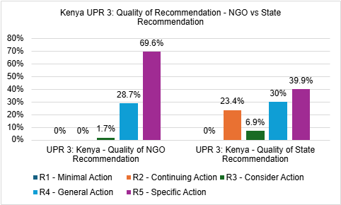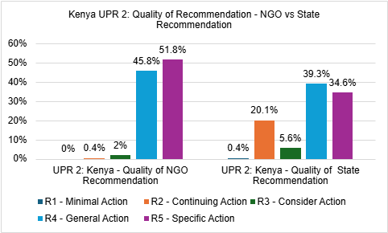
In the case of Kenya, both states and NGOs made specific recommendations (R5) during the UPR 2 and 3. However, the proportion of specific recommendations made by NGOs (about 70% of the total UPR 3 NGO recommendations and 52% for UPR 2) significantly outpaced those made by states (about 40% of the total UPR 3 state recommendations and 35%). In each of the two UPR cycles, less than half of state recommendations were specific compared to more half of NGO recommendations. Our analysis also found that NGOs did not make any recommendations calling the state to seek technical assistance (R1) and barely made recommendations for a state to ‘continue an action’ (R2) (only one recommendation made) or ‘consider an action’ (R3) (no more than 2% of the recommendations in each cycle). In contrast, over 20% of state recommendations to Kenya each of the UPR cycles called for R2 action and over 5% called for R3 action. A further analysis of the language of these recommendations revealed that state recommendations tended to be more diplomatic and framed in generic terms. For example, Ghana’s recommendation that Kenya ‘[c]ontinue to respect, protect, promote and fulfil all the rights and fundamental freedoms as stipulated in the bill of rights’ and Rwanda’s recommendation that Kenya ‘consider further limitations on the use of the death penalty with a view to imposing a de facto moratorium on its use and aiming at its total abolition’. In contrast, NGOs were often more pointed and specific. For example, Independent Medico-Legal Unit (IMLU) recommended that ‘Parliament should amend all laws that currently permit the death penalty. These are Sections 204, 60, 40(3), 296(2) and 297(2) of the Penal Code, CAP 63 Laws of Kenya, the Criminal Procedure Code, CAP 75 Laws of Kenya, and other statutory provisions linked to the death penalty’. The Lutheran World Federation (LWF), Refugee Consortium of Kenya and International Rescue Committee and KADANA UPR Refugees Network, Kenya recommended the government of Kenya ‘[i]mmediately put in place a refugee policy with guidelines on integration of refugees in Kenya as articulated in the Bill of Rights of the Constitution of Kenya’. This reinforces the point we made earlier that state-state recommendations are often worded to reflect diplomatic considerations, bilateral relations, and geopolitical interests whereas NGO, being less burdened by diplomatic constraints, can be more forthright in their critiques and suggestions.

Insert Figures 3, 4 and 5
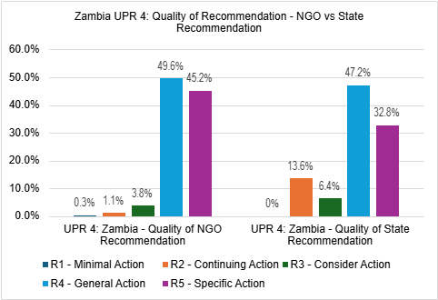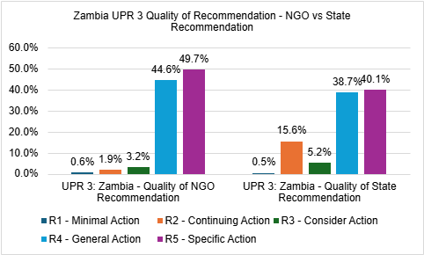
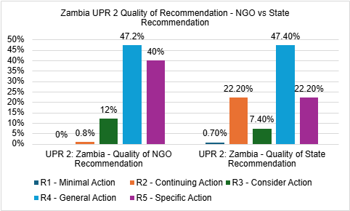
In the case of Zambia, the data indicated that the quality of NGO recommendations were not as strong compared to Kenya, although there was an evolution towards greater specificity across the three UPR cycles. Less than 50% of the total NGO recommendations were specific in each of the three cycles we examined. The majority of recommendations in both cycle 2 and 4 were general recommendations (R4) Our analysis of the quality of recommendations made within the most prominent thematic issues for each cycle arrived at similar findings. The most prominent thematic issue in UPR cycle 3 and 4 for Zambia was the rights of the child. The majority of recommendations within this thematic category (67% in UPR 3 and 64% in cycle 4) were non-specific recommendations. The right to education was the most prominent NGO issue in cycle 2 and 61% of the recommendations within this issue category was non-specific recommendations. We made similar observations in relation to State recommendations which were more general than specific in UPR cycles 4 and 2, even within the most prominent thematic issues. However, for both state and NGO recommendations there were four thematic issues that showed a pattern for receiving a significantly higher percentage of specific recommendations even if they were not the most prominent thematic issues. These included recommendations on ‘Torture and Detention’, ‘Sexual Orientation and Gender Identity’, ‘Death penalty’, and ‘Freedom of Press, Opinion and Expression’. For example, over 60% of both states and NGO recommendations to Zambia during UPR cycle 3 and 4 were specific recommendations. Over 80% of state recommendations to Zambia on ‘Freedom of Press, Opinion and Expression’ and on ‘Sexual Orientation and Gender Identity’ were specific recommendations. While NGOs recommendations across these categories were also specific, the proportion was less compared to state recommendations. In UPR cycle 4, 67% of NGO recommendations on the ‘death penalty’ was specific (compared to 77% by states); 59% on ‘Freedom of Press, Opinion and Expression’ (compared to 84% by states); and 54% on ‘Sexual Orientation and Gender Identity (compared to 82% by states).
When compared to Kenya, we found a significant contrast where the proportion of specific (R4) NGO recommendations across thematic categories were significantly higher than the proportion of specific (R4) state recommendations. For example, in cycle 3 of the UPR, 77% of NGO recommendations on the ’right to life and reproductive rights’ were specific (compared to 33% by states); 81% on ‘sexual and gender-based violence’ (compared to 25% by states); 88% on trafficking (compared to 33% by states); and 83% on ‘disability rights’ (compared to 38% by states). Unlike in the case of Kenya, NGOs in Zambia across UPR the last two cycles made recommendations across R1 (minimal action), R2 (continuing action), and R3 (consider action).
Reflecting on the disparity in the quality of recommendations between Kenya and Zambia, it is arguable that the absence of a well organised national NGO UPR coalition, lobbying and advocacy strategy, and limited engagement with pre-review sessions in Geneva also has an impact on the quality of both NGO and state recommendations in the UPR process. These were absent in the case of Zambia but employed in the case of Kenya.

Concluding Remarks
Overall, our empirical evidence suggests that NGO recommendations in the UPR process tend to be of higher quality than those provided by States. This is particularly true in terms of specificity and actionability. The quality of the NGO recommendations is stronger where there is greater NGO mobilisation through an active national UPR coalition and a well-designed lobbying and advocacy strategy. While the scholarly literature has been critical of state recommendations for their vagueness and generality, our analysis reveal that a significant number of NGO recommendations also tend to be vague and generic.
The higher quality of NGO recommendations can be attributed to several key factors: (i) Independence - NGOs are, in general, independent and not constrained by governmental considerations. They can offer more forthright critiques and suggestions; (ii) Specialisation - many NGOs focus on specific human rights issues, allowing them to provide more detailed and informed recommendations within their areas of expertise; (iii) Ground-level perspective - NGOs often work closely with affected communities, giving them valuable insights into practical challenges and potential solutions that may not be as apparent to state actors; (iv) Lack of diplomatic constraints - Unlike States, which may temper their recommendations due to political considerations, NGOs can be more direct in addressing human rights concerns.
While NGOs may have placed more or less emphases on certain thematic issues, the existence of an alignment for a broad list of thematic issues raised across cycles suggests that the UPR process may be fostering a convergence of priorities between States and NGOs over time. The observable differences in language and specificity between their recommendations underscores the distinct roles of states and NGOs in the UPR mechanism. These findings reveal key implications for the UPR process. Areas where States and NGOs align in their priorities suggest greater potential for progress. Conversely, divergent areas will likely require more dialogue and engagement to bridge the gap between the views of State and NGOs on particular human rights issues. Understanding these areas of convergence and divergence between State and NGO recommendations in the UPR process and the underlying contributing reasons can help to ultimately enhance the impact of the UPR on domestic human rights. Future research could examine the implementation rates of recommendations from areas of high alignment versus low alignment and explore any alignment or misalignment between UPR recommendations by domestic vs international NGOs. There is also need for some empirical evidence to determine whether the quality of recommendations has a significant impact on levels of implementation.
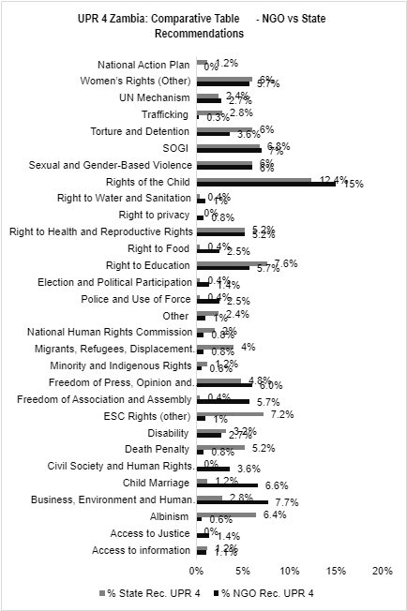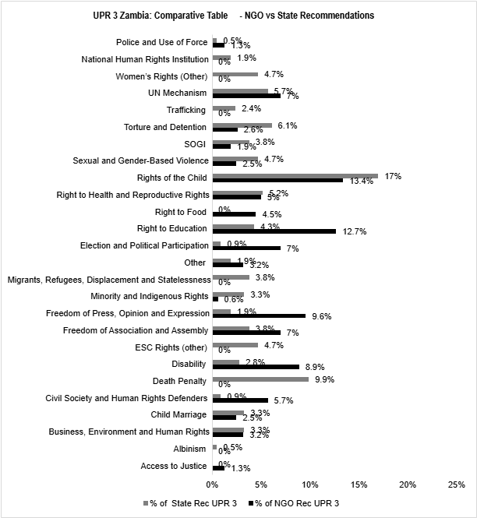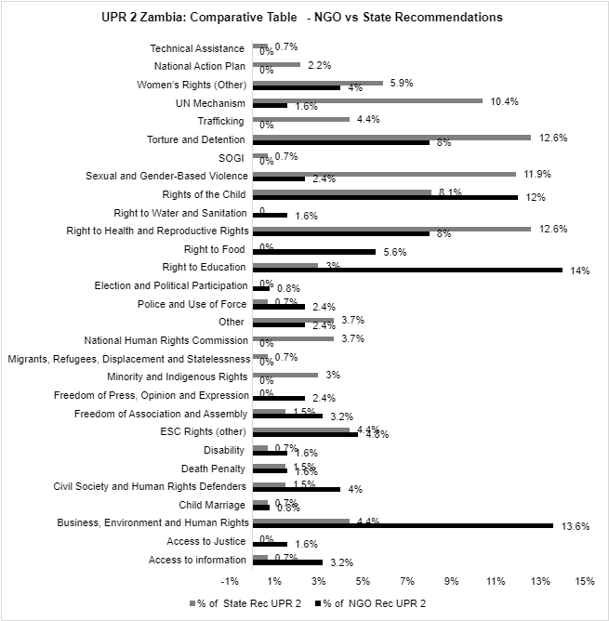
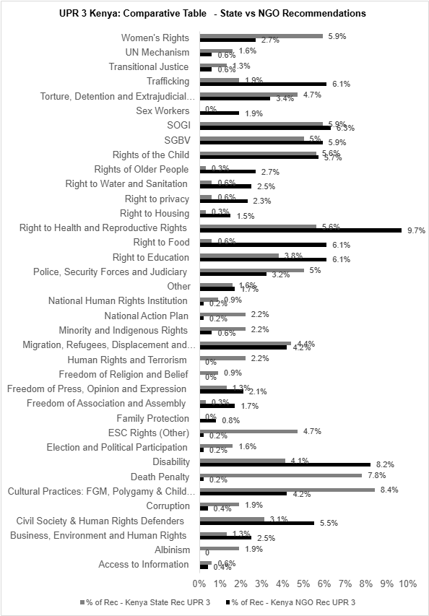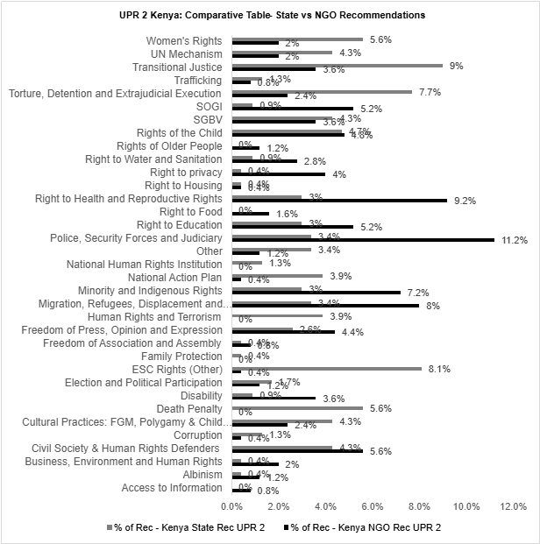

Bibliography
Abashidze, Aslan. 2019. The Process of Strengthening the Human Rights Treaty Body System: The Road towards Effectiveness or Inefficiency?. (2019) Netherlands Int Law Review 66(3): 357 - 389.
Abebe, Allehone M. 2009. Of Shaming and Bargaining: African States and the Universal Periodic Review of the United Nations Human Rights Council. Human Rights Law Review 9 (1): 1-35.
Amnesty International. 2016. Freedom Of Peaceful Assembly In South Korea And International Human Rights Standards. (referenced 14 March 2024)
Ashley, Louisa. 2024. Universal Periodic Review Prospects for Promoting Support for the United Nations Declaration on the Rights of Peasants and Other People Working in Rural Areas (UNDROP). In Damian Etone, Amna Nazir, Alice Storey (eds.), Human Rights and the UN Universal Periodic Review Mechanism. Routledge.
Bae, Su Hyen. 2018. Power, Politicization, and Network Positions: Explaining State Participation in the UPR. The Korean Journal of International Studies 16: 335-365.
Baird, Natalie. 2015. The Role of International Non-governmental Organisations in the Uni-versal Periodic Review of Pacific Island States: Can ‘doing good’ be done better?. (2015 Melbourne Journal of International Law 16(2): 1-35.
Banks, N., Hulme, D. and Edwards, M. 2015. NGOs, States and Donors Revisited: Still too close for comfort? World Development 66: 707-718.
Bantekas, Ilias and Oette, Lutz. 2020. International Human Rights Law and Practice. Cambridge University Press.
Berkovitch, Nitza and Gordon, Neve. 2008. The Political Economy of Transnational Regimes: The Case of Human Rights. International Studies Quarterly 52(4) 881-904.
Cáceres, Sigfrido Burgos. 2012. NGOs, IGOs, and International Law: Gaining Credibility and Legitimacy through Lobbying and Results. Georgetown Journal of International Affairs 13(1): 70-87.
Carolei, Domenico. 2023. Non-Governmental Organisations and the Law: Self-Regulation and Accountability. Routledge.
Child Rights Connect. 2015. Model UPR advocacy strategy for NGOs. https://www.childrightsconnect.org/wp-content/uploads/2015/08/UPR-FS-3-NGO-Advocacy_ENGLISH_table.pdf. (referenced 4 June 2024).
Child Rights Connect. 2023. The Universal Periodic Review, children’s rights and the UN Committee on the Rights of the Child. https://childrightsconnect.org/wp-content/uploads/2018/01/en_factsheet-3.pdf (referenced 4 June 2024).
Cowan, Jane K. and Billaud, Julie. 2015. Between Learning and Schooling: The Politics of Human Rights Monitoring at the Universal Periodic Review. Third World Quarterly 36 (6): 1175–90.
Creamer, Cosette D. and Simmons, Beth A. 2020. The Proof Is in the Process: Self-Reporting Under International Human Rights Treaties. American Journal of International Law 114(1):1-50.
Economic and Social Council. 1996. Resolution 1996/31. Consultative relationship between the United Nations and non-governmental organizations. Adopted 25 July 1996.
Edwards, Nicola. 2020. Challenging Impunity in Indonesia and the Philippines through the Universal Periodic Review Mechanism. Australian Journal of Human Rights 26(2):1-18.
Etone, Damian. 2020. The Human Rights Council: The Impact of the Universal Periodic Review in Africa. Routledge.
Gaer, Felice D. 2003. Implementing international human rights norms: UN human rights treaty bodies and NGOs. Journal of Human Rights 2(3): 339-357.
Gay and Lesbian Coalition of Kenya. 2019. Statements UPR Pre-session on Kenya. https://upr.info/sites/default/files/documents/2019-12/2._gay_and_lesbian_coalition_of_kenya_stmt.pdf (referenced 30 December 2024).
Hinfelaar, Marja and Kaaba, O'Brien. 2019. Adjust, Resist, or Disband: How Does Civil Society Respond to Repression in Zambia?. PRIO Paper. Oslo: PRIO.
Houghton, Ruth Alice. 2014. A Puzzle for International Law: NGOs at the United Nations. North East Law Review 2(2): 1-24.
Human Rights Commission Zambia. 2022. Statement UPR Pre-session on Zambia. https://upr.info/sites/default/files/country-document/2022-11/HRC_Statement_Presession42_Zambia.pdf (referenced 19 May 2024).
INGO Accountability Charter. 2005. chrome-extension://efaidnbmnnnibpcajpcglclefindmkaj/https://www.amnesty.org/en/wp-content/uploads/2021/08/ior800062006en.pdf (referenced 30 December 2024).
Joint CSO Submission. 2010. Women’s Human Rights: Argentine State Pending Debts, Alternative Report from Civil Society Organizations in Connection with the Submission of the Sixth Periodic Report of the States Parties (CEDAW/C/ARG/6) to the Committee for the Elimination of All Forms of Discrimination against Women, 46th Period of Sessions. https://tbinternet.ohchr.org/Treaties/CEDAW/Shared% (reference 14 March 2024).
Joseph, Sara. 2014. Global media coverage of the Universal Periodic Review process. In Hilary Charlesworth and Emma Larking (eds.), Human Rights and the Universal Periodic Review. Cambridge University Press.
KELIN. 2023. Kelin Participates In The Universal Periodic Review Kenya Stakeholders Meet Up. https://www.kelinkenya.org/kelin-participates-in-the-universal-periodic-review-kenya-stakeholders-meet-up/#:~:text=On%2017th%20and%2018,Organizations%20working%20on%20Human%20Rights. (referenced 25 April 2024).
Kellow, Aynsley and Murphy-Gregory, Hannah. 2018. NGOs and global politics. In Aynsley Kellow and Hannah Murphy-Gregory (eds), Handbook of Research on NGOs, pp 1-14 Edward Elgar Publishing.
Kenya UPR Stakeholders’ Coalition. 2018. Kenya's 2nd Cycle Universal Periodic Review Mid Term Report. https://www.eachrights.or.ke/ssd/2024/03/Kenya-CSO-UPR-Mid-Term-Report.pdf (referenced 23 April 2024).
KNCHR. 2011. Accounting for Human Rights Protection Under the UPR: The Difference Kenya’s Stakeholders Made. <https://www.knchr.org/Portals/0/InternationalObligationsReports/Accounting_For_Human_Rights_Protection_Under_the_UPR.pdf?ver=2013-02-21-150102-893> (referenced 20 April 2024).
McGaughey Fiona. 2017. The Role and Influence of Non-governmental Organisations in the Universal Periodic Review – International Context and Australian Case Study. Human Rights Law Review 17: 421 - 450 .
McMahon, Edward et al. 2013. The Universal Periodic Review: Do Civil Society Organisation-Suggested Recommendations Matter? International Policy Analysis: 1-14.
Miller, Alice M. 2000. Women’s Human Rights NGOs and the Treaty Bodies: Some Case Studies in Using the Treaty Bodies to Protect the Human Rights of Women. In Anne Bayefsky (ed), The UN Human Rights Treaty System in the 21 Century, pp 195–207: Brill.
Moss, Lawrence C. 2010. Opportunities for Nongovernmental Organization Advocacy in the Universal Periodic Review Process at the UN Human Rights Council. (2010) Journal of Human Rights Practice 2(1): 122-150).
Mutua, M. 2002. Human Rights: A Political and Cultural Critique. University of Pennsylvania Press
Nader, Lucia. 2007. The Role of NGOs in the he UN Human Rights Council. International Human Rights Journal 7: 1-27.
Nazir, Amna, Storey, Alice and Yorke, Jon. 2024. The Universal Periodic Review as Utopia. In Damian Etone, Amna Nazir, Alice Storey (eds.), Human Rights and the UN Universal Periodic Review Mechanism. Routledge.
O’Flaherty, Michael. 2002. Human Rights and the UN: Practice before the Treaty Bodies. Kluwer Law International.
Office of the Attorney General & Department Of Justice. 2021. Implementation Plan (2021-2025) for the 3rd Cycle Recommendations Under The Universal Periodic Review Process (UPR). https://statelaw.go.ke/wp-content/uploads/2022/04/3rd-Cycle-UPR-Implementation-Plan-2021-to-2025.pdf (referenced 26 April 2024).
OHCHR. 2020. Study on emerging Good Practices from the Universal Periodic Review (UPR). https://www.ohchr.org/Documents/HRBodies/UPR/Emerging_UPR_GoodPractices.pdf (referenced 24 April 2024).
OHCHR. 2021. Study on Emerging Good Practices from the Universal Periodic Review. chrome-extension://efaidnbmnnnibpcajpcglclefindmkaj/https://www.ohchr.org/sites/default/files/Documents/HRBodies/UPR/Emerging_UPR_GoodPractices.pdf. (referenced 30 December 2024).
OHCHR. Undated. Universal Periodic Review (Third Cycle): Information and guidelines for relevant stakeholders’ written submissions. chrome-extension://efaidnbmnnnibpcajpcglclefindmkaj/https://www.ohchr.org/sites/default/files/Documents/HRBodies/UPR/TechnicalGuideEN.pdf (referenced 30 December 2024).
Roesdahl, Mie. 2017. Universal Periodic Review and its Limited Change Potential: Tracking the Complexity of Multiple Actors and Approaches to Human Rights Change through the Lens of the UPR Process of Nepal. Journal of Human Rights Practice 9(3): 401-423.
Šahović, Nevena Vučković, Doek, J. E., and Zermatten, Jean. 2012. The rights of the child in International Law. Stampfli.
Schmitz, Hans Peter and Sikkink, Kathryn. 2002. International Human Rights. In Walter Carlsnaes, Thomas Risse and Beth A. Simmons (eds.), Handbook of International Relations pp. 827-851: Sage.
Schokman, Ben and Lynch, Phil. 2015. Effective NGO engagement with the Universal Periodic Review. In Hilary Charlesworth and Emma Larking (Eds), Human Rights and the Universal Periodic Review: Rituals and Ritualism, pp 126 – 146: Cambridge University Press.
Sky News. 2018. Oxfam scandal: Haiti official was sacked by charity over ‘inappropriate behaviour’. https://news.sky.com/story/oxfam-scandal-haiti-official-sacked-by-charity-over-inappropriate-behaviour-11250718 (referenced 30 December 2024)
Slim, Hugo. 2002. By What Authority? The Legitimacy and Accountability of Non-governmental Organisations. International Council on Human Rights Policy. https://www.gdrc.org/ngo/accountability/by-what-authority.html (referenced 30 December 2024).
Storey, Alice. 2025. The UN’s Universal Periodic Review and FGM in Somalia: The Value of Civil Society Recommendations. African Human Rights Law Journal 25:302-331.
Storey, Alice and Oleschuk, Melisa. 2023. Empowering Civil Society Organisations at the UPR. https://bcuassets.blob.core.windows.net/docs/empowering-csos-at-the-upr-full-report-133680282970363754.pdf (referenced 10 October 2024)
Terman, Rochelle and Byun, Joshua. 2022. Punishment and Politicization in the International Human Rights Regime. American Political Science Review 116(2):385-402.
The East African Centre for Human Rights. The Universal Periodic Review. https://www.eachrights.or.ke/universal-periodic-review/#:~:text=Kenya's%20Stakeholders%20Coalition%20on%20the,on%20Human%20Rights%20(OHCHR) (referenced 21 April 2024).
Theytaz-Bergman, Laura. 2000. State Reporting and the Role of Non-Governmental Organizations. In Anne Bayefsky (ed), The UN Human Rights Treaty System in the 21 Century, 45-56: Brill.
Theytaz-Bergman, Laura. 2007. NGO reporting under the Convention on the Rights of the Child. Conference presentation Amsterdam.
Thomas, C. 2009. Evaluation at Minority Rights Group. Journal of Human Rights Practice 1(3):488-498.
Tistounet, Eric. 2020. The UN Human Rights Council : A Practical Anatomy. Edward Elgar Publishing Limited.
Traglia, Francesca P. Non-Confrontational Human Rights Advocacy: Experiences from the UPR Process in Myanmar. In James Gomez and Robin Ramcharan (eds), The Universal Periodic Review of Southeast Asia: Civil Society Perspectives, pp 171-183 Palgrave Macmillan.
UN Human Rights Council. 2007a. Oral Statement by the European Union on the Universal Periodic Review.
UN Human Rights Council. 2007b. Res. 5/1. Institution Building of the United Nations Human Rights Council. Adopted 18 June. A/HRC/RES/5/1.
UN Human Rights Council. 2013. Civil society space: creating and maintaining, in law and in practice, a safe and enabling environment. A/HRC/RES/24/21.
UN Human Rights Council. 2014. Civil Society Space. A/HRC/RES/27/31.
UN Human Rights Council. 2016. Report of the Special Rapporteur on the rights to freedom of peaceful assembly and of association on his mission to the Republic of Korea. A/HRC/32/36/Add.2.
UN Human Rights Council. 2018. Report of the Working Group on the Universal Periodic Review – Zambia. A/HRC/37/14.
UN Human Rights Council. 2020. Report of the Working Group on the Universal Periodic Review – Kenya. A/HRC/44/9.
UN Human Rights Council. 2023. Report of the Working Group on the Universal Periodic Review – Zambia. A/HRC/53/14.
UN Human Rights Council. 2024. Report of the Secretary General: Cooperation with the United Nations, its representatives and mechanisms in the field of human rights. A/HRC/57/60
UNESCO. 2022. The Universal Periodic Review (UPR) and its potential to foster freedom of expression, access to information and safety of journalists: factsheet on smart recommendations for civil society organizations. https://unesdoc.unesco.org/ark:/48223/pf0000382048 (referenced 30 December 2024).
UNHCR and SAVE THE CHILDREN. 2002. Note for Implementing Partnrs on Sexual violence and exploitation: The experience of refugee children in Liberia, Guinea and Sierra Leone. https://www.unhcr.org/media/26892 (referenced 30 December 2024).
United Nations. 1945. Charter of the United Nations. Adopted 24 October 1945.
UPR Info. 2015a. For impact on the ground the UPR needs SMART recommendations. https://bit.ly/3GBLJ70 (30 December 20204).
UPR Info. 2015b. Identifying best practices: An Analysis of National Reports. https://upr.info/sites/default/files/documents/2015-11/upr_info_identifying_best_practices_in_national_reports_2015.pdf (referenced 30 December 2024).
UPR Info. 2016. Action Categories. https://upr-info.org/sites/default/files/general-document/2022-05/Database_Action_Category.pdf (referenced 30 December 2024)
UPR Info. 2016a. UPR Info Pre-sessions: Empowering human rights voices from the ground. https://upr.info/sites/default/files/documents/2016-12/pre-sessions_web.pdf. (referenced 30 December 2024).
UPR Info. Undated. Pre-sessions Frequently Asked Questions. https://upr.info/en/node/2299 (referenced 30 December 2024).
UPR-Info. 2016b. 4 Sudanese defenders banned from participating in UPR Info Pre-session. https://upr.info/fr/node/1911 (referenced 20 May 2024).
Willetts, Peter. 1996. The Conscience of the World: The Influence of Non-Governmental Organizations in the UN System. Brookings Institution Press.
Wiseberg, Laurie S. 2003. The Role of Non-Governmental Organizations (NGOs) in the Protection and Enforcement of Human Rights. In J Symonides (ed), Human Rights: International Protection, Monitoring, Enforcement, UNESCO Publishing.
Wong. 2012. Internal Affairs. In Sarah S. Stroup, Borders among Activists: International NGOs in the United States, Britain, and France. Cornell University Press.

United Nations, Charter of the United Nations, 24 October 1945, 1 UNTS XVI, art 71.
Economic and Social Council, Consultative relationship between the United Nations and non-governmental organizations, resolution 1996/31, adopted at the 49th plenary meeting, 25 July 1996, preamble.
UN Human Rights Council, ‘Civil Society Space’ (3 October 2014) UN Doc A/HRC/RES/27/31, Preamble.
UN Human Rights Council, ‘Civil society space: creating and maintaining, in law and in practice, a safe and enabling environment’ (9 October 2013) UN Doc A/HRC/RES/24/21, Preamble.
UN Human Rights Council (n 3).
Felice D. Gaer, ‘Implementing international human rights norms: UN human rights treaty bodies and NGOs’ (2003) 2(3) Journal of Human Rights 339; Laurie S Wiseberg, ‘The Role of Non-Governmental Organizations (NGOs) in the Protection and Enforcement of Human Rights’ in J Symonides (ed), Human Rights: International Protection, Monitoring, Enforcement (UNESCO Publishing 2003) 347; Alice M Miller, ‘Women’s Human Rights NGOs and the Treaty Bodies: Some Case Studies in Using the Treaty Bodies to Protect the Human Rights of Women In Anne Bayefsky (ed), The UN Human Rights Treaty System in the 21 Century (Brill 2000) 195; Laura Theytaz-Bergman, ‘State Reporting and the Role of Non-Governmental Organizations’ in Anne Bayefsky (ed), The UN Human Rights Treaty System in the 21 Century (Brill 2000) 45.
Fiona McGaughey, ‘The Role and Influence of Non-governmental Organisations in the Universal Periodic Review – International Context and Australian Case Study’ (2017) 17 Human Rights Law Review 421; Ben Schokman and Phil Lynch, ‘Effective NGO engagement with the Universal Periodic Review’ in Hilary Charlesworth and Emma Larking (Eds), Human Rights and the Universal Periodic Review: Rituals and Ritualism (Cambridge University Press 2015) 126.
Alice Storey and Melisa Oleschuk, Empowering Civil Society Organisations at the UPR (Birmingham City University, 2023)available at https://bcuassets.blob.core.windows.net/docs/empowering-csos-at-the-upr-full-report-133680282970363754.pdf accessed 10 October 2024; See also Lucia Nader, ‘The Role of NGOs in the he UN Human Rights Council’ (2007) 7 International Human Rights Journal.
Edward McMahon, et al, ‘The Universal Periodic Review: Do Civil Society Organisation-Suggested Recommendations Matter?’ (2013) International Policy Analysis 1-14.
Institution Building of the United Nations Human Rights Council, HRC Res. 5/1, UN HRC OR, 5th sess, Annex [IB], UN Doc A/HRC/RES/5/1, annex (18 June 2007) para 3 (m).
The African Group argued that NGOS are ‘detractors, not peers’. See The African Group argued that NGOS are ‘detractors, not peers’, see Algeria’s Statement (on behalf of African Group) see Gareth Sweeney, Human Rights Council Working Group To Develop The Modalities Of The Universal Periodic Review, 3rd Session, 11 And 24 April 2007 (International Service for Human Rights, 2007) 7.
This is in contrast with WEOG that wanted a ‘full and effective involvement of all stakeholders, including NGOs, as well as openness to the public at large.’ See See Human Rights Council Working Group on the Review of Mandates and Mechanisms, ‘Oral Statement by the European Union on the Universal Periodic Review’ (12 February 2007).
Institution Building of the United Nations Human Rights Council (n 10).
Allehone M Abebe, ‘Of Shaming and Bargaining: African States and the Universal Periodic Review of the United Nations Human Rights Council’ (2009) Human Rights Law Review 3, 29.
Institution Building of the United Nations Human Rights Council (n 10) [15] (a).
UPR Info, ‘For impact on the ground the UPR needs SMART recommendations’ (2015) 20, available at https://bit.ly/3GBLJ70
Damian Etone, The Human Rights Council: The Impact of the Universal Periodic Review in Africa (Routledge 2020) 60-65, 101-105, and 153-157.
See Miloon Kothari, ‘Study on Emerging Good Practices from the Universal Periodic Review’ (2021) 96; Etone (n 17); McGaughey (n 7).
Etone (n 17) 102-103.
Ben Schokman and Phil Lynch (n 7) 85.
UPR Info ‘UPR Info Pre-sessions: Empowering human rights voices from the ground’ (2016) available at https://upr.info/sites/default/files/documents/2016-12/pre-sessions_web.pdf
UPR Info (n 21).
Schokman and Lynch (n 7).
UPR Info (n 21).
Natalie Baird, ‘The Role of International Non-governmental Organisations in the Uni-versal Periodic Review of Pacific Island States: Can ‘doing good’ be done better?’ (2015) 16(2) Melbourne Journal of International Law 1, 1-37; Fiona McGaughey, ‘The Role and Influence of Non-governmental Organisations in the Universal Periodic Review— International Context and Australian Case Study’ (2017) 17 Human Rights Law Review 421.
UPR Info, ‘Pre-sessions’ (UPR Info, undated) < https://upr.info/en/presessions> accessed 16 May 2025.
ibid.
Alice Storey and Melisa Oleschuk, above, n8.
Ruth Alice Houghton, ‘A Puzzle for International Law: NGOs at the United Nations’ (2014) 2(2) North East Law Review 1, 6.
ibid.
Hans Peter Schmitz and Kathry Sikkink, ‘International Human Rights’ in Walter Carlsnaes, in Thomas Risse and Beth A. Simmons (eds.) Handbook of International Relations (Sage 2002) 827-851.
Ilias Bantekas and Lutz Oette, International Human Rights Law and Practice (CUP 2020) 116.
ibid, 117.
Baird (n 25) 35.
McGaughey (n 7) 436-437.
UPR-Info, ‘4 Sudanese defenders banned from participating in UPR Info Pre-session’ (UPR Info 31 March 2016) <https://upr.info/fr/node/1911 > accessed 20 May 2025.
See UN Human Rights Council, ‘Report of the Secretary General: Cooperation with the United Nations, its representatives and mechanisms in the field of human rights’ (20 August 2024) UN Doc A/HRC/57/60, para 40-111.
Storey and Oleschuk (above n 8) 27.
UPR Info (n 21) 36.
ibid.
ibid, 16.
Storey and Oleschuk (n 8) 20.
McGaughey (n 7) 434.
Gay and Lesbian Coalition of Kenya, ‘Statements UPR Pre-session on Kenya’ (Gay and Lesbian Coalition of Kenya, 10 December 2019) 2, available at https://upr.info/sites/default/files/documents/2019-12/2._gay_and_lesbian_coalition_of_kenya_stmt.pdf
UN Human Rights Council ‘Report of the Working Group on the Universal Periodic Review – Kenya’ (20 March 2020) UN Doc A/HRC/44/9, paras 144.25, 144.26, and 142.30.
UN Human Rights Council ‘Report of the Working Group on the Universal Periodic Review – Zambia’ (11 April 2023) UN Doc A/HRC/53/14, paras 127.181 and 127.180.
Human Rights Commission Zambia, ‘Statement UPR Pre-session on Zambia’ (HRC 28 November 2022) 4available at https://upr.info/sites/default/files/country-document/2022-11/HRC_Statement_Presession42_Zambia.pdf accessed 19 May 2025.
Schokman and Lynch (n 7) 143.
Sara Joseph, ‘Global media coverage of the Universal Periodic Review process’ in Hilary Charlesworth and Emma Larking (eds.), Human Rights and the Universal Periodic Review (CUP 2014).
ibid, 148.
ibid.
Child Rights Connect, ‘Model UPR advocacy strategy for NGOs’ (Child Rights Connect, August 2015) 1-2, available at https://www.childrightsconnect.org/wp-content/uploads/2015/08/UPR-FS-3-NGO-Advocacy_ENGLISH_table.pdf accessed 4 June 2025.
Child Rights Connect, ‘The Universal Periodic Review, children’s rights and the UN Committee on the Rights of the Child’ (Child Rights Connect, 21 July 2023) 3, available at https://childrightsconnect.org/wp-content/uploads/2018/01/en_factsheet-3.pdf accessed 4 June 2025.
Louisa Ashley, ‘Universal Periodic Review Prospects for Promoting Support for the United Nations Declaration on the Rights of Peasants and Other People Working in Rural Areas (UNDROP)’ in Etone, Nazir and Storey(n 54) 191.
Amna Nazir, Alice Storey, and Jon Yorke, ‘The Universal Periodic Review as Utopia’ in Etone, Nazir and Storey (n 54) 50.
KNCHR, ‘Accounting for Human Rights Protection Under the UPR: The Difference Kenya’s Stakeholders Made’ (KNCHR, September 2011) available at <https://www.knchr.org/Portals/0/InternationalObligationsReports/Accounting_For_Human_Rights_Protection_Under_the_UPR.pdf?ver=2013-02-21-150102-893> accessed 20 April 2025.
Kenya UPR Stakeholders’ Coalition, ‘KENYA'S 2ND CYCLE UNIVERSAL PERIODIC REVIEW MID TERM REPORT’ (October 2018) < https://www.eachrights.or.ke/ssd/2024/03/Kenya-CSO-UPR-Mid-Term-Report.pdf> accessed 23 April 2025.
Kathari (n 18)
The East African Centre for Human Rights, ‘The Universal Periodic Review’ (EACHR, undated) available at https://www.eachrights.or.ke/universal-periodic-review/#:~:text=Kenya's%20Stakeholders%20Coalition%20on%20the,on%20Human%20Rights%20(OHCHR accessed 21 April 2025.
Kelin, ‘KELIN PARTICIPATES IN THE UNIVERSAL PERIODIC REVIEW KENYA STAKEHOLDERS MEET UP’ (20 July 2023) <https://www.kelinkenya.org/kelin-participates-in-the-universal-periodic-review-kenya-stakeholders-meet-up/#:~:text=On%2017th%20and%2018,Organizations%20working%20on%20Human%20Rights.> Accessed 25 April 2025.
ibid.
Office of the Attorney General & Department Of Justice, ‘Implementation Plan (2021-2025) for the 3rd Cycle Recommendations under the Universal Periodic Review Process (UPR)’ (November 2021) available at https://statelaw.go.ke/wp-content/uploads/2022/04/3rd-Cycle-UPR-Implementation-Plan-2021-to-2025.pdf accessed 26 April 2025.
Lawrence Moss, ‘Opportunities for Nongovernmental Organization Advocacy in the Universal Periodic Review Process at the UN Human Rights Council’ (2010) 2(1) Journal of Human Rights Practice 122, 122.
Mie Roesdahl, ‘Universal Periodic Review and its Limited Change Potential: Tracking the Complexity of Multiple Actors and Approaches to Human Rights Change through the Lens of the UPR Process of Nepal’ (2017) 9(3) Journal of Human Rights Practice 401, 411.
Storey and Oleschuk (above n 8) 31.
ibid.
ibid.
Moss (n 63).
ibid.
ibid, 135.
Sigfrido Burgos Cáceres, ‘NGOs, IGOs, and International Law: Gaining Credibility and Legitimacy through Lobbying and Results’ (2012) 13(1) Georgetown Journal of International Affairs 79.
Storey and Oleschuk (above n 8) 50-56.
Francesca P Traglia, ‘Non-Confrontational Human Rights Advocacy: Experiences from the UPR Process in Myanmar’ in James Gomez and Robin Ramcharan (eds), The Universal Periodic Review of Southeast Asia: Civil Society Perspectives (Palgrave Macmillan 2018) 194.
Etone (n 17) 103.
Marja Hinfelaar and O'Brien Kaaba, ‘Adjust, Resist, or Disband: How Does Civil Society Respond to Repression in Zambia?’ (2019) PRIO Paper (Oslo: PRIO) 1-4.
See UN Human Rights Council, ‘Report of the Secretary General: Cooperation with the United Nations, its representatives and mechanisms in the field of human rights’ (20 August 2024) UN Doc A/HRC/57/60, paras 40-111.
Nicola Edwards, ‘Challenging Impunity in Indonesia and the Philippines through the Universal Periodic Review Mechanism’ (2020) 26(2) Australian Journal of Human Rights 274, 284.
These dynamics are addressed by various scholars - See Rochelle Terman and Joshua Byun, ‘Punishment and Politicization in the International Human Rights Regime’ (2022) 2 American Political Science Review 116, 385–402; Jane K Cowan, and Julie Billaud, ‘Between Learning and Schooling: The Politics of Human Rights Monitoring at the Universal Periodic Review’ (2015) 36 (6) Third World Quarterly, 1175–90; Su Hyen Bae, ‘Power, Politicization, and Network Positions: Explaining State Participation in the UPR’ (2018) The Korean Journal of International Studies 16-, 335-365.
These NGO reports are the full reports submitted by NGOs and not the summary compilation prepared by the OHCHR which risk filtering out key recommendations made by NGOs. These NGO reports are available on the OHCHR website. See for example https://www.ohchr.org/en/hr-bodies/upr/uprke-stakeholders-info-s35
For example, Cote d’Ivoire recommended to Zambia during cycle 3 to ‘Seek the necessary technical, material and financial assistance in order to implement the recommendations it has endorsed’ UN Human Rights Council 2018 para 131.109.
Kyrgyzstan recommended during cycle 3 for Kenya to ‘[f]urther continue its political reforms in order to promote political democracy in the country’. See UN Human Rights Council 2020: para 142.25.
For example, Pakistan recommended Kenya ‘[c]onsider adopting a new national action plan on human rights’. See UN Human Rights Council 2020 para 142.43.
Lesotho recommended Kenya ‘[b]eef up measures to ensure that the recurring terrorist attacks taking place in the country are halted’. See ibid, para 142.78.
See the recommendation Zambia made for Kenya to ‘[a]dopt and implement the National Action Plan on Business and Human Rights’. See ibid, 142.73.
See UPR Info (n 16).
See OHCHR, ’ Universal Periodic Review (Third Cycle): Information and guidelines for relevant stakeholders’ written submissions’ para 7 (c) available at https://bit.ly/3ZBUHda; UNESCO, ‘The Universal Periodic Review (UPR) and its potential to foster freedom of expression, access to information and safety of journalists: factsheet on smart recommendations for civil society organizations’ (2022) available at https://unesdoc.unesco.org/ark:/48223/pf0000382048
See UNESCO (n 86) 2.
Etone (n 17) 114-117; Also see Damian Etone, ‘The Universal Periodic Review and Transitional Justice’ in Etone, Nazir and Storey (n 54) 164-166.
Etone (n 17) 117.
Etone (n 17) 119.
UPR Info, ‘Action Categories’ available at https://upr-info.org/sites/default/files/general-document/2022-05/Database_Action_Category.pdf
Abebe (n 14) 16; Etone (n 17)116-117; UPR Info, ‘A Guide for Recommending States to the UPR’ (July 2015] Policy Report, 25.

